Conducting the Test in SPSS
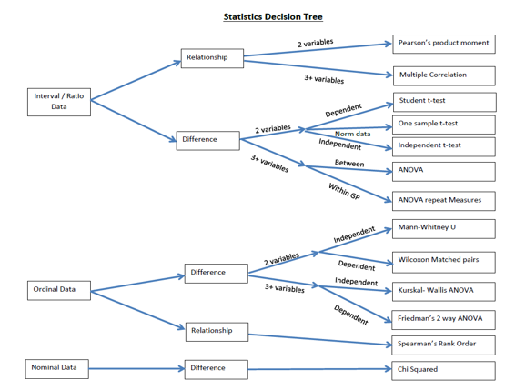
Variable view
set up fist and give some though to the name of the variable Name

- Type of data
- For a paired t-test and correlations the data must be in separate columns
- For an independent t-test there must be a grouping column and the all the data for all groups goes in the variable column. You also need to give labels to the groups.

Basic Tests
Conducted in Data view
Chi- Squared

- Analyse
- Descriptive Statistics
- Crosstabs
- Move on variable to rows
- Mover the other variable to column
- In statistic tick chi squared
- In cells tick observed, expected,
- adjusted standardized.
- Ok

One-Way t-test

- Transfer data from Excel spread sheet
- Analyse
- Compare means
- One sample
- Move BMI before and BMI after into test variable
- Insert comparison value (??)
- Press ok.

Independent T-test

- Analyse
- Compare means
- Independent t-test
- Move nominal variable into the grouping variable box
- Define the groups (the numbers you have assignment the data in column 1)
- Move variables to be analyses to the test variable box
- OK

Descriptive Data

- Analyse
- Descriptive
- Explore
- Move variables across to Dependent list
- OK
Correlation

- Analyse
- Correlate
- Bivariate
- Tick Pearson (Parametric) Spearman (non-parametric , two-tailed and
- Flag significant correlations
- In options tick descriptive statistics (continue)
- Move the two variables you want to correlate into the ‘variables’ box
- Press ok.
Student / Pair t-test

- Analyse
- Compare means
- Paired sample
- Move data to variable 1 and to variable 2
- OK

