A Critical Evaluation of the Role of Digital Innovation in Professional Practice

Introduction
The integration of digital innovation, particularly artificial intelligence (AI), has transformed educational practices across disciplines, including English for Speakers of Other Languages (ESOL) (Johnson et al., 2015). AI tools like ChatGPT offer exciting prospects for enhancing language learning experiences in ESOL classrooms. This essay critically examines the use of ChatGPT in ESOL instruction, assessing its effectiveness, impact on learning outcomes, and implications for professional practice.
By harnessing digital innovation such as ChatGPT, educators can cater to the diverse needs of ESOL learners and cultivate dynamic learning environments conducive to language proficiency and cultural understanding (Kop & Hill, 2008). The discussion explores the theoretical foundations of digital innovation in language education, emphasising its role in fostering engagement, creativity, and interactive learning experiences (Mishra & Koehler, 2006). Furthermore, practical considerations for integrating ChatGPT into the ESOL curriculum, including challenges, best practices, and pedagogical strategies, are investigated. Drawing from scholarly literature and practical experiences, this essay provides a comprehensive analysis of ChatGPT's use in the ESOL classroom, incorporating a literature review, the selection and justification of the SAMR framework model, evidence of ChatGPT application through annotated screenshots, and a thorough review of its efficacy. Through a critical evaluation of its benefits and limitations, valuable insights into effectively leveraging AI technologies to support language learning and meet the diverse needs of ESOL learners can be implemented.
This critical examination explains the transformative potential of ChatGPT in ESOL instruction, underscoring its capacity to revolutionise language learning experiences and empower educators to meet the evolving needs of ESOL learners in the digital age (Veletsianos & Russell, 2014).

The role of creativity and Digital Innovation – Literature Review

The integration of Artificial Intelligence (AI) chatbots into language education has become a focal point of academic inquiry, reflecting the transformative potential of technology in shaping contemporary educational practices. This literature review critically examines and synthesises two pivotal articles that contribute significantly to the discourse on AI chatbots in language learning: "Exploring AI chatbot affordances in the EFL classroom: young learners’ experiences and perspectives" by Jaeho Jeon (Jeon, 2022) and "Using Chatbots as AI Conversational Partners in Language Learning" by Jose Belda-Medina and José Ramón Calvo-Ferrer (Belda-Medina & Calvo-Ferrer, 2022). The objective is to unravel the key themes, trends, debates, pivotal publications, and gaps within this burgeoning field, providing a comprehensive overview.

Overview of Investigated Journals
"Exploring AI chatbot affordances in the EFL classroom: young learners’ experiences and perspectives" by Jaeho Jeon (2022) investigates the utilisation of AI chatbots in English as a Foreign Language (EFL) classrooms, focusing on young learners' experiences and perspectives. The study delves into how AI chatbots contribute to dynamic and engaging language learning scenarios, offering personalised interactions to sustain student interest and foster positive attitudes towards language acquisition. Conversely, "Using Chatbots as AI Conversational Partners in Language Learning" by Jose Belda-Medina and José Ramón Calvo-Ferrer (2022) provides a broader examination of chatbots as AI conversational partners, emphasising their potential to motivate language learners through interactive conversations and personalised interactions.

Trends and Patterns
The distinct trend of integrating AI chatbots into language education is evident in both articles, reflecting the increasing recognition of technology's role in fostering innovative pedagogical approaches (Jeon, 2022; Belda-Medina & Calvo-Ferrer, 2022). This trajectory underscores the timeliness of the exploration, mirroring broader societal shifts towards digitalisation and adaptive learning methodologies. As classrooms evolve, AI chatbots emerge as facilitators of engaging and interactive language learning experiences.
Beyond this predominant trend, both articles contribute to a shared focus on investigating the effectiveness of AI chatbots in enhancing language learning experiences (Jeon, 2022; Belda-Medina & Calvo-Ferrer, 2022). In an era where educational standards are shifting towards learner-centric models, the exploration of AI chatbots as tools to enhance language acquisition aligns with contemporary demands for personalised and technology-integrated learning solutions.

Key Concepts and Findings
The theme of heightened student engagement and motivation emerges as a central aspect in both articles (Jeon, 2022; Belda-Medina & Calvo-Ferrer, 2022). Jeon's investigation into young learners' experiences reveals how AI chatbots contribute to dynamic and engaging language learning scenarios. By creating interactive and personalised learning environments, chatbots sustain student interest, fostering a positive attitude towards language acquisition. Belda-Medina and Calvo-Ferrer (2022) echo this sentiment, emphasising the motivational aspect of AI chatbots through conversational interactions.
The thematic exploration of personalised and adaptive learning experiences is another significant contribution from both articles (Jeon, 2022; Belda-Medina & Calvo-Ferrer, 2022). Recognising the diverse learning styles and paces of students, AI chatbots offer tailored interactions that cater to individual needs. This personalised approach resonates with broader educational frameworks advocating for adaptability and inclusivity, positioning AI chatbots as tools for fostering a more accessible and student-centric language learning environment.
A shared emphasis on the importance of teacher support and involvement surfaces in both articles, emphasising the collaborative potential between educators and AI chatbots (Jeon, 2022; Belda-Medina & Calvo-Ferrer, 2022). Jeon underscores the role of teachers in guiding and facilitating students' interactions with chatbots, establishing a supportive and scaffolded learning environment. Belda-Medina and Calvo-Ferrer echo this sentiment, stressing the need for collaboration between teachers and chatbots to maximise the benefits of AI in language education. This theme highlights the symbiotic relationship between technological tools and human facilitators, emphasising the potential for a harmonious integration of AI in language classrooms.
Another key concept and finding highlighted in both articles is the role of AI chatbots in providing immediate feedback to learners (Jeon, 2022; Belda-Medina & Calvo-Ferrer, 2022). Jeon's study illustrates how AI chatbots can offer instant corrections and guidance during language learning interactions, allowing learners to address mistakes promptly and improve their language proficiency. Similarly, Belda-Medina and Calvo-Ferrer (2022) emphasise the feedback mechanism inherent in AI chatbots, which enhances the learning process by providing learners with timely information on their performance and progress (Belda-Medina & Calvo-Ferrer, 2022). This emphasis on real-time feedback aligns with contemporary pedagogical theories advocating for formative assessment and individualised feedback loops to support student learning and development (Dede, 2010). Thus, AI chatbots serve as valuable tools for facilitating continuous improvement and mastery of language skills in learners, contributing to a more efficient and effective language learning experience.

Debates, Conflicts, and Contradictions
While both articles accentuate the positive impact of AI chatbots on student engagement, a potential debate emerges regarding the extent to which these technologies can replace or supplement traditional teaching methods (Jeon, 2022; Belda-Medina & Calvo-Ferrer, 2022). This debate reflects the ongoing discourse within education about the role of technology in the classroom. Some argue for the supportive role of AI chatbots alongside traditional methods, while others explore the possibility of these technologies as primary instructional tools. The nuanced interplay between technology and traditional pedagogies raises questions about the optimal balance for effective language education.
The integration of AI chatbots in education introduces debates and conflicting perspectives concerning ethical considerations and potential challenges (Jeon, 2022; Belda-Medina & Calvo-Ferrer, 2022). The issues of data privacy, emotional well-being, and the ethical implications of AI-human interactions demand careful examination. This thematic exploration prompts critical reflections on the responsible implementation of AI chatbots in language education, considering the ethical dimensions that underpin the student-technology relationship.
Another debate arising from the integration of AI chatbots in language education revolves around the issue of standardisation and personalisation (Jeon, 2022; Belda-Medina & Calvo-Ferrer, 2022). While AI chatbots offer personalised learning experiences tailored to individual learner needs, there is concern about maintaining consistent educational standards across diverse learning contexts. Some argue that the variability introduced by personalised learning through AI chatbots may lead to disparities in learning outcomes and hinder the establishment of uniform educational benchmarks (Chang, Wu, & Hsu, 2021). Conversely, proponents of personalised learning advocate for the flexibility and adaptability afforded by AI chatbots, arguing that a one-size-fits-all approach to education is outdated and ineffective in meeting the diverse needs of learners (Kondo et al., 2019).

Areas for Further Investigation
A potential gap in the literature emerges concerning the comprehensive exploration of the drawbacks or limitations of AI chatbots in language education (Jeon, 2022; Belda-Medina & Calvo-Ferrer, 2022). While both articles provide valuable insights into the positive aspects, a thorough examination of challenges and areas for improvement would contribute to a more nuanced understanding of the dynamics between AI technology and language learning. Addressing this gap is crucial for a holistic assessment of the feasibility and sustainability of integrating AI chatbots into language classrooms.
A broader exploration of the socio-cultural implications of AI integration in language education could enhance the depth of the literature (Jeon, 2022; Belda-Medina & Calvo-Ferrer, 2022). Examining the socio-cultural nuances would provide valuable insights into how cultural factors influence the effectiveness of AI chatbots across diverse educational contexts. Acknowledging the socio-cultural dimension is imperative for tailoring AI technologies to the specific needs and cultural sensitivities of learners.
A more thorough exploration of the scalability and long-term impact of AI chatbots on language learning outcomes could enhance the literature's completeness (Jeon, 2022; Belda-Medina & Calvo-Ferrer, 2022). This exploration is essential for understanding the sustained impact of AI chatbots on language proficiency and their adaptability across various educational settings. Examining scalability and long-term impact would provide valuable insights into the feasibility of widespread adoption and the enduring effects of integrating AI chatbots into language education.

Theoretical Framework
In examining the literature on AI chatbots in language education, it is essential to employ a theoretical framework that illuminates the underlying principles guiding the integration of these technological tools. Theoretical frameworks serve as conceptual lenses through which researchers can interpret and understand the complex interactions between learners, educators, and technology. For this review, we draw upon several influential educational theories to provide a robust theoretical foundation for the exploration of AI chatbots in language learning.
Sociocultural Theory (Vygotsky, 1978)
Vygotsky's sociocultural theory offers valuable insights into the role of AI chatbots as sociocultural tools within the language learning context (Vygotsky, 1978). According to Vygotsky, learning is a socially mediated process, and language plays a crucial role in cognitive development. AI chatbots, as conversational partners, mediate language learning experiences by facilitating interactions that mirror real-world communication (Belda-Medina & Calvo-Ferrer, 2022). Learners engage in meaningful dialogues, and through these interactions, they construct knowledge collaboratively (Jeon, 2022). The sociocultural lens provides a nuanced understanding of how AI chatbots can scaffold language learning by providing contextualised and socially relevant language input.
Technology Acceptance Model (TAM) (Davis, 1989)
The Technology Acceptance Model (TAM), developed by Davis (1989), is instrumental in understanding the factors that influence the adoption and use of technology in educational settings. Applying TAM to the context of AI chatbots in language education allows us to analyse the perceptions and attitudes of learners and educators towards these tools (Belda-Medina & Calvo-Ferrer, 2022; Jeon, 2022). The model suggests that perceived usefulness and perceived ease of use are key determinants of users' acceptance of technology (Davis, 1989). By employing TAM, researchers can assess how learners perceive the effectiveness of AI chatbots in improving language skills and the ease with which they can integrate these technologies into their learning routines.
21st-Century Skills Framework (Dede, 2010)
Dede's framework for 21st-century skills is particularly relevant when exploring the personalised and adaptive learning experiences facilitated by AI chatbots (Dede, 2010). As education evolves to meet the demands of the digital age, learners require a skill set that extends beyond traditional academic competencies (Beauchamp & Childress, 2013). AI chatbots, through their ability to tailor interactions to individual learner needs, align with the 21st-century skills framework (Dede, 2010). This framework encompasses skills such as critical thinking, collaboration, communication, and adaptability, all of which can be nurtured through the dynamic interactions facilitated by AI chatbots.
Biomedical Ethics Principles (Beauchamp & Childress, 2013)
Ethical considerations are paramount when integrating AI technologies into educational settings. Beauchamp and Childress' principles of biomedical ethics provide a comprehensive framework for evaluating the ethical implications of AI chatbots in language education (Beauchamp & Childress, 2013). The principles of autonomy, beneficence, non-maleficence, and justice guide researchers and practitioners in ensuring that the use of AI chatbots aligns with ethical standards. This framework prompts critical reflections on issues such as data privacy, informed consent, and the potential impact of AI on learners' well-being, contributing to the responsible and ethical implementation of AI chatbots in language learning.

Conclusion
In conclusion, the literature review highlights the trends, themes, debates, and gaps in the existing literature on AI chatbots in language education. Through a theoretical framework, it provides a comprehensive understanding of the academic underpinnings guiding the exploration of AI chatbots in language learning. As the field continues to evolve, addressing gaps and contributing new knowledge remains imperative. As educators and researchers delve deeper into this dynamic field, continued investigation and innovation will be crucial for unlocking the full potential of AI chatbots in enhancing language education.

Selection and Justification

In the ever-evolving landscape of education, the integration of educational technology has become imperative for fostering effective learning environments. Among the myriad of digital tools available, the use of AI chatbots in language education has gained traction due to its potential to engage students in interactive and personalised language learning experiences. This section explores the selection and justification of navigating the landscape of AI chatbots in language education, focusing on the modification stage of the SAMR model. The SAMR model, with its four stages - Substitution, Augmentation, Modification, and Redefinition - serves as a framework to guide the integration of educational technology, progressively moving from enhancing learning to transforming and redefining educational practices (Puentedura, 2010; Hamilton, Rosenberg, & Akcaoglu, 2016).

Selection of AI Chatbots in Language Education
The modification stage involves significant redesign of learning tasks through the use of technology, leading to new possibilities that were previously inconceivable (Puentedura, 2010). In the context of language education, AI chatbots can be employed to modify traditional language learning activities by providing adaptive and personalised language practice tailored to individual learner needs (Hamilton et al., 2016). The selection of this stage aims to elevate language learning experiences beyond mere substitution, offering enhanced opportunities for interaction and engagement (Puentedura, 2010).
The learners engaging in this educational exploration are Post-16 ESOL (English for Speakers of Other Languages) Entry 2 students. As individuals at the Entry 2 level, they possess a foundational understanding of English but are still developing their language skills. These learners typically demonstrate the ability to understand and use simple sentences, express basic needs, and engage in straightforward conversations on familiar topics. However, they may encounter challenges when presented with more complex language structures or abstract concepts.
In the modification stage of the SAMR model, the task of instructing students to use ChatGPT to generate Valentine's Day messages in English represents a significant redesign of language learning tasks through the integration of technology (Puentedura, 2010). Unlike the substitution stage, where technology serves as a direct substitute for traditional methods without significant modification, this task goes beyond mere substitution by leveraging the unique capabilities of AI chatbots to enhance language practice and promote creativity (Hamilton et al., 2016). Instead of conventional written exercises or oral drills, students engage with AI chatbots to produce authentic language output, enabling them to apply language skills in a meaningful context. Educators can reimagine language learning tasks, integrating AI chatbots to provide personalised feedback, scaffolded support, and authentic language practice opportunities. The SAMR model encourages educators to reflect on how technology is used and whether it leads to transformative changes in learning experiences (Hamilton et al., 2016). In the modification stage, AI chatbots redefine language learning activities, offering new possibilities for interaction and engagement while aligning with established pedagogical theories.

Theoretical Underpinnings
To justify the use of AI chatbots in the modification stage, it is essential to explore the theoretical foundations that support this integration. Constructivism, a learning theory emphasising active engagement and knowledge construction, aligns with the use of AI chatbots as they facilitate interactive language practice (Piaget, 1973). Vygotsky's Zone of Proximal Development (ZPD) suggests that learners benefit from tasks slightly beyond their current abilities, which AI chatbots can provide through adaptive feedback and scaffolding (Vygotsky, 1978).
Moreover, Professional standards for further education teachers, work-based learning practitioners, and adult learning practitioners in Wales were considered to ensure that the integration of AI chatbots aligns with established best practices and guidelines (Professional Standards for FE Teachers, 2023).
Furthermore, the Cognitive Theory of Multimedia Learning posited by Mayer emphasises the importance of engaging multiple senses for effective learning (Mayer, 2002). AI chatbots, equipped with natural language processing and interactive features, appeal to auditory and visual senses, enhancing the retention and understanding of language concepts. This alignment with established learning theories strengthens the rationale for integrating AI chatbots into language education at the modification stage.

Synthesis between Innovation, Pedagogical Theory, and Professional Practice
The successful integration of AI chatbots in language education hinges on the synthesis between innovation, pedagogical theory, and professional practice. At the modification stage, educators can achieve a transformative redesign of language learning tasks, harnessing the capabilities of AI chatbots to provide adaptive and personalised learning experiences. This approach aligns with the principles of the Professional Standards for FE Teachers in Wales (2023), which advocate for flexible learning environments that accommodate diverse learner needs. By incorporating AI chatbots, educators can create inclusive language learning experiences tailored to individual students, fostering engagement and motivation. This synthesis demonstrates a cohesive alignment between innovative technological tools, established pedagogical theories, and practical implementation strategies in language education settings.

Challenges and Considerations
While the modification stage presents exciting opportunities for the integration of AI chatbots in language education, it is essential to address potential challenges and ethical considerations. Issues such as data privacy, algorithmic bias, and the ethical use of AI technologies must be carefully considered to ensure responsible implementation (Selwyn, 2022). The ethical use of AI involves ensuring transparency in how data is collected, stored, and used, as well as protecting learners' privacy and autonomy (Floridi & Cowls, 2019). Educators must also be mindful of the digital divide and ensure equitable access to technology and resources for all learners (Warschauer, 2003). It is imperative to foster an inclusive learning environment where all students have equal opportunities to benefit from technological advancements without exacerbating existing inequalities. By proactively addressing these ethical considerations, educators can promote responsible and equitable use of AI in language education, thereby maximising its potential benefits while minimising potential risks.

Conclusion
The selection and justification of navigating the landscape of AI chatbots in language education at the modification stage require a thoughtful synthesis of innovation, pedagogical theory, and professional practice. By leveraging the unique capabilities of AI chatbots to provide adaptive and personalised learning experiences, educators can redefine language learning tasks, promoting engagement, and addressing the individual needs of learners. The SAMR model guides educators in transitioning from enhancement to transformation, ensuring that the integration of AI chatbots evolves with the growing comfort and proficiency of both educators and students. Through careful implementation and consideration of theoretical underpinnings, educators can harness the transformative potential of AI chatbots to enhance language learning and prepare students for a technologically advanced future.

Application of ChatGPT as a Learning Tool

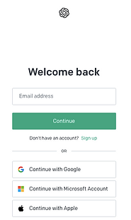
Step 1: Logging into ChatGPT
Figure 1
- At the outset of the lesson, learners were introduced to the ChatGPT platform and provided with login credentials.
- Learners accessed ChatGPT through PCs in the IT suite of the college, navigating to the designated login page.
- The tutor offered guidance and technical support to ensure smooth access, especially for learners who may have encountered difficulties with the login process.
- Learners entered their credentials, including usernames and passwords, to log into the ChatGPT platform (Figure 1).
- The tutor provided a brief overview and recap of ChatGPT's features and functionalities to familiarise learners with the interface before proceeding with the activity.
- This initial step set the foundation for learners to engage with ChatGPT and began the process of generating Valentine's Day greetings in English.

Step 2: Introduction to ChatGPT Interface
- On the PowerPoint presentation, learners were provided with a prompt to generate Valentine's Day greetings in English using ChatGPT (Figure 2).
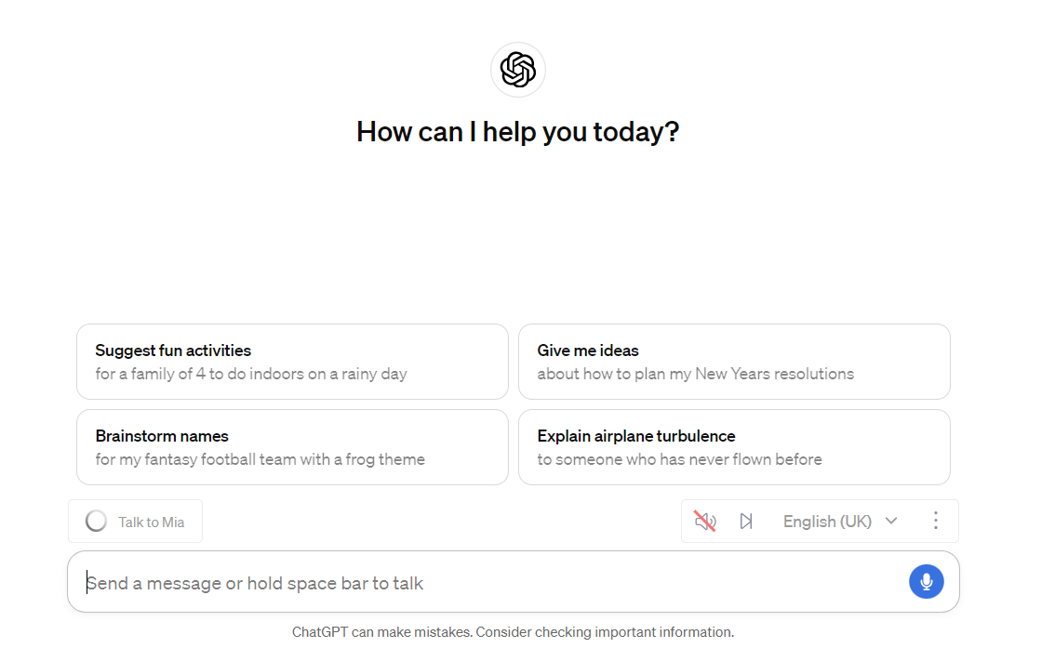
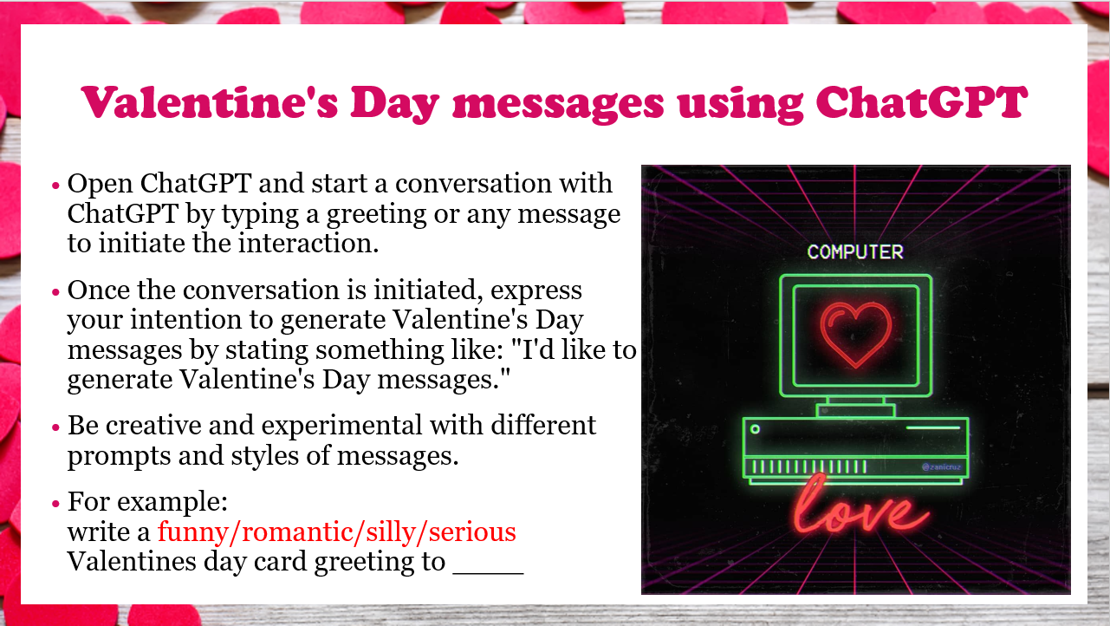
- Learners were introduced to the ChatGPT interface, which featured a text input box where they could type their messages (Figure 3).
Figure 3
Figure 2

Step 3: Typing Valentine's Day Greetings
- Learners typed their Valentine's Day messages into the text input box, expressing their sentiments and feelings (Figure 4).
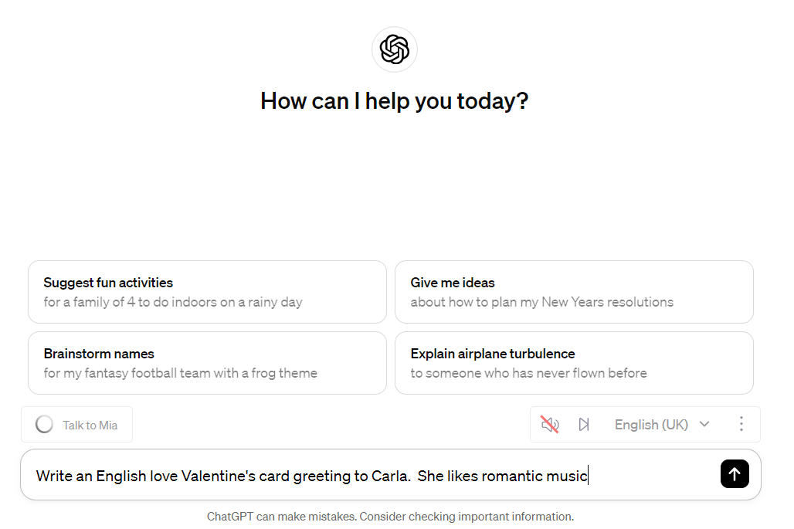
- They experimented with different writing styles, tones, and vocabulary to personalise their greetings.
Figure 4

Step 4: Generating Responses from ChatGPT
- After typing their messages, learners submitted their inputs, prompting ChatGPT to generate responses (Figure 5).
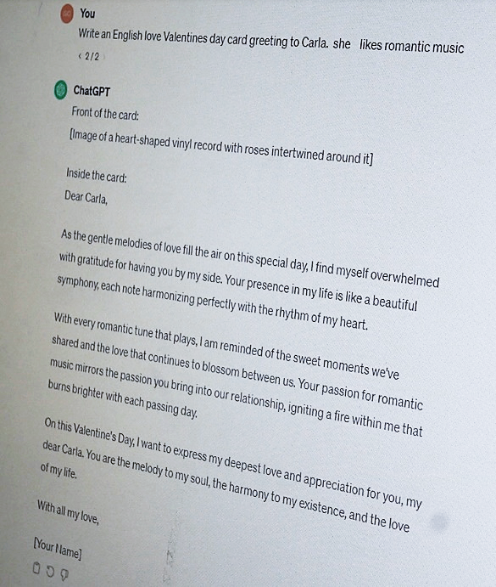
- Learners awaited the AI-generated responses, anticipating creative and contextually appropriate Valentine's Day greetings.
Figure 5

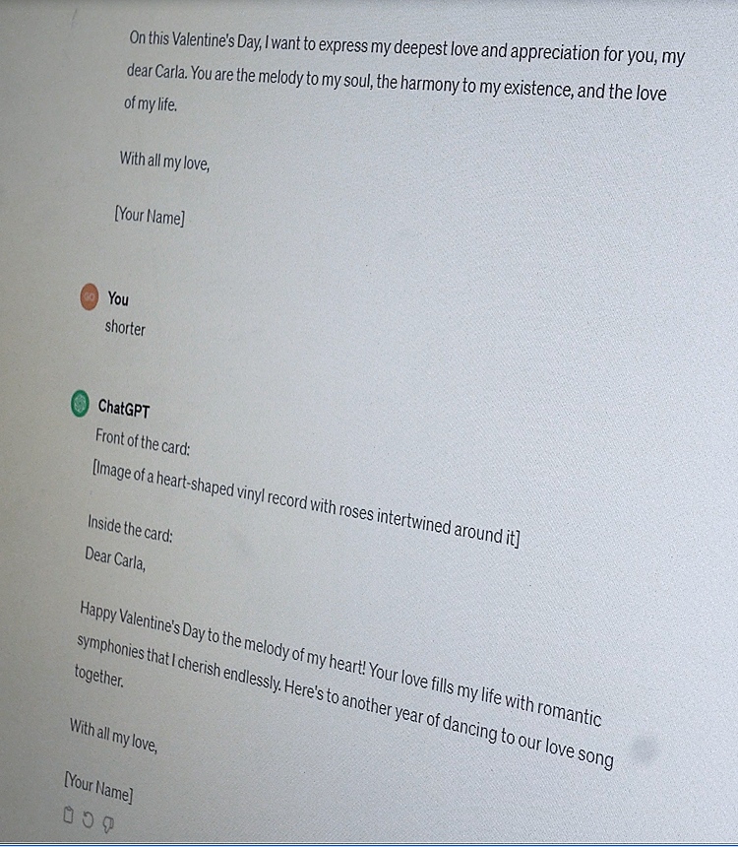
Step 5: Reviewing, editing, and Selecting Responses
Figure 6
- ChatGPT generated multiple responses based on the learners' inputs. Learners asked to change the greetings depending on their specifications (Figure 6).
- Learners reviewed the generated responses, evaluating their relevance, coherence, and language accuracy.
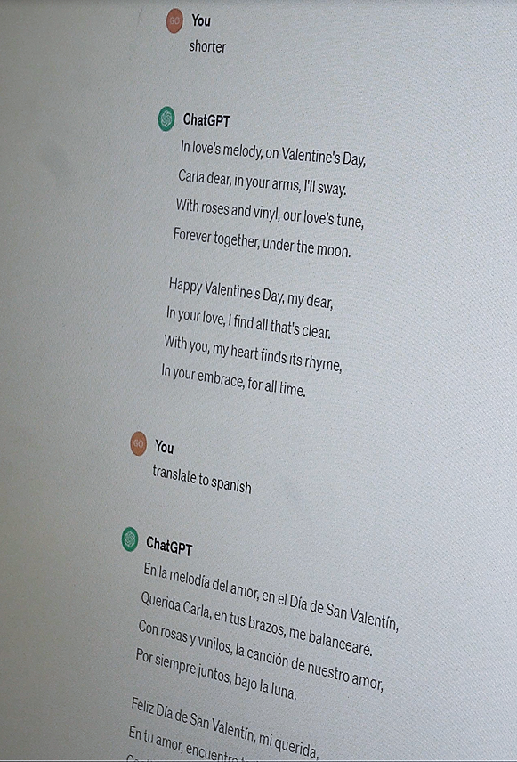
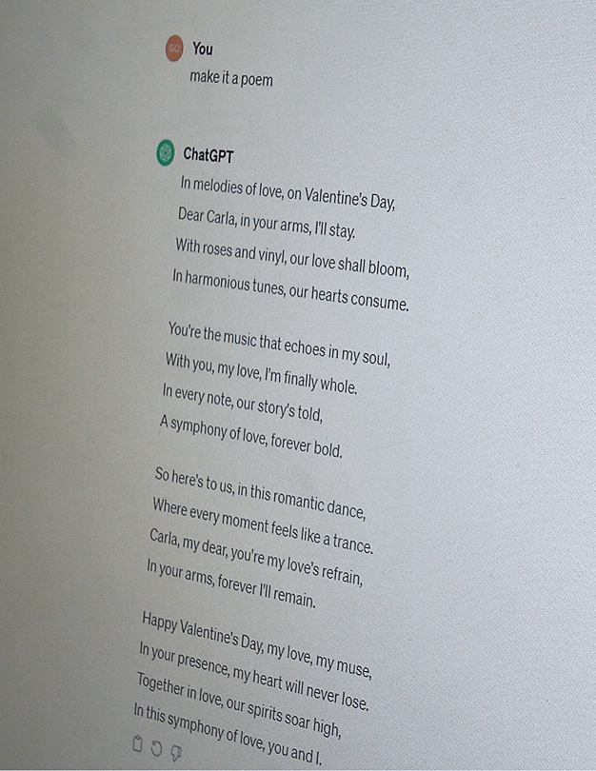
- Learners continued to edit, selecting the most suitable response that aligned with their intended message and tone (Figure 7, Figure 8).
Figure 7
Figure 8
Step 6: Sharing and Discussing Messages
- Learners shared their selected ChatGPT-generated messages with their peers.
- They engaged in discussions, comparing and contrasting different messages, and providing feedback on language use and appropriateness.
- Peer interactions fostered collaborative learning and allowed for cultural exchange.

Step 7: Writing Chosen Messages into Cards
- After selecting their preferred ChatGPT-generated messages, learners were prompted via the PowerPoint to write the messages onto Valentine's Day cards, provided by the tutor (Figure 10).
- They carefully transcribed the messages onto the cards, paying attention to handwriting and presentation (Figure 9).
- This step added a tangible element to the activity, allowing learners to practice written language skills beyond digital platforms.

- Learners also personalised the cards further by adding illustrations or decorations, enhancing the visual appeal of their greetings (Figure 11).
Figure 9
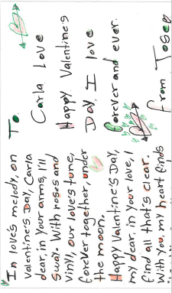

Figure 11
Figure 10

Step 8: Sharing Completed Valentine's Day Cards
- Once the cards were completed, learners shared them with their peers and the tutor.
- This sharing process promoted camaraderie and cultural exchange, as learners appreciated the diversity of messages and expressions.


Step 9: Reflecting on the Card-Making Experience
Figure 12
- Learners reflected on their experience of writing and sharing Valentine's Day cards.
- They discussed the significance of handwritten messages in communication and cultural traditions.
- Reflections included insights into the role of visual elements in conveying emotions and building interpersonal connections.
- The tutor made a classroom display (Figure 12) to showcase the learners Valentines cards and information on how Valentine’s day in celebrated in other cultures (a follow-up activity also completed by learners.)
Step 10: Reflecting on the Experience
- Learners reflected on their experience using ChatGPT to generate Valentine's Day greetings (Figure 13).
- They discussed the effectiveness of the tool in facilitating language practice and creativity.
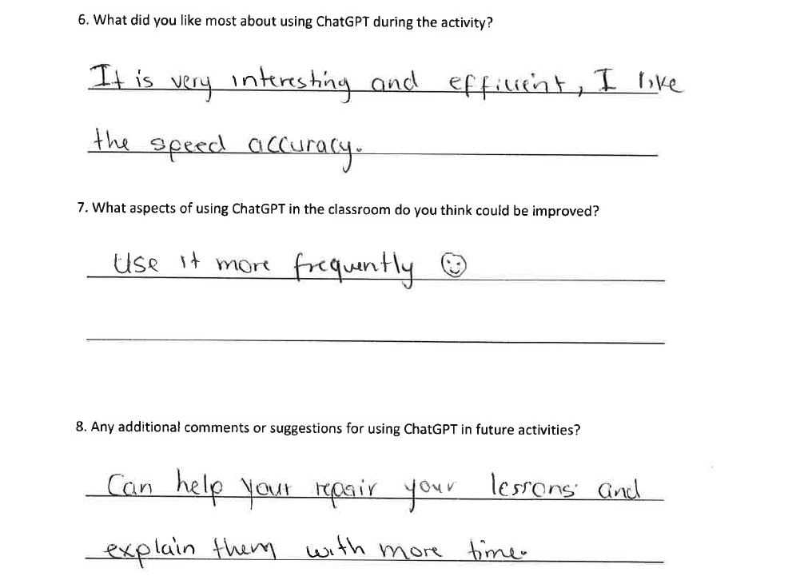
- Reflections included insights into language learning strategies, digital literacy skills, and cultural awareness gained through the activity.
Figure 13



Lesson Plan

Topic: Celebrating Valentine's Day Across Cultures |  | Class: ESOL Entry 2
Date: 07/02/2024 | Length of lesson: 3 hours |  | Number of students: 8
Resources required:
- PowerPoint
- Worksheet printouts
- Valentines Cards
- Paper and pen
- Whiteboard and markers
- Handouts with vocabulary related to Valentine's Day customs and traditions
- Internet access for research
- ChatGPT-enabled devices (laptops, tablets, or smartphones)

Aim of Lesson

- To explore Valentine's Day customs and traditions across different cultures.
- To facilitate discussion and sharing of opinions and experiences related to Valentine's Day.
- To engage students in collaborative activities that promote language skills development.

Learning Outcomes – The Learners Should Be Able To:

- Students will be able to discuss Valentine's Day customs and traditions around the world.
- Students will express their opinions and experiences related to Valentine's Day.
- Students will expand their vocabulary related to Valentine's Day and enhance their reading and comprehension skills through the reading passage activity.
- Students will improve their speaking and presentation skills through the group activity where they research and present Valentine's Day customs from different countries.
- Students will engage in a creative activity using ChatGPT to generate Valentine's Day messages, fostering creativity and language production.
- Students will reflect on their learning and provide feedback on the use of AI technology in the lesson, promoting critical thinking and self-assessment.

Previous student knowledge required for the session:

Previous introduction to ChatGPT with account setup already initiated.

Anticipated difficulties (if applicable):

- Cultural Sensitivity: Some students may come from cultures where Valentine's Day is not widely celebrated or has different connotations. Sensitivity to cultural differences and ensuring an inclusive discussion is important.
- Technical Issues: Using ChatGPT for the interactive activity may encounter technical difficulties such as internet connectivity issues or unfamiliarity with the technology. Providing technical support and clear instructions can help mitigate these challenges.

Professional Standards (where are these being met within the session)

1. Planning and Preparation: The lesson plan demonstrates careful planning and preparation to meet the learning needs of ESOL Entry 2 intermediate level learners. The objectives, materials, activities, and assessments are clearly outlined, ensuring a well-structured and cohesive learning experience.

2. Teaching and Learning: The session promotes effective teaching and learning by employing a variety of instructional strategies to engage learners, such as multimedia presentations, group discussions, reading comprehension tasks, and interactive activities using ChatGPT. Differentiation is also considered to accommodate diverse learner needs and preferences.

3. Assessment and Feedback: The lesson incorporates formative assessment strategies, such as comprehension questions, group presentations, feedback from ChatGPT, and reflective feedback, to monitor student progress and provide ongoing support and guidance. Additionally, the feedback form allows students to provide feedback on their learning experience, promoting learner voice and continuous improvement.

4. Subject Specialism: The lesson plan demonstrates subject expertise in English for Speakers of Other Languages (ESOL) by addressing language proficiency levels, cultural sensitivity, and language skills development tailored to the Entry 2 intermediate level. The content is relevant, accurate, and aligned with language learning objectives.

5. Professional Values and Practice: The session upholds professional values and practice by fostering an inclusive and supportive learning environment where learners feel respected, valued, and empowered to participate actively. Cultural diversity is acknowledged and celebrated, and feedback mechanisms are in place to promote learner engagement and agency.

Lesson Detail:

Stage | Focus | Strategy | Time
Introduction

Warm-up | Introducing the topic of Valentine's Day including the aims and outcomes, and eliciting prior knowledge. | Informal assessment through observation and participation. | 5 minutes
Warm-up game – group count | Prepare the class with a game to encourage interaction in readiness for the lesson. | Ice-breaker game. | 10 minutes
New Vocabulary Introduction | Introducing new vocabulary related to Valentine's Day. | Formative assessment through students' ability to understand and use new vocabulary. | 10 minutes
Development
Presentation and Discussion | Presenting and discussing Valentine's Day traditions worldwide. | Formative assessment through class discussion and participation. | 30 minutes
Vocabulary Building | Reinforcing and practicing new vocabulary. | Formative assessment through vocabulary matching activity. | 20 minutes
Reading and Comprehension | Reading comprehension about the history and origins of Valentine's Day. | Formative assessment through comprehension questions. | 30 minutes
Speaking Activity | Presenting Valentine's Day customs from different cultures. | Summative assessment through group presentations. | 40 minutes
Interactive Activity with ChatGPT | Generating Valentine's Day messages using ChatGPT. | Formative assessment through creativity and language production. | 45 minutes
Plenary/conclusion

Reflection and Feedback | Reflecting on learning experiences and providing feedback. | Formative assessment through student feedback. | 15 minutes
Conclusion | Summarising key points and closing the lesson. | Formative assessment through student engagement and understanding. | 5 minutes

Assessment Strategies: when and how are they included within the lesson?

The assessment strategies used in this lesson are:

1. Group Work:
- When: Included during the Speaking Activity (40 minutes).
- How: Students work in small groups to research and prepare a presentation about Valentine's Day customs in different countries. The presentations serve as a summative assessment of students' understanding of Valentine's Day traditions across cultures and their speaking and presentation skills.

2. Discussion:
- When: Included during the Presentation and Discussion (30 minutes) and Reflection and Feedback (10 minutes) sections.
- How: Students engage in discussions about Valentine's Day customs and traditions around the world, expressing their opinions and experiences related to the holiday. Additionally, students reflect on their learning experience and provide feedback, fostering critical thinking and self-assessment.

3. Question & Answer:
- When: Included during the Reading and Comprehension (30 minutes) section.
- How: After reading a short passage about the history and origins of Valentine's Day, students answer comprehension questions. This assesses students' comprehension of the reading material and their ability to extract key information from the text.

4. Online and Digital Learning Technologies:
- When: Included during the Interactive Activity with ChatGPT (45 minutes).
- How: Students engage in a creative activity using ChatGPT to generate Valentine's Day messages. This activity assesses students' language production skills, creativity, and ability to apply language in a real-world context using online and digital learning technologies.

Informal reflection (to be completed after the session)

  - Today's lesson was a resounding success, with all learners actively engaged and participating throughout.
  - Using ChatGPT was a highlight of the session, and it was great to see the learners embrace the technology with enthusiasm and creativity.
  - I felt confident in my teaching, and it was evident that the learners were genuinely interested in the topic of Valentine's Day.
  - We successfully met the aims and outcomes set for the lesson, which was rewarding to see.
  - Receiving feedback forms from all learners provided valuable insights into their learning experience and allowed us to ensure the assessment strategies were met.
  - The lesson had a good flow, with a balance between challenging activities, like the reading comprehension, and interactive tasks, such as the group research activity.
  - The group dynamics during the research activity were particularly enjoyable to observe, as the learners engaged enthusiastically in exploring Valentine's Day customs from different countries.
  - Fortunately, we didn't encounter any major technical issues, although some learners had problems in the initial phase of logging in to ChatGPT. Learner participation remained consistently high throughout the lesson.
  - Prior collection of materials, such as blank Valentine’s cards, ensured a smooth lesson delivery, contributing to its overall success.
  - I'm pleased with how today's lesson went and look forward to building on this positive experience in future lessons.

Evaluation and Reflection
In today's digitally-driven world, technology plays a significant role in education. This section critically examines ChatGPT's integration into English language learning, evaluating its impact, effectiveness, learner feedback, and the tutor's experiences.

Personal Reflection on Technology Integration
Utilising ChatGPT as a learning tool in the English language classroom was a highly engaging and rewarding experience for both learners and myself. The tool effectively captured the attention of learners and sparked their curiosity, resulting in active participation and exploration (Köseoğlu, Veletsianos and Rowell, 2023). However, some learners encountered challenges with logging into their ChatGPT accounts, which initially hindered their access to the programme. This issue likely stemmed from technical difficulties or unfamiliarity with the login process, emphasising the importance of providing clear instructions and technical support, particularly for those with limited digital literacy skills (Kabilan et al., 2010).
Embedding digital literacy skills into language teaching is crucial, especially for ESOL learners who may have minimal experience with technology. While it may take time for learners to become accustomed to new digital tools, their enthusiasm and willingness to practice and improve were evident throughout the activity (Beetham, 2020). Many learners took the initiative to continue exploring ChatGPT beyond the assigned task, demonstrating a proactive approach to digital learning and a desire to enhance their skills.
Throughout the activity, learners remained engaged and interactive, participating in discussions and sharing their Valentine's Day greetings with laughter and enjoyment. This collaborative environment not only facilitated language practice but also fostered critical thinking and digital literacy skills. With guidance, learners crafted questions and explored various tones and content, refining their language proficiency and communicative abilities (Beetham, 2020).
As a tutor, the experience of using ChatGPT in the lesson was highly rewarding. It seamlessly integrated technology into the curriculum, enhancing the learning experience and reinforcing the value of incorporating digital tools in pedagogical practices. The successful implementation of ChatGPT reaffirmed my confidence in leveraging technology to meet the diverse needs of learners and create meaningful educational experiences (Köseoğlu, Veletsianos and Rowell, 2023).
In future lessons, I plan to continue integrating ChatGPT as a dynamic tool for language learning. Given its success in engaging learners and enhancing language skills, I aim to incorporate ChatGPT into various language activities, such as writing prompts, vocabulary expansion exercises, and cultural exploration tasks. Additionally, I intend to explore ChatGPT's potential for providing personalised feedback on grammar and sentence structures, further supporting learners' language development.

Learner Feedback
Feedback from learners regarding the use of ChatGPT for generating Valentine's Day greetings was overwhelmingly positive, with 7 out of 8 learners (87.5%) expressing understanding of how to use the tool effectively. All 8 learners (100%) found using ChatGPT engaging and enjoyable, highlighting its potential to enhance language learning experiences. Moreover, 8 out of 8 learners (100%) reported finding ChatGPT easy to use and acknowledged its potential to improve their English language skills. In terms of overall experience, 4 learners (50%) rated their experience as excellent, while the remaining learners rated it as good.
Several learners provided specific comments regarding their experience with ChatGPT. One learner remarked, "It is very interesting and efficient. I like the speedy accuracy." Another learner stated, "It's a very efficient, powerful, and clear technology that helps you improve your knowledge and makes your life easier." Additionally, another learner described the activity as "very fun" and expressed excitement in using it.
Furthermore, many learners expressed their intention to continue using ChatGPT outside of the classroom to further advance their learning. They appreciated the tool's ability to mark and provide feedback on their sentence structures, grammar, and vocabulary. Learners also recognised the potential for creating customised homework assignments using ChatGPT to generate worksheets on specific subjects or grammar topics.
When asked about aspects for improvement, 6 learners (75%) expressed a desire to use ChatGPT more frequently in lessons, with one learner mentioning a wish to have known about this technology sooner. Additionally, most learners downloaded the ChatGPT app upon learning of its availability, indicating their eagerness to utilise the tool beyond the classroom environment.
Overall, the feedback provides valuable insights into the efficacy of ChatGPT in language education and informs future implementation strategies to optimise its use for enhanced learning outcomes.

Impact and Effectiveness
With the feedback obtained, the integration of ChatGPT as a learning tool in the English language classroom had a profound impact on both learners and the tutor. It effectively engaged learners, sparking their curiosity and driving active participation in the activity. Throughout the task, learners remained engaged and interactive, demonstrating enthusiasm and enjoyment as they crafted their Valentine's Day greetings. This engagement fostered a collaborative learning environment where learners not only practiced their English language skills but also honed their critical thinking and digital literacy (Köseoğlu, Veletsianos and Rowell, 2023). The positive atmosphere created by the use of ChatGPT contributed to a rewarding learning experience for all participants (Beetham, 2020).
The impact of ChatGPT was assessed through direct observation of learner engagement, participation, and the quality of generated messages (Beetham, 2020). Additionally, feedback forms collected from learners provided valuable insights into their experiences and perceptions of the activity, confirming its positive impact on language learning outcomes. The integration of ChatGPT facilitated meaningful learning experiences and enhanced language learning outcomes for learners.

Meeting Aims and Outcomes.
The integration of ChatGPT successfully met the aims and outcomes of the task, aiming to enhance language proficiency, cultural understanding, creativity, and engagement among learners. ChatGPT provided learners with a dynamic platform to practice their language skills by experimenting with various prompts and writing styles to craft personalised Valentine's Day messages. Additionally, the activity fostered a sense of community and collaboration within the classroom, as learners enthusiastically shared their work, sparking discussions and creating a supportive learning environment. Furthermore, ChatGPT served as a tool to facilitate language practice, offering authentic language production and interaction opportunities, while promoting digital literacy and innovative teaching methods (Beetham, 2020).
Learners conducted self-assessment by reflecting on their experiences with ChatGPT and providing feedback on their preferences for future integration of AI technology in language learning activities. Despite initial challenges, such as technical difficulties, learners demonstrated enthusiasm and willingness to explore the tool, indicating its effectiveness in achieving the learning objectives. ChatGPT effectively engaged learners, fostered creativity, and promoted meaningful interactions within the classroom, aligning with the intended outcomes of the task.

Conclusion.
In conclusion, the integration of ChatGPT as a dynamic learning tool in the English language classroom has demonstrated significant benefits for both learners and the tutor. Through its engaging interface and interactive features, ChatGPT effectively captured learners' interest, fostering curiosity and driving active participation (Köseoğlu, Veletsianos and Rowell, 2023). Despite some initial technical challenges, learners showcased enthusiasm and initiative in exploring the tool, highlighting the importance of embedding digital literacy skills into language teaching (Kabilan et al., 2010). The collaborative environment facilitated by ChatGPT not only enhanced language practice but also nurtured critical thinking and digital literacy skills among learners (Beetham, 2020). As a tutor, the experience of utilising ChatGPT underscored its value in enriching the learning experience and reinforcing the integration of technology into pedagogical practices (Köseoğlu, Veletsianos and Rowell, 2023). Moving forward, the positive outcomes observed with ChatGPT encourage its continued integration into language learning activities, promoting creativity, engagement, and language proficiency among learners.

Word count – 5050

References

- Beauchamp, T. L., & Childress, J. F. (2013). Principles of biomedical ethics. Oxford University Press.
- Beetham, H. (2020). Rethinking Pedagogy for a Digital Age: Principles and Practices of Design. Routledge.
- Belda-Medina, J., & Calvo-Ferrer, J. R. (2022). Using Chatbots as AI Conversational Partners in Language Learning. CALL-EJ, 20(2), 48-61.
- Chang, C. C., Wu, T. C., & Hsu, Y. S. (2021). The effect of augmented reality-based vocabulary learning on students’ learning motivation and vocabulary recall. Education and Information Technologies, 26(6), 6773-6794.
- Davis, F. D. (1989). Perceived usefulness, perceived ease of use, and user acceptance of information technology. MIS Quarterly, 319-340.
- Dede, C. (2010). Comparing frameworks for 21st century skills. 21st Century Skills: Rethinking How Students Learn, 51-76.
- Floridi, L., & Cowls, J. (2019). A unified framework of five principles for AI in society. Harvard Data Science Review, 1(1). https://doi.org/10.1162/99608f92.8cd550d1
- Hamilton, E. R., Rosenberg, J. M., & Akcaoglu, M. (2016). The Substitution Augmentation Modification Redefinition (SAMR) Model: a Critical Review and Suggestions for its Use. TechTrends, 60(5), 433–441. https://doi.org/10.1007/s11528-016-0091-y
- Johnson, L., Adams Becker, S., Estrada, V., & Freeman, A. (2015). NMC Horizon Report: 2015 K-12 Edition. The New Media Consortium.
- Jeon, J. (2022). Exploring AI chatbot affordances in the EFL classroom: young learners’ experiences and perspectives. Computer Assisted Language Learning, 31(1-2), 163-188.
- Kabilan, M. K., Ahmad, N., & Abidin, M. J. Z. (2010). Facebook: An online environment for learning of English in institutions of higher education? The Internet and Higher Education, 13(4), 179-187.
- Kondo, T., Gour, N., AlShaer, A., El Saddik, A., & Hoque, M. E. (2019). Immersive virtual reality for language learning and assessment: State of the art. IEEE Access, 7, 173383-173397.
- Kop, R., & Hill, A. (2008). Connectivism: Learning theory of the future or vestige of the past?. International Review of Research in Open and Distance Learning, 9(3).
- Köseoğlu, S., Veletsianos, G. and Rowell, C. (2023). Critical Digital Pedagogy in Higher Education. Athabasca University Press.
- Mayer, R. E. (2002). Multimedia learning. Cambridge University Press.
- Mishra, P., & Koehler, M. J. (2006). Technological pedagogical content knowledge: A framework for teacher knowledge. Teachers College Record, 108(6), 1017-1054.
- Piaget, J. (1973). To understand is to invent: The future of education. Grossman.
- Puentedura, R. (2010). SAMR - Substitution, Augmentation, Modification, Redefinition. Retrieved from https://www.hippasus.com/rrpweblog/archives/2010/08/23/SAMR_S
- Selwyn, N. (2022). What's the problem with 'AI in education'? Learning, Media and Technology, 46(2), 129-138. https://doi.org/10.1111/ejed.12532
- Veletsianos, G., & Russell, G. (2014). Pedagogical agents: back to the future. In R. Sottilare, A. Graesser, X. Hu, & B. Goldberg (Eds.), Design Recommendations for Intelligent Tutoring Systems: Volume 4-Domain Modeling (pp. 209-213). US Army Research Laboratory.
- Vygotsky, L. S. (1978). Mind in society: The development of higher psychological processes. Harvard University Press.
- Wang, Y. H., & Hsu, Y. C. (2008). Development of an adaptive learning system with two sources of personalisation information. Computers & Education, 51(2), 776-786.
- Warschauer, M. (2003). Technology and social inclusion: Rethinking the digital divide. MIT Press.
- Welsh Government. (2023). Professional standards for further education teachers, work-based learning practitioners and adult learning practitioners in Wales. Cardiff: Welsh Government.

