Application development report
Lowri Jones – 1801539
April 26, 2020
KEmi ademoye
Application Development

Table of Contents

Introduction 2
Requirements 2
Functional Requirements. 2
Design and Implementation 2
Features. 2
Design Features 2
Classes. 3
Screenshots. 3
Home Page. 3
Instructors Page. 4
Lectures Page. 4
Privacy Page. 5
Attributions Page. 7
Register Page. 7
Login Page. 8
Models, Views and Controllers Implemented. 8
Evaluation 9
Testing 9
Test 1. 9
Test 2. 9
Test 3. 10
Test 4. 10
Test 6. 11
Reflection. 11
Recommendations. 12
Bibliography 12

Introduction
This report contains the vital information about a web application the author has created based on a dance school. The items covered in this report are the requirements, the design and implementation details and a detailed evaluation.

Requirements
Prior to this report, the author designed and developed a Web Application based on a dance school local to her. This dance schools offers two main services with one being a ‘Lecture / Workshop Booking platform’. The author has decided that it would be a good idea to create an application that would help her to do this as it will make the job easier and more convenient. The purpose of this chosen web application is to allow Dance Teachers to find out information about up and coming lectures. This topic is highly relevant as the business itself is based around dance, Dance lectures are very popular and this Web Application will make accessing them a lot easier.

Functional Requirements.
In the Web Application a range of different features have been included. Some of the main ones are listed below;
- Controllers – A controller is used in an application as a way of controlling the way that the users can interact with it. [1] The controller decides what response to send back to the user. [1] Within the LJSOD Lectures Web Application, 3 different controllers have been included. These three controllers once selected by the user will show them all data kept in the ‘Lectures’ table and the ‘Instructors’ table.
- Images (Data Display) – Throughout the Application, 6 images have been included. Once the user clicks onto these images they will be taken to a page displaying key information about that instructor.
- Searching (Querying the data) – In this Web application a field as been included where a user can search through the fields in the table, sort them and filter them.
- Modifying the database (CRUD Operations) – On both the lectures and instructors page of the application, there have been options to edit the data, delete a record and create a new field so that the admins of the page are able to alter the information needed.
- Register / Log in enables a user to log in and out and register for an account.

Design and Implementation

Features.

Design Features
On this application, the colour scheme of the LJSOD main business has been included and kept consistent throughout. Colour is one of the key ways to differentiate your business from others in the market place, it is vital to keep it consistent throughout all media and promotions so that it is easy to identify. [2] The LJSOD colour scheme is ‘Pink’ which appears in the background of every page on the application.
When the user is accessing the Web Application in their web browser, they will see LJSOD Lectures in their tab making it easy to see and user friendly.
On the home page, an image of the whole dance school at LJSOD has been included which helps to show the users what the website is all about.

Classes.
Some of the main Classes that have been implemented to provide the main functionality to the application have been listed below:
- LectureFilterViewModel.cs
- LectureFilterQueries.cs
- LectureFilterColumns.cs
- LectureSortOptions.cs
- LecturesController.cs

Screenshots.

Home Page.
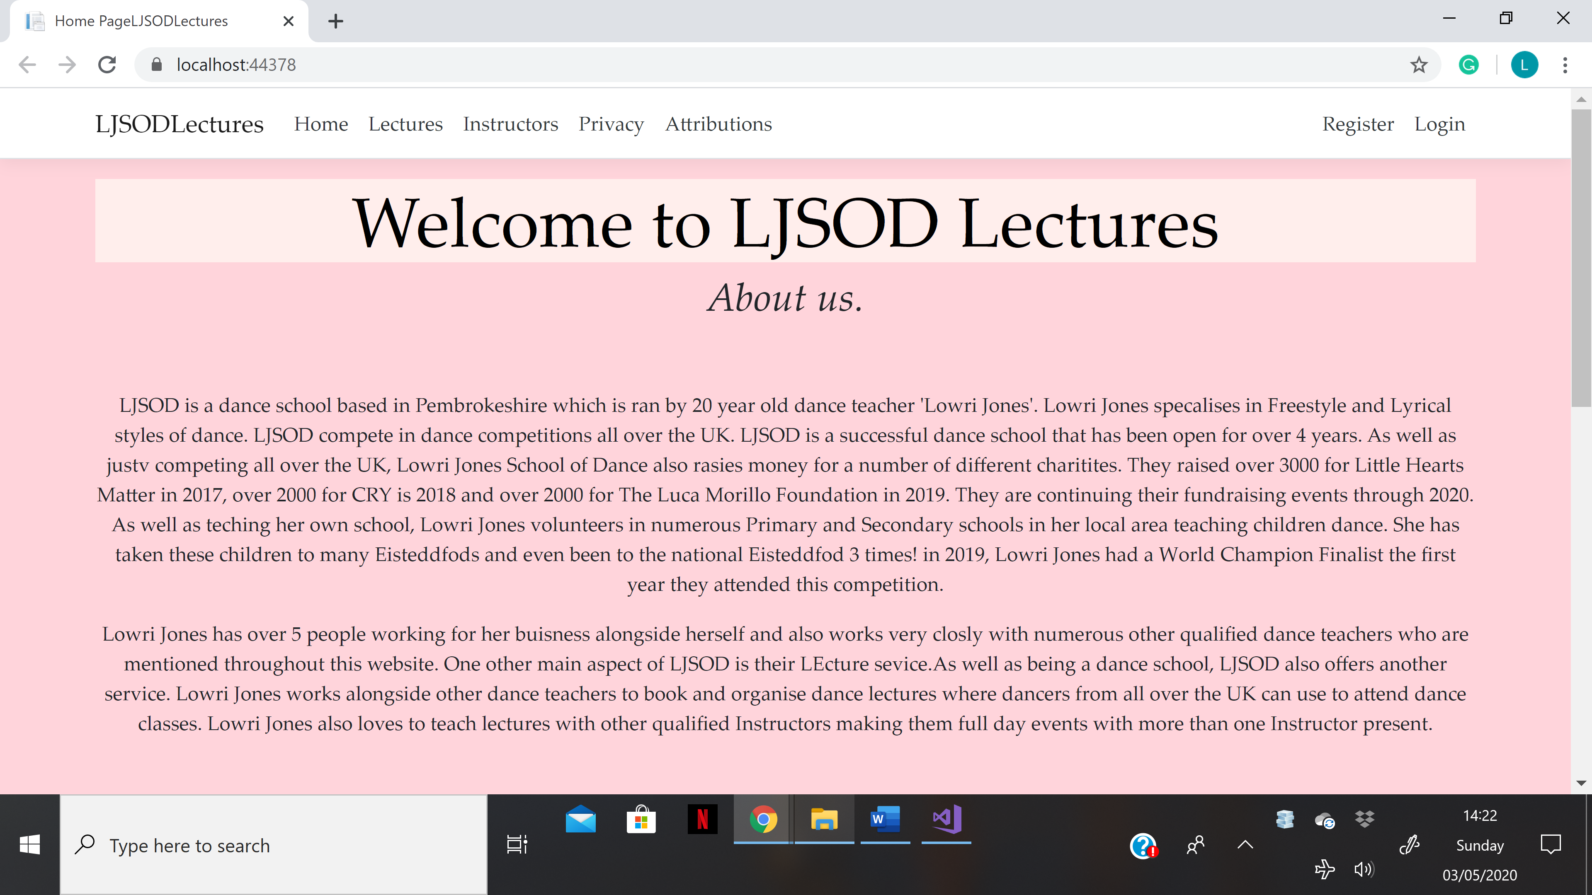
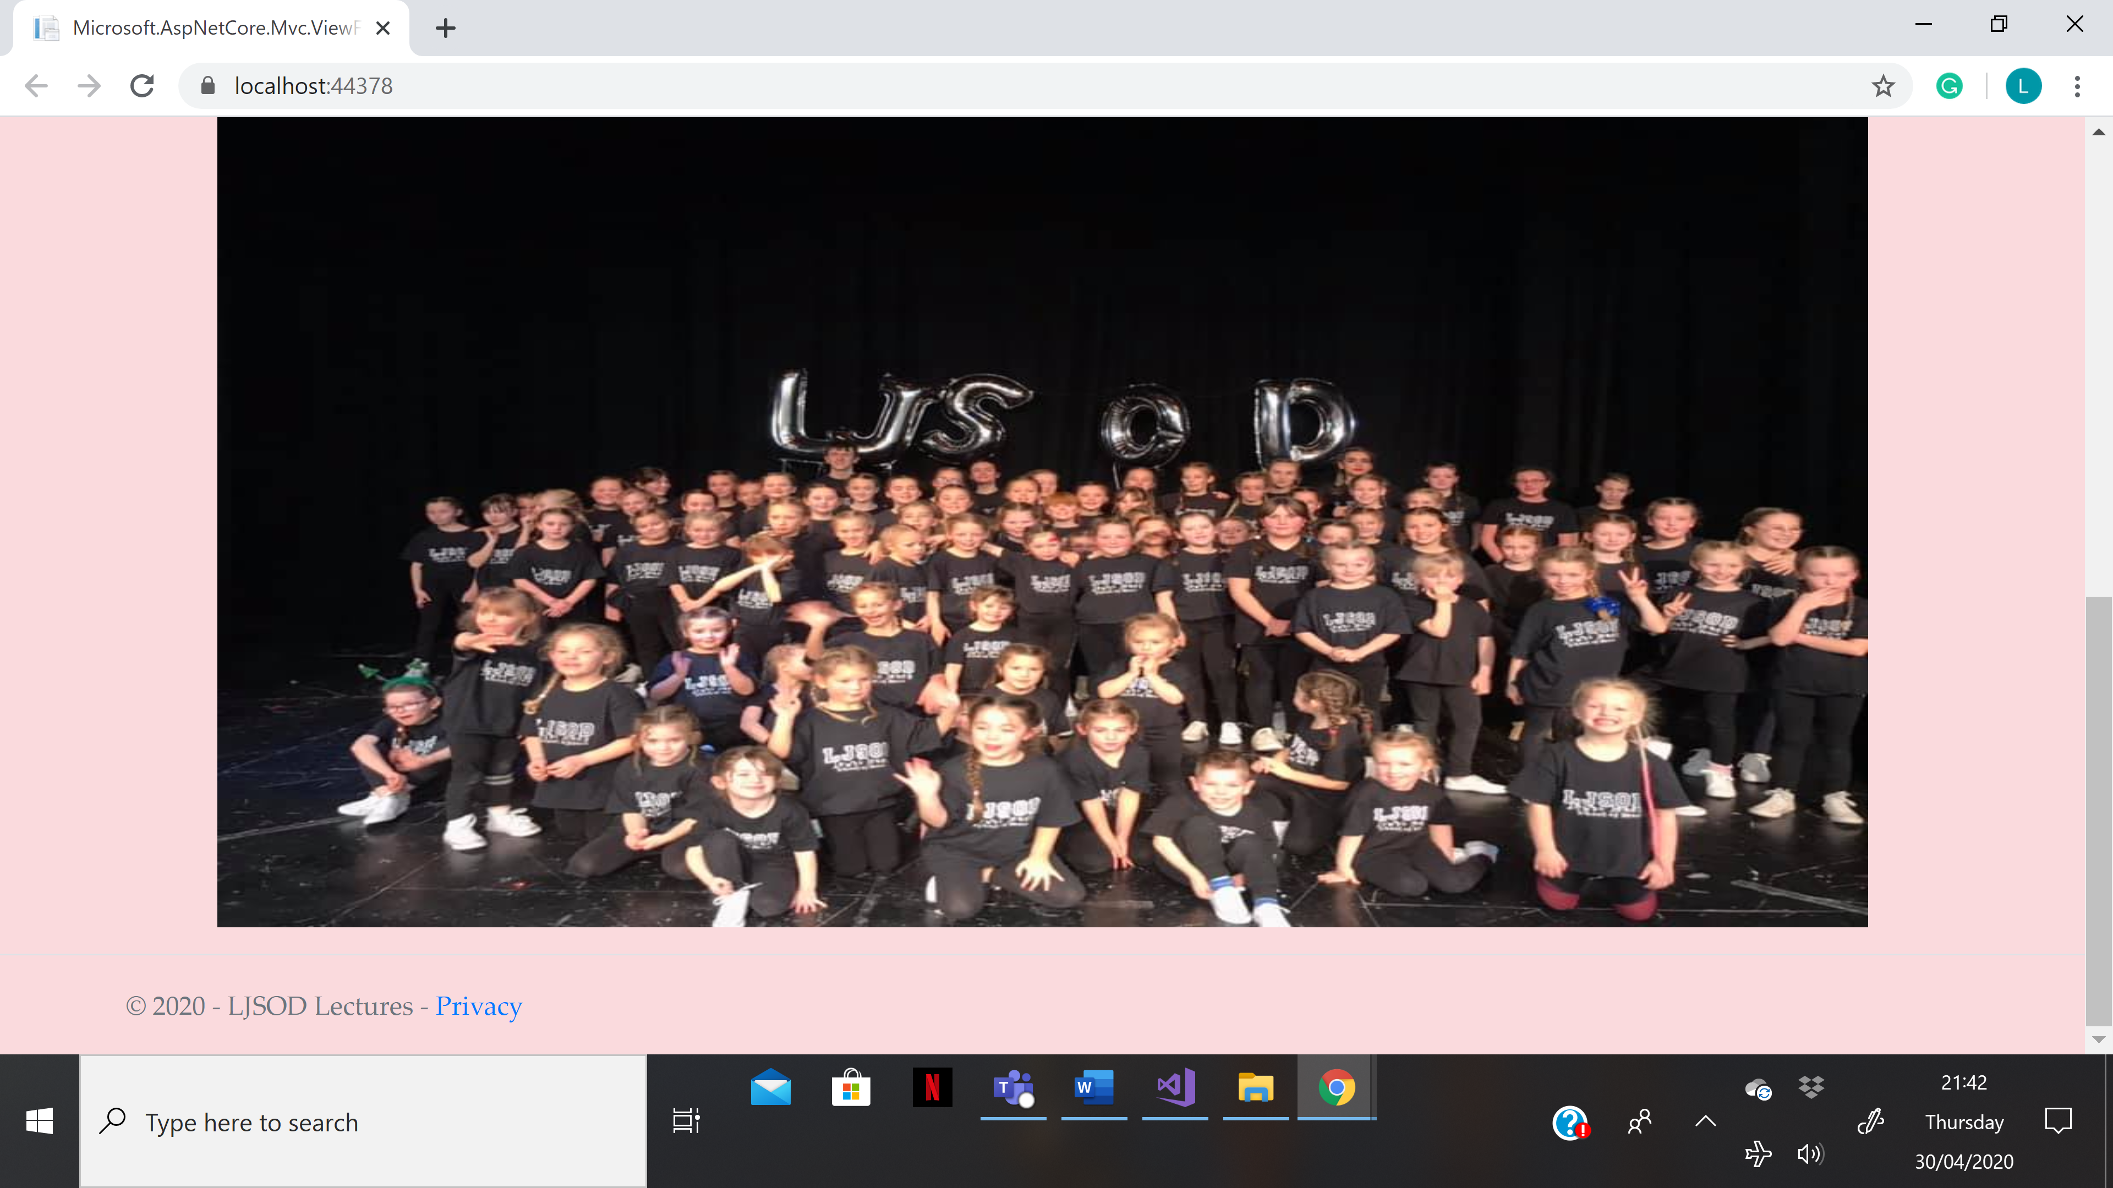

Instructors Page.
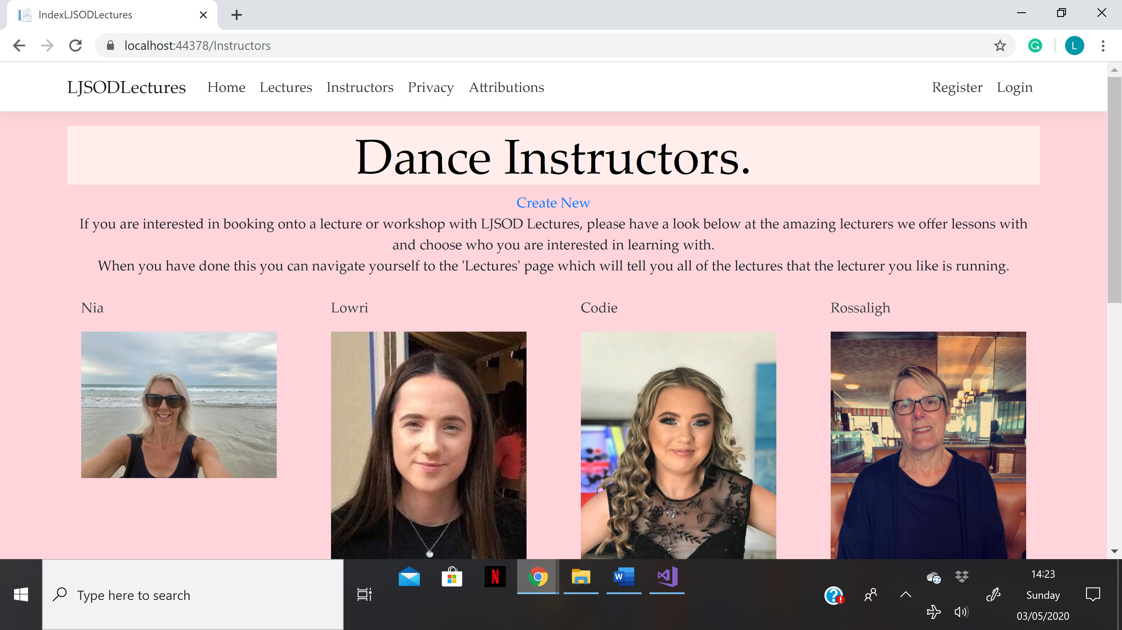
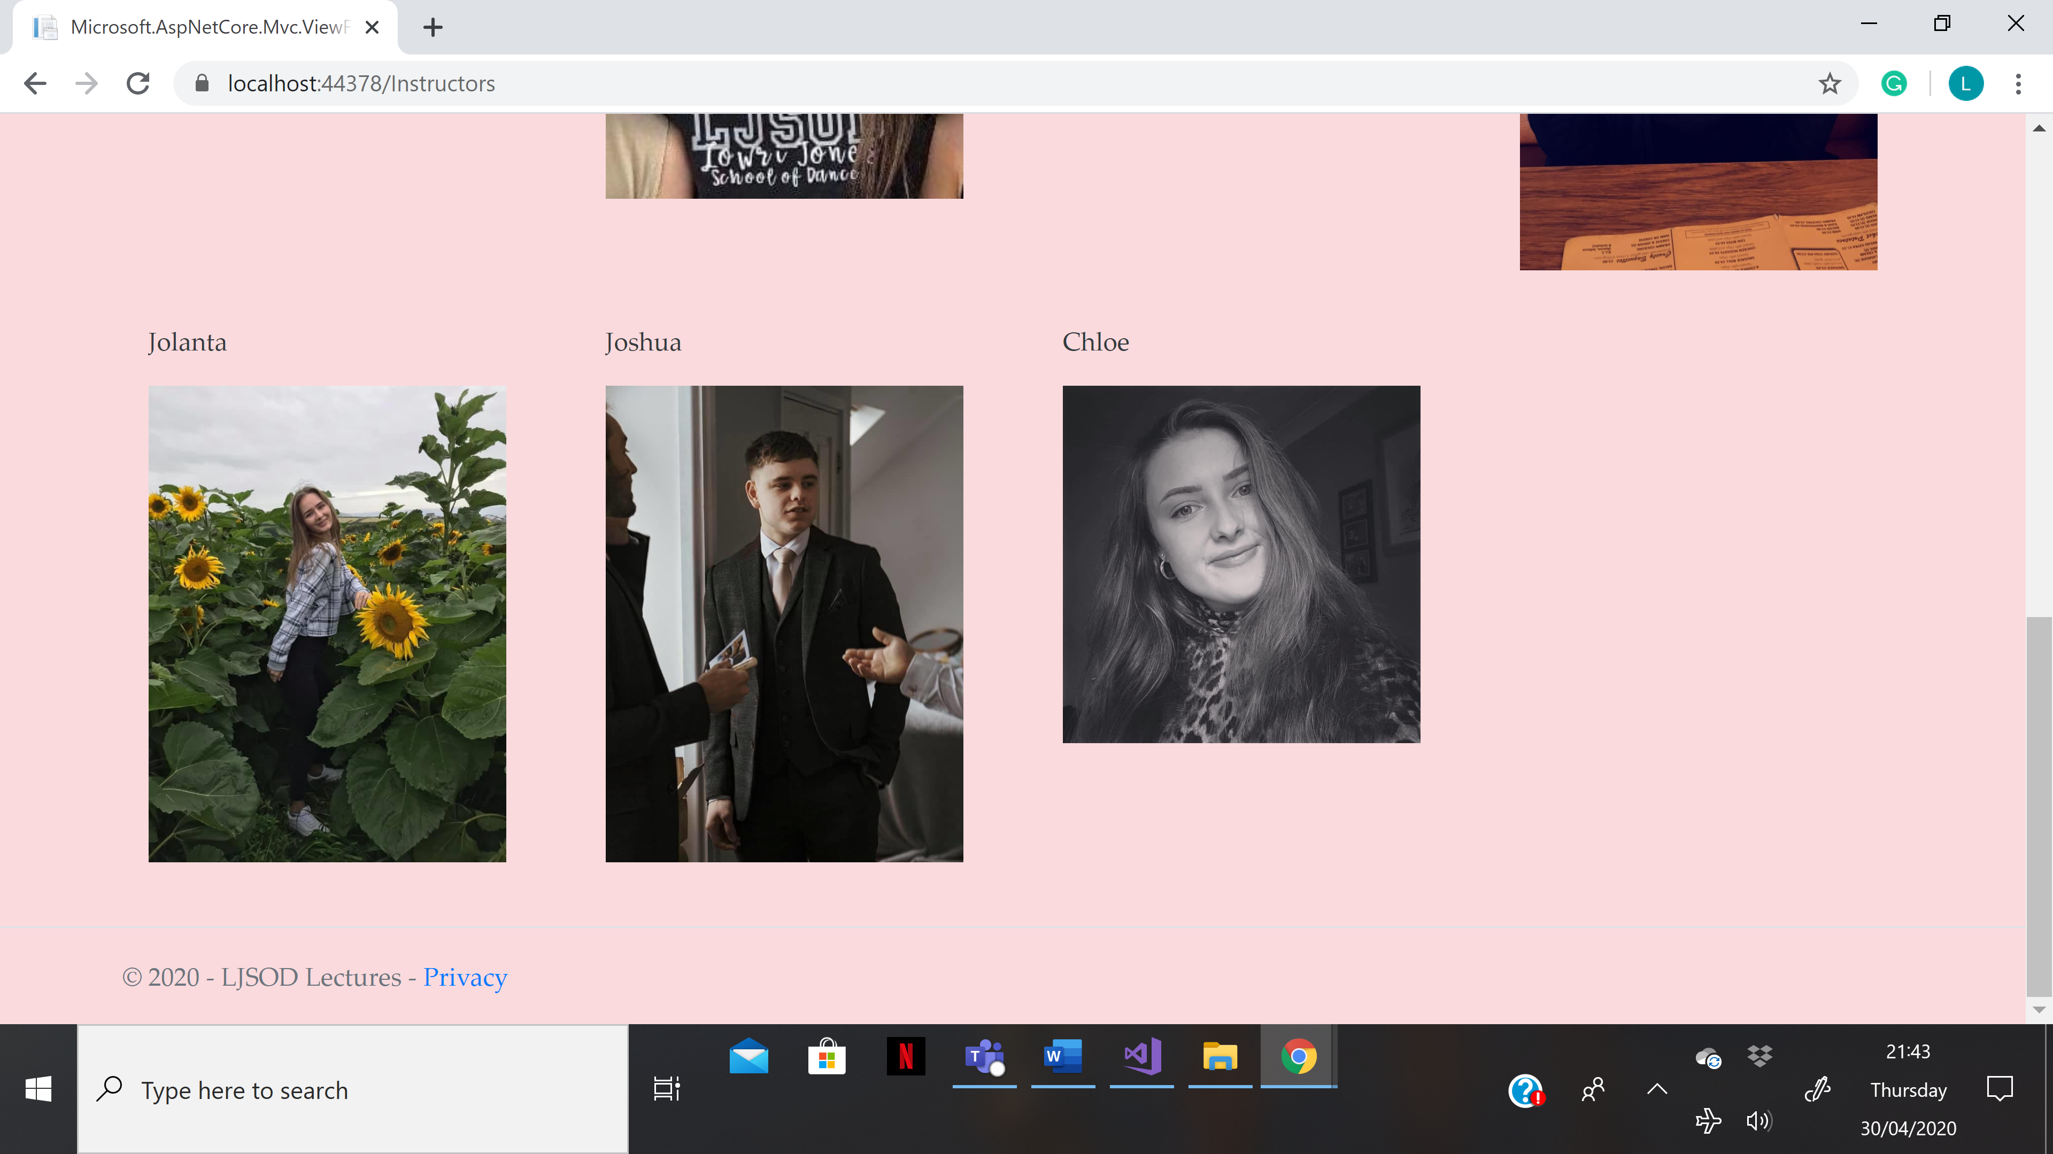

Lectures Page.
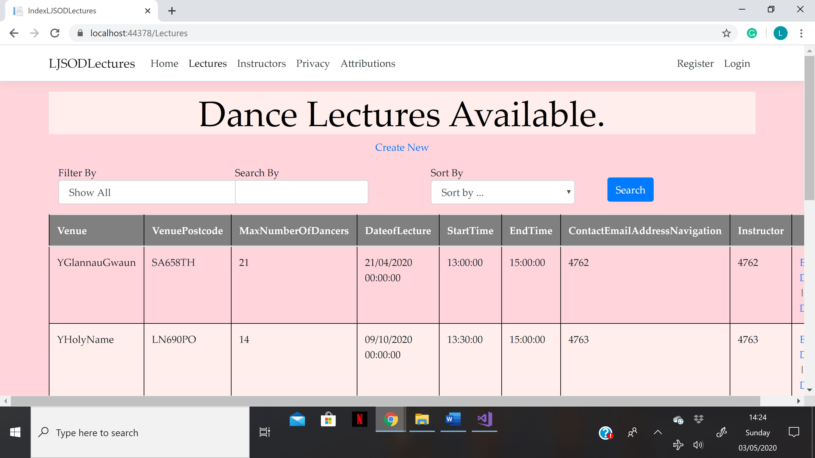
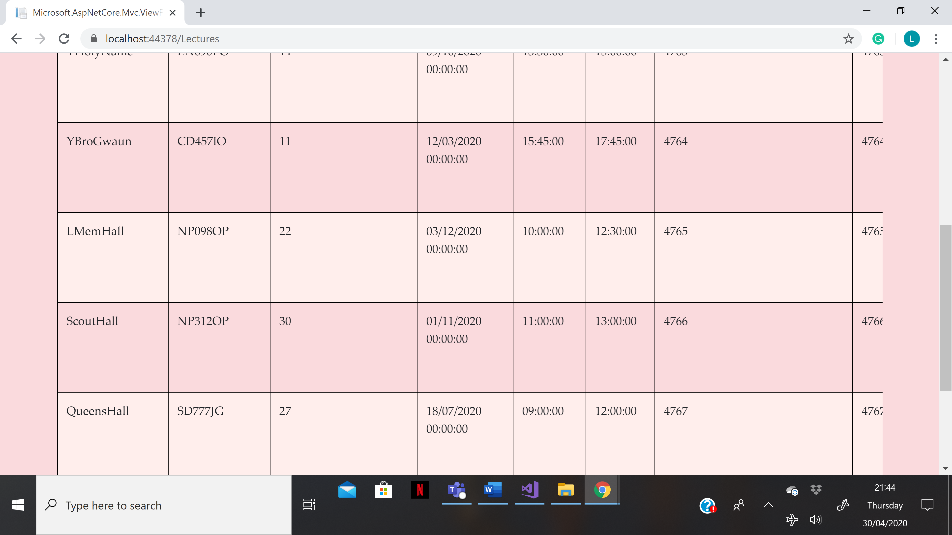
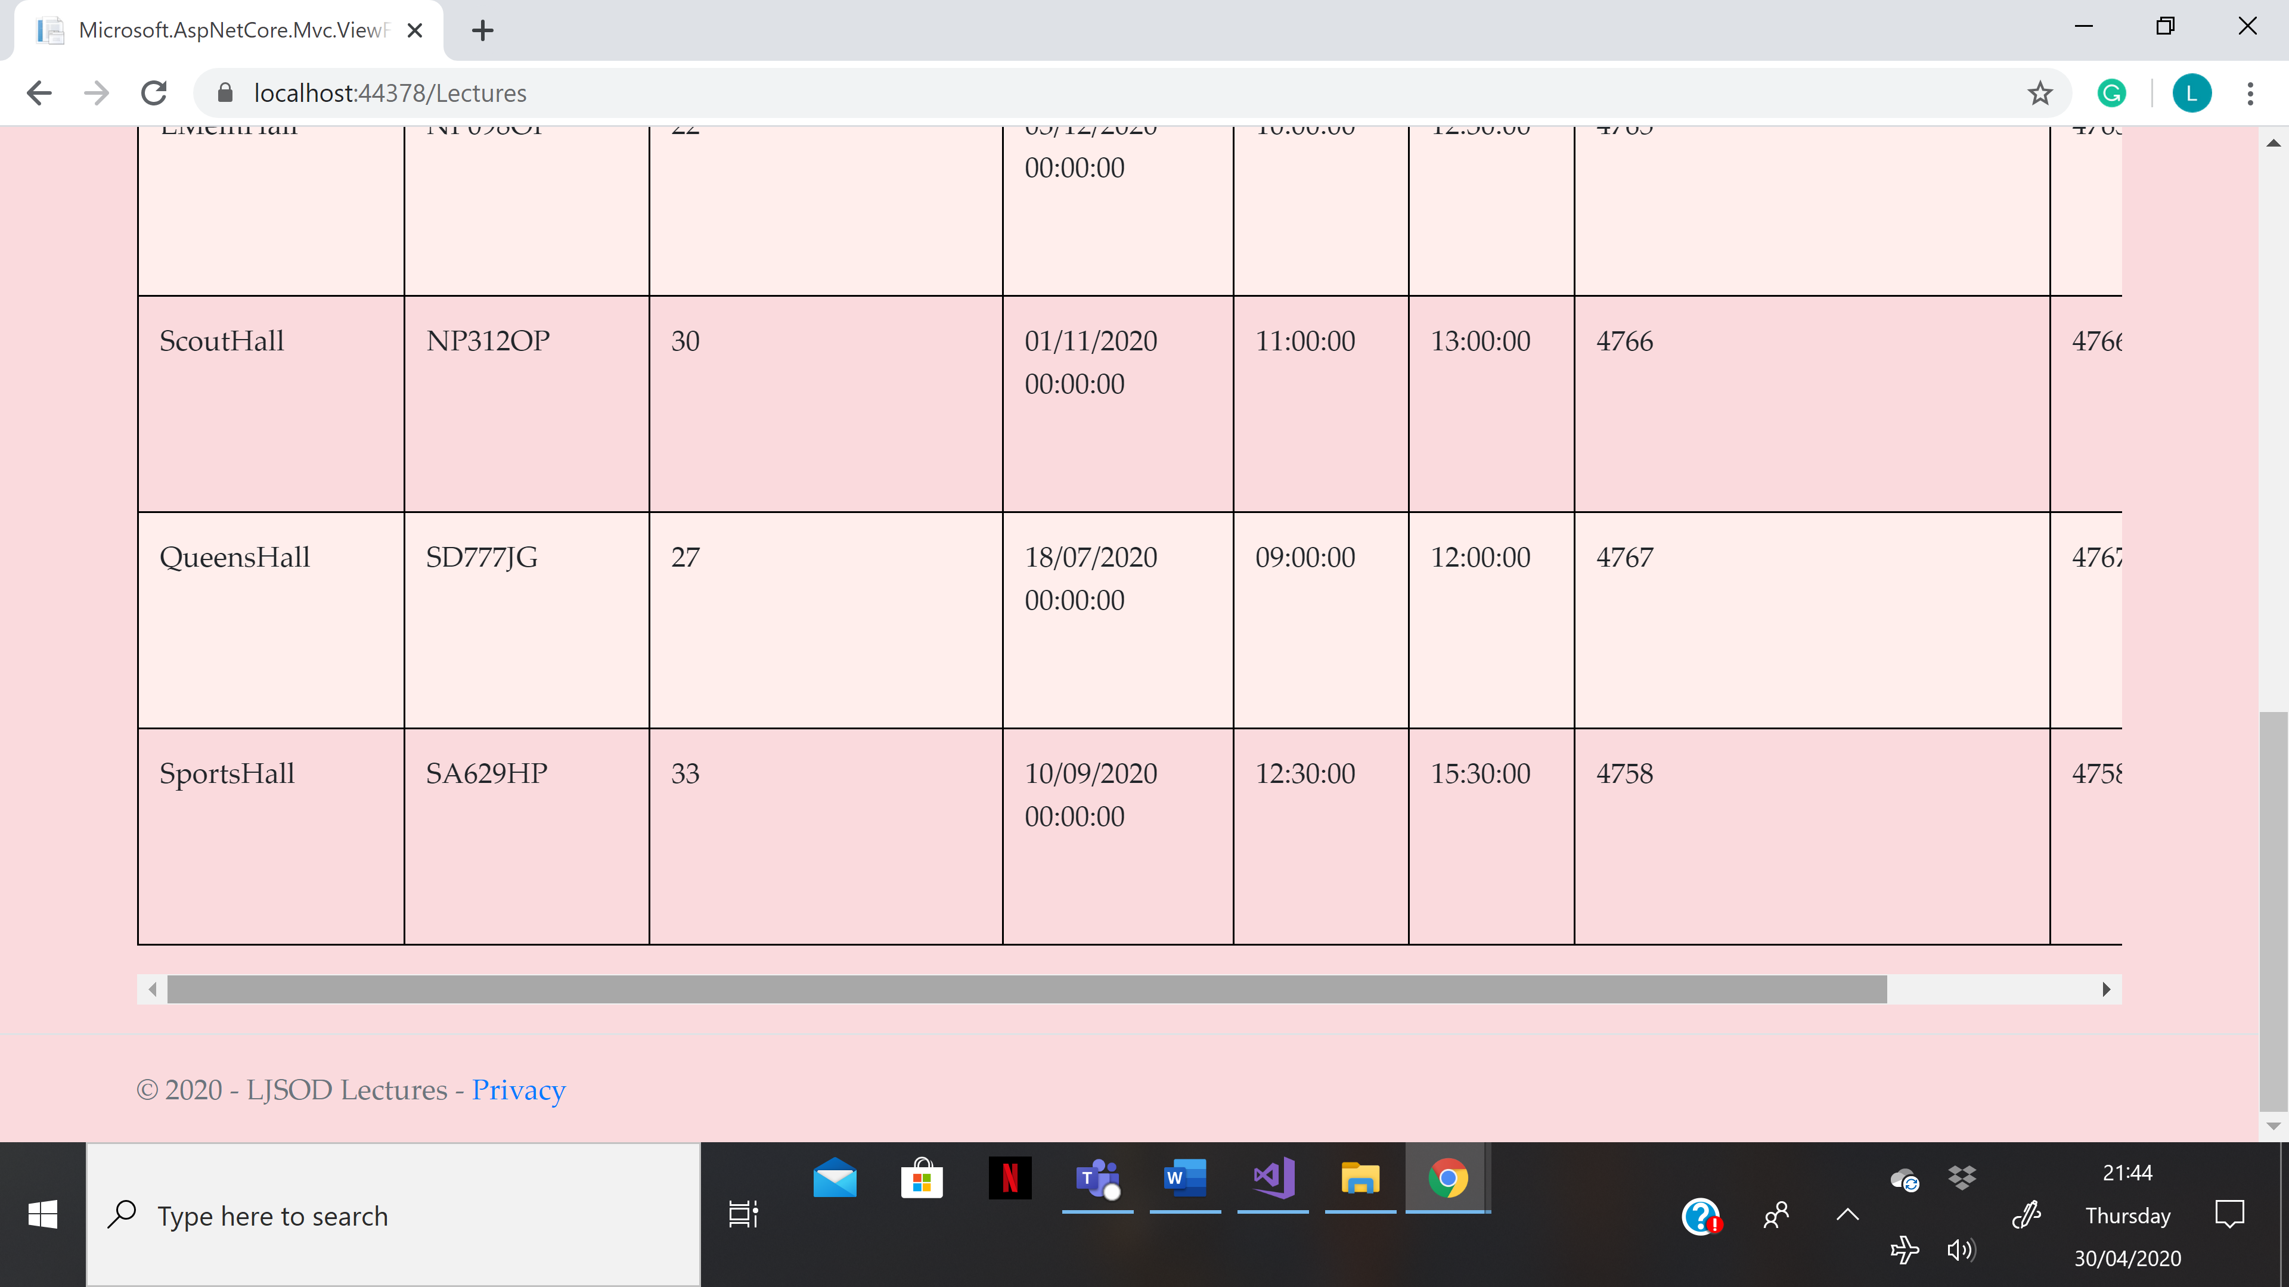

Privacy Page.
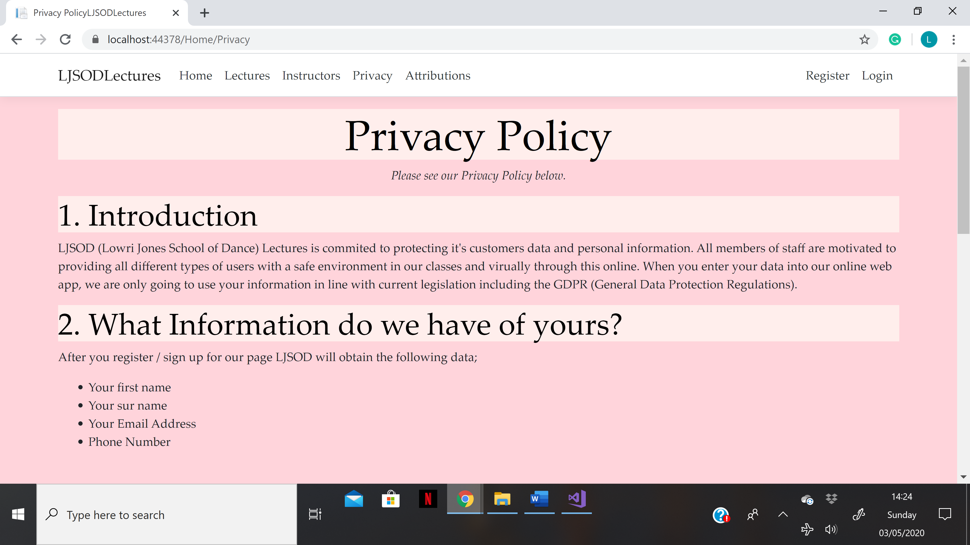
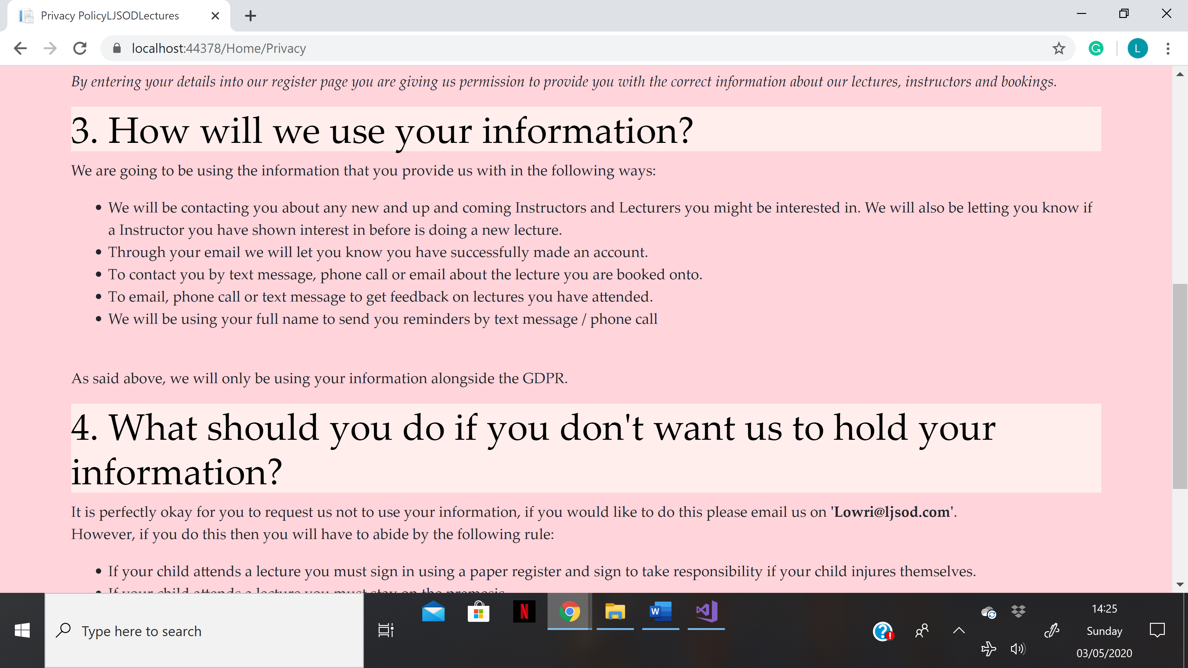
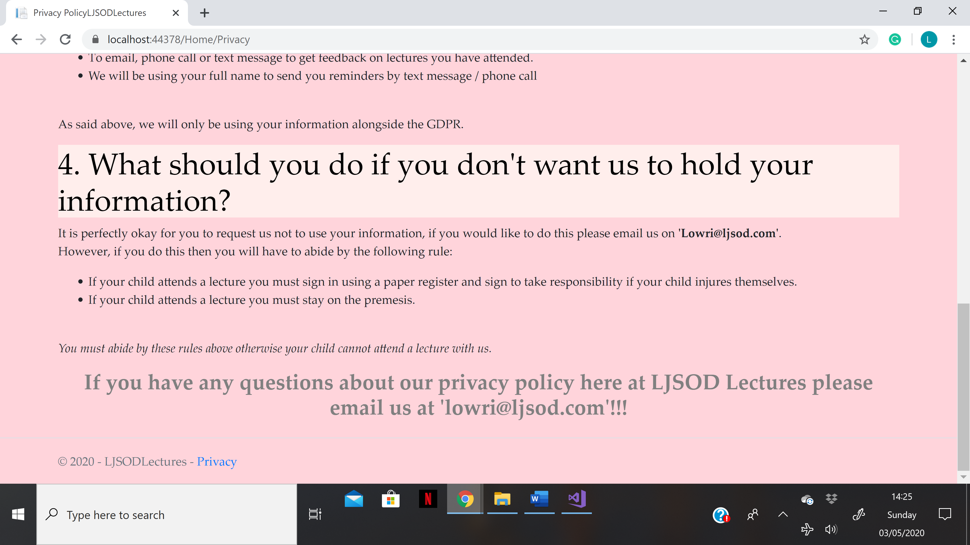

Attributions Page.
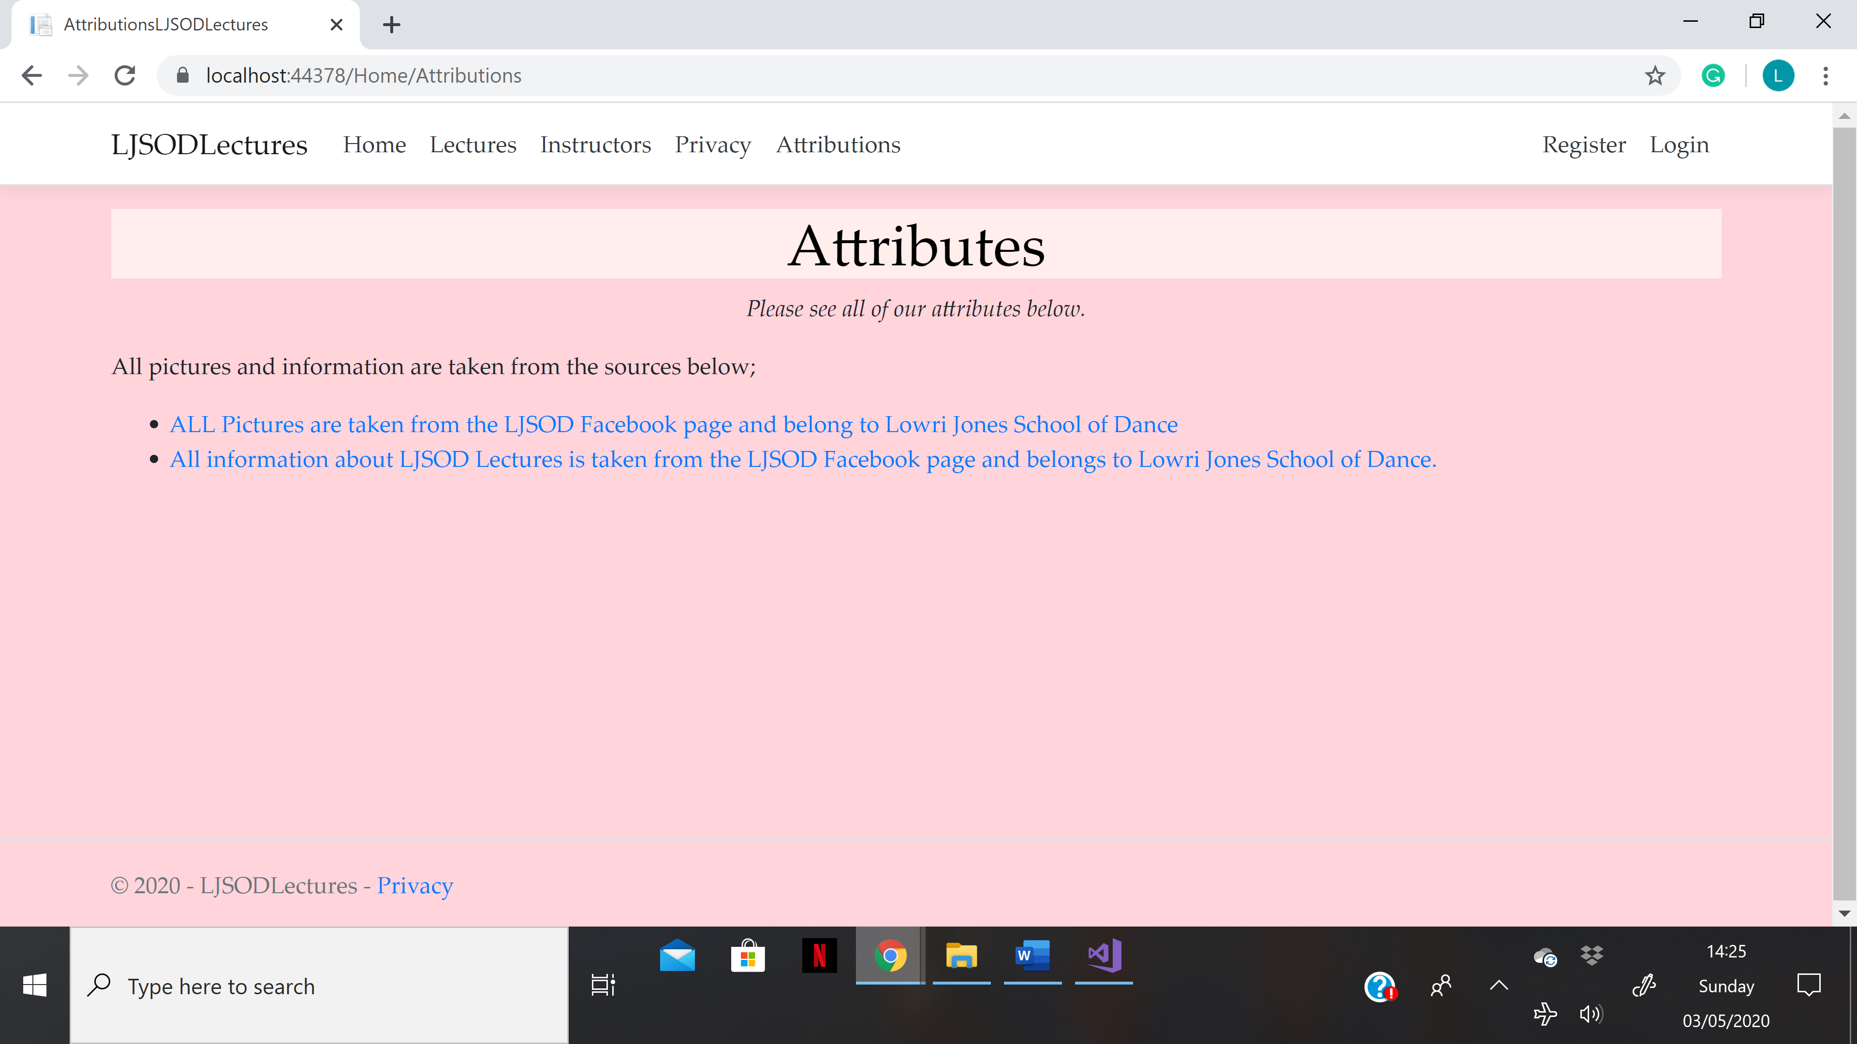

Register Page.
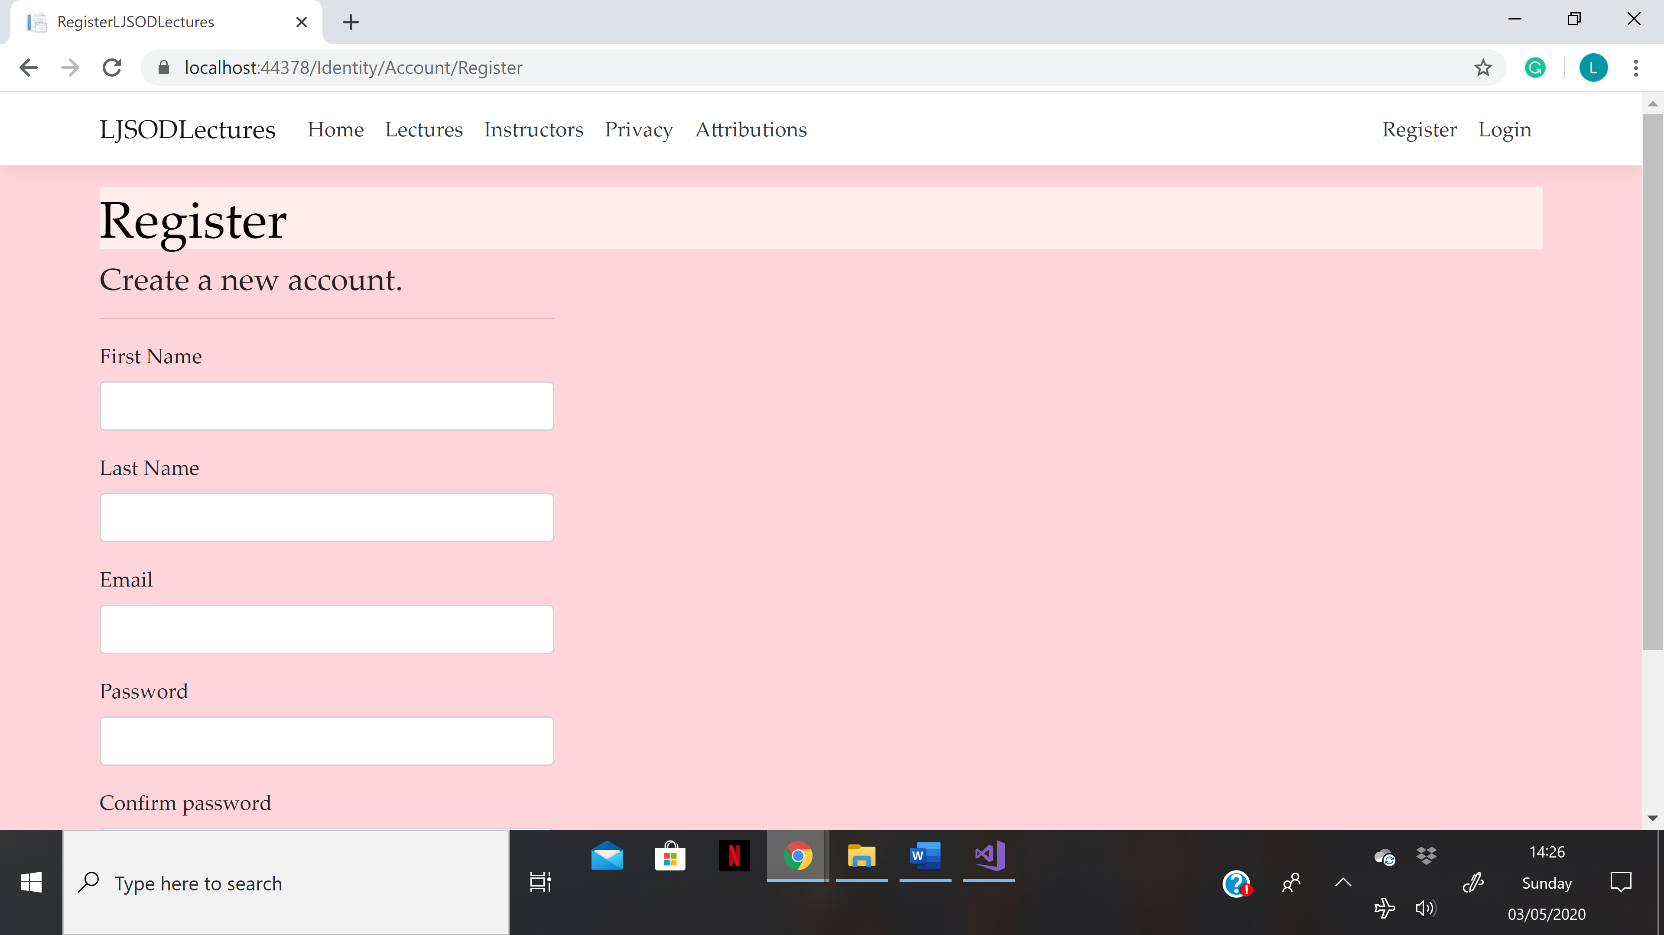
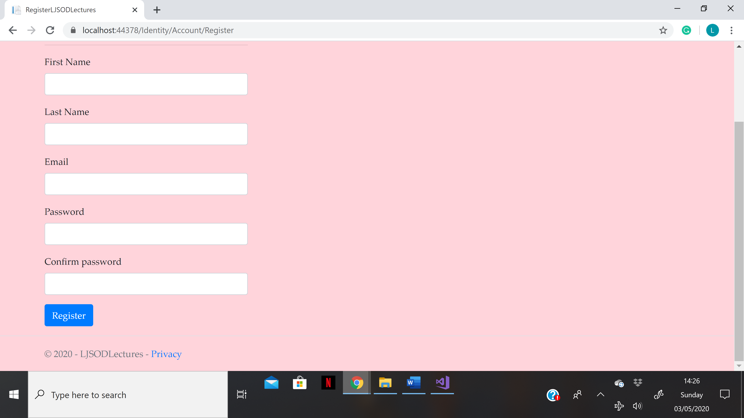

Login Page.
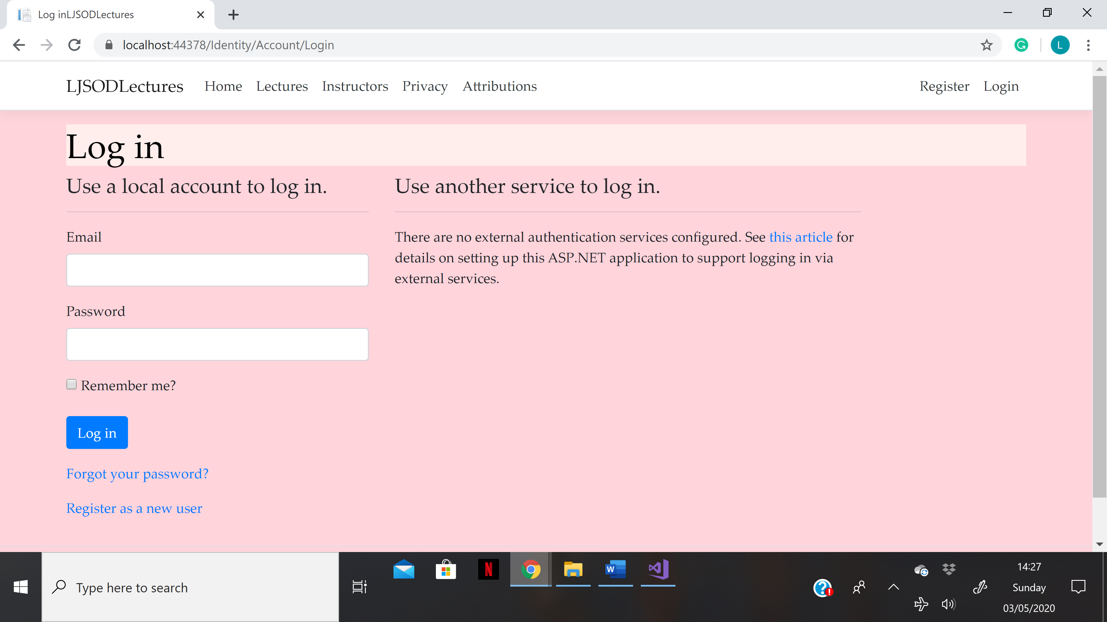

Models, Views and Controllers Implemented.
The models that have been implemented in the web application by the author are listed below:
- Booking.cs
- DanceStyle.cs
- Instructor.cs
- Lecture.cs
- TicketTypes.cs
- WebApp2020DbContext.cs
The views that have been implemented in the application by the author are listed and explained below:
- Bookings.
- Home.
- Instructors.
- Lectures.
The controllers that have been implemented in the web application are listed and explained below;
- Instructor Controller.
- Lecture Controller.
- Booking Controller.

Evaluation

Testing

Test 1.
- Test case summary
This first test is being carried out to test data display. On the Instructors page of the LJSOD Lectures Web Application, 6 images of different dance teachers should appear on the screen. Once clicked by the user, their personal details should appear. This test is going to be completed to test that this works correctly.
- Test steps
Firstly, the author will open the Web Application and locate the ‘Instructors’ page. Once here, each image must be checked by clicking on them and making sure they display the correct information about each lecture instructor.
- Test data
The data that is going to be tested are the images displayed in the Instructor’s controller and the Information that is shown here and taken from the instructors table.
- Expected result
It is predicted that once these pictures are clicked on the correct information for that lecturer will be displayed.
- Actual result
All 6 of the images that were tested displayed the correct information when they were clicked. Every image displayed different information to the previous.
- Pass or Fail?
This test was a pass as it showed what it was supposed to.

Test 2.
- Test case summary
This next test is being carried out to test querying and displaying results. On the Lectures page of the LJSOD Web Application there is a search bar, a sort by field and a filter by. These three fields will all need to be tested to ensure they work with the correct columns.
- Test steps
To carry out this test, the tester will need to navigate to the ‘lectures’ page and enter data in all three fields. After the data has been entered and the search button has been pressed, the correct filters will be applied to the information in the lectures table.
- Test data
The data that is going to be tested for this is the information taken from the ‘Lectures’ table.
- Expected result
When the search button is pressed, the correct filters should be applied to the information in the table.
- Actual result
As expected, when the search, sort by and filter fields were completed and the search was done, the correctly fields were filtered.
- Pass or Fail?
This test was a pass as it filtered what it was supposed to.

Test 3.
- Test case summary
This test is being carried out to check whether the CRUD operations work well for manipulating data. The CRUD operations that have been implemented in this Web Application is the feature for Editing, creating a new record, and Deleting.
- Test steps
In order to complete this test the tester must navigate to either the ‘Instructors’ or ‘Lectures’ page, on these pages they contain links to ‘Edit’, ‘Create New’ and ‘Delete’. These will need to be clicked and finished to see if they work as they’re supposed to. It must be checked that any modifications are updated in the application page.
- Test data
The data that is going to be used for this test is the information on the lectures page and the instructors page.
- Expected result
It is predicted that once either of the three CRUD operations are correctly used, the tables and data will be altered.
- Actual result
As predicted, once these CRUD operations had been applied, the pages were modified. Both of the pages were checked.
- Pass or Fail?
This test was a pass as it completed the tasks correctly.

Test 4.
- Test case summary
This next test is being carried out to test the register page. It is vital that it works in the correct way when a user types in both accurate data and inaccurate data.
- Test steps
In order to complete this test, the tester will need to navigate to the ‘Register’ page of the Web Application and firstly enter a password that doesn’t comply with the password regulations. The test password that will be used will be ‘password’.
The next section of this test will be to enter a password that does comply with the password regulations. This test password will be ‘Password1?’.
- Expected result
For the first section of this result, it is expected that an error message will appear telling the user to try again.
For the last section of this test, it is expected that a new account will be made and it will greet the user with a hi message in the navbar.
- Actual result
As expected, when both tests were completed they worked accurately. The Web Application displayed an error message where it needed to and granted access when the password was entered correctly.
- Pass or Fail?
This test was a pass as it completed everything as it was supposed to.

Test 6.
- Test case summary
This final test is being carried out to test the login page. It is vital that after a user has registered a new account with LJSOD Lectures they are able to log in again using their details.
- Test steps
To test this the tester must navigate to the Login page of the application and enter the details used in the previous step for the Register page.
- Test data
The data that will be used to complete this final test is the information from the Register page.
- Expected result
It is expected that once the account details have been entered correctly, the application will log in.
- Actual result
As predicted, the application allowed the tester to log in using their details.
- Pass or Fail?
This test was a Pass as it allowed the tester to log in.

Reflection.
The application that has been created works effectively in terms of both functionality and usability. The application completes the vital functions that are essential to the company such as the searching, the register and log in page and the instructors page. The application has been made so that it is highly inclusive, this has been done by keeping it simple and easy to use. Looking back at the Web Application created allows the author to see what would have been beneficial to include.

Recommendations.
In future projects, it would be beneficial to look into creating a booking feature that allows users to book to attend a lecture directly through the application rather than them having to contact by their email address.
Another two features that could’ve been included are
- an online chat room - by including a chat room into the website would allow dancers to give their opinions on lectures they’ve been to giving them a chance to review and encourage others to join in.
- a better use of colour throughout - adding more colour would’ve made it more eye catching and enticing for all. More images could have also been used to showcase the talent at LJSOD however, the websites main focus isn’t the dance school it is the Lectures available.

Bibliography

[1] | S. Walther, “Understanding Models, Views, and Controllers (C#),” Microsoft, 19 08 2008. [Online]. Available: https://docs.microsoft.com/en-us/aspnet/mvc/overview/older-versions-1/overview/understanding-models-views-and-controllers-cs. [Accessed 30 April 2020].
[2] | J. Odgis, “Keeping Color Consistent,” HUFFPOST, 12 August 2015. [Online]. Available: https://www.huffpost.com/entry/keeping-color-consistent-_b_8749334. [Accessed 30 April 2020].  ALL INFORMATION AND IMAGES ON THE APPLICATION WERE TAKEN FROM THE LOWRI JONES SCHOOL OF DANCE FACEBOOK PAGE.

