Certificate of Higher Education in Skills for the Workplace

Module: Digital Skills and Research Methods
Module code: BMSW4003
DSR Assignment 2, Group 1
Lecturer: Suneth Fernando

Student Name: Yasminka Yancheva
Student ID: 2123031

Contents
Introduction 2
Background 2
Aims and Objectives of the Research 3
Research Method 4
Results of Research 4
Discussion 12
Conclusion 13
References 14
Appendix 15

Introduction
Using a virtual learning environment, students and teachers can access digital tools that enhance their educational experience. It is important to note that a virtual learning environment (VLE) differs from a virtual classroom in that the VLE uses technology to enhance the in-class experience by facilitating digital communication and engagement as well as quizzes or polls (Cingillioglu, 2014). It is possible to create an engaging, active classroom using a virtual learning environment, which provides instructors with digitally-based solutions. To begin with, VLE was implemented in higher education, but it fell short of the goals outlined in those early days. The VLE hit a turning point in the mid-2000s and began being used in all subjects. University students and faculty alike are big fans of the Virtual Learning Environment (VLE). Students and learners in higher education are not the only ones who can benefit from virtual learning environments. These systems are also well-suited to the needs of independent educational programs, charter schools, and home-based education. As a teaching and learning platform, VLEs may assist instructors to produce, saving and communicating information about their courses, as well as planning and conducting lessons in real-time (Secker, 2014). Learning management systems in higher education commonly include virtual learning environments. Virtual learning environments (VLEs) are expected to have a substantial impact on education in the future. Schools could benefit from the great results of using VLEs in further and higher education. There is a need for research on VLEs because of their impact on the education system.

Background
The VLE is providing a wide range of services to make the learning process more convenient and mobile. Students and teachers can create, store, retrieve, and make use of educational resources thanks to the VLE's content management system. Curriculum mapping and planning services provided by technology also enable lesson planning, assessment, and customisation of the learning experience (Dittler, 2011). Managing access to information and resources for students, as well as keeping tabs on their progress and accomplishments, are all features of this platform. It also provides email, notifications, chat, wikis, and blogs for communication and collaboration. Real-time contact between students and teachers can also be done via live video or audio conferencing. Technology has improved accessibility, inclusivity, cost savings, technical skills, rapid feedback on learning, and greater flexibility and comfort for students for the benefit of the students as a result of the use of this technology. Teachers benefit from VLE technology because it allows them to better prepare lessons and manage resources, as well as keep track of their students and their progress on tests. The amounts of time users save by integrating VLE and MIS systems is immeasurable. Grades are saved and retrieved from the VLE, registration and behavioural data can be submitted immediately and subsequently obtained via reports, and user group management can be automated. In addition, mobile devices such as smartphones and tablets can be used by employees to update data straight from the VLE thanks to MIS integration. If necessary, this information can be made available to others, such as coworkers or children, and it can often be done in real-time (Muller, 2012). The VLE technology has several advantages, but it also has significant drawbacks. As a result of the use of VLEs, teachers and students face issues such as difficulty collaborating, lack of assistance, and poor internet connectivity. Technological dependence is a real possibility for end-users as well. In addition, users run the danger of contracting any number of software-related infections like viruses, worms, and other harmful code (Thomas, 2012). Users must ensure that their user identities and accounts are kept private to avoid any potential dangers. Passwords may need to be changed regularly, and the strength of those passwords must meet certain requirements. During an inquiry into an incidence of misuse, the accounts of users who were involved in it may be suspended. All of the backup dates and times, as well as the specific storage details of each backup, are kept in a database by the Network Manager for safety reasons. As technology continues to advance, new ways of teaching and learning will be needed to keep up with the needs of today's students. The students expect virtual science labs, humanities museums, archaeological sites, and historical periods to be commonplace shortly, as well as virtual corporate training facilities where employees may learn about new technology, attend meetings, and review documents (Orange and Hobbs, 2018).

Aims and Objectives of the Research
In the UK and elsewhere, educational institutions have begun implementing virtual learning systems. Virtual learning has been around for a while, but it hasn't been utilised to the extent it has been during the pandemic (Hamilton, 2013). The dynamic implications of using this procedure for a large number of pupils are something no one anticipated. This study relies on both primary and secondary data from questionnaires to determine the influence of Moodle's Virtual Learning Environment (VLE) and to develop convincing arguments to support that finding. Virtual learning services can be improved and new knowledge gained through this research.
Students' virtual learning platform experience is one of the study's primary goals. Because Moodle is the university's major platform for continuing the virtual learning system, we'll be focusing on what it's like to use VLE - Moodle. Another thing to consider is the channel's usefulness and efficiency as a teaching tool. For students, it will determine the benefits and drawbacks of online education.

Research Method
The study's goal is to determine the university's virtual learning environment's efficacy. The university's Moodle was the subject of a primary study, which collected both quantitative and qualitative data. 60 students from the University of Wales Trinity Saint London campus have been selected at random to collect primary data for this research project. The students were asked a total of ten questions to gather data for the study. The questionnaire had a variety of questions in each section. As a result, their responses were re-examined and incorporated into the study's final report. Secondary data was gathered from a variety of sources, such as books and periodicals. Secondary research was utilised to gather quantitative and qualitative data to better understand VLE services, technology requirements, benefits, downsides, and issues faced by university students, faculty, and administration (Holmes and Gardner, 2006). Secondary research was performed to collect these data. Virtual learning environments and their effects on students were the primary topics covered in those publications. As a result of the outbreak, the survey was not physically distributed. Using Google Forms, students were able to submit their comments online and the form was emailed to them via email. Some questions were used to ensure that only students from the university were participating so that no one from outside could answer them. Anonymity was ensured for the participants. To guarantee that there was no bias in the study, the researcher masked their true identities from them. These processes together resulted in data collection and a consequent rise in trust in both the data and its conclusions as a whole.

Results of Research
The students were asked 10 questions as a part of collecting the primary data. The first question was about whether the students have any experience concerning the usage of a Virtual Learning Environment. 100% of the students have responded that they have experienced the usage of Virtual Learning Environment and 0% of students have responded that they have not experienced it.
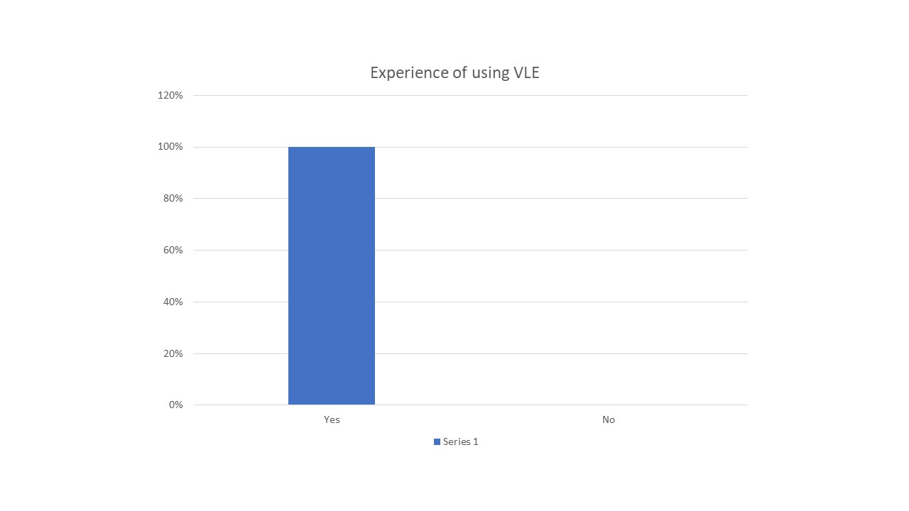
Fig: Experience of using VLE
The second question was whether they do prefer to use VLE for their higher education. In this question, 80% responded Yes and 20% responded No.
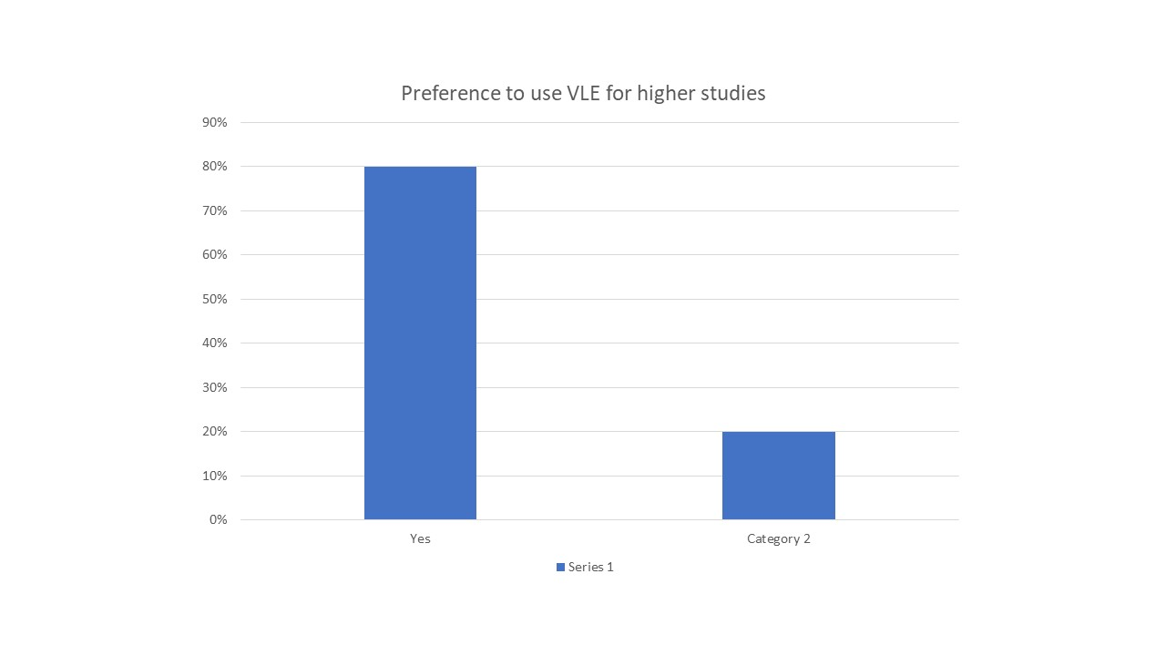
Fig: Preference to use VLE for higher studies
The third question was about whether they have the proper training to use University VLE for their studies. In that question, 60% responded Yes while the other 40% responded No.
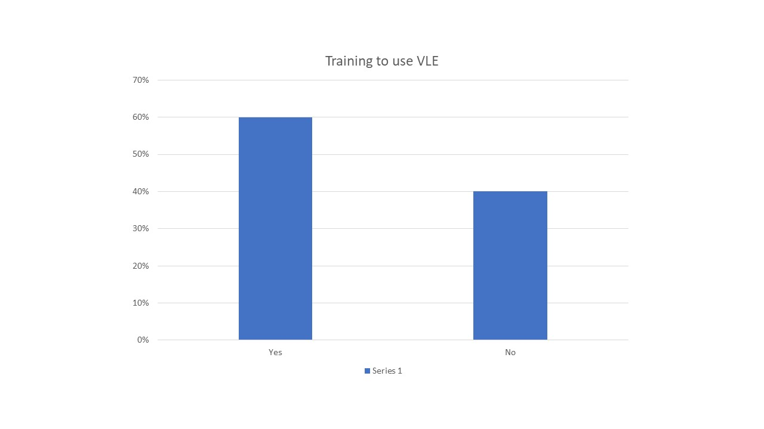
Fig: Training to use VLE
The fourth question was about whether they would like to see the university continue to use the VLE platform after the pandemic as well. 70% of students strongly agreed with the proposal, 20% of students agreed, 5% of students were not sure about their opinion, and other 5% of students disagreed.
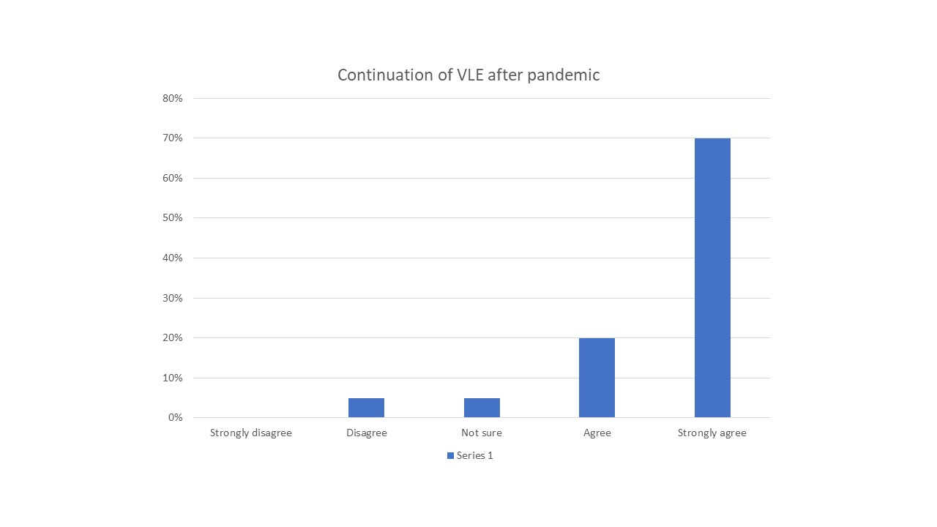
Fig: Continuation of VLE after the pandemic
The fifth question was about if the students prefer to communicate with their lecturers and friends via VLE. 20% of students strongly agreed, 40%students agreed, 10% of students were not sure, 20% of students disagreed; further 10% of students strongly disagreed.
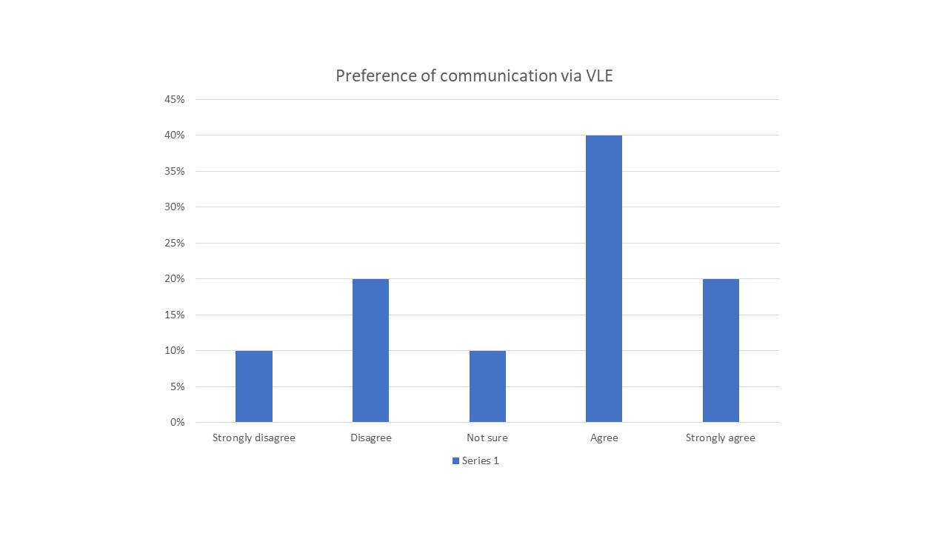
Fig: Preference for communication via VLE
In the sixth question, the students were asked to give a rating of the online learning platform on their academic studies during the pandemic. 60% of students gave a 5 out of 5 ratings, 30% of students rated the platform as 4 out of 5, and 10% of students gave a 3 out of 5 ratings.
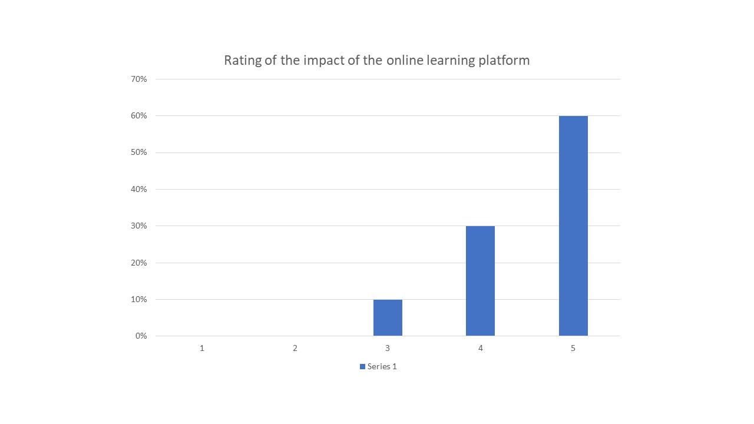
Fig: Rating of the impact of the online learning platform
In the seventh question, students were asked to rate their preference to do their studies in VLE. 80% of students gave a 5 rating out of 5, while the other 20% of students gave a 4 rating.
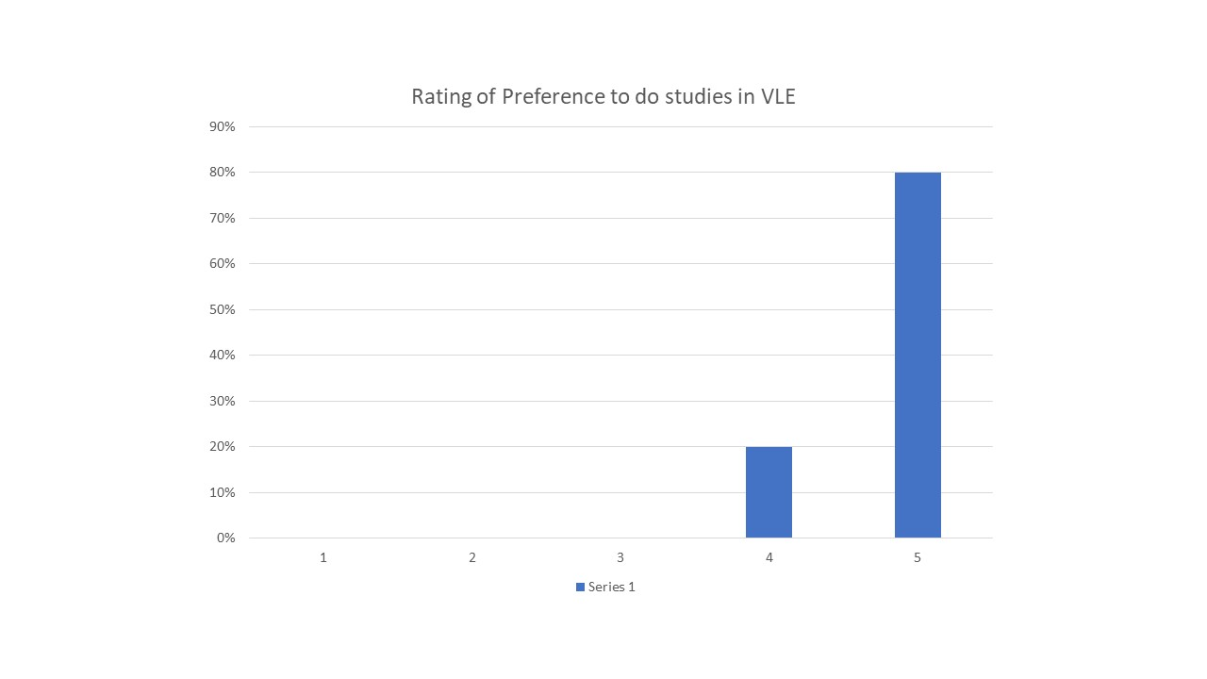
Fig: Rating of preference to do studies in VLE
The eighth question was about whether their e-learning provide appropriate support to complete their assignment. 90% responded as Yes and 10% responded No.
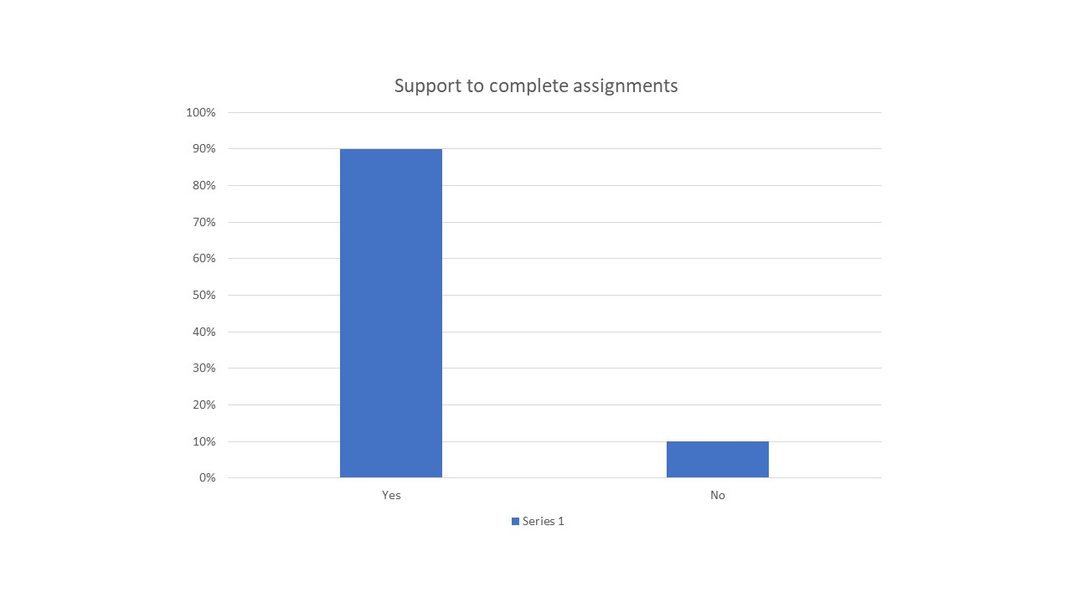
Fig: Support to complete assignments
The ninth question was if they find required and appropriate resources in VLE for each module that they study. 100% of students responded as Yes.
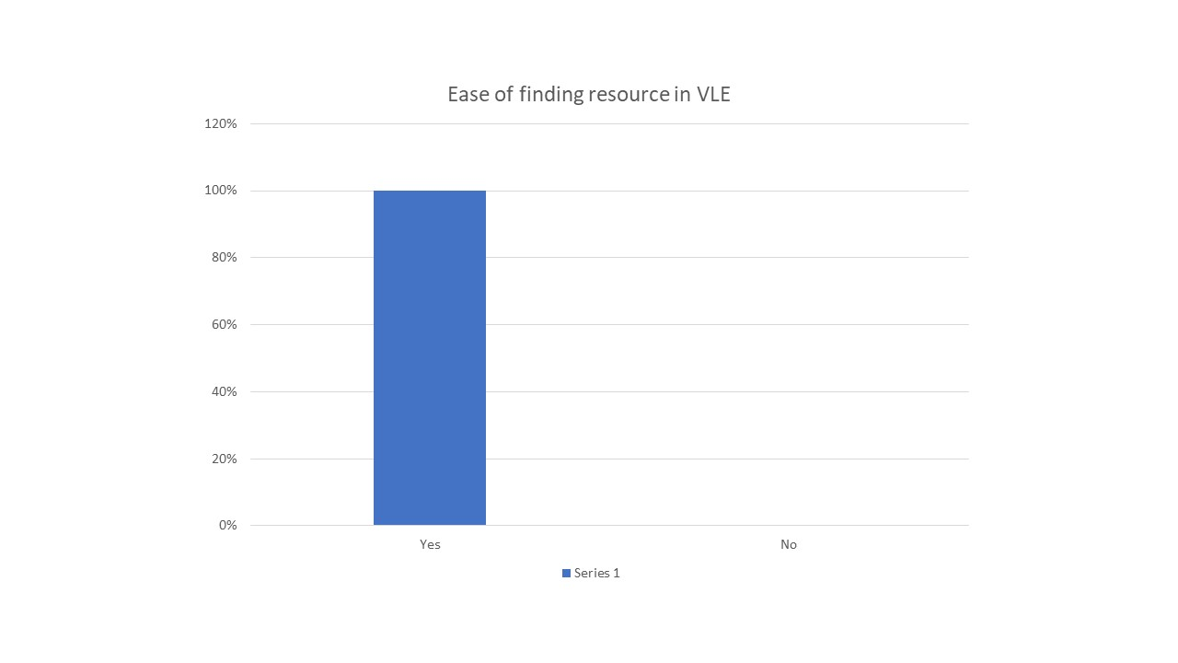
Fig: Ease of finding resources in VLE
The final question was about how satisfied they were with the support of the lecturer, university admin, and management towards their studies in lockdown. 40% of students were extremely satisfied, 50% of students were satisfied, and the other 10% were dissatisfied.
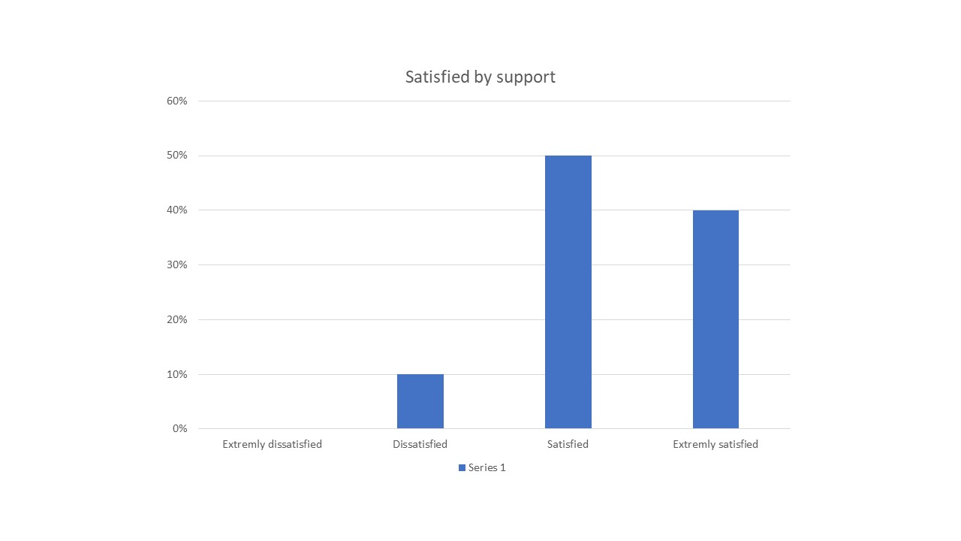
Fig: Satisfaction of support

Discussion
During the lockdown period, Virtual Learning Environment becomes more famous than ever. There was no way to continue physical classes during the lockdown period. The education system is forced to run education system in Virtual Learning Environment. All the students in the UK and all over the world experienced the virtual learning environment. But all the students do not prefer the learning system as there are still some difficulties and all the students were not given proper training regarding the technology (Information Resources Management Association, 2012). Again the maximum numbers of students prefer the system and they want to see the university continue to use the VLE platform after the pandemic. If the drawbacks are overcome, all the students will accept the system. A maximum number of students strongly prefer to communicate with the lecturers and friends via VLE. Thus, there has been a great impact on the online learning platform during the pandemic and students have a preference to do their studies in VLE. The e-learning system provides appropriate support to complete students’ assignments and students find their required and appropriate resources in VLE for their study module. With these benefits and support from the lecturers, university admin, and management, students are highly satisfied with their e-learning. MS Word, PowerPoint, and Excel sheets are used to complete this primary research.
Secondary data analysis reveals that internet platforms are becoming more accessible to students all across the world, regardless of where they live. While they were at home, they were able to continue their research on the pandemic using this method. Students were able to work at their own pace because of online classes. If there were any problems, they could either attend the live classes or watch the recorded sessions, which was not always an option with physical classes. The pupils will be able to concentrate on their studies because they will be able to attend class more comfortably. A variety of studies have shown how the virtual learning environment has impacted energy use. Students no longer need to travel as much, resulting in a reduction in the amount of energy used. Physical classrooms have also seen significant reductions in energy consumption. Paperless education was also aided by this. Due to a drop in the amount of paper used by teachers and pupils in 2021, demand for paper also decreased. The institutions' entire documentation procedure has been relocated to the cloud. In addition, students could submit their responses via the online platform, and the teacher could simply provide feedback in this manner.

Conclusion
Many novel effects have been discovered owing to the widespread use of the virtual learning environment despite its presence for years. These effects were considerable. However, based on the study of both primary and secondary data, the overall response was favourable. Because of the numerous good aspects of virtual learning, the students are enthusiastic about it. Students were able to adjust swiftly to the university's online platform, according to the findings of the study. Because of this, virtual learning can continue after the epidemic, as well as having several advantages over traditional offline education.

References
Cingillioglu, I. (2014) E-lecturing in virtual learning environments. North Charleston, SC, USA: Createspace Independent Publishing Platform.
Dittler, U. (ed.) (2011) E-learning. Oldenbourg Wissenschaftsverlag.
Hamilton, M. (2013) Autonomy and foreign language learning in a virtual learning environment. New York, NY, USA: Continuum Publishing Corporation.
Holmes, B. and Gardner, J. (2006) E-Learning: Concepts and Practice. Thousand Oaks, CA, USA: SAGE Publications.
Information Resources Management Association (ed.) (2012) Virtual learning environments: Concepts, methodologies, tools and applications. Hershey, PA, USA: Idea Group.
Muller, D. (2012) Design characteristics of virtual learning environments: A theoretical integration and empirical test of technology acceptance and IS success research. 2013th edn. Wiesbaden, Germany: Springer Gabler.
Orange, G. and Hobbs, D. (2018) International perspectives on Tele-education and virtual learning environments. Edited by G. Orange and D. Hobbs. London: Routledge.
Secker, J. (2014) Electronic resources in the virtual learning environment: A guide for librarians. Witney: Chandos Publishing (Oxford).
Thomas, P. (ed.) (2012) Design, implementation, and evaluation of virtual learning environments. Hershey, PA, USA: Idea Group.

Appendix


