
MSc Public Health and Social Care in Practice
LCHS7003 Community Care and Management of Longer-term Conditions

Component 1: Information Booklet of Long- term Condition Management

Community Care and Management of Long-term Conditions – Parkinson’s Disease and the NHS

Lecturer: Muhammed Khan
Student Name: Dhwani Patel
Student ID: 2431311

Word Count: 3300
Table of Contents
1.0 Introduction, Prevalence and Burden 1
2.0 Aetiology and Risk Factors 4
3.0 Impact of Parkinson’s Disease on the Patient and their Families and Available Evidence-based Treatment and Services 6
3.1 Impacts of Parkinson’s Disease on the Patient and their Families 6
3.1.1 Biological Impacts 6
3.1.2 Psychological Impacts 6
3.1.3 Social Impacts 7
3.2 Transactional Model of Stress and Coping 8
3.3 Evidence-based Treatments and Services 8
3.3.1 Person-centred Multidisciplinary Care 8
3.3.2 Personalised Care Model for Coordination 8
3.3.3 End-of-Life Considerations 9
4.0 Models and Frameworks for Improved Outcomes 9
4.1 The UK Model 9
4.2 International Model - WHO ICCC 11
5.0 Local and National Policy Implications 12
5.1 NICE NG71 12
5.2 NHS Palliative and Community Neurology Services 12
5.3 Advanced Care Planning 12
5.3.1 Holistic Consultation Model 12
5.3.2 ReSPECT Framework 13
6.0 Recommendations 13
7.0 Conclusion 14
8.0 References 15

1.0 Introduction, Prevalence and Burden
This report pivots around Parkinson's disease and is prepared for family carers and allied health professionals. Parkinson's disease is a common neurodegenerative disorder with clinical manifestations of other non-motor attributes, including hyposmia, constipation, depression, sleep behaviour disorder, pain and cognitive decline (Bloem, Okun and Klein, 2021; Kulcsarova et al., 2024). From the definition of Parkinson's disease, it becomes evident that the early onset of the disease in patients is difficult to detect, as the associated non-motor features of the disease seldom relate to neurodegeneration. This even baffles the caregivers at a later stage of the disease, making the purpose of this report, which is to improve the care of the disease and ensure carer well-being, a worthwhile effort.
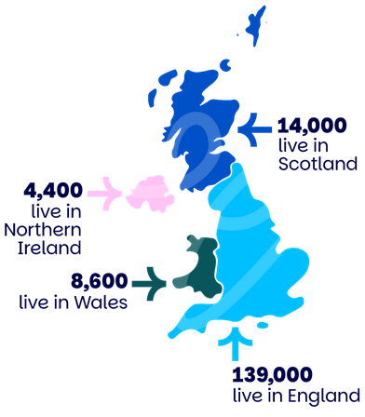
Figure 1: Prevalence of Parkinson's in the UK
(Source: Parkinson's UK, 2025)
Parkinson’s disease is globally regarded as a chronic neurological disorder (Bloem et al., 2020). In order to manage such chronic conditions, personalised care planning is necessary that enables both clinicians and patients to talk about the problem, and also develop plans for managing a patient's conditions (Coulter et al., 2015). Such a coordinated personalised care approach not only helps clinicians with the advantages of early disease detection and deployment of preventive interventions but also empowers patients to self-manage their own health, besides engaging both in clinical decision-making as well (Eaton, Roberts and Turner, 2015). As shown in Figure 1, Parkinson’s disease affects approximately 139,000 people in England, 14,000 in Scotland, 8,600 in Wales, and 4,400 in Northern Ireland. The distribution highlights both the widespread nature of the condition and the importance of region-specific healthcare planning to ensure equitable access to neurological and community support services across the UK.
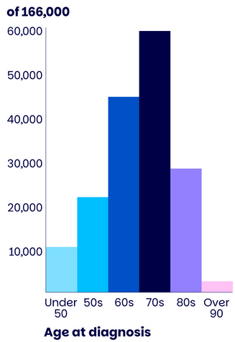
Figure 2: Likely Age of Diagnosis
(Source: Parkinson's UK, 2025)
Furthermore, the onset of Parkinson's disease is generally associated with an increase in age in people (Ben-Shlomo et al., 2024). Data shows that the majority of Parkinson’s diagnoses occur between the ages of 60 and 79, with incidence peaking in the 70s (Parkinson's UK, 2025). This pattern reflects the strong association between ageing and neurodegenerative processes, underscoring the need for age-appropriate screening, multidisciplinary management, and long-term care planning for older adults. As per Clark (2025), in the United Kingdom (UK), the total number of people aged over 65 in the country will become 16.9 million by 2035, compared to 11.85 million in 2015. The analysis of this rising ageing population trend in the UK suggests that in the coming years, the prevalence of Parkinson's disease in the country will go up. As for the care costs, the National Health Service (NHS) highlighted that it costs around 4,422 GBP a year for a patient with mild to moderate Parkinson's disease, while the cost increases to 5,491 GBP per year for a patient in a severe condition of the disease (Chaudhuri et al., 2022).
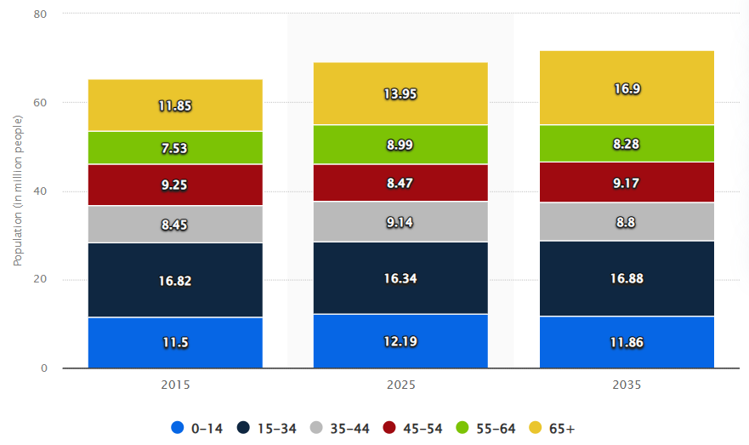
Figure 3: The UK Population Forecast - By Age
(Source: Clark, 2025)
Referring to Engel, Gatchel et al. (2020) explained that any kind of physical disorder in a human is the outcome of the interactions among the physiological, psychological, and social factors. The analysis of this information helps to understand the aptness of the biopsychosocial model while advancing with the report focusing on Parkinson's disease. The integration of this model into this report helps to perceive the dynamics of carer support, coordination among multi-disciplinary teams (MDT), and the end-of-life planning aspects, which are the key determinants of the health conditions and health outcomes of a patient who is suffering from Parkinson's disease. In the following sections, the risk factors, the implications of the disease, recommendations, and concluding remarks are highlighted.

2.0 Aetiology and Risk Factors
Prior studies suggest that mutations in autosomal recessive and dominant genes are one of the leading causes for the development of Parkinson's disease (Cherian and Divya, 2020). However, it has also been argued that Parkinson's disease can also be caused by biochemical, cellular, or other pathogenic reasons. Supporting this claim, Morris et al. (2024) mentioned that accumulation of alpha-synuclein, infection of pathogens in the brainstem and gut, abnormal endosomal, lysosomal, and mitochondrial functions, or asynchronous responses of the immune system in the human body are some of the factors responsible for causing Parkinson's disease. Additionally, age, consumption of coffee, smoking, and exposure to heavy metals and pesticides are also other risk factors for the development of the disease (Angelopoulou et al., 2022; Orozco et al., 2020).
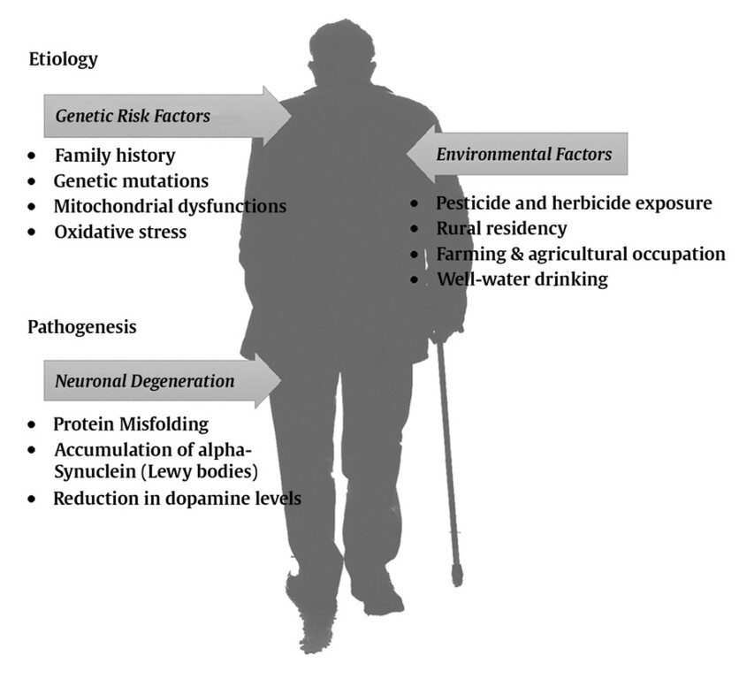
Figure 4: Aetiology of Parkinson's Disease
(Source: Neupsy Key, 2021)
Post-identification of the potential risk factors, it is also important to understand the underlying neurodegenerative mechanisms. As explained by Zhang et al. (2023), because of genetic mutation or other environmental factors, alpha synuclein aggregation occurs in neurons. The presence of microglia there causes toxicity at that place, leading to the gradual loss of dopaminergic neurons (Zhang et al., 2023). The gradual accumulation of such proteins over time, for example, amyloid beta, TAR, TDP43, and neurofibrillary tangles, causes neuron damage, resulting in the inflammation of the cells in the central nervous system (Zhang et al., 2023). In this context, it is worth observing the following diagrammatic representation of the gradual process of the neurodegenerative mechanisms in patients with Parkinson’s disease.
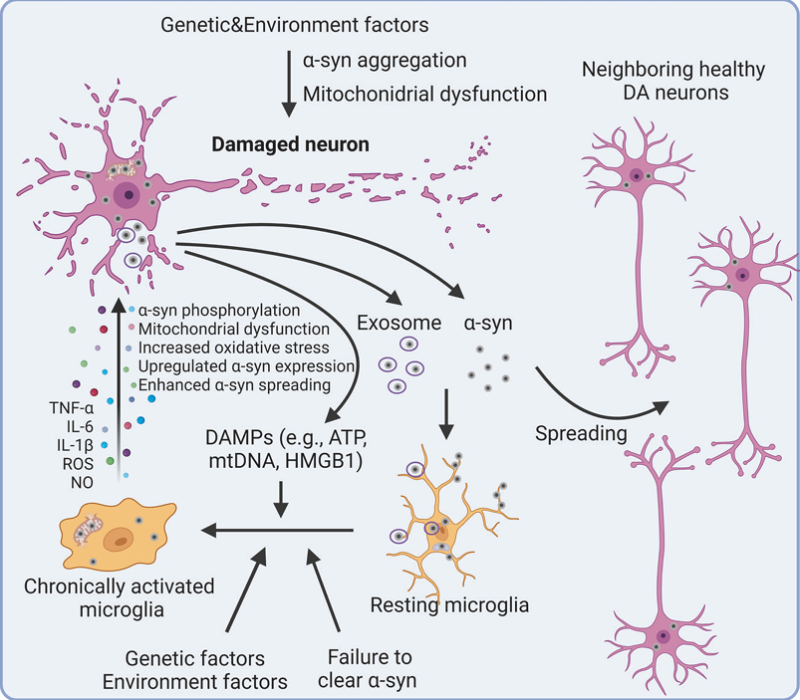
Figure 5: Mechanisms of Neurodegeneration in Parkinson’s Disease
(Source: Zhang et al., 2023)
Considering the involvement of environmental factors and genes that are responsible for the development of neurodegenerative disorders in humans, it is worth integrating the holistic health view that is presented by the World Health Organisation (WHO) into this study. Referring to the WHO, Schramme (2023) explained that health is not only the absence of diseases in humans, but also the state of mental, physical, and social well-being together. Hence, the analysis of this holistic model of health, introduced by the WHO, points to the fact that physical decline can also be influenced by emotional and social domains.

3.0 Impact of Parkinson’s Disease on the Patient and their Families and Available Evidence-based Treatment and Services

3.1 Impacts of Parkinson’s Disease on the Patient and their Families

3.1.1 Biological Impacts
The biological impacts of the disease are exclusively borne by patients. The clinical manifestation of the disease in patients includes motor and non-motor attributes that can be noticed during the early and later stages of the disease. For example, Jankovic and Tan (2020) listed constipation, sleep disorder, loss of smell, postural instability, rest tremor, rigidity, and cognitive impairment as some of the impacts of Parkinson's disease on patients. In some cases, the heart rate, digestion, and blood pressure of patients are also affected by this disease (Jankovic and Tan, 2020). The analysis of this information helps to understand the huge and all-round physical impacts of the disease on patients.
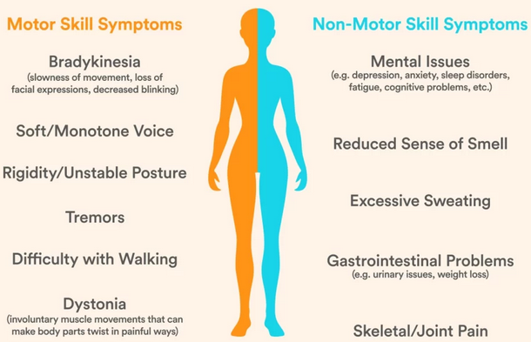
Figure 6: Biological Impacts
(Source: The Brain Docs, 2023)

3.1.2 Psychological Impacts
The emotional or psychological impacts of Parkinson's disease are equally felt by both patients and their families. A study conducted by Khedr et al. (2020) revealed that 40.6% of patients suffering from the disease experience anxiety, while 31.25% of patients with the disease feel depressed. The result of the research also upheld the fact that 23.4% of patients with Parkinson’s disease experience both simultaneously. On the other hand, Fekonja, Irgolič and Vrbnjak (2024) argued that when family members become aware of the disease, they tend to feel scared, helpless, worried, and sad. Moreover, providing continuous care assistance to patients also makes their family members feel the burden and stress as well (Fekonja, Irgolič and Vrbnjak, 2024). Parkinson’s disease significantly affects mental health, with anxiety, apathy, depression, and hallucinations being common non-motor symptoms [Figure 7]. These psychological challenges not only reduce quality of life but also influence disease progression and self-management, highlighting the need for integrated biopsychosocial care that addresses both neurological and emotional wellbeing.
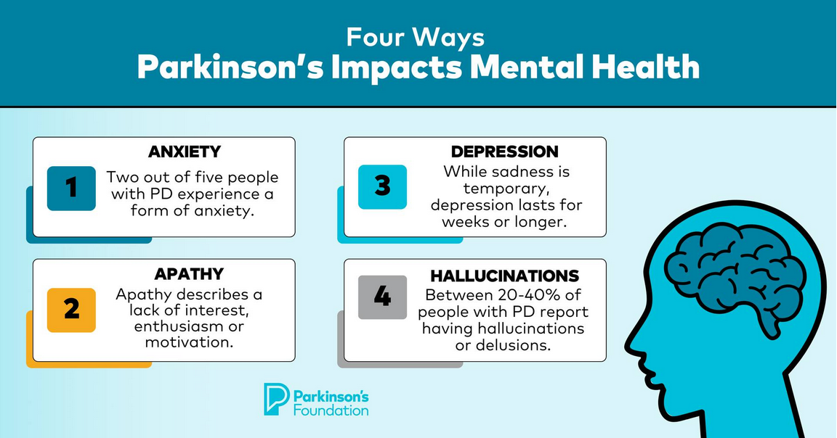
Figure 7: Psychological Impacts
(Source: Parkinson's Foundation, 2025)

3.1.3 Social Impacts
It is important to note here that Parkinson's disease exerts different kinds of social impacts on both patients and their families. Going by the findings presented by Mammen et al. (2024), it becomes evident that Parkinson's disease severely affects the movement of patients as they struggle to keep their balance on their feet, and hence rely on assistance from others. As a consequence, it can be synthesised that such a difficulty in movement in patients leads to social isolation, as they always need to rely on others for their movement within societies. The study also underscored that the family members of patients with Parkinson's disease often go through embarrassing situations in public and experience being stigmatised, which all leads to their reduced social participation as well (Mammen et al., 2024).

3.2 Transactional Model of Stress and Coping
The coping mechanisms of individuals in response to stress factors are clearly explained through the transactional model of stress and coping. According to Lazarus and Folkman (1984), there are different mechanisms to cope with stress factors. For example, stress avoidance is a coping behaviour, while the display of anger in protest to an undeniable fact is another coping behaviour (Lazarus and Folkman, 1984). Showing frustration is the other coping behaviour to deal with stress factors, and detachment or denial is also a coping mechanism (Lazarus and Folkman, 1984). These explain the gradual adaptation of patients with the disease and their family members, with their changing roles in their families.

3.3 Evidence-based Treatments and Services

3.3.1 Person-centred Multidisciplinary Care
Due to the clinical manifestation of different motor and non-motor related symptoms in patients who are suffering from Parkinson's disease, it is essential to follow a suitable person-centred and comprehensive therapeutic course (Rajan et al., 2020). Such a comprehensive therapeutic approach, besides managing the medical aspects, can also take different non-pharmacological measures as well, such as speech therapy, physiotherapy, education, and support, all aiming at enhancing the overall health-related quality of life (HRQoL) of patients and their families (Rajan et al., 2020). On the other hand, Nutt and Wooten (2005) talked about offering surgical therapy to severe Parkinson's patients by implanting electrodes into their brains for thalamic and thalamotomic stimulation to treat their tremor issues. The analysis of this information helps to synthesise that, depending on individual cases of Parkinson's patients, integrated care for them is introduced as per their suitability, and specialists from multiple disciplines can work together for patients' better HRQoL as well.

3.3.2 Personalised Care Model for Coordination
According to the findings presented by van Halteren et al. (2020), personalised care is delivered to Parkinson's patients based on their needs and their preferences. One of the core components of the individualised treatment of Parkinson's patients is care coordination, through which the sharing of a patient's health information, generating a common understanding of the individual patient's needs, aligning multidisciplinary treatment plans to avoid contradictions, and sharing synchronised responsibilities are achieved. Hence, the analysis of this information helps to understand the multifaceted benefits of care coordination, especially within a personalised care delivery setting. Further developing on the realised benefits of a coordinated and personalised care model, Pirtošek (2024) noted that such a care delivery setting not only eliminates disconnects between patients and caregivers but also is quite effective in managing symptoms and preventing further complications. Therefore, based on the discussion, it can be inferred that with multidisciplinary teams to provide personalised care, coordination is enhanced, and a patient's overall quality of life.

3.3.3 End-of-Life Considerations
According to the NHS, it is imperative for Parkinson's patients to take their medicines on time every time to keep the balance of necessary chemicals in their body at an optimal level, and non-adherence to this may cause further complications to this disease in a short time (NHS, 2022a). Hence, the timing of medicines for end-of-life Parkinson's patients is crucial. The other consideration for end-of-life Parkinson's patients involves advanced therapies. Contextually, Lennaerts-Kats et al. (2025) revealed Parkinson's patients' data, from their electronic medical records, of the last six weeks of their lives, which showed that advanced therapies, including apomorphine therapy, intra-jejunal infusion of levodopa gel, and deep brain stimulation, are administered to them. Additionally, people suffering from Parkinson's disease who are at their end-of-life stage also receive community palliative support. The Community Specialist Palliative Care Services offered by the NHS manages a patient's symptoms, emotional and psychological needs, their family issues, and end-of-life planning (NHS, 2025a). The discussion up to this point helps to perceive the evidence-based treatments and services available to Parkinson's patients.

4.0 Models and Frameworks for Improved Outcomes

4.1 The UK Model
The NHS is known for utilising the Comprehensive Model of Personalised Care, which also underpins neurological, along with carer support, regarding Parkinson’s (NHS England, 2022). Shared Decision Making is known for observing the fact that specialist nurses alongside neurologists are co-designing medication timing and symptom plans with various patients and caregivers, utilising “What Matters to Me” discussions (NHS, 2021). Personalised Care, along with Support Planning, is known for following the Right to Rehabilitation of the NHS, along with NICE NG71 for guiding various plans that combine physio, speech therapy, and medication review (NICE, 2017). This helps in translating national policy into various local practices. Enabling Choice helps patients to select a hospital, along with community or virtual follow-ups and setting up therapies. This also helps caregivers access respite with ease, with the management being conducted locally (Parkinson's UK, 2025).

Figure 8: Comprehensive Model of Personalised Care
Social Prescribing and Community Support is known for connecting families via link workers to various Parkinson’s groups in the UK, along with exercise or dance programs and mental health support within the ICS networks. These are also conducted using local or voluntary resources (Parkinson’s, 2025; NHS England, 2024). Supported Self-Management is known for including various programs and toolkits such as the “Live Well with Parkinson’s Self-Management Toolkit” for symptom tracking, along with nutrition and mental health (Walters et al., 2023). It is essential to note that these are also included with national content, which supports local delivery. Lastly, Personal Health Budgets are known for being offered by some ICBs, which also fund home adaptations along with mobility aids or even assistive technology for the purpose of sustaining independence and easing caregiver strain through various local initiatives.

4.2 International Model - WHO ICCC
The Innovative Care for Chronic Conditions (ICCC), developed by the WHO, is an action-oriented international model for tackling the challenges posed by chronic ailments globally. The ICCC framework suggests that action plans need to be shared with decision makers first, which needs to be fortified with chronic ailment data of the local region (WHO, 2025). This can help to sensitise the threats posed by the chronic diseases to health authorities (WHO, 2025). Media needs to be used to raise awareness and educate the masses (WHO, 2025).
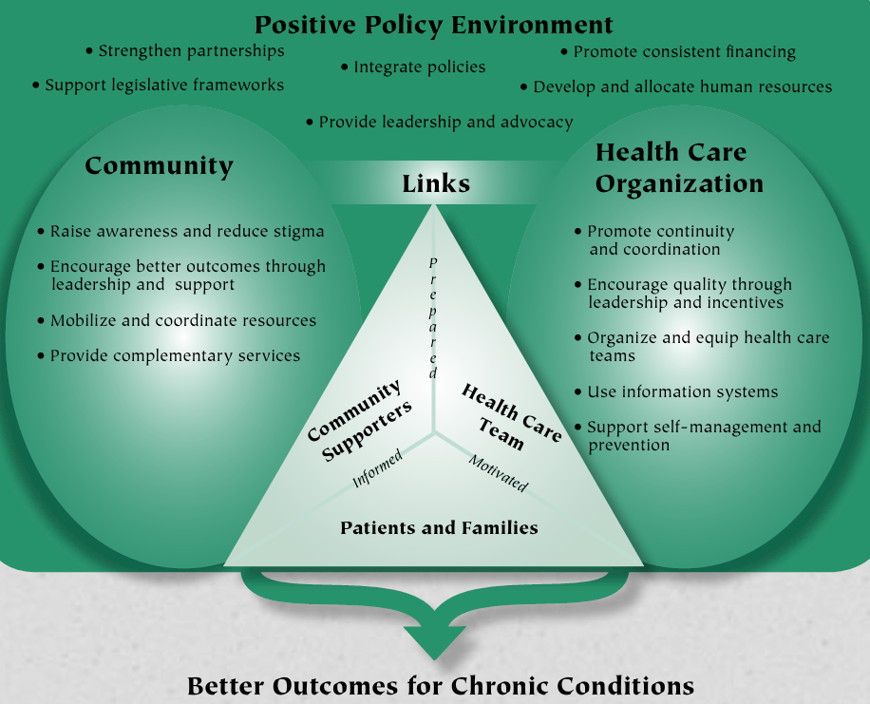
Figure 9: The ICCC Framework by WHO
(Source: WHO, 2025)
The analysis of this international chronic ailment management policy, aimed at achieving better outcomes, indicates that with the help of a legislative framework and integrated policies, it would be possible to generate consistent financing and supply of human resources, which can strengthen partnerships between patients and caregivers. Based on the comparative analysis of both models, it becomes evident that the ICCC model by WHO is ahead in terms of carer inclusion, while for continuity of care, the UK model is superior.

5.0 Local and National Policy Implications

5.1 NICE NG71
The National Institute for Health and Care Excellence (NICE), through its NG71 guideline, limited the use of medicines for the pharmacological management of Parkinson's disease. Only Levodopa, Monoamine Oxidase beta inhibitors, and Dopamine Agonists can be used for Parkinson's patients, ensuring no sudden withdrawal of such medications (NICE, 2017). The guideline also encourages caregivers to offer appropriate advice to patients with daytime sleepiness, restless legs, or depression (NICE, 2017). The guideline has a specific policy promoting neuroprotective therapy among Parkinson's patients, with zero use of vitamin E (NICE, 2017). These indicate the policy's holistic governance of motor and non-motor syndromes in Parkinson's patients.

5.2 NHS Palliative and Community Neurology Services
The NHS community neurology services are widely available in the country. For example, in East London through the NHS Foundation Trust, in Nottingham through Nottingham City Care, and in Hampshire and the Isle of Wight (NHS, 2025c; NHS, 2025d; NHS, 2025e). Such services offer coordinated interventions through multidisciplinary teams, offer lifestyle advice, rehabilitation gyms, and also spread awareness through specialist physicians, nurses, physiotherapists, and rehabilitation technicians (NHS, 2025e). The personalised palliative care extended by the NHS to terminally ill patients, suffering from neurodegenerative disorders, includes focusing on shared decision-making, planning personalised care, exercising legal rights to choose, and offering community-based support as well (NHS, 2025f).

5.3 Advanced Care Planning

5.3.1 Holistic Consultation Model
The insights derived from the study presented by Armstrong et al. (2021) suggest that empowering Parkinson's patients through individualised care, which will integrate expertise from biological, psychological, and social domains into the care practice, can develop their holistic self-management capabilities. The analysis of this information helps to synthesise the fact that by following the holistic consultation approach by involving experts from diverse domains, it is not only possible to achieve a holistic and enhanced health outcome for Parkinson's patients, but it also can help in reducing the biopsychosocial burden on patients, as well as on their families.

5.3.2 ReSPECT Framework
The Recommended Summary Plan for Emergency Care and Treatment (ReSPECT) is a framework implemented in the UK in 2016, which facilitates a meaningful collaboration among a patient, their family, and healthcare professionals (Eli et al., 2024). The framework enables the mutually agreed documentation of future treatment plans on a form to be duly signed by healthcare professionals, and retained by the patient party, as a memo of shared decision-making (Eli et al., 2024). The analysis of this information helps to synthesise that, with a structured and documented approach to tackle future emergencies or complications in Parkinson's patients, immediate measures can be taken without wasting much valuable time.

6.0 Recommendations
- It is recommended that family carers and allied health professionals consider developing training programs to either sharpen or develop relevant skills and knowledge so that better support can be extended to the patients who are suffering from Parkinson's disease. This will ensure better overall health outcomes in the country as well.
- It is also suggested that coordination among the members of multidisciplinary teams needs to be improved as well. For this family, carers and allied health professionals may consider developing their digital skills for seamless interactions. It is essential to note here that multidisciplinary team environments always need to prioritise individualised care for better health outcomes.
- It is advised that family carers and allied health professionals consider embedding advanced care planning into their training programs. This can make them familiar with any sudden emergency situations, as well as make them familiar with what they need to do in such situations. As a result, tackling neurodegenerative disorders, such as Parkinson's disease, can be efficiently done.
- It is recommended that family carers and allied health professionals consider developing respite programs at individual blocks, depending on the burden of patients on healthcare facilities. This can help them freshen up both physically and mentally, which can then enable them to serve Parkinson's patients in a better manner.

7.0 Conclusion
Based on the discussion here, it can be concluded that holistic, person-centred, and family-inclusive care is important to achieve better outcomes for patients with Parkinson's disease. By integrating the biopsychosocial model, as well as the ReSPECT framework, the report ensured that both patients and their families need to be meaningfully involved in clinical decision-making processes. The report also highlighted the fact that collaboration among multidisciplinary teams (MDT), based on the values of empathy and coordinated care planning, enables personalised interventions to address the physical, emotional, and social needs of a Parkinson's patient. Therefore, it can be inferred that accepting a holistic approach to care not only enhances the quality of life of a patient but also strengthens the continuity of care for Parkinson's patients.

8.0 References
Angelopoulou, E., Paudel, Y. N., Papageorgiou, S. G., and Piperi, C. (2022). Environmental impact on the epigenetic mechanisms underlying Parkinson’s disease pathogenesis: a narrative review. Brain Sciences, 12(2), 175.
Armstrong, M., Tuijt, R., Read, J., Pigott, J., Davies, N., Manthorpe, J., Frost. R. Schrag. A. & Walters, K. (2021). Health care professionals’ perspectives on self-management for people with Parkinson’s: qualitative findings from a UK study. BMC geriatrics, 21(1), 706.
Ben-Shlomo, Y., Darweesh, S., Llibre-Guerra, J., Marras, C., San Luciano, M., and Tanner, C. (2024). The epidemiology of Parkinson's disease. The Lancet, 403(10423), 283-292.
Bloem, B. R., Henderson, E. J., Dorsey, E. R., Okun, M. S., Okubadejo, N., Chan, P., Andrejack. J. Darweesh. S. K. L. & Munneke, M. (2020). Integrated and patient-centred management of Parkinson's disease: a network model for reshaping chronic neurological care. The Lancet Neurology, 19(7), 623-634.
Bloem, B. R., Okun, M. S., and Klein, C. (2021). Parkinson's disease. The Lancet, 397(10291), 2284-2303.
Chaudhuri, K. R., Hand, A., Obam, F., and Belsey, J. (2022). Cost-effectiveness analysis of the Parkinson’s KinetiGraph and clinical assessment in the management of Parkinson's disease. Journal of medical economics, 25(1), 774-782.
Cherian, A., and Divya, K. P. (2020). Genetics of Parkinson's disease. Acta Neurologica Belgica, 1-9.
Clark. D. (2025). Forecasted population of United Kingdom in 2015, 2025 and 2035, by age group [Online]. Available at: https://www.statista.com/statistics/967406/age-distribution-of-united-kingdom/ [Accessed on: 31.10.2025]
Coulter, A., Entwistle, V. A., Eccles, A., Ryan, S., Shepperd, S., and Perera, R. (2015). Personalised care planning for adults with chronic or long‐term health conditions. Cochrane Database of Systematic Reviews, (3).
Eaton, S., Roberts, S., and Turner, B. (2015). Delivering person centred care in long term conditions. Bmj, 350.
Eli, K., Harlock, J., Huxley, C. J., Bernstein, C., Mann, C., Spencer, R., Griffiths. F. & Slowther, A. M. (2024). Patient and relative experiences of the ReSPECT process in the community: an interview-based study. BMC Primary Care, 25(1), 115.
Fekonja, Z., Irgolič, N., and Vrbnjak, D. (2024). Family members’ experiences of everyday caregiving for a family member living with Parkinson’s disease: a qualitative thematic analysis study. BMC nursing, 23(1), 98.
Gatchel, R. J., Ray, C. T., Kishino, N., and Brindle, A. (2020). The biopsychosocial model. The Wiley encyclopedia of health psychology, 1-8.
Jankovic, J., and Tan, E. K. (2020). Parkinson’s disease: etiopathogenesis and treatment. Journal of Neurology, Neurosurgery & Psychiatry, 91(8), 795-808.
Khedr, E. M., Abdelrahman, A. A., Elserogy, Y., Zaki, A. F., and Gamea, A. (2020). Depression and anxiety among patients with Parkinson’s disease: frequency, risk factors, and impact on quality of life. The Egyptian Journal of Neurology, Psychiatry and Neurosurgery, 56(1), 116.
Kulcsarova, K., Skorvanek, M., Postuma, R. B., and Berg, D. (2024). Defining Parkinson’s disease: past and future. Journal of Parkinson’s Disease, 14(s2), S257-S271.
Lazarus, R. S., and Folkman, S. (1984). Stress, appraisal, and coping. Springer publishing company.
Lennaerts-Kats, H., Elbers, A., Muente, C., van Stigt, R., Bloem, B. R., Vissers, K. C., Groot. M. M. & Meinders, M. J. (2025). A glimpse of the end-of-life of people with Parkinson's disease and atypical parkinsonism: A descriptive analysis of electronic health records. Journal of Parkinson’s Disease, 1877718X251372875.
Mammen, J. R., Tyo, M., Cadorette, J., Adams, J. L., Xiao, Y., Stephenson, D., and Bale, C. (2024). Understanding what aspects of Parkinson’s disease matter most to patients and families. Scientific Reports, 14(1), 21171.
Morris, H. R., Spillantini, M. G., Sue, C. M., and Williams-Gray, C. H. (2024). The pathogenesis of Parkinson's disease. The Lancet, 403(10423), 293-304.
Neupsy Key (2021). Etiology and Pathogenesis of Parkinson Disease. [online] Neupsy Key. Available at: https://neupsykey.com/etiology-and-pathogenesis-of-parkinson-disease/#_Ref10718092 [Accessed 31 Oct. 2025].
NHS (2021). What Matters To You. [online] betterhospitalshumber.nhs.uk. Available at: https://betterhospitalshumber.nhs.uk/wp-content/uploads/2023/09/What-Matters-to-You-Feedback-Report-Full.pdf [Accessed 10 Nov. 2025].
NHS England (2018). NHS England» NHS Continuing Healthcare. [online] England.nhs.uk. Available at: https://www.england.nhs.uk/healthcare/ [Accessed 10 Nov. 2025].
NHS England (2022). Comprehensive model of personalised care. [online] NHS England. Available at: https://www.england.nhs.uk/personalisedcare/comprehensive-model-of-personalised-care/ [Accessed 10 Nov. 2025].
NHS England (2024). Social Prescribing. [online] NHS England. Available at: https://www.england.nhs.uk/personalisedcare/social-prescribing/ [Accessed 10 Nov. 2025].
NHS. (2022a). Medications for Parkinson’s Disease [Online]. Available at: https://www.happyhealthylives.uk/clientfiles/files/Parkinson%27s%20Disease%20-%20Why%20take%20medications%20on%20time%20-%20Care%20Homes%20-%20July%202022.pdf [Accessed on: 31.10.2025]
NHS. (2022b). Parkinson’s patients benefit from revolutionary watch on the NHS to manage care at home [Online]. Available at: https://www.england.nhs.uk/2022/04/parkinsons-patients-benefit-from-revolutionary-watch-on-the-nhs-to-manage-care-at-home/#:~:text=Patients%20with%20Parkinson%27s%20disease%20are,stop%20the%20condition%20getting%20worse. [Accessed on: 31.10.2025]
NHS. (2025a). Community specialist palliative care services [Online]. Available at: https://www.cornwallft.nhs.uk/community-specialist-palliative-care-services/ [Accessed on: 31.10.2025]
NHS. (2025c). Community Neurological Service (Newham) | East London NHS Foundation Trust [Online]. Available at: https://www.google.com/url?sa=t&source=web&rct=j&opi=89978449&url=https://www.elft.nhs.uk/services/community-neurological-service-newham&ved=2ahUKEwjM5Y-V486QAxXmxjgGHcSRHu8QzsoNegQIDRAP&usg=AOvVaw2L-IuonxjuVeZ5tyK7-Ent [Accessed on: 31.10.2025]
NHS. (2025d). Community Neurology Service :: Nottingham City Care [Online]. Available at: https://www.google.com/url?sa=t&source=web&rct=j&opi=89978449&url=https://www.nottinghamcitycare.nhs.uk/our-services/community-neurology-service&ved=2ahUKEwjM5Y-V486QAxXmxjgGHcSRHu8QzsoNegQIDRAT&usg=AOvVaw2zX3_bSdG3ZpdQ3_VwImdS [Accessed on: 31.10.2025]
NHS. (2025e). Community Neurological Services and Rehabilitation [Online]. Available at: https://hiowhealthcare.nhs.uk/our-services/a-z-list-of-services/community-neurological-services-and-rehabilitation [Accessed on: 31.10.2025]
NHS. (2025f). Personalised palliative and end of life care [Online]. Available at: https://www.england.nhs.uk/eolc/personalised-care/ [Accessed on: 31.10.2025]
NICE. (2017). Parkinson’s disease in adults [Online]. Available at: https://www.nice.org.uk/guidance/ng71/chapter/Recommendations#pharmacological-neuroprotective-therapy [Accessed on: 31.10.2025]
Nutt, J. G., and Wooten, G. F. (2005). Diagnosis and initial management of Parkinson's disease. New England Journal of Medicine, 353(10), 1021-1027.
Orozco, J. L., Valderrama-Chaparro, J. A., Pinilla-Monsalve, G. D., Molina-Echeverry, M. I., Castaño, A. M. P., Ariza-Araújo, Y., Prada. S. I. & Takeuchi, Y. (2020). Parkinson’s disease prevalence, age distribution and staging in Colombia. Neurology international, 12(1), 8401.
Parkinson’s UK. (2025). Home care and care homes [Online]. Available at: https://www.parkinsons.org.uk/information-and-support/home-care-and-care-homes [Accessed on: 31.10.2025]
Parkinson's (2025). The Excellence Network regional networks in England. [online] Parkinson’s UK. Available at: https://www.parkinsons.org.uk/professionals/excellence-network-regional-networks-england [Accessed 10 Nov. 2025].
Parkinson's Foundation (2025). Four Ways Parkinson’s Impact Mental Health. [online] Facebook.com. Available at: https://www.facebook.com/photo/?fbid=1127489896084124&set=a.421995073300280 [Accessed 31 Oct. 2025].
Parkinson's UK (2025). Parkinson’s Statistics. [online] Parkinson’s UK. Available at: https://www.parkinsons.org.uk/about-us/parkinsons-statistics [Accessed 1 Nov. 2025].
Parkinson's UK (2025). Respite care. [online] Parkinson’s UK. Available at: https://www.parkinsons.org.uk/information-and-support/respite-care [Accessed 10 Nov. 2025].
Pirtošek, Z. (2024). Breaking barriers in Parkinson’s care: the multidisciplinary team approach. Journal of Neural Transmission, 131(11), 1349-1361.
Rajan, R., Brennan, L., Bloem, B. R., Dahodwala, N., Gardner, J., Goldman, J. G., Grimes. D. A. Iansek. R. Kovács. N. McGinley. J. Parashos. S. A.Piemonte. M. E. P. & Eggers, C. (2020). Integrated care in Parkinson's disease: a systematic review and meta‐analysis. Movement Disorders, 35(9), 1509-1531.
Schramme, T. (2023). Health as complete well-being: The WHO definition and beyond. Public Health Ethics, 16(3), 210-218.
The Brain Docs (2023). Parkinson’s disease: symptoms, causes, treatments, and the future. [online] The Brain Docs | Brain Health Resources & Courses. Available at: https://thebraindocs.com/parkinsons-disease-explained/ [Accessed 1 Nov. 2025].
van Halteren, A. D., Munneke, M., Smit, E., Thomas, S., Bloem, B. R., and Darweesh, S. K. (2020). Personalized care management for persons with Parkinson’s disease. Journal of Parkinson’s Disease, 10(s1), S11-S20.
Walters, K., Armstrong, M., Gardner, B., Ambler, G., Hunter, R., Maydon, B., Davies, N., Atkinson, C., Brown, R., Tasmin Rookes, Davis, D. and Schrag, A. (2023). Clinical and cost-effectiveness of ‘Live Well with Parkinson’s’ self-management intervention versus treatment as usual for improving quality of life for people with Parkinson’s: study protocol for a randomised controlled trial. Trials, 24(1). doi:https://doi.org/10.1186/s13063-023-07700-7.
WHO. (2025). Innovative Care for Chronic Conditions [Online]. Available at: https://iris.who.int/server/api/core/bitstreams/e3ce2c65-c0d8-496c-ae93-4709403fe79a/content [Accessed on: 31.10.2025]
Zhang, W., Xiao, D., Mao, Q., and Xia, H. (2023). Role of neuroinflammation in neurodegeneration development. Signal transduction and targeted therapy, 8(1), 267.

