Research report

Name: Evdokiya Stefanova
Student number: 2018698
Module code and title: BMSW4001 Digital Skills and Research Methods
Lecturer’s name: Sayeed Nasirpourosgoei

Abstract
This report tests the hypothesis that Microsoft Teams (MS) is the most used digital tool for collaboration with fellow students, explains the methodology which was questionnaire-based used behind the testing of the hypothesis, as well as discussing the results and ethics of the method.
Sample size equals 6 participants (n=6). The main findings have been that the MS hypothesis proves true, that most students use several digital tools at once, and that digital tools provide several advantages when it comes to education.
E-learning via the use of several digital tools seems to be the next step to education, as it has been proven to yield better results than traditional learning. Institutions should look to adopt this technology as early as possible and use as many tools at their disposal as they can.

Contents
Abstract 2
Introduction 4
Research design 5
Chosen question 5
Methods used 5
Questions asked 5
Ethical considerations 6
Results 7
Discussion 9
Conclusion 10
References 11

Introduction
In this report I will be going over my chosen research question, as well as going over and explaining in depth the methods I used to gather data, from collecting a good enough and relevant sample size, to the type of questions and implications of these. I will be going over any ethical considerations made as well.
Then I will portray my results and explain the meaning and assumptions I am making from them, followed by a discussion of how they fit with literature of the topic and comparing them to my hypothesis.
My hypothesis is that Microsoft teams is the most widely used digital tool in UWTSD when it comes to collaboration. I will then summarise it all in a conclusion.
Digital tools are affecting education in several positive ways, Purcell, Buchanan and Friedrich (2013) say that they are ‘offering more opportunities for collaboration, interaction and feedback.’
Amhag, Hellström and Stigmar (2019) also note the importance of digital tools by saying that there is a ‘subsequent need for digital competence in higher education.’ They make learning much easier, accessible to everyone from anywhere, and enable collaboration and contact between peers and teachers almost instant, which greatly speeds up the process of learning as knowledge gaps can be filled very fast.

Research design

Chosen question
My chosen research question is, ‘Which digital tool is most commonly used for collaboration at UWTSD?’. I chose this question because I believe that while digital tools are all useful in a way, there is a clear winner when it comes to overall efficiency and general use, I think this to be Microsoft Teams but also think that there is good competitors, so I have set out to find out what my fellow peers and students most commonly use in their student tasks.

Methods used
So for this question, my method of research was questionnaires. I thought this to be the best method because it is not time consuming to collect a large sample of participants, like it would be for another method like interviewing.
Jones, Murphy, Edwards and James (2008) explore the advantages of this method and conclude that ‘this approach to data collection appears to have potential’.
And it is a method using primary data, which I know to be reliable as I have collected it myself, it also ensures that the sample is a relevant population, my fellow students and peers which interact with digital tools for collaboration in UWTSD directly.
I chose the participants to my questionnaire by looking for my class members e-mails, and then e-mailing them each an invitation to take part in the questionnaire.

Questions asked
The questions I asked had several types of answering to them, for example some questions had the participant rank a different array of software used to collaborate with others, from most to least frequently used. This gives me a deeper insight to the answers rather than just picking ‘one’ most frequently used.
The first question of this type had them rank MS Teams, One drive, MS Word, Whatsapp and moodle from most to least frequently used.
Other questions had the participants read a statement, and circle a response ranking how much they disagreed or agreed with the statement, with a range of 4 levels; strongly agree, agree, disagree, strongly disagree. This would give me a score depending on their answer, that I can later use to compare the veracity of statements and how people feel towards certain affirmations.
The sentences I used in this type of question were:
- I use the OneDrive more than I use MS Teams to collaborate with others
- I use WhatsApp more than I use MS Teams to collaborate with others
- I do not use any digital tools to collaborate with peers
- I use a range of different digital tools to collaborate
- There is no digital tool that I use more frequently than others
- I use both MS Teams and the OneDrive equally often when working with others
- I use MS Teams most frequently to collaborate with others
Then I continued with some yes/no type of questions, these questions are mostly very specific to leave little room for interpretation and to make sure a yes/no answer is enough to answer satisfactorily.
These questions were; ‘Do you use one drive more than other digital tools to collaborate with peers or colleagues?’ and, ‘Do you use MS Teams more than other digital tools to work with your peers or colleagues?’.

Ethical considerations
Ethics are ideas about what is right and wrong, Fox, Murray and Warm (2003) say that we should have ‘ethical considerations involved when conducting empirical research with web-based questionnaires’. This is because we might easily ask insensitive or invasive questions that lead to skewed data or an empty questionnaire.
Boynton (2004) shows us that ‘Questionnaires tend to fail because participants don't understand them, can't complete them, get bored or offended by them’.
For these reasons I prefaced the questionnaire with a question asking for the consent of the participant, the statement reads ‘I consent to take part in this questionnaire voluntarily’, and the answers are ‘Yes’ and ‘No’, any questionnaires with a ‘No’ answer would have been discarded and disregarded.

Results
For my first question which was asking for consent in taking part of the survey, every participant was eager and consented to it.
For my second question, here is the chart showing what people said they used more frequently:
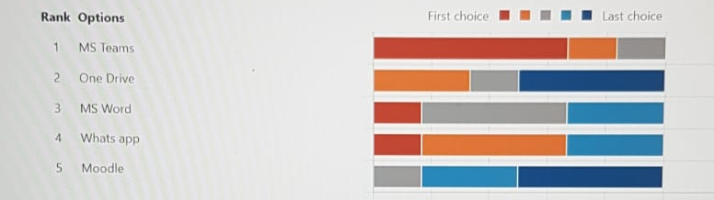
As we can see, like I predicted, MS teams is the most used to collaborate with peers, however Whatsapp also had a lot of support which was unexpected, and came in as a strong second.
For my third question where people had to circle an answer in a range, in terms of how much they agreed with a statement, I got these answers:
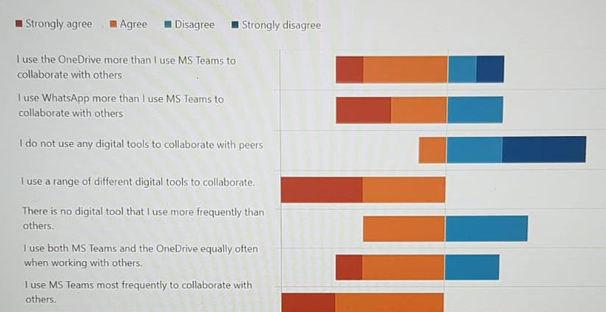
Overall this also confirms that MS teams is most used over other apps, and also shows that mostly everyone is using digital tools to collaborate with peers, with a very small amount of people not using them at all. However it also shows me that people in general use a broad range of different tools to collaborate, instead of limiting themselves to one, even if that one is the most used.
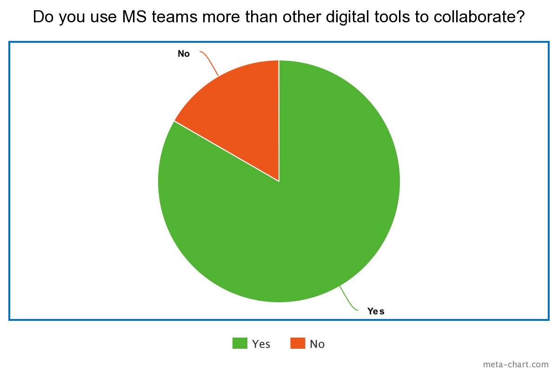
This pie chart also shows that a majority of the responses say ‘Yes’ to using MS teams more than other digital tools, which is consistent with my other data and help me confirm my hypothesis confidently.

Discussion
The results seem to show that my hypothesis was partly correct but not as much as I had believed. While Microsoft teams is the most widely used tool amongst students and teachers at UWTSD, it does not have the dominance I thought it would, though it is still the winner.
This does however add credibility to my claims in the introduction, that digital tools are a key and vital part of modern education, and that they open the door to a lot of opportunities which were not possible before. There is supporting primary data for this as we can see from my data that most people are using a broad range of digital tools to collaborate, showing how frequent and ingrained they are when it comes to educational work.
“Digital education is generating new learning opportunities as students engage in online, digital environments’’ says Kaur (2019). And that is because almost every part of our life can benefit of digitisation nowadays, the education sector was specially affected through the COVID pandemic as institutions all over the world had to adapt and provide continued support and teaching while not being able to hold presential classes.
It is here that we quickly adapted to Microsoft teams meetings and other technologies. These methods of learning have been replacing the more traditional presential classes and have proven to have many advantages, mainly the ability to access class from anywhere in the world, at any moment, provided you have an internet connection and a modern device.
It has also allowed us to have learning flexibility, as the time of delivery of knowledge can be picked more freely, for example in UWTSD all the classes are recorded, and available with easy access to every student that wishes to watch them. This can help fill the gaps of a class by going over it again, or even making up for missing a class in case something prevented us from attending. Elfaki, Abdulraheem and Abdulrahim (2019) say that ‘students who participate in online/ E-learning achieve better grades than those who studied traditional approach’. Which just shows the tangible advantages of e-learning and how we should embrace digital tools for teaching.
Digital tools also provide 24-h resources, people are most productive at different times of the day, and digital tools allow us to study at our own pace unlike in the traditional learning method. UWTSD for example provides us with a whole library of published literature, and several pdf and word files with the exercises we have done in class, and information we have both covered and yet to cover. This can allow us for example to prepare for a class before the fact, by reading up online on the content that we will be covering during said class.
They also help with peer-to-peer connection, as being available 24/7 and just one e-mail away, encourages a lot of people to be more open and talkative to their peers, which can help them motivate each other and work better in groups. This idea is reinforced by Ito et al. (2018) that say ‘many young people are taking to digital tools to engage in shared projects and causes’. Most students can use apps like WhatsApp or Teams, to keep in contact and work in group projects together or ask questions to each other.

Conclusion
Digital tools are revolutionising learning by opening many opportunities for online education, which has many advantages as opposed to traditional education. Mainly how accessible it is for anyone from anywhere, there’s also evidence showing that e-learners tend to score higher than their traditional class peers.
Digital tools are also great for connecting with like minded people, including peers in education. Which can help forming bonds and helping motivate students while fomenting a good group work ethic.
My results confirm my hypothesis that the most commonly used digital tool for collaborating is Microsoft Teams, which is no surprise as the app offers many functionalities to connect and share information with others, in an easy and intuitive way. However my results also showed an interesting piece of information which is the use of several digital tools across learning, instead of limiting to one.

References
Amhag, L., Hellström, L. and Stigmar, M., 2019. Teacher educators' use of digital tools and needs for digital competence in higher education. Journal of Digital Learning in Teacher Education, 35(4), pp.203-220. Accessed on: 5th April 2022

Boynton, P.M., 2004. Administering, analysing, and reporting your questionnaire. Bmj, 328(7452), pp.1372-1375. Accessed on: 5th April 2022

Elfaki, N.K., Abdulraheem, I. and Abdulrahim, R., 2019. Impact of e-learning vs traditional learning on student’s performance and attitude. International Journal of Medical Research & Health Sciences, 8(10), pp.76-82. Accessed on: 5th April 2022

Fox, J., Murray, C. and Warm, A., 2003. Conducting research using web-based questionnaires: Practical, methodological, and ethical considerations. International journal of social research methodology, 6(2), pp.167-180. Accessed on: 5th April 2022

Ito, M., Martin, C., Pfister, R.C., Rafalow, M.H., Salen, K. and Wortman, A., 2018. Affinity online: How connection and shared interest fuel learning (Vol. 2). NYU Press. Accessed on: 5th April 2022

Jones, S., Murphy, F., Edwards, M. and James, J., 2008. Doing things differently: advantages and disadvantages of web questionnaires. Nurse researcher, 15(4). Accessed on: 5th April 2022

Kaur, H., 2019. Digitalization of education: Advantages and disadvantages. International Journal of Applied Research, pp.286-288. Accessed on: 5th April 2022

Purcell, K., Buchanan, J. and Friedrich, L., 2013. The impact of digital tools on student writing and how writing is taught in schools. Washington, DC: Pew Research Center, 16. Accessed on: 5th April 2022

Appendix

