2


Assistant General Manager Report
Augusta- Roxana Toth (2226559)
BMIH5003 Foreign Languages and Cultural Awareness
LEVEL 5
Module Lead Lisa Bassler

Executive Summary
As a manager learning about the hotel chain's operations and brand standards in France, it is crucial to understand the unique dynamics of the French hospitality market. France is renowned for its rich cultural heritage, gastronomy, and diverse tourism offerings, making it an attractive destination for travelers worldwide (Gill, 2023). However, succeeding in this competitive landscape requires a deep understanding of local preferences, regulations, and market trends.

Contents
Executive Summary 1
1. Introduction 2
2. Main Body 2
2.1. The Global Project’s scores. 3
2.1.2.Power Distance: 5
2.1.3.Uncertainty Avoidance: 6
2.1.4.Future Orientation: 6
2.2The key Differences between England and France's hotel industry 6
2.2.1.Hospitality Market Overview 6
2.2.2.Hotel Types and Accommodations 7
2.2.3.Service Standards and Hospitality Culture 7
2.2.4.Culinary Offerings and Dining Experiences 7
2.2.5 Marketing and Branding Strategies 7
2.3.The challenges of intercultural leadership in the hospitality industry 7
Communication Barriers: 7
2.3.1.Cultural Differences: 7
2.3.2.Customer Service: 8
2.3.4.Leadership Challenges: 8
2.3.5.Training and Development: 8
2.4.Recommendation 8
4. Conclusion 9
5. Recommendations 9
6. References 10

1. Introduction

The hospitality industry, particularly the hotel sector, thrives on effective leadership to navigate through its myriad challenges and ensure exceptional guest experiences. This report seeks to provide a comparative analysis of hotels in England and France, shedding light on the key similarities and differences in their leadership styles, approaches to management, and broader cultural contexts.
The English hospitality industry places a strong emphasis on professionalism, quality service delivery, and adherence to standardized procedures. On the other hand, in France, hotel management is deeply influenced by the country's rich cultural heritage, culinary traditions, and emphasis on elegance and sophistication. French hotel managers are known for their diligence, emphasis on personalized service, and commitment to preserving the art of hospitality (Ibanez, 2021).
Through an in-depth analysis of managerial practices in the hospitality industry of England and France, this report aims to provide valuable insights for hoteliers, and industry stakeholders seeking to navigate the complexities of intercultural leadership in a globalized marketplace.

In the subsequent sections of this report, we will delve into specific aspects of outlining the key differences between England and France, the GLOBE Project’s culture and leadership study, and the challenges of intercultural leadership in the hospitality industry.

2. Main Body
The hotel industry in both England and France is characterized by its diversity, with establishments ranging from boutique hotels to luxury resorts, catering to a wide array of domestic and international clientele. Despite sharing certain commonalities as European nations, England and France possess distinct cultural identities that permeate their respective hospitality sectors (Albert, 2022).
Both English and French hotels face familiar challenges such as labour shortages, fluctuating market demands, and the need to adapt to emerging technologies. However, their approaches to addressing these challenges may vary based on cultural preferences, societal norms, and industry trends prevalent in their respective countries.

The GLOBE Project's culture and leadership study provides valuable insights into the cultural dimensions and leadership styles prevalent in different countries. This report aims to compare and contrast the cultural dimensions and leadership styles in the hospitality industry of England and France, drawing upon the findings of the GLOBE Project.

2.1. The Global Project’s scores.
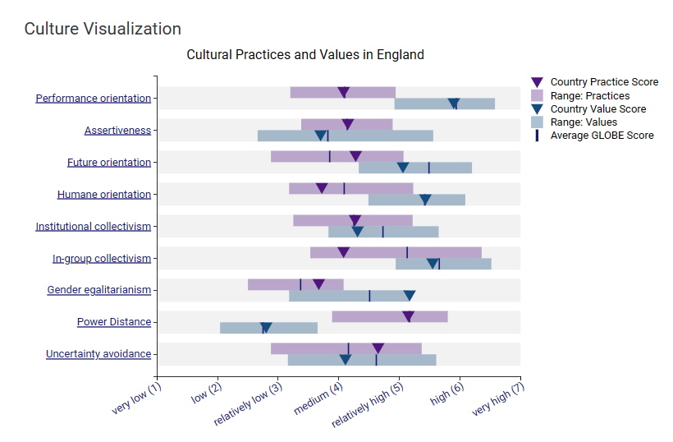
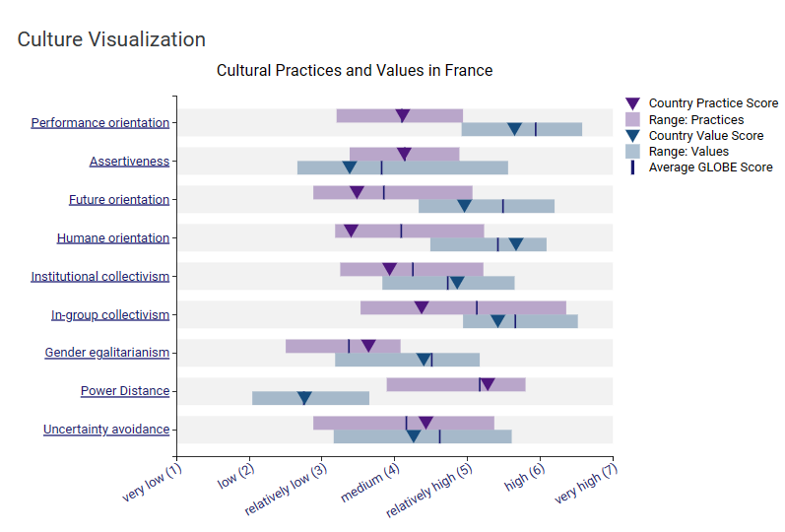
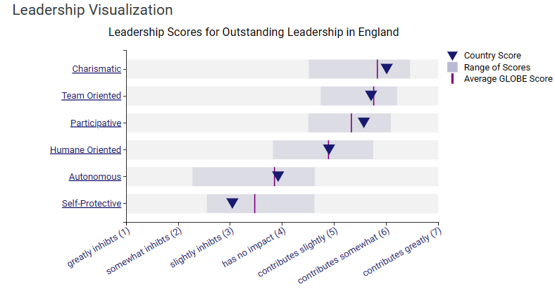

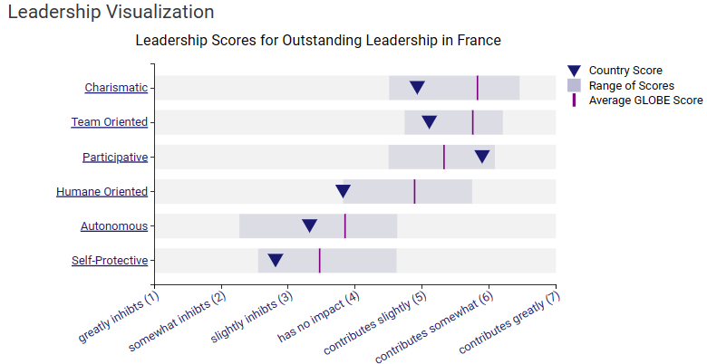

(Globe 2020).

2.1.2.Power Distance:
- England: The GLOBE Project suggests that England tends to have a lower power distance, indicating a preference for egalitarianism and decentralized decision-making. In the hospitality industry, English managers may adopt a participative leadership style, empowering employees to contribute ideas and take ownership of their roles (Gunnel, 2016).
- France: In contrast, France exhibits a higher power distance, with a greater acceptance of hierarchical structures and respect for authority. French hotel managers may adopt a more authoritative leadership style, providing clear direction and guidance to their teams.

2.1.3.Uncertainty Avoidance:
- England: England demonstrates a moderate level of uncertainty avoidance, balancing risk-taking behaviours with a desire for stability and predictability. English hotel managers may encourage innovation and flexibility while also ensuring adherence to established standards and procedures.
- France: The GLOBE Project indicates that France has a higher uncertainty avoidance compared to England. French hotel managers may prioritize structured environments, rigorous planning, and adherence to rules and regulations to mitigate uncertainty and risk.

2.1.4.Future Orientation:
- England: Both England and France exhibit a future-oriented outlook, emphasizing planning and goal setting. In the hospitality industry, hotel managers in both countries may prioritize strategic initiatives, investment in technology, and long-term sustainability.
- France: French hotel managers may also place a strong emphasis on preserving cultural heritage and traditions while adapting to evolving market trends and consumer preferences (Khan, 2019).

2.2The key Differences between England and France's hotel industry

2.2.1.Hospitality Market Overview
- England: Diverse hospitality market with a range of accommodations, from budget hotels to luxury resorts.
- France: Well-established hospitality industry with a strong focus on luxury accommodations and boutique hotels.

2.2.2.Hotel Types and Accommodations
- England: Mix of branded hotel chains, independent hotels, and boutique accommodations.
- France: Emphasis on boutique hotels, luxury properties, and historical landmarks converted into hotels.

2.2.3.Service Standards and Hospitality Culture
- England: Focus on efficiency, professionalism, and personalized service; emphasis on guest satisfaction and loyalty.
- France: Emphasis on hospitality as an art form; diligence, personalized service, and gastronomic experiences are paramount (O’Brian, 2023).

2.2.4.Culinary Offerings and Dining Experiences
- England: Diverse culinary scene featuring international cuisines and traditional British fare; emphasis on quality ingredients and innovation.
- France: Renowned for its culinary excellence and gastronomic traditions; emphasis on local produce, seasonal ingredients, and fine dining experiences.

2.2.5 Marketing and Branding Strategies
- England: Hotels focus on brand reputation, loyalty programs, and online presence to attract guests; emphasis on value and convenience.
- France: Emphasis on heritage, luxury, and exclusivity; hotels leverage their historical significance, location, and cultural appeal in marketing campaigns.

2.3.The challenges of intercultural leadership in the hospitality industry

Communication Barriers:

In a multicultural team, language barriers can hinder effective communication. Misinterpretations or misunderstandings may occur when instructions or guest requests are not communicated clearly due to language differences (Kuang, 2023).

2.3.1.Cultural Differences:
Cultural differences in work ethic may lead to conflicts within the team. Employees from cultures that prioritize punctuality and efficiency may clash with those who have a more relaxed approach to time management.

2.3.2.Customer Service:
Lack of cultural sensitivity among team members can result in poor customer service experiences. A guest's cultural preferences or customs may not be respected, leading to dissatisfaction and negative reviews.

2.3.4.Leadership Challenges:
Intercultural leaders may struggle to adapt their leadership style to accommodate diverse cultural preferences. A directive leadership style that is effective in one culture may be perceived as authoritarian or disrespectful in another.

2.3.5.Training and Development:

Lack of cultural competency training for employees can exacerbate intercultural challenges. Providing training on cultural awareness, communication strategies, and conflict resolution can help mitigate misunderstandings and promote a more inclusive work environment.

2.4.Recommendation
Hotel industry management teams can create a more inclusive, culturally competent, harmonious work environment, and enhance guest satisfaction and loyalty by ensuring that all guests feel welcomed and valued regardless of their cultural background (Guedj, 2023).
- Implement comprehensive cultural sensitivity training programs for all employees, including frontline staff, supervisors, and managers. These programs should cover topics such as cultural differences in communication styles, work ethics, and customer service expectations.
- Offer language classes or resources to improve communication skills, especially for employees working in multicultural teams or interacting with guests from diverse backgrounds.
- Encourage team members to share their cultural traditions, customs, and experiences in a supportive and inclusive environment.
- Emphasize the importance of active listening, empathy, and cultural intelligence in effective leadership, encouraging leaders to seek feedback and continuously improve their intercultural management skills (Kuang, 2023).

4. Conclusion
In conclusion, the differences between England and France's hotel industry, culture, and hotel chain operations are notable, each contributing to unique experiences for guests and distinct challenges for hotel management.
England emphasizes politeness, efficiency, and professionalism in hospitality service. Tends to have a more diverse hospitality market with a mix of branded chains and independent hotels. France prioritizes elegance, sophistication, and personalized service in hospitality (LF., 2022).
Hotels in England often focus on brand reputation, loyalty programs, and value-driven offerings to attract guests. French hotel often leverages heritage, luxury, and exclusivity in their branding and marketing strategies.
In conclusion, while both England and France offer exceptional hospitality experiences, they do so in distinct ways shaped by their cultural values, market dynamics, and brand standards (Goldstein, 2023). Understanding and navigating these differences are crucial for hotel management teams to effectively meet the needs and expectations of guests, maintain brand integrity, and drive success in the competitive hospitality industry.

5. Recommendations
- Standardise operational procedures across all properties to ensure consistency in service delivery.
- Invest in technology solutions such as property management systems and guest experience platforms to streamline operations (Smith, 2023).
- Implement training programs for staff.
- Conduct regular performance evaluations and audits to monitor compliance with operational standards and identify areas for improvement.
- Teamwork and collaboration among staff to promote a positive work environment and improve guest satisfaction.
- Regularly assess guest feedback and reviews to identify areas where brand standards may be falling short and take corrective action as needed.
- Invest in branding initiatives such as marketing campaigns, loyalty programs, and partnerships to strengthen brand awareness and loyalty (Rempillo, 2023).

6. References
- Albert E. (2022) 'Playing spot, the difference between the French and British economies reveals their parallel decline'. Available at: https://www.lemonde.fr/en/opinion/article/2022/12/08/playing-spot-the-difference-between-the-french-and-british-economies-reveals-their-parallel-decline_6006958_23.html/ (Accessed 02 February 2024).
- CN (2021) 6 DIFFERENCES BETWEEN ENGLISH AND FRENCH CULTURE. Available at: https://www.countrynavigator.com/blog/6-differences-between-english-and-french-culture/ (Accessed 02 February 2024).
- Gunnel M. (2016) A Comparison of the GLOBE and Geert Hofstede findings and their Implications for Global Business Leaders. Available at: https://www.linkedin.com/pulse/comparison-findings-globe-geert-hostede-implications-global-gunnell/ (Accessed 03 February 2024).
- Guedj B. (2023) European hospitality sector surges forward, anchored by France. Available at: https://www.swisslife-am.com/en/home/hub/2023/q3/european-hospitality.html/ (Accessed 04 February 2024).
- Gill R. (2023) UK and London lead European hotel development. Available at: https://www.businesstravelnewseurope.com/Accommodation/UK-and-London-lead-European-hotel-development/ (Accessed 04 February 2024). https://www.knightfrank.com/research/article/2023-05-16-positive-first-quarter-for-the-uk-hotel-market/ (Accessed 07 February 2024).
- Globe 2020 A unique large-scale study of cultural practices, leadership ideals, and generalized and interpersonal trust in 150 countries in collaboration with 500 researchers. Available at: https://globeproject.com/results/countries/FRA%3Fmenu=list.html#list/ (Accessed 14 February 2024).
- Goldstein P. (2023) Positive first quarter for the UK hotel market. Available at: https://www.knightfrank.com/research/article/2023-05-16-positive-first-quarter-for-the-uk-hotel-market/ (Accessed 14 February 2024).
- Ibanez F. (2021) Top 5 cultural differences between France and the UK. Available at: https://www.alphatrad.co.uk/news/cultural-differences-france-uk/ (Accessed 31 January 2024).
- Khan Y. H. (2019) Cross-cultural leadership and the hospitality industry: a leadership style towards success in organizational goals in France. Available at: https://medcraveonline.com/AHOAJ/AHOAJ-03-00100.pdf/ (Accessed 03 February 2024).
- Krzman J. (2020) Challenges of Cultural Diversity in Hospitality Organisations. Available at: https://www.linkedin.com/pulse/challenges-cultural-diversity-hospitality-jugoslava-krzman-/ (Accessed 03 February 2024).
- Kuang I. (2023) Unlocking the Secrets of Cross-Cultural Leadership Excellence in the Hospitality Industry. Available at: https://www.linkedin.com/pulse/unlocking-secrets-cross-cultural-leadership-excellence-yee-kuang/ (Accessed 07 February 2024).
- LF. (2022) Know The Similarities & Differences Between English And French. Available at: https://www.linkedin.com/pulse/know-similarities-differences-between-english-french-// (Accessed 31 January 2024).
- Mendez R. G. (2023) Challenges of Cultural Differences in Hospitality Teams. Available at: https://www.linkedin.com/pulse/challenges-cultural-differences-hospitality-teams-gon%C3%A7alves-mendes/ (Accessed 03 February 2024).
- O’Brian C. (2023) France Tourism Grew 12.3% In Q1 2023. Available at: https://www.forbes.com/sites/chrisobrien/2023/05/26/france-tourism-grew-123-in-q1-2023/ (Accessed 07 February 2024).
- Rempillo E. (2023) Hotel Brand Standards .Available at: https://safetyculture.com/topics/hotel-management/hotel-brand-standards/ (Accessed 07 February 2024).
- Smith J. I. (2023) What British hotels can learn from the French. Available at: https://www.telegraph.co.uk/travel/destinations/europe/france/what-british-hotels-can-learn-from-the-french/ (Accessed 04 February 2024).
- Vokrinek B. (2024) OSPITALITY MARKET TRENDS & DATA. Available at: https://www.cushmanwakefield.com/en/united-kingdom/insights/hospitality-market-trends-and-data/ (Accessed 07 February 2024).
- Weniger M. (2020) 1 GLOBE Project - Understanding Culture: Create Better Relationships Using International Business Cultural Tools. Available at: https://www.linkedin.com/pulse/1-globe-project-understanding-culture-create-better-weniger-ph-d-/ (Accessed 02 February 2024).

