

Student Name: Foqia Farooq
Student number: 2424146
Lecturer Name: Tomy Adattu Chacko
Programme Title: BSc Health & Social Care
Module: Changemakers: Creativity & Value Creation
Module Code: BMHP5014
Assignment Title: Online Portfolio of Set Exercises

Contents Page

Task 1 Concept Map: Creativity, Value Creation and Health Social Care Improvement……………….…...…3-4
Task 2 - Self-Reflection of Group Activity..…………………………………………………………………....…..……..5
Task 3 - Case Study of a UK innovation….………………………….…………………………………………..….….6-7
Task 4 - Research Task……………………………………………….….……………………………..……….....….….....8
Task 5 – Podcast……………………………………………………………………………………………….….…....…….9
Task 6 - NHS Leadership Framework Analysis…………………………………………………………..…..…..…10-11
Task 7 - Self-Reflection Journal Entry……………………………………………………………….…..………..…..…12
Reference List……………………………………………………………………………………………..….……….….13-14

Task 1 – Concept Map
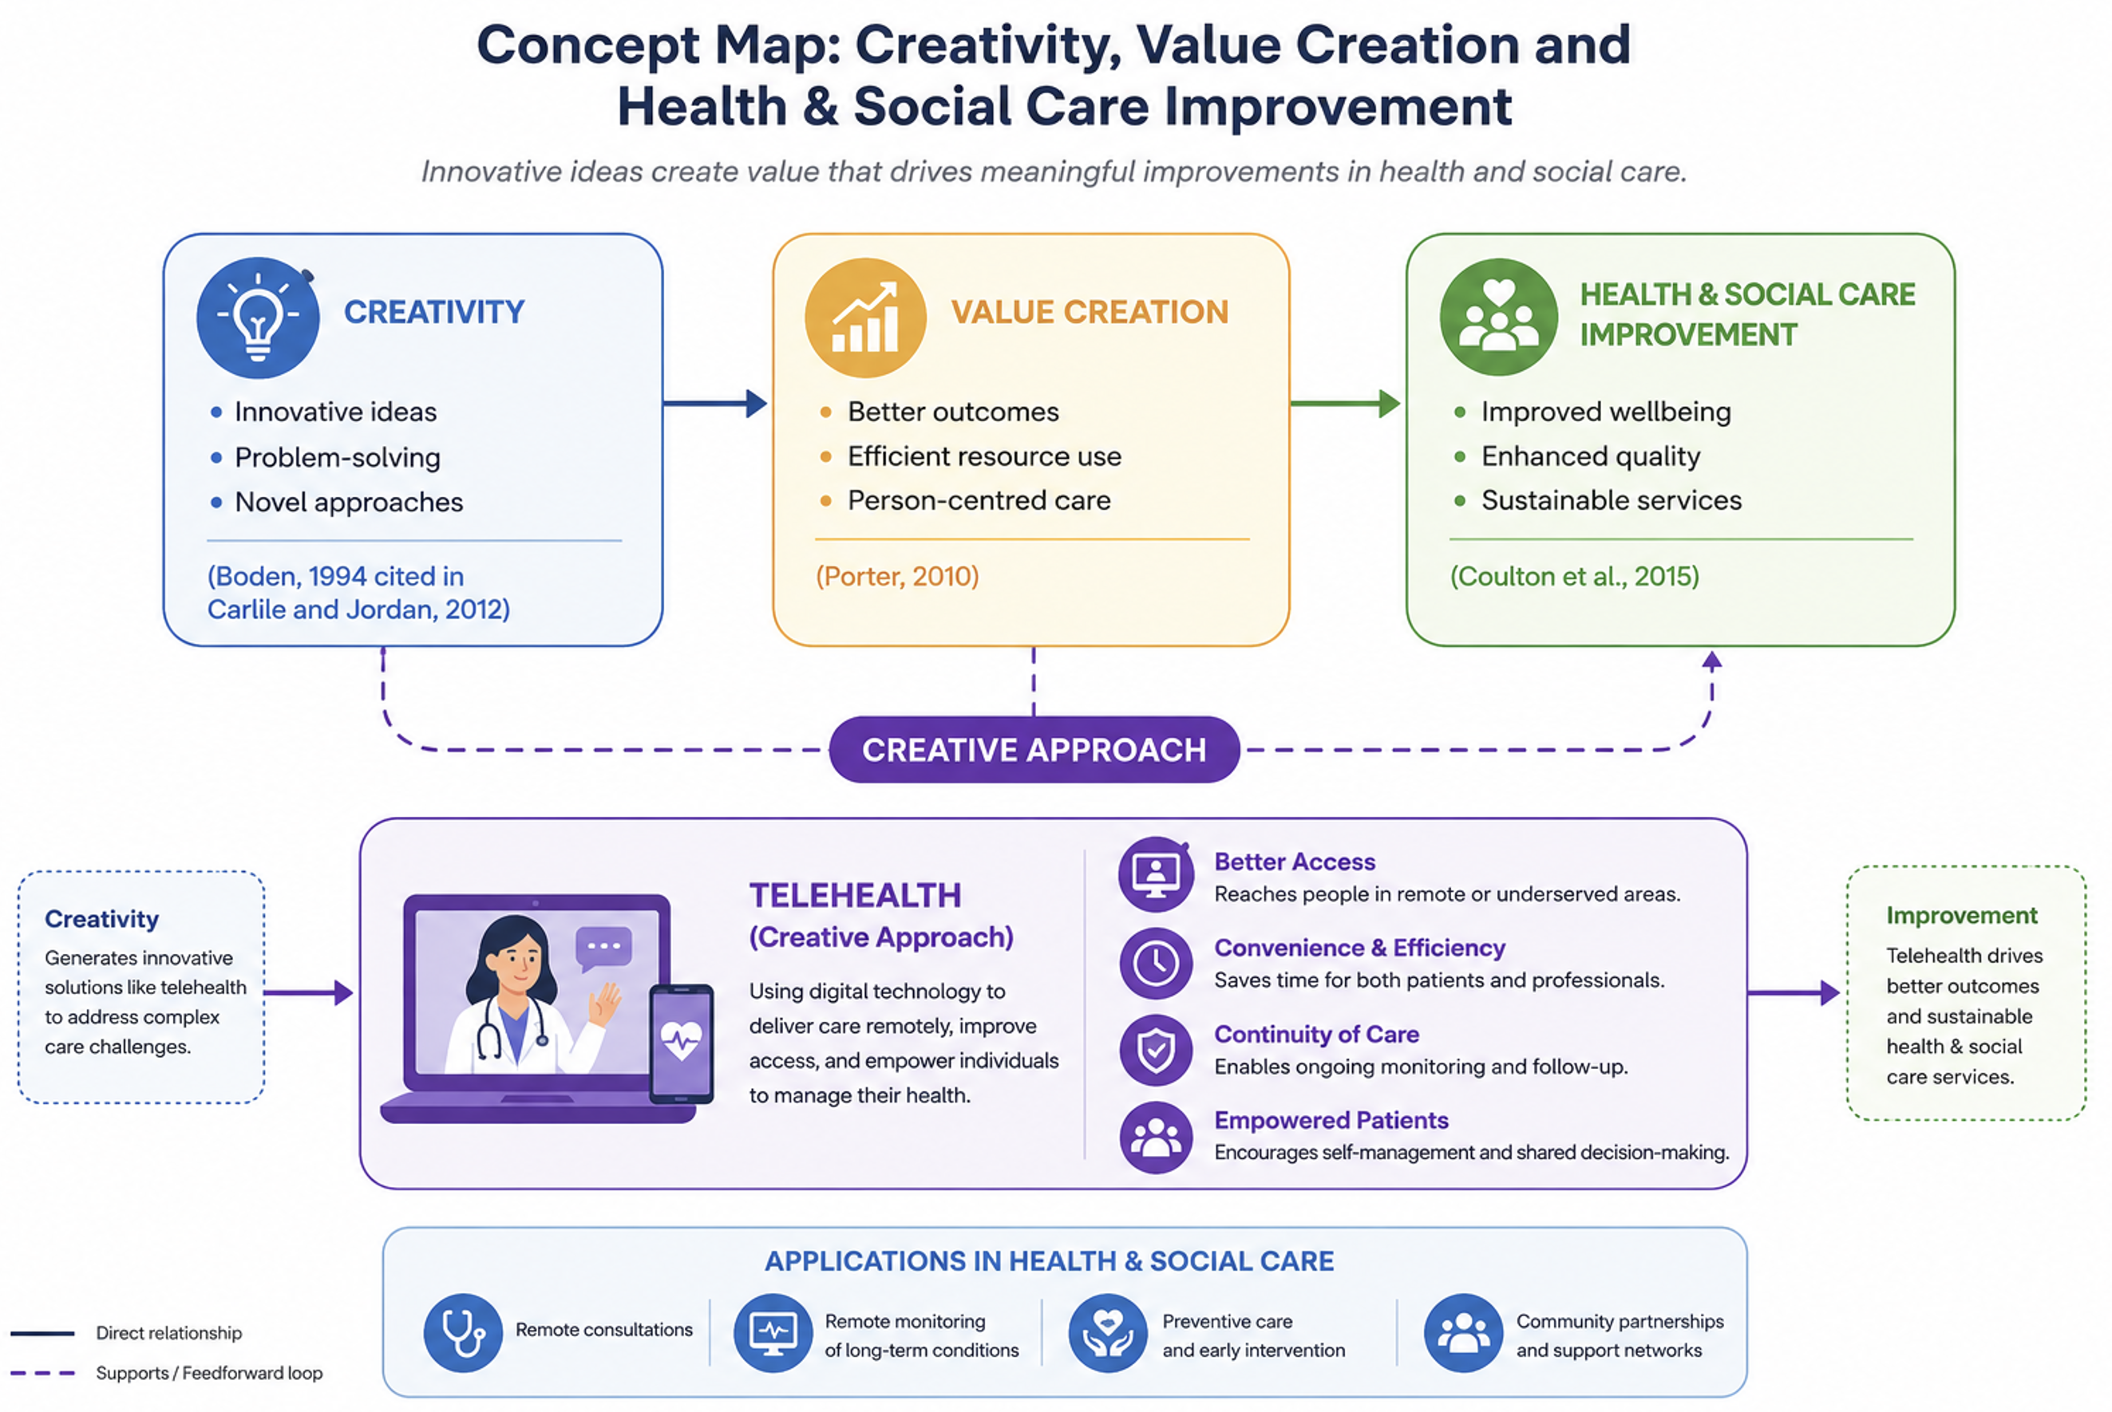
Creativity, value creation and health and social care improvement are closely interconnected concepts that contribute to the delivery of effective and person-centred services. Creativity involves generating novel and useful ideas that can address existing problems or improve current practices. Within health and social care, creative thinking enables professionals to develop innovative approaches that respond to the increasingly complex needs of service users. Boden defines creativity as the ability to produce ideas that are both new and valuable (Boden, 1994, cited in Carlile and Jordan, 2012).
The application of creativity can lead to value creation by improving outcomes while ensuring that available resources are used efficiently. Porter (2010) suggests that value in healthcare is achieved by obtaining the best possible outcomes relative to the costs involved. Therefore, value creation extends beyond financial savings and includes enhancing quality of care, promoting equity and ensuring that care remains centred on the individual's preferences and needs.
As a result, value creation contributes to continuous improvement within health and social care settings. Innovative interventions such as telehealth services, shared decision-making and preventative health initiatives demonstrate how creative solutions can improve accessibility, patient experiences and overall wellbeing. Furthermore, participation in creative activities has been associated with positive mental health outcomes and enhanced quality of life, particularly among vulnerable populations (Coulton et al., 2015). The Mental Health Foundation (2020) also highlights that creativity can strengthen social connections and support recovery. Consequently, fostering creativity within health and social care practice can create value and drive meaningful improvements in service delivery and patient outcomes.

Task 2 - Self-Reflection of Group Activity
Description: During the paperclip thinking activity, my group was asked to generate as many alternative uses for a paperclip as possible before evaluating which ideas were the most practical. We produced approximately fifteen ideas by working collaboratively and building upon each other's suggestions.
Feelings: At first, I felt confident because I believed the task would be straightforward. However, after suggesting the more obvious ideas, I found it difficult to think creatively. As my classmates shared different perspectives, I became more engaged and realised that there were many possible solutions beyond my initial thinking.
Evaluation: I believe the activity was effective because everyone was encouraged to contribute without criticism during the brainstorming stage. This created an environment where creativity could develop freely. The second stage was more challenging because it required us to critically assess our ideas and justify which solutions were the most realistic.
Analysis: The first stage demonstrated divergent thinking by encouraging the generation of multiple creative ideas without immediate judgement. (Guilford, 1967) explains that divergent thinking promotes creativity by exploring a wide range of possible solutions. The evaluation stage reflected convergent thinking, where ideas were analysed logically to identify the most appropriate outcome (Williams, 2003). Using Gibbs' Reflective Cycle (1988) helped me understand not only what happened during the activity but also why reflecting on my experiences can improve future learning and decision-making (Gibbs' Reflective Cycle, 1988).
Conclusion: This activity showed me that creativity and critical thinking complement one another. Generating numerous ideas is valuable, but selecting the most effective solution requires logical evaluation.
Action Plan: In future group activities, I will contribute more confidently during brainstorming while remaining open to the ideas of others. I will also take a more active role in evaluating options to strengthen my problem-solving and collaborative working skills.

Task 3 - Case Study of a UK innovation
Case Study Analysis: NHS at Home – Creativity Driving Innovation in Healthcare
The NHS at Home initiative represents an innovative approach to healthcare delivery that addresses increasing pressures on hospitals, rising rates of chronic illness and the need for more person-centred care. Traditional models of care have largely been hospital-centred and reactive, often requiring patients to attend frequent appointments or remain in hospital for monitoring. NHS at Home sought to challenge this approach by using remote monitoring technologies to support patients within their own homes (Imperial College Healthcare NHS Trust, 2024).
Creativity was central to the development of this initiative. Rather than viewing hospitals as the default setting for treatment, healthcare professionals reimagined where and how care could be delivered. Digital monitoring devices enabled patients with long-term conditions to record health data, which clinicians could review remotely. This innovative use of existing technology transformed the patient-professional relationship from one based on episodic contact to one characterised by continuous support and shared responsibility. By redesigning service delivery, the initiative promoted patient empowerment and encouraged individuals to play a more active role in managing their health.
The creative shift towards home-based care also addressed wider system challenges. Remote monitoring improved the efficiency of healthcare services by identifying signs of deterioration earlier, reducing the need for emergency interventions and unnecessary hospital admissions. Furthermore, it supported the NHS objective of moving care from hospitals into community settings, creating a more sustainable model of healthcare delivery.
The value created through NHS at Home extended beyond cost savings. Imperial College Healthcare NHS Trust (2024) reported a significant reduction in hospital readmissions among patients receiving remote monitoring. Improved accessibility allowed individuals to receive high-quality care without the burden of repeated travel to healthcare settings. In addition, patients often experienced greater autonomy, confidence and satisfaction because they could remain in familiar surroundings while still feeling supported by healthcare professionals. Therefore, NHS at Home demonstrates how creativity can lead to practical innovations that improve patient outcomes, enhance experiences of care and alleviate pressures across the healthcare system.

Task 4 - Research Task
Mental health stigma remains a significant issue within UK health and social care because it can prevent individuals from accessing the support and treatment they need. Despite increased awareness campaigns, many people continue to experience discrimination, fear negative judgement, or internalise harmful stereotypes surrounding mental illness. This contributes to delayed help-seeking behaviours, poorer health outcomes and increased pressure on healthcare services.
Research by Henderson, Evans-Lacko and Thornicroft (2013) identified several reasons why mental health stigma persists and acts as a barrier to care. The authors found that limited knowledge about mental illness, uncertainty about where to obtain support, and fears of discrimination can discourage individuals from seeking professional help. They argued that anticipated stigma often results in people concealing symptoms or postponing treatment, which may worsen their condition. Their findings suggest that both public attitudes and structural barriers within healthcare systems contribute to the ongoing problem of mental health stigma.
Similarly, Clement et al. (2015) conducted a systematic review exploring the relationship between stigma and help-seeking. Their findings demonstrated that stigma has a negative impact on individuals' willingness to access mental health services. Participants frequently reported concerns about being labelled, judged by others, or experiencing social exclusion if they disclosed their mental health difficulties. The review also highlighted that certain groups, including young people, men and individuals from minority ethnic backgrounds, may be disproportionately affected by stigma-related barriers. Consequently, these populations may delay seeking support until their symptoms become more severe.
Overall, the evidence indicates that mental health stigma is maintained by a combination of societal misconceptions, fear of discrimination and self-stigmatisation. Addressing these underlying causes through education, anti-stigma campaigns and improved accessibility of services is essential to encourage early intervention and reduce inequalities in mental healthcare provision (Thornicroft et al., 2016).

Task 5 - Podcast
Record a two-minute Podcast introducing your idea for component 2 using https://www.rev.com/onlinevoicerecorder The MP3 audio must be downloaded and embedded as a file (see guidance video on how to do this here: https://www.youtube.com/watch?v=D21isId0agw) or an accessible OneDrive link if using a chromebook (make accessibility – anybody) before inserting into your portfolio. Check the accessibility of the link before submitting.
CARELINK+ Podcast

Task 6 - NHS Leadership Framework Analysis
Summary of the NHS Leadership Framework
The NHS Leadership Framework identifies the behaviours and skills required for effective leadership at all levels of healthcare. It consists of seven key components that support high-quality, patient-centred care. Demonstrating Personal Qualities involves self-awareness, integrity, resilience and continuous professional development, enabling leaders to act with confidence and professionalism (NHS Leadership Academy, 2013). Working with Others focuses on building positive relationships, encouraging teamwork and communicating effectively across multidisciplinary services (West et al., 2020). Managing Services requires leaders to organise resources, monitor performance and ensure safe, efficient service delivery. Improving Services encourages innovation, quality improvement and the use of evidence to enhance patient outcomes (NICE, 2021). Setting Direction involves analysing information, understanding future challenges and establishing priorities that align with NHS objectives. Creating the Vision requires leaders to inspire others by communicating a clear purpose and motivating staff towards shared goals. Finally, Delivering the Strategy focuses on implementing plans, evaluating progress and sustaining improvements through effective leadership and accountability. Together, these seven domains promote compassionate, collaborative and effective leadership that supports continuous improvement while ensuring patients remain at the centre of decision-making across NHS organisations (NHS Leadership Academy, 2013).
Using Improving Services to Encourage Creativity and Improve Care
The Improving Services component enables leaders to foster creativity by encouraging staff to identify new ideas that enhance patient care and service efficiency. Leaders can create an open culture where employees feel confident sharing suggestions, testing innovative approaches and learning from both successes and failures. For example, introducing quality improvement projects allows multidisciplinary teams to redesign clinical processes using evidence-based practice, reducing delays and improving patient experiences (NICE, 2021). Leaders who actively involve frontline staff in decision-making increase engagement because employees often recognise practical solutions to everyday challenges (West et al., 2020). Creativity can also be supported through regular reflection, staff training and collaboration across departments, ensuring that improvements are sustainable rather than temporary. By promoting continuous learning and empowering teams to contribute to service development, leaders can improve patient safety, staff satisfaction and overall quality of care while supporting the NHS commitment to innovation and continuous improvement (NHS Leadership Academy, 2013).

Task 7 - Self-Reflection Journal Entry
Journal Entry
Throughout this module, my understanding of creativity and value creation within health and social care has developed significantly. At the beginning, I viewed creativity mainly as generating new ideas. However, I now recognise that creativity is about finding practical, person-centred solutions that improve the quality, accessibility and efficiency of care. I have learned that innovative thinking can support better patient outcomes while making effective use of limited healthcare resources, creating value for both service users and the NHS (Porter, 2010).
The module also highlighted the importance of collaboration, leadership and evidence-based practice in driving innovation. Learning about examples such as remote monitoring and telehealth demonstrated how creative approaches can improve patient independence, reduce unnecessary hospital admissions and support more sustainable healthcare services. These examples showed that innovation does not always require entirely new technology but can involve improving existing ways of working.
As a healthcare professional, I will apply these lessons by remaining open to new ideas, working collaboratively with colleagues and actively contributing to service improvement initiatives. I now appreciate that creativity is everyone's responsibility, regardless of job role, and that small, continuous improvements can make a meaningful difference to patient experiences, safety and overall quality of care while supporting continuous improvement across health and social care services (Mental Health Foundation, 2020; Porter, 2010).

Reference List
Bajwa, J., Munir, U., Nori, A. and Williams, B. (2021) ‘Artificial Intelligence in healthcare: Transforming the practice of medicine’, Future Healthcare Journal, 8(2), pp. 188–194. Available at: https://doi.org/10.7861/fhj.2021-0095 (Accessed: 16 June 2026).
Boden, M.A. (1994) Dimensions of Creativity. Cambridge, MA: MIT Press, cited in Carlile, O. and Jordan, A. (2012) Approaches to Creativity: A Guide for Teachers. Maidenhead: Open University Press.
Clement, S., Schauman, O., Graham, T., Maggioni, F., Evans-Lacko, S., Bezborodovs, N., Morgan, C., Rüsch, N., Brown, J.S.L. and Thornicroft, G. (2015) ‘What is the impact of mental health-related stigma on help-seeking? A systematic review of quantitative and qualitative studies’, Psychological Medicine, 45(1), pp. 11–27.
Coulton, S., Clift, S., Skingley, A. and Rodriguez, J. (2015) ‘Effectiveness and cost-effectiveness of community singing on mental health-related quality of life of older people: Randomised controlled trial’, British Journal of Psychiatry, 207, pp. 250–255.
Gibbs, G. (1988) Learning by Doing: A Guide to Teaching and Learning Methods. Oxford: Further Education Unit.
Guilford, J.P. (1967) The Nature of Human Intelligence. New York: McGraw-Hill.
Henderson, C., Evans-Lacko, S. and Thornicroft, G. (2013) ‘Mental illness stigma, help seeking, and public health programs’, American Journal of Public Health, 103(5), pp. 777–780.
Imperial College Healthcare NHS Trust (2024) Remote monitoring of heart attack patients significantly reduced hospital readmissions. Available at: https://www.imperial.nhs.uk/about-us/news/remote-monitoring-of-heart-attack-patients-significantly-reduced-hospital-readmissions (Accessed: 16 June 2026).
Mental Health Foundation (2020) Creativity and innovation: Findings from the Mental Health Fellowships. Available at: https://www.mentalhealth.org.uk/sites/default/files/2022-06/MHF-Winston-Churchill-Memorial-Trust-Creativity-Innovation-Findings.pdf (Accessed: 4 January 2025).
Porter, M.E. (2010) ‘What is value in health care?’, New England Journal of Medicine, 363(26), pp. 2477–2481.
Thornicroft, G., Mehta, N., Clement, S., Evans-Lacko, S., Doherty, M., Rose, D., Koschorke, M., Shidhaye, R., O'Reilly, C. and Henderson, C. (2016) ‘Evidence for effective interventions to reduce mental-health-related stigma and discrimination’, The Lancet, 387(10023), pp. 1123–1132.
Vats, K. (2024) ‘Navigating the digital landscape: Embracing innovation, addressing challenges, and prioritizing patient-centric care’, Cureus, 16(4). Available at: https://doi.org/10.7759/cureus.58352 (Accessed: 16 June 2026).
Williams, W.M. (2003) ‘Convergent versus divergent thinking’, in Sternberg, R.J. (ed.) Encyclopaedia of Creativity. San Diego: Academic Press, pp. 577–581.

