
Service Improvement Through Supply Chain Management and Continuous Improvement
Assignment 1 [ACEA7009]
By Jordan Thomas [1503513]
Lecturer – Peter Charlton
research methods and professional development

Table of Contents
Table of figures 1
Abstract 2
1: Introduction 2
1.1: Project relevance to industry 3
2: Literature review 4
2.1: Supply Chain 4
2.2: Supply chain weaknesses 5
Supply Chain Management 5
2.2: Continuous improvement 6
2.2.1: Kaizen Cycle 7
2.2.2: Kanban 9
2.2.3: Plan Do Check Act – PDCA 10
2.3: Literature review summary 11
3: Methodology 12
3.1: Interviews 12
3.2: Group Discussions 12
3.3: Initial Testing & Set-up 12
3.4: Further Interviews 13
4: Results Collection 14
4.2: Analysis 14
5: Project Plan 15
6: Evaluation 16
6.1: Expected outcome 16
6.2: limitations of Study 16
6.3: Areas for Further Improvement 16
Bibliography 17

Table of figures
Figure 1 - Kaizen 6 Step Cycle 9
Figure 2 - Kanban Methodology 10
Figure 3 - Kanban Board 11
Figure 4 - PDCA Cycle 12
Figure 5 - Project Plan 16

Abstract
This research proposal briefly looks at the supply chain and current issues being faced by engineering repair companies. To reduce the reliance and help protect customers from downtime a suggestion of in house manufacturing has been looked at. In order to successfully perform this in house manufacturing a review of continuous improvement techniques has been undertaken to identify a suitable options. The literature review identifies a number of methodologies, some more suited to the industry than others. The research methodology includes qualitative and quantitative approaches to provide an understanding on how the CI has been implemented and how the overall customer satisfaction has been improved. By implementing the in-house manufacturing and Continuous Improvement techniques lead times should be reduced and customer satisfaction will increase.

1: Introduction
The purpose to this research is to investigate current issues around the supply chain and how these can be mitigated. Furthermore, as a result of the research and employment experience, the research will look at how Continuous Improvement techniques could be implemented within the workplace to enable successful in-house manufacturing of critical components.

1.1: Project relevance to industry
Currently working as a project manager for a rotating machines repair company, Quartzelec. The core of the business is fault finding, rewinding and overhauling AC/DC electrical motors up to 20T. These repairs require a large amount tasks and processes to be completed as part of the work scope and as a result, require a huge variety of components to be supplied promptly. As expected the general stores holds a number of high use items, however this is a small proportion spares used.
Recent global events have created a situation which has put this repair market under great strain. Firstly there is a labour shortage of skilled workers around the south wales area which is effecting the major industries. The result has seen an increase of repairs required due to (1) a lack of on-site understanding causing an increase in faults (2) an increase in of repairs which typically would have been carried out by the customers engineering department. Additionally, supplies of unique items such as armature coils or stators coils have been negatively impacted due to the labour shortages or reduced skill level. The second issue is the impact on global trade and global supply chains. Whilst the lead time on many every day products has increased, an area of particular concern Is the supply of DC motors and large AC motors, typically the lead time has increase from 8 weeks (2020) to 40 – 52 weeks (2023). This situation has seen an increase in the amount of motor rewinds carried out with the aim of reducing lead time.
Many customers are now increasingly vulnerable to costly down time as they do not have the required amount of spares to cope with the grossly increased lead times. This places strain on repair companies whether at fault or not.
In addition to the above issues the main supplier of armature coils has pulled out of the market to focus their business on other areas. As a means of reducing supply chain reliance and risk reduction, Quartzelec has proceeded to investigate the feasibility of sourcing raw material (sectional copper wire) and manufacturing armature coils in house, a process and skill that was a common practice 20 years ago before being outsourced.
In order to progress and develop there will be a requirement to implement Continuous Improvement techniques with the aim on improving quality, improving service and eventually reducing costs. If the process can be successfully implemented and achieve the desired out comes then the company reputation will be enhanced whilst also providing an opportunity to sell coils direct to the struggling open market.

2: Literature review

2.1: Supply Chain
A supply chain is a network of individuals & organisations involved in the creation and delivery of a product to the end user. Raw materials will be turned into a finished product after passing through many organisations offering different services and skills. There are a number of fundamental steps of the supply chain that would be applicable to any industry or product:
- Supply of raw material
- Manufacture components from raw material
- Assembly of components to make a product
- Sales and order fulfilment of product
- Transportation of product to end user
- Continued customer support of product

2.2: Supply chain weaknesses
Complex supply chain networks and a combination of unpredictable world events can negatively impact the stability of supply chains around the world. Virtually all supply chains have suffered from disruptions which have affected total production levels for companies (Zhao, 2023). Disruption at the beginning of a supply chain, even if only effecting a limited number of companies, can generate a ripple effect which can seriously impact the performance of the entire supply chain. (Yanadori, 2022). There has been a number of global events over previous decades which have servilely affected supply chains such as covid 19, Japanese tsunami, 9/11 attacks. An example would be the covid 19 outbreak and the global semiconductor shortage. Due to the requirement of a global supply chain and multiple lockdowns, a bottle neck was created which is still effecting production of car manufacturing today. (Scott, 2023)
Another area where a supply chain can show weakness is through a lack of skilled and qualified workers. Skilled labour has been lost from a number of industrial or manufacturing facilities causing an increase to lead times. Additionally logistics plays an important role within any supply chain, and like other industries, there has recently been a shortage of HGV drivers capable of connecting the supply chain. (Lawrence, 2022)

2.3: Supply Chain Management
Many businesses will operate within a supply chain however, this does not mean supply chain management is being undertaken. Furthermore, good supplier management complete supply chain management (Davies, 1993). Supply chain management is a process which looks to oversee the delivery of a raw material to a finished good. Supply chain management is critical for a business to maintain competitive, particularly in the current climate. By carrying out in-house manufacturing this give a business greater overall control and reduce the over reliance on a global supply chain. Supply chain reliance (SCR) is a process where businesses and organisations implement procedures or processes with the aim of reducing disruptions and supply chain venerability’s.
(Ballinger, 2021)

2.2: Continuous improvement
Continuous improvement is a philosophy of identifying, analysing, and improving many business processes and services. These improvements can be made by making ongoing improvements to efficiency, quality and speed of various processes within a business. As a result of these benefits a company who successfully implements continuous improvement techniques is likely to maintain a competitive advantage over their competitors (Falak, 2020). Furthermore, the long-term health of any organisation depends on the commitment to continuous improvement (Kovach, 2011).
Continuous improvement is everyone’s responsibility and for successful implementation of continuous improvement there are a number of steps that top-level management, middle management and individuals need to follow (Wiley, 1992). Whichever methodology of continuous improvement is implemented, it should be developed and deployed by a selected team over a set period of time (Arnaiz, 2022). Successful implementation requires full commitment from all levels of management, leaders and team members. It is important to ensure Incremental changes in order to review the success and avoid workplace disruption.
There are many potential benefits to identifying and implementing successful Continuous Improvement within the workplace:
- Increased quality
- Increased efficiency
- Cost savings and increased profitability
- Develop and improve a competitive advantage
- Smoother processes – reduced waste
- Increased customer satisfaction
There are many methodologies and techniques associated with continuous improvement. These methods are in a range of complexities, additionally some methods are more suited to certain industries and processes. Bellow gives an explanation to a selection of methodologies with the aim of identifying suitable method(s) for this project.

2.2.1: Kaizen Cycle
The kaizen philosophy states that our way of life should be continuously improved and that these improvements should be made possible by making small incremental changes that combine to make a noticeable change over time (Do, 2017). The kaizen methodology targets process orientated thinking because processes must be improved for results to improve (Imai, 1997). Furthermore a failure to achieve the expected results indicates there is a failure within the process.
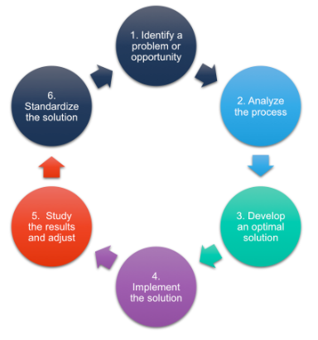
Figure 1 - Kaizen 6 Step Cycle
The Kaizen cycle, or 6-step cycle as it is also referred to (shown in figure 1), is a continuous improvement and lean manufacturing tool. The recognisable benefits associated with this method are employees at all levels are encouraged to engage with the process and make suggestions. By empowering employees it is expected they will take ownership of their tasks and fully participate in the Continuous Improvement. Additionally, the aim is to humanize the workplace by creating a positive working environment and eliminating overly hard work. Like many other philosophies there is an emphasis on low small incremental changes to the process. Furthermore, this approach is said to be inexpensive and low risk. The 3 main goals or Kaizen are to improve quality, cost and delivery of a product or service by means of continually improving (Prayudaa, 2020)

2.2.2: Kanban
Kanban is a Japanese word which translates roughly to visual sign. The method was first developed by ask a scheduling system by Toyota during the 1950’s. The Kanban methodology is a continuous improvement philosophy which has been applied to many manufacturing environments. The methodology is a work scheduling system that aims to use visual aids to manage workflow and improve efficiency. The methodology works on the principle of a pull system where the team is required to pull tasks into the workflow only when there is available capacity and the required customer demand. The methodology also looks to reduce all forms of waste and to optimise material flow (Wakode, 2015).
The six key components to the methodology which need to be considered for successful implementation:
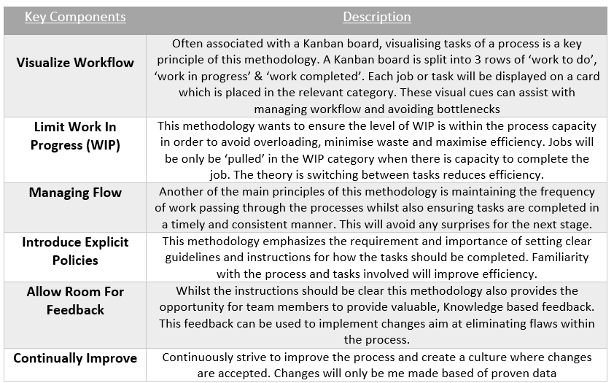
Figure 2 - Kanban Methodology
(Wakode, 2015)
As mentioned in figure 2, one of the most recognizable components of this methodology is the Kanban Board. Any major project will have a number of tasks and processes that need to be completed at various stages before the project can be completed. The Kanban Board will visualist the complete process in a simplistic way which will allow individuals at any level to instantly see how tasks are moving through the process. As a result, bottlenecks in any process will be clearly visible.
Figure 3 below shows an example of a basic Kanban Board with the 3 categories discussed. The complexity of the board is dependent on the application and requirements. Additional tasks or teams could be added.
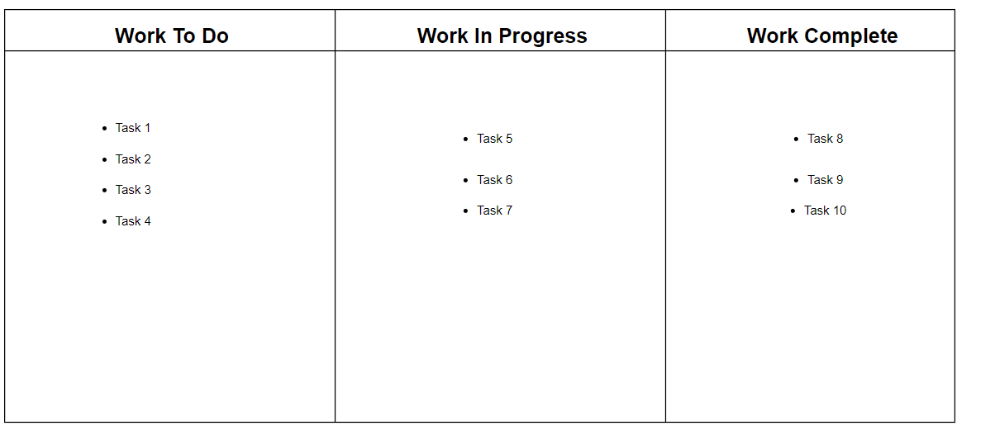
Figure 3 - Kanban Board

2.2.3: Plan Do Check Act – PDCA
The Plan Do Check Act (PDCT) cycle is a commonly used Continuous Improvement and Lean framework tool used in industry to assist with improvements in a business’s processes and systems (Fisher, 2020). This 4 step improvement cycle is also known as the Deming Cycle or Deming wheel as it was originally developed by Dr William Deming, a quality-control Pioneer, in the 1950’s (Feldman, 2018). The fundamental principles of this method involve identifying an initial goal or problem to improve, implementing small scale improvements before analysing the results and integrating the information gathered. This 4 step tool is a never ending cycle of improvement (Deshpande, 2017).

PLAN
The initial step of this method is to plan. This involves the business understanding and identifying current issues or potential areas of improvements. Once identified there is a requirement to identify the root cause of a problem in order to provide the highest chance of success. Following this route forward, solution or improvement should be created. For successful application of this method it is critical a full specification and available resources have been agreed with higher management as part of a wider implementation plan (Deshpande, 2017). Once a plan has been developed the process moves to the next step.

DO
On completion of understanding the situation and a possible solution or improvement has been identified, there is a requirement to implement the changes. The changes should be made on a small scale trial in a controlled environment to prevent disruption to the process and business should a fault occur. The results of which will be gathered for analysis. (Deshpande, 2017)

CHECK
The third stage is considered the most important of the PDCA cycle. Here significant learning will take place as a result of the processes implemented. The results of the trial will need to be interpreted and evaluated to see if the desired outcome has been achieved.

ACT
If the results are negative or do not achieve the desired outcome then the small scale changes will not be implemented throughout the business and the process will restart. If the outcomes meet the predetermined success criteria then the changes will be standardized throughout the process or business in order to maximize success. Following this step the cycle will return to step one where the next issue or improvement will be identified.

Figure 4 - PDCA Cycle
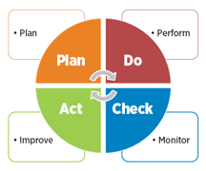
Figure 4 is a typical image used to visualise the PDCA process. This clearly shows the four stages of the method and the can be used in the industry to emphasise the continuous improvement efforts being implemented. One of the Main benefits of PDCA facilitates continuous improvement and can be applied to a wide variety of applications regardless of function, due to the flexibility. (Anon., n.d.)

2.3: Literature review summary
The PDCA cycle is currently used by the companies Safety, Health, Environment & Quality (SHEQ) team and as a result the workforce would already have a basic understanding and be familiar. This would reduce the push back and reluctance to change however the effectiveness for the intended purpose is unknown. The PDCA methodology is also the most basic of the 3 mentioned. The Kaizen 6 step cycle provides additional stages and detail to the improvement process however, the complexity of the process is also increase. A benefit to method would be the empowerment of all levels of employees and the additional knowledge which could be shared about the process. The small changes create a culture where unsuccessful new ideas are accepted as the process can revert to previous set-up at little cost. From the initial research I would recommend the Kanban methodology and board would be best suited to the environment due to the simple visualisation of tasks, management of workflow and the large number of tasks being carried out at any given time.

3: Methodology
The initial thesis will need further investigation and research to determine the feasibility, cost and potential business impact. Firstly a business model will need to be developed to ensure the funding will be available and to understand what level of machinery could be targeted. Initial targets need to be agreed with predetermined performance measures.

3.1: Interviews
Interviews will be primary source of information during the initial stages of this research. The first interviews will need to take place with stakeholders to ensure they see potential in the planned route forward and to ensure the finances would be available. The second round of interviews would be with our previous supplier who has initially expressed an interest in sharing their knowledge and experience so setup the in-house manufacturing. During these interviews a great amount of knowledge would be shared in a number of different areas. Particular areas of interest would be the supply chain & inventory levels, Skills training on relevant machinery & and the process controls required to ensure consistency of quality. Continuous improvement techniques would also be vitally important to the process and an interesting comparison could be made between the literature review and what the industry currently implements.

3.2: Group Discussions
Once an initial road map has been agreed, group discussions will take place. Initially these will be departmental to extract any additional knowledge, experiences or ideas from the skilled winding team (management and shop floor). The discussions will include best working practices, initial set-up of the equipment, their current understanding of quality and Continuous Improvement methods. The feedback will be reviewed to create a workable plan which all levels buy into. Once the initial plan has been agreed, wider group discussions will take place with the whole workforce to ensure the change is accepted by and to ensure all employees understand the importance on overall customer satisfaction.

3.3: Initial Testing & Set-up
The management with previous coil manufacturing experience and supervisors will perform initial testing by manufacturing a small amount of sample coils. During this, simple PDCA improvements will be made to remove any bottle necks or issues identified within the process. The feedback will be addressed and allow for gradual improvements. As improvements are made, the sample size and coil complexity will increase. On completion the results, defects and issues will be documented and reviewed

3.4: Further Interviews
Final interviews will be carried out between stakeholders, management and employees who took part in the testing to review the findings. The aim would be understand if the participants agreed that the implementation of a Kanban Board & PDCA methodologies would assist in creating a positive Continuous Improvement culture. The improvements made during the trials would also provide an insight as to the potential improvements that could be achieved overtime.

4: Results Collection
Every job file will need to include data covering the whole manufacturing process to enable a detailed analysis to be carried out. Areas include:
- Coil complexity rating
- Defects found during manufacturing
- Defects found during motor assembly
- Total waste material
- Total time taken per coil
- Set-up time
- Labour requirements – specifically labour heavy tasks (2 or 3 person tasks)
- Area utilisation & the amount of spate jobs that can run concurrently
This data will be collected during the initial set-up and for the forcible future in order to review the Continuous Improvement and develop a further plan based on the findings.

4.2: Analysis
Whilst customer satisfaction is important, they will not be aware of the processes within the workshop. Internal analysis will need to be carried out to ensure the correct processes are implemented and improvements are being made. Statistical analysis will be performed using Excel on the above listed data. The trend will hopefully show a reductions of costs, lead times and waste whilst showing increased are utilization and the ability to increase the coil complexity.
The ultimate analysis will be made based on the overall lead time and customer satisfaction. Accurate customer satisfaction is notoriously hard to collect in this industry as it is usually only received when extremely negative or extremely positive. To combat this the analysis will be carried out in a number of methods.
Statistical data will need to be recorded on every job with a comparison made against the alternative (supply new) and a comparison against historical data, if available. The areas of comparison will include:
- Lead time vs supply new vs historical
- Total cost vs supply new vs historical
- Customer reported defects
In addition the data collection, a specific customer survey will be designed and issued with each repair. The survey will specifically aim at gauging customer satisfaction of lead times, quality, costs, defects or concerns raised. We will encourage them to investigate and review the quality of work once the equipment has been returned (Where possible).

5: Project Plan
Figure ** Shows the project timeline for the initial research and implementation plan. On completion of the review and evaluation, a consultation will be carried out to determine the business direction.
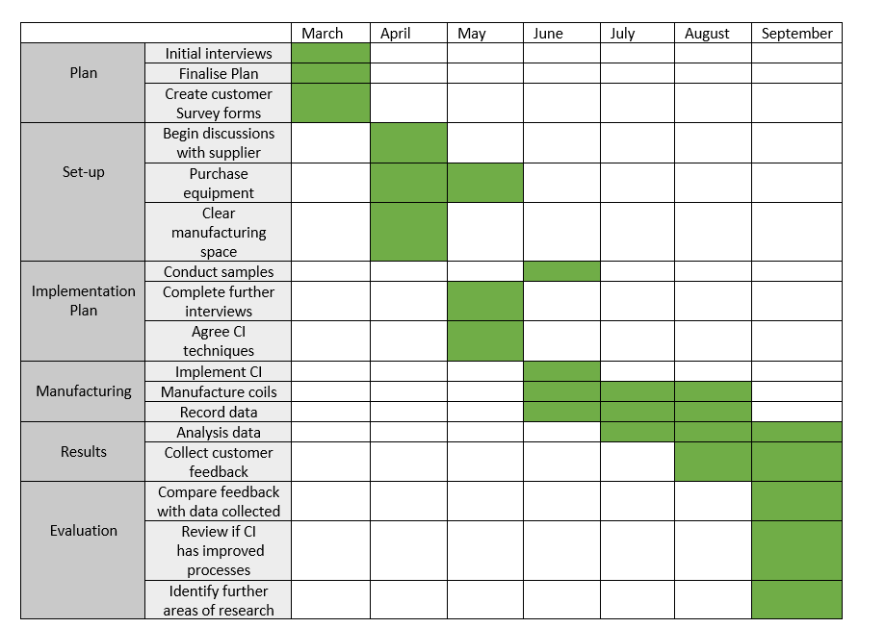
Figure 5 - Project Plan

6: Evaluation

6.1: Expected outcome
The initial research would suggest the Kanban board has the penitential to have the greatest influence and impact from the continuous improvement methods discussed due to the potential to improve efficiency, increase productivity, reduce waste, prevent overburden, flexibility & improved collaboration. The workshop has a high number of tasks being carried out at any given time, including a very large WIP. By beginning the process of controlling the WIP and using visual aims it is expected the efficiency of completing individual tasks will improve. Initially the overall improvements are expected to be significant as the employees become accustomed to the new processes and a culture where everyone’s opinion is valid.

6.2: limitations of Study
There will be limitations to the accuracy of the data collected, particularly at the start of the project. Whilst new procedures are implemented there could be errors of the data collected or errors in which the data is interpreted however, this is expected to improve as time goes on. Employee acceptance to change could also place limitations of the accuracy of in-house data collected. Comparisons between ‘supply new’ data and ‘historical’ data could be difficult on bespoke equipment which hasn’t been repaired previously and cannot be purchased new. The current supplier is prepared to perform a handover with the equipment however, there is still a possibility ok a skills shortage or over-reliance on individuals at the beginning of the process. Finally whilst the process should drastically reduce lead time, these gains are based on the ability to source the raw materials within a sensible lead-time.

6.3: Areas for Further Improvement
Once the Kanban board has been installed and provided success the aim will be to modify the basic idea into a bespoke board which suits the coil manufacturing. The modifications could include 2 WIP sections (1) for jobs at the investigation and quoting stage (2) for jobs with purchase orders and a defined deadline. Rows could also be added to separate teams or tasks. Research will be undertaken on the optimal size of the Kanban Board and how it can be integrated with all areas of the workshop.
Further research will be required based on the findings of the initial implementation stage. It is expected to identify weakness and these areas will need to be improve, possibly by implementing alternative Continuous Improvement techniques or quality management.

Bibliography
Anon., 2022. Identifying Critical Success Factors in continuous improvement Projects in a steel company. Procedia Computer Science, Volume 196, pp. 832-839.
Anon., n.d. ASQ - WHAT IS THE PLAN-DO-CHECK-ACT (PDCA) CYCLE?. [Online]
Available at: https://asq.org/quality-resources/pdca-cycle
[Accessed 20 03 2023].
Arnaiz, A. M. &. C., 2022. Identifying Critical Success Factors in continuous improvement Projects in a steel company. Procedia Computer Science, Volume 196, pp. 832-839.
Ballinger, N., 2021. Supply Management. [Online]
Available at: https://www.cips.org/supply-management/opinion/2021/september/three-supply-chain-weaknesses-exposed-by-covid/
[Accessed 05 03 2023].
Davies, T., 1993. Effective Supply Chain Management. Sloan Management review , Volume 34, pp. 35 - 35.
Deshpande, P. &., 2017. Application Of Plan-Do-Check-Act Cycle For Quality And Productivity Improvement - A Review. International Journal for Research in Applied Science & Engineering Technology (IJRASET), 5(1), pp. 197 - 201.
Do, D., 2017. What is Continuous Improvement (Kaizen). [Online]
Available at: https://theleanway.net/what-is-continuous-improvement
[Accessed 02 03 2023].
Falak, K. N. &. N., 2020. Evalution of continuous improvement techniques using hybrid MCDM technique under fuzzy environment. Materials Today: Proceedings, 22(4), pp. 1295-1305.
Feldman, K., 2018. ISIXSIGMA. [Online]
Available at: https://www.isixsigma.com/dictionary/deming-cycle-pdca/
[Accessed 20 03 2023].
Fisher, S. &., 2020. Daily plan-do-check-act (PDCA) cycles with level of development (LOD) 400 objects for foremen. Advanced Engineering Informatics, Volume 44.
Imai, M., 1997. Gemba Kaizen: A commonsense, Low-cost Approach to Management. 2nd ed. s.l.:McGraw-Hill.
Kovach, C. &. E., 2011. The use of continuous improvement techniques. MultiCraft, 3(7), pp. 89-100.
Lawrence, D., 2022. IT in the supply chain. [Online]
Available at: https://itsupplychain.com/how-the-labour-shortage-is-impacting-the-supply-chain-industry/
[Accessed 20 03 2023].
Norman, R. M. &. C., 2009. Evolution of the PDCA cycle. Tokyo, Asian Network for Quality.
Prayudaa, R. Z., 2020. Contiuous Improvement Through Kaizen In An Automotive Industry.. Journal of Industrial Engineering & Management Research, Volume 1, pp. 37-42.
Scott, G., 2023. Why the chips are down: Navigating the global chip shortages and beyond. [Online]
Available at: https://www.jabil.com/blog/global-chip-shortages.html#:~:text=As%20of%20early%202023%2C%20lead,average%20pre%2Dpandemic%20lead%20times
[Accessed 6 March 2023].
Shih, W. C., 2020. Global supply chains in a post-pandemic world.. Havard Buisness Review, 98(5), pp. 82-89.
Wakode, R. &. T., 2015. Overview on Kanban Methodology and its Implementation. IJSRD - International Journal for Scientific Research & Development, 3(2).
Wiley, A. L., 1992. The meaning of continuous improvement. Technical Communication, 39(4), pp. 709-10.
Yanadori, N. &., 2022. Forming post-COVID supply chains: does supply chain managers social network affect resilience. International Journal of Physical Distribution & Logistics Management, 52(7), pp. 538-566.
Zhao, H. &. L., 2023. Impact of supply chain digitalization on supply chain resilience and performance. International Journal of production economics, 259(0925-5273).

