Student Name: Alex Marin Cornea
Student Number: 2441412
Lecture name: Rejwan Bin Sulaiman
Module Name – Employability and Career Development
Module Code: LCLM4005_LON

First Job Advert
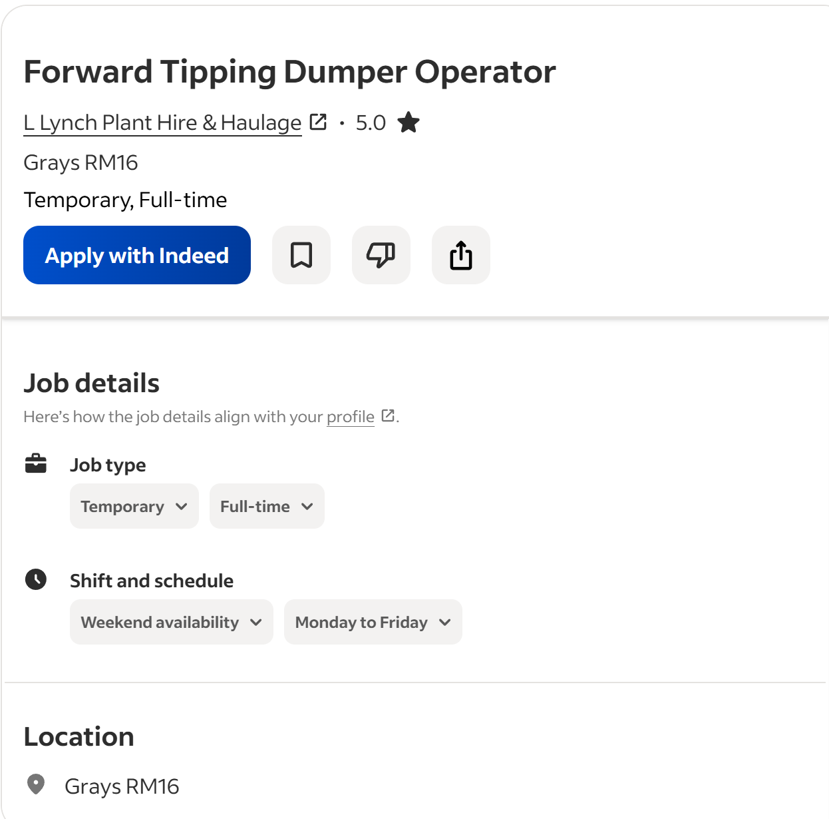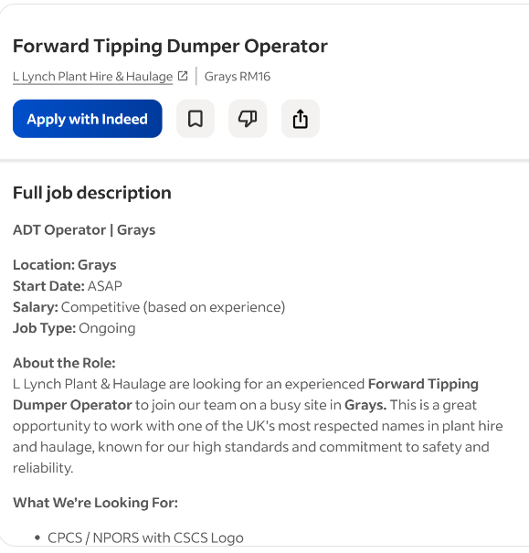
Second Job Advert
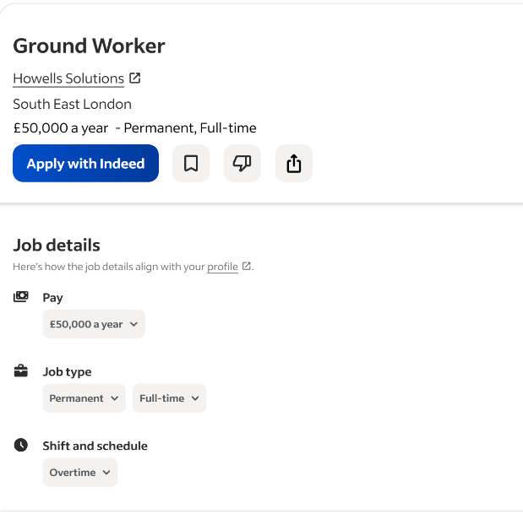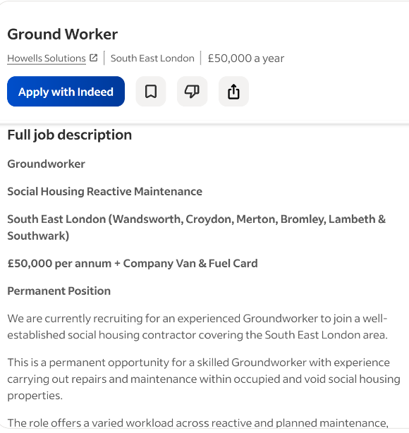

Task 1 – Key Skills and Areas of Knowledge

For this task, I have compared two job adverts for jobs in the construction industry, focusing on the role of a Dumper Driver or a Groundworker. Both job adverts show that workers need practical skills, knowledge and the right attitude to work safely and successfully on a construction site.
The first job advert requires skills such as operating construction machinery, following health and safety rules, teamwork, communication and attention to detail. The worker also needs to understand how to move materials safely around a construction site and follow instructions from site managers. Being able to work with other construction workers is also important.
The second job advert has many similar requirements. It asks for , good communication, teamwork, time management and knowledge of site safety procedures. The worker needs to be reliable and able to complete tasks correctly and on time. They also need to follow instructions from supervisors and work well in a busy environment.
There are several common skills and areas of knowledge in both adverts. These include health and safety, teamwork, communication, machinery operation, time management and attention to detail. Both employers also want workers who are reliable, responsible and able to work well with others. These skills are important because construction sites can be dangerous if workers do not follow safety rules or communicate properly.
I already have some of these skills from my previous work experience. When I worked as a Dumper Driver/Groundworker at Julian Paving Ltd, I operated dumper trucks to move materials such as soil and gravel around construction sites. I followed health and safety rules and worked with groundworkers, excavator operators and site managers. This helped me improve my teamwork, communication and ability to work safely.
One key skill I could use in my future employment is attention to detail. This is important because I need to make sure that machinery is operated correctly and that instructions and safety procedures are followed. In my current role as a Tank Installer/Plumber, I also use attention to detail when reading technical drawings, installing tanks and carrying out pressure tests.
Overall, the two job adverts show that construction employers need workers who are reliable, safety-conscious, skilled and able to work well with others. Developing these skills will help me progress in my future career.

Task 2 – Self-Assessment and Evidence of Readiness

Self-Assessment – SWOT Analysis
For this task, I have completed a SWOT analysis to look at my personal strengths and weaknesses, as well as the opportunities and threats that could affect my future career. I think this is useful because it helps me understand what I am already good at and what I still need to improve.
Strengths
One of my biggest strengths is that I am hardworking and reliable. I have had different jobs since finishing school, including construction and hospitality. I currently work as a Tank Installer/Plumber at Global Water Tanks. This job can be physically demanding, but I make sure I complete my work properly and follow instructions.
I also think teamwork is one of my strengths. In my current job, I work with engineers, site supervisors and other trades. In my previous job at Julian Paving Ltd, I worked with groundworkers, excavator operators and site managers. I have learned that good communication is important because everyone needs to know what is happening on site.
Another strength I have is my practical and technical skills. In my current job, I read technical drawings and use them to install water tanks. I also carry out pressure tests and leak inspections. This has helped me improve my attention to detail because even a small mistake can cause problems.
My previous hospitality jobs have also helped me develop communication and customer service skills. At Strada, I served customers, took orders and dealt with complaints. At The Marble Arch Hotel, I handled cash and card payments and used a POS system.
Weaknesses
One area I need to improve is my business knowledge. Most of my work experience has been in construction and hospitality, so I do not have as much experience in business. I want to learn more about how businesses are managed, including finance, marketing and management.
Another weakness is that I can sometimes be less confident when doing something new. Once I understand a task, I become more confident, but at the beginning I may need some guidance. I can improve this by asking questions and being willing to try new things.
I would also like to improve my written communication. I can communicate well face-to-face, but I want to become better at writing professional emails, reports and workplace documents.
Opportunities
I have several opportunities that can help me improve. One of them is continuing with my Business studies. Learning more about business could give me a better understanding of how companies work and could open up different career options.
My current job is also a good opportunity because I work with experienced people. I can learn from engineers and supervisors and gain more knowledge about construction and how projects are organised.
I could also gain more qualifications in the future. I already have an NPORS Forward Tipping Dumper card, and getting more training could help me progress into better jobs and take on more responsibility.
Threats
One threat to my future career is competition for jobs. There may be other people applying for the same jobs who have more qualifications or experience than me. Because of this, I need to keep improving myself and gaining new skills.
Another threat could be not continuing my education or training. If I stop learning new things, I may miss out on better job opportunities. Construction work can also be physically demanding and involve risks, so I need to continue following health and safety rules.
Evidence of My Readiness for Employment
I believe I am ready for employment because I already have a good amount of work experience. I have worked in different types of jobs, which has helped me become more responsible and adaptable.
My current job at Global Water Tanks is good evidence of this. I install fire sprinkler water storage tanks, read technical drawings and work with different trades. I also carry out pressure tests and leak inspections. These responsibilities have taught me to be careful, work safely and pay attention to detail.
My experience as a Dumper Driver/Groundworker is also important. I operated dumper trucks to transport materials such as soil and gravel. I followed health and safety rules and worked closely with other workers. I also have my NPORS card, which shows that I have completed relevant training.My education is another part of my readiness. I completed my GCSEs at The Warren School, including Maths, English, Science and Spanish. These subjects helped me develop communication, problem-solving and numeracy skills.y previous hospitality experience has also prepared me for employment. Working at Strada and The Marble Arch Hotel taught me how to communicate with customers, work under pressure, handle payments and work as part of a team.
Overall, my main strengths are that I am hardworking, reliable, practical and able to work well with other people. I know that I still need to improve my business knowledge, confidence and written communication. However, I am willing to learn. My work experience, qualifications and education show that I am ready to continue developing myself and move forward in my future career.
Task 3 – Employment Goals and Personal Development Plan
Area I need to improve | Action I will take | Timeline | Resources needed | How I will measure my progress
Business knowledge | Attend my Business lessons, complete assignments and use online resources to learn more. | 6–12 months | College lessons, tutor support and online resources. | My grades and feedback from my tutor.
Written communication | Practise writing professional emails, reports and other workplace documents. | 3–6 months | College support and feedback from my tutor. | Fewer mistakes and better feedback on my writing.
Confidence | Take on new tasks at work and ask experienced workers for advice when needed. | Ongoing | Support from supervisors and colleagues. | Feeling more confident when completing new tasks.
Career progression | Research construction qualifications and look at supervisor and management roles. | Within 12 months | Job websites, college and advice from experienced workers. | Finding suitable qualifications and training opportunities.
Practical skills | Continue gaining experience in my current construction job and learn from experienced workers. | Ongoing | Workplace training and support from colleagues. | Being able to complete more tasks safely with less supervision.

