University of Wales Trinity Saint David

Engineering Academic Discipline



Tensile Test

Charlie Morrish

2405178

BEng Motorcycle Engineering

15/12/2024

Engineering Science (ACHA4002)

1229/1500

Contents Page
Contents
Introduction 2
Experimental Procedure 2
Steel 4
Aluminium 4
Duralumin 5
PVC 5
Results and Analysis 5
Steel 5
Aluminium 6
Duralumin 7
PVC 7
Conclusion 8
Evaluation 8
Further Work 8
References 9
Further Work 9

Introduction
This assignment consists of a practical and a written theory part. The practical is conducted in a lab and then the theory is up to the writer. The practical is where materials are placed into a Tensile Tester and then stretched apart until they buckle, then the results recorded are placed into a graph and the gradient is calculated.

Experimental Procedure
This experiment is a simple experiment, but it has a lot of factors riding on it going correctly. The first thing to do is to acquire the materials we will be testing in the ES6 Tensile Tester Kit. The next thing to do is to piece the actual Kit together so it is ready to be used.
The Tensile Tester has two chucks to hold the material in place, the Load Nut at the top of the tester pulls the upper chuck towards it and with it the material, every full turn of the Load Nut is 1mm. The Load Nut also has a small notch on it and a small scale split into increments of 10 to help see how far the Load Nut has been turned and it allows more control over each turn. The bottom chuck is connected to two large springs. The Dial indicator measures the deflection of the springs as force is applied to them. The springs obey by Hooke’s Law, meaning the measurement from the Dial Indicator helps to show the force applied. The Top Plate has a vertical scale to help remember how many turns the Load Nut has done.
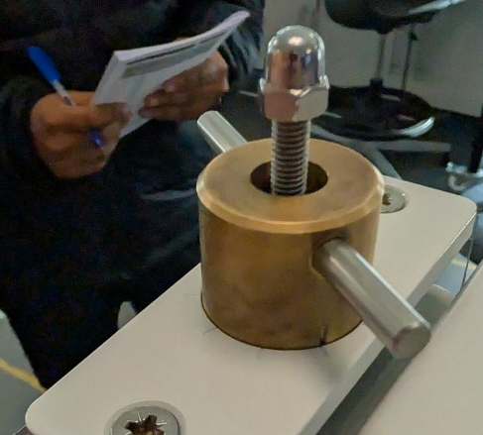

Attaching the kit to the work panel is quite simple, with just a few nuts and bolts it is on the work panel and ready to be used.
Whenever a new material is fitted into the Tensile Tester, the Dial Indicator must be set to zero. To do this, the force control must be carefully turned to one of the ten marks of its scale, and then the outer bezel of the dial indicator must be turned so that its pointer aligns with the zero value.
All materials are measured before and after they are put into the Tensile Tester to see how much it has been stretched out by the force of pulling at both ends of the metal.
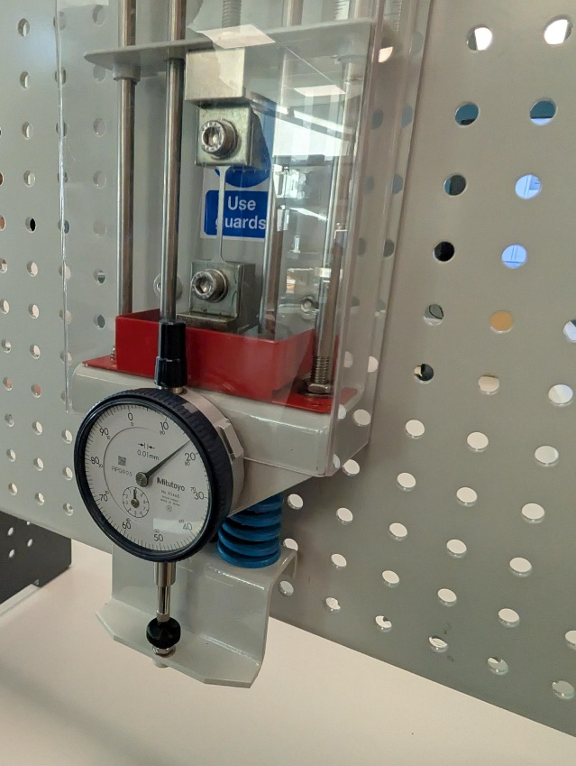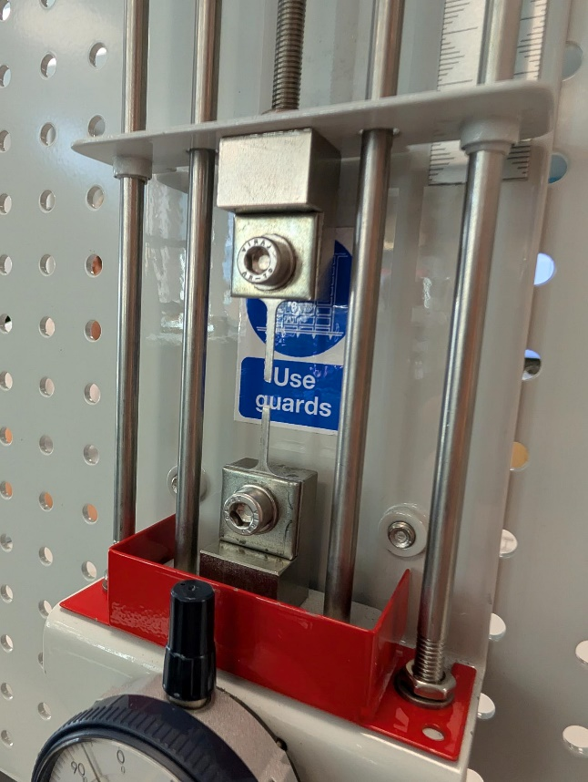

Steel
The first material assessed is Steel. First, the material is fitted into the Tensile Tester by firstly removing the safety guard and using a hexagonal tool to undo the material fixings and then fit the new material into the fixings, tightening the fixings. Then the Load Nut must be turned a few times to ensure the material fits correctly before it can be acted upon with force from turning the Load Nut and recording results. After a few full turns, the material snapped, and then it was taken out of the Tensile Tester, and it was remeasured.

Aluminium
The second material assessed is Aluminium. To make sure that we put the right material in, there was a small notch in the aluminium that made it easy to differentiate. The process for putting the Aluminium into the Tensile Tester is the exact same as the Steel. Once the material has snapped, it is then taken out of the tester and remeasured.

Duralumin
The Duralumin was the same process as the materials before. Put into the machine, assessed and when it buckled under the force it was remeasured and then set to one side.
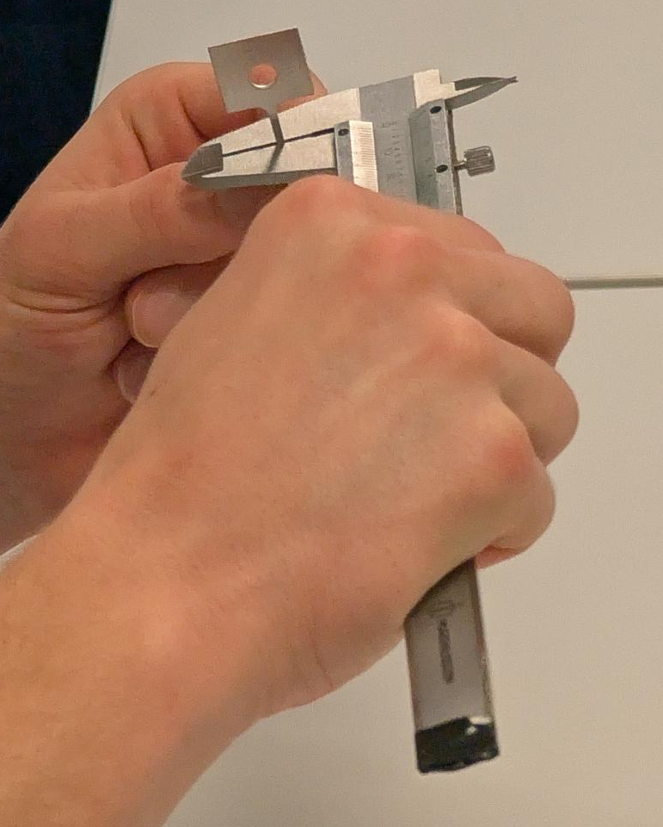

PVC
The last material to be assessed was PVC (plastic) and this was the material that had varied results. This material went through the same process as the rest, it was put into the tester and then pulled apart until it buckled and was then remeasured for results.
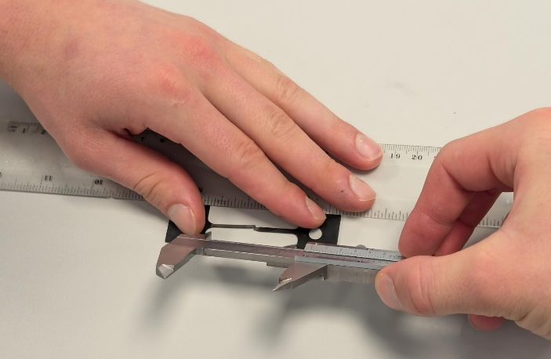

Results and Analysis

Steel
Steel was uniform the more force pulled it apart, as seen in the table and graph, and it withstood 528N before buckling and being pulled apart.
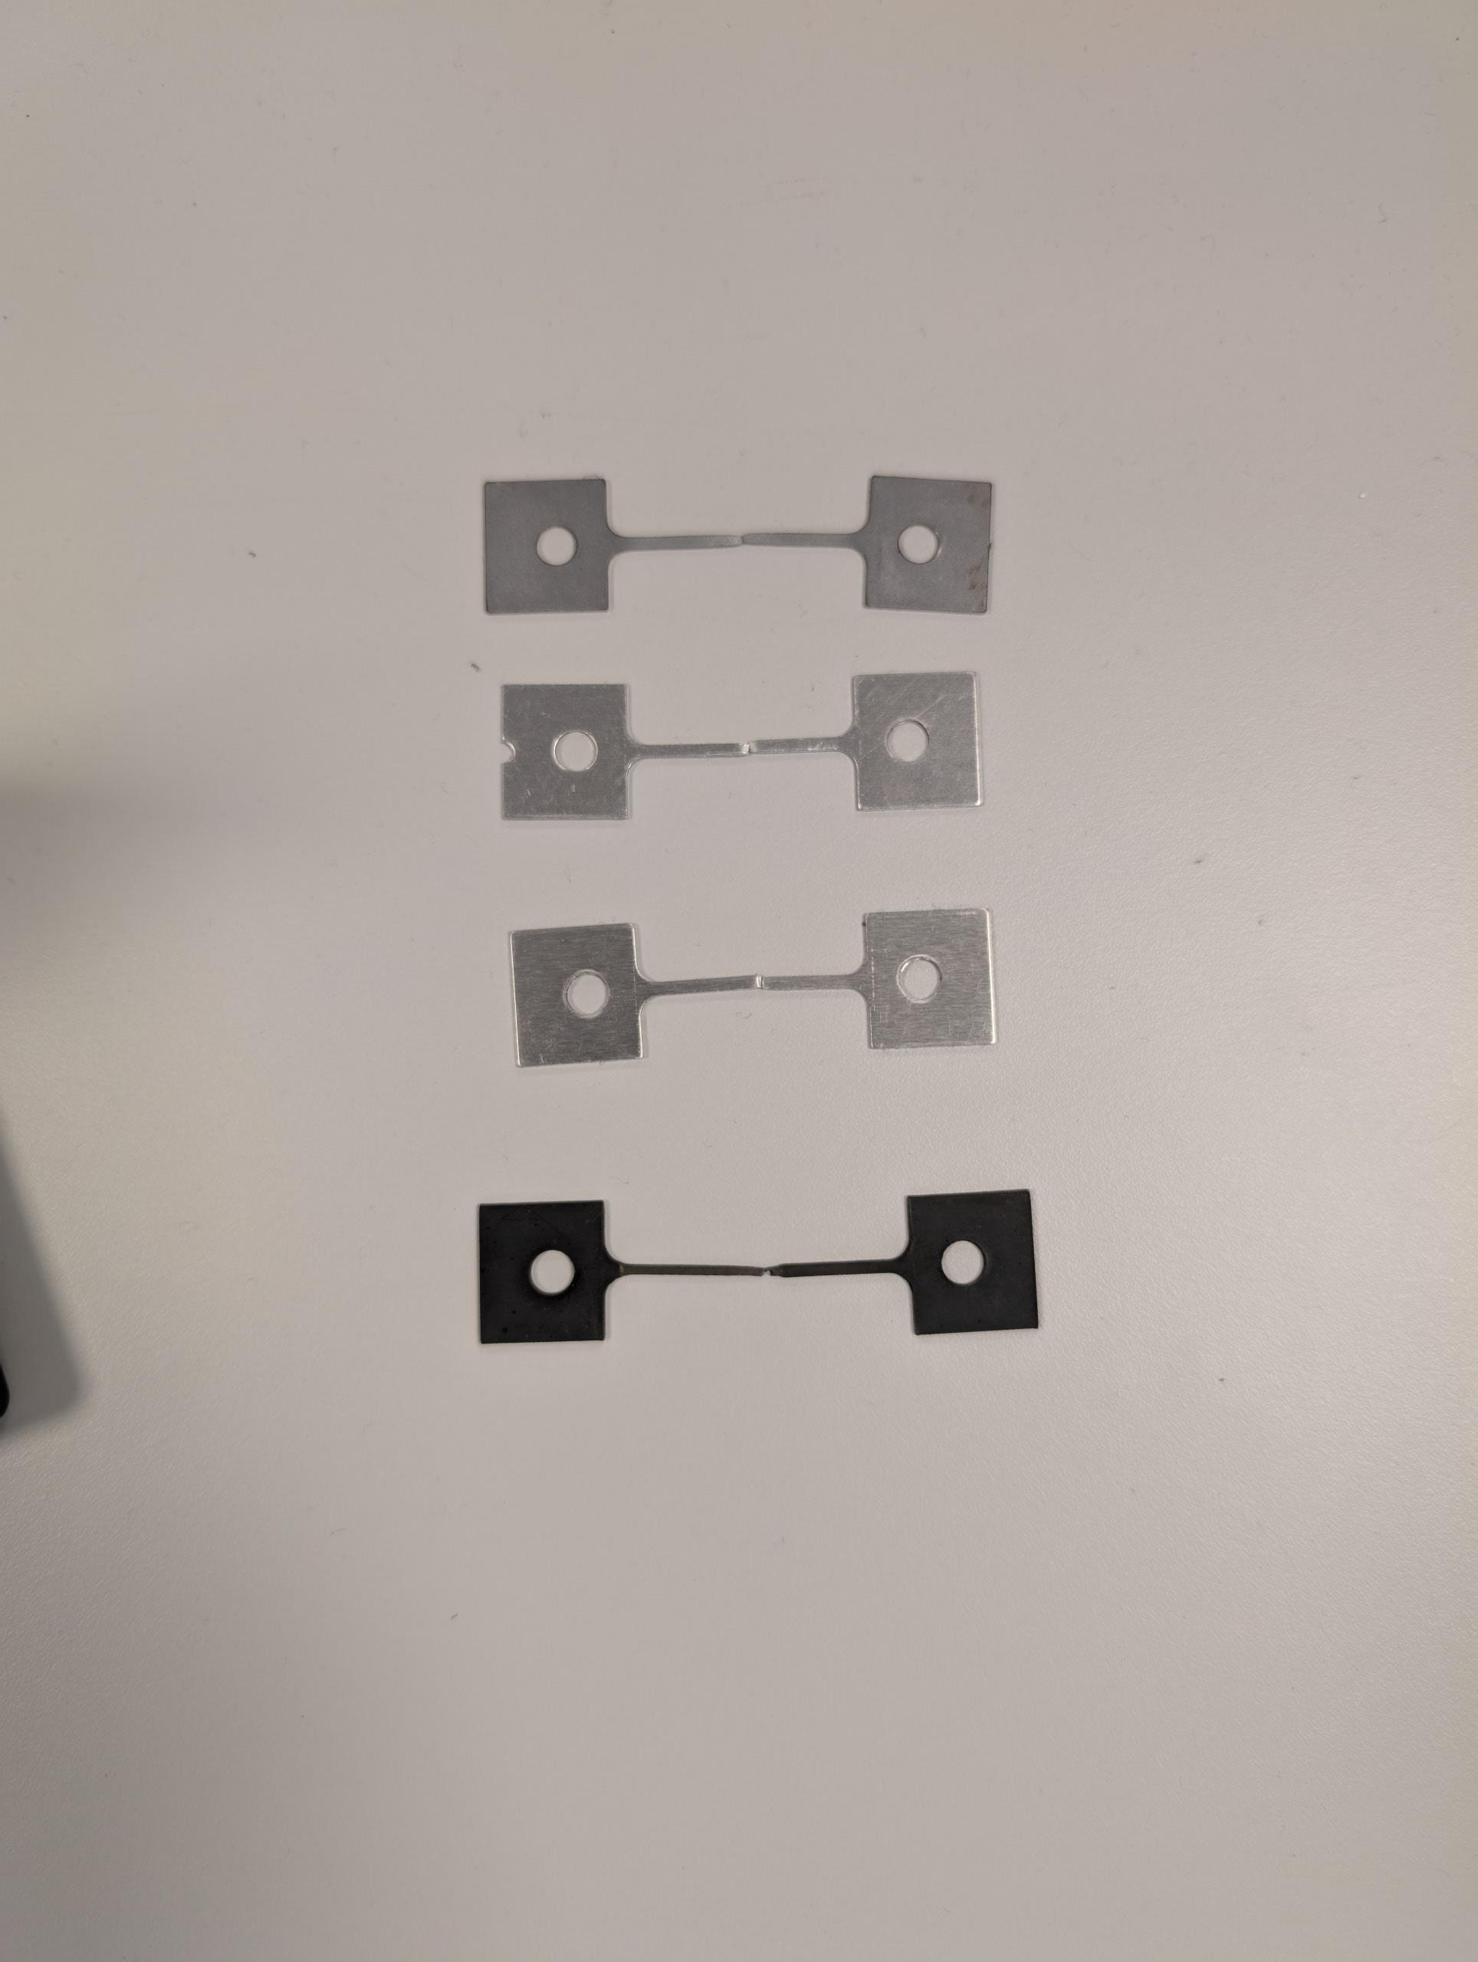

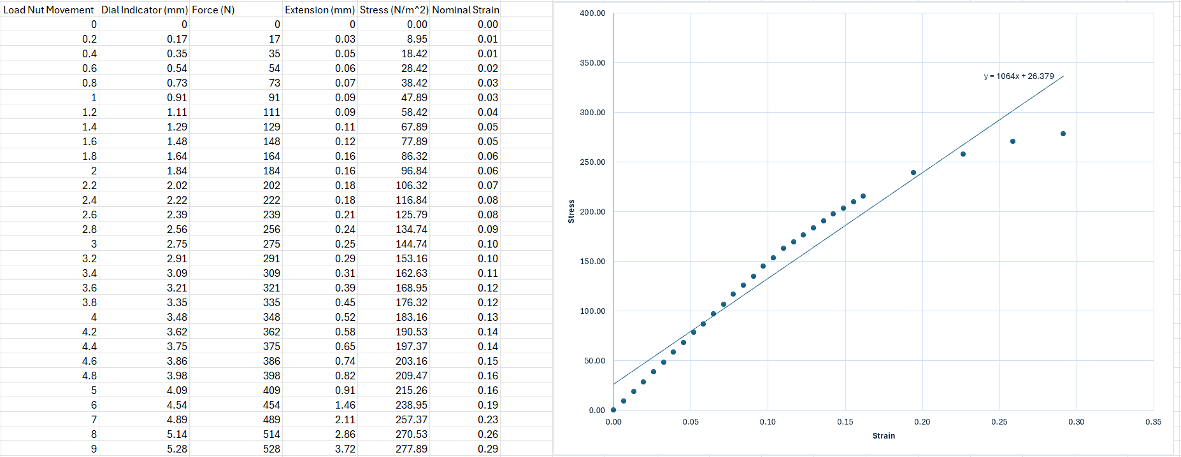

Aluminium
Aluminium was also very uniform for the most part; it wavers slightly at multiple points, but it stayed uniform and there were not any anomalous results. It withstood 282N before buckling which is less than Steel but that is to be expected because Steel is a stronger metal.
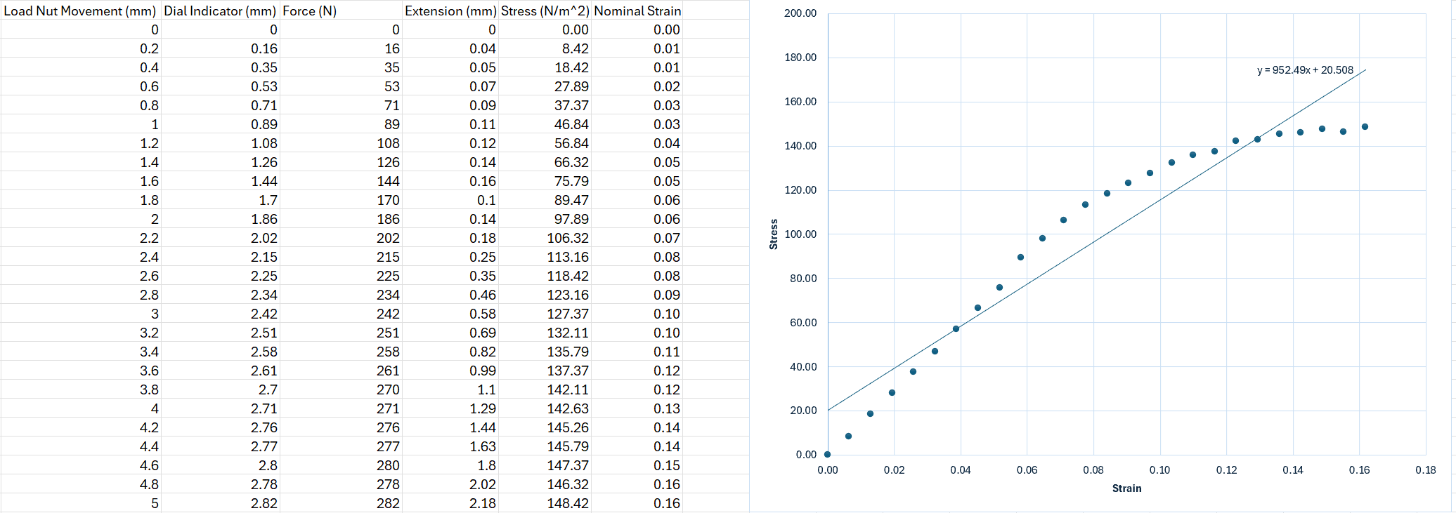

Duralumin
Duralumin is the most uniform out of all the materials assessed. It withstood 530 before buckling which is like the Steel. The alloy is quite strong when looking at the results.
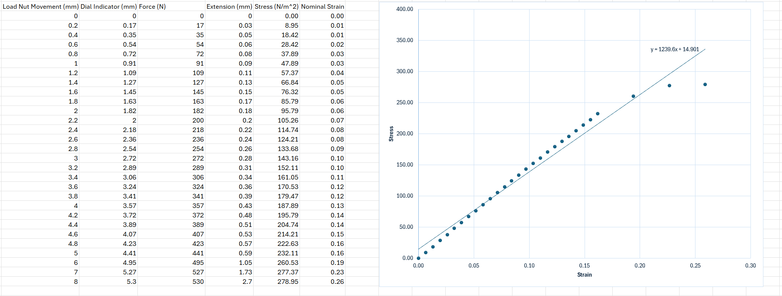

PVC
Plastic (PVC) was the most unpredictable of all the results, as seen in the graph below, as it does not follow any form of pattern in the results.
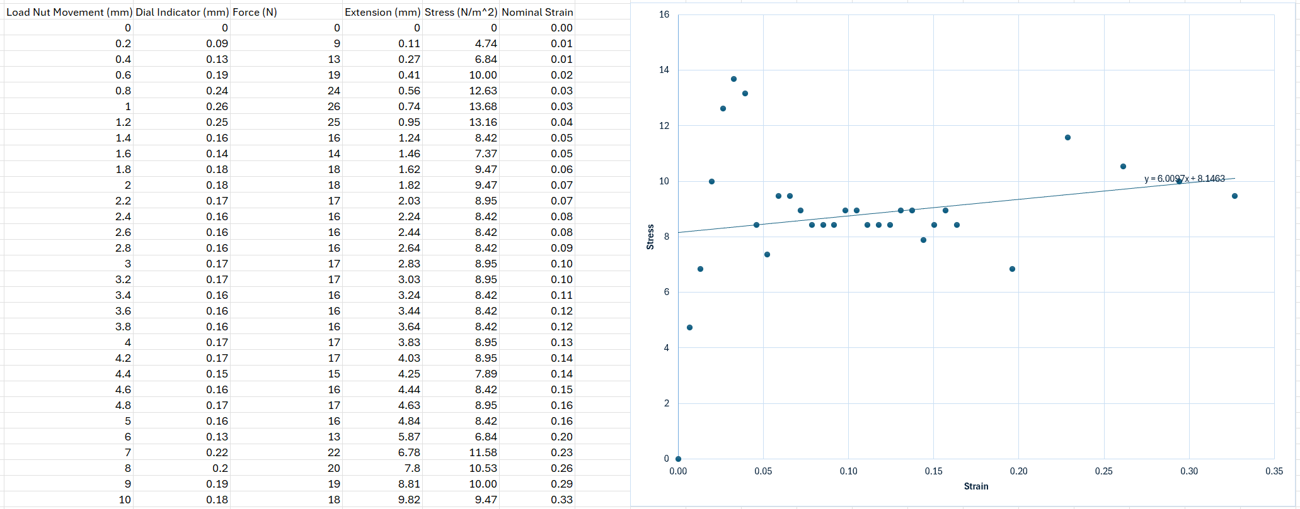

Conclusion
This assignment consists of a practical and a written theory part. The practical is conducted in a lab and then the theory is up to the writer. The practical is where materials are placed into a Tensile Tester and then stretched apart until they buckle, then the results recorded are put into a table, the force, stress and, strain are calculated and then placed into a graph and the gradient is calculated.

Evaluation
To eliminate errors and anomalies as far as possible, the same machine was used and one person read the results instead of multiple people changing for every material. Another factor that went unchanged was the person that turned the dial and measured the materials before they went into the tester.

Further Work
If given unlimited time and resources, things done differently would be that the tests would be done in a more controlled environment and done with a digital tensile tester for more accurate results to record and evaluate. A digital tensile tester such as the CS2 Plus which can exert a force of around 5kN would give more of an accurate reading than the Tensile Tester used for this assignment. Another factor that could be kept the same is the same person reading the results and another being the one to operate the machine. This ensures a constant and allows for less chances of anomalies to occur in the results from having more than one person read the digital results.
If given more time, proper research before hand could be conducted into what other people have done for tensile tests like the one conducted and what they did right and wrong and how those mistakes could be prevented in the test conducted. Some scientists did tensile tests on sheet metals and found that the sheet metal had cracked when enough force was acted upon it and found out that the crack did not become visible until enough force was acted upon it and then it became bigger. Another group of scientists took it upon themselves to assess out something that is called nanocrystalline metals. The results for said test are unavailable but the method for it is quite like the one quoted above and is another source that could be referenced to prevent errors or anomalies in the test and results.

References

Further Work
Digital Force Testing Machine - Chatillon CS2Plus Series
Evaluation of sheet metal formability by tensile tests - ScienceDirect

