Saminah ayub chohan
BSC health and social care
BMHP5003_BIRM
Introduction to physiology
Mumtaz Goolam

Digestive system

Liver. The liver controls most chemical levels in the blood and excretes bile. The liver filters all the blood that leaves the stomach and digestive tracts.(O'Connor, A. and O'Moráin, C., 2014)

Salivary Glands The salivary glands, also known as Parotid glands, the submandibular glands, and the sublingual glands, are the largest glands in the body, producing saliva within the mouth.

Mouth The mouth is the first organ in the digestive system, and it is a cavity in which the teeth and the tongue exist, and the salivary glands are opened, The function of the mouth is cutting and grinding the food by the teeth, and It digests the starch into the sugar.

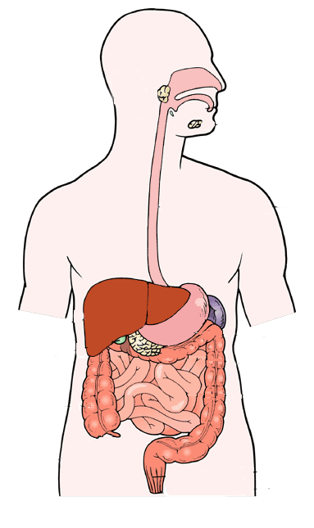
Oesophagus The oesophagus is a muscular tube that runs from the back of the mouth (the pharynx) to the top of the stomach, carrying food and liquids. As far as organs go, it is sturdy and resilient, designed to withstand most of the material humans consume. It is not a particularly difficult organ, for the most part.( Choice Reviews Online, 2005)

Stomach The human stomach's primary role is to aid digestion The function of the stomach as a reservoir, acid secretion, enzyme secretion, and its participation in gastrointestinal motility are the four major components of gastric digestive function. The stomach's reservoir capacity permits it to expand greatly in volume while only minimally increasing internal pressure. Acid secretion is a vital non-immune defence against invading viruses, as well as a process that allows vertebrates to eat a more diverse diet.

Large intestine the intestine is responsible for absorbing nutrients from food. The purpose of the big intestine is to absorb water and vitamins from the dietary content. The remaining is converted to faeces and expelled from the body via the anus.

Gallbladder The gallbladder is a small pouch that sits beneath the liver. The gallbladder is a storage organ for bile produced by the liver. The gallbladder is empty and level after eating, comparable to a flattened balloon. The gallbladder may be full of bile and the size of a little pear before a meal.

Small intestine
The small intestine's duties include finishing the digestion of various types of food and absorption of the digested food. The small intestine is made up of three anatomical parts: the duodenum, jejunum, and ileum. Absorption is the process of transporting digested food from the small intestine to the bloodstream. The small intestine follows the stomach and is followed by the large intestine. The small intestine has a length of around seven metres and coils inside the abdominal cavity. (Organsofthebody2021)
Pancreas It is responsible for transforming the food we ingest into energy for our bodies' cells. The pancreas has two primary functions: exocrine digestion and endocrine blood sugar regulation. The Pancreas is located in the abdomen. The pancreas is placed in the upper left abdomen, behind the stomach. ((Columbia surgery. 2021)

appendix

Anus
The main purpose of the rectum in the digestive tract is to store all of the waste that is excreted after food is processed inside the human body. Once the body has completed the digestion process in the gut, everything that is left over, including germs and digestive fluids, is directed to the rectum. The rectum stores all of the faeces until the person excretes them. (.nih.gov. 2021
Rectum The rectum is the last section of the large intestine before it enters the anal canal, and it's typically 6 to 8 inches long. The rectum's primary role is to serve as a temporary storage spot for faeces before it is removed from the body via the anal canal. (Healthfully. 2021)

One of the effects of a poor digestive system can be gallbladder disease, according to () Inflammation, infection, stones, and gallbladder blockage are all symptoms of gallbladder disease. Intermittent discomfort, often known as biliary colic, is the mildest and most prevalent sign of gallbladder illness. A continuous gripping or gnawing pain in the upper right abdomen near the rib cage, which can be severe and spread to the upper back, is the most common symptom.
The ache behind the breastbone is experienced by certain biliary colic patients. Nausea and vomiting are possible side effects. When stones or sludge obstruct the duct, between 1% and 3% of persons with symptomatic gallstones develop acute cholecystitis, which causes inflammation in the gallbladder.
The symptoms are like biliary colic, but they last longer and are more severe. They include intense, continuous pain in the upper right abdomen that might continue for days. When you take a deep breath, the pain usually gets worse. Fever and chills affect about a third of the patients.
Nausea and vomiting are possible side effects. Gallstones and moderate inflammation are two symptoms of chronic gallbladder disease. The gallbladder may become scarred and rigid in such circumstances. Gas, nausea, and abdominal discomfort after meals, as well as recurrent diarrhoea, are all symptoms of chronic gallbladder disease. If the patient has gallstones or the gallbladder is not working properly, surgery to remove the gallbladder may be necessary. Most of the time, this may be done as an outpatient surgery laparoscopically (via small incisions).

References

timac, D., Klobucar Majanovic, S. and Franjic, N., 2014. Stomach - Key Player in the Regulation of Metabolism. Digestive Diseases, 32(3), pp.192-201.
2021. [online] Available at: <https://doctorlib.info/anatomy/ross-wilson-anatomy-physiology-health-illness/12.html> [Accessed 20 June 2021].
BLOG. 2021. Digestive system without labels clip art clipart collection - Cliparts World 2019. [online] Available at: <https://clipartsworld.com/digestive-system-without-labels-clip-art.html> [Accessed 20 June 2021].
Choice Reviews Online, 2005. The encyclopaedia of the digestive system and digestive disorders. 42(06), pp.42-3154-42-3154.
Columbiasurgery.org. 2021. The Pancreas and Its Functions | Columbia University Department of Surgery. [online] Available at: <https://columbiasurgery.org/pancreas/pancreas-and-its-functions> [Accessed 20 June 2021].
Healthfully. 2021. Healthfully. [online] Available at: <https://healthfully.com/what-function-rectum-4572120.html> [Accessed 20 June 2021].
Healthfully. 2021. Healthfully. [online] Available at: <https://healthfully.com/erythematous-mucosa-rectum-6827224.html> [Accessed 20 June 2021].
Ncbi.nlm.nih.gov. 2021. LiverTox. [online] Available at: <https://www.ncbi.nlm.nih.gov/books/NBK547852/> [Accessed 20 June 2021].
O'Connor, A. and O'Moráin, C., 2014. Digestive Function of the Stomach. Digestive Diseases, 32(3), pp.186-191.
Organsofthebody.com. 2021. Large Intestine Function in Human Digestive System. [online] Available at: <https://www.organsofthebody.com/large-intestine/large-intestine-function.php> [Accessed 20 June 2021].

