Student Name: Sara Botfield
Student Number: 2116845
Module (BMHP_6029): Psychological Classifications and Provision Component 1: Presentation assignment
Lecture: Chloe Harries

Autism Spectrum Disorder (ASD): Understanding Causes, Diagnosis, Treatment, and Support

Introduction
Autism Spectrum Disorder (ASD) is a neurodevelopmental condition involving challenges in social interaction, communication, and repetitive behaviors. It presents across a spectrum, meaning individuals vary widely in abilities and support needs.

Causes & Risk Factors
Genetic predispositions, neurological differences, and environmental influences such as prenatal health or parental age contribute to ASD risk. Studies link ASD to altered brain connectivity and neurochemical imbalance.

Signs & Symptoms
Common traits: limited eye contact, repetitive movements, adherence to routines, atypical sensory responses, and communication difficulties. These differ greatly among individuals.
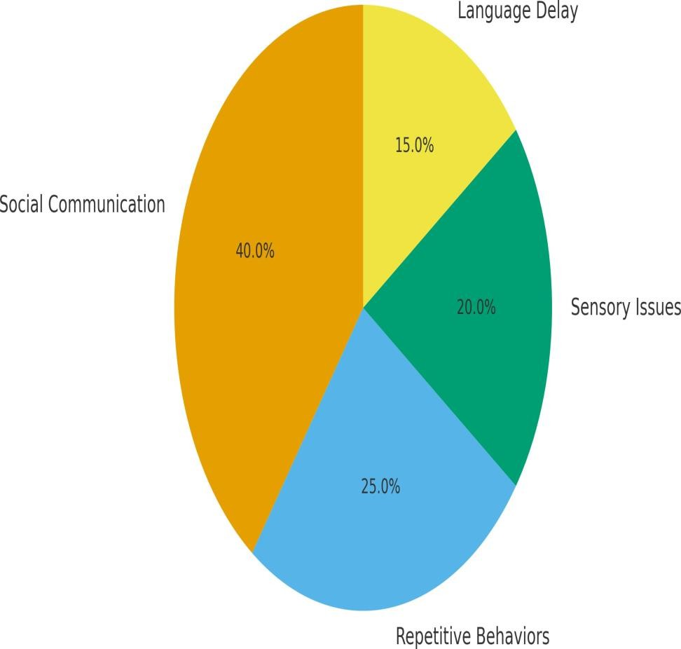

Diagnosis
Diagnosis is based on DSM-5 criteria, focusing on persistent deficits in communication and restricted behaviors. Tools include ADOS and ADI-R, alongside parent interviews and observation.

Treatment & Interventions
Effective supports include Applied Behaviour Analysis (ABA), speech and occupational therapy, Cognitive Behavioral Therapy (CBT), social training, and sometimes medication. Early intervention yields the best results.
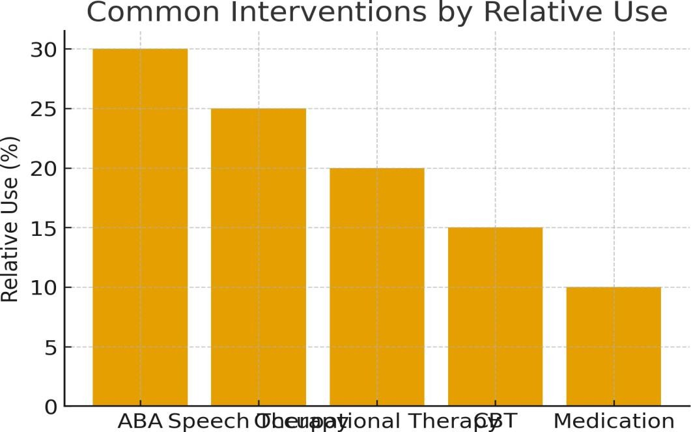

Education & Social Inclusion
Inclusive education frameworks encourage autistic learners’ participation in mainstream schools with Individualised Education Plans (IEPs) and adaptive teaching. Community support reduces stigma and fosters belonging.

Psychological Perspective
Psychological theories such as Theory of Mind, Executive Dysfunction, and Weak Central Coherence explain cognitive and behavioral differences in ASD. These models guide interventions and research.

Conclusion
Autism Spectrum Disorder requires integrated psychological, educational, and social approaches. Early identification, tailored intervention, and inclusive societal attitudes improve life outcomes and well-being.

References
American Psychiatric Association (2013) Diagnostic and Statistical Manual of Mental Disorders (5th ed.). Washington, DC: APA. Baron-Cohen, S. (2008) 'Theories of the autistic mind', The Psychologist, 21(2), pp. 112–116.
Happé, F. and Frith, U. (2020) 'Annual Research Review: Looking back to look forward – changes in the concept of autism and implications for future research', Journal of Child Psychology and Psychiatry, 61(3), pp. 218–232.
Lord, C. et al. (2020) 'Autism spectrum disorder', Nature Reviews Disease Primers, 6(1), pp. 1–23.
National Institute for Health and Care Excellence (NICE) (2017) Autism spectrum disorder in under 19s: recognition, referral and diagnosis. London: NICE.
Pellicano, E. and Stears, M. (2011) 'Bridging autism, science and society: Moving toward an ethically informed approach to autism research', Autism Research, 4(4), pp. 271–282.
Wing, L. and Gould, J. (1979) 'Severe impairments of social interaction and associated abnormalities in children: Epidemiology and classification', Journal of Autism and Developmental Disorders, 9(1), pp. 11–29.
Frith, U. (2003) Autism: Explaining the Enigma. 2nd ed. Oxford: Blackwell.
Bölte, S. et al. (2019) 'The contribution of twin studies to the understanding of autism', Autism, 23(2), pp. 223–235. Howlin, P. (2014) 'Outcomes in adults with autism spectrum disorders', Autism, 18(7), pp. 765–784.
Lai, M.C. et al. (2020) 'Sex/gender differences and autism: setting the scene for future research', Journal of the American Academy of Child and Adolescent Psychiatry, 59(1), pp. 36–45.
Rutter, M. (2011) 'Progress in understanding autism: 2007–2010', Journal of Autism and Developmental Disorders, 41(4), pp. 395–404.
Baio, J. et al. (2018) 'Prevalence of Autism Spectrum Disorder among children aged 8 years', MMWR Surveillance Summaries, 67(6), pp. 1–23.
Tager-Flusberg, H. (2015) 'Neurodevelopmental disorders: The biological basis of autism', Annual Review of Neuroscience, 38, pp. 1–19.
White, S.W. et al. (2014) 'Cognitive-behavioral therapy for anxiety in youth with autism spectrum disorders: A randomized controlled trial', Journal of Clinical Child & Adolescent Psychology, 43(5), pp. 719–731.
Zwaigenbaum, L. et al. (2015) 'Early intervention for children with autism spectrum disorder under 3 years of age: Recommendations for practice and research', Pediatrics, 136(Supplement 1), pp. S60–S81.

