
Assessment 1 – Reading Task Template
PART 1: Upload your photo of your A3 in-class notes here:
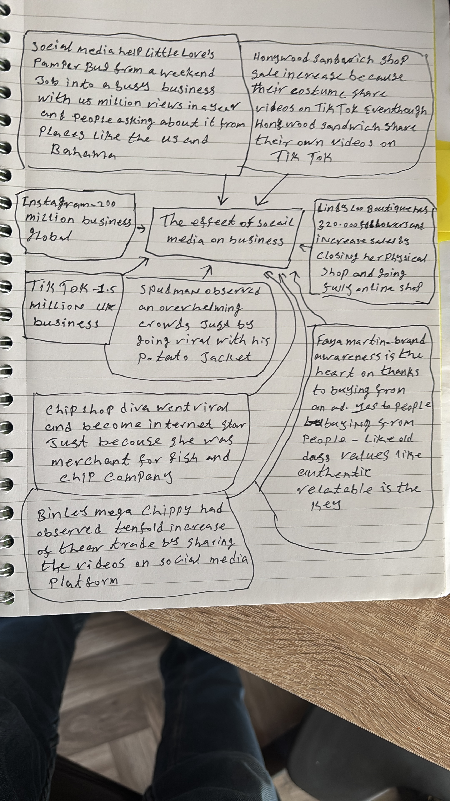

PART 2:
- Answer every question below in 1-3 full sentences.
- Use your own words. Do not use generative AI to answer these questions.
- Include a specific detail from the text when asked.
REMINDER
- The main idea is the overall message of the whole text.
- A key point helps to explain the main idea.
- A specific detail or example from the text shows that the key point is true.

- What is the main idea of the whole text?
- The main idea of the whole text is to describe the effect of social media have on business, especially small local business. It shows that it has a big benefiting and useful effect.

- What is one key point that supports the main idea, and which specific example from the text shows this?
- One key point that supports the main idea is that Instagram holds 200 million business globally, while TikTok holds 1,5 million UK business. This means that it is easier now that people meet people and thereby increase the sales.

- What is a different key point that supports the main idea, and which specific example from the text shows this?
- It is the different successful stories that small local business owner is sharing, and their different way of using social media, but still getting same benefiting result. For example, shares little lovers pamper bus reach 45 million views in under a year, and have request from US and Bahamas.

- Which part of the text do you think is most important, and why?
- The parts, where the shop owners own video didn’t get viral, but his customers video made viral, and because of that shop owner experience increase in sales, this proof why is important people meets people as Faye Martin was stating.

Reflection:
- What did you find difficult in this task (including in-class components), and why was it difficult?
- It was a bit difficult to create a mindmap with describe too much and having too much text, and I still don’t if I need to make shorter and because of some of my classmates has very short text.

- What helped you with this difficulty, and how did it help you?
- To trust myself and know that I will get feedback from my teacher when it is review. I also by telling myself, it is learning process, so it is okay that it is not perfect from the get-go.

