Effective Team Working & Communication

Student Name: | Samuel Yousef Sali
Student Number: | 1710464
Module No: | BMSK4002
Lecture’s Name: | G. COWEN
Semester: | 1

Table of Contents

Introduction .3

Experience in the Process of Communication 3

Interpersonal Communication 4

Models of communication 4

Importance of Communication 6

Communication and Conflicts 6

Teamwork and its Importance 7

Findings and Analysis 8

Improvements in communication skill 8

Conclusion 9

Reference 9

Introduction
From the very beginning of human life, communication is one of the most important things. It means exchanging of one's view with other. This is the modern world and the importance of communication in the workplace can’t be described in words. In the workplace, there need to communicate with different people for various reasons and written communication is the most used communication method (Blanchard, 2000). This report is all about one of my friends named Zara, who is currently working in a restaurant. she described all the details of how she has to communicate with the differentpersonalitieseffective way.
To maintain a better relationship with customer it's important to behave mannerly and she had to answer phone calls or reply various forms of the question in chat or email, taking orders from customers. As the senior manager of the workplace, she had to manage others through the proper use of communication. I am going to describe the communication experience of my friend in this report.
Experience in the Process of Communication
To make the communication most effective, there is different process that is followed by the different organization. In Zara’s workplace, they follow different types of communication. She had experienced both written and verbal communication with different people. Verbal means speaking process of communication and writing is the formal way of communication that dealt with business activities. Here is the different process of communication that Zara experienced:
Letter: Letter is the most common and old format of communication that followed by a different organization (Johnson,2000). It has clear wordings that can briefly make a meaningful sentence with the accurate tone it can solve different conflicts or problems in business purpose. Zara needs to write different letters for various purposes internally or externally.
Report: Report makes the overall analysis regarding the different situation and make final statement. As a senior manager of the restaurant, Zara needs to make an overall report based on analysis or different findings. To organize the report, she needs to collect information verbal or in a written way.
Memos: Memos are prepared for purchasing different materials or equipment’s that are essential for the organization. In the restaurant, Zara needs to purchase different equipment’s or while selling there need to provide memos for the clients.
Informal or Verbal Communication: For internal communication, Zara used to follow verbal communication that helps to understand the overall situation easily. Here are different ways of informal communication:
- Face to face
- Gesture
- Eyes
These methods help to make positive influence in the workplace and improve the understanding with all.
Interpersonal Communication
Zara shared her strategies regarding different interpersonal communication. That helped her to communicate properly with different people through expression or body movements, here is some interpersonal communication that she gathered:
Body Language: Communication through body movements means body language. Zara learned this while communicating with different people in the workplace and that doesn’t make any sound.
Active Listening: Listening helps to learn properly what the speaker wants to say. Zara always listens properly what her senior or junior members want to express. Listening removes different conflicts or makes the best solution to problems.
Customer Service: Zara needs to answer phone calls, take orders or provide different information regarding food or handle any other situation of customers. An effective way of communication helps to get proper customer attention.
Personal Presentation: Zara learned how to present herself properly to the customers. As a Senior Manager, she had to present herself in a good manner that increases overall impression.
Context Awareness: Context awareness helps to let the people aware of what he is doing. Zara has the responsibility to aware others regarding the proper way of working.
Models of communication
In Zara’s Workplace, she had faced different models of communication. From the very beginning of human being, models of communication got improved or modified. Here are different models of communication that Zara shared experience in her workplace:
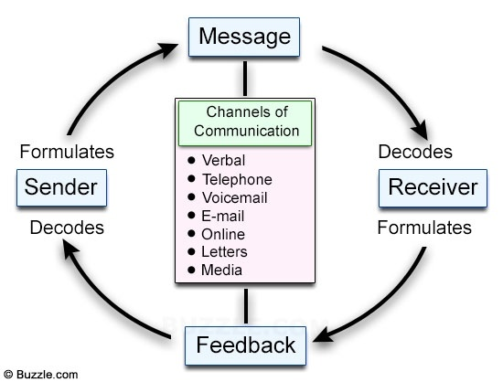
Figure: Linear Model (Bell, 2005)
Linear Model: This is the most common model that used by the different organization. It has one sender and a receiver that message is passed through a channel. Communications are verbal, telephone, voicemail, E-mail, Online chat, Letters or different media (Bell, 2005). In Zara’s workplace, she had to use this form of communication.
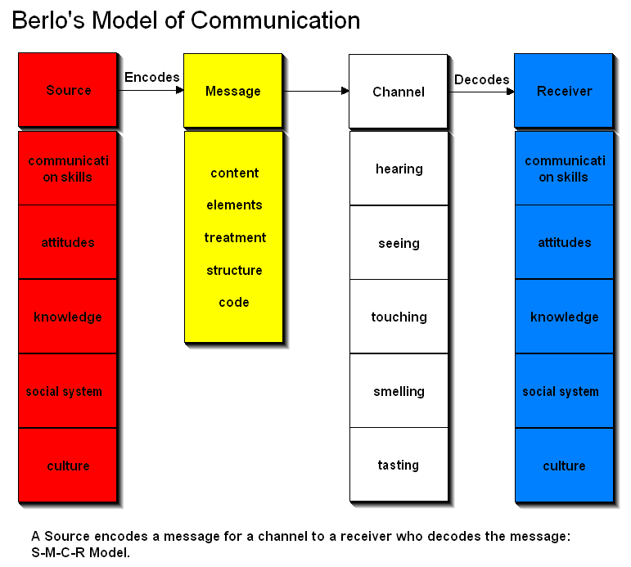
Figure: Berlo’s Model (Cottrell, 2011)
Berlo’s Model: Another way and most used method of communication in Zara’s workplace is Berlo’s Model. It has all the source and advanced way of exchanging various information through communication method. It helps to analyze a different method that has a source, message, channel, and receiver (Cottrell, 2011). As her workplace is a restaurant and she needs to analyze the different form of the channel as hearing, seeing, touching, smelling and tasting the foods that’s why it helps her to collect better feedback from customers.
Importance of Communication
Communication is the most common and important part of an organization that helps to get the final goal (Morgan, 2016). Zara used different ways of communication as per the requirements and here is the importance of communication that she shared with me:
- Communication helps to resolve different problems while working and remove all the conflicts while working.
- Communication makes good bonding inside the organization and helps to get the goals through overall effort.
- Written communication helps to reduce the gap through maintaining confidentiality in the workplace.
- It helps to motivate other people easily that improves the way or working.
- Effective communication makes the complex situation easy and makes a good relationship.
- Cost minimization is another important task of communication by making a proper plan and best decision.
- Communication makes a good environment in the workplace that makes several improvements.
Communication and Conflicts
Everything is not perfect, there is some conflict in every invention (Stegman, 2015). Zara shared some experience regarding communication in the workplace that held due to misunderstanding among all. There are some people who want to make conflict intentionally as well, here are the experience of conflicts through communication in Zara’s workplace:
Personal Problems: Every person is different than others and Zara shared that she has some problems as well. She is very good at communicating and managing other people but she had lack of audience building capacity. Her analytical capability is not strong as well that made some problems in the workplace. Due to work pressure, she becomes angry at times and that made trouble to communicate with other people. Some people also don’t cooperate with her properly that made her work difficult.
Organization Problems: Zara shared some problems in her work as well. As it’s a large restaurant, it's difficult to manage all the people due to the way of communicating. There are some people who don’t work friendly and don’t give proper report or feedback of timely. The modern way of communication should be involved in the workplace that helps to increase the overall working output in her workplace. Some people want to make conflict that leads problem and job left, it makes trouble to run all the process in a smooth way. Passing of communication is not friendly in her workplace, all the notice or information are passed from here to there. Lack of proper structure is making conflict among other that causes difficulty to work. Some customer wants proper support or care from the employees, but due to lack of communication proper information or offers are not passed to the customer on time.
Teamwork and its Importance
Teamwork means working in a group or team way, that helps to make working easy and complete before the lead time. In the workplace, team working is the most important task and that makes the spirit of working among all (Julia, 2017). In Zara’s workplace, they always work in a team manner and Zara has the responsibility to follow up or create all the team. There is a team leader in each team who leads or pass information to all. Zara shared some importance of team working, here are below:
- Teamwork helps to reduce the workload through working in a single way or passing the work to all and make all the working easy.
- Proper communication among all the team member helps to make the work easy and solve on time way.
- Team spirit reduces the conflict among workplace and makes strong bonding that helps to become a strong leader in the market.
- Team working increases overall respect to senior that helps to reduce the gap.
- Through group discussion before any project or task, teamwork helps to increase overall performance by finding out a different solution.
To make the best team, it’s important to follow the communication process in the workplace. Zara shared her experience of effective teamwork, here are the process of effective teamwork through communication:
- Source
- Encoding
- Channel
- Receiver
- Decoding
- Feedback
Source: Information is collected from the proper source than pass it to all so that everyone can follow instruction. That’s why spruce of information is important, usually, sender passes the information to others. Sources are credibility, attractiveness, and expertise. Credibility means find out information is proper or not, attractiveness is assigning work to different members. The manager always has to be experts to make the team working easier.
Channel: Channel is one of the most important factors in communication that makes accurate passes of information to the receiver. Zara uses verbal, oral, telephone, chat, the conference as the channel in her workplace. She also uses some non-verbal or facial expression helps to communicate with internal people in the workplace.
Feedback: Feedback is important to provide the information regarding different attempt and make the final agreement. All the team members work properly to make feedback regarding the work and make the best decision from the information of the sender and the receiver. Feedback can be positive or negative and can be verbal or written (Hoechsmann,2012). As the senior manager, Zara used to provide feedback and manages all of them based on the decision.
Findings and Analysis
After collecting all the information from Zara, it's clear that communication is the most important thing in the workplace. That helps to create a better workplace through making the best decision and manage internal and external people in the organization. Here are some findings and analysis on communication:
- Communication helps to reduce the gap and make the best decision for better performance in the workplace.
- Effective communication helps to manage other people easily.
- Proper feedback in communication helps to make improvements in the workplace.
- Different forms of communication models are made communication easier.
- Verbal communication is used as an internal way that helps to make the best decision and written communication are important to deal with different agreements.
- Information communication helps to deal with the different normal situation.
- Communication and teamwork are linked with each other that improves overall performance.

Improvements in communication skill
Analyzing all the models, skills and information I have made some improvements that are related to increasing the communication skill and performance in the workplace. Here are some improvements in communication and performance:
- Using smaller word and meaning sentences helps to make communication easier.
- There should avoid some word that can hurt others.
- Proper use of communication must need accordingly to increase overall performance through motivation.
- Gathering feedback from different person or clients are necessary to make further improvements
- Should make a calm and quiet environment in the workplace while communicating with others.
- Listen carefully to what the sender wants to say and make the teamwork environment through communication is important.

Conclusion
To sum up the report, it can be said that communication is important to make the best team working and increase overall performance in the workplace. Zara faced different trouble and shared the solution as well as to make the best use of communication. There are different ways that are important to follow accordingly. All these methods will help to remove conflict and make a successful organization.

Reference
Blanchard, K.H.,and Johnson, D.E. (2000) Management of organizational behavior: Leading human resources. 8th edn. United Kingdom: Prentice Hall
Bell, J. (2005) Doing your research project: A guide for first-time researchers in social science, education,and health. 4th edn. Maidenhead, England: Open University Press.
Cottrell, S. (2011) Critical thinking skills: Developing effective analysis and argument (Palgrave study skills). 2nd edn. Basingstoke: Palgrave Macmillan.
Hoechsmann, M. (2012) Media literacies: a critical introduction. Malden, MA., Wiley- Blackwell.
Julia S. (2017). Certificate in Higher Education: Skills for the Workplace Student Yearbook. Sage Publications.
Morgan, P. (2016). The Business Student’s Guide to Study and Employability. Sage Publications.
Stegman, J. (2015). The Importance of Managerial Communication. The Bulletin of the Association for Business Communication, 51(3), pp.25-26.

