Effective Team-working and Communication
Module Code: BMSK4002

Name: Claire Edwards

Student Number: 1812182

Executive Summary
In this report recommendations will be made for Terrance Thomas for his Grocery store in Neath. It will be looking at the importance of effective communication and why two-way communication is essential in business. It will highlight what recommendations are critical for a growing organisation and adapting certain theories will help build teams with existing employees and retraining will help the organisation.

Content Page
Introduction……………………………………………………………………………………………………page 4
Findings………………………………………………………………………………………………………….page 5-8
Conclusion………………………………………………………………………………………………………page 9
Recommendations………………………………………………………………………………………….page 10
Action Plan……………………………………………………………………………………………………..page 11
References……………………………………………………………………………………………………..page 12

Introduction
This report will look at the communication in Terrance Thomas Grocery store, and how adapting certain theories will ensure a thriving business. It will highlight how the organisation communicate verbally and non-verbally to their employees, and the value of team working, how expanding Terrance Thomas business will create a better run company and ensure larger problems do not occur. By retraining staff, they will have a better understanding of their roles within the company and by working as a team, they will understand communication is vital, this will help the leader to improve and have better knowledge of leading a team.
It will also show how using different teaming working exercises and communicating with the staff, will ensure a soaring business. Theories such as Belbin and Tuckman, can guarantee that Terrance Thomas staff communicate in a respectful manner, without unnecessary conflict occurring, and sore to the result successfully and more effectively.

Findings
This report is written for Terrance Thomas regarding his current medium sized grocery store, when a business experiences a rapid growth in a short period of time, managing and communicating effectively becomes a vital importance. To be able to do this in an effective manner means as the business grows, employees must have direction and clear tasks set out for each working shift. This needs to be done in a professional but effective manner. For employees to be able to work as an effective team, employees must know what tasks are expected for each working shift. The recommendation is for Terrance Thomas to schedule individuals their own job roles so that employees will understand and acknowledge what other colleagues are doing.
Team Building
Team building is a course of recognising duties that need individual attention within a work environment. The purpose is to enhance the total achievements in a group of workers that connect as a team. Observations of the team is undertaken on working duties and personal bonds, in particular the team leader’s bond with other team members. (Mullins, L. 1999).
The recommendation for Terrance Thomas staff could be a team building exercise, this would create bonds and friendships in the workplace. Doing the team building, will also create team dynamites so believing and achieving the end goal together will be accomplished.
Definition of Communication
When two or more people interact and speak, they are classed of communicating. Communication is plainly an act of giving and receiving messages from person to person. However, people or groups that communicate, often there are two or more people involved. There is always senders and recipients, making sure that the message gets received in the correct content as messages that are not face to face can be taken out of context.
‘The complexity is why good communication skills are considered so desirable by employers around the world: accurate, effective and unambiguous communication is actually extremely hard. (skillsyouneed.com 2019).
Face to Face communication
These recommendations are to be used for effective face to face communication, the need for a team meeting is essential for the business. The employees must know what is going to be done to structure shifts and rota change that are made, this needs to be done in a meeting that all staff must attend. It is important that communicating with all staff is done in an effective manner and that body language is also kept professional, because body language needs to support words that are spoken.
‘Effective face-to-face communication involves a clear delivery of a message from one person, and appropriate and correct receipt and interpretation of the message by a second person, according to the University of Maine. Aspects like tone, word choice, body language, eye contact and attentiveness can influence whether this type of communication is effective enough to create meaningful dialogue between the two people, or whether it leads to miscommunication and misunderstandings.’ (Oureverydaylife.com. 2019).

Two-way Communication
To ensure communicating with managers and employees is done correctly, it is important for the organisation that their managers can give feedback to employees but also vital that employees can communicate feedback too.
This recommendation shows that two-way communication in a workplace is essential as everyone knows their place and that the sender has sent information that the recipient acknowledges that the message was received.
‘Two-way communication is when one person is the sender and they transmit a message to another person, who is the receiver. When the receiver gets the message, they send back a response, acknowledging the message was received. The model looks like this:
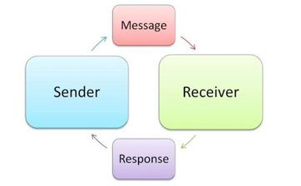 ‘(Study.com. 2019).
This diagram illustrates the cycle of two-way communication, where the sender will send a message to a recipient and the receiver then responses and then the cycle will start again until the communication has come to an end.
Study.com. 2019 acknowledges that when interacting with businesses, it is important that it is a two-way. When information is despatched between key players of the business it is critical so that feedback can let the organisation know that the idea or point was collected and accepted.
Tuckman’s Theory
A recommendation is being made for Terrance Thomas to use certain theory’s in and around the team at the Grocery store, for team building and team exercises the suggestion that is being put forward is Bruce Tuckman’s team working theory. This theory can help break down any barriers in a group of people and build relationships to make a team, it helps sort the difference within the group to make them stronger. Conflict along the way will occur but settle as each individual settle into their team role, when the team have reached their positions within their job role each team member will feel more confident about what has happened and what to do if problems occur again.
Understanding and appreciating the various viewpoints involved in conflict are key factors in its resolution. These are key skills for all team members to develop. The important thing is to maintain a healthy balance of constructive difference of opinion, and avoid negative conflict that's destructive and disruptive. (Mindtools.com. 2019).
This theory is set up of five different but important stages: these stages are 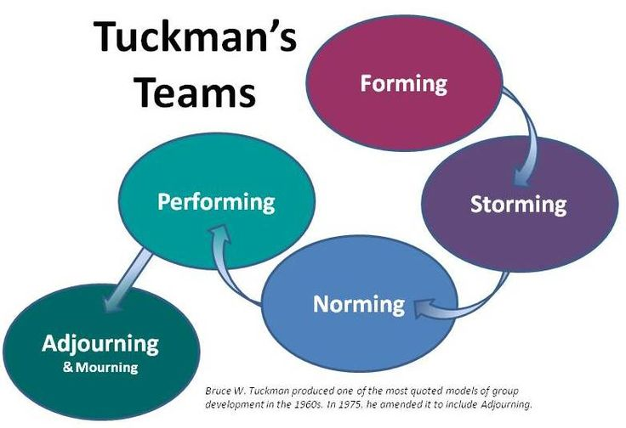 (Uk.images.search.yahoo.com. 2019).
Using these stages, it can help build a team from a group of employees. By letting individuals form they suss the opposition out, then this can lead to discussions of opinions. By the norming and performing stages the team will do tasks without difficulty and Terrance Thomas can feel more at ease within the organisation.
According to Morgan, P. (2017) not all team members will contribute in the same way, everyone will bring something different to the workplace. As this happens, conflict will occur throughout the team. This does not have to be a bad thing, as the employees can express their opinions and have their say. This allows the leader to calm the situation down by acknowledging team members disagreements and discuss them together rather than on their own, so that every1 know their place and know what is expected from them. Once the team has got over their disagreements, as a team, individuals will have to agree on terms along the way so that unnecessary conflict does not occur in future, or how would it be handled better if it was to arise again. As a result of these three stages the team should now have rules and boundaries set, individuals now understand each other better and will fit into the roles that have been given. They start to perform better as a team and therefore the results are soaring.
Belbin’s Theory
To be able to know what type of role employees would need, it is suggested that Terrance Thomas should put forward the Belbin’s questionnaire to his employee’s. This is to figure out what team role everyone would be. Once each employee understands what type of learner they are, it is recommended that Terrance Thomas undergoes a training plan with some of his colleagues.
To continue with the success of the grocery store each employee needs to be able to fall into one of the team roles that is required. In the business, individuals would need to have different skills to manage in the working environment.
By using Belbin, individuals have a greater self-understanding of their strengths, which leads to more effective communication between colleagues and managers. Great teams can be put together, existing teams can be understood and improved, and everyone can feel that they are making a difference in the workplace. (Belbin.com. 2019).
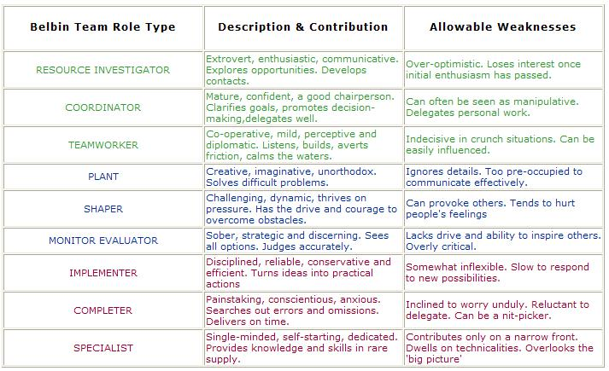 (Uk.images.search.yahoo.com. 2019).

Conclusion
To conclude this report for Terrance Thomas, it is important for the continued success of the grocery store to have effective communication within the workplace, some examples of that could be face to face meetings, meetings via phone or email, this must be done in an orderly manner. Communicating with the employees is essential for the business as employees must know about the change being made, and that implementing rota changes will be done immediately. Effectivity working as a team will help improve job satisfaction and help make communication throughout the workplace much easier.
By the team adapting to each other through team working activities, it will help settle any differences that have occurred and have settle any conflict in an orderly manner. Some individuals will naturally take the lead within the work environment, but each team member must know that communicating with Terrance Thomas is essential.
Understanding and learning as a team is important, not every individual learns in the same way. Finding a balance with employees is essential so that everyone acknowledges their role within the team. Discussions in meeting is important for individuals to express their views with Terrance Thomas and the team, if conflict arises it is important that each member is heard and discusses their view, whilst remembering not all conflict is bad.

Recommendations
In this report the recommendations for Terrance Thomas medium size Grocery store are, regular team meeting to discuss changes in and around the workplace and for employees to discuss concerns with other team members.
Working together within an organisation not only works in employees’ favour but also makes business owners feel more at ease when not in or around the business. Expressions of feelings and points of view can help individuals that do not learn as quickly as others. It has been recommended in the report that team building exercises is essential for growing businesses, for the team members to form bonds and working in a better environment makes a more relaxed shift for employees.
Doing Belbin’s questionnaire to find out what type of worker the employees are will have the organisation, this will determine what training schemes would need to be put in place for certain individuals.

Action Plan
This action plan has been put together using the recommendations that are advising Terrance Thomas throughout the report. The action plan will have tasks that will need to be completed and a time scale that is appropriate for the business.

Task 1 | Rota changes | Within the first two weeks of team meeting.
Task 2 | Team meeting | With immediate effect. (reviewing each month)
Task 3 | Belbin’s questionnaire | Within two weeks of team meeting.
Task 4 | Necessary training for individuals | Should come into effect after staff’s strengths have been evaluate.
Task 5 | Team building exercises | Within the first month of the  Rota changes.

References

2011-2019, (. (2019). What is Communication? Verbal, Non-Verbal & Written | SkillsYouNeed. [online] Skillsyouneed.com. Available at: https://www.skillsyouneed.com/ips/what-is-communication.html [Accessed 21 Jun. 2019].

Belbin.com. (2019). The Nine Belbin Team Roles. [online] Available at: https://www.belbin.com/about/belbin-team-roles/ [Accessed 28 Jun. 2019].

Mindtools.com. (2019). Resolving Team Conflict: Building Stronger Teams by Facing Your Differences. [online] Available at: https://www.mindtools.com/pages/article/newTMM_79.htm [Accessed 2 Jul. 2019].
Morgan, P (2017) The Business Student’s Guide to Study and Employability, London; SAGE publication Ltd
Mullins, L. (1999). Management and Organisational Behaviour (5th edition), London; PITMAN publication

Oureverydaylife.com. (2019). [online] Available at: https://oureverydaylife.com/158753-effective-face-to-face-communication.html [Accessed 21 Jun. 2019].

Study.com. (2019). What Is Two-Way Communication? - Definition, Systems & Examples - Video & Lesson Transcript | Study.com. [online] Available at: https://study.com/academy/lesson/what-is-two-way-communication-definition-systems-examples.html [Accessed 24 Jun. 2019].

Uk.images.search.yahoo.com. (2019). Yahoo is now part of Oath. [online] Available at: https://uk.images.search.yahoo.com/search/images?p=Bruce+Tuckman+theory&fr=mcafee&imgurl=https%3A%2F%2Fronjcharity.files.wordpress.com%2F2010%2F02%2Flearning-theory-teamwork.jpg#id=2&iurl=https%3A%2F%2Fronjcharity.files.wordpress.com%2F2010%2F02%2Flearning-theory-teamwork.jpg&action=click [Accessed 24 Jun. 2019].

Uk.images.search.yahoo.com. (2019). Yahoo is now part of Oath. [online] Available at: https://uk.images.search.yahoo.com/search/images;_ylt=AwrJS9bZ.RldWTUArDsM34lQ;_ylu=X3oDMTB0ZTgxN3Q0BGNvbG8DaXIyBHBvcwMxBHZ0aWQDBHNlYwNwaXZz?p=belbin+theory&fr2=pivweb&fr=mcafee&guccounter=1&guce_referrer=aHR0cHM6Ly91ay5zZWFyY2gueWFob28uY29tL3NlYXJjaD9mcj1tY2FmZWUmdHlwZT1FMjExR0I1MzJHMCZwPWJlbGJpbit0aGVvcnk&guce_referrer_sig=AQAAAArUO904aJuBGKBzgoJViMKH5GZA2IFf6qL0pExorf8UbrdXM4XXXo2mbM6ozV9rSnSM9XfSq9N5fCACWjdyci0pclemASo9ij0LufEdmCA3QEZBL5WsOgzwaqS9ljk_icuSsqoYpeeNAdiDr8dxQMhqLl5tM0JeUTCF3qIbQ8#id=8&iurl=http%3A%2F%2Fwww.pacificconsulting.com.au%2Fimages%2Fbelbin%2520table.JPG&action=click [Accessed 1 Jul. 2019].

