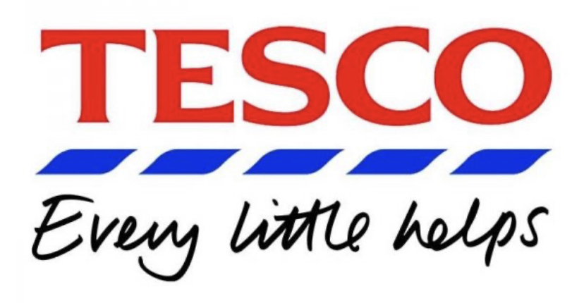
Values, beliefs and attitudes of

Values: An individual’s personal set of principles which one thinks of great importance.
Belief: “An idea that is accepted at true without any facts”
Attitude: A way of feeling or thinking with consideration of something or someone (FutureLearn,2020).

Tesco is one of the biggest supermarket chains in the world. It was found by Jack Cohen in 1919.

Tesco’s mission statement:

“be the champion for customers” (Tesco PLC 2020)

The mission statement of Tesco is an expression of the overall purpose of the organisation (Business Case Studies, 2020).

Tesco’s vision:
“To be the most highly valued business by the customers we serve, the communities in which we operate, our loyal and committed colleagues and of course, stakeholders” (Business Case Studies, 2020).

This vision was created by Tesco to motivate and inspire all of its stakeholders and employees in order to achieve its goals and objectives (Business Case Studies, 2020).

Tesco’s Values, Beliefs and Attitudes

- Be first to meet customers’ needs “No one tries harder for customers”
- Obtain high quality, low priced, sustainable and healthy products
- Consistently better service for its customers
- Excellent teamwork, understand, assist and polite expression
- Every little help makes a big difference
- Committed to customers, colleagues and communities
- Loyalty, trust and respect

Tesco aims to ensure what matters the most to its employees, customers and entire community are understood and improvements are made to those factors that matter. Tesco understand that taking care of its employees in a culture of respect and trust is beneficial to the success of Tesco. Employees of Tesco feel as one is recognised and praised by being rewarded for completing tasks with others. Tesco supports its employees in their developmental stage and as a result the employees try to work hard for customers (Tesco PLC 2020).
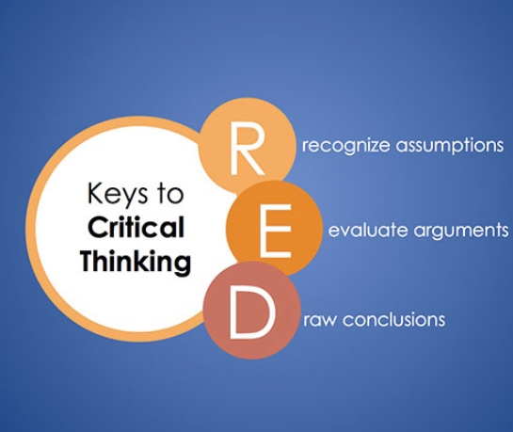
(Talentlens.co.uk 2020)

By applying the RED critical-thinking model,

R – Tesco claims to be first to meet customers’ needs. This is evidenced by the statement “No one tries harder for customers” (Tesco PLC 2020).

E – According to The Grocer, Tesco won The Grocer of the year award 2017. However, in 2018 Tesco suffered a defeat as the organisation’s competitor Aldi won The Grocer of the year award 2018. Aldi is a German grocery chain, One of Aldi’s value is, “We exist to offer the best values for our customers” (Careers.aldi.us, 2020). Aldi asserts that its typical basket of shopping is significantly cheaper in comparison to Tesco. To disprove Aldi’s claim, Tesco CEO Dave Lewis produced a Tesco advert which showed that a basket of shopping of 12 comparable items at Tesco was 74p cheaper in comparison to Aldi. In addition, the world’s largest professional analyst, Monteyne of the European Food Retail reported that, “ultimately you can only really compare prices on products (or services) that are the same. On those comparable ranges, Tesco is as cheap, arguably cheaper, then the discounters” (Grocer, 2020). In 2019 Tesco’s CEO Dave Lewis strived for Tesco to reclaim its rightful The Grocer of the year award 2019 and it was accomplished just like the organisation stated, “No one tries harder for customers” (The Grocer,2020).

D- Tesco is an award-winning grocery chain which highly values its customers as the customers are the key to success of the organisation. Tesco consistently sells low priced, high quality, sustainable and healthy products in relation to this Tesco aims for its products to be sold at a lower price than its competitors.

References:

Careers.aldi.us (2020) Working Here [online] Available at: https://careers.aldi.us/working-here (Accessed on 19/02/2020)

Business Case Studies (2020) Vision-values-and-business-strategies-Business Case Studies [online] Available at: https://businesscasestudies.co.uk/vision-values-and-business-strategies/amp/ (Accessed on 8/02/2020)

FutureLearn (2020) Values, beliefs and attitudes [online] Available at:
https://www.futurelearn.com/courses/supporting-learning-secondary/0/steps/58621 (Accessed on 9/02/2020)

Quinn, I. The Grocer (2020) Can Tesco convince consumers its cheaper than Aldi and Lidl? [online] Available at: https://www.thegrocer.co.uk/prices-and-promotions/can-tesco-convince-consumers-its-cheaper-than-aldi-and-lidl/572624.article (Accessed on 19/02/2020)

Talentlens.co.uk (2020) critical thinking [online] Available at:
https://www.talentlens.co.uk/wp-content/uploads/sites/5/Whitepaper_CriticalThinking_UK.pdf
(Accessed on 11/02/2020)

Tesco PLC (2020) Core Purpose and Values [online] Available at: https://www.tescoplc.com/about/how-we-do-business/core-purpose-and-values/ (Accessed on 8/02/2020)

The Grocer (2020) Grocer Gold Awards 2018: all the winners revealed [online] Available at:
https://www.thegrocer.co.uk/the-grocer-gold-awards/grocer-gold-awards-2018-all-the-winners-revealed/568111.article (Accessed on 13/02/2020)

The Grocer (2020) Grocer Gold Award winners 2019 announced [online] Available at: https://www.thegrocer.co.uk/events/grocer-gold-award-winners-2019-announced/593763.article (Accessed on 9/02/2020)

