Appendices
Appendix 1: Ethics Form.
APPLICATION FOR ETHICAL APPROVAL
In order for research to result in benefit and minimise risk of harm, it must be conducted ethically. A researcher may not be covered by the University’s insurance if ethical approval has not been obtained prior to commencement.
The University follows the OECD Frascati manual definition of research activity: “creative work undertaken on a systematic basis in order to increase the stock of knowledge, including knowledge of man, culture and society, and the use of this stock of knowledge to devise new applications”. As such this covers activities undertaken by members of staff, postgraduate research students, and both taught postgraduate and undergraduate students working on dissertations/projects.
The individual undertaking the research activity is known as the “principal researcher”.
SECTION A: About You (Principal Researcher)
Full Name: |  | Chloe Mai Roberts
Tick all boxes which apply: |  | Member of staff: | ☐ | Honorary research fellow: | ☐
Undergraduate Student | ☒ | Taught Postgraduate Student | ☐ | Postgraduate Research Student | ☐

Faculty/School/Centre: | ITE: Yr Athrofa, UWTSD
Campus: | Carmarthen
E-mail address: | 1600932@student.uwtsd.ac.uk
Contact Telephone Number: | 07548107728
For students:
Student Number: | 1600932
Programme of Study: | BA Primary Education (QTS)
Director of Studies/Supervisor: | Dr Sioned V Hughes

SECTION B: Approval for Research Activity
Has the research activity received approval in principle?  (please check the Guidance Notes as to the appropriate approval process for different levels of research by different categories of individual) |  | YES | ☒ | NO | ☐
 |  |  |  | Date
If Yes, please indicate source of approval (and date where known): Approval in principle must be obtained from the relevant source prior to seeking ethical approval | Research Degrees Committee |  | ☐
 | Faculty Research Committee |  | ☐
 | Other (write in) Module Lead |  | ☒ | 06.02.20

SECTION C: Internal and External Ethical Guidance Materials
Please list the core ethical guidance documents that have been referred to during the completion of this form (including any discipline-specific codes of research ethics, and also any specific ethical guidance relating to the proposed methodology). Please tick to confirm that your research proposal adheres to these codes and guidelines.
UWTSD Research Ethics & Integrity Code of Practice | ☒
UWTSD Research Data Management Policy | ☒
BERA (British Educational Research Association) guidelines - Ethical Guidelines for Educational Research (2018). | ☒
The research is within the bounds of the normal classroom and in accordance with the Athrofa guidelines for parental consent as per Athrofa letter. | ☒
Education Workforce Council (EWC) Research and Ethics Guidelines (2019) | ☒

SECTION D: External Collaborative Research Activity
Does the research activity involve collaborators outside of the University? |  | YES | ☐ | NO | ☒
If Yes, please provide the name of the external organisation and name and contact details for the main contact person and confirmation this person has consented to their personal data being shared.as part of this collaboration.
Institution
Contact person name
Contact person e-mail address

Has this individual consented to sharing their details on this form? |  | YES | ☐ | NO |  |  | ☒
Are you in receipt of a KESS scholarship? |  | YES | ☐ | NO |  |  | ☒
Is your research externally funded |  | YES | ☐ | NO |  |  | ☒
Are you specifically employed to undertake this research in either a paid or voluntary capacity? | Voluntary | YES | ☐ | NO |  | ☒
 | Employed | YES | ☐ | NO |  | ☒
Is the research being undertaken within an existing UWTSD Athrofa Professional Learning Partnership (APLP) | If YES then the permission question below does not need to be answered. | YES | ☒ | NO |  |  | ☐
Permission to undertake the research has been provided by the partner organisation | (If YES attach copy)  If NO the application cannot continue | YES | ☐ | NO |  |  | ☐

Where research activity is carried out in collaboration with an external organisation
Does this organisation have its own ethics approval system? | YES | ☐ | NO | ☒
If Yes, please attach a copy of any final approval (or interim approval) from the organisation

SECTION E: Details of Research Activity
Indicative title: | The relationship between learning environments and well-being.
Proposed start date: | 10/02/20 | Proposed end date: | 01/07/20
Introduction to the Research (maximum 300 words)
Ensure that you write for a Non-Specialist Audience when outlining your response to the three points below:
- Purpose of Research Activity
- Proposed Research Question
- Aims of Research Activity
- Objectives of Research Activity
Demonstrate, briefly, how Existing Research has informed the proposed activity and explain
- What the research activity will add to the body of knowledge
- How it addresses an area of importance.
Purpose of Research Activity
To explore and identify how different learning environments can impact children’s engagement and well-being within the education sector.
(this box should expand as you type)
Research Question
The relationship between learning environments and well-being.

(this box should expand as you type)
Aims of Research Activity

This research aims to identify the benefits and limitations of using different learning environments to teach and how this can affect the way children learn.
Within the research there will be an attempt to discover and compare children’s opinions of different learning environments, e.g. classroom and outdoor learning. Barnes (2015) suggests that outdoor learning can boost children’s creativity and motivate them to engage with tasks. The research activity will take opposing views into account and aim to find out whether different learning environments can lead to different levels of engagement and well-being.
(this box should expand as you type)
Objectives of Research Activity
- To explore the use of different learning environments within a school.
- To observe lessons and children’s reactions in different learning environments.
- To interview staff and children to capture their views on different learning environments and how they impact teaching and learning.
- To critically reflect on findings and consider how I can use this to improve and transform my professional practice.

(this box should expand as you type)
Proposed methods (maximum 600 words)
Provide a brief summary of all the methods that may be used in the research activity, making it clear what specific techniques may be used. If methods other than those listed in this section are deemed appropriate later, additional ethical approval for those methods will be needed.
Interviews- Individual or group interviews from a variety of children across Foundation Phase and Key Stage 2. The children will be asked to respond to key questions relating to their thoughts and preferences regarding different learning environments and where they feel they work best. The setting these questions will be asked in will be informal and I will make notes of their responses or, with their permission, I will make an audio recording. EXIT: The children will not be forced to participate or answer questions. I will ask them if they want to take part and make them aware that they can chose to not answer questions or withdraw from the interview at any time. I will check throughout the interview that they feel comfortable continuing. In my written response I will ensure no names are used.
Additionally, I will interview members of staff. These questions will be of a professional or pedagogical nature. I may also interview other members of staff that do not hold a teaching post e.g. TA or head teacher. EXIT: participation will be voluntary, and this will be expressed to the staff from the onset. They will be informed that they can withdraw from the interview or not respond to a question at any point of time without providing notice.

Observations/Field notes-I will observe different activities or lessons taking place in different learning environments within or outside the school which will enable me to observe good practice and make note of how children respond differently to changes in learning environments. I will make note of children’s engagement during the sessions and record the information in my observational book. EXIT: Both children and staff involved in the observations can request to see the diary at any time and ask for the observation to be removed.

Video or Audio Taping- I will record different groups of children answering questions in the informal interview. Photographic evidence may also be used but I will ensure that none of the children’s faces are in the pictures and that a consent form is signed before this is done. I will ask permission from all participants before recording before doing so. EXIT: Participants will be made aware that this is voluntary, and they can withdraw at any point and ask for the recording to be discarded.

Questionnaire- Depending on the children’s responses throughout the research period, I may create and administer a questionnaire if I believe this will assist me to gather quality data. Throughout the creation of the questionnaire I will adhere to and follow the training provided by the university during my second year of study when the design and distribution of a questionnaire was necessary for a specific module. The questionnaire may focus on qualitative or quantitative data, or both, depending on its focus. Furthermore, the questionnaire may be administered to learners, staff, or both. If a questionnaire is necessary, then participants will not be required to list their name or any personal information. However, they may be asked to share their status in the school (i.e. pupil or teacher) if the questionnaire is completed by both learners and staff. EXIT: Before the participant submits their questionnaire, they have the right to retain their response. However, once I receive the response and it is added to the pool there will be no fair means of identifying their response in order to return it to them. This will be explained before the questionnaires are administered.

Learning walk- To support my research I may conduct a learning walk through the school to observe displays and discus aspects of provision with members of staff or pupils. The learning walk may be self-directed or facilitated by a member of staff, learner or group of learners. EXIT: I will obtain consent from a member of staff. If facilitated I will ask the participant who hosted the walk for consent to use the information they provided in my research.

Examples of pupils’ work- Where I feel examples of pupils’ work would support my research, I may request samples. EXIT: Prior to gathering samples of work I will ensure that I have the class teachers consent and the consent of the pupil to which the work belongs. After gathering the samples, I will take responsibility of the work and ensure confidentiality and security is upheld.
At no times will children’s and adult’s names be recorded.
(this box should expand as you type)

Location of research activity
Identify all locations where research activity will take place.
The proposed research activity will be conducted in a Primary School within the Athrofa.

(this box should expand as you type)
Research activity outside of the UK
If research activity will take place overseas, you are responsible for ensuring that local ethical considerations are complied with and that the relevant permissions are sought. Specify any local guidelines (e.g. from local professional associations/learned societies/universities) that exist and whether these involve any ethical stipulations beyond those usual in the UK (provide details of any licenses or permissions required). Also specify whether there are any specific ethical issues raised by the local context in which the research activity is taking place, for example, particular cultural and/or legal sensitivities or vulnerabilities of participants.
N/A
(this box should expand as you type)
Use of documentation not in the public domain: Are any documents NOT publicly available? | NO | ☒
 | YES | ☐
If Yes, please provide details here of how you will gain access to specific documentation that is not in the public domain and that this is in accordance with prevailing data protection law of the country in question and England and Wales.
(this box should expand as you type)

SECTION F: Scope of Research Activity

Will the research activity include: | YES | NO
Use of a questionnaire or similar research instrument? | ☒ | ☐
Use of interviews? | ☒ | ☐
Use of diaries? | ☒ | ☐
Participant observation with their knowledge? | ☒ | ☐
Participant observation without their knowledge? | ☐ | ☒
Use of video or audio recording (interviews)? | ☒ | ☐
Access to personal or confidential information without the participants’ specific consent? | ☐ | ☒
Administration of any questions, test stimuli, presentation that may be experienced as physically, mentally or emotionally harmful / offensive? | ☐ | ☒
Performance of any acts which may cause embarrassment or affect self-esteem? | ☐ | ☒
Investigation of participants involved in illegal activities? | ☐ | ☒
Use of procedures that involve deception? | ☐ | ☒
Administration of any substance, agent or placebo? | ☐ | ☒
Working with live vertebrate animals? | ☐ | ☒
Other primary data collection methods, please explain in this box  For example, ‘focus groups’. Please indicate the type of data collection method(s) in this box and tick the accompany box. | ☒ | ☐
Details of any other primary data collection method:  Learning walk, Field notes and samples of pupils’ work.  (this box should expand as you type) | ☒ | ☐
If NO to every question, then the research activity is (ethically) low risk and may be exempt from some of the following sections (please refer to Guidance Notes).

If YES to any question, then no research activity should be undertaken until full ethical approval has been obtained.

SECTION G: Intended Participants

Who are the intended participants: | YES | NO
Students or staff at the University? | ☐ | ☒
Adults (over the age of 18 and competent to give consent)? | ☒ | ☐
Vulnerable adults? | ☐ | ☒
Children and Young People under the age of 18? (Consent from Parent, Carer or Guardian will be required) | ☒ | ☐
Prisoners? | ☐ | ☒
Young offenders? | ☐ | ☒
Those who could be considered to have a particularly dependent relationship with the investigator or a gatekeeper? | ☐ | ☒
People engaged in illegal activities? | ☐ | ☒
Others (please identify specifically any group who may be unable to give consent) please indicate here and tick the appropriate box. | ☐ | ☒
Other – please indicate here:  (this box should expand as you type) | ☐ | ☒

Participant numbers and source
Provide an estimate of the expected number of participants. How will you identify participants and how will they be recruited?
How many participants are expected? | About 100 participants in a Primary School.  (this box should expand as you type)
Who will the participants be? | Approx. 1 head teacher, 20 teachers, 80 pupils from Nursery up to Year 6.  (this box should expand as you type)
How will you identify the participants? | Prior to conducting the research, I will discuss and seek advice from the head teacher or senior mentor in the school setting.  (this box should expand as you type)

Information for participants: | YES | NO | N/A
Will you describe the main research procedures to participants in advance, so that they are informed about what to expect? | ☒ | ☐ | ☐
Will you tell participants that their participation is voluntary? | ☒ | ☐ | ☐
Will you obtain written consent for participation? | ☒ | ☐ | ☐
Will you explain to participants that refusal to participate in the research will not affect their treatment or education (if relevant)? | ☒ | ☐ | ☐
If the research is observational, will you ask participants for their consent to being observed? | ☒ | ☐ | ☐
Will you tell participants that they may withdraw from the research at any time and for any reason? | ☒ | ☐ | ☐
With questionnaires, will you give participants the option of omitting questions they do not want to answer? | ☒ | ☐ | ☐
Will you tell participants that their data will be treated with full confidentiality and that, if published, it will not be identifiable as theirs? | ☒ | ☐ | ☐
Will you debrief participants at the end of their participation, in a way appropriate to the type of research undertaken? | ☒ | ☐ | ☐
If NO to any of above questions, please give an explanation
(this box should expand as you type)

Information for participants: | YES | NO | N/A
Will participants be paid? | ☐ | ☒ | ☐
Is specialist electrical or other equipment to be used with participants? | ☐ | ☒ | ☐
Are there any financial or other interests to the investigator or University arising from this study? | ☐ | ☒ | ☐
Will the research activity involve deliberately misleading participants in any way, or the partial or full concealment of the specific study aims? | ☐ | ☒ | ☐
If YES to any question, please provide full details
(this box should expand as you type)

SECTION H: Anticipated Risks

Outline any anticipated risks that may adversely affect any of the participants, the researchers and/or the University, and the steps that will be taken to address them.

If you have completed a full risk assessment (for example as required by a laboratory, or external research collaborator) you may append that to this form.
Full risk assessment completed and appended? |  | Yes | ☐
 |  | No | ☒
Risks to participants
For example: emotional distress, financial disclosure, physical harm, transfer of personal data, sensitive organisational information
Risk to Participant:  The risk to participants is that they be involved in the research without their consent.  There is also the risk that the children might be overwhelmed or upset by the research or feel under pressure to respond.  Anonymity  (this box should expand as you type) | How will you mitigate the Risk to Participant  I will ensure all consent procedures are in place by informing children and staff of my research. I will explain to both parties that they have the right to withdraw and can leave the research or express that they do not wish any data to be used, at any time.  I will always be sure to do frequent well-being checks, reassure the children, praise and thank them for their responses, fostering an  inclusive and accepting environment. Pupils will be told there is no consequence for what they say, I only want open and honest answers which they can choose whether or not to give.  Pupils will be made aware that all data will be anonymised and will remain confidential. They will be aware that no pupil will be able to be identified from the research.  (this box should expand as you type)
If research activity may include sensitive, embarrassing or upsetting topics (e.g. sexual activity, drug use) or issues likely to disclose information requiring further action (e.g. criminal activity), give details of the procedures to deal with these issues, including any support/advice (e.g. helpline numbers) to be offered to participants. Note that where applicable, consent procedures should make it clear that if something potentially or actually illegal is discovered in the course of a project, it may need to be disclosed to the proper authorities
N/A
(this box should expand as you type)
Risks to investigator
For example: personal safety, physical harm, emotional distress, risk of accusation of harm/impropriety, conflict of interest
Risk to Investigator:  Being accused of unprofessional practice.  Allegations from pupils in the classroom whilst completing the research.  (this box should expand as you type) | How will you mitigate the Risk to Investigator:  I will always adhere to the university and BERA ethical guidelines and ensure I have the necessary approval to conduct any research.  The majority of the research is during a normal classroom activity, During the interview, there will be another researcher in the room.  (this box should expand as you type)
University/institutional risks
For example: adverse publicity, financial loss, data protection
Risk to University:  The need to uphold the good name of the University.  Behaving in a way which could impact the relationship between the school and University.  (this box should expand as you type) | How will you mitigate the Risk to University:  I will make sure that I follow the UWTSD and BERA ethical guidelines when conducting my research task.  I will behave in a professional manner, at all times.  (this box should expand as you type)

Disclosure and Barring Service
If the research activity involves children or vulnerable adults, a Disclosure and Barring Service (DBS) certificate must be obtained before any contact with such participants. | YES | NO | N/A
Does your research require you to hold a current DBS Certificate? | ☒ | ☐ | ☐

SECTION I: Feedback, Consent and Confidentiality
Feedback
What de-briefing and feedback will be provided to participants, how will this be done and when?
I will not be providing feedback to participants as it is not relevant for the research. If the participants request feedback from the response then I, as the author, will provide a summary of the data collected.

(this box should expand as you type)
Informed consent
Describe the arrangements to inform potential participants, before providing consent, of what is involved in participating. Describe the arrangements for participants to provide full consent before data collection begins. If gaining consent in this way is inappropriate, explain how consent will be obtained and recorded in accordance with prevailing data protection legislation.
Participation consent – children
I will converse with my class teacher and senior mentor and inform them of the research I will be undertaking, providing reason and rationale behind the research. However, I will verbally ask children identified to participate whether they wish to participate, e.g. use traffic light fans to support the children. If they show the green face, then I know they are happy to take part. If they show the red face, then I know they are not willing. This will be an individual exercise so that children are encouraged to respond honestly with their interest and wellbeing in mind. Children will also be informed that they can approach me at any time and discuss their contribution to the research project and explain whether they wish to participate.

Participation consent — teachers
For the class teachers, I will ask them to sign a document if they agree to take part in the research. If they are not willing to sign this document, then I shall not use them in my research. The consent form will include a box for the participant to tick if they agree with the statements, e.g. I confirm that I have read and understand the information sheet. I have had the opportunity to consider the information, ask questions and had these answered satisfactorily. I understand that my participation is voluntary and that I am free to withdraw at any time, without giving any reason. I understand that any information given by me may be used in future report, articles or presentations by the research team. I understand that my name will not appear in any report, articles or presentations I agree to participate in the above study.

(this box should expand as you type)
Confidentiality / Anonymity
Set out how anonymity of participants and confidentiality will be ensured in any outputs. If anonymity is not being offered, explain why this is the case.
I will ensure that no individual data (raw scores, individual identifiable performance outcomes) are made available to Schools/Parents etc. Only non-identifiable summary/aggregate data can be provided in this way

I will also place a statement on the consent form indicating the 'if you decide to remain anonymous, maintaining your anonymity will be a priority and every practical precaution will be taken to disguise your identity, there will not be any identifying information on audiotapes and transcripts without your prior consent. All materials generated from this or any interview will remain confidential.'

(this box should expand as you type)

SECTION J: Data Protection and Storage

In completing this section refer to the University’s Research Data Management Policy and the extensive resources on the University’s Research Data Management web pages (http://uwtsd.ac.uk/library/research-data-management/).
Does the research activity involve personal data (as defined by the General Data Protection Regulation 2016 “GDPR” and the Data Protection Act 2018 “DPA”)? | YES | NO
“Personal data” means any information relating to an identified or identifiable natural person (‘data subject’). An identifiable natural person is one who can be identified, directly or indirectly, in particular by reference to an identifier such as a name, an identification number, location data, an online identifier or to one or more factors specific to the physical, physiological, genetic, mental, economic, cultural or social identity of that natural person. | ☐ | X
If YES, provide a description of the data and explain why this data needs to be collected:
(this box should expand as you type)
Does it involve special category data (as defined by the GDPR)? | YES | NO
“Special category data” means sensitive personal data consisting of information as to the data subjects’ –  (a) racial or ethnic origin,  (b) political opinions,  (c ) religious beliefs or other beliefs of a similar nature,  (d) membership of a trade union (within the meaning of the Trade Union and Labour Relations (Consolidation) Act 1992),  (e) physical or mental health or condition,  (f) sexual life,  (g) genetics,  (h) biometric data (as used for ID purposes), | ☐ | X
If YES, provide a description of the special category data and explain why this data needs to be collected:
(this box should expand as you type)
Will the research activity involve storing personal data and/or special category data on one of the following: | YES | NO
Manual files (i.e. in paper form)? | ☒ | ☐
University computers? | ☐ | ☒
Private company computers? | ☐ | ☒
Home or other personal computers? | ☐ | ☒
Laptop computers/ CDs/ Portable disk-drives/ memory sticks? | ☒ | ☐
“Cloud” storage or websites? | ☒ | ☐
Other – specify: | ☐ | ☒
For all stored data, explain the measures in place to ensure the security of the data collected, data confidentiality, including details of password protection, encryption, anonymisation and pseudonymisation:
Confidentiality will be upheld by not requesting participant names on any piece of the data collected. Data will be stores in a locket cupboard and password protected computer. Any correspondence between me and my tutor will be through a password protected email account.

(this box should expand as you type)
All Data Storage
Will the research activity involve any of the following activities: | YES | NO
Electronic transfer of data in any form? | ☐ | ☒
Sharing of data with others at the University? | ☐ | ☒
Sharing of data with other organisations? | ☐ | ☒
Export of data outside the European Union or importing of data from outside the UK? | ☐ | ☒
Use of personal addresses, postcodes, faxes, emails or telephone numbers? | ☐ | ☒
Publication of data that might allow identification of individuals? | ☐ | ☒
Use of data management system? | ☐ | ☒
Data archiving? | ☐ | ☒
If YES to any question, please provide full details, explaining how this will be conducted in accordance with the GDPR and DPA (and/or any international equivalent):
Raw data will be available to the university module lead and external examiner, on request. All data will be stored until the relevant research assignment goes through the university exam board. After this point, the data will be destroyed. All data will be archived on password protected OneDrive in line with the UWTSD data management guidelines.

(this box should expand as you type)
List all who will have access to the data generated by the research activity:
Researcher (Chloe Roberts), supervisor, marker

(this box should expand as you type)
List who will have control of, and act as custodian(s) for, data generated by the research activity:
Researcher (Chloe Roberts)

(this box should expand as you type)
Give details of data storage arrangements, including security measures in place to protect the data, where data will be stored, how long for, and in what form. Will data be archived – if so how and if not why not.
Any electronic data will be held on a password protected OneDrive account. Only I will have access to this. Any hard copies of work will be kept in a locked draw. Only I will have access to the key.
All data will be stored until the relevant research assignment goes through the university exam board. After this point the data will be destroyed.

(this box should expand as you type)
Please indicate if your data will be stored in the UWTSD Research Data Repository (see https://researchdata.uwtsd.ac.uk/ ). If so please explain. (Most relevant to academic staff)
N/A

(this box should expand as you type)
Confirm that you have read the UWTSD guidance on data management (see https://www.uwtsd.ac.uk/library/research-data-management/) | YES | ☒
 | NO | ☐
Confirm that you are aware that you need to keep all data until after your research has completed or the end of your funding | YES | ☒
 | NO | ☐

SECTION K: Declaration
The information which I have provided is correct and complete to the best of my knowledge. I have attempted to identify any risks and issues related to the research activity and acknowledge my obligations and the rights of the participants.

In submitting this application I hereby confirm that I undertake to ensure that the above named research activity will meet the University’s Research Ethics and Integrity Code of Practice
Signature of applicant: |  | Date:  06.02.20

For STUDENT Submissions:
Director of Studies/Supervisor: | Dr Sioned V Hughes | Date:  07.02.20
Signature: | S.V.Hughes | Date:  07.02.20

For STAFF Submissions:
Head of School/Assistant Dean: |  | Date:
Signature: |  | Date:

Checklist: Please complete the checklist below to ensure that you have completed the form according to the guidelines and attached any required documentation:
☒ | I have read the guidance notes supplied before completing the form.
☒ | I have completed ALL RELEVANT sections of the form in full.
☒ | I confirm that the research activity has received approval in principle
☐ | I have attached a copy of final/interim approval from external organisation (where appropriate)
☐ | I have attached a full risk assessment (and have NOT completed Section H of this form) (where appropriate) ONLY TICK IF YOU HAVE ATTACHED A FULL RISK ASSESSMENT
☒ | I understand that it is my responsibility to ensure that the above named research activity will meet the University’s Research Ethics and Integrity Code of Practice.
☒ | I understand that before commencing data collection all documents aimed at respondents (including information sheets, consent forms, questionnaires, interview schedules etc.) must be confirmed by the DoS/Supervisor, module tutor or Head of School.
☒ | I have deleted the guidance notes before submitting the PG2 for consideration

Appendix 2: Letter to parents requesting consent for their child to participate in
the research undertaken.
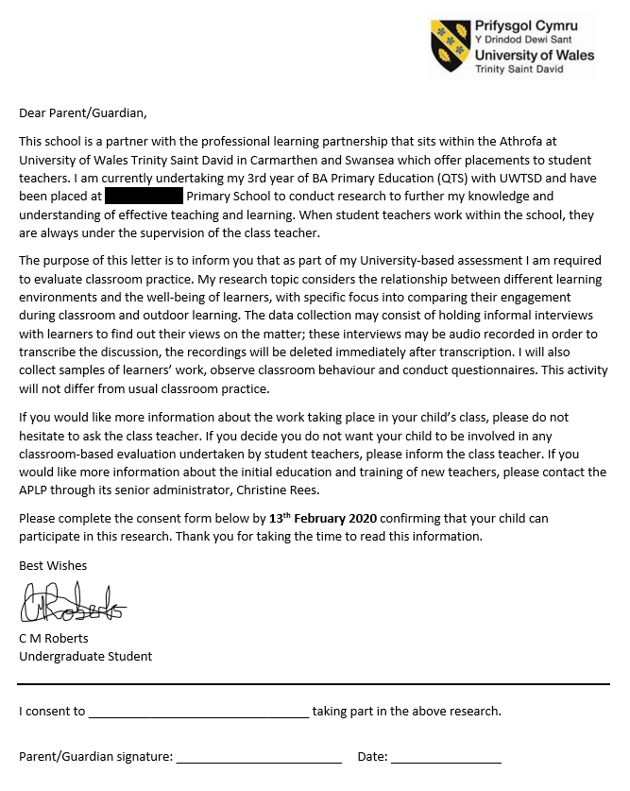

Appendix 3: Participation consent form filled in by any staff participating in the
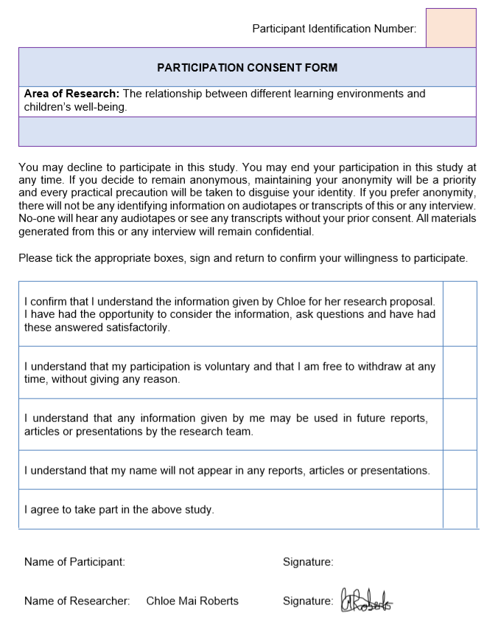
Research.

