


Final Year Project
"The Efficacy of Explosive trace detection kits for Identifying Unknown Samples during Breakdown of Ordnance, Munitions, and Explosives"
by
Andrew R Hurley

1st Supervisor: Jenni Steen
2nd Supervisor: Dave Holley

Project submitted as part of the requirements for the award of BEng (Hons) "OME: Breakdown and Disposals."

Declaration of Originality

I, Andrew Robert Hurley declare that I am the sole author of this Project; that all references cited have been consulted; that I have conducted all work of which this is a record, and that the finished work lies within the prescribed word limits.

This work has not previously been accepted as part of any other degree submission.

Signed : Andrew R Hurley
Date : 24/07/2023

FORM OF CONSENT

I, Andrew Robert Hurley hereby consent that my Project, submitted in candidature for the BEng (Hons) OME degree, if successful, may be made available for inter-library loan or photocopying (subject to the law of copyright), and that the title and abstract may be made available to outside organisations.

Signed : Andrew R Hurley
Date : 24/07/2023
Copyright Acknowledgement

I acknowledge that the copyright of this project report, and any product developed as part of the project, belong to University of Wales Trinity Saint David, Swansea.

Abstract

This paper investigates the effectiveness of Explosive Trace Detectors (ETDs) in identifying pure and impure samples of energetics found during munitions breakdown processing.
The paper discusses the challenges faced by the Munitions Breakdown Team (MBT) in identifying unknown samples and the potential benefits of using ETDs in this context.

The research found that 1 mg of energetic sample, pure or impure, is an adequate sample size to indicate positively with the automated colourimetry ETD. The use of ETDs within the munitions breakdown context will save time and money for QinetiQ and its customers.

Further research is recommended to ascertain whether two separate explosives on one swab would be distinguishable from one another, and expanding the reports knowledge by using the Expray dropper bottles covering chlorate, bromate and peroxide based energetics.

Keywords

– Explosive Trace Detection, Munitions Breakdown, Automated Colourimetry.

Table of Contents
1 Abstract 3
2 Keywords 3
3 List of Figures 7
4 List of Tables 7
5 List of Abbreviations 8
6 Preface 9
6.1 Introduction 9
6.2 Aim 9
6.3 Objective 9
7 Literature Review 10
7.1 Safety and Suitability for Service (S3) 10
7.1.1 Breakdown, Testing and Critical Analysis (BTCA) 10
7.1.2 Munitions Breakdown 11
7.2 Explosive Trace Detectors 12
7.2.1 Technical Overview 12
7.3 Vapour-Based Technology 12
7.3.2 Ion Mobility Spectrometry (IMS) 13
7.3.3 Gas Chromatography-Ion Mobility Spectrometry (GC-IMS) 14
7.3.4 High-Pressure Mass Spectrometry (HPMS) 15
7.3.5 Chemiluminescence 15
7.4 Non Vapour-Based Technology 16
7.4.1 Automated Colourimetry 16
7.5 Comparative Analysis of ETDs 17
7.5.1 Comparative Table of ETD Technology 17
7.5.2 ETD Considerations for Munitions Breakdown 17
8 Experimentation and Methodology 18
8.1 Samples 18
8.1.1 Sampling Considerations for ETD's 18
8.1.2 Sampling Considerations for Munitions Breakdown 18
8.2 Experiments 18
8.2.1 Minimum Sample Mass Experimentation 18
8.2.2 Minimum Concentration for Contamination Experimentation 21
8.3 Health and Safety 22
8.3.1 Experiment/Trial Health and Safety 22
8.4 Energetic Samples 23
8.4.1 RDX 23
8.4.2 HMX 23
8.4.3 TNEB 23
8.4.4 DADN 23
8.4.5 NC200W 23
8.4.6 WC855 24
8.4.7 WC859 24
8.4.8 N06 24
8.4.9 NS 34-10 24
8.4.10 RD1303, Ba(NO₃)₂, CaSi₂ mix 24
8.4.11 RD1337 24
9 Results 25
9.1 Minimum Sample Size 25
9.1.1 High Explosives 25
9.1.2 Propellants 26
9.1.3 Primary Compositions 27
9.2 Minimum Concentration 28
9.2.1 High Explosives 28
9.2.2 Propellants 29
9.2.3 Primary Compositions 30
10 Discussion 31
10.1 Experimentation Learning 31
10.1.1 The ETD Kit 31
10.1.2 Weighing 31
10.2 Minimum Sample Size 31
10.2.1 High Explosives 31
10.2.2 Propellants 32
10.2.3 Primary Explosives 32
10.3 Minimum Concentration 33
10.3.1 Potassium Bromide 33
10.3.2 High explosives 33
10.3.3 Propellants 33
10.3.4 Primary Explosives 33
11 Conclusions and Recommendations 35
11.1 Conclusion 35
11.2 Recommendations 35
12 Acknowledgements 36
13 Works Cited 37
14 Annex and Supporting Documents 40
14.1 Technical Peer Review 40
14.2 Experimentation/Trial Notes 44
14.3 Experimentation/Trial Photo list 53

List of Figures
Figure 1 - IMS Spectra for TNT (Trinitrotoluene 2,4,6) [36] 13
Figure 2 - GC-IMS Diagram [36] 14
Figure 3 - Chemiluminescence Detector Diagram [34] 16
Figure 4 - Blank swab processed 19
Figure 5 - ETD Colour Chart 19
Figure 6 - RDX Crystals 23
Figure 7 - HMX Powder 23
Figure 8 - TNEB Crystals 23
Figure 9 - DADN Powder 23
Figure 10 - NC200W pellets 23
Figure 11 - WC855 pellets 24
Figure 12 - WC859 pellets 24
Figure 13 - N06 propellant 24
Figure 14 - NS 34-10 propellant 24
Figure 15 - RD1303 Mix 24
Figure 16 - RD1337 sample 24

List of Tables
Table 1 - ETD Comparative Analysis 17
Table 2 - Minimum sample size results - High explosives 25
Table 3 - Minimum sample size results - Propellants (SB: Single Base, DB: Double Base, TB: Triple Base) 26
Table 4 - Minimum sample size results - Primary Compositions 27
Table 5 - Minimum concentration results - High Explosives 28
Table 6 - Minimum concentration results - Propellants 29
Table 7 - Minimum concentration results - Primary Compositions 30

List of Abbreviations

BTCA – Breakdown, Testing and Critical Analysis
DB – Double Base
DSA – Defence Safety Authority
ETD – Explosive Trace Detector
GC/IMS – Gas Chromatography/Ion Mobility Spectrometry
GLP – Good Lab Practice(s)
HE – High Explosive
HPMS – High Pressure Mass Spectrometry
HSE – Health and Safety Executive
IMS – Ion Mobility Spectrometry
KBr – Potassium Bromide
MBT – Munitions Breakdown Team
NC – Nitrocellulose
NG – Nitroglycerine
NQ – Nitroganidine
OME – Ordnance, Munitions and Explosives
PPE – Personal Protective Equipment
RD1303 – Lead Styphnate
RD1337 – Lead 2,4 Dinitroresorcinate
SB – Single Base
S3 – Safety and Suitability for Service
TB – Triple Base
VP – Vapour Pressure

Preface

Introduction

Explosives have had civilian and military applications since the 10th century, evolving from gunpowder fireworks to lethal packages used during wartime by armed forces worldwide [1]. In recent years within the United Kingdom, these items of Ordnance, Munitions and Explosives (OME) have undergone various trials and tests to demonstrate their Safety and Suitability for Service (S3) within the armed forces [2].

The Munitions Breakdown Team (MBT) at QinetiQ Fort Halstead are vital to the Breakdown, Testing and Critical Analysis (BTCA) activities conducted on OME. The Breakdown team are responsible for thoroughly inspecting all OME received from stock, in-service and post-trial. The OME is reverse engineered to acquire components and explosive compositions for thorough inspection, testing and critical analysis [3].

Identifying unknown samples encountered during the breakdown process is described as "safety critical" by the customer (Ministry of Defence, BAE, MBDA etc.) and employer [4]. The current process to identify unknown samples is time consuming and requires specialist equipment and expertise. During the identification process, the breakdown process is stopped until the unknown sample can be identified and a suitable, safe way to continue is established [5].

Law enforcement agencies and military personnel have used explosive detection kits widely to identify potential explosives in various settings [6]. However, their efficacy in identifying samples found during the disassembly of OME remains unknown, with no current testing or research.

Aim

This research aims to investigate and assess the effectiveness of explosive trace detectors in identifying the known-pure (bare energetic samples) and known-impure samples (energetics combined with oil, greases and other debris), along with their capacity for identifying unknown samples that arise during the breakdown process.

Objective

This paper will discuss the current literature on explosive detection devices, the challenges faced by the Munitions Breakdown team in identifying unknown samples, and the potential benefits of using explosive detection devices in this context. The findings of this research could have significant implications for improving the safety and efficiency of OME disassembly operations.

Literature Review

Safety and Suitability for Service (S3)

Breakdown, Testing and Critical Analysis (BTCA)

BTCA is a crucial process used in the management and safety assessment of OME. The primary objective of BTCA is to evaluate and understand the life limitations and potential risks associated with OME by examining their components, construction, and design in a systematic manner [2].

Safety Assurance: OME, by nature, are hazardous, incorporating many dangerous materials. They can cause severe injuries, destruction, and loss of life if not handled, stored, and transported safely. BTCA helps ensure these materials are designed and constructed with the highest safety standards, minimising the risks of accidents, misfires, or mishandling [7].
Risk Identification: BTCA aims to identify vulnerabilities, weaknesses, and potential failure points in OME. By analysing the critical components and failure modes, experts can pinpoint means of unintended initiation of the OME and material failures within the design [8].
Compliance: Various national, international, and industry-specific regulations and standards govern the design, manufacture, storage, and transportation of OME. BTCA is an essential tool to assess and demonstrate compliance with these regulations, ensuring that the OME meet safety, environmental, and security standards per the Health and Safety Executive (HSE) and Defence Safety Authority 03-OME documentation [2].
Reliability and Performance: OME are used in critical applications, including military operations and defence systems. BTCA helps assess the reliability of these products, ensuring that they perform as expected in various conditions, which is particularly important for defence and security applications [9].
Root Cause Analysis: In the event of an accident or failure involving OME, BTCA processes can be used to investigate the incident's root cause. Though a long process, it can greatly aid in determining what went wrong and why, leading to improvements in design and safety protocols.
Life Cycle Management: OME typically have a “shelf life”, as their safety and performance can change over time due to factors like ageing, environmental conditions, or handling. BTCA evaluates OME throughout its life cycle, ensuring continued safety and reliability.
Risk Mitigation: Once vulnerabilities are identified through BTCA, appropriate mitigation measures can be developed and implemented to reduce the risks associated. These mitigations/control measures could involve design changes, safety protocols, storage improvements, or changes in handling procedures [8].
Decision Support: The data generated from BTCA is valuable for making informed decisions regarding the use, storage, transport, and disposal of OME. This information helps agencies and organisations to manage their OME stores in a way that minimises risks and maximises safety.
Public Safety: Ensuring OME's safe handling and management is vital for military use, defence purposes, and the general public's safety. Accidents involving OME can have catastrophic consequences and, in worst-case scenarios, affect civilians. Hence, BTCA contributes to public safety and security to ascertain OME's safe use and operation [10].

In summary, Breakdown Testing and Critical Analysis (BTCA) on Ordnance, Munitions, and Explosives (OME) is a systematic process that critically assesses the safety, reliability, compliance, and overall risk associated with these hazardous materials. It helps prevent accidents, protect lives, and ensure OME's secure and effective use in various applications.

Munitions Breakdown

Munitions breakdown as part of BTCA is critical to the retrieval of energetic components/compositions to allow samples for critical analysis/testing to be conducted. It serves several other vital functions, especially in managing and ensuring the safety of OME. Along with the above points (2.1.1), the other essential functions of munitions breakdown are given below.

Munitions Breakdown is involved in assessing the quality and consistency of OME production. OME will be radiographically and visually inspected often repeatedly as the store is taken from all up round to sub-assemblies and components. This process ensures that the munitions are manufactured to meet specific safety and performance standards. Should the quality be sub-standard, this information can then be used to refine the design and construction of the OME for enhanced safety and performance.

Like other products, munitions can change over time due to ageing or environmental conditions. Munitions breakdown can be part of a broader life cycle management strategy to ensure the continued safety and reliability of munitions. Investigating age-related faults such as nitroglycerine leeching from propellants to mechanical failure such as a sheered bolt.

Munitions breakdown can also be used for training. It provides valuable insights into the internal workings of munitions, which can be used for educational and training programs for personnel involved in handling and managing munitions.

In summary, munitions breakdown as part of BTCA is a comprehensive process that plays a vital role in assessing munitions' safety, quality, and performance. It helps prevent accidents, improve design, ensure compliance, and support the safe handling and use of munitions in various applications.

Explosive Trace Detectors

Technical Overview

Explosive trace detectors (ETDs) are chemical detection units that screen and quickly identify explosive residues. In its standard application with anti-terrorist personnel and security teams, this technology relies on the fact that persons who handle explosives will leave trace residue on items they have interacted with. A fingerprint can potentially have an explosive particle mass of 100 μg, with ETDs capable of <1 μg detection limits [11].

The analysis process is designed to be simple to use and read, allowing rapid results. The tested item can be wiped with an adhesive swab, collecting particles off the surface, or placed into a dish/cavity. The instrument inserts, scans, or sprays the sample for analysis without sample preparation. Within a minute, the ETD will indicate a positive or negative for the presence of explosives [12].

ETDs are currently available to purchase on the commercial market and utilise several different measurement technologies; some also utilise multiple detector technologies, where special considerations are needed relating to use; this is discussed further below [12].

Vapour-Based Technology

Vapour-based trace explosive detection is fundamental for understanding vapour pressure (VP). The VP of a chemical compound is a measurement of its tendency to evaporate. The higher the VP of a solid explosive compound, the higher the concentration will be in the air saturated with the compound in vapour form [13].

Generally, for explosive compounds VP doubles with every 5 ºC increase in its temperature. Upon insertion into the instrument, the sample temperature is raised to increase the VP of the explosive compound, increasing the quantity of vapour available for detection. Due to some explosive compounds having naturally low VPs, these may be undetectable even when heated. [12]

Ion Mobility Spectrometry (IMS)

Ion Mobility Spectrometry (IMS) is a technique used to separate ions in the gaseous phase based on differences in their mobility under an electric field [14]. It has historical use for analysing explosives, illicit drugs, and chemical warfare agents [15].

In an IMS-based ETD, the compounds' vapours travel to a section of the instrument where they are exposed to an ionisation device, fragmenting the vapour into one or more distinct ions [16]. These ions enter one end of the instrument's "drift tube" drawn by electrostatic forces into an ion collector at the other end. Different ions travel through the tube at different rates and are collected at differing times. This time difference is measured and represented as an IMS spectrum (a plot of the number of ions collected versus drifted time). When measured this way, many explosive compounds can be identified by the unique IMS spectra they produce.

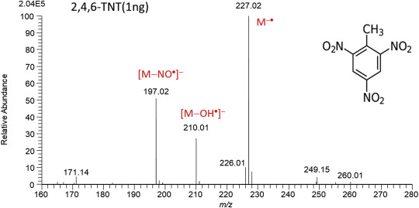
On-board spectrum analysis software compares the samples' IMS spectrum against a library of IMS data from various compounds and elements, to identify the compound present. However, this comparison process is limited being only able to recognise known IMS spectra in the registered database [17].
Figure 1 - IMS Spectra for TNT (Trinitrotoluene 2,4,6) [36]

Gas Chromatography-Ion Mobility Spectrometry (GC-IMS)

Gas Chromatography-Ion Mobility Spectrometry (GC-IMS) is an analytical technology that combines gas chromatography (GC) and ion mobility spectrometry (2.3.2 - IMS). GC-IMS is mainly used to detect trace volatile and semi-volatile organic compounds in different substrates [18]. GC-IMS combines the high separation capability of GC and the rapid response of IMS, making it a robust and easy-to-handle technique. It is widely used and common among trace detectors. The general principles of GC-IMS are presented in several studies; it has been applied to food flavour analysis, drug detection, explosive detection, disease detection/surveillance, and environmental protection [19].

Vaporised explosives compounds first enter the GC segment of the instrument, where they pass through a chromatographic column - a narrow metal tube containing materials (with high temperature stability such as Silicon based oils) named the “stationary phase” that binds to the chemical compounds passing through it. Within that column, chemical compounds are separated based on their volatility; more volatile compounds (those that boil at a lower temperature) pass through the column quicker than less volatile compounds. [20].

As the separated explosives compounds leave the column, they enter the instrument's IMS segment their spectra are determined (as described above 2.3.2). Explosives compounds are identified on the dual basis of their retention times on the chromatographic column and their IMS spectra.
The GC separation is one of the significant advantages of this technique, allowing for the separation of individual compounds during analysis [21].
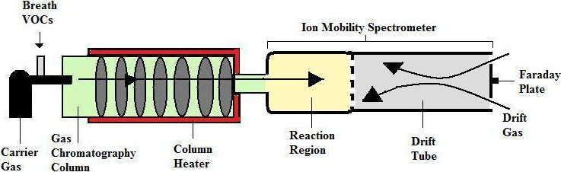
Figure 2 - GC-IMS Diagram [36]

High-Pressure Mass Spectrometry (HPMS)

High-Pressure Mass Spectrometry (HPMS) is an ion measurement technique like IMS (2.3.2). An HPMS-based ETD is a miniature version of a benchtop laboratory mass spectrometer. Benchtop mass spectrometers require heavy, power-intensive turbo-pumps to achieve a sufficiently low pressure for ion measurements. However, the HPMS-based ETD design allows it to make ion measurements at a pressure that, while still relatively low, can be obtained using a small, battery-powered vacuum pump [22].

Sample ionisation process is achieved using a corona discharge device, the ions produced enter the low-pressure portion of the instrument. From there, the ions are guided by electrostatic forces to the mass analyser to be measured. The mass analyser sequentially samples and counts the stream of ions arriving in order of their masses. Measurement data can be represented as a mass spectrum.
The HPMS instrument's analysis software automatically compares the measured mass spectrum against a mass spectrum library of chemical compounds [23]. When matches are found, those explosives compounds are indicated as having been detected.

Chemiluminescence

Chemiluminescence refers to chemical reactions that produce light. In an ETD, explosive compound vapours are heated to a high temperature, causing them to degrade into simple gaseous compounds [24]. The thermal degradation products pass to the detector, where a sensor detects chemiluminescent reactions with the thermal degradation products of nitrogen and peroxide-based explosive compounds. The light output is measured, and at a certain level, the ETD's internal software indicates that an explosive compound has been detected – "Go" or "No-go" [24].

A flaw with this system is that it is designed purely for the indication of the presence of an explosive (nitrogen or peroxide-based). No explosive identity is indicated to the user, so further testing would need to be done should more information on the explosive be required.

Chemiluminescence-based ETDs are also limited to detecting nitrogen and peroxide-based explosives, due to other explosive compounds' inability to be thermally degraded into chemical compounds that undergo chemiluminescent reactions with the detector cartridge sensor material. Additionally, the detector cartridges must be periodically replaced from wear, depending on the frequency of samples analysed which can be costly and time consuming, which is not ideal for field work [25].
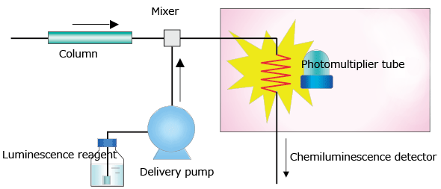
Figure 3 - Chemiluminescence Detector Diagram [34]

Non Vapour-Based Technology

Automated Colourimetry

Colourimetry detection kits are widely used to detect explosives, narcotics and toxic chemical compounds. Users will observe colour changes when a sample containing compounds of interest reacts with the reagent chemicals supplied with the test kit. The colour change occurs when a reagent spray comes in contact with the sample on the test paper [26].

The item to be screened is wiped with a manufacturer-provided detector card and, once sprayed with specific reagents for compound identification, will provide a colour-changing response to indicate whether a compound of interest is present. Colourimetry detection kits can also indicate what compound it could be, depending on the vibrancy of the indicated colour.

For energetics, the reagents react with nitroaromatic compounds, nitroamines, nitroesters and inorganic nitrates. These compounds cover a large majority of explosive compositions though further reagents can be purchased to test for specific energetic makeups such as bromates, chlorates and peroxides [27].

These quick and low-technology kits are advantageous as they allow use in all environments (field work, lab work, building security etc.), though relying on human observation and handling which increases the potential for human error [28].

Comparative Analysis of ETDs

Comparative Table of ETD Technology
Detector Technology | Analysis Modes | Detectable Compounds | Analysis Results | Detection Limits | Analysis Time | Power System | Price Average*
IMS [29] | Swab/  Vapour | Nitrogen- and Peroxide- based | ID (within available libraries) | 1 ng | <25 s | Battery | £21,500
GC-IMS [30] | Swab/  Vapour | Nitrogen- and Peroxide- based | ID (within available libraries) | 1 ng | 20-120 s | Power supply/Mains | £31,000
HPMS [31] | Swab/  Vapour | Nitrogen- and Peroxide- based | ID (within available libraries) | 1 ng | ~60 s | Battery | £56,000
Chemiluminescence [32] | Swab/  Vapour | Nitrogen- and Peroxide- based | Go/No-Go | 10 ng | 2-8 s | Battery | £20,000
Automated Colourimetry [33] | Swab | Nitrogen-, Peroxide-, Chlorate- Based and Bromates** | Go/No-Go + Type | 20 ng | >1 s | N/A | £400
Table 1 - ETD Comparative Analysis
* - Taken from four devices on the market using the same detector technology in 2023
** - To test for peroxides, chlorates and bromates, dropper bottles must be purchased ontop of the regular kit.

ETD Considerations for Munitions Breakdown

Due to the HSE [34] and DSA-OME policies [2], the explosives area at QinetiQ Fort Halstead where munitions breakdown processing is undertaken has contraband rules in-place to limit the potential hazards that could enter the explosive site. Contraband items include electronic devices with removable batteries, or that could emit in the electromagnetic spectrum.
These devices are not permitted as standard, though the business can run tests and request dispensation for use in-area. However, due to the variety of stores being processed, asking for dispensation may take a long time and could limit work if there was a greater potential to interfere on particular stores. This policy, therefore, removes all bar one of the potential detection systems (Figure 4) from use on-site.

Automated colourimetry is non-electronic and requires no power, so this detection system is permitted on-site. It can be used during breakdown processing without increased hazard to the on-site OME, environment or personnel.

Experimentation and Methodology

Samples

Sampling Considerations for ETD's

Regarding the sample mass requirements for ETDs, Figure 4 states that the smallest recorded sample limit would be 20 ng—the most significant sample size limit on all detector types.

20 ng is very small and unlikely to be seen during a munitions breakdown process; samples are often in the milligram range (visible to the naked eye). According to Figure 4, all ETDs have no limitation with sample sizes around 1 mg; however, demonstration of this will be necessary to prove usefulness during processing.

Sampling Considerations for Munitions Breakdown

The samples recovered during any munitions breakdown processes are rarely pure energetics. They can be contaminated with various contaminants, such as dirt, debris, sealants, and oils. Due to this, the ETD chosen will require further testing to prove the reliability of impure sample detection.

Experiments

Minimum Sample Mass Experimentation

Determining the minimum sample mass relevant for munitions breakdown with an Automated-Colourimetry ETD involves a series of experiments establishing the detection limit. Below is the primary experimental methodology.

During setup, there is a requirement to source a representative set of explosive compounds to test - including energetics likely to be found within OME undergoing munitions breakdown processing.
        - All tests are to be conducted in triplicate; the samples of the chosen energetic will be prepared into suitable masses. Beginning with the smallest mass of 0.001 g and increasing successively 0.005 g, 0.010 mg should no positive indication be given. The ETD has failed if there is no positive indication of energetics at 0.010 g.

Accurate mass measurements will be measured with Fisher Scientific scales (DRAE 339449, Calibrated 16/08/2023, Due 08/2024).
        - All explosives shall be handled and weighed using polypropylene-conducting weighing boats in accordance with local procedures and regime conditions.

Expray 1: 100 ml Bottle, Date Opened 12/2/2024, LOT:01510/38/2023, EXP DATE:12/2025

Expray 2: 100 ml Bottle, Date Opened 12/2/2024, LOT:01520/38/2023, EXP DATE:12/2025

Expray 3: 60 ml Bottle, Date Opened 12/2/2024, LOT:01530/33/2023, EXP DATE:12/2025

Methodology:

Take photographs of each swab before and after testing.
Swab removed | Peel Removed | Expray 1 | Expray 2 | Expray 3
 |  |  |  | 
Figure 4 - Blank swab processed

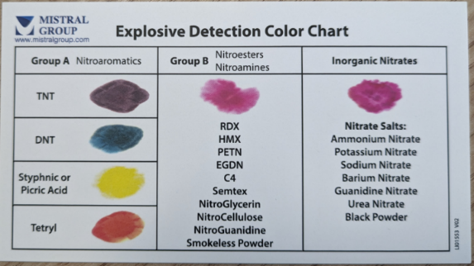
Measure the colourimetric response against a colour chart of the three sprays (without explosives) to establish the baseline or background reading. (This reading serves as a reference for subsequent measurements.)
Figure 5 - ETD Colour Chart
        - Start with the smallest mass of energetics (1 mg) and swab using the kits provided swab. Record the colourimetric response and photograph with each ETD spray before using the next spray (repeat until all sprays have been used).

Continue the above process, increasing the sample mass and repeating until the ETD detects the energetics reliably or reaches the maximum sample size (10 mg), indicating the detection limit.

Statistical Analysis:

Conduct triplicate measurements at each sample mass to account for variability and establish a reliable detection limit.

Repeat with Other Explosives:

Repeat the experiment with different energetic compounds to determine the concentration limit on each explosive.

Data Analysis:

By analysing the data, it should be possible to determine the smallest sample size at which the ETD reliably detects common energetics found during breakdown. Sample size may vary for different energetics; however, there will be a minimum mass that will be reliable on all tested energetics besides anomalies.

Minimum Concentration for Contamination Experimentation

Determining the minimum concentration for a sample required using an Automated-Colourimetry ETD involves a series of experiments. Below is the primary experimental methodology.

Experimental Setup:
During the experimental setup, a representative set of energetic compounds must be sourced to test, including energetics that are likely to be found within OME being processed for breakdown.

Prepare mixtures of the chosen energetics using the minimum detection limit mass found in 2.7.1 and increasing quantities of diluent (Potassium Bromide - KBr).
        - Start with a low explosive to greater diluent ratio, increasing successively to create a range of samples. Ensure accurate concentration measurements.

Accurate mass measurements will be measured with Fisher Scientific scales (DRAE 339449, Calibrated 16/08/2023, Due 08/2024).

All weighing and handling of explosives shall be done using a polypropylene conducting weighing boat in accordance with local procedures and regime conditions.

Expray 1: 100 ml Bottle, Date Opened 12/2/2024, LOT:01510/38/2023, EXP DATE:12/2025

Expray 2: 100 ml Bottle, Date Opened 12/2/2024, LOT:01520/38/2023, EXP DATE:12/2025

Expray 3: 60 ml Bottle, Date Opened 12/2/2024, LOT:01530/33/2023, EXP DATE:12/2025

Methodology:

Take photographs of each swab with the mixture present, then again after each Expray used to record colour response (See figure 5 in 3.2.1.3).

Measure the colourimetric response against a colour chart of the diluent (KBr) to establish the baseline or background reading. (This reading serves as a reference for subsequent measurements - See Figure 6 in 3.2.1.3).

Start with the highest ratio of energetic and KBr (1:99 = 1 %), and swab using those provided within the kit.
        - Spray with each ETD spray, record the colourimetric response, and take photographs of the results before using the next spray (repeat until all sprays have been used or the colourimetric response has been recorded)

Continue the above process, reducing the solution ratio (1:99, 1:19, 1:9, 1:3, 1:1) until the ETD records a colourimetric response. This point indicates the limit of detection for contaminated samples.

Statistical Analysis:

Conduct triplicate measurements at each sample mass to account for variability and establish a reliable detection limit, e.g. all three tests at “α ratio” pass, end of the test. Alternatively, one out of three tests at “α ratio” passed, increase to “β ratio” repeat test in triplicate.

Repeat with Other Explosives:

Repeat the experiment with different energetic compounds to determine the concentration limit on each explosive and see if it varies.

Data Analysis:

By analysing all the datasets from the differing explosive compositions, it should be possible to determine whether contaminated samples can be reliably detected, potentially proving the kit useful to the MBT.

This concentration may vary for different energetics, depending on their characteristics and the sensitivity of the ETD.

Health and Safety

Experiment/Trial Health and Safety

All primary hazards have been risk assessed, hazard stated and listed (See Annex 11.1 & Section 3.4); all personnel commencing this trial will be given a safety brief and follow technical peer review and risk assessments as can be found within the job folder and peer review, this includes PPE, Handling and weighing samples, chemical disposal and Good Lab Practices (GLP).

Energetic Samples

RDX

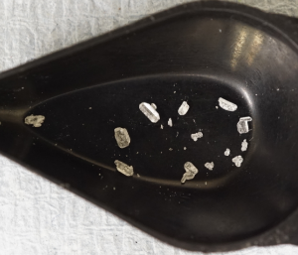
1,3,5-trinitro-1,3,5-triaza-cyclohexane, colloquially known as RDX or Hexogen, is a white solid crystalline high explosive. It is a standard explosive found in various mixtures and compositions and used frequently in all types of OME. C₃H₆N₆O₆ is a nitroamine – Should indicate pink on Expray 2 [35].
Figure 6 - RDX Crystals

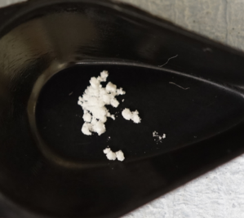
HMX

1,3,5,6-tetranitro-1,3,5,7-tetra-aza-cyclo-octane, HMX or Octogen is a white solid crystalline high explosive. It is commonly found within OME for warheads, stemming, detonators, and sometimes rocket motors. C₄H₈N₈O₈ is a nitroamine – Should indicate pink on Expray 2 [36].
Figure 7 - HMX Powder

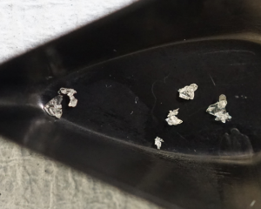
TNEB

1-ethyl-2,4,6-trinitrobenzene, or TNEB for short, is a high explosive used as an energetic plasticiser within explosive mixtures and compositions such as Rowanite 8001. TNEB is a yellow crystalline solid; it is nitroaromatic—should be indicated on Expray 1 [36].
Figure 8 - TNEB Crystals

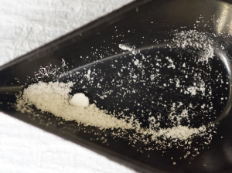
DADN

1,5-Diacetyl-3,7-Dinitro-1,3,5,7-Tetra-azacyclooctane, DADN, is an intermediary High explosive, a derivative of HMX. It is a white crystalline solid material classed as a nitroamine – It should indicate pink on Expray 2 [37].
Figure 9 - DADN Powder

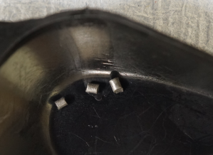
NC200W

NC200W is a single-base nitrocellulose propellant used in igniters and flash generators in general munitions. It is a solid-grain propellant characterised as a nitroester - it should be indicated on Expray 2.
Figure 10 - NC200W pellets

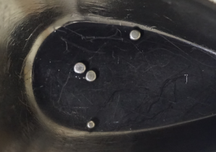
WC855

WC855 is a double-based (nitrocellulose and nitroglycerine) propellant in grain form, used as the main propellant in 30 mm HEDP cartridge ammunition. This propellant is characterised as a nitroester - should be indicated on Expray 2 [38].
Figure 11 - WC855 pellets

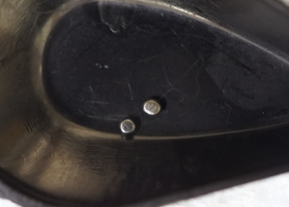
WC859

WC859 is a double-based (nitrocellulose and nitroglycerine) propellant in grain form, used as a main propellant in 20 mm Penetrator cartridge ammunitions. This propellant is characterised as a nitroester – it should indicated on Expray 2 [38].
Figure 12 - WC859 pellets

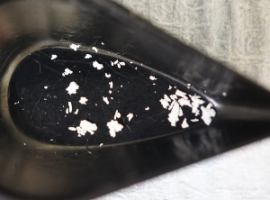
N06

N06 is a triple-based (nitrocellulose, nitroglycerine, and nitroguanidine) solid stick propellant used in artillery shell bag charges and ejection charges within illuminating rounds. As a double-base propellant, it would be classed as a nitroester - it should be indicated on Expray 2.
Figure 13 - N06 propellant

NS 34-10

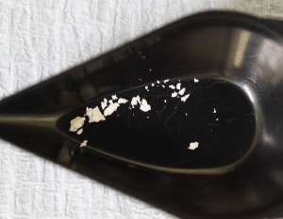
NS 34-10 is a triple-based (nitrocellulose, nitroglycerine, and nitroguanidine) solid stick propellant used in artillery shell bag charges and ejection charges within artillery illum rounds. As a double-base propellant, it would be classed as a nitroester - it should be indicated on Expray 2.
Figure 14 - NS 34-10
propellant

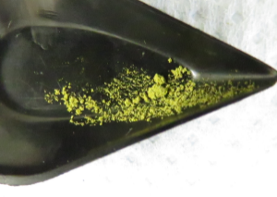
RD1303, Ba(NO₃)₂, CaSi₂ mix

The lead styphnate, barium nitrate, and calcium silicide mix is a primary cap-conducting composition within 30 mm ammunition primer caps. The styphnic acid within the Lead Styphnate is nitroaromatic - should be indicated on Expray 1 [35].
Figure 15 - RD1303 Mix

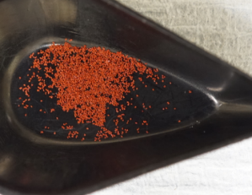
RD1337

Lead 2,4-dinitro-resorcinate is a primary explosive found in various OME detonators and initiators. It is a red solid crystalline composition, characterised as nitroaromatic - it should be indicated on Expray 1 [36].
Figure 16 - RD1337 sample

Results

Minimum Sample Size

High Explosives
Name | Sample | Expray 1 | Expray 2 | Expray 3 | Sample Size
RDX |  |  | 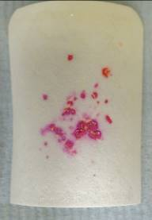 | N/A | 1 mg
HMX |  |  |  | N/A | 1 mg
TNEB |  | 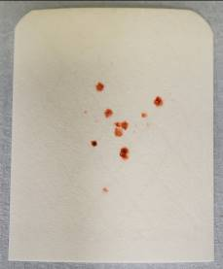 | N/A | N/A | 1 mg
DADN |  |  |  | N/A | 1 mg
Table 2 - Minimum sample size results - High explosives

Propellants
Name | Sample | Expray 1 | Expray 2 | Expray 3 | Sample Size
NC 200W  (SB) |  | 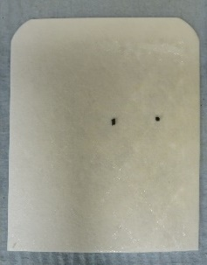 |  | N/A | 1 mg
N 06 (TB) |  |  | 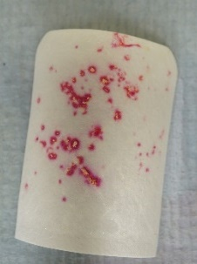 | N/A | 1 mg
NS 34-10 (TB) |  | 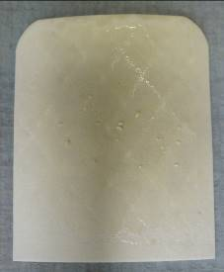 | 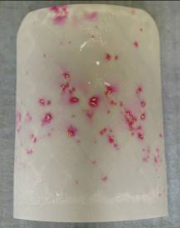 | N/A | 1 mg
WC 855  (DB) |  |  | 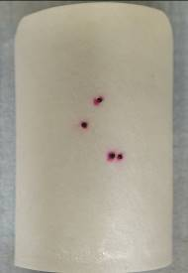 | N/A | 1 mg
WC 859 (DB) |  | 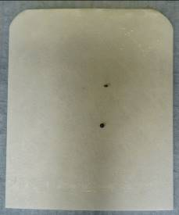 | 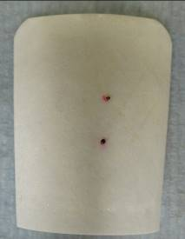 | N/A | 1 mg
Table 3 - Minimum sample size results - Propellants (SB: Single Base, DB: Double Base, TB: Triple Base)

Primary Compositions
Name | Sample | Expray 1 | Expray 2 | Expray 3 | Sample Size
RD1303, Ba(NO₃)₂,  CaSi₂ mix |  |  | 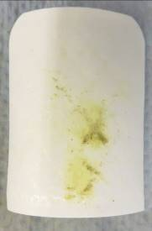 | 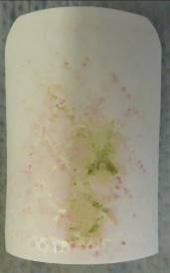 | 1 mg
RD1337 |  |  | N/A | N/A | 1 mg
Table 4 - Minimum sample size results - Primary Compositions

Minimum Concentration

High Explosives
Name | Mixture | Expray 1 | Expray 2 | Expray 3 | Mixture Ratio (Exp:KBr)
RDX | 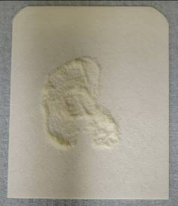 |  | 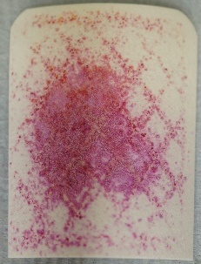 | N/A | 1 mg:99 mg
HMX |  |  | 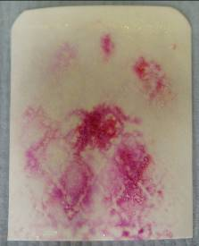 | N/A | 1 mg:99 mg
TNEB | 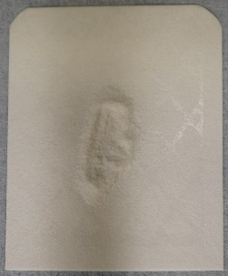 | 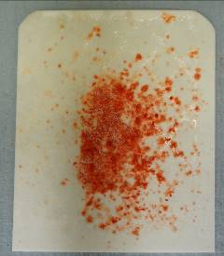 | N/A | N/A | 1 mg:99 mg
DADN |  |  |  | N/A | 1 mg:99 mg
Table 5 - Minimum concentration results - High Explosives

Propellants
Name | Mixture | Expray 1 | Expray 2 | Expray 3 | Mixture Ratio (Exp:KBr)
NC 200W  (SB) | 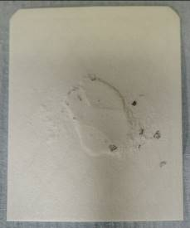 | 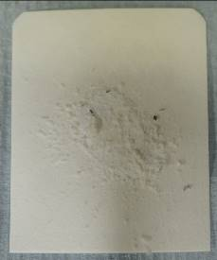 | 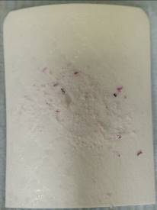 | N/A | 1 mg:99 mg
N 06 (TB) |  |  |  | N/A | 1 mg:99 mg
NS 34-10 (TB) |  |  | 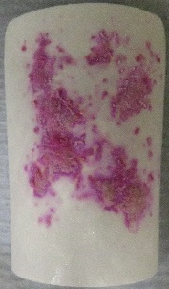 | N/A | 1 mg:99 mg
WC 855  (DB) | 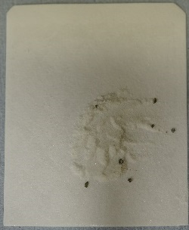 | 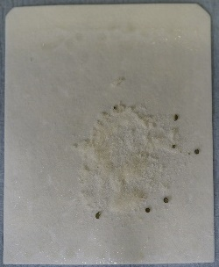 | 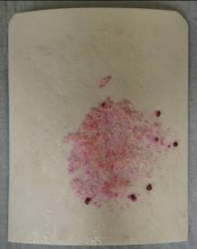 | N/A | 1 mg:99 mg
WC 859 (DB) | 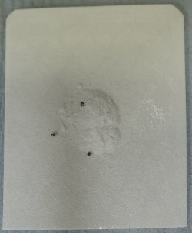 | 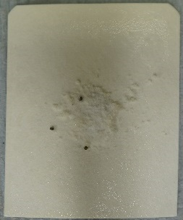 | 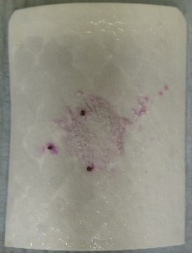 | N/A | 1 mg:99 mg
Table 6 - Minimum concentration results - Propellants

Primary Compositions
Name | Mixture | Expray 1 | Expray 2 | Expray 3 | Mixture Ratio (Exp:KBr)
RD1303, Ba(NO₃)₂,  CaSi₂ mix |  | 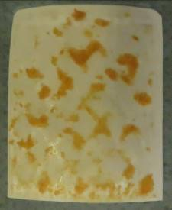 | 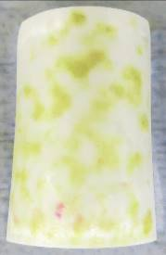 | 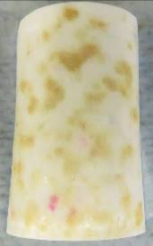 | 1 mg:99 mg
RD1337 | 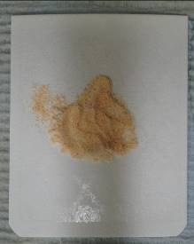 | 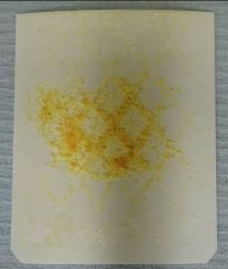 | N/A | N/A | 1 mg:99 mg
Table 7 - Minimum concentration results - Primary Compositions

Discussion

Experimentation Learning

The ETD Kit

During all of the testing, an issue arose surrounding the adhesive used on the swabs; as it is a criss-cross pattern across the swab, not all of the sample would stick to the surface, especially on larger samples masses (E.g. the KBr mixtures). This issue means that upon using the Exprays, the pressure behind the spray would propel some of the sample off the swab before sufficiently wetting and sticking it down. As a result, this required further clean-up after each test to avoid cross-contamination; however, it is unlikely to cause issues when in service.

Weighing

When using the scales (Fisher Scientific—DRAE 339449, Calibrated 16/08/2023, Due 08/2024), accurate readings for all of the samples could take a considerable length of time. The sensitivity could cause fluctuations in the measurement for various reasons, such as increased airflow nearby, mass or pressure on the desktop nearby, and the location of the sample on the weighing plate.

Due to this, consistency when measuring was paramount. All laboratory doors were closed, shutters on the scales closed apart from the top parted open slightly to allow equalisation of pressures, the polypropylene weighing boat had to be placed as centrally as possible, and a consistent measurement readout for five seconds before taking the mass reading.

Minimum Sample Size

High Explosives

During the experimentation, four different HE (High Explosive) compositions were tested three times, each returning a positive indication with 1 mg samples. While most returned a vibrant colour in line with what was expected from the colour chart (3.2.1.6—Figure 6), DADN indicated very faintly with a light pink. This result could prove an issue when in service: users who do not know what to look for, e.g. inexperienced users.

During testing, the user made this error, continuing to spray with the 3rd Expray when unnecessary, as it proved hard to read when the user was used to the vibrant colours seen in previous tests.

From the twelve tests, it was noted that fine-powder samples are more easily seen once sprayed as the powder spreads across the swab at a greater surface area; there is also more surface area on the explosive to react with the Expray. However, the more crystalline samples, while having a smaller surface area across the swab, are still very vibrant in colour locally. All sample types are visible once sprayed at 1 mg.

Propellants

During experimentation of the minimum sample size, five different propellant compositions were tested: 1 x Single base, 2 x Double base, and 2 x Triple base. Each of these was tested in triplicate, totalling fifteen experiments.

During this testing, all propellants indicated positive throughout all tests, though it was noted that grain propellants indicated minimally when sprayed; while still vibrant, they indicated locally around the individual grains; similar to 5.2.1.2, it was noted that surface area was a key variable for vibrancy and quantity of colour in propellants. All sample types are visible once sprayed at 1 mg.

Primary Explosives

Testing RD1303 Mix initially proved an issue due to a human error when reviewing the results. The mixture is a yellow/green colour (See 4.1.3) and should be indicated on Expray 1; however, Expray 1 on styphnic acid results in a yellow indication on the swab. The user missed this yellow indication, assuming it was still the colour of the mixture now wetted by the spray. This error then led to Expray 2 being sprayed, which gave no indication. Expray 3 was then used per the instructions, resulting in a positive result due to the barium nitrate within the composition reacting to Expray 3 as an inorganic nitrate.

The user then continued to the next sample of the triplicate; however, to confuse the matter further, Expray 2 indicated pink. It was learnt after the fact that during the breakdown and drilling of the composition from its primer cap, there rests a nitrocellulose disc on top of the mixture; it is likely that during drilling, some of this disc contaminated the mixture resulting in a positive pink indication of nitrocellulose from Expray 2.

After reviewing the results and photographs, it is clear that the lead styphnate within the mixture did indicate on Expray 1, and thus, no further sprays should have been used.

For the primary explosives, two samples were found creating a total of six tests for minimum sample size, both indicated on Expray 1 as expected. All sample types are visible once sprayed at 1 mg.

Minimum Concentration

Potassium Bromide

Potassium bromide (KBr) was the diluent for the concentration mixtures. Its non-reactivity with all the energetics and Exprays used made it perfect for the experiments.

KBr is, however, a slightly sticky substance, causing some delay and issues when weighing and grinding in the pestle and mortar. This is because we do not want to lose any KBr mass to keep the concentration ratio as accurate as possible.

Overall, KBr proved an excellent imitation for contaminants such as dirt, grease and oil as it was gritty and sticky with no ability to indicate on the swab.

High explosives

Four samples were used for HEs, creating twelve tests. In all tests, the mixture of KBr and HE increased the indication of the energetic on the swab, making it easier to identify and detect. This is likely due to the energetic being ground and mixed into the KBr, thus increasing the total reactive surface area. All sample types are visible at a 1% concentration.

Propellants

During the experimentation of the minimum concentration size, five samples of propellant were used, creating fifteen tests in total: 1 x Single base, 2 x Double base, and 2 x Triple base.

The ball powder propellants (WC855, WC859, NC200W) proved hard to grind into the KBr, often only crushing slightly; this may present a more accurate representation of how the sample would be found in munitions breakdown (non-homogenous), but does mean the tests are not comparative to the same homogeneity of other energetic mixtures used in the experiments All sample types are visible at a 1% concentration.

Primary Explosives

Testing the primary explosives raised one unexpected problem surrounding humidity. To handle the primary explosives, conducting conditions had to be in place: 65%< relative humidity and conducting boots worn. The KBr in high humidity absorbed the moisture in the atmosphere rapidly, causing agglomeration; when ground down with the primary explosives, the mixture would agglomerate together rather than being smooth.

Due to this, when it came time to test the mixture with the Exprays, the mixture lay agglomerated on the swab, and the pressure from the Exprays often caused the mixture to leave the swab. This required extra cleaning and time to make the area safe and free from contamination before the next test.

Two samples were used for the primary explosives, creating six total tests; all tests were successful, indicating Expray 1 for lead styphnate. All sample types are visible at a 1% concentration

Conclusions and Recommendations

Conclusion

Having completed 33 minimum sample tests on 11 samples of various energetic materials, it is evident that 1 mg of energetic sample is an adequate sample size to indicate positively with the automated colourimetry explosive trace detector. An ETD within munitions breakdown could be possible where the sample size is concerned and types of energetics are seen throughout processing. Staff would require training to know what a positive indication looks like and how to identify the group from which the energetic sample is characterised.

Continuing with 33 minimum concentration tests on 11 samples of various energetic materials, all samples indicated at a readable level, some more so than when tested as a pure sample. This result assures that swabbing a sample and any contaminant during breakdown processing will still allow for a correct indication should an energetic be present.

Due to the trials undertaken, there is evidence that automated colourimetry ETDs would benefit the MBT at Fort Halstead. The team will save time on unknown sample identification during breakdown processing using an ETD, saving QinetiQ’s customers money.

Recommendations

During the concentration experiment, rather than grinding the sample and KBr together, mixing to cover more of the sample rather than grinding the sample to mix homogenously could produce a different indication response due to the reduced surface area. Continuing this experimentation may yield more accurate results for contamination or amplify the current results, leading to more confidence in the ETD kit.

Further research could be done to ascertain whether two separate explosives on one swab would be distinguishable from one another or indistinguishable, should they be indicated at all. The results of this experiment would not lessen the results of this report but rather increase the range of abilities these ETD kits have in the broader BTCA context.

Testing of the Expray dropper bottles that indicate the presence of chlorates, bromates and peroxides would benefit and support this research encompassing a greater variety of energetics.

Acknowledgements

A massive thankyou to colleagues at QinetiQ Fort Halstead and staff at UWTSD Swansea for all the help and advice that was given to do these experiments.

Special thanks to:
- D Tod, for the bountiful support in starting the project, technical expertise and proof reading.
- M Gupta for support in the laboratories, GLP, composition understanding, training and primary energetic competence.
- A Head for support in the team aiding in idea creation and proof reading.
- J Hamid for support in the labs giving a space to do the project work, primary energetic competence along with weighing out some samples.
- D Williams for support in the labs, gathering some samples from magazines, giving a space to do the project work, primary energetic competence along with weighing out some samples.
- J Steen for being a wonderfully supportive project supervisor, ever-uplifting through the hard start of the project and title change.
- Munitions Breakdown Team for your unwavering commitment and support towards completing the course and major project, you are an incredible team.

Works Cited

[1] | S. M. Shanley, “INDUSTRIAL EXPLOSIVES - A BRIEF HISTORY OF THEIR DEVELOPMENT AND USE,” Journal of Hazardous Materials, pp. 183-201, 1990.
[2] | Defense Safety Authority, “DSA 03-OME Part 1 - Defense Code of Practice and Guidance Notes for OME Acquisition,” DSA, London, 2019.
[3] | NATO, “AOP-62, In-Service surveillance of Munitions general guidance,” NATO Standards publication office (NSO), Brussels, 2017.
[4] | P. Mostak, “Vapour and Trace Detection of Explosives,” in Vapour and Trace Detection of Explosives for Anti-Terrorism Purposes, Netherlands, Springer, 2004, pp. 23-30.
[5] | C. Klapec DJ, “Interpol review of the analysis and detection of explosives and explosives residues.,” in Forensic Sci Int Synerg, Lyon, 2023.
[6] | K. C. To, “Recent Developments in the Field of Explosive Trace Detection,” ACS NANO, vol. 14, no. 9, pp. 10804-10833, 2020.
[7] | Joint Services Munition Safety Test Working Group, “JOINT ORDNANCE TEST PROCEDURE (JOTP) 001,” NATO, Brussels, 2013.
[8] | Health and Safety Executive, “Risk assessments,” HSE, [Online]. Available: https://www.hse.gov.uk/involvement/riskassessments.htm. [Accessed 26 10 23].
[9] | USA Department of Defence, “Munitions System Reliability,” USA DoD, Washington, 2005.
[10] | Ministry of Defence, “Joint Services Publication 520,” MOD, London, 2015.
[11] | C. L. Rhykerd, “Guide for the Selection of Commercial Explosives Detection Systems for Law Enforcement Applications,” National institute of Justice, Vols. 100-99, p. 124, 1999.
[12] | U.S. Department of Homeland Security, Science and Technology Directorate, “Explosive Trace Detectors (ETD's) - Market Survey report,” National Urban Security Technology Laboratory , Manhatten, 2021.
[13] | D. Ambrose, “Vapor Pressures,” Experimental Thermodynamics, vol. 2, no. 1, pp. 607-656, 1968.
[14] | R. Cumeras, “Review on ion mobility spectrometry. Part 1: current instrumentation.,” Analyst, vol. 140, no. 5, pp. 1376-1390, 2023.
[15] | S. Armenta, “A review of recent, unconventional applications of ion mobility spectrometry (IMS),” Analytica Chimica Acta, vol. 703, no. 2, pp. 114-123, 2011.
[16] | C. Lapthorn, “Ion mobility spectrometry-mass spectrometry (IMS-MS) of small molecules: separating and assigning structures to ions,” Mass Spectrom Rev, vol. 1, no. 1, pp. 43-71, 2013.
[17] | G. S. H. Hill, “Capabilities and limitations of ion mobility spectrometry for field screening applications,” Field analytical Chemistry and Technology, vol. 1, pp. 119-134, 1997.
[18] | J. Yin, “Application and development trends of gas chromatography–ion mobility spectrometry for traditional Chinese medicine, clinical, food and environmental analysis,” Microchemical Journal, vol. 168, pp. 026-265, 2021.
[19] | C. Weller, “Non-Targeted Screening Approaches for Profiling of Volatile Organic Compounds Based on Gas Chromatography-Ion Mobility Spectroscopy (GC-IMS) and Machine Learning,” Molecules, vol. 26, no. 18, pp. 54-57, 2021.
[20] | R. P. Erickson, “Closed tube sample introduction for gas chromatography–ion mobility spectrometry analysis of water contaminated with a chemical warfare agent surrogate compound,” Analytica Chimica Acta, vol. 556, no. 2, pp. 455-461, 2006.
[21] | P. A. Snyder, “Portable hand-held gas chromatography/ion mobility spectrometry device,” Analytical Chemistry, vol. 65, no. 3, pp. 299-306, 1993.
[22] | K. H. B. Miller, “Development of High-Pressure Mass Spectrometry for Handheld and Benchtop Analyzers,” in Portable Spectroscopy and Spectrometry, Chichester, John Wiley & Sons Ltd., 2021, pp. 391-413.
[23] | T. McMahon, “High Pressure Mass Spectrometry,” in Energetics of Stable Molecules and Reactive Intermediates, Dordrecht, Springer Netherlands, 1999, pp. 259-280.
[24] | A. J. Navas, “Chemiluminescnce detection systems for the analysis of Explosives,” Journal of Hazardour Materials, vol. 106, no. 0304-3894, pp. 1-8, 2004.
[25] | J. Yinon, Counterterrorist Detection Techniques of Explosives, Amsterdam: Elsevier Science, 2007.
[26] | M. K. McPherson, “Explosive Detection Equipment Program,” in IEEE International Carnahan Conference on Security Technology, San Jose, 2010.
[27] | T. S. Andrew Trisha, “Detection of Explosives via Photolytic Cleavage of Nitroesters and Nitramines,” The Journal of Organic Chemistry, vol. 76, no. 9, pp. 2976-2993, 2011.
[28] | R. A. Crocombe, “Field-portable detection of fentanyl and its analogs: A review,” Journal of Forensic Sciences, vol. 68, no. 5, pp. 1570 - 1600, 2023.
[29] | Bruker, “Road Runner Explosive Trace Detection,” Bruker Optics, Billerica, MA, 2021.
[30] | Anchortex, “Scintrex Trace EN5000 GCIMS,” Anchortex, Berlin, 2015.
[31] | 908 Devices, “MX 908 Mass Spectrometer,” 908 Devices, Boston, MA, 2019.
[32] | rsdynamics, “miniEXPLONIX3,” RS Dynamics, Zug, Switzerland, 2019.
[33] | Westminster International, “Explosive Detection Identification Field Test Kit,” ADS, Banbury, 2020.
[34] | Health And Safety Executive, “Explosive licensing,” HSE, [Online]. Available: https://www.hse.gov.uk/explosives/licensing/. [Accessed 27 10 2023].
[35] | The Royal Military College of Science, Chemical Aspects of Explosives and Propellants, Shrivenham: The Royal Military College of Science, 1971.
[36] | The Royal Military College of Science, Introduction to Explosives, Shrivenham: The Royal Military College of Science, 1984.
[37] | M.D.Coburn, “Process-Development Studies on 1,5-Diacetyl-3,7-Dinitro-1,3,5,7-Tetra-azacyclooctane (DADN), an intermediate in a new synthesis of HMX,” Los Alamos Scientific Laboratory, New Mexico, 1974.
[38] | General Dynamics, Ordnance and Tactical Systems, “Ball Powder Propellants,” 21 05 1998. [Online]. Available: https://www.gd-ots.com/propellants/ball-powder-propellants/#. [Accessed 06 01 2024].
[39] | Shimazdu, “About Chemiluminesence Detection,” Shimazdu, [Online]. Available: https://www.shimadzu.com/an/service-support/technical-support/analysis-basics/basic/chemiluminescence_detection.html. [Accessed 26 10 2023].
[40] | D. T. Yamabe, “A novel contrast of the reactions of 2,4,6-trinitrotoluene (TNT) in atmospheric-pressure O2 and N2 plasma: Experimental and theoretical study,” International Journal of Mass Spectrometry, vol. 440, no. 1387-3806, pp. 116-308, 2020.
[41] | T. Mathew, “Technologies for Clinical Diagnosis Using Expired Human Breath Analysis,” Diagnostics, vol. 5, no. 5010027, pp. 27-60, 2015.

Annex and Supporting Documents

Technical Peer Review

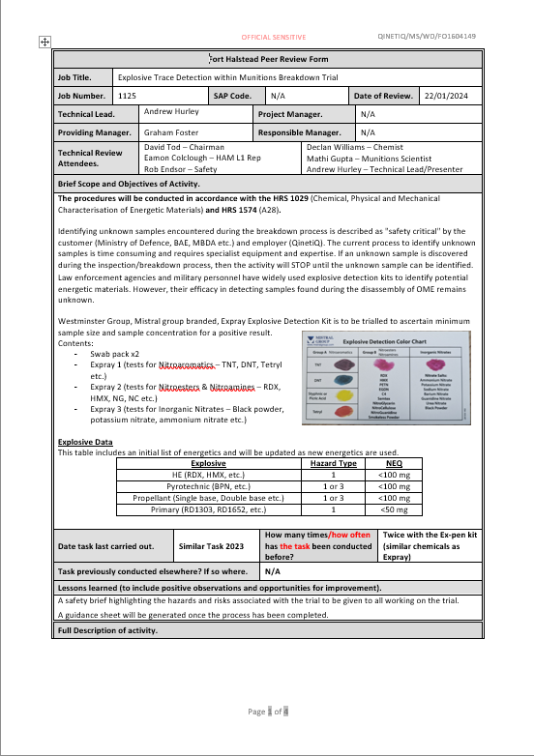



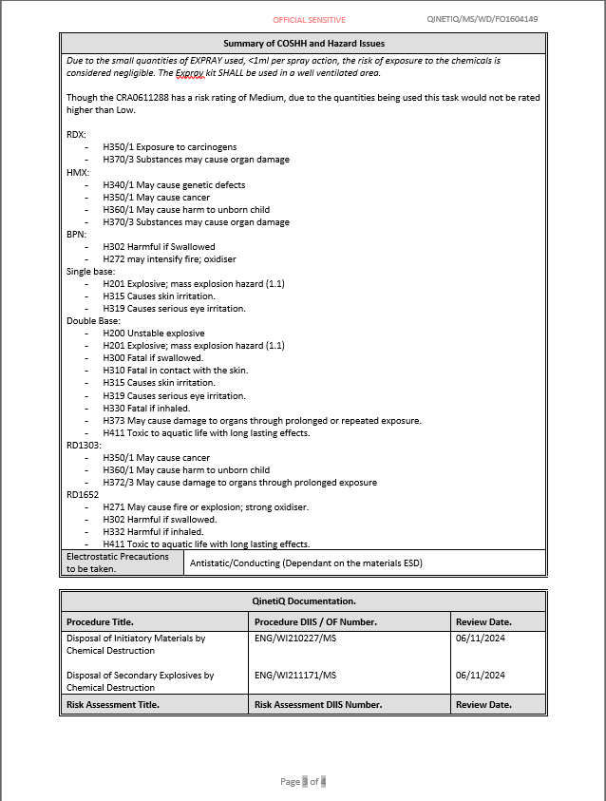

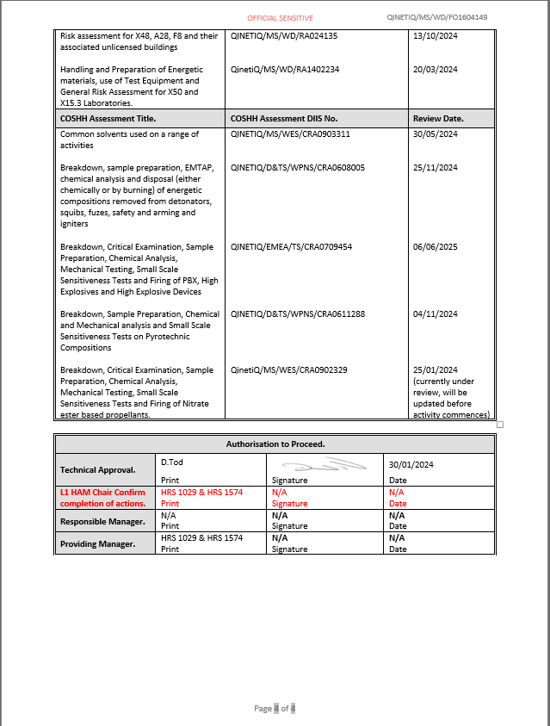

Experimentation/Trial Notes

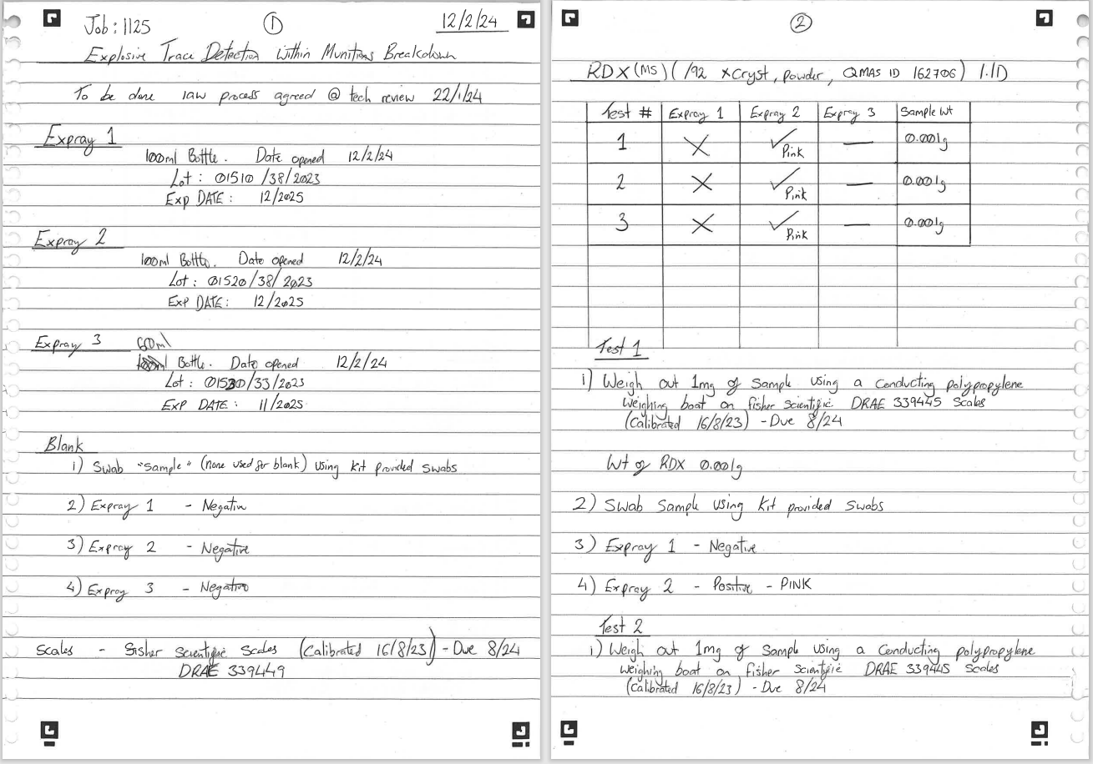

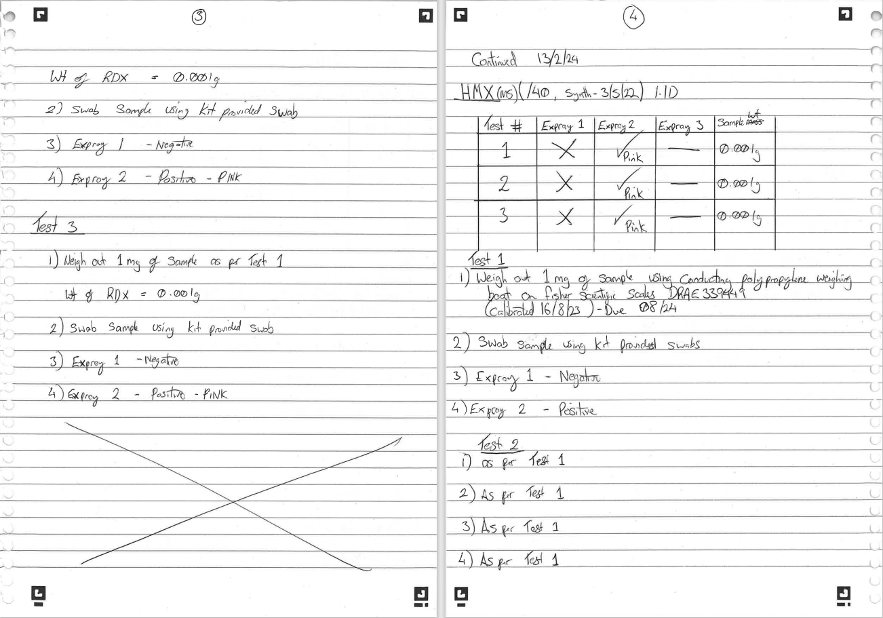

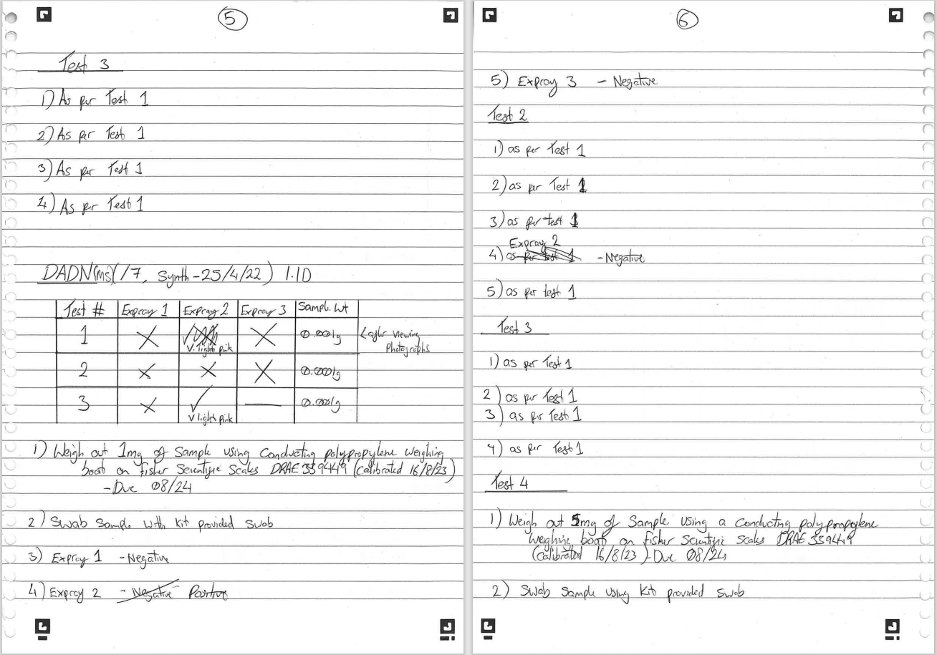

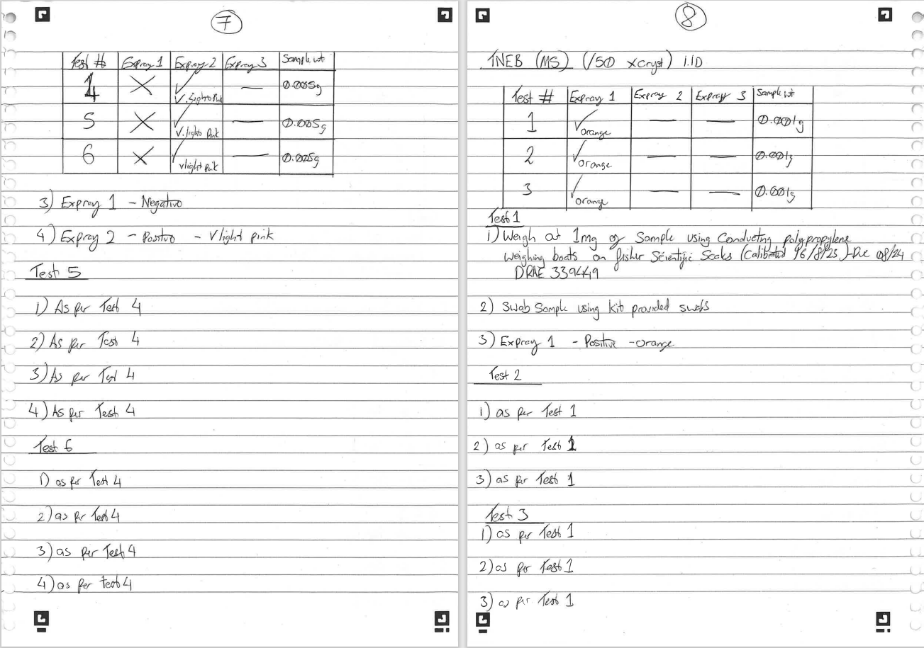

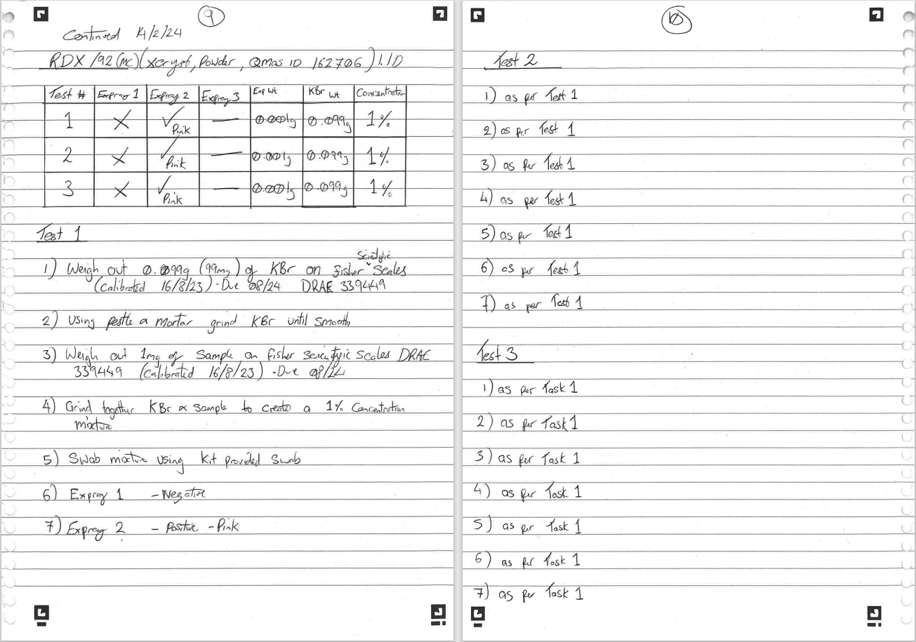

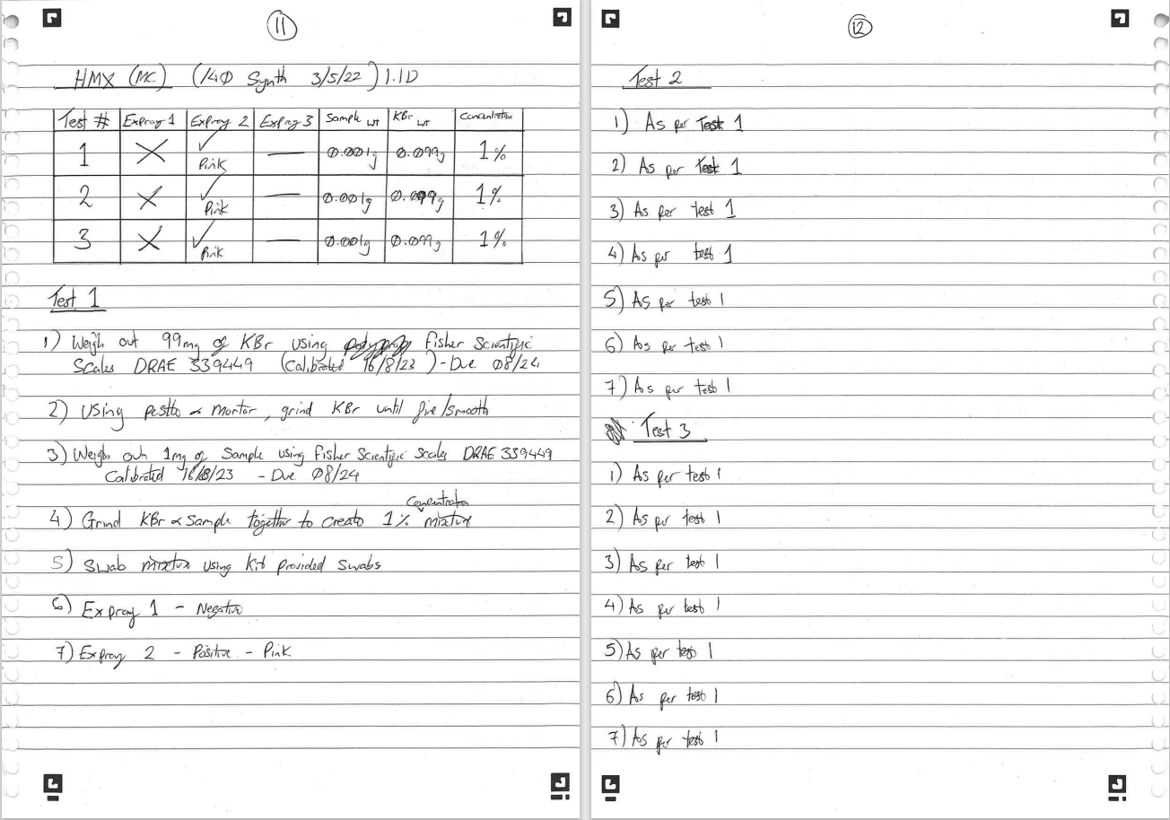

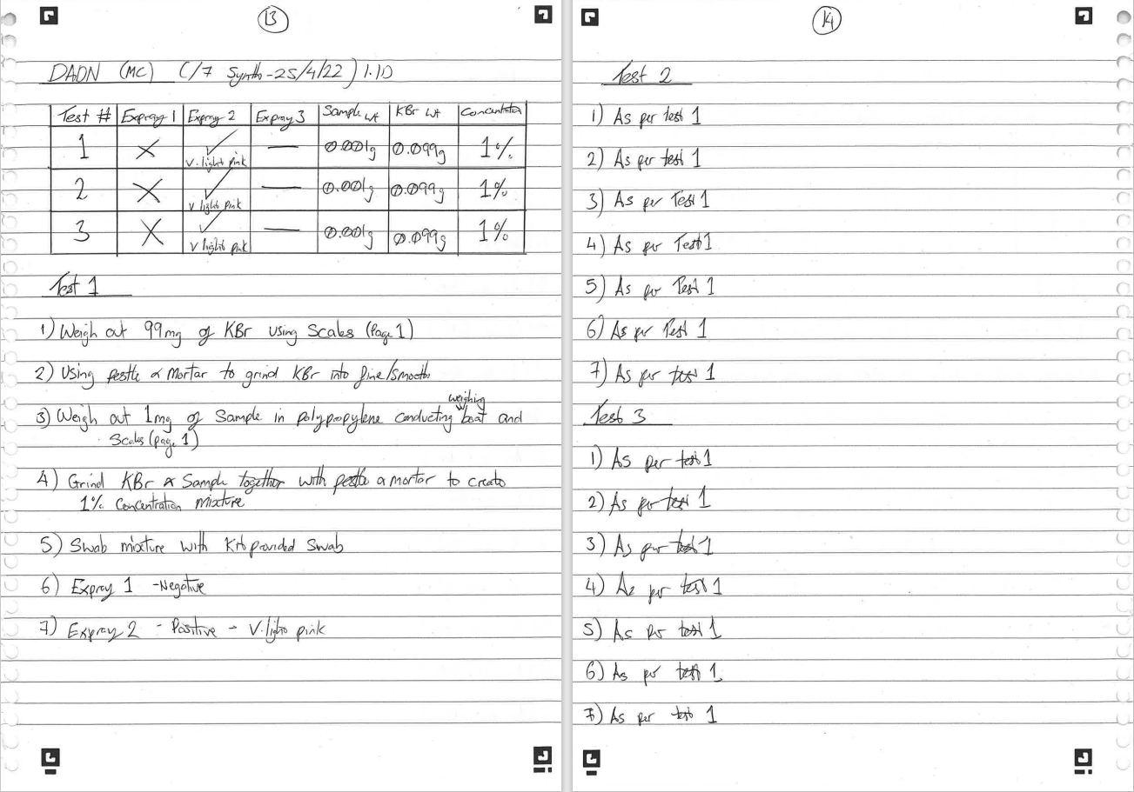

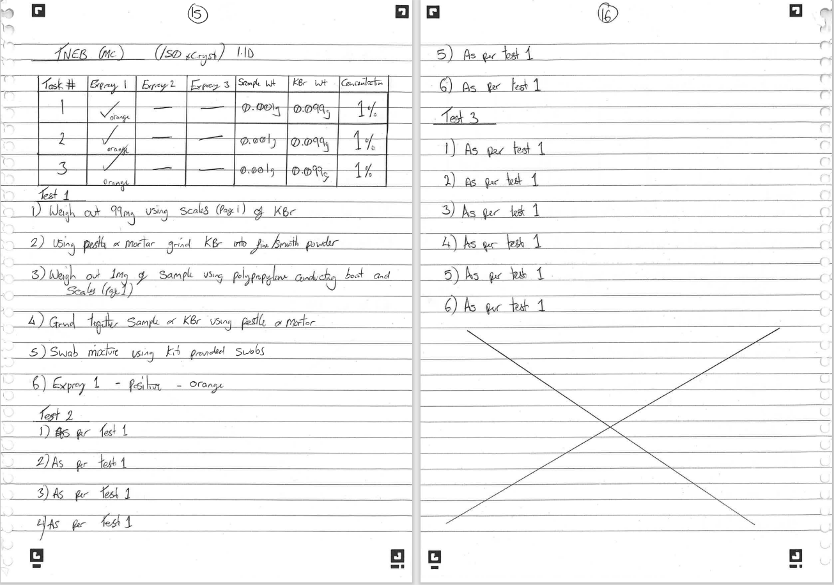

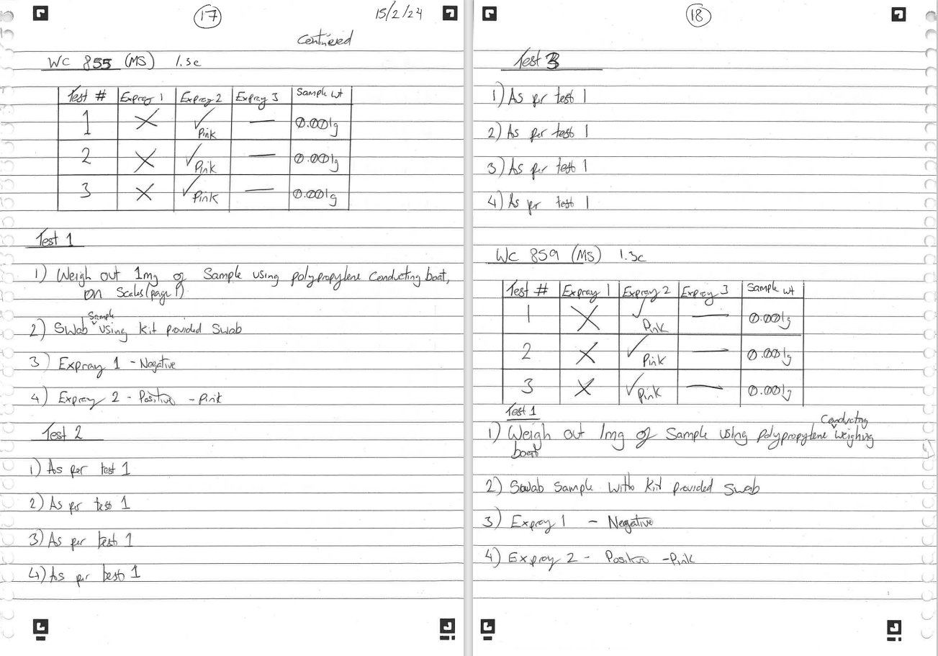

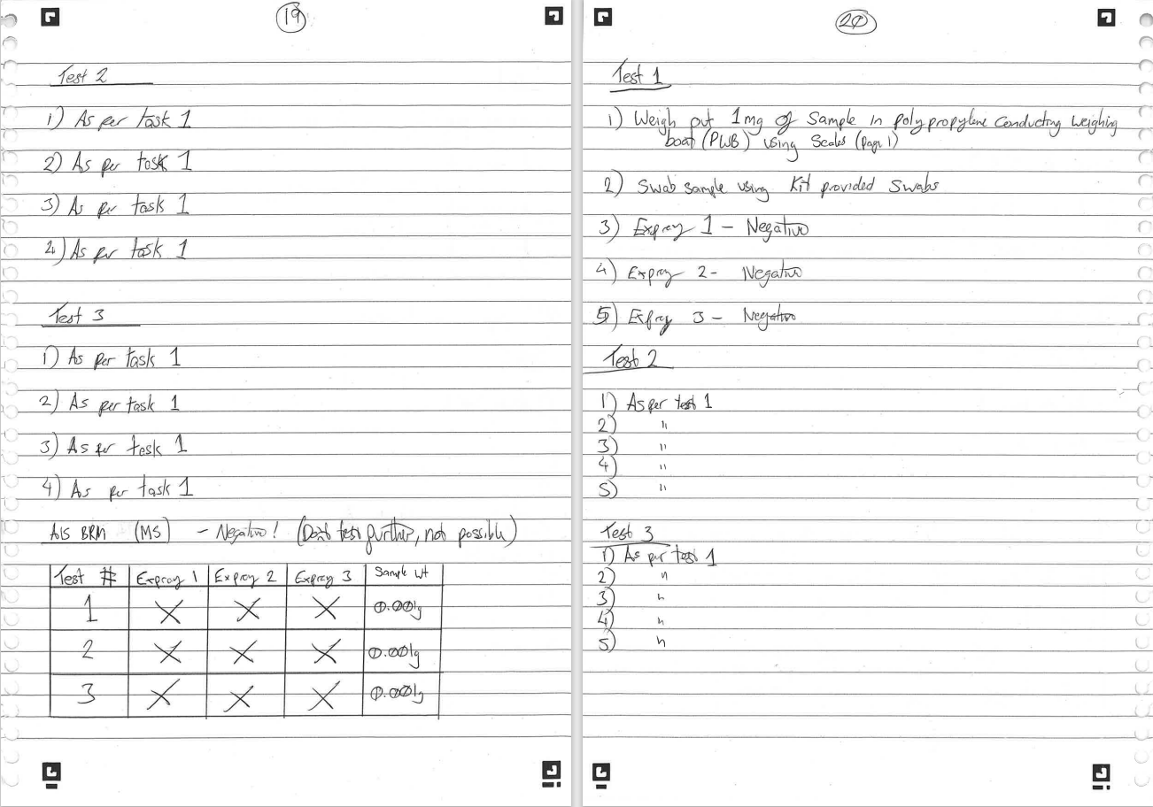

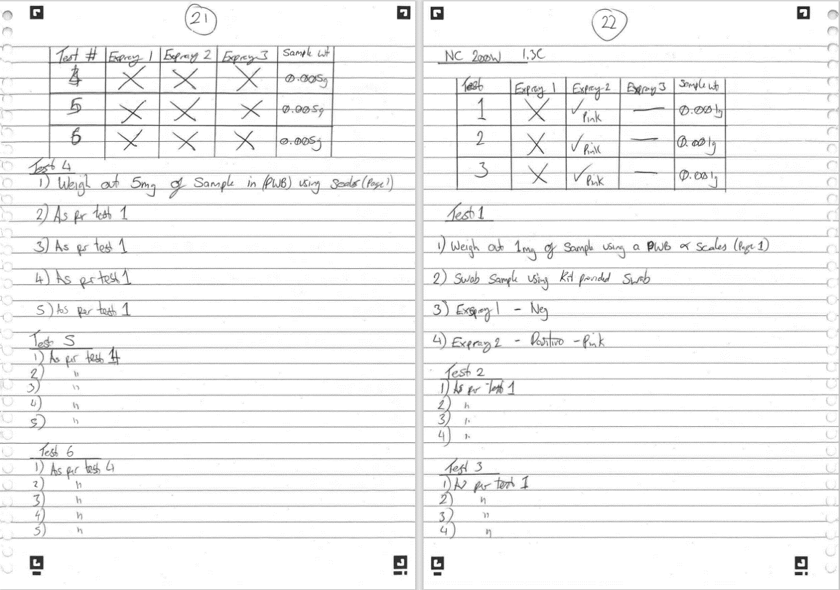

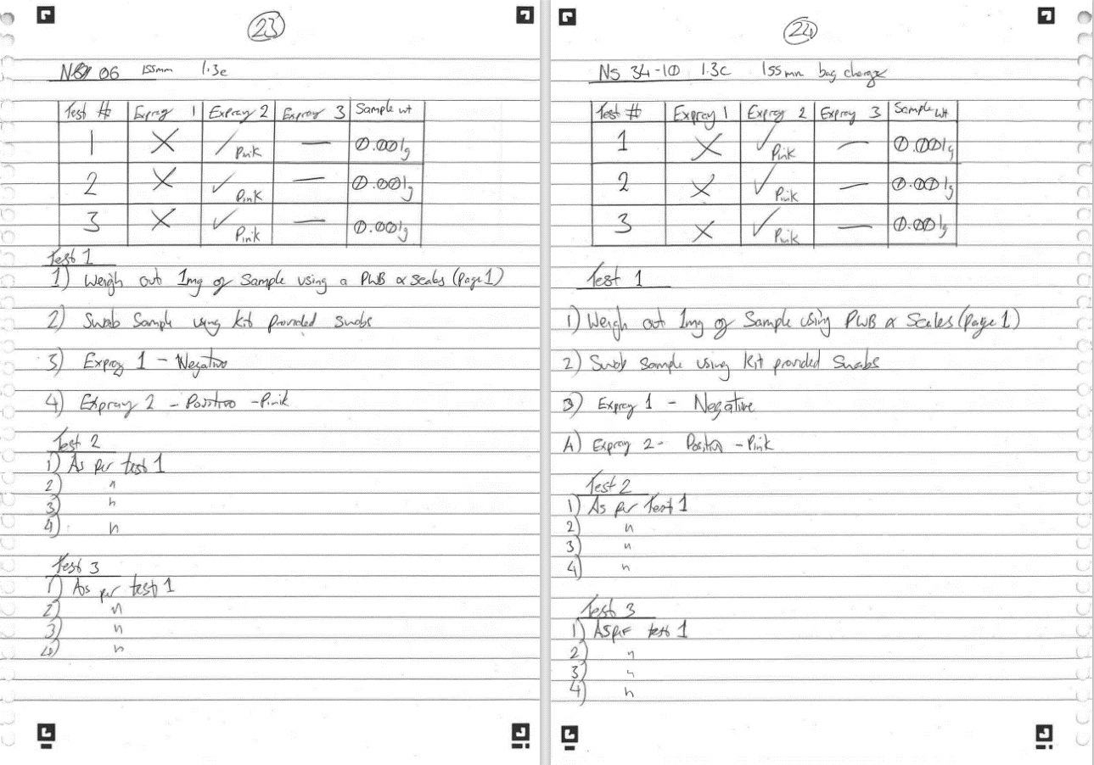

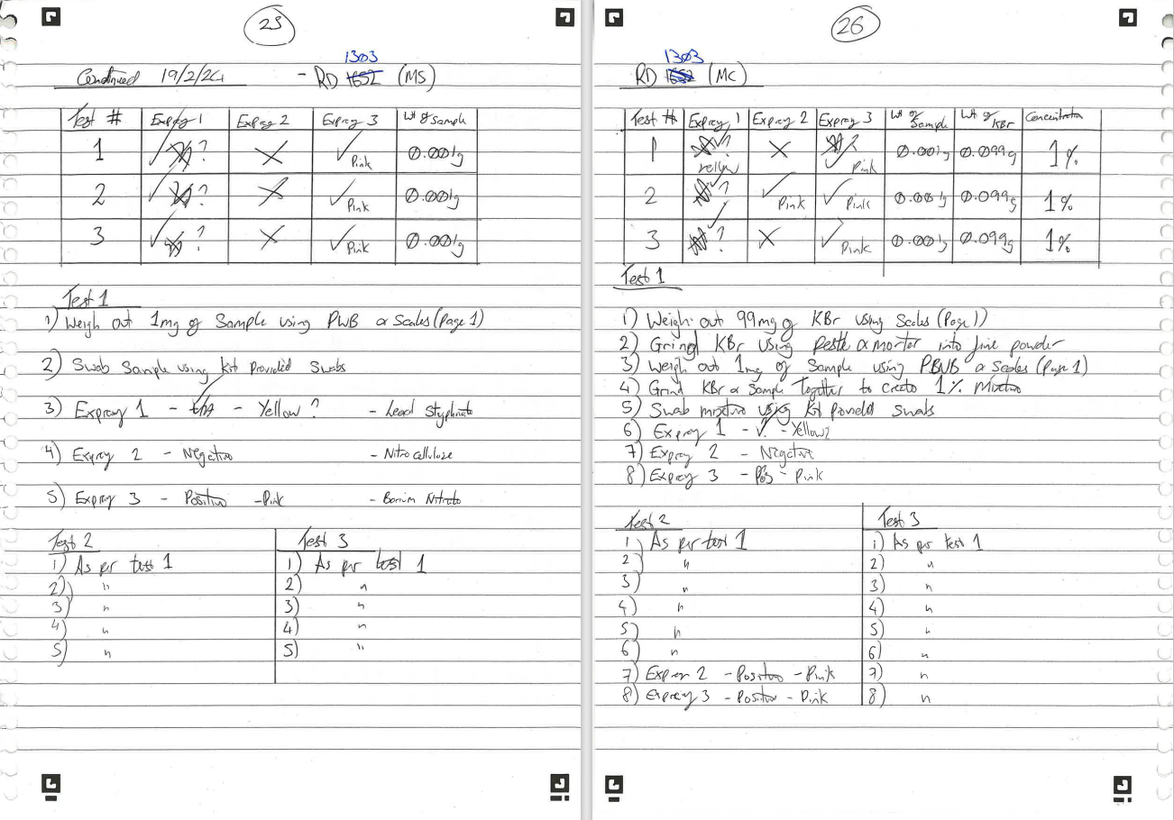

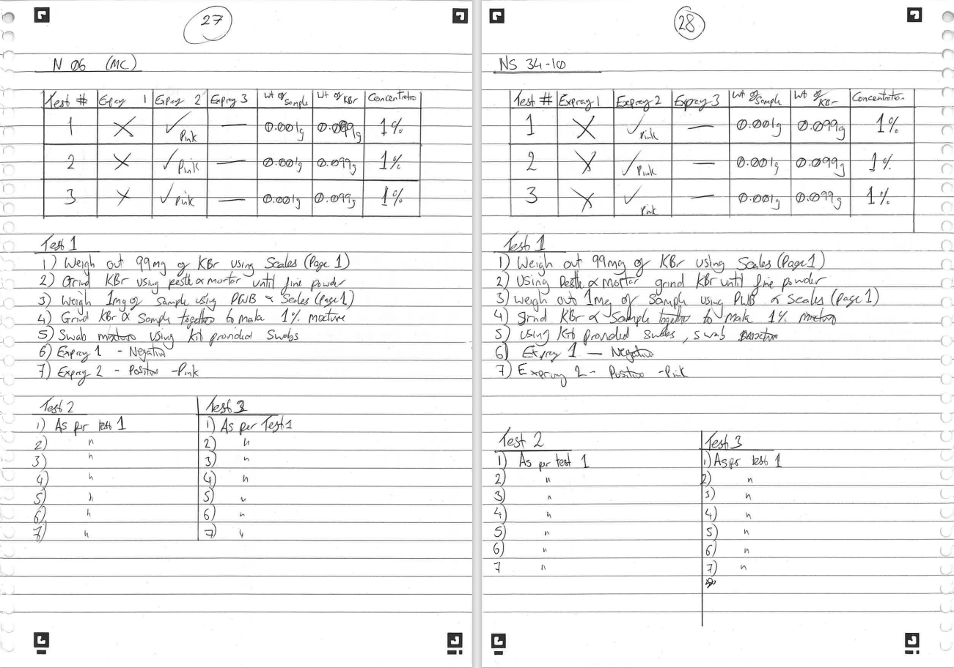

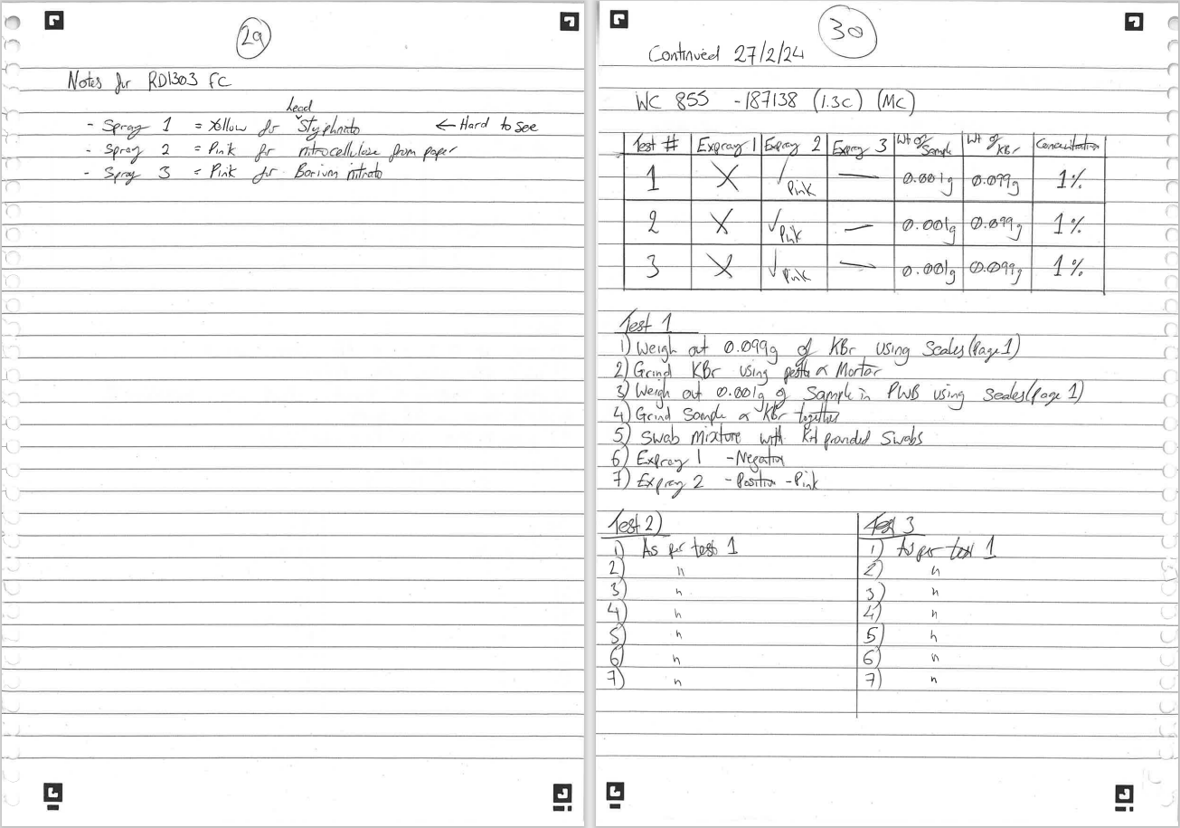

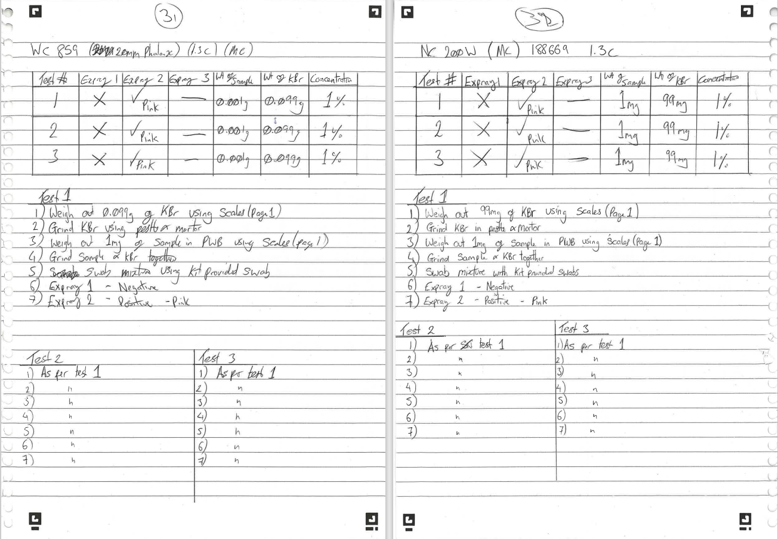

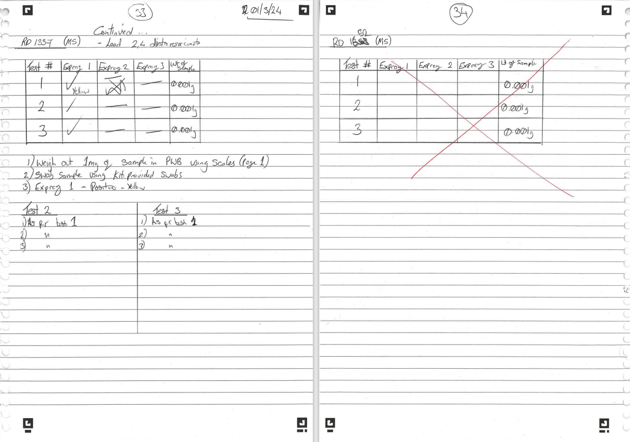

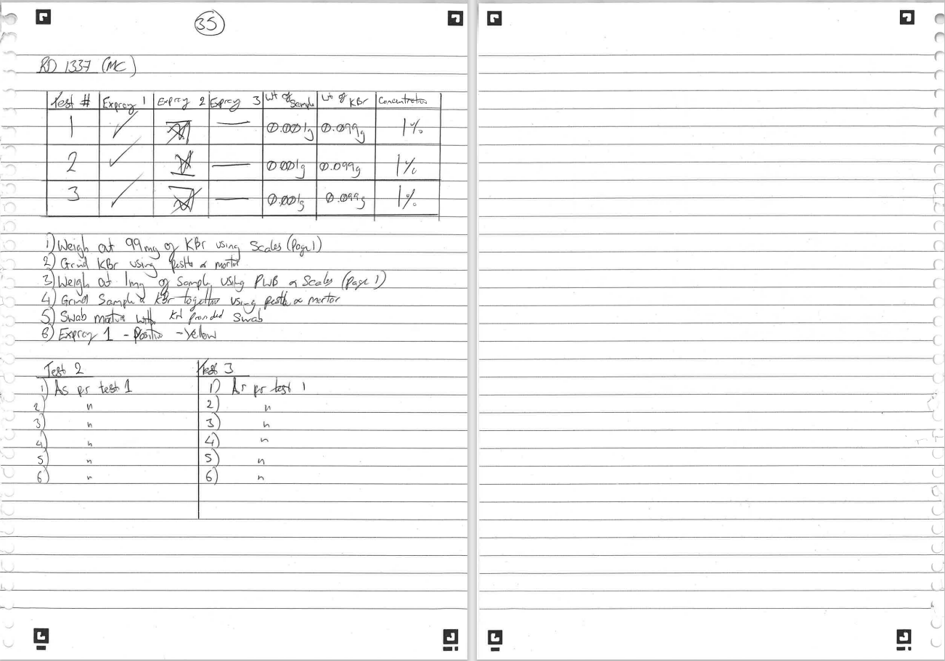

Experimentation/Trial Photo list



