DS 1

My Screenshots/Photos
- Please add 4–6 screenshots or photos of your digital life.
- You can use your phone or laptop.
- For each screenshot, write one or two sentences explaining what it shows.

Screenshot/Photo 1 – Outlook Calendar with DS1,DS2 and DS3 deadlines.
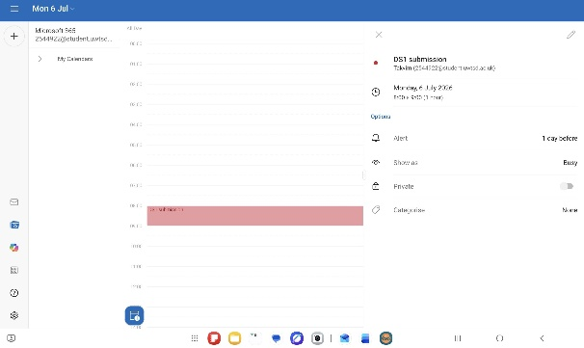
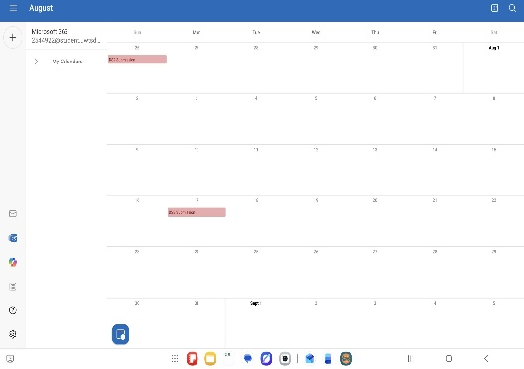
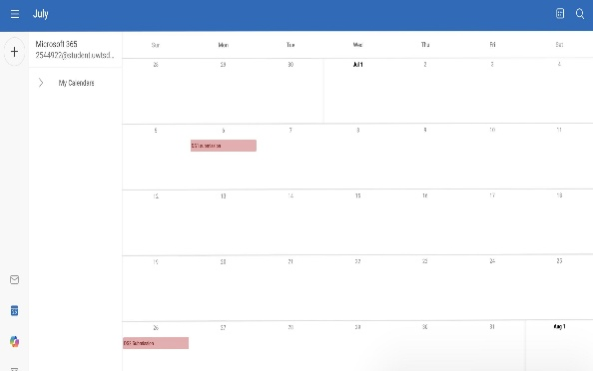
I use these digital tools in order to enhance operational efficiency, accelerate output, and simplify procedures. This screenshot shows my assessment deadlines in my Outlook calendar. Using these tools most importantly reduces my stress with the automated reminders which again saves my time, whilst remaining proactive and prepared in advance.

Screenshot/Photo 2 – Microsoft Word.
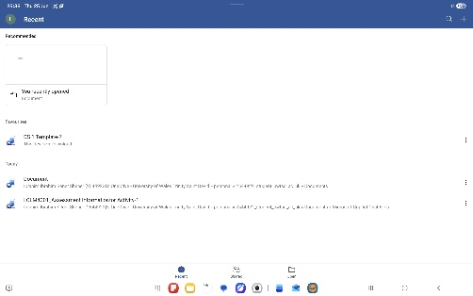
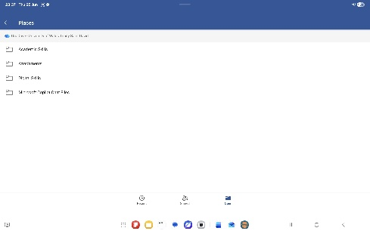
As it appears in the above screenshots, I use Microsoft World in order to complete my assignments, share, edit and create documents. I feel confident when using Microsoft World as it has many advantages of use from document creations, editing, text formatting to collaboration.

Screenshot/Photo 3 – Microsoft Outlook email.
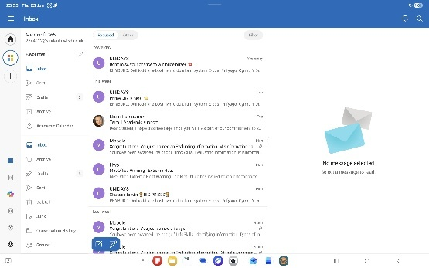
Within the screenshot above it is shows my Outlook email. I sometimes feel nervous when expecting an email, as it can appear in the junk folder sometimes, but using this tool is really effective within my studies and daily life as it's an all-in-one productivity hub, where I can manage emails, to-do lists, contact lists and many more in one places, knowing all my data are securely stored.

Screenshot/Photo 4 – Microsoft teams.
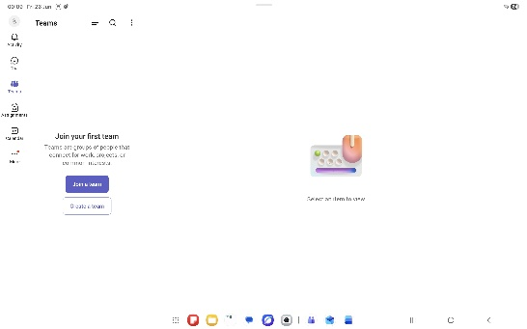
The screenshot shows Microsoft teams, which can be used to join online meetings, communicate with teachers, and access learning materials. This is an effective communication platform that keeps conversations organized and boosts productivity.

Screenshot/Photo 5 – OneDrive
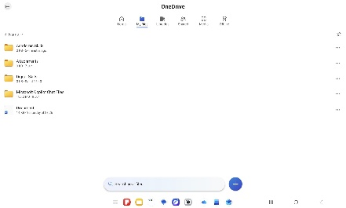
Using OneDrive supplies flexible cloud storage optimised for productivity. As shown in the screenshot I save my documents into this tool well organised into its own and separate folders. One of the functional features are that I can access all my files from any device with advanced security that protects my data with end-to-end encryption and identity verification.

Screenshot/Photo 6 – Moodle (Learning Website)
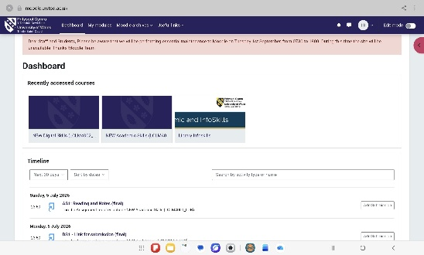
The screenshot shows the learning website I use for my course. I use it to access assignments and course resources with ultimate flexibility, as it enables me to study from anywhere at my own pace whilst boosting my digital skills, since using online platforms like Moodle would naturally build my technical skills.

My Short Reflection
- Write 5–8 simple sentences about your digital life.
- You can use the sentence starters below if helpful.
Digital skills are important for me because it is an essential part in our daily lives, they aid us to remain competitive in a technology-driven world whilst keeping our data secured. The internet provides us to obtain a wealth of information to learn and explore.
Digital skills have an impact upon us in career growth and employability, problem solving, social connections, everyday convenience, continuous learning and in many more ways.
From time to time, I would feel nervous when learning new software’s, however practicing has always been the best ways of overcoming this feeling, in which I think this module will help me too.

Sentence starters
- I use digital tools to …
- I feel confident when I …
- I want to improve …
- I often use these tools: …
- I sometimes feel nervous about …
- I hope this module will help me …
- Digital skills are important for me because …
You can write more if you want.
Submission Checklist
Before you submit, please check:
​​​ ☐ I added 4–6 screenshots
☐ I wrote short sentences for each screenshot
☐ I wrote my short reflection
☐ My work is my own
☐ My file opens correctly
​​☐ My file opens correctly

