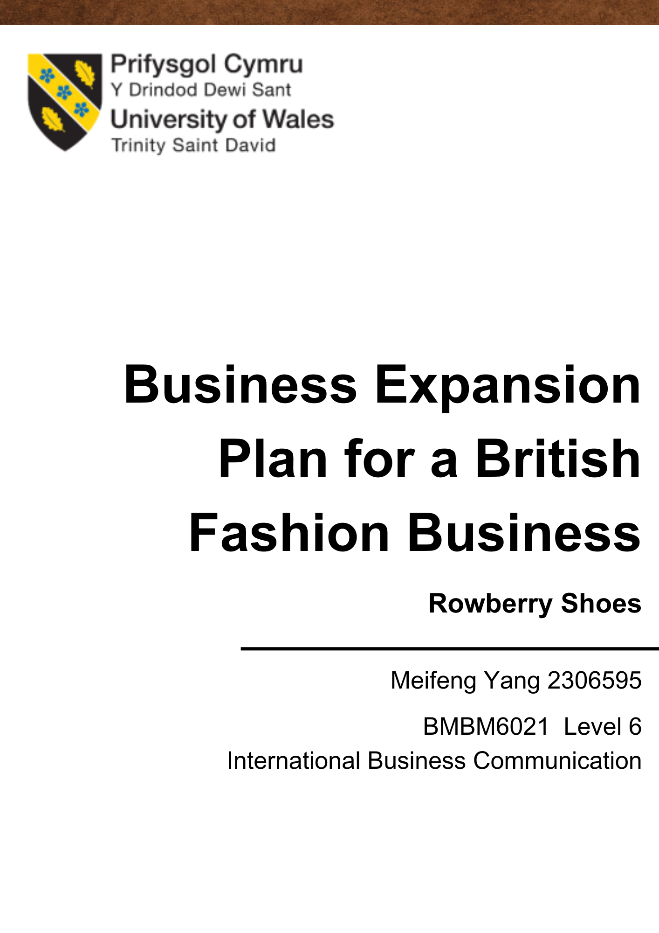

Executive Summary
The purpose of this article is to enable the Swansea, UK retailer Rowberry Shoes to successfully expand their brand into the Chinese market. To achieve this, the challenges that the company needs to go through include international business communication, skills requirements, methods of communication, effective communication, international culture, importance of building relationships, how to build trust, and failed relationships. The business is expanding their business to another country for the first time, so they might be inexperienced. This article presents the business with detailed considerations and advice that will help the business to be able to successfully find a clear direction in the Chinese market. By reading the articles, companies can learn how to communicate correctly with their partners and use some skills and behaviours to show respect for Chinese culture. Companies will also learn the consequences of wrong communication ways, so it is important to avoid making mistakes.

Content Page
Executive Summary 2
1.0 Introduction 4
2.0 Main Findings 5
2.1 International Business Communication 5
2.2 Skills Requirements 6
2.2.1 Eye contact 6
2.2.2 Body language 7
2.2.3 Silence 8
2.3 Methods of Communication 8
2.3.1 Halls High Low Context 8
2.4 Effective Communication 9
2.5 International Culture 10
2.5.1 Trompenaars and Hampden-Turner’s 7 Dimension of Culture 11
2.6 The Importance of Building Trust in Business 12
2.7 The Importance of Build Successful Business Relationships 14
2.8 Failed Relationships 15
3.0 Conclusions 16
4.0 Recommendations 17
References 20
Appendices 28

1.0 Introduction
The purpose of this article is to enable Swansea UK retail Rowberry Shoes to expand into the Chinese market. Before this project is implemented, the company needs to have some knowledge of the traditional culture and business culture of this country to avoid misunderstanding and ineffective communication. As the business has no experience of globalisation, the business needs to be aware of the considerations for market expansion.
Currently, Rowberry Shoes brand has many shops with business addresses located in Swansea (Shops.Wales, 2023). Their products provide a classic and unique design style, which is favoured by local customers in the UK (Rowberry, 2023). Check out the detailed business background track in the appendix.
In 2022, China was the second-largest personal luxury goods market worldwide (Ma, 2023). In China, there is a demand for high quality footwear amongst the business community, while female customers are looking for shoe brands that are beautiful on the outside and comfortable on the inside (Chevalier and Lu, 2010, p. 251). This shows that companies have an advantage in choosing to develop new markets in China because they have a higher demand for imported brands.
According to Facebook images, Rowberry Shoes' product advantages include independent design styles, especially the French fashion boots, which have attracted many local female customers, see Appendix image (Rowberry Shoes, 2023). The design of these high heeled boots has a classical style which is very rare in China, so this will be a bold attempt.
However, companies looking to expand their business into China will face challenges include international business communication, skills requirements, methods of communication, effective communication, international culture, the importance of building relationships, how to build trust, and the consequences of failed relationships.

2.0 Main Findings

2.1 International Business Communication
The purpose of international business communication is to enable effective communication and relationship building between international business partners. Businesses can also use some communication techniques to reduce potential cultural differences within the organisation and enhance teamwork (Griffith, 2002).
Rowberry Shoes has been a Swansea, UK retailer, so their first challenge in entering the Chinese market was language communication. Most of the customers in China do not communicate in English, so the company should find out where the international market in China congregates to pick a partner, such as working with the business team in Shanghai or Beijing. These large cities have a certain international profile because China held the 2008 Beijing Summer Olympics and 2010 Shanghai World Expo (Chen, 2012). This means that these cities are places where a lot of business talent and entrepreneurs gather, so Rowberry Shoes can resolve language differences by finding a great partnership or just hiring an interpreter.

2.2 Skills Requirements
Effective Communication skills refer to the ability to make the other person clearly understand the meaning of surface and hidden messages, and to use good dynamic or static behaviours to make the other person feel listened to and understood. These dynamic behaviours include eye contact, visible mouth, body language, silence, checking for understanding, smiling face, summarising statements, encouraging others, and asking questions (Schuller, 2020).

2.2.1 Eye contact
Eye contact is helpful for individuals to accurately gather information and understand the mood changes of others (Hietanen, 2018). Western European cultures believe that maintaining eye contact is a sign of respect for others, but a small percentage of Middle East cultures with religious beliefs suggest that men and women should avoid prolonged eye contact in order to be polite (Ulrike, 2008). This suggests that different cultures do have a different understanding of eye contact and that companies should pay attention to this behaviour when communicating with their partners. For example, Rowberry Shoes should have investigated whether China would be offended by eye contact and politely suggested to the partner the tolerance level of eye contact that would be acceptable. If both sides are very supportive of eye contact, the flow of the meeting will be smoother because both of them can seriously read from each other's eyes the correct focus of the information to improve the organisation's internal collaboration.

2.2.2 Body language
Body language is dynamic behaviour, which is used to communicate personal feelings and intentions. For example, nodding has many meanings, this includes greeting, acknowledging the other person, and being interested in the topic (Pease, 1981). During a meeting, Rowberry Shoes more nodding can be used to show approval of what the Chinese partner is saying, which can encourage others' self-confidence to continue to tell more. This suggests that using more dynamic body language can give encouragement without disturbing others, which is a subconscious indication of agreeing with others' ideas.

2.2.3 Silence
Silence is associated with being a listener and the duty of being a listener is to be quiet and listen to what the speaker is saying (Ephratt, 2008). It is important to remain silent and attentive while others are speaking and should not interrupt others' thoughts. For example, the agent of Rowberry Shoes should be a good listener when listening to the Chinese partner's speech and he can record the key points and questions for the questioning session at the end. This shows that it is respectful to let others finish their sentences before presenting their ideas, and it also ensures that others speak fluently.

2.3 Methods of Communication

2.3.1 Halls High Low Context
High context cultures prefer to keep key messages subtle, whereas low context cultures want to be explicit (Hall, de Jong and Michaël, 2004).
People in high context cultures pay more attention to the emotional language used by others to express information, and they also focus on subjects not related to business topics. For example, leaders will ask staff about their personal life situation rather than starting the meeting straight away, which is often the case in China, France and Spain (United Language Group, 2022).
People in Low context cultures will tell others what they think directly. Their way of speaking is direct and short, which helps them to share ideas efficiently to the team, this is often seen in the UK, Australia and the USA (United Language Group, 2022).
Since the British company Rowberry Shoes is used to using Low context cultures, it will be a challenge for them to match the High context cultures of their Chinese partner. The truth is that the best way to communicate in business is in low context, because teams need to convey a lot of information in short phrases. Rowberry Shoes can match the Chinese partner's High context cultures before the meeting and give them a polite greeting. During the formal meeting, the company can directly and clearly talk about the brand plan and terms of the important information.

2.4 Effective Communication
The purpose of communication is the process of passing information from one person or group of people to another. The most common forms of communication include verbal, non-verbal, written, listening, visual, aural, and external communication (Team Leverage EDU, 2023).
Effective communication involves the exchange of ideas, opinions, knowledge, and data, which allows the receiver of the message to more clearly understand what is important. The person sending the message needs to use clear, complete, and concise statements because this will speed up the receiver's comprehension (Coursera, 2023).
The most suitable methods of communication between Rowberry Shoes and their Chinese partners would be emails and video calls, of course face-to-face communication would be the most effective. Due to the time difference between countries, anything important could not be known to the other party at the very first time, which could lead to a decrease in internal efficiency. The most effective communication is definitely face-to-face problem solving, so that the dialogue is more emotional and the level of understanding can be increased through body language.

2.5 International Culture
International cultures mean cultural identities that transcend national borders. These cultures are spread through immigration, colonisation and globalisation, such as a common language culture. This knowledge can be applied to international co-operative ventures to effectively improve national skills and capabilities (Morden, 1995). This suggests that culture allows for a wider adaptation of business to different operating environments.

2.5.1 Trompenaars and Hampden-Turner’s 7 Dimension of Culture
Trompenaars and Hampden-Turner’s 7 Dimension of Culture consists of universalism versus particularism, individualism versus collectivism, achievement versus ascription, neutral versus affective, specific versus diffuse, internal versus external, and time orientation (Pirlog, 2021).
Specific means that people should separate their work from their personal life. People can have a wide range of relationships at work, but this should be kept separate from their personal lives because specific believes that people should be more focused on their own objectives and that they can work together even without good relationships. Countries that often use specific include the United States and Switzerland (Dudovskiy, 2013).
Diffuse refers to the idea that people should overlap work and life because they believe that relationships are the focus for achieving business objectives. They will be willing to spend personal time with customers, which is more likely to contribute to the success of a business project. Countries that often use diffuse include Switzerland, China and Spain (Dudovskiy, 2013).
According to Country comparison tool, Chinese companies make a clear distinction between subordinates and superiors and the employees are sure to respect their leaders. They usually give up their personal interests for the benefit of the group, and they are also able to control their desires well (Hofstede Insights, 2023). British companies seek equal competition and treatment and they focus on achieving personal fulfilment while enjoying life (Hofstede Insights, 2023).
For example, when an Rowberry Shoes agent or team arrives in China, the Chinese partner will surely greet and take care of them. Traditional Chinese culture includes friendly and treating guests well, so they are likely to offer to take the Rowberry Shoes team to visit local attractions and experience the food culture on their behalf. The British business should adapt to their warmth and helpfulness because Chinese culture includes accepting the good intentions of others as courteous behaviour.

2.6 The Importance of Building Trust in Business
Organisations exist when they have trust, and accumulating trust requires building long-term collaborative relationships. This also relates to the leader of the business, where the knowledge and competence of the individual has to be recognised by others so that they will entrust important collaborative projects to the organisation (Brenkert, 1998).
In western cultures, they believe that building trusting relationships presupposes standing above the rules and terms. They expect the trust to be backed up by a detailed contract in a formal relationship of interest because the legal system has the mandate to enforce the terms of the contract (Lyon, M "llering and Saunders, 2011, p. 320). This shows that businesses in Western cultures are prone to worrying about wrongdoing by their partners, so they can only be assured that others are trustworthy through the terms of a valid contract or other evidence-based content.
In Chinese culture, they believe that the foundation of business is building good relationships. They focus a lot on individuals and teams being cordial and respectful to each other, and they are the ones who want to know the personal habits and lives of their partners to judge whether others are trustworthy for the relationship (Meyer, 2015). This shows that the way to build trust with the Chinese culture is to treat others like a friend. The way they feel comfortable is to put aside their relationships of interest, and explore interesting experiences in their lives as friends instead.
Rowberry Shoes want to get the trust of their partners can approach each other through food culture. Chinese companies like to do business in restaurants because it brings them closer to each other. This also allows the other partner to forget about the relationship of interest for a while and ask for dinner as a normal friend. This is a very effective way to build trust because Chinese teams like to speak their minds in a relaxed atmosphere. Rowberry Shoes can also prepare a contractual agreement that maps out the responsibilities of both parties, so that if there is a loss of interest, they will not lose their trust in each other.

2.7 The Importance of Build Successful Business Relationships
Being able to successfully build business relationships has a great correlation to the growth of a business. Businesses can get partners who can trust the business to recommend the business to a larger market, which is conducive to building more relationships and accessing better resources. Having stable business relationships also reduces stress in the work environment (Cooper and Gardner, 1993). This suggests that the more relationships a business can build, the better resources it can acquire, which helps the business to grow towards success in the future.
Once Rowberry Shoes has gained the trust of their Chinese partners, they can politely offer to let the Chinese team recommend their brand to more major cities. This helps them to build more relationships because their brand has been recognised and trusted. This helps them to scale up their business and they can create more shops in more cities in China to make their business more recognisable. If the company is able to achieve this expansion plan in China, this will help them to target different countries in the future.

2.8 Failed Relationships
Gift giving and hospitality to partners play an important role in facilitating business relationships and practices when firms build relationships. However, the timing of the gift and the meaning of the gift itself can easily be interpreted as a bribe, which creates the wrong approach to relationship building (IBE, 2012). This shows that companies should pay attention to whether there are some prohibited behaviours in the other country's culture, such as male leaders giving gifts to female workers.
In Chinese culture, bad business gifts include giving cash, which can be taken as a bribe. There are also taboos against giving overly expensive luxury goods or giving gifts alone in private (Qin, 2016). Rowberry Shoes should be especially careful not to make inappropriate gifts directly because sometimes the good intentions of a gift can be turned into the opposite because of inappropriate timing. For example, giving a house or a car to a Chinese partner's worker or leader in private can cause fears among most of the workers. This behaviour may lead to the termination of the cooperation because it is a common form of gifting that is not compatible with the Chinese culture. This shows that gift-giving in business relationships is likely to mean favouritism and that it is unethical to tempt and influence the judgement of the other person.

3.0 Conclusions
Since Rowberry Shoes has no experience in international business, the first problem they faced when implementing business expansion would be language communication, so the best practice would be to work with the business team in China or recruit an interpreter to solve the language communication. The business can use eye contact, body language, silence to show respect for the speech of others and to build a good business culture. However, face-to-face communication can get the message across more accurately and effectively. In a business meeting, Low Context is more important to keep information concise, while in a private conversation, High context cultures can be used to show respect for others. Rowberry Shoes should accept the warm hospitality of the Chinese team because it is their way of showing respect and kindness. The food culture is part of the Chinese relationship to build trust, which helps companies to build friendships. Also, gaining the trust of a Chinese partner helps a company to gain better access to marketing resources and build up business relationships with other markets. This helps companies gain international business experience and also allows them to target their expansion to more cities or countries in the future. However, companies should avoid the wrong way of giving gifts, which may be perceived as a bribe. The best timing for gift-giving is to show their appreciation for their Chinese partners by sending British tea or snacks on Chinese New Year, this gift-giving culture is warm and unforgettable.

4.0 Recommendations
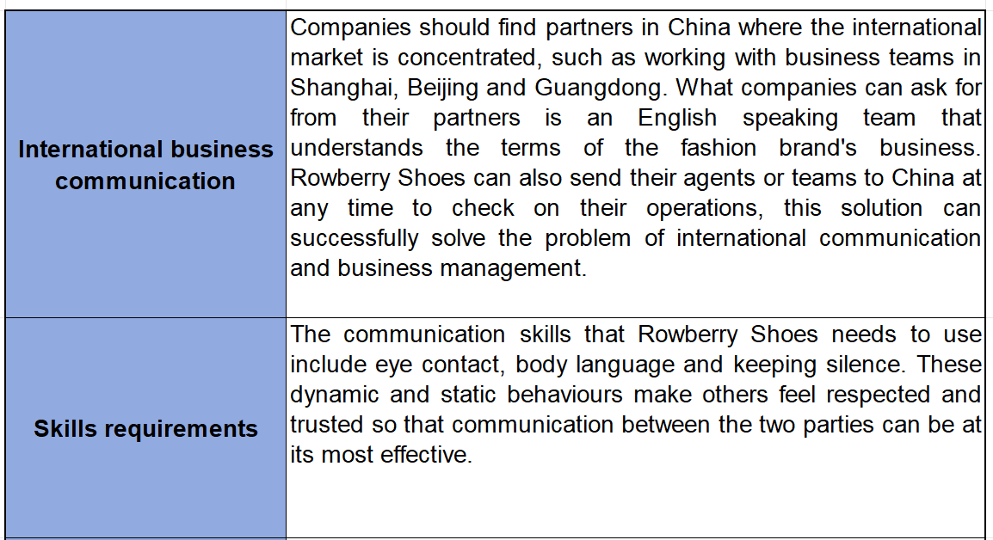
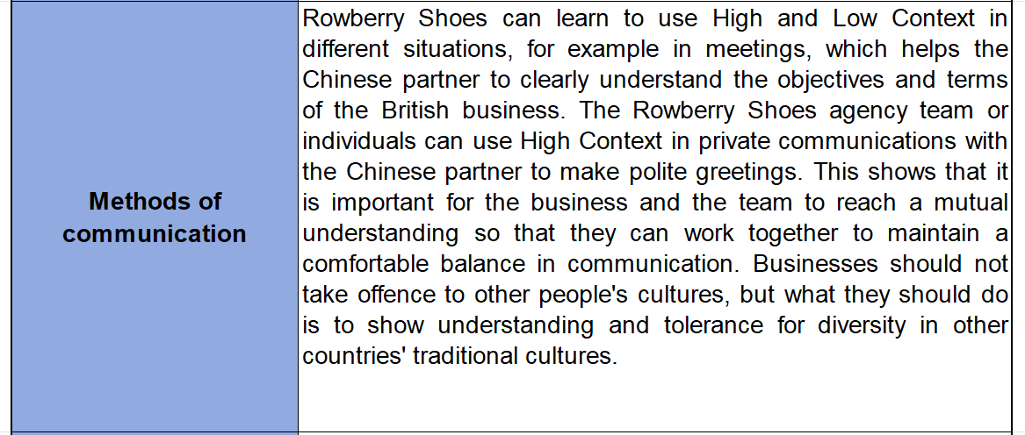
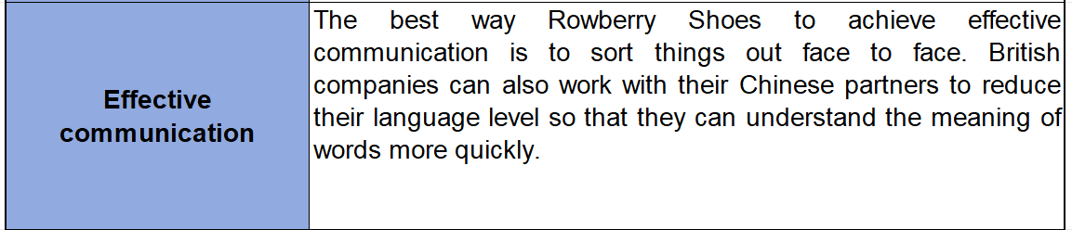
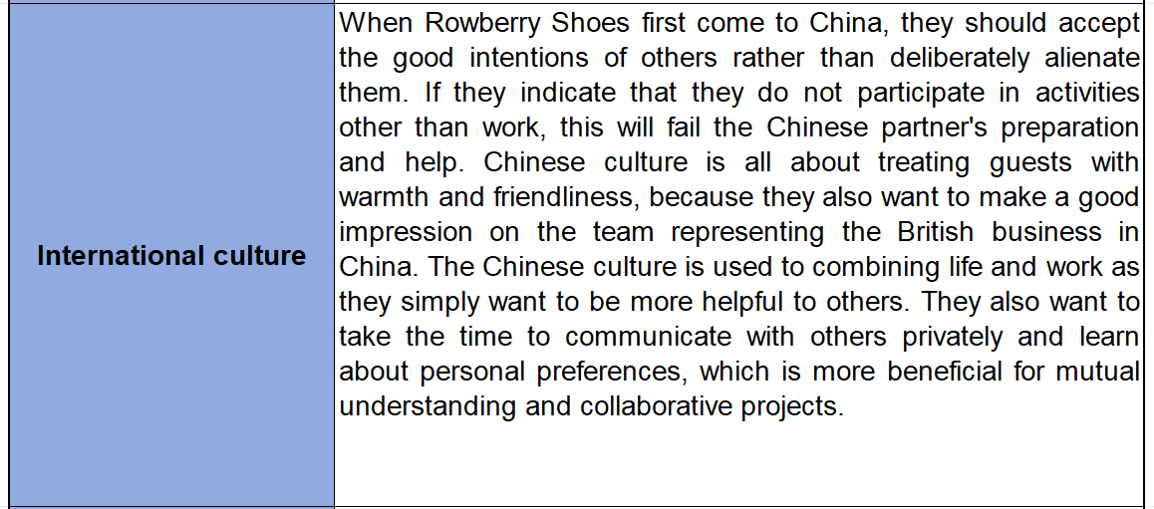
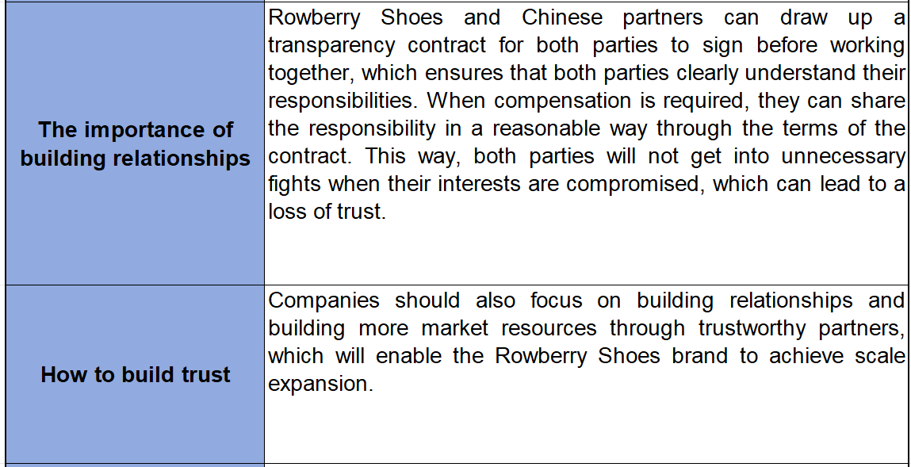
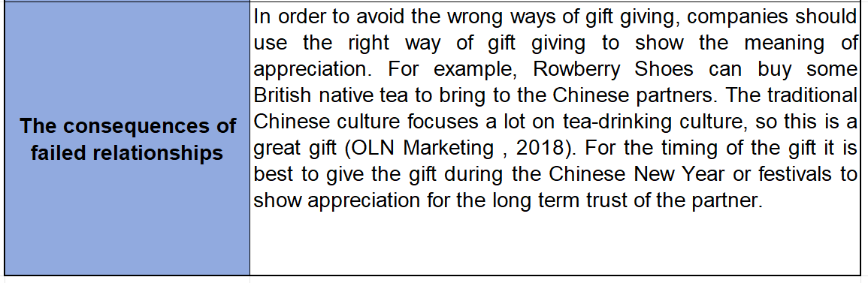

References
Brenkert, G.G. (1998). Trust, Business and Business Ethics. Business Ethics Quarterly, 8(2), pp.195–203. doi: https://doi.org/10.5840/beq19988219 [Accessed 22 Nov. 2023].

Chen, N. (2012). Branding National images: the 2008 Beijing Summer Olympics, 2010 Shanghai World Expo, and 2010 Guangzhou Asian Games. Public Relations Review, 38(5), pp.731–745. doi: https://doi.org/10.1016/j.pubrev.2012.04.003 [Accessed 22 Nov. 2023].

Chevalier, M. and Lu, P.X. (2010). Luxury China: Market Opportunities and Potential. [online] Google Books, John Wiley & Sons, p.251. Available at: https://books.google.co.uk/books?hl=zh-CN&lr=&id=KUymiv50tpQC&oi=fnd&pg=PR9&dq=China+pursues+demand+for+shoe+products&ots=oeolmYu0IN&sig=I2XaXFQG4pu6sHuzpCK3Fs0OV78&redir_esc=y#v=onepage&q&f=false [Accessed 22 Nov. 2023].

Cooper, M.C. and Gardner, J.T. (1993). Building Good Business Relationships: More than Just Partnering or Strategic Alliances? International Journal of Physical Distribution & Logistics Management, 23(6), pp.14–26. doi: https://doi.org/10.1108/09600039310044876 [Accessed 22 Nov. 2023].

Coursera (2023). What Is Effective Communication? Skills for work, school, and Life. [online] Coursera. Available at: https://www.coursera.org/articles/communication-effectiveness [Accessed 22 Nov. 2023].
Dudovskiy, J. (2013). Trompenaars and Hampden-Turner Cultural Dimensions - Research-Methodology. [online] Business Research Methodology. Available at: https://research-methodology.net/trompenaars-and-hampden-turner-cultural-dimensions/ [Accessed 22 Nov. 2023].

Ephratt, M. (2008). The Functions of Silence. Journal of Pragmatics, [online] 40(11), pp.1909–1938. doi: https://doi.org/10.1016/j.pragma.2008.03.009 [Accessed 22 Nov. 2023].

Griffith, D.A. (2002). The Role of Communication Competencies in International Business Relationship Development. Journal of World Business, 37(4), pp.256–265. doi: https://doi.org/10.1016/s1090-9516(02)00092-5 [Accessed 22 Nov. 2023].

Hall, M., de Jong, M. and Michaël, S. (2004). Cultural Differences and Usability Evaluation: Individualistic and Collectivistic Participants Compared. Technical Communication, [online] 51(4), pp.489–503. Available at: https://www.ingentaconnect.com/content/stc/tc/2004/00000051/00000004/art00003 [Accessed 22 Nov. 2023].

Hietanen, J.K. (2018). Affective Eye Contact: an Integrative Review. Perception Science, 9(1), p.1. doi: https://doi.org/10.3389/fpsyg.2018.01587 [Accessed 22 Nov. 2023].

Hofstede Insights (2023). Country Comparison Tool. [online] The Culture Factor. Available at: https://www.hofstede-insights.com/country-comparison-tool?countries=china%2Cunited+kingdom [Accessed 22 Nov. 2023].

IBE (2012). The Ethics of Gifts & Hospitality. [online] Institute of Business Ethics. Available at: https://www.ibe.org.uk/resource/the-ethics-of-gifts-hospitality.html [Accessed 22 Nov. 2023].

Lyon, F., M”llering, G. and Saunders, M. (2011). Handbook of Research Methods on Trust. [online] Google Books, Edward Elgar Publishing, p.320. Available at: https://books.google.co.uk/books?hl=zh-CN&lr=&id=NoAouYIOr7UC&oi=fnd&pg=PA50&dq=How+different+cultures+build+trust&ots=CetDBtPwHM&sig=AC6-_9bSdBPlP6y2GzcEnEdD-eg&redir_esc=y#v=onepage&q=How%20different%20cultures%20build%20trust&f=false [Accessed 22 Nov. 2023].

Ma, Y. (2023). Luxury goods market in China - statistics & facts. [online] Statista. Available at: https://www.statista.com/topics/1186/luxury-goods-market-in-china/ [Accessed 22 Nov. 2023].

Meyer, E. (2015). Building Trust Across Cultures. [online] INSEAD Knowledge. Available at: https://knowledge.insead.edu/leadership-organisations/building-trust-across-cultures [Accessed 22 Nov. 2023].

Morden, T. (1995). International Culture and Management. Management Decision, 33(2), pp.16–21. doi: https://doi.org/10.1108/00251749510081674 [Accessed 22 Nov. 2023].

OLN Marketing (2018). Business Gift-giving Etiquette in China. [online] Oldham, Li & Nie. Available at: https://oln-law.com/business-gift-giving-etiquette-in-china/ [Accessed 22 Nov. 2023].

Pease, A. (1981). Body Language. [online] Elibrary Mukuba Education, pp.75–76. Available at: http://elibrary.mukuba.edu.zm:8080/jspui/bitstream/123456789/550/1/Psychology%20-%20Body%20Language%20How%20to%20read%20others%20thoughts%20by%20th.pdf [Accessed 21 Nov. 2023].

Pirlog, A. (2021). National Cultural Profile in the Republic of Moldova According Hofstede and Trompenaars-Hampden-Turner Models. Revista de Management Comparat Internațional, [online] 22(4), pp.450–457. Available at: https://www.ceeol.com/search/article-detail?id=1047373 [Accessed 22 Nov. 2023].

Qin, C. (2016). Giving Gifts to Chinese People: Beware of Certain Taboos. [online] Dig Mandarin. Available at: https://www.digmandarin.com/chinese-taboos-gifts.html [Accessed 22 Nov. 2023].

Rowberry (2023). Rowberry Shoes & Bags. [online] Rowberry Bridal & Fashion. Available at: https://www.rowberrybridalandfashion.com/accessories/bags-and-shoes/ [Accessed 21 Nov. 2023].

Rowberry Shoes (2023). Rowberry Shoes . [online] Facebook. Available at: https://www.facebook.com/rowberryshoes [Accessed 22 Nov. 2023].

Schuller, M.L. (2020). Chapter 1: Defining Effective Communication. In: CoachMotivation: Developing Transformational Leadership by Increasing Effective Communication Skills in the Workplace - ProQuest. [online] Seattle Pacific University: ProQuest LLC, pp.2–3. Available at: https://www.proquest.com/docview/2476566063?pq-origsite=gscholar&fromopenview=true [Accessed 21 Nov. 2023].

Shops.Wales (2023). Rowberry Shoes - Mumbles. [online] Shop.Wales. Available at: https://shop.wales/item/rowberry-shoes/ [Accessed 21 Nov. 2023].

Team Leverage EDU (2023). Types, Methods and Modes of Communication. [online] Leverage Edu. Available at: https://leverageedu.com/blog/modes-of-communication/ [Accessed 22 Nov. 2023].

Ulrike, W. (2008). Making Eye Contact: What Are You Saying in Various Cultures? [online] Bright Hub Education. Available at: https://www.brighthubeducation.com/social-studies-help/9626-learning-about-eye-contact-in-other-cultures/ [Accessed 21 Nov. 2023].

United Language Group (2022). Communicating in High Context vs. Low Context Cultures. [online] United Language Group. Available at: https://www.unitedlanguagegroup.com/learn/communicating-high-context-vs-low-context-cultures [Accessed 22 Nov. 2023].

Appendices
According to research, the origin of the Rowberry Shoes brand is that Mr Aueurin Rowberry relocated his footwear and cobblers business from Llandilo to the Port Tennant area of Swansea in 1898 (Shops.Wales, 2023). In 1965, the business was officially managed by Aueurins' granddaughter, and the business address for their current multiple shops is local to Swansea (Shops.Wales, 2023). Their products are shoes of various styles made by designers from England, Spain and Italy (Rowberry, 2023). The number of years that the business has been in operation is enough to show that the brand's reputation has remained consistently good and that local customers in the UK love the design style of their products.


