

Student name: Vilma Rodrigues
Student number: 2336478
Lecturer’s name: Laila Surani
Module Code: BMHP5014
Assignment Title: Component 2

Poster:
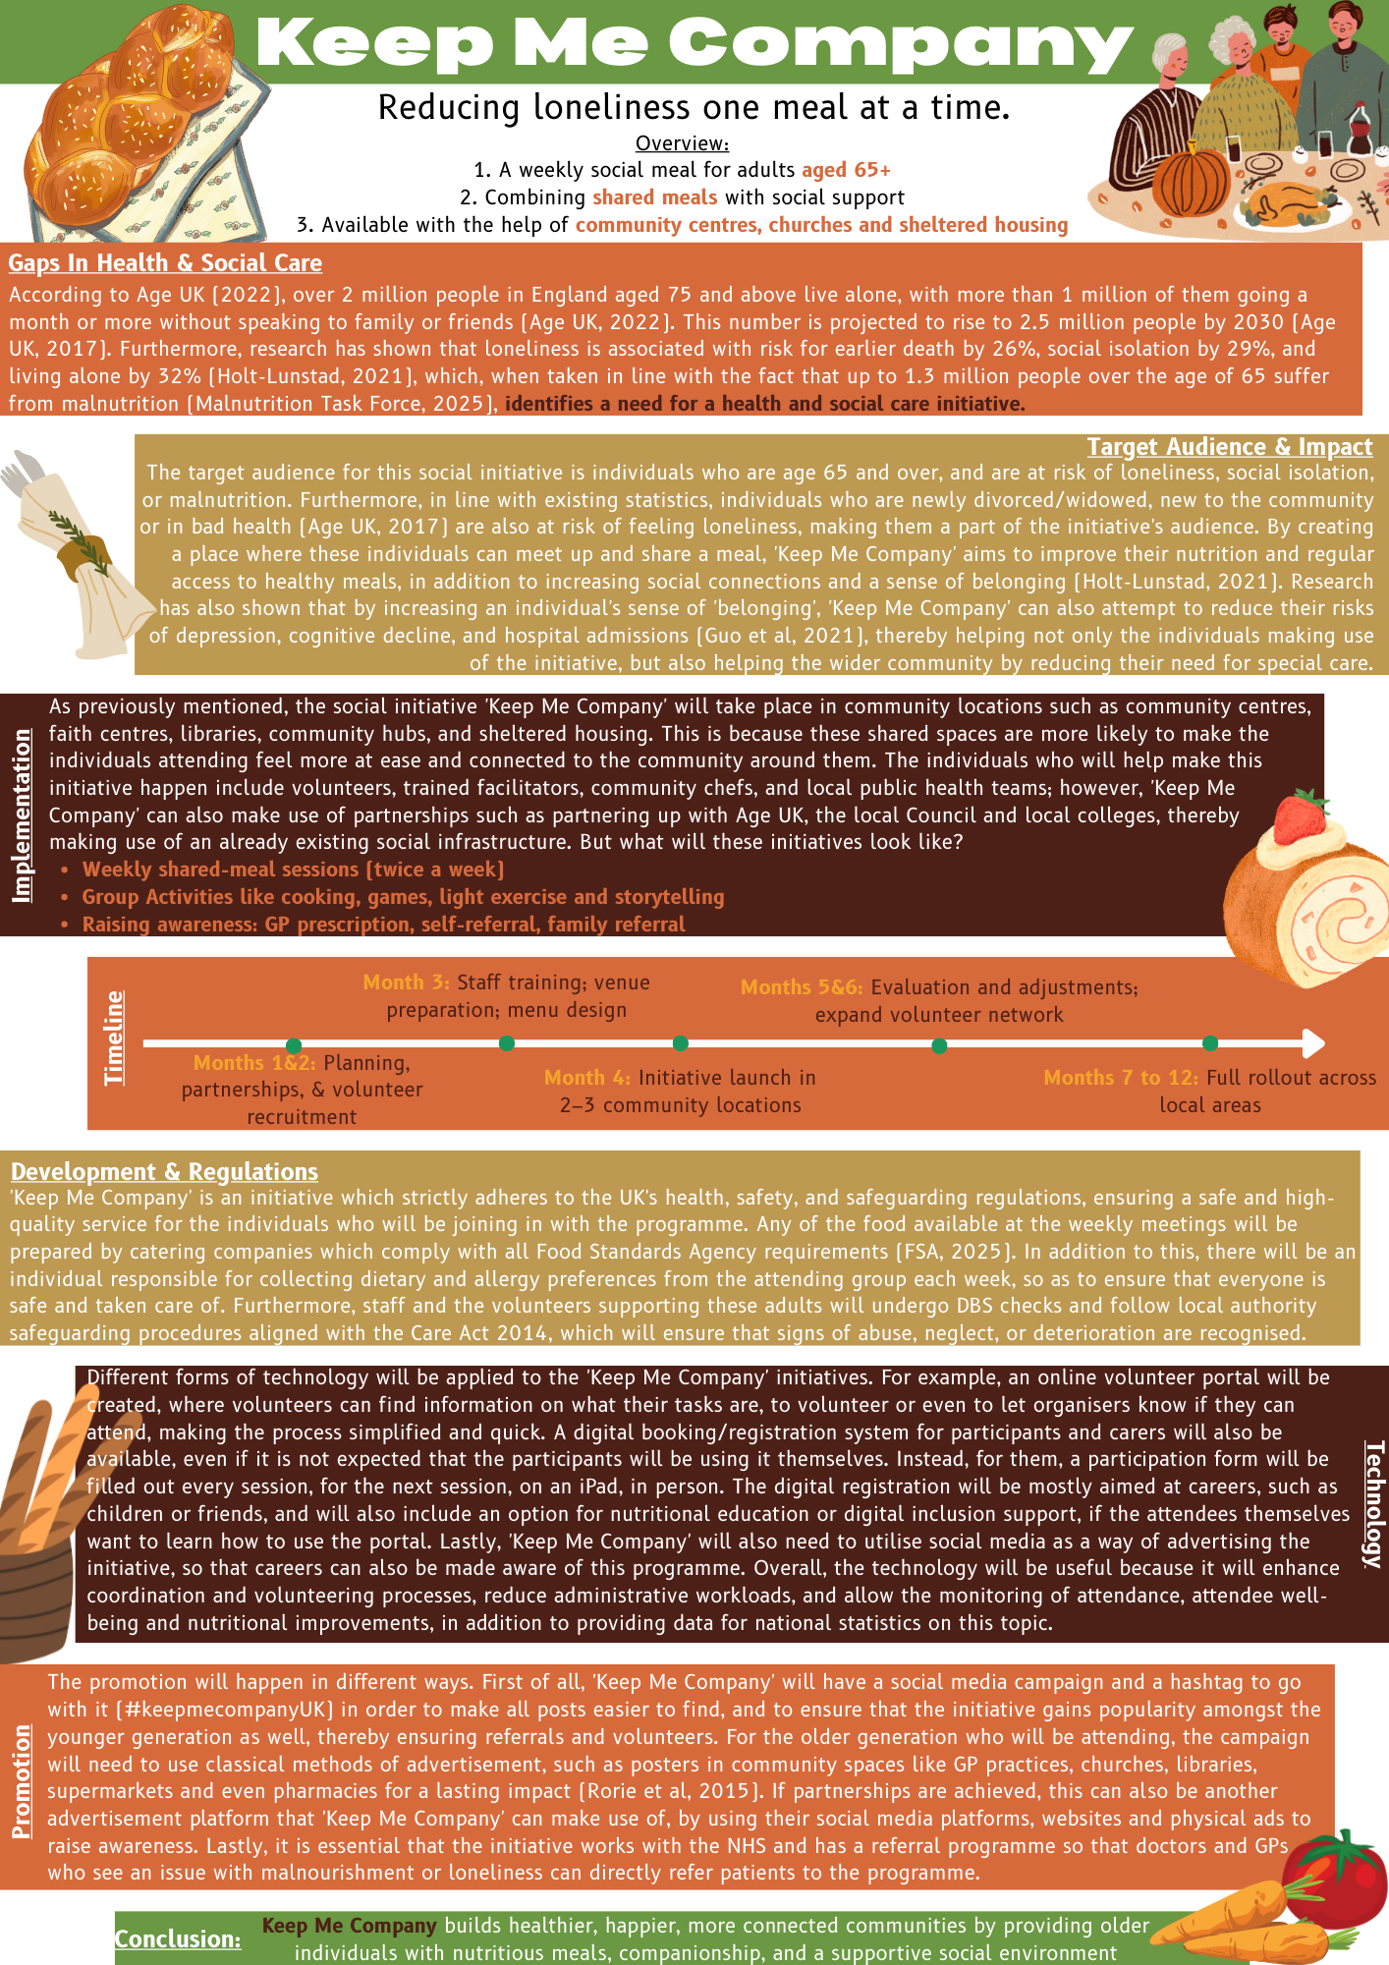
Poster Page 2:
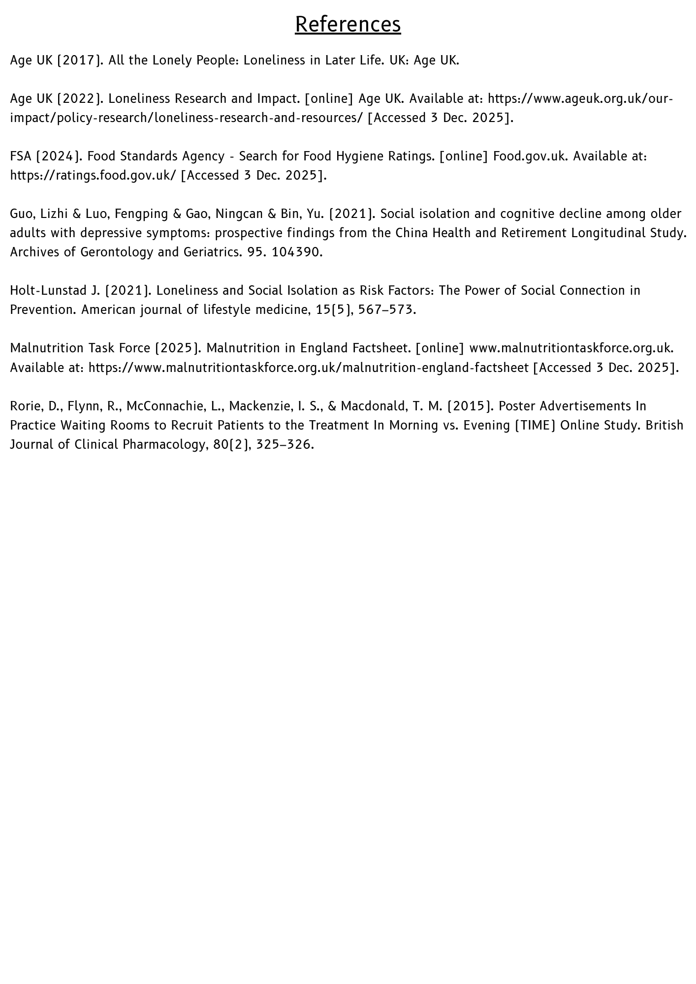
Pitch

Introduction:
The purpose of this pitch is to introduce the initiative being put forward: ‘Keep Me Company’. Keep Me Company is an initiative which aims to reduce loneliness amongst older people in the UK through efforts such as twice-a-week meetings in public spaces, where participants can have a warm meal and socialise with other individuals who feel the same as them, creating a safe space for sharing. This initiative was chosen due to the pressing need for social and institutional action to reduce loneliness and malnutrition amongst older individuals in the UK, which are two interconnected factors. Research has shown that over 2 million people in England aged 75 and above live alone, with more than 1 million of them going a month or more without speaking to family or friends, and this number is expected to keep rising (Age UK, 2022). The issue of loneliness is a national one due to its close association with risks such as earlier death, social isolation (Holt-Lunstad, 2021).

To tackle all of these points, this pitch will cover the following aspects: needs, solutions, benefits, legislation, involvement, and impact, and in doing so, attempt to persuade stakeholders such as health professionals, community leaders, local government, and the public to support Keep Me Company.

The Problem:
Currently, there is a high prevalence of loneliness amongst individuals over the age of 75 in the UK (Age UK, 2022), and, as already constituted, this feeling of loneliness has continuously been linked to detrimental social and physical outcomes, including an increased risk of earlier death and social isolation (Holt-Lunstad, 2021). In addition to this, research has shown that loneliness and depression are correlated but clearly different constructs (Weeks et al, 1980) and are largely dependent on the size of a person’s social network (Domenech-Abella et al, 2017). Furthermore, limitations in currently available services, such as the UK’s overstretched social care, uneven provision of community-based activities and long waiting lists for support groups, mean that it is not always easy, or entirely possible, for individuals suffering from loneliness to find support through official channels.

As such, these findings also indicate that whilst loneliness and depression amongst older individuals are often influenced by various factors, by creating a social initiative where older individuals can form more connections and socialise, it is possible to reduce the negative effects, whilst also attempting to tackle malnutrition, another prevalent problem in individuals of that age group. In achieving this, Keep Me Company will not only improve the lives of these individuals but will also help alleviate the burden on caregivers, families, the community and even national institutions.

Description:
A single session of Keep Me Company will take place as follows: individuals attending will have to have signed up before the session, so that volunteer count and food specifications are taken into account. Once all attendees have arrived, the individuals will have just over an hour to have their meal together and chat amongst eachother, with volunteers being available throughout the whole time to answer questions or help. Once everyone has dined, the volunteers and initiative leaders will play some social games with the attendees to encourage sharing and getting to know eachother. The session will end with attendees signing up for the next session if they want to.

Target Audience:
Even though being over 65 will not be a specific requirement, priority will be given to individuals who fall under the following categories: over 65, older adults experiencing social isolation, low mood, bereavement, mobility limitations, and/or lower incomes. It is important to prioritise these individuals since their group faces bigger barriers in accessing social and nutritional support (Chen et al, 2023), especially since they are unable to find help online due to the lack of technological skills. As such, the initiative will improve the health and well-being of these people by increasing social connectedness, improving diet and hydration, reducing anxiety and depression, supporting cognitive stimulation and reducing the risk of malnutrition-related hospital admissions.

Policy & Legislation:
With regards to the UK’s policy and legislation, which could affect Keep Me Company, the initiative will need to pay special attention to:
- The Care Act 2014 (prevention, wellbeing, community services)
- FSA (Food Standards Agency) hygiene regulations and
- Volunteer DBS checks and safeguarding protocols

Technology:
The initiative will be supported by technology to a high degree, as the use of technology will improve both user experience and decrease administrative load for the volunteer and the initiative manager. For example, the implementation of a digital volunteer training module and portal will ensure consistency and accessibility, even if the volunteers change on a regular basis. Furthermore, although it might be harder for the attendees themselves to access, an online booking and attendance tracking system can be useful for more technologically advanced participants, careers and even professionals. At the same time, collecting anonymous data through the use of these platforms will be advantageous not only for Keep Me Company but also for the UK as a whole, because the collection of this type of data can help build a more realistic picture of the issue and raise awareness, especially when it comes to social initiatives and their attendance.

Implementation & Sustainability:
Keep Me Company’s existence will rely on a strong community partnerships and sustainable, volunteer-driven models, which is why sessions will be delivered by trained volunteers and facilitators at community locations such as libraries, churches, and community hubs. Furthermore, all staff will receive food-hygiene, safeguarding, and basic first-aid training to ensure safe, high-quality support, whilst sustainability will be achieved through collaboration with local councils, Age UK, and possibly colleges.

Public Involvement:
The general public can become a part of this initiative and help improve the lives of older people through different means; for example, individuals, or even businesses, can choose to volunteer, donate, host sessions, or even simply spread awareness by advertising the initiative’s posters in physical locations, or support social media efforts by re-posting, collaborating and more. Public involvement is the pinnacle of this initiative because, through it, Keep Me Company can build stronger communities, encourage intergenerational contact and raise awareness of an otherwise ignored issue. Sharing meals is a universal human experience, so why not be a part of something so simple and yet significant?

Conclusion:
In conclusion, creating an initiative that tackles two socially-solvable problems like malnutrition and loneliness amongst older individuals is an effort that does not require a lot of funding or continuous investment. However, Keep Me Company can do all that, and more. By investing time, money and effort into this social initiative, any individual can do the bare minimum to help the UK fight the spread of loneliness.

References

Age UK (2022). Loneliness Research and Impact. [online] Age UK. Available at: https://www.ageuk.org.uk/our-impact/policy-research/loneliness-research-and-resources/ [Accessed 3 Dec. 2025].
Chen, L., Huang, H., Jiang, S., Yao, H., Xu, L., Huang, Q., Xiao, M. and Zhao, Q. (2023). Facilitators and Barriers to the Implementation of Dietary Nutrition Interventions for community-dwelling Older Adults with Physical Frailty and sarcopenia: a Qualitative meta-synthesis. International Journal of Nursing Sciences, 11(1).
Domènech-Abella, J., Lara, E., Rubio-Valera, M., Olaya, B., Moneta, M.V., Rico-Uribe, L.A., Ayuso-Mateos, J.L., Mundó, J. and Haro, J.M. (2017). Loneliness and Depression in the elderly: the Role of Social Network. Social Psychiatry and Psychiatric Epidemiology, 52(4), pp.381–390.
Holt-Lunstad J. (2021). Loneliness and Social Isolation as Risk Factors: The Power of Social Connection in Prevention. American journal of lifestyle medicine, 15(5), 567–573.
Weeks, D.G., Michela, J.L., Peplau, L.A. and Bragg, M.E. (1980). Relation between Loneliness and depression: a Structural Equation analysis. Journal of Personality and Social Psychology, 39(6), pp.1238–1244.

