E-Portfolio

Kai Tang

Student Number: 1651339

Changemakers: Creativity and Value Creation

ACCA5033

Wales Institute for Science and Art

University of Wales Trinity Saint David



Contents
E-Portfolio iii
1. Task 1 - Mind Map 1
2. Task 2 – Image-based Video presentation 2
3. Task 3 – Video Presentation 2
4. Task 4 – Academic Poster 3

E-Portfolio

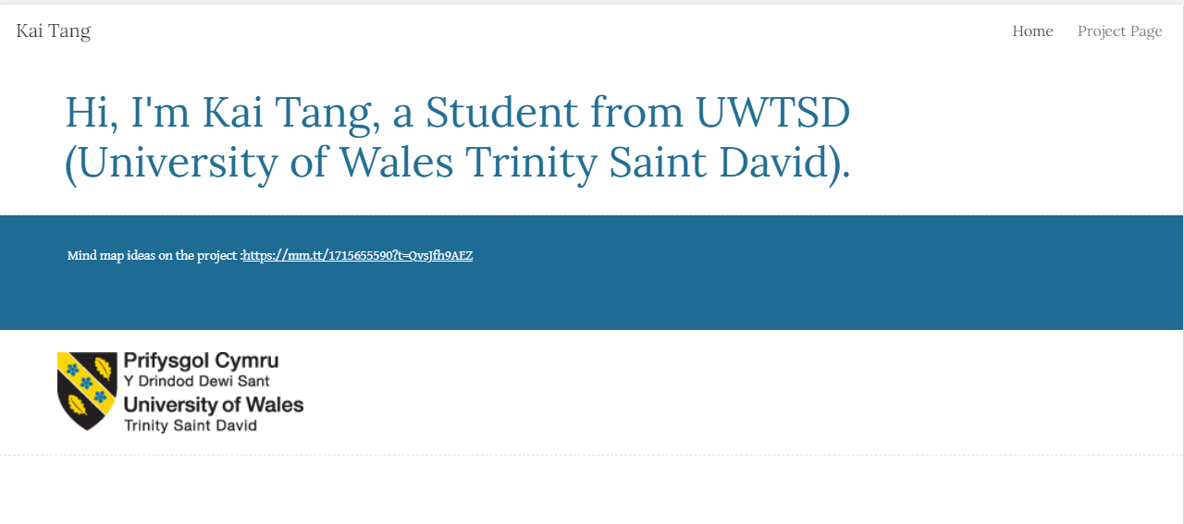
https://sites.google.com/view/p151918/home

Task 1 - Mind Map
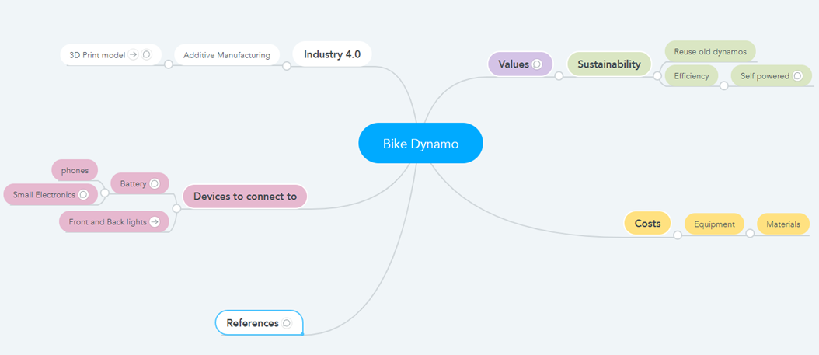
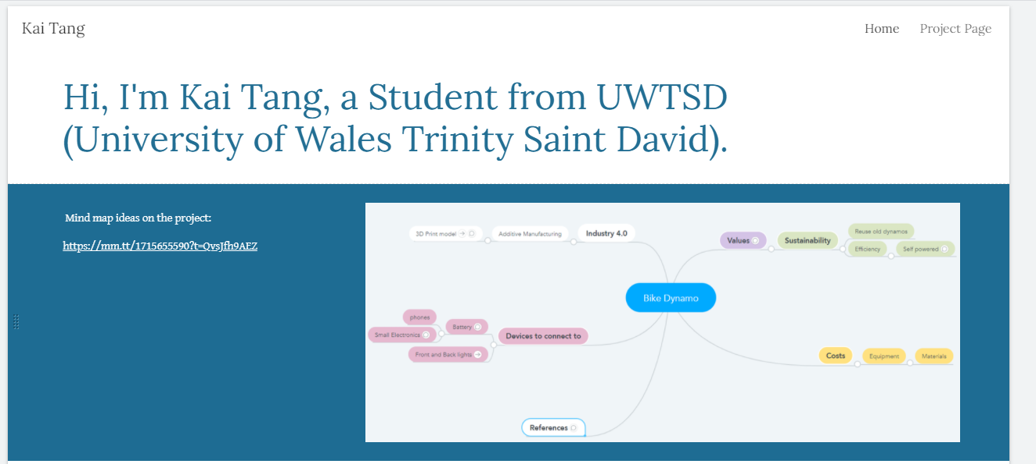
https://mm.tt/1715655590?t=QvsJfh9AEZ

Task 2 – Image-based Video presentation
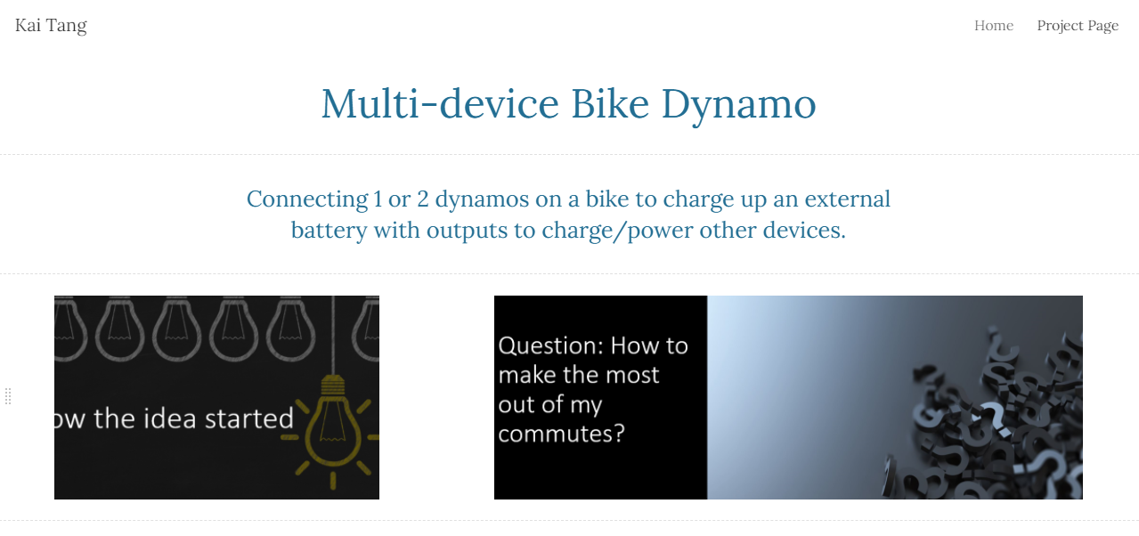
https://sites.google.com/view/p151918/project-page

Task 3 – Video Presentation

https://sites.google.com/view/p151918/project-page

Task 4 – Academic Poster

https://sites.google.com/view/p151918/project-page

