Atodidau Traethawd Yr Athro Ymholgar

Atodiad 1- Llythyr caniatad
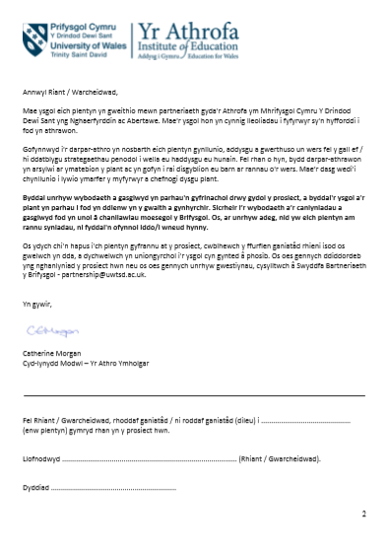

Atodiad 2- Cwestiynnau o yr cyfweliad grwp ffocws
- Sut ydych chi’n teimlo am y wers heddiw?
- Beth oedd eich hoff agwedd o’r wers? Pam?
- Pa agwedd buasech chi’n newid o’r wers? Pam?
- Beth oeddech chi;n meddwl o gynnwys y wers?
- Beth wnaethoch chi ddysgu o’r wers?
- Pa adnoddau oedd yn eich helpu chi fwyaf?
- A oedd unrhyw beth wedi eich rhywstro/ rhywbeth y gwelsoch yn anodd?
- Sut ydych chi’n teimlo am T.G. Ch?
- Ydych chi’n meddwl bod T.G. Ch yn helpu chi I ddysgu? Pam?

Atotiad 3- Ffurflen Arsylwi Gwers
RHAN A
Enw athro/athrawes: Tracey Evenden

Dyddiad arsylwad: 20/02/2019

Enw arsylwydd: Jac Wyn Williams

Amcanion yr arsylwad: Ydy T.G.Ch yn helpu datblygu llythrennedd plant?

Agweddau penodol: Arsylwi 3 plentyn targed (wedi eu dewis o flaen llaw)
Gwybodaeth ychwanegol:
- 3 plentyn targed wedi eu leoli mewn gwahanol llefydd o few y dosbarth.
- Plant yn dda yn dwyn ei gof am bethau maent wedi dysgu yn flaenorol. Yn gallu enwi ffeithiau a pobl.
- Ymateb I’w gilydd ac yn ychwagengu gwybodaeth ymhellach.
RHAN B
Cyflwyniad
1= Gwan
2= Boddhaol
3= Da
4 = Da iawn

Yn ol canllawiau BERA (2011) mae enwau y plant o fewn yr arsylwad wedi cael eu cuddio.
 | Plentyn 1 | Plentyn 2 | Plentyn 3
1.Sirchau sylw disgyblion | 1 2 3 4 | 1 2 3 4 | 1 2 3 4
2. Amcanion clir | 1 2 3 4 | 1 2 3 4 | 1 2 3 4
3. Ymateb I wybodaeth flaenorol | 1 2 3 4 | 1 2 3 4 | 1 2 3 4
Arsylwadau ychwanegol:
Amcanion yn glir I blant ac wedi cael ei esbonsio yn glir ac yn gywir.

Prif Wers
 | A | B | C
1.Ymglymiad y disgyblion | 1 2 3 4 | 1 2 3 4 | 1 2 3 4
2. Dealltwriaeth y dasg | 1 2 3 4 | 1 2 3 4 | 1 2 3 4
3. Cymhwysedd TGCh | 1 2 3 4 | 1 2 3 4 | 1 2 3 4
4. Cyfleu gwybodaeth | 1 2 3 4 | 1 2 3 4 | 1 2 3 4
Sylwadau ychwanegol:
Plant yn digon fodlon I gario ymlaen gyda y tasg.
Dim digon a amser I gwblhau y dasg.

Diweddglo
 | A | B | C
1.Wedi deall yr amcanion? | 1 2 3 4 | 1 2 3 4 | 1 2 3 4
2. Cyfranogiad | 1 2 3 4 | 1 2 3 4 | 1 2 3 4
3. Mwynhad y dasg | 1 2 3 4 | 1 2 3 4 | 1 2 3 4
Arsylwadau ychwanegol:
Pob plentyn targed wedi cymryd rhan yn y cwis Kahoot ac wedi mwynhau.

Atotdiad 4- Ffurflen adfyfyrio
Taflen Adfyfyrio
Disgrifiad
I am currently on a teaching practice placement in an adult education college in the south-west of England, learning how to teach GCSE maths to various groups of adults. As my placement is in the early stages, I am mainly assisting the class tutors and have just started planning and delivering a small part of each lesson. The incident occurred in an evening class during which I was due to deliver my very first session. The class tutor had been teaching the learners about fractions, and my task was to continue with this instruction, looking specifically at how to multiply two fractions. However, when I was due to teach the session, I got to the whiteboard and became so nervous that I struggled to speak to the group. I felt myself visibly shaking and was unable to articulate my first sentence coherently. The students were quite understanding, as they are all mature students who are aware that I am new to teaching and am nervous, but the - 3 - Academic Services & Retention Team SD Mar2016 class teacher was unsympathetic and responded by taking over the lesson whilst I sat not s

Teimladau
I felt extremely miserable at the time and even considered leaving my teacher training course. I was also embarrassed and upset by my own inability to speak in front of the group, but I was also extremely angry with the class teacher for her response in the presence of the learners. I felt afterwards that she had not given me sufficient time to compose myself, and that she should have allowed me to address my nerves. The situation left me very distressed and I rang in sick the following week; it was only when I reflected on the experience that I decided I needed to speak to the placement supervisor. I also realised later that feeling nervous is a natural reaction to speaking in public (Jones, 2000) which made me feel less embarrassed.

Gwerthuso
At the time, I did not feel that the situation had been resolved at all. I very deliberately left at the end of the class without speaking to the class teacher or the learners. However, after speaking to a fellow trainee about his own experience, I felt much more positive. I realised that everyone feels nervous before their first few classes. This is clear in the relevant literature, as Greene (2006, p. 43) points out, saying that nine out of ten new trainee teachers found their first session “incredibly daunting”. It appears that most trainee teachers have moments of being “tongue-tied” and “losing their way with the lesson” (Parbold, 199
8, p. 223).

Dadansoddiad
The situation was made worse by both my own actions and those of the class teacher. I feel that I should have stood up to her, rather than letting her take control of the lesson, and that I should have spoken to her immediately after the lesson about how I was feeling. Dealing with situations like this immediately is dfg
Rfgth

Casgliad

