

PROGRAMME: MSC ENGINEERING PROJECT MANAGEMENT, MSC INDUSTRIAL ENGINEERING
MODULE: PROJECT MANAGEMENT
MODULE CODE: ACHA7025
ASSIGNMENT TITLE: BUSINESS MANAGEMENT IN PROJECTS

STUDENT NAME: Aminur Islam Tonmoy
STUDENT ID NUMBER: 2522779
Table of Contents
1. Introduction 3
2. Fundamental Principles of Project Management 3
2.1 Project Scope 3
2.2 Project Planning and Project Life Cycle 4
2.3 Project Scheduling 5
2.4 Stakeholder Management 7
2.5 Communication Management 8
2.6 Risk Management 10
2.7 Quality management 11
3. SWOT Analysis 11
4. PESTLE Analysis 13
5. Organisational Structure and Technology 15
5.1 Proposed Organisational Structure 15
5.2 Communication Technology 15
6. Issues Related to Moving to New Premises and Leadership 16
6.1 Relocation Issues 16
6.2 Time–Cost Trade-off (Crash Costing) 16
6.3 Leadership Styles 19
7. Recommendations 20
8. Conclusion 20
References 21

1. Introduction
Company Background
The company is operating on a special recipe for high-quality fruit smoothies using apples and some specific fruits, such as strawberries, kiwi, blueberries and bananas. These are delivered to two big UK supermarkets via a well-established production facility. Well-developed links are maintained with UK and European fruit growers, allowing the business to develop a reputation for providing healthy beverage products.
Current business problems
There is strong sales growth, bringing pressure up the supply chain. Poor communication between suppliers, transport companies and the company is causing delivery delays, poor product quality, and delivery of inconsistent fresh fruit. Also, the lack of efficiency in the organisation and ineffective change management procedures are hampering the operational performance and the company's capacity to aid ongoing business growth.
Expansion Plan
Business expansion is being considered with a view to moving to a larger industrial building with facilities to expand the production capacity. There's also a possibility of diversifying the products to coconut water, children's juice, healthy soups and coconut yoghurt drinks. These can help to fulfil the rising demand of the supermarkets and improve competitiveness in the longer term.
Aim
Aim of the report is to assess project management strategies to support the business relocation, organisation improvement, communication enhancement, leadership effectiveness and sustainable business growth based on evidence-based recommendations.

2. Fundamental Principles of Project Management

2.1 Project Scope
Project scope is the activities, deliverables, resources and boundaries necessary to complete a project successfully. In the current case study, the project measure is defined by the relocation of production facilities, an increase in the manufacturing base, and enhancements of operational performance. Also, there is a need to strengthen supplier coordination, transport management, organisational structure, communication system strengthening, quality management, and stakeholder engagement strengthening.

2.2 Project Planning and Project Life Cycle
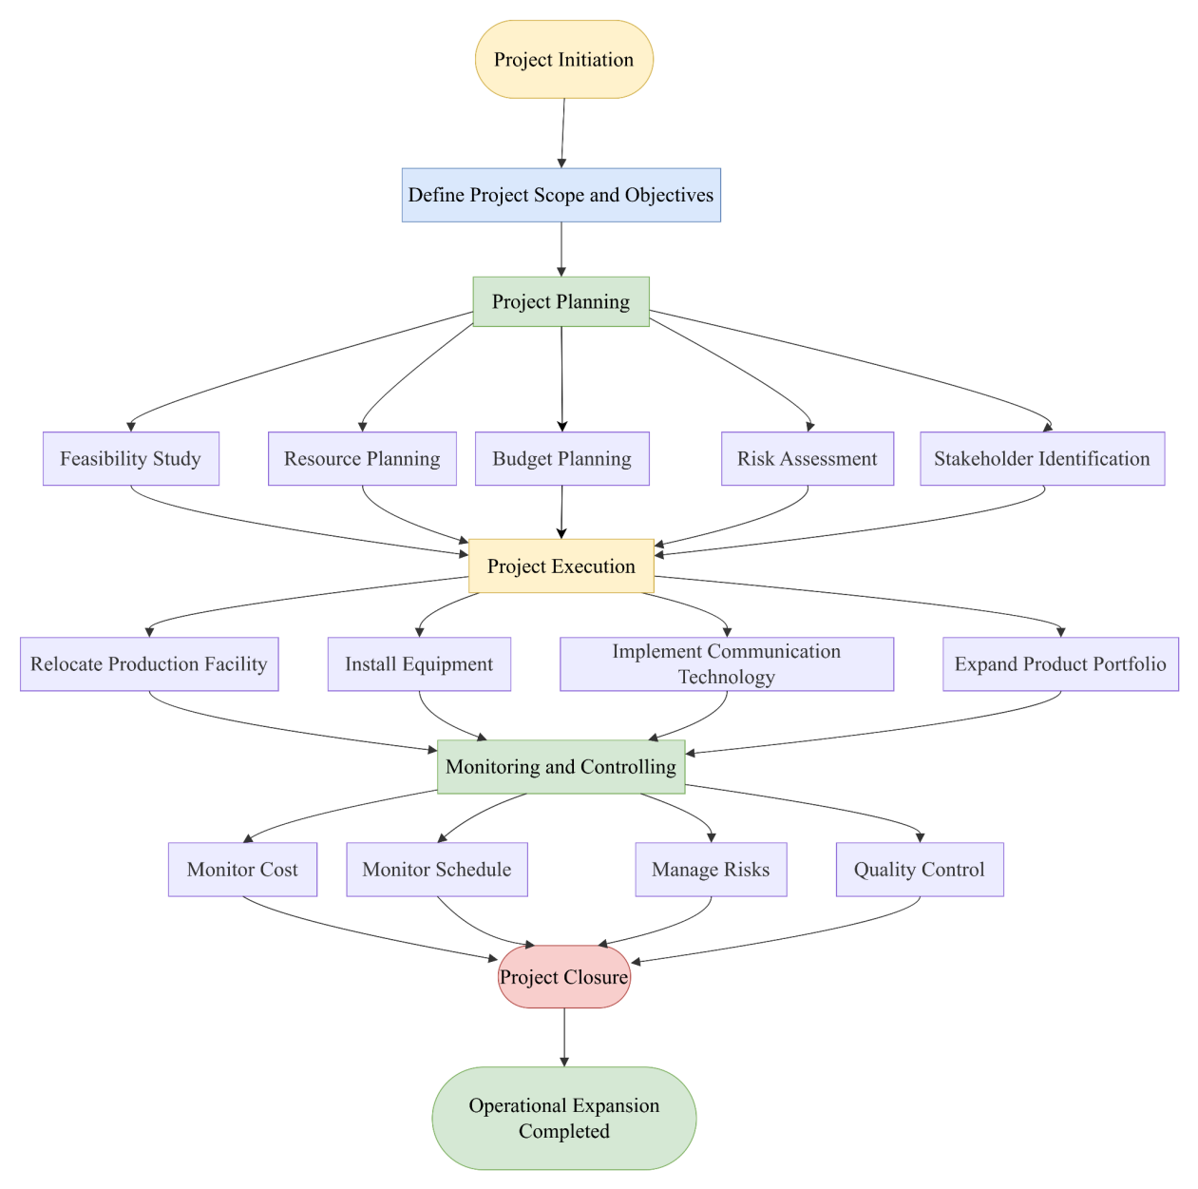
Figure 1: Project Life Cycle
The project planning and project life cycle are suggested for the relocation and extension of the smoothie company. This process starts with a project scope, and the deliverables are highlighted, which can be achieved. Feasibility analysis, resource allocation, budget planning, risk assessment and identification of stakeholders are then carried out in the pursuit of comprehensive planning, to aid informed decision making. In the execution phase, the production plants and communication technologies are presented to boost the production capacity (Datta et al. 2024). There are activities that are carried out continuously while implementing to monitor and control project costs, schedule performance, risk responses and quality. So, the project is completed when all the desired deliverables are accomplished, and the quality is ensured.

2.3 Project Scheduling
Activity | Description | Duration (Days) | Predecessor | Normal Cost (£)
A | Project Initiation | 2 | – | 2,000
B | Site Selection | 5 | A | 5,000
C | Lease Agreement | 4 | B | 4,000
D | Facility Preparation | 10 | C | 20,000
E | Equipment Procurement | 8 | C | 18,000
F | Equipment Installation | 7 | D, E | 15,000
G | Communication System Installation | 4 | F | 8,000
H | Staff Recruitment & Training | 6 | D | 6,000
I | Production Testing & Quality Inspection | 5 | G, H | 7,500
J | Commercial Launch | 2 | I | 3,000
Table 1: Proposed Activity Schedule
The proposed project activities are planned in a logical sequence to smoothly implement the relocation and expansion of the smoothie company. The activities are given a duration, a normal cost, and a predecessor relationship to ensure systematic execution of the project. The sequence of scheduling activities starts with project initiation and moves on to planning, preparing facilities, installing equipment, training staff and conducting production tests before commercialisation. Dependencies identified help reduce scheduling conflicts to ensure that activities are actually started after the ones that precede them. This structured approach helps to allocate resources, plan budgets, and assist in the production of a network diagram. It assists in the identification of the critical path and then in the final crash cost analysis for schedule optimisation.
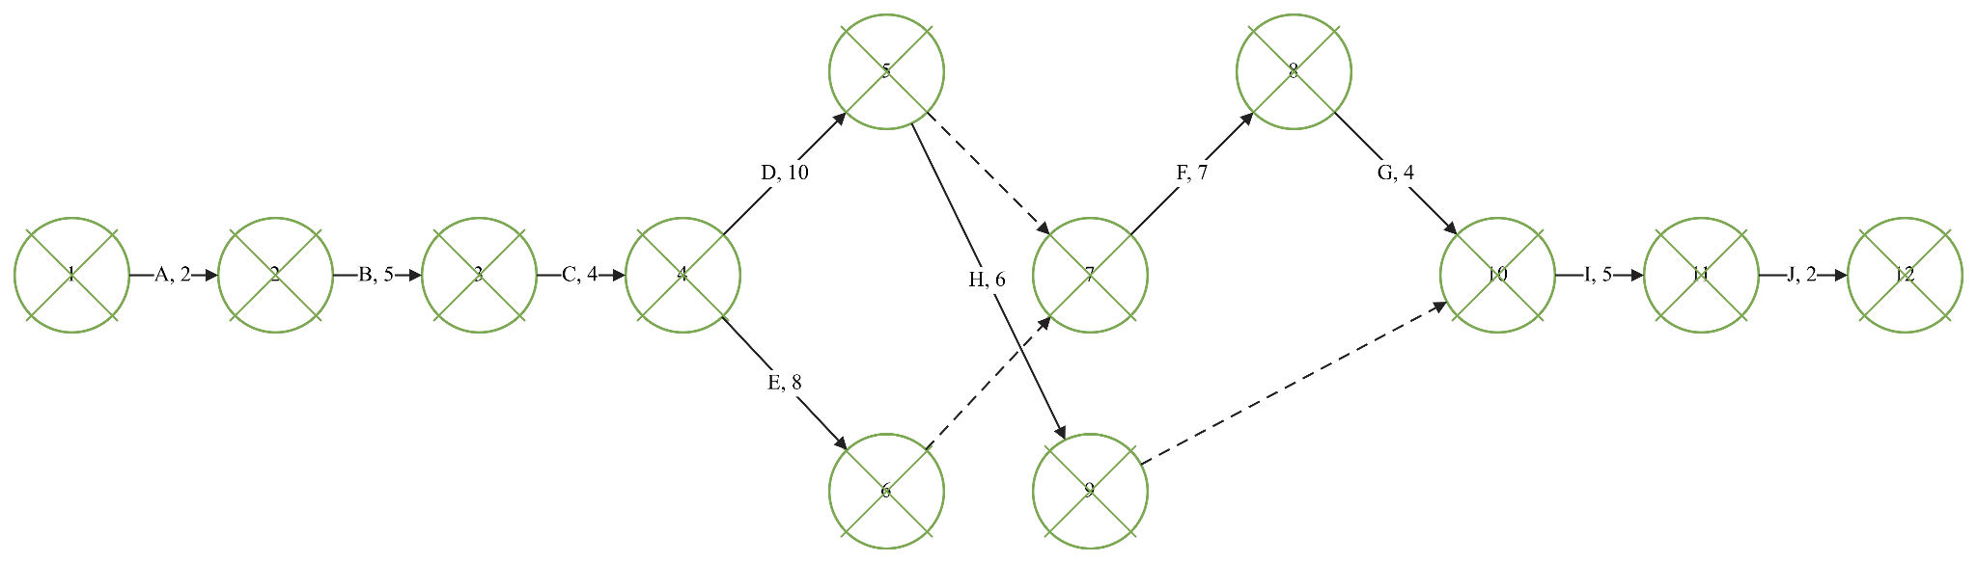
Figure 2: Network Diagram (Activity Structure)
The proposed activity network diagram for the relocation project of the Smoothie company is highlighted in the figure. The diagram shows the activity sequence, activity durations and dependencies starting from the project launch and finishing with the commercial launch. All activities have been added to maintain logical precedence, giving the structure needed for project scheduling, estimating durations and critical path analysis.
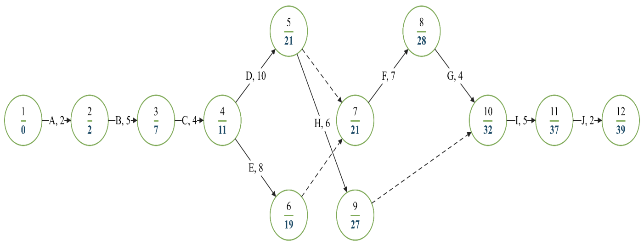
Figure 3: Network Diagram (Forward Pass – Earliest Event Times)
The forward pass analysis is shown in the calculation of event times in the earliest state throughout the activity network. The sum of the durations for all activities shows that the project can be finished in 39 days on the schedule. These calculations help determine the earliest possible completion date and assist in optimal resource allocation and scheduling.
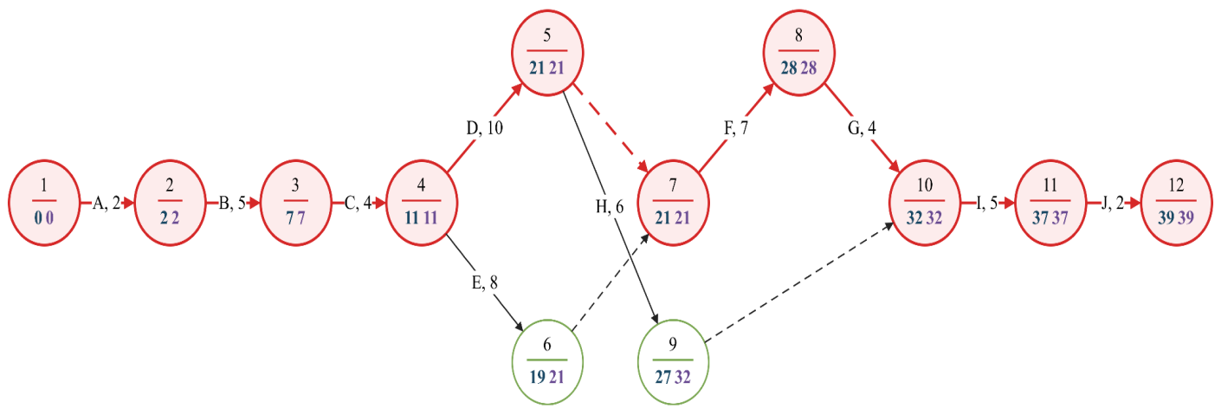
Figure 4: Network Diagram (Complete – Critical Path Analysis)
The backward pass analysis is demonstrated in the figure, where the last allowable event times are calculated, and the critical path is found (A – B – C – D – F – G – I – J). The activities highlighted have zero float and can cause a delay if late in the project. Hence, these are prioritised activities for crash costing & for optimising the schedules.

2.4 Stakeholder Management
Power / Interest | Low Interest | High Interest
High Power | Keep Satisfied  - Regulatory Authorities  - Local Government  - Investors | Manage Closely  - Company Directors  - Project Manager  - Major UK Supermarkets
Low Power | Monitor  - Local Community  - Media | Keep Informed  - Employees  - Fruit Suppliers  - Transport Providers
Table 2: Stakeholder Management Matrix
Stakeholder management is seen as a key to successful delivery of a relocation project, as it includes many internal and external stakeholders with varying influence and interest in the project. A classification of stakeholders is highlighted based on the Power–Interest Matrix. The company directors, project manager and key supermarket customers have a high interest in the project and a high level of power (Taboada et al. 2023). It indicates that there is a need for regular contact to be highly involved in decision-making. The regulatory authorities and investors have high power, but their operational interest is comparatively less. Employees, fruit suppliers and transport providers show high interest, and they need to be kept informed to help with good operational coordination. While the local community and the media need to be monitored from time to time due to their relatively small influence on project implementation.

2.5 Communication Management
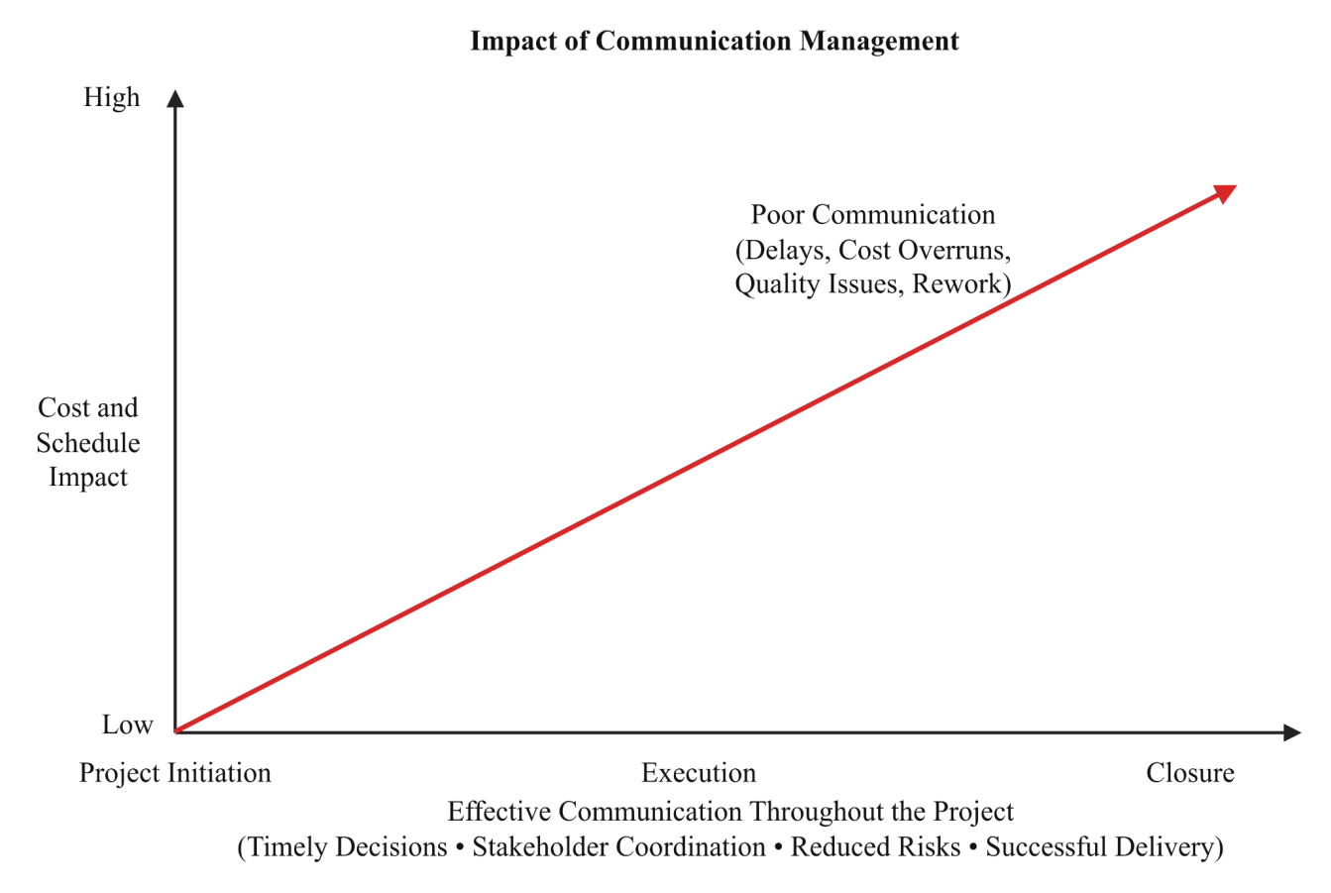
Figure 5: Communication Management
The cost and schedule impacts due to poor communication from project initiation to project closure. Lack of timely information sharing, poor stakeholder coordination, and poor decision making lead to rework, quality issues, and operational delays (Evitha et al. 2023). So, good communication is needed to facilitate timely decisions, teamwork, mitigate project risks and contribute to the successful delivery of the smoothie company relocation project.
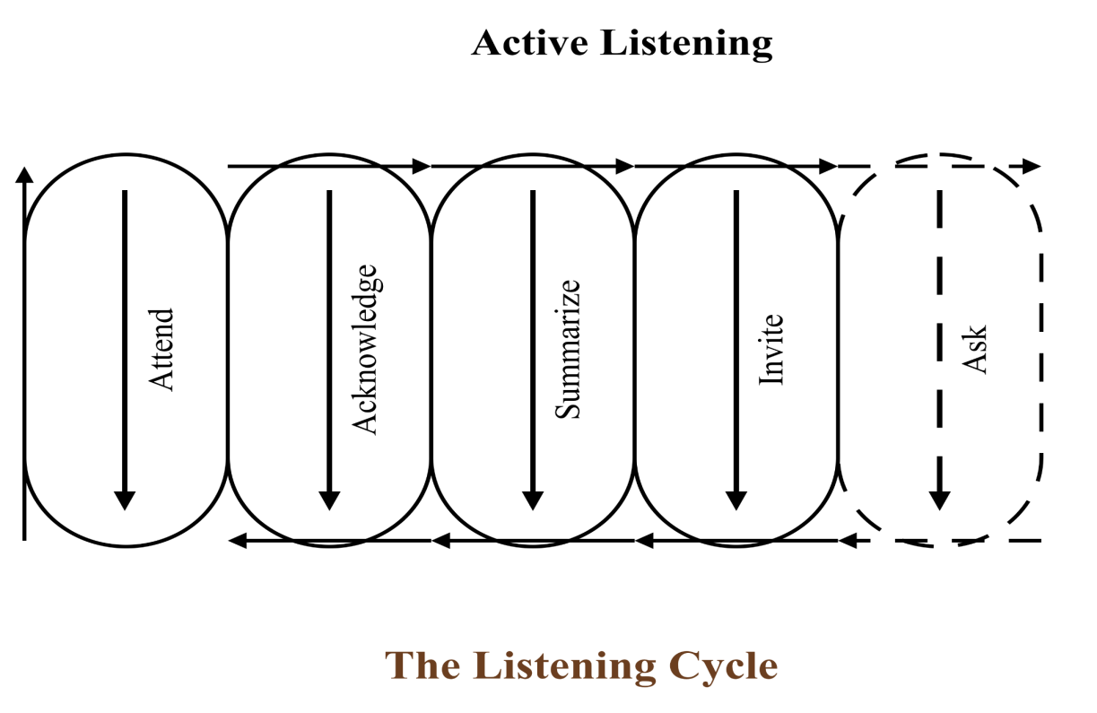
Figure 6: The listing cycle
The active listening cycle is a model of communication that includes listening, acknowledging, summarising, inviting discussion and asking questions. This cycle deepens stakeholder engagement, enhances the clarity of the message, minimises misunderstandings and aids collaboration in decision-making. With better listening, quality of communication is improved and achieves better and more successful delivery of the smoothie company relocation project.
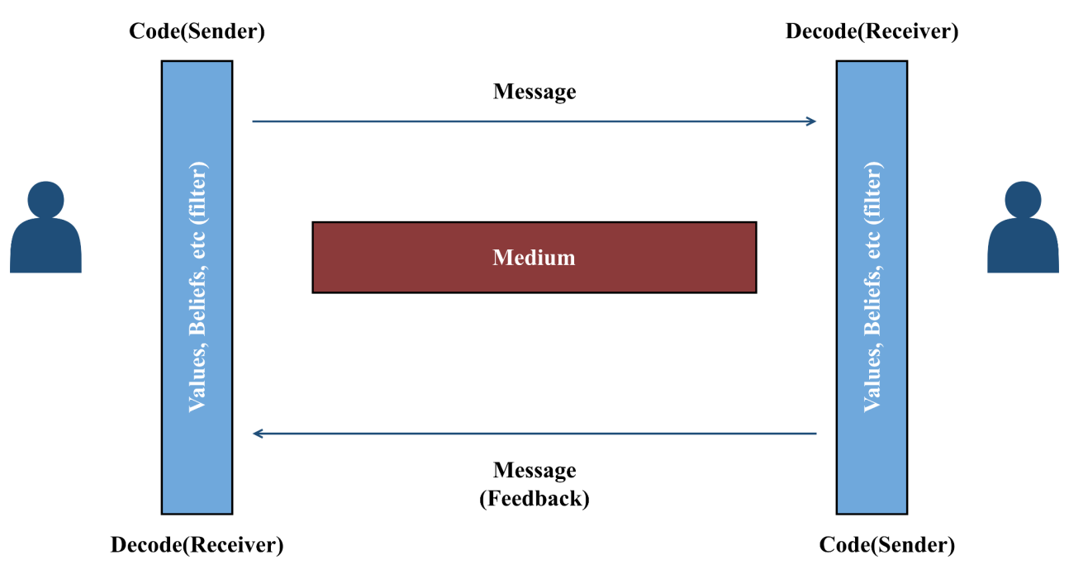
Figure 7: Communication Process Model for Stakeholder Information Exchange
The communication process model shows the sender and receiver of the message communicating via a suitable communication medium (Swart et al. 2022). By providing regular feedback and the right communication channels, message accuracy is enhanced, and misunderstandings are reduced. The collaboration of stakeholders is further improved throughout the smoothie company relocation project.

2.6 Risk Management
Likelihood / Impact | Very Low (1) | Low (2) | Moderate (3) | High (4) | Very High (5)
Very High (5) | Minor Housekeeping Issue | Staff Shortages | Supply Chain Disruptions | Production Delays | Critical Operational Failure
High (4) | Documentation Errors | Equipment Failure | Communication Breakdown | Budget Overruns | Major Production Interruption
Moderate (3) | Minor Quality Issues | IT System Failure | Transport Delays | Supplier Delivery Delays | Product Recall
Low (2) | Administrative Errors | Training Delays | Inventory Inaccuracy | Minor Equipment Fault | Customer Complaints
Very Low (1) | Negligible Risk | Minor Documentation Delay | Routine Maintenance | Minor Schedule Variation | Low Business Impact
Table 3: Risk Matrix
The risk matrix is used to assess potential risks for the relocation of the smoothie company, based on the likelihood and impact of the risk. The red zone risks are considered significant enough and have the potential to impact the project's success (Sami et al. 2022). So, these risks need to be addressed as soon as possible. Moderate risks, including the risk of delays in transport and equipment failure, need to be monitored and controlled to minimise disruption to operations. On the other hand, routine events such as administrative mistakes and common maintenance activities need to be solved in the usual way. This analysis allows for the effective prioritisation of mitigation actions, which helps to improve the chances of the relocation project being completed within the planned time, budget and quality targets.

2.7 Quality management
A quality management system is used to guarantee that the smoothie business project delivers the expected level of performance, smoothie quality and customer satisfaction. Quality planning helps to set goals and standards for operations before project implementation. Quality assurance is a process that checks the project process throughout its execution against the food safety regulations, industry standards and organisational policies. During production, quality control keeps track of production processes and equipment performance and addresses deviations promptly. Continuous inspections and monitoring of performance and employee training ensure the relocated production facility can provide safe, high-quality smoothie products and contribute to sustainable business growth.

3. SWOT Analysis
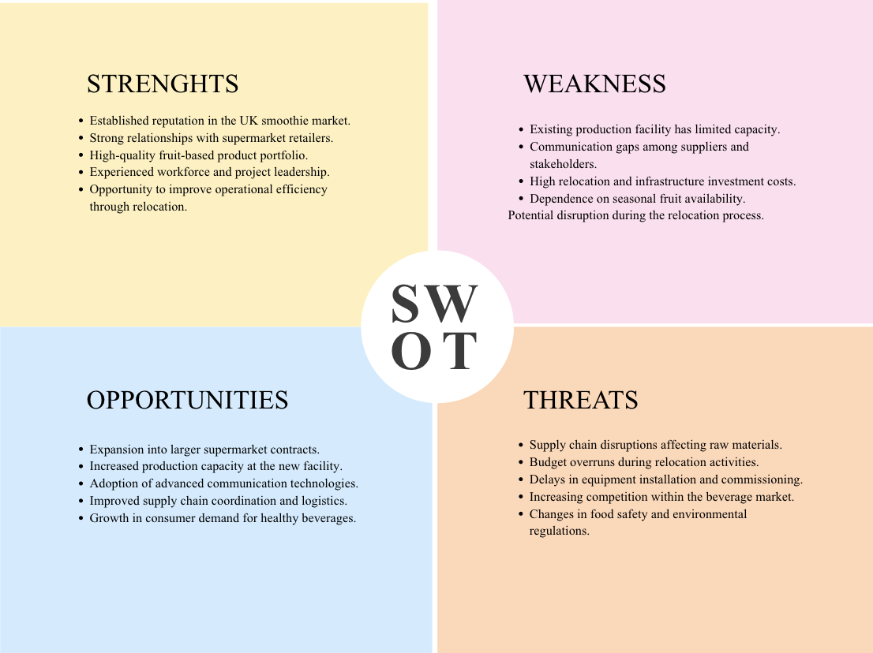
Figure 8: SWOT Analysis
A SWOT analysis is used to analyse a smoothie fruit company's internal and external factors that can affect the successful relocation and expansion of the company (Malope et al. 2025). An analysis of the strengths and weaknesses of the organisation, as well as external opportunities and threats, helps to inform strategic decisions to ensure sustainable project delivery and business growth.
Strengths
The company has several internal strengths which support the relocation project. It is also vital for customers to have confidence in product and reputation, which leads to better relationships with major supermarket retailers. The experienced employees and project leadership facilitate an efficient project execution, and a high-quality product portfolio enhances market competitiveness.
Weaknesses
There are some internal constraints which need to be handled effectively in the relocation project. The current production system does not offer the production capacity required to meet growing demand (Budi et al. 2023). The cost of relocation and infrastructure investment can create financial constraints for the project.
Opportunities
There are many opportunities for future growth and development within the relocation project. The expansion of production capacity may allow the company to obtain more supermarket orders and increase its market share in the healthy beverage market. The use of refined communication technologies and supply chain integration enhances supply chain coordination between suppliers, distributors and retailers.
Threats
Some external issues can impact the successful implementation of the project and its operating effectiveness. However, issues in the supply chain, delays in transportation and equipment installation issues may prolong the relocation program and project costs. Also, operational adjustments can be needed as a result of changes in food safety laws and requirements for environmental compliance.

4. PESTLE Analysis
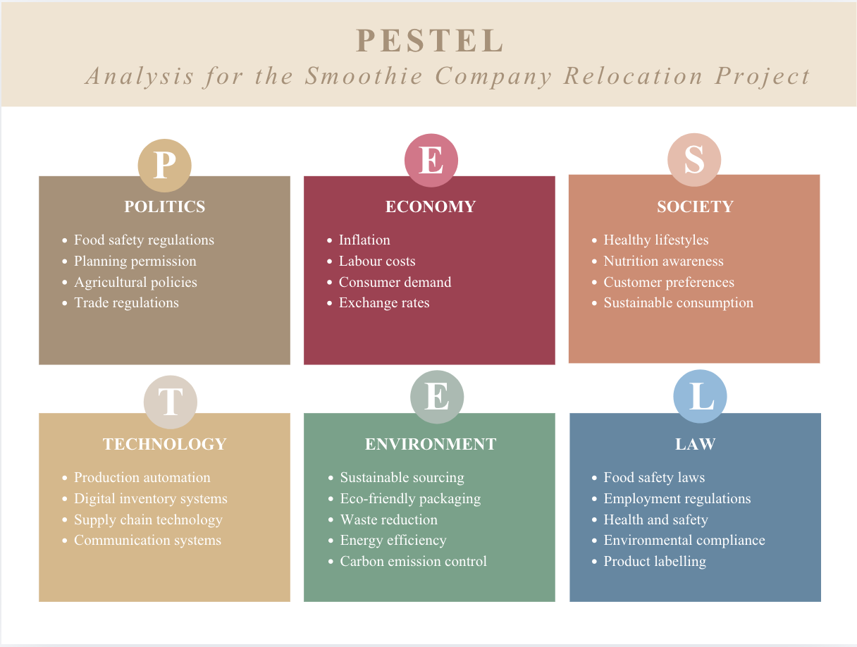
Figure 9: PESTLE Analysis
A PESTEL analysis is used to evaluate the external factors which can affect the smoothie manufacturing firm's success when relocating and expanding. The framework is used to analyse the political, economic, social, technological, environmental and legal aspects for the organisation's overall performance in the future.
Political
Government policies, planning permissions and food industry regulations are all political factors that affect the implementation of the project. The uninterrupted supply of raw materials is ensured by compliance with the agricultural policies, trade agreements and import regulations.
Economic
Relocation expenses, operating costs, and future profit or loss are impacted by economic conditions. Project budgets and procurement activities can be affected by inflation, labour costs, transportation costs, and exchange rate fluctuations.
Social
Social factors can impact the relocation project as the people can get healthy, natural and easily accessible fruit products (Gutiérrez et al. 2025). There is increasing consumer interest in nutrition, wellness and ‘green consumption’ that drives up the demand for smoothie products.
Technological
Technological innovations enhance the efficiency of operation, such as automated production machinery, digital inventory management and communication platforms (Uztürk and Büyüközkan, 2023). Advanced quality monitoring and supply chain technologies help to ensure effective coordination among stakeholders.
Environmental
Waste reduction, energy-efficient production and environmentally friendly packaging are part of the sustainable business operations influenced by environmental concerns. Through this, the environmental standards enhance corporate sustainability and decrease the ecological impact.
Legal
Legal factors involve handling by the laws regarding food safety, workplace health and safety, environmental laws, employment laws and product labelling. Fulfilling these legal requirements, it reduces the risk of regulatory issues and helps to safeguard consumer interests.

5. Organisational Structure and Technology

5.1 Proposed Organisational Structure
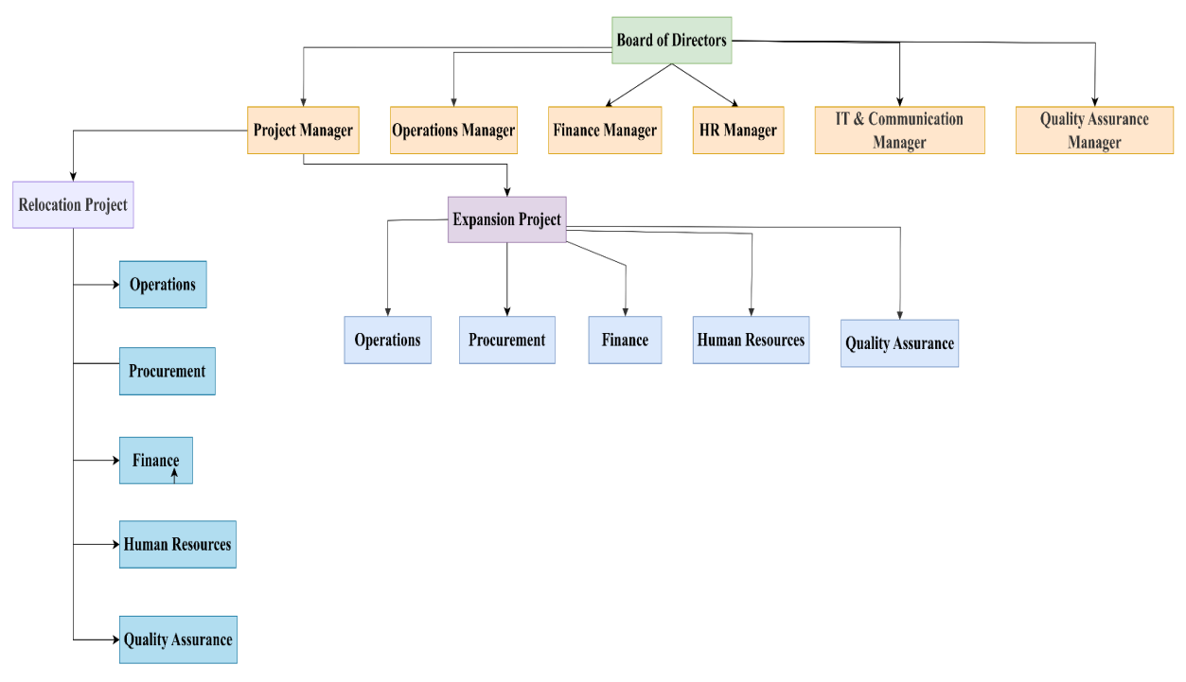
Figure 10: Proposed Organisational Structure
The proposed organisational structure defines the hierarchical structure to manage the smoothie company relocation and expansion project. The functional managers are responsible for day-to-day operations, finances, HR, IT, communication and quality assurance, whereas the Board of Directors are responsible for strategic direction (Tomproum, 2025). The Project Manager manages the relocation project, while the Expansion Project brings together cross-functional teams to help fulfil demand for growth. This organisational structure facilitates good resource utilisation, fosters interdepartmental cooperation, facilitates communication and provides clear relationships.

5.2 Communication Technology
Communication technology is used to enhance the information-sharing, stakeholder cooperation and project coordination during the smoothie company relocation and expansion project.
- Email Communication: Email is used for formal communication, project approvals, progress reporting and providing project documentation to managers and stakeholders (Dhonju et al. 2024).
- Video Conferencing: Virtual meetings with suppliers, representatives from supermarkets and project teams are made possible with the help of video conferencing platforms for speedy discussion and collaborative decision-making.
- Project Management Software: Project management software is used to keep a check on the project schedule, resource allocation, milestones and to communicate the progress of the tasks in real-time.

6. Issues Related to Moving to New Premises and Leadership

6.1 Relocation Issues
The move of the smoothie production plant can bring some operational challenges that need to be addressed to ensure a smooth transition. Several operational challenges need to be managed effectively to minimise disruption when the smoothie production plant is moved.
- Cost: To relocate a facility, a lot of money has to be invested in preparation, equipment installation, transportation and infrastructure development, which adds to the project cost.
- Delays: Construction operations, supplier coordination, regulatory approvals and equipment installation can cause delays in the project timelines and impact the expected operation timeline. (du Plessis et al. 2023)
- Staff Training: All staff need to be extensively trained to use the new equipment, changeover procedures in place and have an understanding of safe working practices in the new facility.
- Business Interruption: Stoppages of production during relocation may lead to loss of product, customer delivery and impact on an organisation's revenue.

6.2 Time–Cost Trade-off (Crash Costing)
Activity | Normal Duration (Days) | Crash Duration (Days) | Normal Cost (£) | Crash Cost (£)
A – Project Initiation | 2 | 1 | 2,000 | 3,500
B – Site Selection | 5 | 4 | 5,000 | 6,500
C – Lease Agreement | 4 | 3 | 4,000 | 5,500
D – Facility Preparation | 10 | 8 | 20,000 | 26,000
E – Equipment Procurement | 8 | 6 | 18,000 | 23,000
F – Equipment Installation | 7 | 5 | 15,000 | 20,000
G – Communication System Installation | 4 | 3 | 8,000 | 10,000
H – Staff Recruitment & Training | 6 | 5 | 6,000 | 7,500
I – Production Testing & Quality Inspection | 5 | 4 | 7,500 | 9,000
J – Commercial Launch | 2 | 1 | 3,000 | 4,000
Table 4: Crash Costing Analysis
The crash-costing analysis involves a comparison of the normal and accelerated duration and costs of each project activity (Zareei et al. 2025). The table illustrates the requited addition costs to shorten activity times. It allows project managers to determine if it is cost-effective to accelerate the project schedule without compromising project quality and operational goals.
Activity | Normal Duration (Days) | Crash Duration (Days) | Normal Cost (£) | Crash Cost (£) | Crash Increase (£) | Crash Cost per Day (£)
A | 2 | 1 | 2,000 | 3,500 | 1,500 | 1,500
B | 5 | 4 | 5,000 | 6,500 | 1,500 | 1,500
C | 4 | 3 | 4,000 | 5,500 | 1,500 | 1,500
D | 10 | 8 | 20,000 | 26,000 | 6,000 | 3,000
E | 8 | 6 | 18,000 | 23,000 | 5,000 | 2,500
F | 7 | 5 | 15,000 | 20,000 | 5,000 | 2,500
G | 4 | 3 | 8,000 | 10,000 | 2,000 | 2,000
H | 6 | 5 | 6,000 | 7,500 | 1,500 | 1,500
I | 5 | 4 | 7,500 | 9,000 | 1,500 | 1,500
J | 2 | 1 | 3,000 | 4,000 | 1,000 | 1,000
Table 5: Crash Cost Analysis
The crash cost analysis is based on the extra costs of reducing activity duration and the crash cost/day for each activity. This table helps determine the financial consequences of schedule compression and helps to select the activities that can offer the best value for compressing the project.

Activity | Crash Cost per Day (£) | Normal Duration (Days) | Crash Duration (Days) | Time Saved (Days) | Cumulative Project Cost Increase (£)
J | 1,000 | 2 | 1 | 1 | +1,000
A | 1,500 | 2 | 1 | 1 | +2,500
B | 1,500 | 5 | 4 | 1 | +4,000
C | 1,500 | 4 | 3 | 1 | +5,500
H | 1,500 | 6 | 5 | 1 | +7,000
G | 2,000 | 4 | 3 | 1 | +9,000
E | 2,500 | 8 | 6 | 2 | +14,000
F | 2,500 | 7 | 5 | 2 | +19,000
D | 3,000 | 10 | 8 | 2 | +25,000
Table 6: Crash Cost Sequence
Crash Sequence: J → A → B → C → H → G → E → F → D
Sequence of project activities identified by the crash cost is the one that starts with the least expensive activities (Schiere and Gregorini, 2023). This helps to reduce the extra cost of the project and to fulfil the required schedule reductions. The sequence helps in making effective decisions on the time/cost trade-off and enables the economical acceleration of the critical project schedule.

6.3 Leadership Styles
Leadership Style | Characteristics | Application to the Relocation Project
Transformational | Inspires staff with vision, innovation and change in the organisation. | Appropriate for relocation management as it fosters collaboration among employees, employee engagement and acceptance of organisational change.
Transactional | Emphasises organised tasks, tracking of performance, and rewards given for meeting goals. | Fit for the management of project schedules, budgets, the quality of standards, and the performance in operation while it is being implemented.
Situational | Uses the right leadership style for different levels of team ability, project complexity and changing circumstances. | Facilitates informed decision making in the solution of relocation issues, stakeholder needs and unexpected project risks.
Table 7: Comparison of Leadership Styles
The comparison shows that the different approaches of the three leadership styles have different impacts on the success of projects.

7. Recommendations
These recommendations are made to facilitate the successful relocation of the smoothie manufacturing company in the long run and for the smooth and efficient operation of the project.
- A detailed project timeline is required to be created to track project milestones and reduce implementation delays.
- Improve communications between suppliers, transport, staff and supermarket stakeholders.
- Integrated project management and communication technologies are required to enhance communication and coordination.
- Thorough training for employees is needed before the beginning of operations at the new plant.
- Advanced risk management and contingency plans are required to be established for supply chain and operational disruptions (Ottaviani et al. 2024).
- A transformational leadership style is needed to adopt to facilitate change in the organisation, employee engagement and ongoing business improvement.

8. Conclusion
A proposed project management strategy is demonstrated in this report to assist in the successful relocation and expansion of the smoothie fruit company. The project planning, scheduling, management of stakeholders, communication, risk analysis, SWOT, PESTEL, organisational structure and leadership analysis are all aspects that offer a broad spectrum of information for making decisions. So, effective implementation is expected to improve production capacity, ensure the quality of the products and contribute to sustainable long-term development of the organisation and its competitiveness.

References
Budi, W., Rita, M.R., Taman, A., Riri, A., Leny, C.N. and Yurike, A., 2023. The potential development of leading fruit commodity agribusiness in Samarinda City of East Kalimantan, Indonesia. Russian Journal of Agricultural and Socio-Economic Sciences, 138(6), pp.92-100.https://cyberleninka.ru/article/n/the-potential-development-of-leading-fruit-commodity-agribusiness-in-samarinda-city-of-east-kalimantan-indonesia
Datta, S.D., Islam, M., Sobuz, M.H.R., Ahmed, S. and Kar, M., 2024. Artificial intelligence and machine learning applications in the project lifecycle of the construction industry: A comprehensive review. Heliyon, 10(5).https://www.cell.com/heliyon/pdf/S2405-8440(24)02919-0.pdf
Dhonju, H.K., Walsh, K.B. and Bhattarai, T., 2024. Management information systems for tree fruit—1: A review. Horticulturae, 10(1), p.108.https://www.mdpi.com/2311-7524/10/1/108
du Plessis, F., Goedhals-Gerber, L.L. and van Eeden, J., 2023. Forecasting fruit export damages and enhancing food safety through risk management. Sustainability, 15(21), p.15216.https://www.mdpi.com/2071-1050/15/21/15216
Evitha, Y., Sari, S.N., Suprayitno, D. and Irrianda, J., 2023. Digital Communication Management Government of the Republic of Indonesia for Inclusive and Sustainable Economic Recovery in Indonesia. KnE Social Sciences, pp.621-631https://knepublishing.com/index.php/KnE-Social/article/download/13710/22143
Gutiérrez Calle, A., López Vanegas, D.A., Márquez Vanegas, A.M. and Monsalve, M.C., 2025. Business Plan for the production and export of freeze-dried fruits from Colombia to Germany (Bachelor's thesis, Negocios Internacionales).https://alejandria.poligran.edu.co/bitstream/handle/10823/8005/Poyecto%20de%20grado%20ultima%20entrega%20.pdf?sequence=3
Malope, P., Madisa, M.E., Solani, D. and Mabikwa, O.V., 2025. Opportunities and Constraints in the Horticultural Sector of Botswana: A SWOT Analysis. Sustainability 2025, 17, 3088 [online]https://www.academia.edu/download/123086128/sustainability_17_03088_1_.pdf
Ottaviani, F.M., De Marco, A., Rafele, C. and Castelblanco, G., 2024. Risk perception-based project contingency management framework. Systems, 12(3), p.93.https://www.mdpi.com/2079-8954/12/3/93
Sami Ur Rehman, M., Thaheem, M.J., Nasir, A.R. and Khan, K.I.A., 2022. Project schedule risk management through building information modelling. International Journal of Construction Management, 22(8), pp.1489-1499.https://www.academia.edu/download/96200159/15623599.2020.172860620221222-1-1x3mfhu.pdf
Schiere, J.B. and Gregorini, P., 2023. Complexity, crash and collapse of chaos: clues for designing sustainable systems, with focus on grassland-based systems. Sustainability, 15(5), p.4356.https://www.mdpi.com/2071-1050/15/5/4356
Swart, K., Bond-Barnard, T. and Chugh, R., 2022. Challenges and critical success factors of digital communication, collaboration and knowledge sharing in project management virtual teams: a review. International Journal of Information Systems and Project Management, 10(4), pp.84-103.https://repository.up.ac.za/bitstreams/181ed8a9-9bd2-4aa6-9dfd-d64fc712cdc0/download
Taboada, I., Daneshpajouh, A., Toledo, N. and De Vass, T., 2023. Artificial intelligence enabled project management: a systematic literature review. Applied Sciences, 13(8), p.5014. https://www.mdpi.com/2076-3417/13/8/5014
Tomprou, M.O., 2023. Opportunities and challenges for the creation and governance of productive landscapes in urban transformations: The case of Klosterøya urban fruit forest park. Sustainability, 15(4), p.2864.https://www.mdpi.com/2071-1050/15/4/2864
Uztürk, D. and Büyüközkan, G., 2023. Strategic analysis for advancing smart agriculture with the analytic SWOT/PESTLE framework: A case for Turkey. Agriculture, 13(12), p.2275.https://www.mdpi.com/2077-0472/13/12/2275
Zareei, M., Knox, C., Helgeson, J., Gray, S.A., Sadler, R.C., Olabisi, L.S. and Wentworth, C., 2025. Community-informed decisions for equitable, cost-effective, and inclusive disaster resilience planning (Co-DECIDR): A modeling approach. Socio-Environmental Systems Modelling, 7, pp.18759-18759https://sesmo.org/article/download/18759/18340

