SAMIA ASSEBAB
P151305
Abstract
This report explores the process of developing a website using HTML, PHP and CSS. It briefly displays the validation process, the errors involved and how to remedy them. This report highlights general and specific recommendations and improvements that can be applied when developing a website
HTML AND CSS WEB DEVELOPMENT
ACCA4018

Table of Contents
1 INTRODUCTION 2
2 REQUIREMENTS 2
3 PROJECT SCREEN SHOTS 3
4 VALIDATION OF HTML AND CSS 9
4.1 HTML VALIDATION REPORT 10
4.2 CSS VALIDATION REPORT 10
5 FINDINGS 10
5.1 Perceivable 10
5.2 Operable 10
5.3 Understandable 11
5.4 Robust 11
5.5 usability 11
5.6 Functionality 11
6 RECOMMENDATIONS 11
7 CONCLUSION 12
8 REFERENCES 13

INTRODUCTION

The principle objective of this report is to formulate the coding of a website titled “WALES ONLINE HOSTEL BOOKING SYSTEM”. For the purpose of making certain that the requirements of the website are sufficiently met, the report will outline the basic descriptions which form different basic components of the website, using class notes and other sources, the website will be coded in programming language HTML and CSS on platform visual studio 2017 and XMAPP to host, using PHP to integrate a data processing system.

REQUIREMENTS

Wales online hostel booking system is a website that will focus on facilitating effective booking process for student hostels. The website aims at achieving the convenience of hostel booking such as keeping records of the occupants. The website users are predominantly students and hostel managers. The student is required to register their details before using the system. The hostel admin on the other hand is responsible for ensuring that any unlisted hostel is registered into the system. The hostel admin has predefined login credentials that they must use in order to access the system and execute different management roles. The system is relevant since it will eliminate the situation whereby students struggle to avail their physical presence in order to find their accommodation. The system aims to increase the effectiveness of the booking process through complete virtualization.

PROJECT SCREEN SHOTS
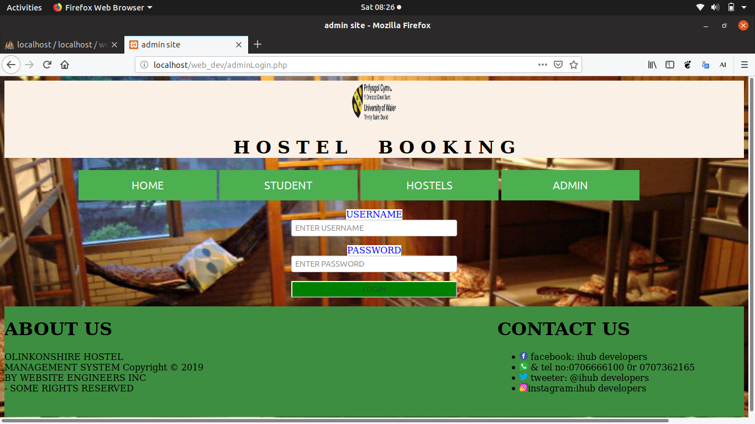
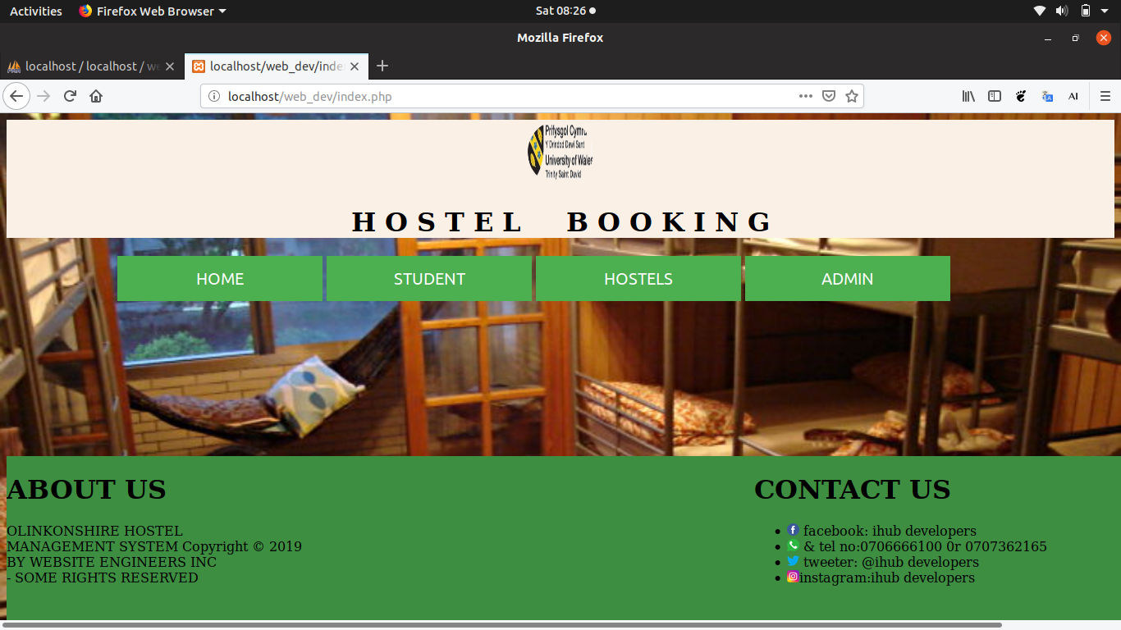
Figure 1 - Homepage
Figure 2 - Student Log in Page

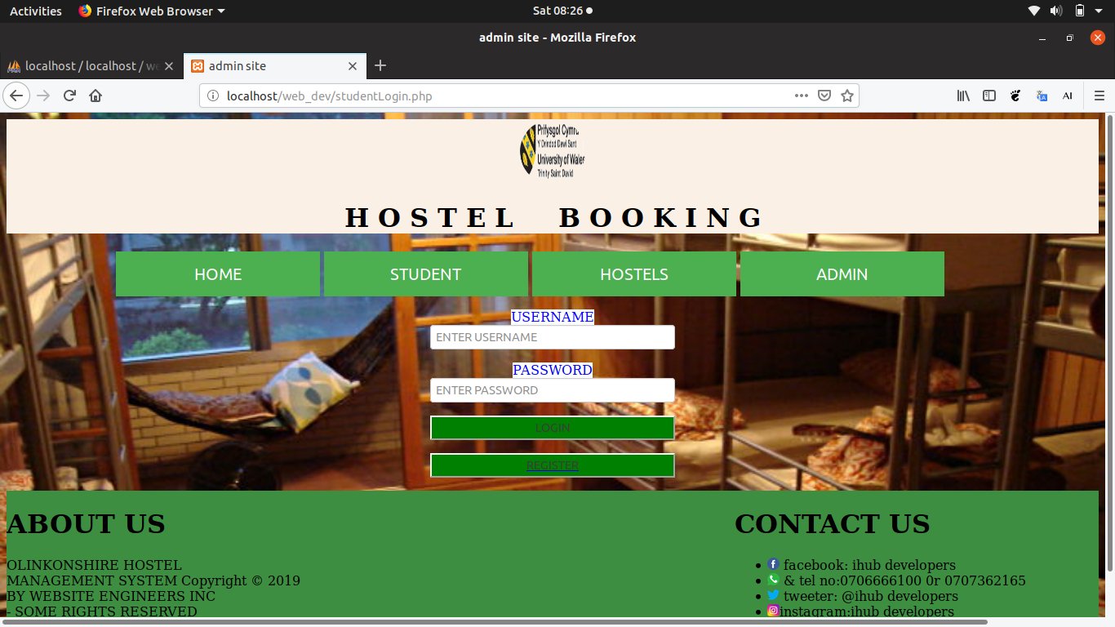
Figure 3 - Admin login page

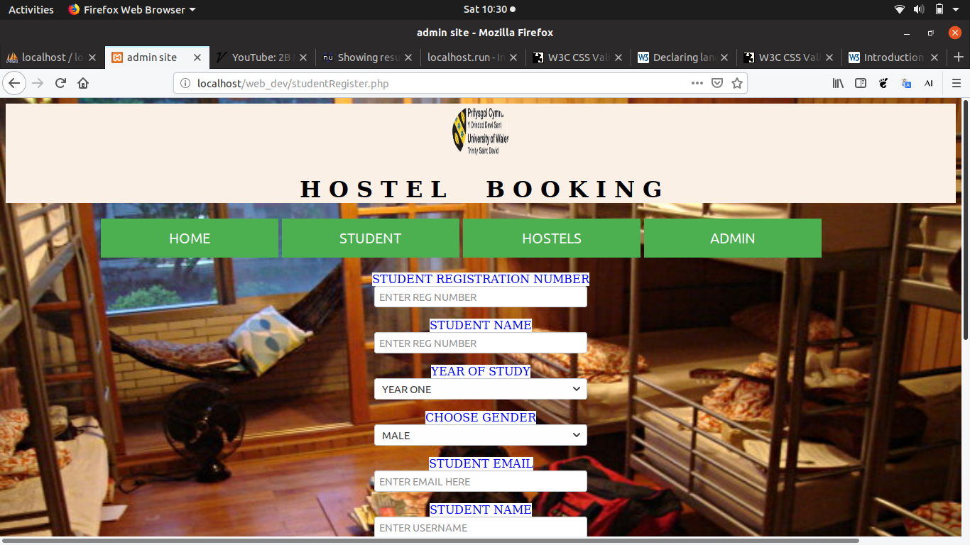
Figure 4 - Student register page

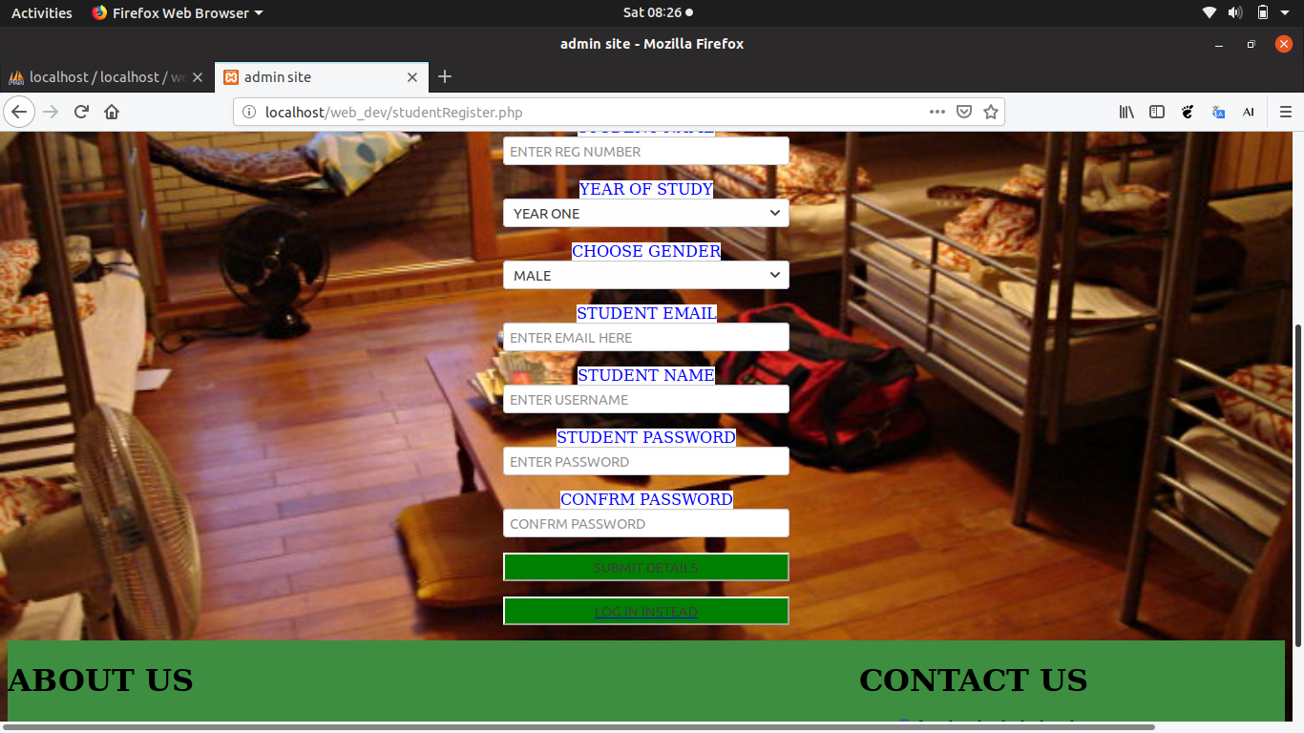
Figure 5 - Student register page continued
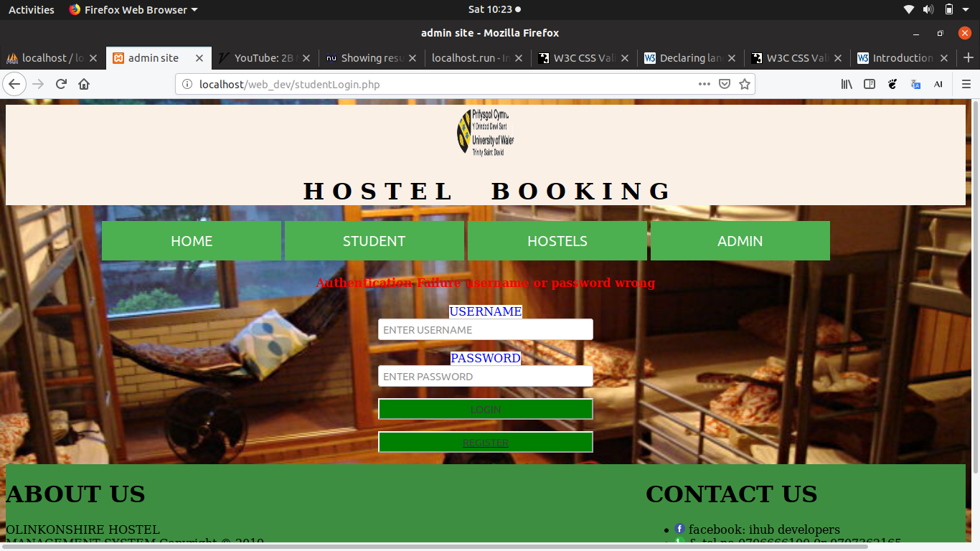
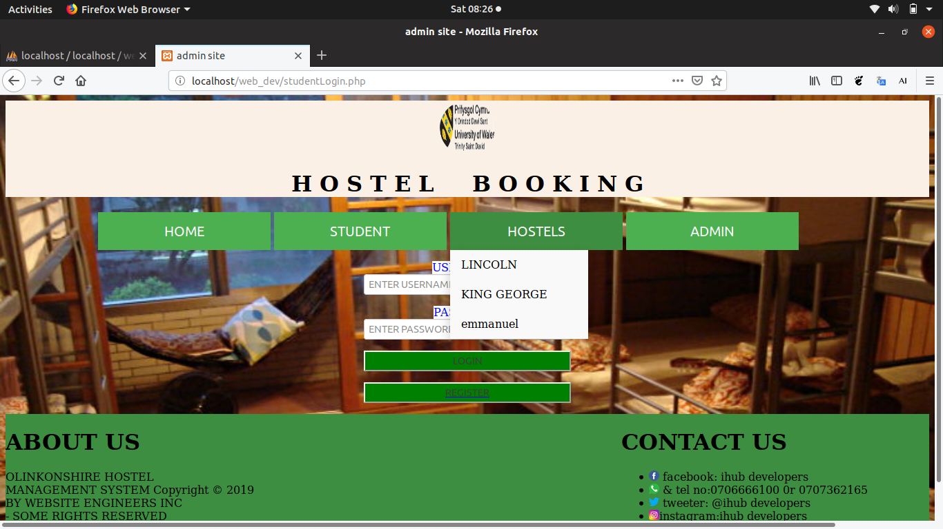
Figure 6 - Showing hostel

Figure 7- failed login

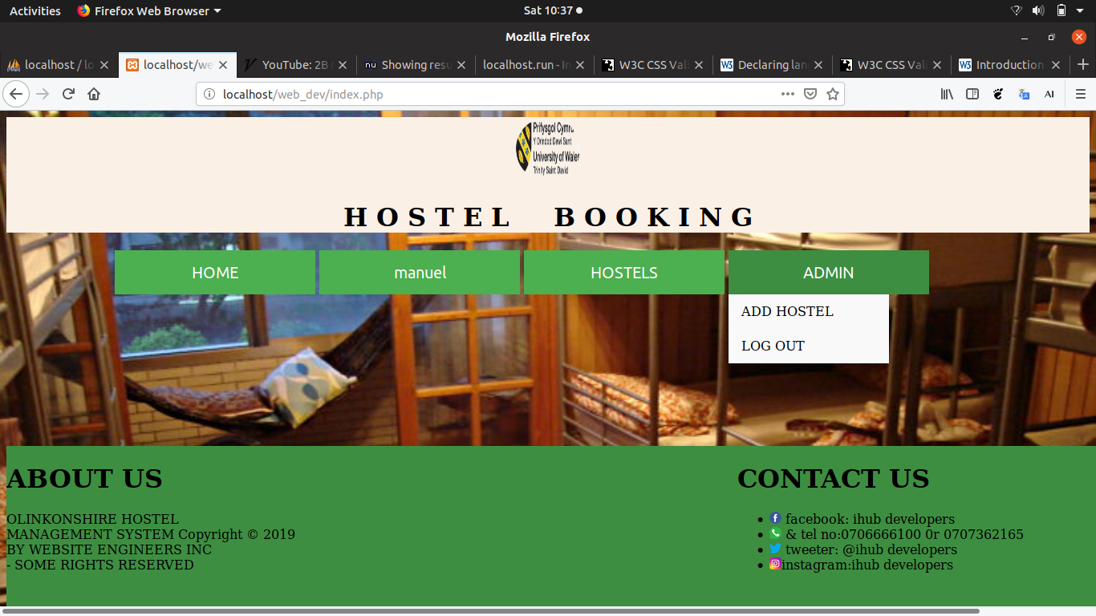
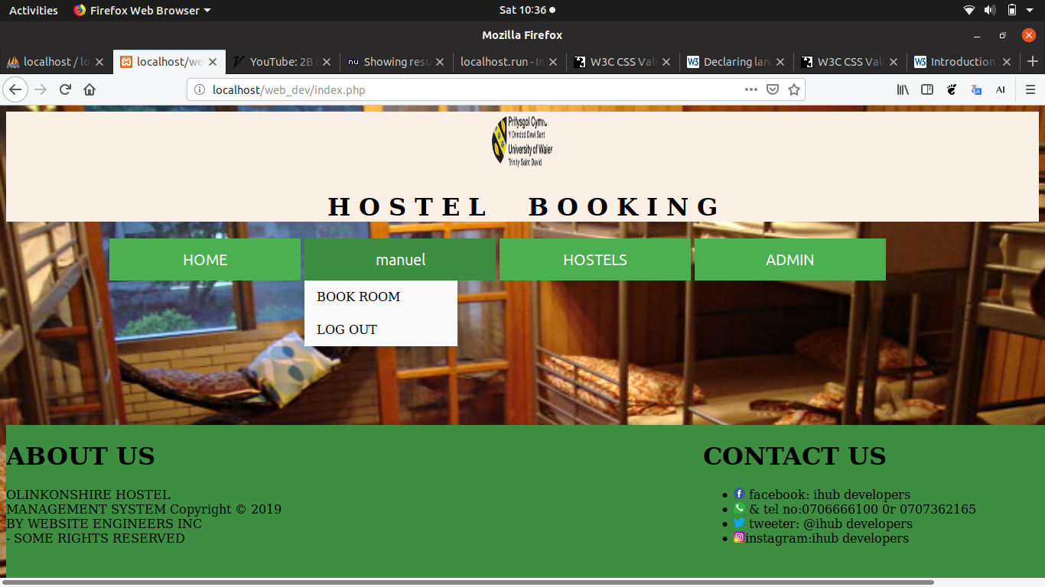
Figure 8 - Student successfully logged in
Figure 9 - Admin successfully logged in

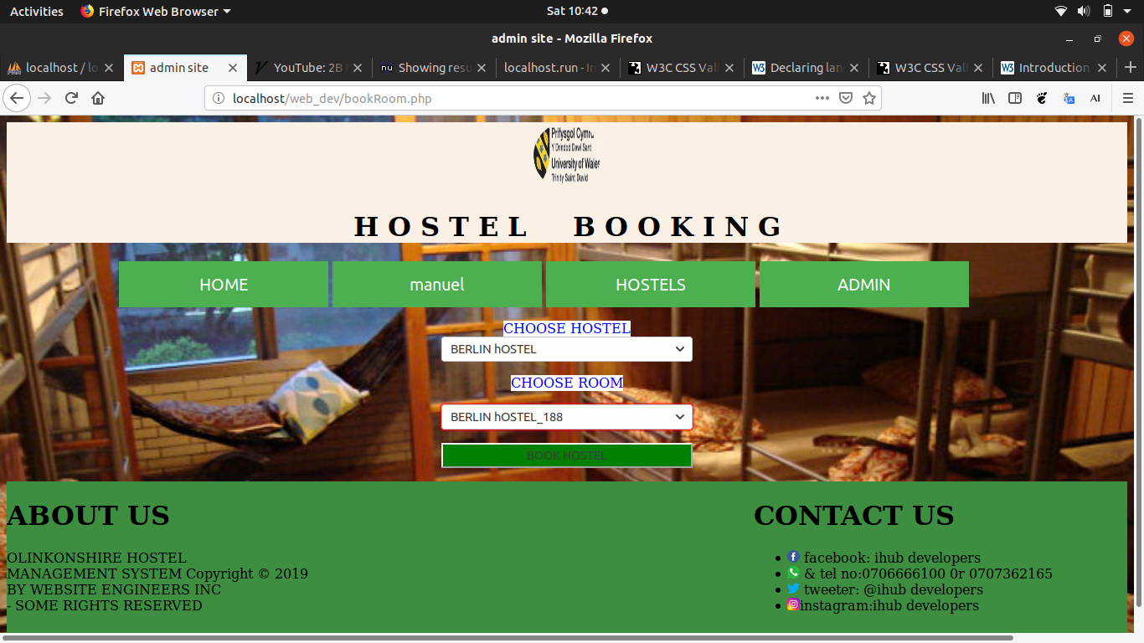
Figure 10 - CHOOSING HOSTEL

VALIDATION OF HTML AND CSS

Warning: Consider adding a “lang” attribute to the html start tag to declare the language of the document.
From line 1, column 16; to line 2, column 6
type html>↩<html>↩ <hea
For further guidance, consult declaring the overall language of a page and choosing language tags.
If the HTML checker has misidentified the language of the document, please file an issue report or send e-mail to report the problem.
Error: The character encoding was not declared. Proceed using windows-1252.
Error: Stray start tag html.
From line 4, column 3; to line 4, column 18
<head>↩ <html lang="en">↩ <lin
Error: Element head is missing a required instance of child element title.
From line 6, column 2; to line 6, column 8
e.css"> ↩ </head>↩<body
Content model for element head: If the document is an <iframe> ‘srcdoc’ document or if title information is available from a higher-level protocol: Zero or more elements of metadata content [4], of which no more than one is a title element and no more than one is a base element.
Otherwise: One or more elements of metadata content[5], of which exactly one is a title element and no more than one is a base element.

Error: Saw <?. Probable cause: Attempt to use an XML processing instruction in HTML. (XML processing instructions are not supported in HTML.)
At line 8, column 2
/head>↩<body>↩<?php↩include_on
Error: Saw <?. Probable cause: Attempt to use an XML processing instruction in HTML. (XML processing instructions are not supported in HTML.)
At line 11, column 2
der.php");↩?>↩<?php↩include_on

HTML VALIDATION REPORT

The errors found within the homepage were caused by the external pages applied to modify the contents of the homepage. The pages comprised of the headers and footers. The validator found on the server-side code snippets within the homepage as errors. After a careful observation, none of these errors were alarming or even destructive to the functionality and workflow of the website.

CSS VALIDATION REPORT
URI: site.css

81 | #container | Value Error : background-color none is not a background-color value : none
95 | footer | Value Error : font auto is not a font value : auto

FINDINGS

None of the CSS errors could be solved based on the given case. Fonts needed to be automatic while maintaining visibility when interacting with the background-color.

Perceivable
The website was constructed in a simplified way so that the user could locate different elements with ease. The layout of the website was enhanced by providing a well elaborated title. The navigation bar is well designed in a manner that it explains tittles displayed under different buttons. The subtle colors were applied to avoid distractions. Moreover, the use of dull colors was eliminated to help the users differentiate between various components of the website.

Operable
The website operates smoothly and displays all pages systematically. The navigation bar which appears uniform regardless of the page, this creates a consistent theme and fluidity to the website layout. The drop-down menus on navigation buttons makes it easy for the user to view available options. The interface is friendly; such that, no page requires the user to press the browser since the back button is provided. The website provides options to different directions and elements the user might be interested in.

Understandable
The website was constructed in a more understandable way. The descriptive words such as “book hostel”,”log in”,” register” were used to easily engage the user and their needs, without the need of searching. Considering the target audience was based on students, the language used was uncomplicate and devoid of any jargon.

Robust
The contents of the website can easily be accessed through different tools such as search engines. However, there are a few restrictions where the inserted data must be obtained from form pages.

usability
The website is implemented in a user-friendly way. An example of this is the navigation bars, their labels make it readable without any effort. The design was driven by the desire to formulate a simple and appealing website created to facilitate the booking of hostels.

Functionality
The main role of the current website is to enable students to book hostels remotely. The registration detail of each student assists the school to administer different hostels as completely different entities from other institutional obligations. The student simply registers and logs in with the same details provided in the institution. The admin has the responsibility of presenting vacant hostels to the students.

RECOMMENDATIONS

- To facilitate efficient functionality of the website in future,
- The website’s search engine optimization needs be improved.
- To ensure sure that the validated students have access to the hostels rooms, the database must be fetched from the main school’s server.
- The website must be incorporated with a data encryption to make certain that the personal and confidential details of students are completely protected.

- On-page search engine optimization
- The On-page search engine optimization of the website is simple in nature. Every page has links to all other pages. This is essential since the multiple links on the website will optimize searches for other pages.
- The websites’ optimizations; The application of multiple search words such as ‘online hostel’, ‘hostel booking’ and ‘university’ were used to optimize the search engine. The words appear mostly on the search engine’s index every time a search is executed.

CONCLUSION

The author’s familiarity with website development and the confidence earned through this, inspired a greater challenge, their experience with the data processing system encouraged the integration of a data absorbing website, through little research PHP seemed the most compatible for achieving this result. However, PHP was a concept alien to the author prior to this report, this meant, much of the written code was difficult to grasp and left little time to focus on the functionality of the website.
The use of PHP adopted may issues when attempting to display the website as it required an additional application unknown to the author, this exhausted the timeframe of completion as the focus was heavily emphasized on the external elements of the assignment.
It would have been advantageous to focus solely on the aesthetics of the website, although the website runs smoothly there is little content, such as an “about us” page which would typically involve a paragraph about the organization.
The adaptation of PHP allowed the author to advance their knowledge, however the decision to implement it when against a deadline proved detrimental to the overall performance of the website. Moreover, neglecting to produce a time sensitive plan of execution was also wrongful, as this would usually be paramount in a scenario where the web developer was given a task.

REFERENCES

[1 ]https://www.phpmyadmin.net/
[2] https://www.php.net/manual/en/intro-whatis.php
[3] https://www.thoughtco.com/php-with-html-2693952
[4] https://html.spec.whatwg.org/multipage/dom.html#metadata-content-2
[5] https://html.spec.whatwg.org/multipage/iframe-embed-object.html#an-iframe-srcdoc-document
[6] https://www.w3.org/International/techniques/authoring-html#textprocessing

