

Student Name: | Isa Nsimbe Maseruka
Student Number: | 1705769
Semester: | 2
Lecturer: | Sylvia Hoffmann
Module No: | BMSK4001
Module Title: | Academic and Employability skills

Table of Contents

Reflective Essay 3
Description 4
Feelings 5
Evaluation 6
Analysis 6
Conclusion 9
Action Plan 9
References 10

Reflective Essay
This reflective essay is based on academic and employability skills that I was able to learn from the module in last semester. This is the firsthand experience for me to write a reflective essay about what I learned last semester from the module. I am extremely grateful to get to opportunity to learn and write about this module regarding the knowledge I gained. This module appealed to me as it consists of many academic concepts such as academic writing, research methods and referencing techniques. Moreover, this module made me understand the skills and abilities that I need to be able to compete in a job and confirm a job position in this competitive market. When the module provided to me, I knew this will be challenging for me but has the ample of opportunity of learning and know about my true inner self. This reflection is presented below in the Gibbs Reflective Cycle.
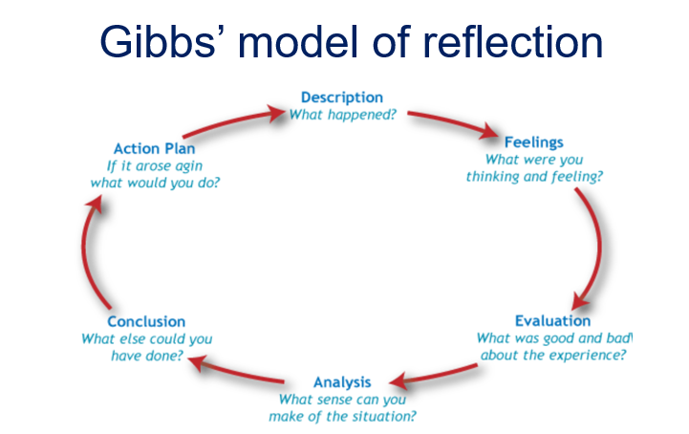

Description
In last semester, all the students learned about academic skills and employability skills that every student should have to be well qualified for getting a job. Last semester a new module, which is Academic and Employability skills, was introduced among the students and we are asked to write a reflective report on our learnings regarding academic and employability skills. I really panicked at first, as I did not had any idea about how to write a reflective report. However, the module introduced to us was self-explanatory and got the help of my teachers regarding the way to write reflective essays. I was worried at first so I searched the internet to find more about reflective writing and got the real idea about it. Most of the reports are about research about certain topic but reflective essays are real life experience that I have faced in my life. My classmates and I sat for a group study session regarding reflective writing. We shared ideas about reflective writing and helped one another regards the issues we faced regarding the topic. We had to start remembering what we learned in the last semester regarding the academic skills and employability skills. I made sure I sat was my friends regarding discussion about this topic every week to understand how much we have progressed. I saw some other friends taking help from seniors who had already done this type of reflective essay writing. Therefore, one day I told one of my friend to introduce me with one of the senior brothers so that I can learn from them and understand how to get better marks in this reflective writing. The result of the situation was more than I expected, as I was able to learn a lot from the senior brothers and gave me a clear idea about what to write. I just had to go through the module of last semester to clearly remember what I learned and make a plan for myself about the self-reflection essay.

Feelings
Before the situation took place, I was quite happy, as there was no extra pressure of learning. I was attending all my classes regularly and learning what was taught in class. Doing group study regularly was a thing for me and I always used to stay at my friend’s house for study regarding any difficult topic taught in class. When this module was introduced, I got very curious to learn more about it. At first, I was not giving much attention to it as I thought it should be easy. I am the type of person who like to start things when it is mandatory to do so. However, I saw other people was serious about this topic and taking help from classmates and seniors in the university. This made me more serious and hence I contracted my friends and started doing group studies. I even stayed at my friend’s house and discussed about what we learned before and how to come up with an excellent reflecting essay. During the last few days of the reflective essay submission, I remember putting so much effort into the work. Sleepless nights took place, as I knew that I had to finish the work in given time. I remembered about the academic skills that I have acquired in the last semester such as Harvard referencing, proper report writing, improving my communication and presentation skills. The learning that I did was one heel of an experience that will help me a lot in future both for academic purposes and for employability purposes as I put a lot of effort to improve my employability skills as well. The issue that got me concerned the most was not having enough knowledge on employability skills. Therefore, I tried even harder to improve my skills such as improving my job interview skills and CV writing skills.

Evaluation
I regret not putting too much effort on my learning during the first few week. As a result, I was unable to learning more about employability skills. I know that time is valuable and every second wasted can haunt me down later. For learning about academic skills, I was able to improve my presentation skills, writing skills, research skills, and Harvard referencing skills and for employability skills, I was able to learn about how to write a proper CV of learning and myself about job description in different kind of jobs. The most difficult part of the learning experience was when everyone in the class seemed to struggle to understand how to write a reflective report and most of the students were chilling in the first few weeks after this module was introduced. Thankfully, with the help of my seniors and some fully committed classmates I was able to work in a group, discuss more about my learning, and come up with a learning plan.

Analysis
The main positive to take away was to learning experience from this module. As I mentioned earlier that I put a lot of effort to improve my academic and employability skills. The analysis of my learning regarding academic and employability skills are given below:
- Harvard Referencing- One of the most interesting thing that I learned last semester was Harvard referencing, its techniques, and the process of putting in text citation in academic reports. University students to site information sources primarily use Harvard referencing. Two types of citation are included in academic reports. One of them is in text citation, which is used for directly quoting and paraphrasing a source from the book, journals, magazine, newspapers and the internet. Another type of citation is the reference lists that are included in academic reports at the end of the writing, which consists of all the list of references that has been cited in the report. Each citation included various information such as name of the authors, year published, title, city published, publisher, pages used (Citethisformecom, 2018). Learning about Harvard referencing was tough as the beginning but with the help of my mentors, seniors, friends and obviously the internet, I learned a lot and now I can say that I am good enough to do proper Harvard referencing in academic reports.
- Group work and Presentation- I focused on my abilities regarding presentation skills, as I believed I have lacked this skill. In the meantime, I was able to learn more about how to work in a group as this was the first time students were asked to present on their academic report and had to work with others to come up with a successful result. For improving presentation skills, I practiced in front of my classmate and I practiced alone by recording myself in front of a camera to understand my strengths and weaknesses. I figured out that I can speak well with my voice and have ability to use proper grammar, but I faced difficulties with explaining a topic in simplified words. Therefore, I worked on that to improve myself and had worked in a group to improve each and everyone’s skills. I figured out that working in a group is more fun than working alone as I am getting the opportunity to work with people from different age, gender, race and ethnicity.
- Research and evaluation- Another interesting learning from the semester was regarding research and evaluation skills. I learned about doing many types of research such as handing over survey questionnaires to get responses regarding a topic. I learned about qualitative and quantitative research methods and gained some knowledge about focused group discussion regarding a topic (Macmillanihecom, 2018). By searching the internet and taking help from my seniors, I gained knowledge regarding ways to represent data using graphs and pie charts. This learning experience really made me as excited as it was something very new for me to learn and this module was useful as it contained ample of opportunity for learning.
- CV writing skills- As a student, I need to keep my CV updated every semester that is what I learned from my university. As I am in the first year of my university, I need to learn about ways to write a perfect CV. In my class, I gained some knowledge regarding CV writing and then I went home and searched more about in in the internet. I was amazed to see the ways of making CV’s as everyone has their own creative ways of writing CV. As I did not had any prior experience in writing CV before, I learned some easy ways to make the CV. I choose Microsoft word to make my CV in a simple and easy way that will be understandable for everyone and good enough to get me a job.
- Job Description- As I am a student and has no prior experience of working for an organization, I searched many online job portals and newspapers and LinkedIn to see what are the different type of job description posted by different organizations. Understand what a job description is and work that I will be required to do is very important before joining any jobs. It gives clear idea about whether the job is right fit for me or not. JD is a piece of document that briefly describes the general tasks, or other related duties, and responsibilities of a job position in an organization (Chroncom, 2018).

Conclusion
Looking back at the scenario as a student is learning process; I would say this module was helpful for all the students. In this scenario, I could have asked some more help from the university professors and lecturers regarding any issues I faced. Rather than doing that, I tried to find solution of my problems by myself and focused too much on the internet. In this modern world, academic skills and employability skills are important for every student to learn. To get my dream job, this module acts, as a beginner is learning curve that will help me in the future. If similar situation arose again, then I would like to work on my hard skills and soft skills that are very essential for getting a job in this competitive world.

Action Plan
The action plan would be to become more proactive in terms of learning academic and employability skills. The focus should be to not waste any time and spend a little bit more on my employability skills, which consists both hard skills and soft skills. If this kind of situation comes again then I would definitely try learning more about computer skills such as Microsoft office uses and do short courses on them. I would like to further improve my communication skills as it is very essential to become successful in any organization and I will try to become fore extrovert and ask for others help to solve the issues that I faced. Moreover, I need to learn to show positive attitude towards learning, improve my leadership and problem solving skills and become more efficient in decision-making skills. I know these skills cannot be improved within short period of time but this kind of module and years of practice and self-learning approaches can help me to improve my weaknesses and turn them into strengths.

References
- Higher Education Academy, 2009. Reflective Learning. Available: http://www.heacademy.ac.uk/hlst/resources/a-zdirectory/reflectivelearning. Last Accessed 01 May, 2013.
- University of Kent, 2013. Reflective Learning Study Guide. Available: http://www.kent.ac.uk/learning/PDP/reflectivelearningstudyguide1112.docx‎. Last Accessed 01 May, 2013.
- Ursula Lucas and Leng Tan, 2007. Developing a Reflective Capacity Within Undergraduate Education: the role of work-based placement learning. York: Higher Education Academy.
- Citethisformecom. 2018. Cite This For Me. [Online]. [14 April 2018]. Available from: http://www.citethisforme.com/harvard-referencing
- Macmillanihecom. 2018. Macmillanihecom. [Online]. [14 April 2018]. Available from: https://www.macmillanihe.com/studentstudyskills/page/choosing-appropriate-research-methodologies/
- Chroncom. 2018. Chroncom. [Online]. [14 April 2018]. Available from: http://work.chron.com/meaning-job-description-6819.html

