Portfolio on
The Professional Practitioner

Part 1
What do I know already: At this moment in time, I’m currently working in a private nursery which is Do Re Mi in Letterston. I have currently been working there for 3 and a half years since completing my level 3 in children’s care, play, learning and development. I have realised since working there that I am passionate working with children and I want to help children grow and progress in areas they need to.
What have I learnt so far: So far, I’ve learnt that my passion has progressed and got stronger through working with children for such a long period of time and watching children from being babies starting at the nursery until they are older enough to finish and leave nursery to go to school. This helps as I have watched children grow and progress.
What do I want to develop: I want to develop my understanding and knowledge and to progress my career further and to become higher in my job role. But, also to progress my knowledge and understanding in areas which will help the children progress.
Objective | Actions (how will I achieve this objective/what needs to be done?) | Resources (What support and resources are needed to achieve this objective?) | Target date for achieving objective | Success criteria (How will I know I have achieved this goal; how will I review this?)
To complete my university degree which is Early Years Education and Care: Early Years Practitioner Status in Trinity Saint David university in Carmarthen (2025) | For me to be able to achieve this goal, I will need to complete the early years degree within the 2 years, and I will need to focus, attend university lectures on a Monday evening and complete assignments which are set every four weeks by their deadline. | To achieve my university degree, I will need to attend lectures every Monday evening in Carmarthen University, where I will learn about different areas of children’s development which I will then have to plan and write essays based on what I have learnt. To achieve this goal, I will need a laptop, pen and paper to make notes and type essays on the focused areas. | This course will take 2 years to complete and will be completed in June 2027. | I will know if I have completed my degree at the end of the 2 years. Where I will have a graduation and a certificate showing I have completed my degree. The reason I am wanting to complete this degree is to progress my knowledge and understanding and to gain a higher qualification to hopefully open my own nursery.
To carry out an additional learning need (ELSA training) through Dewis Cymru online training. | To be able to complete and access this course, I can apply to attend the course through Dewis Cymru (2023) which is an online training course website. Once I can then access the course I will need to watch videos, read articles and listen to people talking about additional learning needs. Following on from that I will then have to show my understanding by answering a questionnaire. | To achieve this online training on additional learning needs I will need to take time to go online and carry out research, read and listen to people who are specialised in additional learning needs. | This course will be an ongoing online course that will be completed once I have carried out all areas of learning. | I will know if I have completed this training once I have a full understanding about additional learning needs. I want to carry out this course because in the setting I am currently working in there are some children getting diagnosed and I want a better understanding to help them better and know what they need coming to an early year’s setting.
To complete a biting strategies/behaviour course through NDNA online training. | To be able to complete this course I applied through NDNA (2024) which is an online training course website. | To achieve this course about biting strategies/behaviour course I will need to carry out an online course. Where I will access this course through NDNA online and carry out the course as and when I’m able to. I will need to read biographies with information linked to behaviour and answer questions linked to the area to show the knowledge I have. | This course will be an ongoing online course that will be completed once I have carried out all areas of learning. | I will know if I have completed this biting strategy/behaviour course, once I have a good understanding and find new ways to help children.

Reference list
Dewis Cymru (2023) Available at: https://www.dewis.wales/training (Accessed: 6 October 2025)
NDNA (2024) Available at: https://ndna.org.uk/hub/training-resources/ (Accessed: 6 October 2025)
University of Wales (2025) Available at: https://www.uwtsd.ac.uk/programme-courses/undergraduate/youth-work-and-early-years-studies/early-years-education-and-care-6 (Accessed: 6 October 2025)

Part 2
What is reflection and reflective practise?  Reflection is where we look back on what we have done and see what needs improving, this helps us reflect on what went well, things we need to improve and things that might need changing.  We also reflect in practice by observing children and seeing if they are meeting their milestones, and if what we are doing with children is up to standards, and at the right age but also, appropriate with the children.  (London Deanery (N/A) | Why is reflective practise important to Early Years practice?  Reflective practice is crucial in early years as it allows us to analyse on past activities we have done and see what needs improving and changing to make the activities better.  It also allows practitioners to recognise if there is any change in a child’s progress and see if they are meeting their targets and milestones for their age. It also allows us to see if there are any children suffering with additional learning needs, if there are and we see this as we are reflecting then we can allow the child to gain help as we make activities more suitable to the child at the same time as we are referring for the child to gain help from special services trained in the correct areas.  Another reason it is important for us to reflect is due to policies and procedures changing, and the United Nations Convention on the Rights of the Child, Curriculum for Wales and National Minimum Standards changing and improving.
The theory of reflective practice:
There are many theorists that investigate reflective practice, two main ones are John Dewey and Schon, they both believe it is important.
John Dewey was the founder of reflective models, and he believes that by reflecting it allows us to make sense of situations and have a better understanding of what is going on. Dewey’s reflective model looks at the doing, to reflect on the situation and then to apply it to practice. This theory is done to show that by reflecting on the situation you have done then makes the next activity better as your reflecting on the good and bad things that need to be improved, and this allows us to be able to approve by reflecting on the first activity.
Schon’s reflective model, focuses on reflection in action and reflection on action. These two reflective models are both good ways of reflecting in practice, as reflection in action is as the moment is happening this allows us to think about what is going on immediately and what can happen in the moment. Where, reflection on action happens after the moment, this allows us to look back and see what might need improving whilst also thinking about new things we could add.
Both models are affective and good as they are both focusing on the importance of reflecting in practice and different ways we can do so.
Gibbs’ model  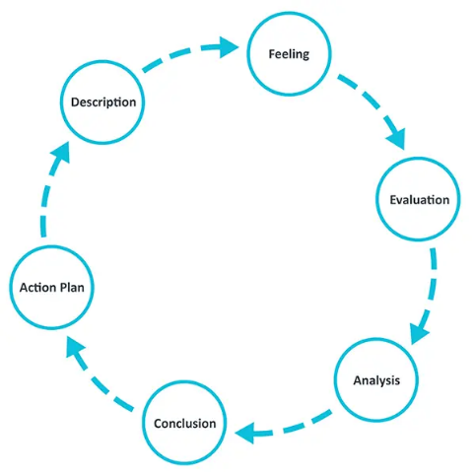  (University of Edinbrugh, 2024) | Kolb’s model  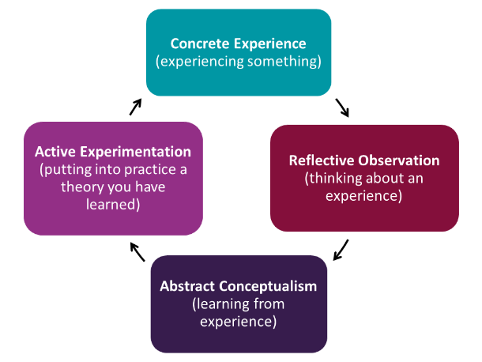  (University of Hull, 2025)
Analysis of models – compare/contrast/pros/cons
Gibbs’ model focuses on reflection using six parts which are, action plan, description, feeling, evaluation, analysis and conclusion. This model is simple for people to follow as it’s straight to the point and uses simple words that everybody will understand. Although, it’s a basic structure and easy for some people it doesn’t allow much help if people are stuck and need more help with what they need to be reflecting on. Gibbs’ model allows you to start reflecting by giving you things to think about from what you have seen. This reflective model will need to be used after an instant has happened as your reflecting about what has happened and not in the moment.
Kolb’s model focuses on reflection using only four areas which are concrete experience, reflective observation, abstract conceptualization and active experimentation. This model allows you to think more as it has less points, however, it uses bigger words that not everybody will be able to understand. This may result in reflecting not being as affective and people may struggle more which may not make people want to reflect. Kolb’s model also allows people to reflect after the experience has occurred as it’s looking back at what has happened and not what is happening in the moment.
Both Gibbs’ and Kolb’s model’s focus of rection and allow people to use a model that suits them there both similar in the way they have pointers for people to focus on and be able to start reflecting.
Conclusion
Overall, reflection is important as it can benefit not only our work in getting better but it can benefit the people we are observing. Reflecting whilst in practice with early years is beneficial as it protects workers when policies and procedures change, but it also helps children meet their needs as we are reflecting and seeing what needs improving then being able to improve it in the next activity.

Reference list
London Deanery Professional Support Unit (N/A) Reflective writing skills Reflection and Reflective Practice Available at: https://londonprofessionaldevelopment.hee.nhs.uk/sites/default/files/reflection-and-reflective-practice.pdf (Accessed: 26 October 2025)
The University of Edinbrugh (2024) Available at: https://reflection.ed.ac.uk/reflectors-toolkit/reflecting-on-experience/gibbs-reflective-cycle (Accessed: 23 October 2025)
University of Hull (2025) Available at: https://libguides.hull.ac.uk/reflectivewriting/kolb (Accessed: 23 October 2025)
University of Hull (2025) Reflective writing Schon Available at: https://libguides.hull.ac.uk/reflectivewriting/schon (Accessed: 26 October 2025)
University of Southampton (N/A) Dewey – reflection as a rationalized process Available at: https://edshare.soton.ac.uk/11124/1/index.htm (Accessed: 26 October 2025)

Part 3
Professional practice is where we adhere to the standards and the needs of which the setting you work for set out. We do this by being professional and knowledgeable by following the policies and procedures which are set in place by the setting and following the curriculum for Wales. The curriculum for Wales is important for us to be knowledgeable on as it is a guide for schools to make their own curriculum but to be based on four key purposes which are then organised into six areas of learning. We also be professional by sticking to uniform rules or being smartly dressed, having a smile with good hygiene as this allows you to look professional as well as being professional. Being professional can also be shown by being creative, respectful by being confidential, being able to communicate effectively and being punctual with a good attitude.
Values are important to a professional practitioner as it helps guide their actions and judgments to whether their actions are desirable or not and allows you to be trusted in your role. It’s important that in practice we meet the values for children through following the United Nations Convention on the Rights of the Child which is made up of 54 article which ensures that all of children’s rights are met and shows all children have a right. The UNCRC article 3 states that we have the best interest of the child this is important as we put the child at the centre, and we base everything off the child. Also, article 29 is based on goals of education, this article focuses on the child’s needs in education being met but also for children to learn to also have respect for adults.
(UNCRC N/A)
It is important to have effective and good communication and relationships to be professional and to meet the needs of the children. This is important as you need to have good communication between the practitioner and the child, between multiple practitioners, and the parents and possibly other services. This is due to you must communicate a lot and you must ensure you are communicating in a manner that everybody can understand, this is by it being in a language everybody can understand and by using words everybody can use by not using big words that parents might not get. This is also important as it builds trust and allows you and everybody to know what the children can and cannot do, whilst also knowing the children’s likes and dislikes. By having good communication and relationships it makes a positive working environment, Bronfenbrenner’s theory supports this.
Whilst being professional it is important that we are knowledgeable to understand the children in an in-depth way and help them develop effectively, we can work as a team for the children to get the most out of us practitioners. It is also important for us to follow a safeguarding procedure whilst being professional as we need to ensure that we are being confidential by not sharing children’s information with other people and not using situations that happen out of the setting to be spoken about with anyone else or outside of the setting.
Being a professional practitioner also means you must be able to work in partnership with multiple agencies. A reason you may need to do this if there is something going on with the child or if the children aren’t meeting targets they need to be meeting for their age. It is important that you have good teamwork to be able to do this with effective communication as you need to help each other out to get the best results for the children whilst sharing information and findings you have found with everyone. Although you need good communication to share your findings and opinions you also need good listening as you will receive information whilst working with other agencies which will help you have a better understanding of the child and a better understanding of what you and the setting could do to help the child.
Following on from working with different agencies you need to ensure that your observations and planning are done effectively whilst meeting the children’s needs. This is important as by observing the children you learn what milestone they are at what the child’s likes and dislikes are. This helps when planning an activity as we can make the activity suitable for the children whilst progressing their knowledge. By observing the child, you can then reflect on what you have seen and plan a new activity which will have them engaged whilst completing an activity that is going to progress the child’s development. This also allows us to refer children if they have any additional learning needs to the correct services which will help the children massively now and in the future.
The United Nations Convention on the Rights of the Child is important to inform professional practice as it’s made up of four general principles which are fundamental in practice and to children. In article 2 it states non-discrimination this is important for us to be professional practitioners as it ensures we don’t discriminate against any children regardless of their religion, belief, likes or dislikes. This is important for us to follow as not every child is the same and we shouldn’t treat children differently they should all be treated equally and fairly. The UNCRC also states in article 3 that it should be the best interest for the child, this is important as if the child is interested, they will learn more. Article 6 states children have the right to life, survival and development. This means that professionals should provide a safe and nurturing environment for children to come to when ensuring they are living in safe places at home. Finally, article 12 states that children have the right to their views, this means children have the right to express their opinions and its important as professionals that we allow the children to express their views whenever we can.
To conclude, it’s important for us to be professional practitioners and follow policies and procedures and legislation. As it doesn’t only progress our knowledge, it also allows us to help the children develop and have their needs met. Overall, a professional practitioner needs to ensure they are knowledgeable, have effective communication and good listening if the practitioner has this then it makes a positive working environment whilst also helping the children, parents, staff and multiple different agencies.

References
Legislation (2021) Curriculum and Assessment (Wales) Act 2021 Available at: https://www.legislation.gov.uk/asc/2021/4/contents (Accessed: 26 October 2025)
UNICEF (N/A) United Nations Convention on the Rights of the Child Available at: https://www.unicef.org.uk/what-we-do/un-convention-child-rights/ (Accessed: 25 October 2025)

