

Student Name: Ishan Dineshbhai Rana
Student ID: 2507137
Module Name: Marketing Management
Module Code: LCMB7024
Lecturer’s Name: Dian Mayasari
Work Count: 2465
Term 1

MARKETING STRATEGY PORTFOLIO
Nike Recover+ – Smart Recovery Boots Brand Extension

TABLE OF CONTENT
Poster 4
ELEMENT 1: BRAND EXTENSION OVERVIEW (POSTER SUMMARY) 6
ELEMENT 2: STDP ANALYSIS 6
2.1 Market Segmentation 6
2.2 Targeting Strategy 7
2.3 Differentiation Strategy 7
2.4 Positioning Strategy 8
ELEMENT 3: MARKETING MIX (7Ps) 8
3.1 Product 8
3.2 Price 8
3.3 Place 9
3.4 Promotion 9
3.5 People 10
3.6 Process 10
3.7 Physical Evidence 10
ELEMENT 4: REFLECTION 11
References 13

Poster
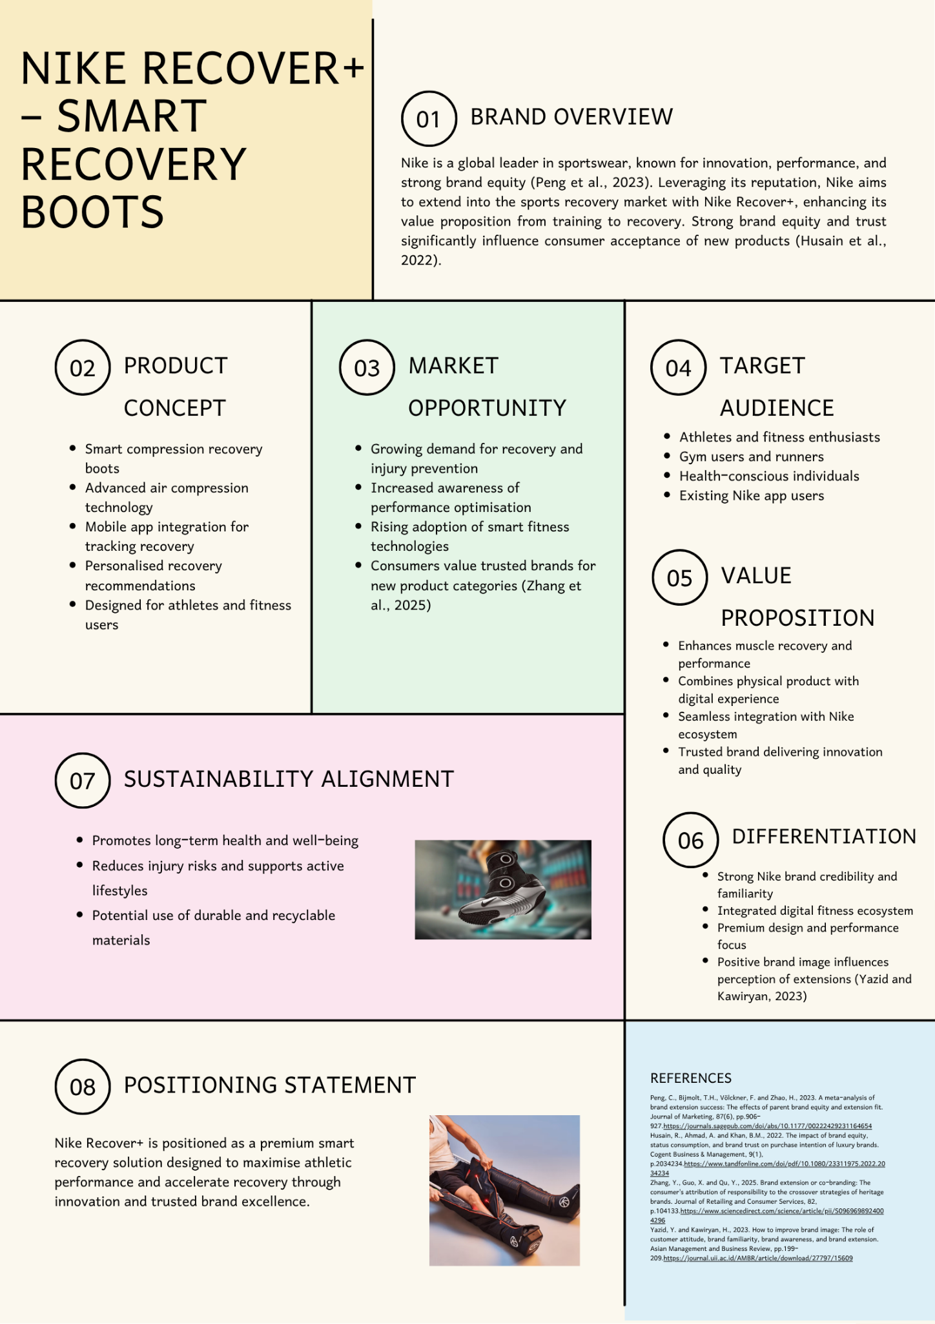

ELEMENT 1: BRAND EXTENSION OVERVIEW (POSTER SUMMARY)
The Nike Recover+ is a strategic brand extension to the sports recovery technology sector, which adds to Nike emphasis on athletic performance (Peng et al., 2023). The product will be composed of smart compression boots that apply air compression to the legs in order to enhance blood flow and reduce muscle fatigue, and improve recovery after exercises. It is also connected with a mobile application where it can give the real-time data, personalised recommendations and performance tracking to enhance the overall user experience. Such extension is applicable because of the increased significance of the concept of recovery in fitness (Kaur et al., 2022). Recovery is being identified by consumers as a necessity to performance, injury prevention, and health in the long run. The digital development has also facilitated people to track and maximise their fitness sessions, which has increased the demand of such items (Vărzaru and Bocean, 2024). Nike Recover+ is also sustainable as it enhances health and minimizes the risk of injuries. Besides, its efficacy in line with the performance-based and robust brand image of Nike and high brand equity improves its chances of success and acceptance among consumers (Sarmah and Singh, 2024).

ELEMENT 2: STDP ANALYSIS

2.1 Market Segmentation
In the fitness and sports market, market segmentation is crucial in order to understand the different consumer needs. With the market segmentation in terms of geographic, demographic, psychographic, and behavioural attributes, Nike will be able to design specific tactics which enhance engagement and value. The segmentation itself is enhanced by data as one can identify the major customer categories and the efficiency of marketing (Imani et al., 2022). On its part, Nike Recover+ concentrates on developed markets like the United States, the United Kingdom, and Europe where the prevalence of fitness, infrastructure, and purchasing power is high. Demographically, the product will target people aged between 18 and 45 years of middle and high income because they can afford to invest in high quality fitness products. Psychographically, the target market has performance-oriented and health oriented customers who adore and appreciate novelty and brand name. These factors are very effective impacts on the perception of brand extensions (Yazid and Kawiryan, 2023). On behavioural fronts the product aims at athletes, gym-users, and current Nike app users because the more these individuals are involved in carrying out fitness activities and the more known they are with the brand the higher the chances of adoption.

2.2 Targeting Strategy
According to the segmentation analysis, Nike uses the differentiated targeting strategy targeting at the primary and secondary market segments. The main target audience is composed of sportspersons and real-fitness fans who make performance and recovery among the factors of their training programs. These people are very active in their physical activities, and they are ready to invest in the high-quality recovery solutions improving their performance and minimizing the poor chances of injury. The second target segment is comprised by fitness enthusiasts, including gym attendees, working professionals, etc., who would like having an easy and efficient way of recovering in order to maintain their demanding schedules. This category is especially applicable since it is the category of an ever-increasing number of consumers who are far more sensitive to the need to recover but do not have access to professional recovery equipment. The fact that the target markets are chosen based on the concept of brand trust and perceived value, which plays a significant role in consumers purchasing intentions, especially when it comes to high-end products, justifies this (Husain et al., 2022). Through reaching consumers with a high level of brand recognition of Nike and who are heavily involved in their athletic activities, Nike will be more likely to be adopted and the brand extension succeed.

2.3 Differentiation Strategy
It is important to differentiate to develop a competitive edge in the emerging market of sports recovery. The intensive brand equity, technological integration and better customer experience are the differentiating factors of Nike Recover+ and other brands like Hyperice and Therabody. Brand extensions are more successful because the developed brand equity made by Nike through the continuous quality and proper marketing makes more people accept and trust new products (Peng et al., 2023). One of the distinguishing points here is the fact that Nike Recover+ is integrated into Nike digital ecosystem and users can track their performance, recovery, and fitness in one platform. Such a smooth flow makes it more convenient and establishes audience motivation. The role of customer experience in satisfying and gaining customer loyalty is enormous, and thus, the maximisation of the customer journey is important (Poorrezaei et al., 2023). Moreover, innovation, design and performance aspect of Nike product make sure that it gives functional and experiential value. Digital transformation leads to enhancement of competitive advantage and market performance through innovation that assists Nike Recover+ to emerge as one among a highly competitive market (Vărzaru and Bocean, 2024).

2.4 Positioning Strategy
Nike Recover+ is positioned as a high-quality smart recovery product that should be able to maximise the performance of athletics and recover faster. This brand position is in line with the overall brand image of Nike which has focused on the areas of performance, innovation and empowerment. The positioning strategy is targeting the provision of the intelligible value proposition indicating the advantages of the product regarding the performance enhancement, injury prevention, and convenience. Focusing on these advantages, Nike will be able to distinguish the product among other competitors and develop a powerful and unique brand image. Proper positioning also makes a difference to the better brand image and overall brand image as consumers can see the specific value that the product provides to them (Yazid and Kawiryan, 2023). In this regard Nike Recover+ serves to both strengthen the market standing of Nike in the sports and fitness sector, as well as its exposure to the recovery market.

ELEMENT 3: MARKETING MIX (7Ps)

3.1 Product
The Nike Recover+ is an innovative product of technology that integrates physical and digital features. The product has been shaped to deliver quality muscle recovery by using controlled air compression, in addition to showing personalised reports using an integrated mobile app. The quality of technology in this matter adds to the total value proposal and to the difference between the product and the traditionally-recovery solutions. The success of the product is directly associated with the idea of brand extension fit which is the amount of compatibility between a brand and a new product category. The high fit contributes to consumer acceptance and most probably success (Peng et al., 2023). Here, the performance-recovery extension is a good continuation of the brand idea that is in line with the main brand values of Nike.

3.2 Price
Nike Recover+ pricing strategy will be conducted on basis of premium positioning, which is based on high quality and advanced technology and strong brand equity attributed to the product. The price range is expected to be between £600 and £900, which positions the product within the high-end segment of the market. Premium pricing will be reasonable based on the subjective perception of the product, the effects that brand trust and status consumption bring to consumer behaviour (Husain et al., 2022). Consumers who relate Nike to quality and performance will tend to pay premium prices especially where the product cannot offer any tangible benefits.

3.3 Place
The Nike Recover+ distribution concept is a hybrid-based approach with a higher emphasis on physical and online distribution channels so that as many customers as possible can enjoy the product convenienceably. The product will be sold in the official Nike stores, online and in selected sports shops, which will cover a large market area. Secondly, collaboration with fitness centres, gyms, and physical therapy centers will allow obtaining direct entry into the most relevant target groups, especially those who are athletic and rehabilitation users (Lestari, 2023). This would not only promote the visibility of the product, but also credibility that would be created as a result of professional endorsement. Omnichannel approach to distribution strategy will help consumers to interact with the product consistently through various point-points to enhance the customer experience. It is a key principle of successful marketing strategy and success in the long-run to align the distribution channels with the consumer preferences and changing market conditions.

3.4 Promotion
Nike Recover+ is marketed based on the positive brand equity and capabilities possessed by Nike in digital platforms to generate awareness and develop consumer interaction. It is aimed at social media marketing, influencer cooperation, and athlete endorsement as effective means of executive communication of product values and benefits in its performance. Nike has an advantage in using celebrity athletes and social media figures as Nike overpowers authenticity and boosts the emotional resonance of its target audience. The social media marketing systems are relevant in defining the consumer engagement as well as brand awareness, especially in digital environments where consumers actively relate with brands (Varela-Neira et al., 2023). Moreover, the existing network in Nike can be utilized to conduct specific and influential campaigns and address consumers interested in fitness. This holistic method of promotion enhances visibility and extends to instilling confidence and urging people to use the novel product.

3.5 People
People play a key part in the marketing mix, as they can help provide the customer with a positive and consistent experience throughout all touchpoints. Nike guarantees that the employees will be well trained, informed and able to deliver high quality services both online and in the physical stores. This involves advising customers on how to use their products, their advantages, and also appropriateness depending on their levels of fitness requirements. When combined with the contributions of fitness professionals, trainers, and physiotherapy specialists, it increases the credibility of Nike Recover+ because these professionals will be able to provide recommendations and show how the product can be utilized in practice (Poorrezaei et al., 2023). Their experience builds credibility and solidarity of product positioning being a high-quality, performance-based solution. Proper management of customer interaction plays a vital role in determining the general satisfaction and brand perception.

3.6 Process
The process component addresses the customer experience throughout the lifecycle, including starting the experience with product discovery and awareness, buying the product, onboarding, and continuing to use it. Nike also tries to ensure a smooth and easy experience through harmonized product design and effective delivery of services in both the physical and digital space. Customers are able to view the product with ease using online content, in store demonstrations, and expert advice which will minimize uncertainty and improves the decision-making process. Onboarding is also made easy and straightforward, and the user is guided to set up the application and customize the experience of recovery within a short time (Poorrezaei et al., 2023). The customer service, as well as app-based assistance applied in the post-purchase service, is another customer pleasing. To enhance customer satisfaction, create loyalty opportunities, and clarify the recurrence use, it is important to optimise each customer journey stage.

3.7 Physical Evidence
Physical evidence means all the material things that create consumer image and brand reinforcement such as product design, packaging and the retail environment. In the case of Nike Recover+, the smooth high quality of the product design shows the innovation and performance, which make it consistent with the high-end brand of Nike. The packaging shall be simple but elegant with distinct focus on functionality and sustainability. In store display, interactive display bins and demonstration bins help in improving the customer experience as it gives the consumer the opportunity to interact with the product before making the purchase. Also, the physical evidence is provided by the digital interface of the companion app due to its ease of use and design (Poorrezaei et al., 2023). When combined, these factors reinforce the brand perception, trust and help the premium positioning of the product and ultimately end up affecting the consumer buying behaviour and the overall experience.

ELEMENT 4: REFLECTION
This portfolio of marketing strategies has allowed me to have a profound experience in the implementation of theoretical marketing concepts towards practical and real world application. Among the key lessons that I have learnt during this exercise is the importance of keeping the brand extensions in line with the main identity and values of the parent brand. I came to understand that a high level of fit between the new product and the established brand enhances consumer acceptance and also the risks of introducing new products are reduced. This insight was supported by the scholarship literature, pointing out that the key factors influencing the success of brand extensions are brand equity and brand extension fit (Peng et al., 2023). This project helped me realize that strategic consistency is very critical in developing trust and credibility in the market. Moreover, the fact that I applied the framework of STDP helped me to gain a better insight into consumer behaviour and market trends. Through the segmentation variables analysis and the search of suitable target groups, I managed to appreciate the fact that different consumer groups possess different needs and preferences. This made me realize how imperative it is when coming up with specific marketing strategies instead of one-fits-all strategies. I also understood that the accuracy of decisions and effectiveness of marketing can be significantly enhanced with the help of data-driven approaches to segmentation (Imani et al., 2022). This experience boosted my power to reason analytically and make wise strategic decisions. The next important learning point of the portfolio is the increased significance of sustainability in contemporary marketing. I realized that the adoption of sustainable aspects in product development as well as the marketing strategy is no longer an option but a requisite in order to succeed in the long term. Sustainability is beneficial to the environmental and social welfare, as well as positively affects consumer attitudes and brand perception and loyalty (Kaur et al., 2022; Sarmah and Singh, 2024). This has prompted me to have a holistic approach in coming up with the marketing strategies taking into consideration the profitability but also the broader effects of the society. Nonetheless, the procedure was not easy. It was specifically hard to explain some of my strategic choices through academic literature because I needed to critically analyze various sources and make sure that my points were well-founded. This provoked me to enhance my research activities and become more critical in analysing information. Also, the combination of theory and practice needed a greater degree of learning and synthesis that was hard at first but eventually enhanced my analytical skills. In the future, I think I would consider using primary research and data out of the world to make my analysis more reliable and better. All in all, this portfolio has played a major role in equipping me with the most important skills like strategic thinking, problem-solving, and academic research. The skills will be critical in my work practice of marketing management in future and this experience has made me more confident in putting the ideas of marketing into practice in a business situation.

References
Husain, R., Ahmad, A. and Khan, B.M., 2022. The impact of brand equity, status consumption, and brand trust on purchase intention of luxury brands. Cogent Business & Management, 9(1), p.2034234.https://www.tandfonline.com/doi/pdf/10.1080/23311975.2022.2034234
Imani, A., Abbasi, M., Ahang, F. and Ghaffari, H., 2022. Customer Segmentation to Identify Key Customers Based on RFM Model by Using Data Mining Techniques. International Journal of Research in Industrial Engineering (2783-1337), 11(1).https://www.researchgate.net/profile/Abdolmajid-Imani/publication/369022429_Customer_Segmentation_to_Identify_Key_Customers_Based_on_RFM_Model_by_Using_Data_Mining_Techniques/links/640588dd0d98a97717e0873f/Customer-Segmentation-to-Identify-Key-Customers-Based-on-RFM-Model-by-Using-Data-Mining-Techniques.pdf
Kaur, B., Gangwar, V.P. and Dash, G., 2022. Green marketing strategies, environmental attitude, and green buying intention: A multi-group analysis in an emerging economy context. Sustainability, 14(10), p.6107.https://www.mdpi.com/2071-1050/14/10/6107
Lestari, V., 2023. Strategic approaches to marketing management in contemporary business environments. Advances: Jurnal Ekonomi & Bisnis, 1(5), pp.255-268.http://advancesinresearch.id/index.php/AJEB/article/download/210/136
Peng, C., Bijmolt, T.H., Völckner, F. and Zhao, H., 2023. A meta-analysis of brand extension success: The effects of parent brand equity and extension fit. Journal of Marketing, 87(6), pp.906-927.https://journals.sagepub.com/doi/abs/10.1177/00222429231164654
Poorrezaei, M., Pich, C. and Resnick, S., 2023. A framework to improve retail customer experience: a qualitative study exploring the customer journey. Qualitative Market Research: An International Journal, 26(5), pp.663-686.https://www.emerald.com/qmr/article-pdf/26/5/663/2869324/qmr-07-2022-0120.pdf
Rai, N. and Pandey, A.C., 2025. Book review: Marketing 5.0: Technology for Humanity.https://www.emerald.com/lbsjmr/article-pdf/23/2/302/10576140/lbsjmr-12-2025-090en.pdf
Sarmah, P. and Singh, A.P., 2024. The effectiveness of sustainable marketing practices in influencing consumer behaviour and brand loyalty. International Journal For Multidisciplinary Research, 6(2), pp.1-11.https://pdfs.semanticscholar.org/847f/0d9fff7eeefc9044671167bda29440631857.pdf
Varela-Neira, C., Dwivedi, Y.K. and Camoiras-Rodriguez, Z., 2023. Social media marketing system: conceptualization, scale development and validation. Internet Research, 33(4), pp.1302-1330.https://www.emerald.com/intr/article-pdf/33/4/1302/1217106/intr-06-2021-0393.pdf
Vărzaru, A.A. and Bocean, C.G., 2024. Digital transformation and innovation: The influence of digital technologies on turnover from innovation activities and types of innovation. Systems, 12(9), p.359.https://www.mdpi.com/2079-8954/12/9/359
Yazid, Y. and Kawiryan, H., 2023. How to improve brand image: The role of customer attitude, brand familiarity, brand awareness, and brand extension. Asian Management and Business Review, pp.199-209.https://journal.uii.ac.id/AMBR/article/download/27797/15609
Zhang, Y., Guo, X. and Qu, Y., 2025. Brand extension or co-branding: The consumer's attribution of responsibility to the crossover strategies of heritage brands. Journal of Retailing and Consumer Services, 82, p.104133.https://www.sciencedirect.com/science/article/pii/S0969698924004296

