Understanding and Engaging in the Customer Experience

Module Code: BMSW5103

Lecturer Name: Vajira Balasurya

Student Name: Erum Naz

Student ID: 1711121


This Photo by Unknown Author is licensed under CC BY

Executive Summary:
This report will discuss the Asda’s Ethics and sustainability and it will cover the topic that how Asda have disappointingly maintained their employees in Bangladesh by paying them 25p and hour. It will cover issues of how their eggs have been bought by the suppliers on cheaper prices who have illegally caged the hens. It will use the quality models and theories to discuss the techniques to use to compete with their competitors and how to maintain the good balance between the customers and employee and most importantly how to treat and trained their employees to deliver excellent customers service. Also, this report will give some recommendation to Asda how to maintain their excellent service and quality of the products in their supermarket.

Content Page:

Executive Summary: 2
Introduction: 4
Asda: 4
Ethics and Sustainability: 5
Ethics: 5
Sustainability: 5
Quality models and theories and TQM 7
Deeming theory of quality: 7
Juran’s Theory of quality: 9
Total Quality Management: 10
Customer Relationship Management: 11
Conclusion and recommendation: 11
References: 13

Introduction:
This report will analyse the customer experience of Asda and other supermarkets based on ethics and sustainability and how they can improve them. Also, it will demonstrate the critical discussion using the quality models and theories and how Asda can improve their customer relationship and grow their business sustainability. Every business has its competitors and how Asda should maintain their compatibility and have a big profit in their products and how their customer services will have a positive effect on the business. Furthermore, it will evaluate the benefits and challenges of developing and maintain a good customer relationship.

Asda:
Asda is one of the biggest supermarkets in the UK where the customers can get shopping and all household stuff under one floor. Asda has been established in 1994 and they believe strongly in their ethics. Asda’s marketing promotions are usually based on exclusively on price but since its parent’s company Walmart, Asda has promoted itself under the slogan “Save Money. Live Better”.At Asda, they have more than 145,00 dedicated Asda colleagues who serve more than 18 million customers who shop in their store weekly. According to Asda (2018) “Income Tracker growth is boosted by the lowest rate of inflation in two years at 1.8% 30 to 49-year olds see the strongest income growth among all age groups”.
Ethics and Sustainability:

Ethics:

Ethics are the principles and behaviour of any business. They imply general ethical ideas to business behaviour. they improve the profitability of the business and adopts business relationship and employs efficiency. According to an article in business, ethics wrote by M. Manjulatess (2015) “Business Ethics is an art and science for maintaining a harmonious relationship with society, its various groups and institutions as well as recognizing the moral responsibility for the tightness and wrongness of business conduct”.

Sustainability:

“Sustainability focuses on meeting the needs of the present without compromising the ability of future generations to meet their needs. The concept of sustainability is composed of three pillars: economic, environmental, and social—also known informally as profits, planet, and people. (M. Grant 2020)
Ethics of Asda are important of them and they need improvement and close eye to compete for the market; such as Asda George uniform including shoes have been offered less then £10.00 which is a good strategy to lead the market and have profit in business and they have a policy where if a uniform has been ripped in the date of warranty you can replace the item. Whilst in Tesco they have high prices for the uniform, and they do not have the policy to return or exchange and they do not offer warranty because they think of the business perspectives and they want their business to go bigger. Asda is paying less than 25 an hour to the workers in Bangladesh and buying their clothes on cheapest prices and breaching international law.
“ASDA-one of three major discount clothing retailers accused of breaching international labour standards said it would audit its suppliers in response to a report in today's Guardian into the pay and conditions of Bangladeshi garment workers who supply British companies. (Guarding news and media,2020).”
While Asda is earning enough money to open other stores in the UK and extending its business globally. They should treat their workers equally and pay them a legal wage to maintain their business and their trust with their employee. In Bangladesh, workers are not sending their children to school to complete Asda’s orders on time and they could not afford to pay their children fee and they could not even run their family.
According to an article where Mathew Waver (Wednesday 30th May 2007) “The £9.96 price tag - cheaper than an FA Cup final programme - underlines the increasingly competitive nature of the £1bn school uniform market. Asda insisted its George uniform was "ethically" sourced from factories which are regularly audited, but the pressure group War on Want cast doubt on the claim.”
Asda should invest more on their employee to keep them happy to maintain the sustainability for the clothes so they will have enough stock at school time because at the beginning of the term they will always be short of stock and people struggle to get the sizes. In some cases, if Asda is lucky people order online which take long for them to receive the item. In most cases customers buy from other store and that cost them extra and the customer end up returning the item and that is the loss of the business. If they have enough stock customers will come back to them and they will recommend to family and friends. They should keep the record of the customers and they should start a loyalty card where; when a customer shop from Asda they have some loyalty points to spend on next purchase and they have some discount because Tesco have loyalty points card and they post the customers regular vouchers in their home which bring them back to Tesco for shopping.
According to ASDA (2020) “At Asda, our mission is to be the most trusted retailer. We know our customers care about sustainability too – so as well as reducing our impact on the environment, we want to help you to do the same. We stock sustainable products at an affordable price to make being green an achievable goal.”
Meat and poultry are big markets in the industry. Many people like to shop in one place like Asda and wants to save their time in shopping because of the busy life they have. Eggs, meat, milk is the daily industry and needs to meet the requirement of the quality of the products. Eggs have been sold daily and most of their eggs are from caged hens where hens have been poorly maintained and other brands like free-range eggs have been sold on high prices where the trustworthy ethical position encourages people to spend more, so, Asda should have a policy to continuously having sales on eggs and people feel happy about buying the product rather than staying in doubts about the prices.
According to Stills. (2019) “It is therefore unsurprising that Asda, Lidl and Morrisons last week joined the UK’s other major retailers by pledging to phase out the sale of eggs from caged hens by 2025, two weeks after Tesco did so. Increasingly, brands which do not respond to consumers’ ethical considerations such as animal welfare risk damaging their equity and even losing custom.”
Ethical factors for animal welfare have risen so Asda should pay enough money to the farmers for the better quality of their eggs so they will look after their hens properly and feed them good food to lay good quality eggs and their sustainability of the products will be maintained on a high level.
According to ASDA (2020) “At Asda, we’re always working to bring you the best products at the same everyday low prices. When it comes to providing products that are better for people and the planet – it’s no different. We know that our customers care about where their food comes from. And it’s our job to help them make an informed choice.”

Quality models and theories and TQM

Deeming theory of quality:

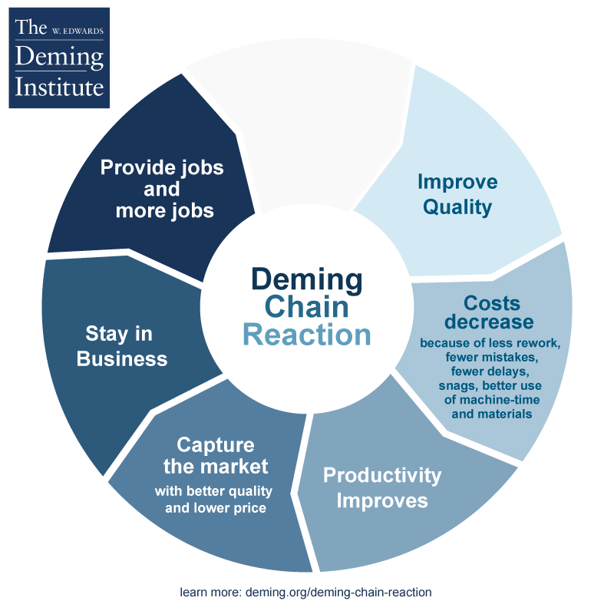
“William Edwards Deming (1900-1993) is widely acknowledged as the leading management thinker in the field of quality. He was a statistician and business consultant whose methods helped hasten Japan’s recovery after the Second World War and beyond. He derived the first philosophy and method that allowed individuals and organisations to plan and continually improve themselves, their relationships, processes, products and services. His philosophy is one of cooperation and continual improvement; it avoids blame and redefines mistakes as opportunities for improvement. (Library British, 2020)
Asda should use the Demin Theory to produce the prices in the peak season. Last year, before Easter weekend, Asda advertised the price of Dairylea triangle on a TV for £1.00 with other big brands. When the customers went for shopping for that price of £1.00, it came up £1.88 on till. When the customer asked for the manager to complain after the person who served him on checkout, the manager denied the fact that the advert was true and said it might have been an old advert. When visited another store in West midlands that price exists, so, it was misleading the customers because the customer heard the advert again very clearly before visiting another Asda in West Midlands. The Asda supermarket chain has been fined £9,000 for “misleading” customers over price reduction. According to BBC News (September 2001), “District Judge Patrick Haley said the practice would have significantly "misled" customers. The supermarket was found guilty of nine counts of breaching the Consumer Protection Act and was fined £1,000 for each breach and ordered to pay more than £5,000 in costs.”
One of the 7 cycles of the Demin theory clearly states that the management and workforce should work together to lead the business so the customer will get the better deal in all Asda store in the UK. They should have regular meetings between Area managers before they apply any sort of offers on any store so all the people in west midlands get the same offer. That will make the customers happy and they will have a good profit in business. With that, they can extend their business more by getting more staff to serve customers in busy times so their shelve will not be empty and they can hit the big sale at that time than Tesco. Also, it states in one the 7 circles which clearly explain that there should be a plan before they do it and they should check before they act so their customers in one store in West midlands would not be disappointed and stopped their shopping from that store because that will be a loss of the business in that area.
With the 14 points of the Demin theory, In peak time such as before the Easter Weekend, Christmas, Religious festivals etc they can adopt new strategies such as they can reduce the cost by 90p so they will have a big sale than other supermarkets like Tesco. People will be attracted with that offer and they will end up buying the whole week shopping from Asda that will have a positive impact on the sale. “Despite the impact that Deming and his 14 Points have had on the practice of quality management, empirical support for the effectiveness of the Deming Management Method has not advanced beyond the presentation of anecdotal, case‐study evidence. (Anderson, 1995)”

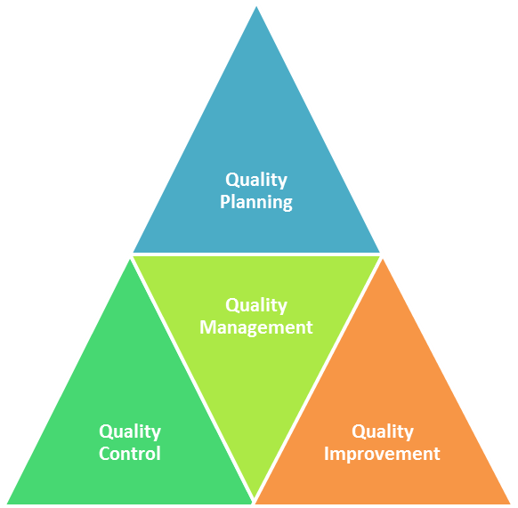
Juran’s Theory of quality:

“The Juran Trilogy, also called Quality Trilogy, was presented by Dr Joseph M. Juran in 1986 as a means to manage for quality. The traditional approach to quality at that time was based on quality control, but today, The Trilogy has become the basis for most quality management best practices around the world.
The Juran Trilogy diagram is often presented as a graph, with time on the horizontal axis and cost of poor quality on the vertical axis. The initial activity is quality planning, or as we refer to it today, ‘quality by design’ – the creation of something new. This could be a new product, service, process, etc.” (Dr Joseph A DeFo, April 2015)
Asda sells eclectic products of its Asda brand such as iron, kettles, microwaves and toasters alongside with other brands such as LG, Russels Hobs etc. The quality of their iron comparing to Russels Hobs is very bad. Their iron does not steam up to the same level as Russel's Hobs but to convey the customers they have same features written in their packaging. when a customer compares them, they attract with Asda brand and they end up buying it from Asda and in return, they expect the same return policy as Russel’s Hobbs products and that is misleading to the customers. Asda does not have a policy where they can replace the item or repair it for the customers and that is upsetting for the customer because they have put the trust on them, and they are breaking their trust. In many cases, the customer does not get the response from the management because of their policy which is a big hassle for the customer, and it is the waste of the time.
They should apply Juran theory to the improvement of the quality by quality control and quality management and all that is possible with the planning of the quality. When people will compare the quality feature they will be attracted and will buy Asda products and they will recommend to others.
According to D. Powell (February 2016) “A pre-inquest heard today how an iron or electric fault in a tumble dryer could have caused the fire that claimed the two men's lives. Today, David Lewis, assistant coroner for North Wales Central, ruled he needed more information about the tumble dryer's manufacturer and door maker before he holds another pre-inquest on May 19. Mr Lewis, who also heard that a faulty iron could have been to blame, said the case would be legally challenging and "distressing" for Garry Lloyd Jones, who was in a relationship with Mr Hender.”
Juran’s quality map can be used to check the understanding of the requirements, establishments and optimising the needs of the iron before they make the structure and shape into an iron because first, the Asda needs to know the faults and then the needs of the people for that iron such as how many hours a daily household use iron so then they can choose the volt and fuse for the iron. Then they can give the sample to the customers to test it before they launch the new iron and their prices. With the feedback they will be able the make the changes before they produce the irons on a big stock because it is the need about customers which needs to be met all the time. That will build trust with their customers and they will be able to deliver excellent customer services.
Asda should choose a quality level and performance of the quality of the product that way they will be able to get the better irons and there would be fewer chances of the faults in irons. Total quality management is a tool which is used in businesses to improve the quality of the product and the service of the business. Based on TQM many businesses invest in the product where customers’ needs are met so there would be a big market for the competitors.so, Asda should invest in quality rather than quantity because the quality is everything for customers.

Total Quality Management:

“It is implied from the present research that TQM is still a management philosophy in practice. Because it is diffused cross‐culturally, it is encouraged for its adopters not to use it as a “canned technique” of management change. Rather the management ideas need to be adapted within specific organizational settings, putting into consideration employees' personality, organizational leadership styles, reward system, and other cultural practices. Implementers of TQM should endeavour to fully understand the antics of the management philosophy and implement accordingly. A clear understanding and training of personnel on TQM philosophy are pertinent for protecting it from becoming a management fad” (J Anderson 1994).
“Total Quality Management (TQM) is an approach in which all of the organisation’s employees are involved in constantly improving the quality of products, services and business processes. (M. G. White, 2017)”
Importance of TQM would be beneficial for the employees and the positive effects on the business. where needed they can put them on the right training and that will have a long term success to the customers and the business so that will be a really good way of using that technique.so, there would be satisfying customers for Asda at a lower price. Asda will be able to maintain the well-defined cultural values for the business, so they wouldn’t have the Russels Hobbs as a thereat with their own Asda brand.

Customer Relationship Management:

“A CRM system helps businesses manage all the interactions it has with customers and potential customers. With a CRM system, customer preferences are recorded, and customer activity can be tracked. So, every time they are spoken to, regardless of who they talk to, customers get a fully personalised and consistent experience. (Act,2020)
CRM is another method which has been widely used in the businesses which allow managers to engage with their customers, colleagues, partners and suppliers through data analysis about customers history and improvement of the businesses. Asda should follow that to maintain the balance between the customer’s needs so the customer will come back to them and purchase again from them. “Customer relations differs because it consists of both the inbound and outbound measures taken by your company. It considers your organization's ability to react to present issues as well as your approach to bettering future experiences. Customer relations focuses on the proactive steps you're taking to engage customers and improve the customer experience. (C Fonetenella, 2019)”
The benefits of CRM will be a cross-team collaboration, high quality, accurate sale, increased customer satisfaction and enriched product and services.

Conclusion and recommendation:

In conclusion, Asda should maintain their ethical values for business and have a trusted approach in public by paying a good wage to the workers in Bangladesh so they can feed their families and their children can go to school. That will give a good reputation on the business and their profit will go higher. the news will have good publicity for them by publishing some positive articles.
Asda should have a limitation and policy where it states that the checks would be made on any return so they need to check the product properly before they make a refund or return; such as if a customer brings a trouser back and says it is ripped because my daughter/son fell over and it ripped from the knee. They should not refund that because they can sell another trouser and still if the customer is not happy they can only reduce the cost to sustain the profit so at least they will not have a loss and customer would be happy to come back and that will show the excellent customer service. If there is a problem with the stitching which is minor in many cases because of thread. If they have not been used properly or a stitch has been missing then they can give the customer a refund or exchange because they can get that fixed very easily on a low cost and they can sell that trouser after washing on a cheap price. Even though the customers are happy with the brand and prices because they can afford it, but the business point of view, Asda should make more profit and keep their customers happy all the time.
Asda could get funding from the government to cover the cost of their goods to pay good money to their workers in Bangladesh.
Asda should treat the employee's families in the festival season with gifts such as Christmas, Eid, Diwali etc to feel them rewarded and their work would be appreciated. They will work harder to give them good quality in their clothes. People in Uk will have a sympathy factor for them, and they will get more shopping from them and they will donate them to send the money to the poor families in Bangladesh. Asda will have more profit and again their customers will be happy.
They should reward their employees with some bonuses or higher training for free, that will have a great impact on the growth of the business and the employees will be happy to work with them for long terms. They would be satisfied with the employers and they will work in peace and they will feel appreciated. In return, they will deliver excellent customer service because, without the excellent performances of the employees, Asda will not be able to run a successful business.
They should pay good money to the farmers to maintain the health of their hens to lay good quality eggs. They could buy the eggs from the UK so, there would not be any health issues with hens and there would not be any caged hens which have been treated inadequately. They can make the profit by good selling products and they can gain sustainable competitive advantages through customers satisfaction.
They should use good quality products to make their products such as iron. They should test the quality of a higher standard because without testing the product they should not even sell them. After all, the electric products are easy to the source to catch fire in 7 out of 10 cases in Britain. They should educate their staff to help the customers to buy electric products because if a customer uses an iron over an hour because they are happy with the same features as Russell Hobbs their house would end up having sparking because of the fuse or less capacity of the product. To remain farm Asda must meet and exceed customer’s expectations.
Asda should use the reward scheme or loyalty card for the customers. That will make them come back to their store and they will have more profit in their business.
Asda should give the customers to try their products before they buy them. By trying the products by a customer, Asda already had their customers ready by recommendations, so they do not have to worry for their competitors.
Excellent customer service is everything to run a successful business, if there is a complain, Asda should treat it positivity and effectively so customers are happy with their refund or return so they will recommend them to others and they will have more customers. With more customers, they will have more profit in the business.
They can reward the customers with little compensation so, the customers will have a good impression about Asda, and they will not lose the customers.

References:
- ACT! (2020) WHAT IS CRM? [Online] Accessed on 08th March 2020 Via: https://www.act.com/en-uk/what-is-crm-template-c?gclid=EAIaIQobChMIgqe15cWV6AIVBbDtCh1zKAOHEAAYASAAEgLcj_D_BwE&utm_expid=.Fy-cJWv1TFexS-E_w8NiAg.1&utm_referrer=https%3A%2F%2Fwww.google.com%2F
- Anderson, J.C., Rungtusanatham, M., Schroeder, R.G. and Devaraj, S., 1995. A path analytic model of a theory of quality management underlying the Deming management method: preliminary empirical findings. Decision Sciences, 26(5), pp.637-658
- Asda (2018) Asda Income Tracker January 2019 [Online] Accessed 05th February 2020 Via: https://corporate.asda.com/newsroom/2019/02/27/asda-income-tracker-january-2019
- ASDA (2020) OUR FOCUS [Online] Accessed 07th February 2020 [Online] Via: https://www.asda.com/creating-change-for-better/better-planet
- Asda Supplier (2020) Responsibility: sustainability In Our Products [Online] Accessed 07th February 2020 Via:https://www.asdasupplier.com/responsibility/sustainability-in-our-products
- BBC News ( 2001 ) Asda Fines For Misleading Customers [Online] Accessed 20th February 2020 Via: http://news.bbc.co.uk/1/hi/business/1555149.stm
- British Library (2020) Business and Management; W Edward Deming Accessed on 01/03/202 [Online] Via: https://www.bl.uk/people/w-edwards-deming
- Business Ethics (2020) Business ethics and their benefits [ online ] Accessed 20th February 2020 Via: http://www.economicsdiscussion.net/business/business-ethics/31798
- Ehigie, B.O. and McAndrew, E.B., 2005. Innovation, diffusion and adoption of total quality management (TQM). Management Decision.
- Guarding news and media (2020) Asda, Primark and Tesco accused over clothing factories [Online] Accessed 10th February 2020 Via: https://www.theguardian.com/business/2007/jul/16/supermarkets.retail2
- HubSpot (2019) What is Customer Relationship? Everything you need to know: Customer services vs. Customer relationship [Online] Accessed 07/03/2020 via https://blog.hubspot.com/service/customer-relations
- Investopedia Sustainability investigation: Sustainability [Online] Assessed 10th March 2020 Via: https://www.investopedia.com/terms/s/sustainability.asp
- Juran (2020) The Juran Trilogy: Quality Planning [Online] Accessed 03/03/2020 Via: https://www.juran.com/blog/the-juran-trilogy-quality-planning/
- Kotler, P. Armstrong, G. Harris, L. C. and Piercy, N. (2017). Principles of Marketing, 7th European Edition, Pearson.
- McIntyre, D.P. and Chintakananda, A., 2013. Real options approach to releasing “network” products. The Journal of High Technology Management Research, 24(1), pp.42-52.
- Meyer, C. and Schwager, A. (2007), “Understanding Customer Experience,” Harvard Business Review, February 1, 17–26
- Mirror (2020) Fire that Killed Two Men Could Have Been Caused by Faulty Iron or Electric Fault in Tumble Dryer [Online] Accessed 03/03/2020 Via: https://www.mirror.co.uk/news/uk-news/fire-killed-two-men-could-7467880
- Pryor, M. G., White, J. C., & Toombs, L. A. (1998). Strategic Quality Management: A Strategic, Systems Approach to Quality. Thomson Learning.
- Skills. (2019) ETHICAL FACTORS ARE BECOMING MORE ESSENTIAL FOR SUPERMARKETS [Online] Accessed 07th February 2020 via https://www.stills.co.uk/blog/ethical-factors-becoming-essential-supermarkets/
- The Guardian (2020) Ethical Fears over Asda’s £10 School Uniform [Online] Accessed 05th February 2020 Via:https://www.theguardian.com/environment/2007/may/30/supermarkets.schools

