
Applied Leadership and Management in the Workplace
Module Assignment Submission
Student Name: | Andrew White
Student Number: | 2503042
Module No: | BMSK4011
Module Title: | Continuous Professional Development

Statement of Confirmation of Authenticity
By the act of making this submission, the student declares that this is the work of the student named above. The work has not, in whole or in part, been knowingly presented elsewhere for assessment, or where assessment has been built on a previous assessment, this has been identified. Where materials have been used from other sources it has been properly acknowledged. If this statement is untrue, the student acknowledges that an assessment offence has been committed.
Attention is drawn to the plagiarism and unfair practice policies of both the University and of ILM.

Table of Contents
Introduction 3
1.0 Identify learning styles for self and another 3
1.1 Development needs for self & another 4
1.2 Potential barriers to learning and Strategies for overcoming them 5
1.3 Development options 5
1.4 support mechanisms for the development of self & another 6
1.5 Plan of action 6
1.6 Monitor progress 8
1.7 Conclusion 8
Reflection on the Recruitment process 9
References 10
Appendix A Curriculum Vitae 11
Appendix B Continuous Professional Development Record 12

Introduction

1.0 Identify learning styles for self and another
Myself
The Honey and Mumford learning style questionnaire (1986) helps to identify four different learning styles; Activist, reflector, Theorist and pragmatist which will identify how individuals approach learning. I completed the questionnaire to identify my preferred learning styles. The results discovered that I approach learning as a theorist. I like to understand the full task at hand before completing any action with clear instructions. I like working, completing research or investigations independently with logical structured processes over spontaneous actions and group discussions. My least preferred activities for this style would be, jumping into the deep end without clear instructions or direction.
Additional learning style I have utilised is the Vark Model (1987) Vark stands for Visual, Aural (auditory, Read/Write and Kinesthetic. The Vark Model helps us to understand how we process, recall and absorb information most effectively. I have identified my most effective learning style as being Kinesthetic. Kinesthetic learners have a preference of learning through hands on, physical experiences and movement. I prefer and remember tasks when I try things out for myself. An explanation of a written concept I preferred over written instruction. My least preferred learning activities would be reading books for information and learning through charts, graphs and or diagrams.
I utilised the Dantec Learning style questionnaire which builds on Kolbs (1984) experimental learning theory. This is through experience reflection, conceptualisation and experimentation. The Dantec learning style types are reflective learner, analytic learner, common-sense learner and dynamic learner. I have identified as a dynamic learner, I learn best when I try things out for myself. I also like to see results quickly and prefer logical and structured activities. I least prefer learning through discussions, reflecting on what I have done and analysing situations to break them down into smaller parts.

Colleague
The Honey and Mumford learning style questionnaire (1986) helps to identify four different learning styles; Activist, reflector, Theorist and pragmatist which will identify how individuals approach learning. My colleague has completed the questionnaire to identify her preferred learning styles. The results discovered that her approach to preferred learning as a pragmatist. My colleague prefers logical reasoning and is enthusiastic with the full task at hand. They like to be hands on and apply what they have learnt in practical situations. My colleagues least preferred way of working for this style would be, unclear instructions or goals as well as theoretical discussions.
Additional learning style my colleague has utilised is the Vark Model (1987) Vark stands for Visual, Aural (auditory, Read/Write and Kinesthetic. The Vark Model helps us to understand how we process, recall and absorb information most effectively. My colleague has identified their most effective learning style as being Read/write. Read/write learners have a preference of learning through taking in process and information through the written word. They are more comfortable with studying independently and by learning through text-based materials. Their least preferred learning activities would be working in groups without all the theoretical information, and they May lose focus when only hearing information without written or visual instruction.

1.1 Development needs for self & another
SWOT / Gap analysis
Strengths, weaknesses, opportunities and threats analysis
Swot analysis is a technique which is used to identify development needs for yourself and others. The SWOT framework was created in the 1960s by Albert Humphrey to help understand an organisation’s strengths and weaknesses (Panagiotou, 2003).
- Strengths - What advantages do you have that others don't have?
- How do others perceive your key strengths for example your boss or colleagues?
- Which of your achievements are you most proud of?
- What values do you uphold that others are missing?
- Are you involved in any groups that others aren’t?
- Do you have relationships with individuals who can influence outcomes within your field?

- Weaknesses – what type of tasks do you tend to avoid?
- What do you believe are your weaknesses in your field?
- Are you happy with your current level of training and confident?
- Do you have any negative traits at work?
- Are there any barriers preventing you from progressing in your field?

- Opportunities- is your company growing?
- Are there any areas that you can see needs improvement that others don’t?
- Is there any new technology that could help you within your field?
- Are there any gaps in the market that you have identified?
- Are there any issues in your company that you could offer a solution too?

- Threats- Are there any challenges you are currently facing at work?
- Is there any competition for your immediate role?
- Could any of your weaknesses potentially create threats?
- Is the modernisation of any new technologies a risk to your role?
- Do you have any weaknesses that could lead to threats within your company of job role?

SWOT Person 1

STRENGTHS  What I am proud of is implementing a new way of uploading whitemail to the company’s online portal, giving everybody instant access and preventing a backlog of work. I have an in-depth knowledge of my role and am currently the only person able to carry out this work. | WEAKNESSES  My negative traits would be I get frustrated if anyone else attempts to do my work while on holidays for example. It’s very hard to progress as the main barrier being I’m the only one who carries out my work in my current role.
OPPORTUNITIES  A solution to the current delays and double handing would be to implement training for a colleague or for myself to be shadowed for a period so the work is up to standard. | THREATS  An issue I have identified is that if I’m on annual leave the work is getting picked up by colleagues that are not adequately trained resulting in delays and work having to be redone, therefore causing double handling taking twice as long as it should.

SWOT Person 2

STRENGTHS  My colleague has been at the company for a very long time resulting in connections withing the field. | WEAKNESSES  My colleague’s way of working with the current technology implemented is very outdated therefore can make the process slower.
OPPORTUNITIES  With the outdated technology my colleague could use his knowledge and connections to get pre approval for a new system and way of working. This could result in new clients and a more efficient working environment. | THREATS  With the lack of efficiency and speed in the current way of working the process now could lose current clients. This market has vast competitors and without progression could lead to loss of roles.
Gap Analysis person 1

Objective | Current Position | Deficiency | Action
What do I want to do? | What can I already do? | What am I lacking? | How do I fix this?
I would like to implement a new online portal giving access to all colleagues that are trained in how to use the system. | I can manually access the system and grant individual permissions. | I am lacking the system requirements to implement access permissions to all colleagues. | Draw up a proposal to present to the company’s management and explain all the benefits of the new system access.

Gap Analysis person 2

Objective | Current Position | Deficiency | Action
What do I want to do? | What can I already do? | What am I lacking? | How do I fix this?
My colleague would like to draw more customers into the store to boost takings and attract more customers. | My colleague can already advertise on social media and spread the word by word of mouth. | They are lacking the social media know how in to getting the advertisements sponsored and shared among the community. | This is fixable by using the tools online which shows how to get more traffic to your page and advertisements.

1.2 Potential barriers to learning and Strategies for overcoming them
There are barriers to learning for everybody. External and internal barriers.

- External barriers – Any outside influence that could affect you for example could be, being dependent on others for transport to work, money, private life or understanding terminology.

- Internal barriers – There are a number of internal barriers that could affect your ability to learn for example. Understanding and skill levels also, attitude, behaviour and physical abilities.

Identifying strategies to overcoming barriers

- Identify the barriers affecting yourself
- List any potential barriers
- Find a possible solution for each barrier
- Try each solution and evaluate the results
- Apply improvements and repeat the process

Barriers for myself and others:
Me | Internal | External | Strategy
 | Health has been a barrier for myself |  | Taking good care of myself and regular doctors check ups
 | Understanding some of the terminology |  | Asking for help and doing my own research into the unknown terms.
 |  | Public transport being late | Learning to drive or arranging a ride share would be far more advantageous than relying on public transport
 |  | My Daughter’s disabilities can make it not possible to always be able to attend | Making sure there is adequate and safe childcare in place. Relying on family.

1.3 Development options

It’s important we understand the range of development options that are available to us, from books, to training courses and independent online learning. There are formal and informal ways of developing, formal being qualifications and training courses and informal being mentoring, shadowing others and independent learning.

Why it’s important to self-develop for yourself and company objectives:
- As in individual representing the company by developing yourself will increase your overall performance and skills.
- Will help to increase your motivation which will in turn strengthen teamwork
- Communicating more effectively will in turn help you to work better as a team
- To understand development needs will give the company an insight into where improvements can be made
- Employees that are supported in their progression are far more likely tom feel valued, and this will also increase productivity
- There are many different learning styles that we can use for our development options from previously mentioned 1.1 identifying learning styles.

1.4 Support mechanisms for the development of self & another
- Many if not all of us need a support system and this isn’t a sign of weakness, it simply recognises that we all need practical support and mentorship. Often there are obstacles that can get in the way of our work life from family, means of transport to even lack of confidence. We must balance our work life around many things. Understanding this and knowing which support systems are available to ourselves is important to continuing our development. Our support systems are key to continuing our development.
- A useful tool for continuing your professional development is the GO Mad (Make A Difference) triangle (Gilbert, A., & Chakravorty, I. (2002). Go mad about coaching. Go Mad). This model will help you to use ideas and put them into action by focusing on what matters and how you will achieve it. The Go M.A.D.® (Make A Difference) Thinking Model is a helpful way to solve problems.

An example of the GO M.A.D external triangle:

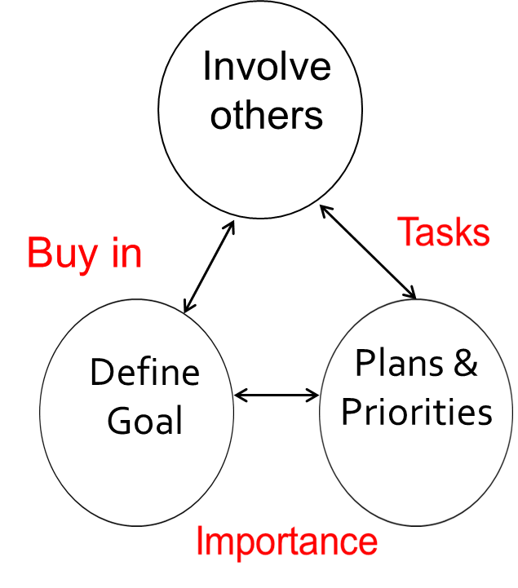

Person | Support Mechanisms Available | How They Help
Self | Manager  Colleagues in the workplace | A manager can have formal or information meetings or a “catch up” to discuss progression and to put a plan in place of where I would want to be in no specified timeframe. Recommended a PDP (Personal Development Plan).  I have found it beneficial to discuss with colleagues their future plans within the company and what plans they potentially have in place and how they will achieve them. I have found this is mostly different for everybody.
Another | Car share scheme and public transport  Family | There is a car share scheme available to colleagues living in the same area this has been suggested as well as utilizing different forms of public transport.  My colleague has had instances of missing work to childcare issues or school closures. They have identified a family member that is going to be able to help with childcare when these instances might occur.

1.5 Plan of action
We understand the barriers we need to overcome and have identified opportunities for learning. We can do this by creating a personal development plan, (a PDP). We can say what we need to have in place, how you’ll do it, what you need, how you’ll check you’re on track, and when you want it done. It is important that your plan is as clear as possible. It has to be SMART. Doran, G. T. (1981). There’s a S.M.A.R.T. way to write management’s goals and objectives. Management Review. AMA FORUM
SMART stands for Specific, Measurable, Achievable, Realistic, and Time-bound.

Person 1
What do I want to learn? | What do I have to do? | What support and resources will I need? | How will I measure success? | Target Date for Review
I would like to liaise with management on a regular basis to recognise and hopefully implement a new way of working by granting access to all colleagues for the computer systems. | Arrange weekly meetings with management to discuss what we need to-do in order to gain access for all colleagues. Request any Colleague feedback of any access issues. | Meeting rooms. Colleague and management feedback as to whether this is possible and a better way of working. Possible new online portal with faster upload speeds. | Management confirms access for all colleagues is possible and would be far more efficient. Colleagues would no longer face delays in waiting for someone else to upload the documentation. | Complete by: 30 May 2028  Review on: 01 May 2026 also meeting with management.
I would like to be in a position where I could take a lead role in implementing the new changes. | Ill need to speak to my management team to see how I can work towards this. | Management support as to gain information on what I need to do and if any plans will need to be in place before the changes are implemented. | Effectively if a new process is put in place to implement these new changes and I could be over seeing these changes as a team lead or a supervisor this would be great for my personal progression. | Complete by: 30 April 2027  Review on: 01 April 2026

Personal Objectives

Short Term Goals (next 12 months)
Short term goals will be gaining feedback from management and colleagues as to whether its possible to even upgrade a legacy system and if its financially viable for the company.
Medium Term Goals (2-3 years)
My short-term goals over the next 2-3 months would to be in a position to oversee and supervise the implementation and planning of upgrading the system access for all colleagues.

Long Term Goals (3-5 years)
Long term goals would be to have the new upgraded system access for colleagues in place as this would result in a massive reduction in delays for colleagues and a more agile way of working with far more efficiency.

Person 2
What do I want to learn? | What do I have to do? | What support and resources will I need? | How will I measure success? | Target Date for Review
My colleague is looking to improve all around social media awareness and engagement within the company’s website. | My colleague will need to attend a training course on how use social media tools effectively. Once this is achieved this will draw more customers to the website. In effect this should also boost sales. | There are internal and external courses my colleague can attend to gain more knowledge and understanding of social media. Management will be able so set up meetings and reviews to help along this process. | This will be successful by boosting engagement with the company’s website and making people more aware of the products on social media. | Complete by: 30 April 2026  Review on: 01 February 2026

Personal Objectives

Short Term Goals (next 12 months)
Short term goals will be to attend a social media course and to learn how to engage with customers online. This will also in affect make the website more visible.

Medium Term Goals (1-2 years)
To have completed a social media course and now have a full understanding on how to make the website more visible and how to interact with customers. To be able to use all the social media tools learnt during the course.

Long Term Goals (2-3 years)
Long term all the knowledge learnt will influence the company’s overall websites visitors making the company more profitable. To oversee a team and pass on the knowledge learnt.

1.6 Monitor progress
Monitoring progress in a Personal Development Plan (PDP) is important because it helps you see whether you’re achieving your goals. It lets you see what still needs improving and what can be worked on. You can stay motivated be seeing your progress and checking in regularly keeps you focused. I have found if I have a goalto work towards the I will be more organised in my working life.

Feedback, reviews and deadlines are important as they will help you to work towards your goals and to stay on track. Feedback helps you to see what your doing correct or what you need to work on. Deadlines will give a clear timeframe of when you are looking to achieve goals by. Performance reviews over see your progress, help you think about new goals and improvements you need to make, and to ensure you’re heading in the right direction.

1.7 Conclusion

Continued Personal development is about taking the time to reflect on what’s working and why, what isn’t working and why, and deciding what steps to take to make things better. Reflection is at the centre of CPD (continuous professional development) it gives you a chance to learn from experiences. Reflection Supports Self-Awareness and Personal Growth. This self-awareness will let you to set SMART goals in your PDP and CPD record. Reflecting will let you take responsibility for your own learning.
Driscoll, J. (Ed.). (2007). Practising clinical supervision: A reflective approach for healthcare professionals (2nd ed.). Baillière Tindall.
Graham Gibbs model of reflection (1988) is a useful tool to refer to as it will help you to relecft on what you have learnt. What will change as a result of my learning. What are the next steps and what is my action plan.
My learning style, as a theorist, involves fully understanding a task before taking action, supported by clear and detailed instructions. I prefer to work independently, carrying out research or investigations using logical, structured processes rather than spontaneous activities or group discussions. My least-preferred approach is being expected to dive in without clear guidance or direction.

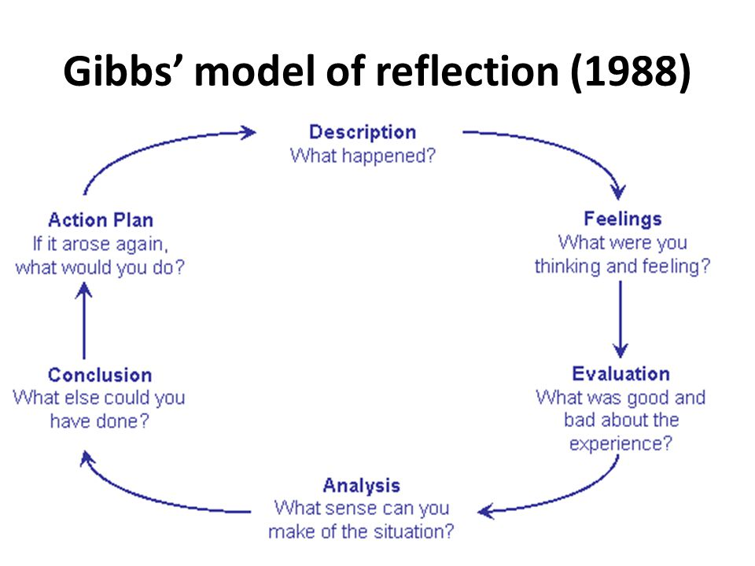

Gibbs, G. (1988). Learning by doing: A guide to teaching and learning methods. Further Education Unit.

Reflection on the Recruitment process

After completing this assignment, I can reflect on both my capabilities and my areas for development. Through reviewing my learning style, I’ve realised that having clear instructions is essential for me and helps build my confidence.
I also enjoyed completing the SWOT and GAP analyses, as they were useful in highlighting my strengths and weaknesses.
- Interviews play a crucial role in the recruitment process, enabling employers to evaluate a candidate’s suitability, experience, and potential, while giving applicants the chance to demonstrate their abilities. It is important that interviews are carried out fairly and in line with employment legislation, such as the Equality Act 2010, which protects individuals from discrimination based on protected characteristics like age, gender, race, disability, and religion. Employers must ensure that all questions are relevant to the job, impartial, and legally compliant to maintain a transparent and lawful hiring process.

- I have included my CV as part of the assignment. Reviewing my CV has shown me how much experience I have within my previous roles and where I will need to progress and gain new qualifications.

References
- Honey, P., & Mumford, A. (1992). The manual of learning styles. Peter Honey Publications.
- Fleming, N. D. (1987). VARK: A guide to learning styles. University of Canterbury.
- Kolb, D. A. (1984). Experiential learning: Experience as the source of learning and development. Prentice Hall.
- Dantec, C., &amp; Mozzon-McPherson, M. (2006). Supporting independent learning through explicit strategy-based training. In Supporting independent language learning: Issues and interventions. Peter Lang.
- Panagiotou, G. (2003). Bringing SWOT into focus. Business Strategy Review, 14(2), 8–10. https://doi.org/10.1111/1467-8616.00254

- Gilbert, A., & Chakravorty, I. (2002). Go mad about coaching. Go Mad.
- Doran, G. T. (1981). There’s a S.M.A.R.T. way to write management’s goals and objectives. Management Review. AMA FORUM
- Driscoll, J. (Ed.). (2007). Practising clinical supervision: A reflective approach for healthcare professionals (2nd ed.). Baillière Tindall.

- Gibbs, G. (1988). Learning by doing: A guide to teaching and learning methods. Further Education Unit.

Appendix A Curriculum Vitae

CV

Appendix B Continuous Professional Development Record

Continuous Professional Development Plan – Andrew White
Formal | Informal | Date | Duration | Status | Details
ILM Level 4 Diploma in Leadership and Management |  | 2025 | 1 Year | In Progress | ILM
L4 Certificate of HE Applied Leadership and Management |  | 2025 | 1 Year | In Progress | University of Wales Trinity Saint David

