
Professional Career Development
Reflective report
Mirela Urzica | 4/20/21 | CERTHE in skills for workplace

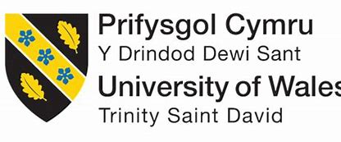

PROFESSIONAL CAREER DEVELOPMENT

PCD BMSW4005
Student name: Mirela Mihaela Urzica
Module teacher name: Nadeem Mirza
Student ID: 1922003
Course title: CERTHE Skills for the workplace
Name of the University: Trinity Saint David

Reflection on Role Play and career development planning

TABLE OF CONTENTS:
-Introduction-
-Recruitment and selection-
-Discussion
-Conclusion
-References
-Appendix-

Introduction
Professional Career Development skills influence learner for being attractive and productive in study and benefit in progress of proficiency and benefit them in obtain prosperity in its course. The accomplishment and knowledge in Professional Career Development make as individual intensively competitive in our career and in various, different circumstances. This study will be mentioning about our reflection on the act play and career development planning. My act play is based on questions and answer on job interview applied from me and job application form required which I want to apply in future. Is reflecting all my duties, skills and knowledge achieve.

Recruitment and selection
My role play was based on interview regarding my job application form.
Role plays discuss on task 1 is about my job which I been applied and let me understand how employee select people, how to talk and how to behave. My reflection on the condition to become a Teacher Assistant based on my job application form, is to develop practice skills, tasks and attributes needed. I start to prepare for the role play and my teacher make me understand what I need to say and what is not recommend speaking. The module Professional Career Development allow me to understand about recruitment and selection. I learn about how the process could be in recruitment and I understand that is efficient, effective, and fair for selecting the right candidate. I learn about legislation applied to protect people from discrimination in the workplace. My teacher let me understand that the interview can have more type of questions- Open, probing, closed, leading, hypothetical, and behavioural questions and this encourage me to answer all the questions from my interviewer. All this information helps me to prepare better for interview job and learn about employee rights to work. Role play is an exercise to perform excellent in your application for job that is suitable for everyone.
Here is my swot analysis. This allows me to identify my strengths, weakness, opportunities, and threats.
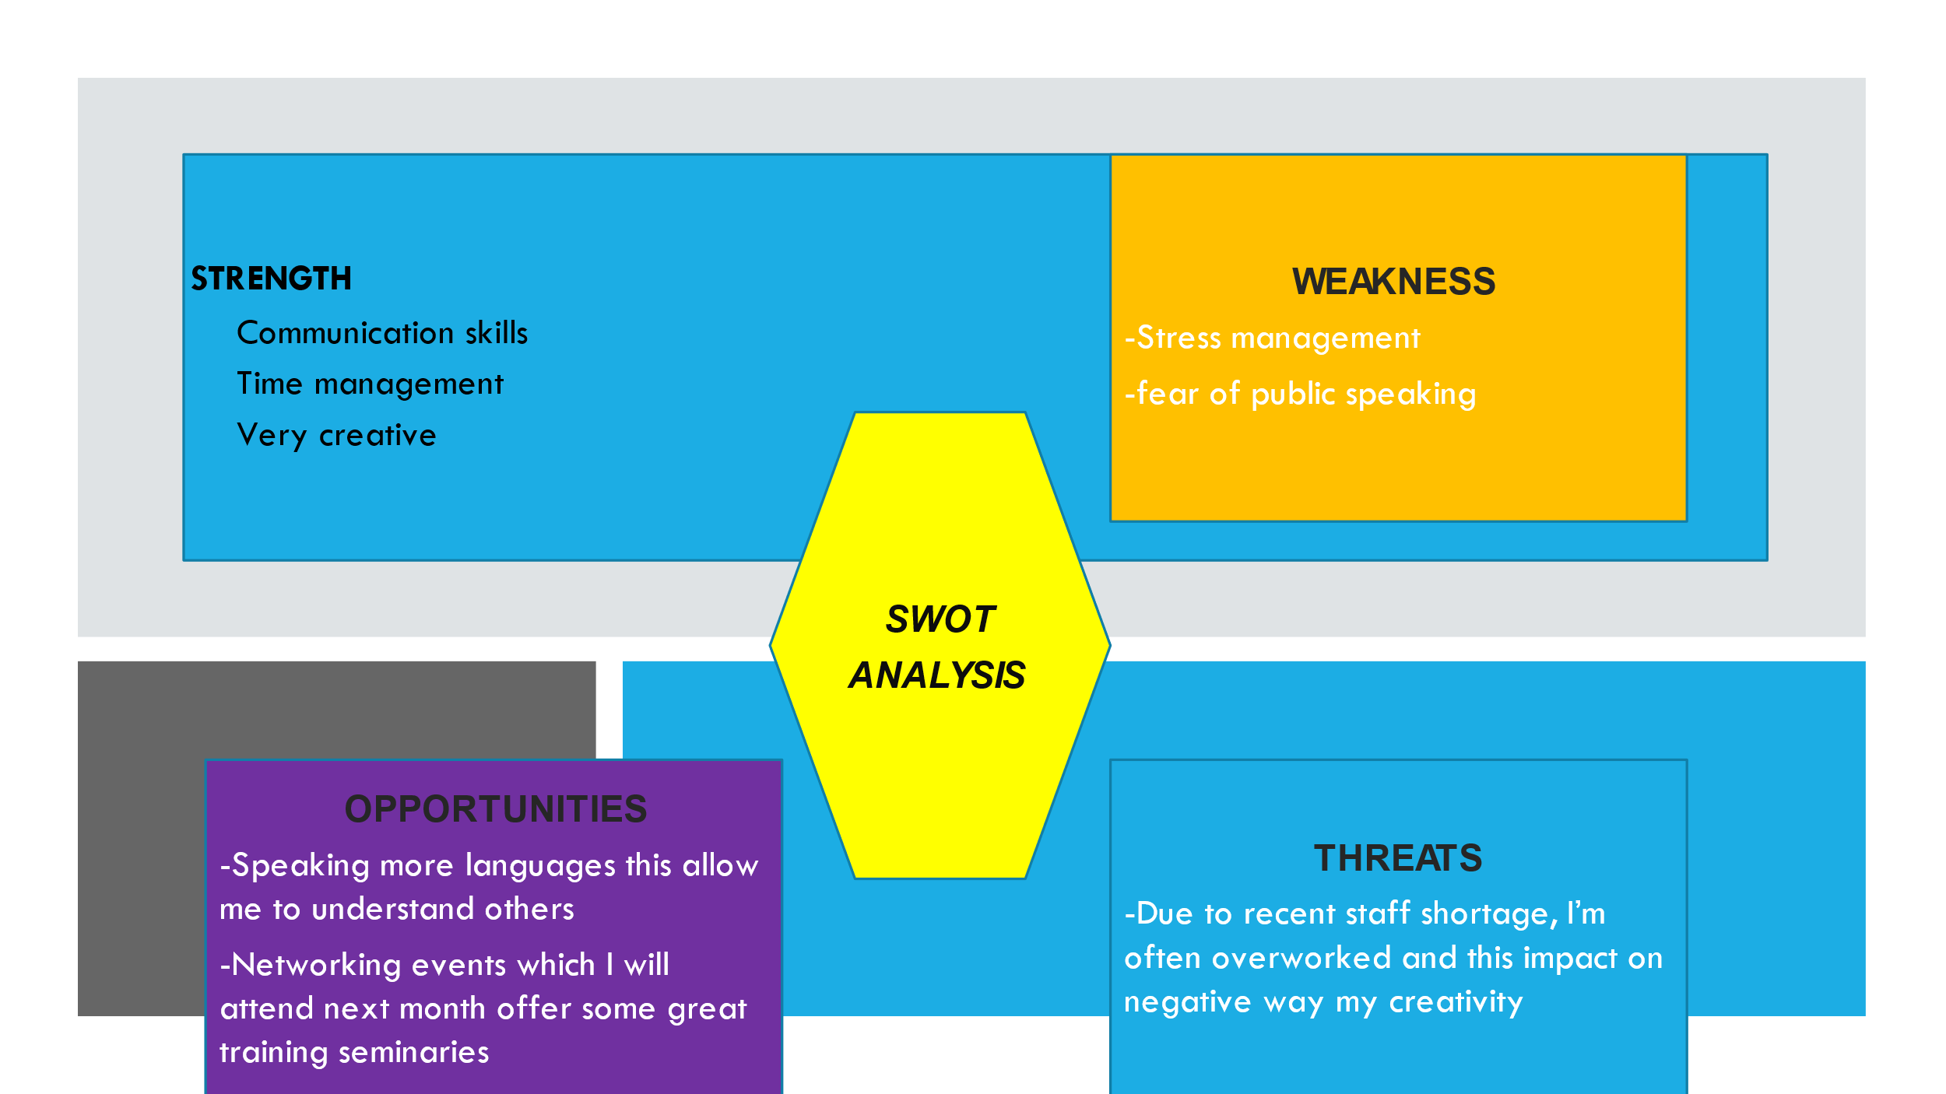
Image: (Created by author).

Discussion
KOLB Reflection cycle
Concrete experience
The module Professional Career Development get remain adequate to provide me with comprehensive proficiency on various skills that is requirement in career development. I accept my capability to develop interchangeable skills and understanding my performance in future career development planning about my priorities is essential for ensuring that my task and attributes is proficient in an approximated timeline. (myworldofwork.co.uk, 2020). To become a good mentor, I need to think about the words in the meaning time, the fact or process in my demonstration and how they correlate in a common way. (Brill,2019). I accept prevail adept to grow my accomplishment about employees and can create as well as convey with peers together like management, with a higher level of determination. I has realised that I have develop the various prospective with ingenious and modern edge. This get advised me in examination about idea everything works, and I can calculate problem seriously, assisting in problem solving. Is crucial for a respective to understand about particular reasoning and expand abilities, and this help in obtain accomplishment. (Liu, 2018). I have been able to understand and learn about different sets of encouragement as attitude and concede appreciate everybody aspect. Is helping me to understand all about the concept of recruitment and selection and now I feel more confident about myself to applying for a job. The module Professional Career Development has been able to help me with the ability to understand everyone thinks about a career, about various cultures, and my own strength. I have been able to develop and improve my strength, and being proactive and motivated, take initiative and manage my own time and I remain adept to expand ability in handwriting a CV, that get benefit me in establish bigger grade of courage in my application for a job. Moreover, is important to write a personal development plan that can open yourself in job interest, displayed the experiences and skills owned. (Eduan, 2017). It is worth nothing that the job application form can demonstrate the interest of a person in the job required. (Bournique, 2020). I have been growing and understand what my strength is, and I found that I am a great working with other like a team worker, develop a good communication skill and my ability is to take on and complete multiple tasks whilst under pressure.
Reflective observation
This module increases my knowledge and my skills and help me to develop various academic experience. This create higher number of repeat unless I realised that the module Professional Career Development is at hight level and professional. This build up my ability, including different action do with individuals and along with contemplation I can recognize how so many stuffs get replaced. I stay adept to catch the excitement of comfort fulfilled with my satisfaction when stuff was adequate to accomplish my objectives and was adept to perform my ambition. Study gets remain a big component development, decent relevant with build-up perceptive my skills and proficiency and other stuff involved with studies. Is nothing that extra exercise in this module helps in the improvement of career development to professionally compose (Cottrell,2019). Generation has made recognise that, if somebody must conduct the control than, that individual can do all the best in some position. I accept and recognize some brief summaries are better in the time and appreciate studies as considerate all.
This course has strengthened my knowledge on how my reflective career development is being runner which includes:
Analysing work pattern in the workplace
Effective level of organization leadership and motivation
Improve my decision making
Hight level of communication skills
At the end of my studied I will be awarded in BA(Hons) in Leadership and Management Business (Level 5&6).
Abstract Conceptualisation
I accept and think about to take less notes and make refine of some information and life in general. I am determinate with my contemplation in mind and behaving. When a specific practice is improving by reflection, permit of understanding something and transform by steps the new achievement become wealthy, wide, and profound. (Kolb, pg.309). In my previous experience in workplace during the years, working with different range of people I meet different situation and problems to solve. I can give an example of a problem of workplace: time management which this is a common problem and with my experience and knowledge adapted I went able to solve this problem on my workplace. Other problem was my conversation dexterity. My vocabulary is reported to my conversation accomplishment to be efficient in the frame of sense of intercommunication. On other part, I have my dictionary and linguistic performance, and this can help me to formulate decisions and it groundwork. I totally agree with this capability to be helpful for me in the competent range.
Active experimentation
I learned and understood from others what is my role model. (Brill,2019). My first year as a childminder was not very successful. Through the years I deal and cope with stress time management and different cultures and languages. I accept that I have a lot to learn. I also include and thinking for some possible strategies to become more approached to that families and I had considered in future that I would try to be more professional in my post. Such as a simple knowledge improvement. (Brill,2019). I am a firm administrator and organiser; a devote worker and I would consistently put my strength and abilities in front of children. I want to become a good Assistant Teacher in future because I understand, and I wish to work in this category of aspect where I get to make positive difference to people daily lives. I will get to observe the impact of my work over supporting the teacher in their aspiration in providing remarkable education and development. Whilst I appreciated there will be constant tasks to bring out as a Assistant Teacher. I appreciate the fact I would have to be productive in helping the teacher expand and distribute interesting and informative lessons plan. In the following next 5 years I can see myself successfully employed and in full district prospect. Being a teacher would make a difference in many people.
Further improvement of my career development based on my role play

Solution based on theoretical framework.
KOLB Reflective Model is associated with analytical framework that examine experiences. Through the four steps, my action plan for the improvement my career development is as follows:

Table 1:
Table 2: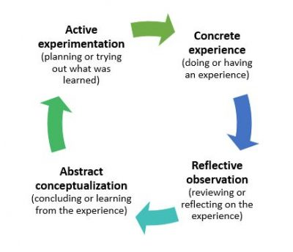
Figure: Kolb Reflective Cycle

Steps | Specification
Concrete experience  (Feeling) | I get in my experience, some expectation of my development to be improve. I get enforced in leadership, my emotional control, and my patience.
Reflective observation  (Watching) | I have identified the negative aspect that is my ability is not sufficient. The confident aspect of my evolution and my accomplishment.
Abstract conceptualisation  (Thinking) | I desire pursue my Professional Development Plan  I can improve my comprehensive dexterity.
Active experimentation  (Doing) | My feedback from professional judgment can be constructive and this can improve my dexterity.

Table 1: Application of Kolb Reflective Model
(Source: Brown N, Social Research & Practice and Education, Accessed 24.03.2021)
Table 2: Kolb reflective cycle
(Source: Created by author)
David Kolb Reflective model cycle is based on four-stage of learning style mentioned above. Kolb explained that most of the people have preferred a quite range of style to achieve the knowledge. This can be different in many ways, for example: social domain, knowledge experience in education. (McLeod, S. A. (2017, October 24).
Reflective report based on my role play and my experience, knowledge, achievement I write my Personal Development Plan to improve and sharpen my employability skills significantly.

Personal Development Plan
 | Short-Term Time Frame  What do I want to  accomplish in the next  three to six months? | Mid-Term Time Frame  What do I want to  accomplish in the next  six months to two years? | Long-Term Time Frame  What do I want to  accomplish in the next  two to three years?
Section 1 - My Goals  What are my overall goals that I want to accomplish in this time period?  Example: become a Student Affairs Officer; learn computer graphics | Improve computer skills, learn new thinks, learn how to be a professional leadership, have more confidence in myself. | Become a good student, involve in practice at workplace, have more experience. | I want to be a good teacher or leadership in a organisation.
Section 2 - Skills and Knowledge to be  Learned  What specifically do I need to learn? What project do I need to work on?  Example: Student advising;  Banner; Dreamweaver; develop a procedures manual | Communication skills to improve, learn how to work in a team, and have more self confidence in myself | Complete my degree in BA(Hons) | Practice all skills and knowledge that I learn and work more in an Institution
Section 3 - Next Steps  How am I going to acquire the skills and knowledge? How am I going to do this project?  Example: take Dreamweaver class; do an  informational interview; set up a project outline | Studied, work hard and practice | All skills and knowledge achieve I want to put in practice | Work in a Company or in a big Organisation like a leadership Management
Adapted from: http://www.hr.ucdavis.edu/sdps/forms/IDP%20Final%2010.14.11.pdf

 | Short-Term Time Frame  What do I want to  accomplish in the next  three to six months? | Mid-Term Time Frame  What do I want to  accomplish in the next  six months to two years? | Long-Term Time Frame  What do I want to  accomplish in the next  two to three years?
Section 4 - Resources  What resources do I need?  Example: free time; funding | More free time | funding | experience
Section 5 - Time Schedule  What is my time schedule? | 20-40h/week | 30-50h/week | 50+
When will I start? | June 2020
When do I expect to finish? | June 2023-2024
Section 6 - Completion  When have I completed each  step? | □_20.06.2020_________  Date  □20.06.2021________  Date  □20.06.2022_________  Date | □__20.10.2020________  Date  □20.10.2021__________  Date  □20.10.2022__________  Date | □_20.02.2021_________  Date  □_20.02.2022_________  Date  □20.02.2023__________  Date

Conclusion

In conclusion my reflective report about my professional career development makes me understand my ability, my skills, and my strengths in my future career. The skills and knowledge achieve of intellectual is fundamental and build up a system very powerful and proficient. Furthermore, during my study I achieve an experience that helps me to develop individual leadership and good management skills.

References
Bournique, M.,2020. Preparing for Your First Job: A Resident’s Outline to Curriculum Vitae Writing. HCA Healthcare Journal of Medicine, 1(1),p.3.
Cottrell, S.,2019. The study skills handbook. Macmillan International Higher Education.
Eduan, W., 2017.Tracking Study Abroad Outcomes: A Longitudinal Curriculum Vitae Analysis of Global Engagements in Research in Higher Education (Doctoral dissertation, UCL (University College London)).
Higgs, J. Brill, 2019. Values and interpretations, ProQuest E book Central.
Liu, J., 2018. Cultivation of critical thinking abilities in English writing teaching. Theory and Practice in Language Studies, 8(8), pp 182-287.
Myworldofwork.co.uk, 2020. What are my skills? (online) http://www.myworldofwork.co.uk/what-are-my-skills-o (accessed 23 March 2021).
https://www.nicole-brown.co.uk. Reflective model according to Kolb- Dr Nicole Brown.
Kolb., D. A., 1984. Experimental learning experience as the source of learning and development. Englewood Cliffs, NJ., Prentice Hall.

Appendix
Task 1
I attached the questions and my answer from my job interview and my job application form based on my role play in task 1.

