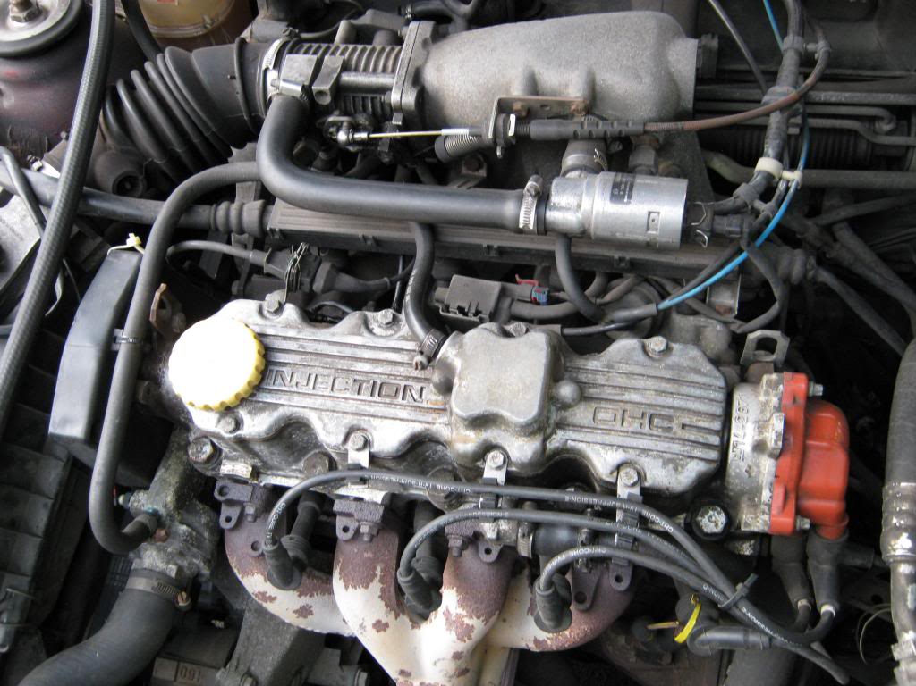  Engine Control Systems  Electronic Ignition & Fuel Injection Systems | Alexander Wright (1701086)  HND Automotive/Motorsport Engineering

Contents
1.
2.
3. Introduction/Abstract.
4. List of Figures (continued to page 7).
5.
6.
7.
8. Testing equipment.
9. Procedure, testing data (continued to page 15).
10.
11.
12.
13.
14.
15.
16. Injection on Time data & observations
17. Overview of systems & testing
18. References

Introduction
To achieve the basic operation of an internal combustion engine, thereby converting chemical energy into mechanical energy, three main important things are needed; a fuel supply, oxygen supply (oxidizer), combined with some form of ignition, i.e. a spark plug used in petrol ICE (internal combustion engines).
Ever since the dawn of the ICE, these three elements are the key to making any unit run efficiently and properly. Over the course of the 20th century and up to the present day, the vehicle industry has made a massive amount of development and technological progress with regards to overall operational efficiency and many other functional aspects.
While the mechanical aspects of reciprocating piston internal combustion engines has remained virtually unchanged, maintaining the basic mechanical operation and components, it is the development and constant evolution of control systems that has seen the most significant progress.
To achieve a greater understanding of vehicle ignition and fuel injection systems, a group of us will be analysing 2 similar engines with different operating systems for fuel & spark supplies. This activity will not only demonstrate the key operating principles of certain systems, but also possibly broaden our understanding of what measures are put in place to help an engine run as efficiently as possible.

List of Figures
Fig 1: Pin 16 - 80°C (Motronic)
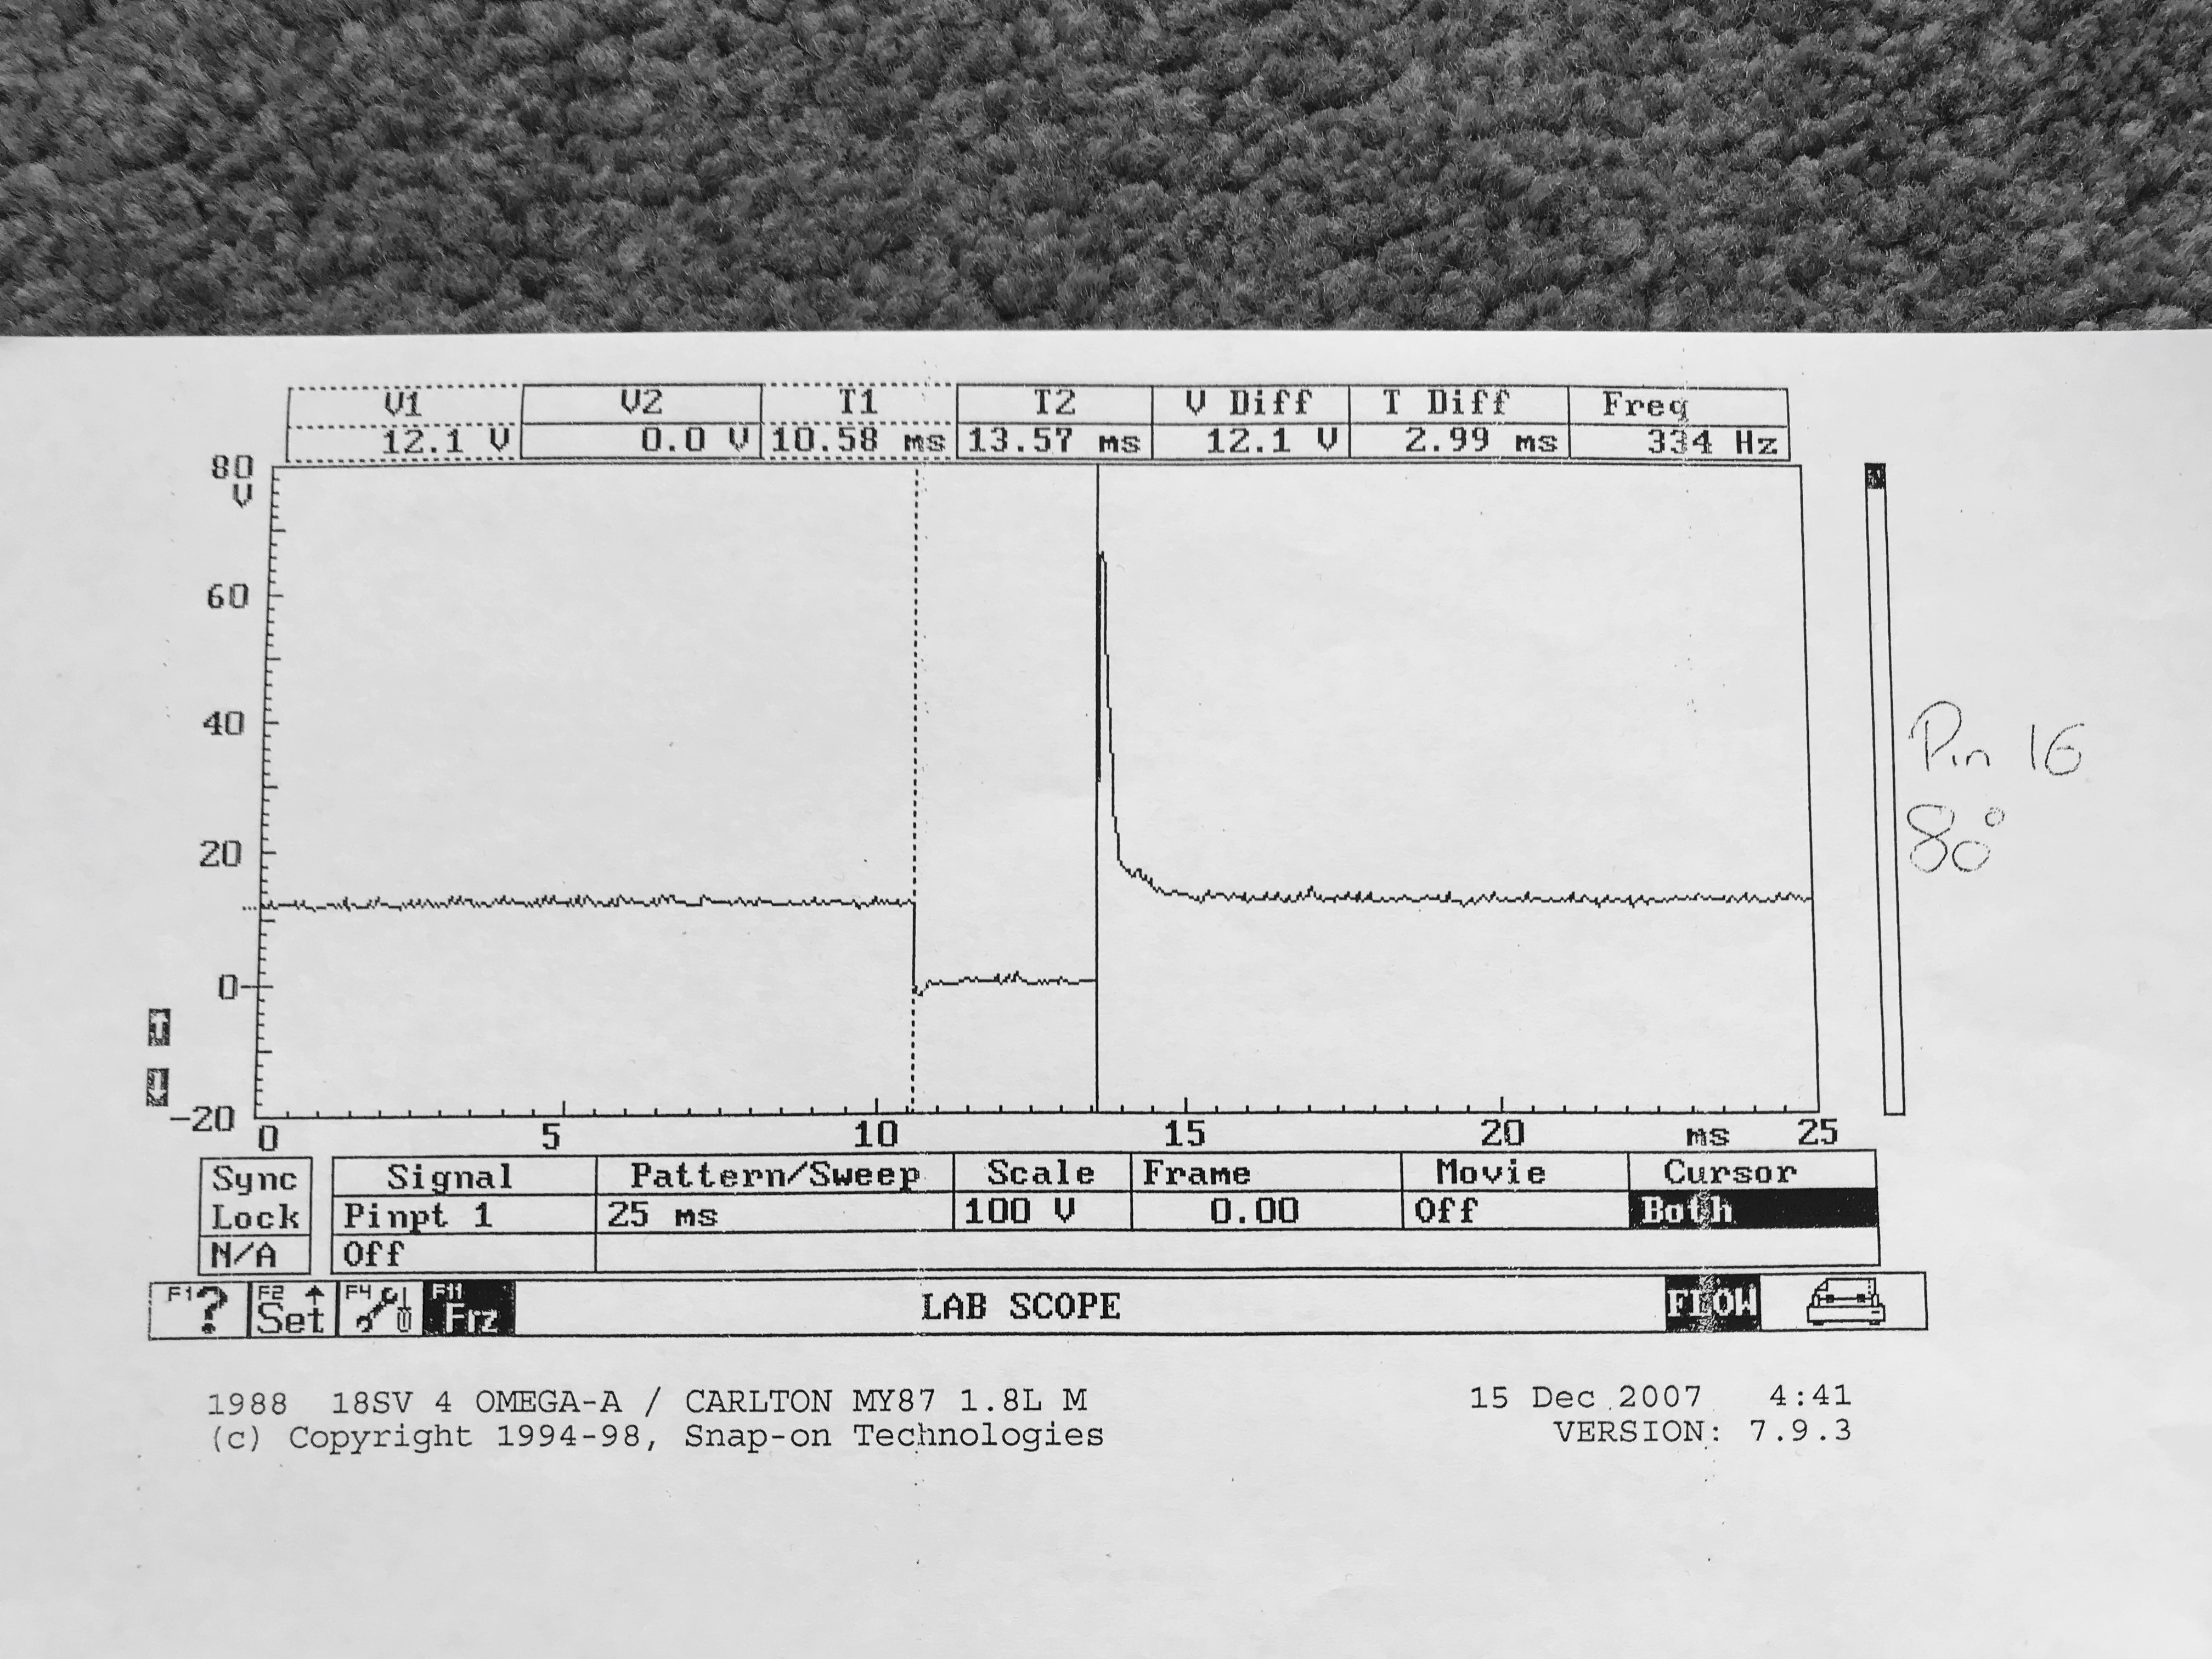
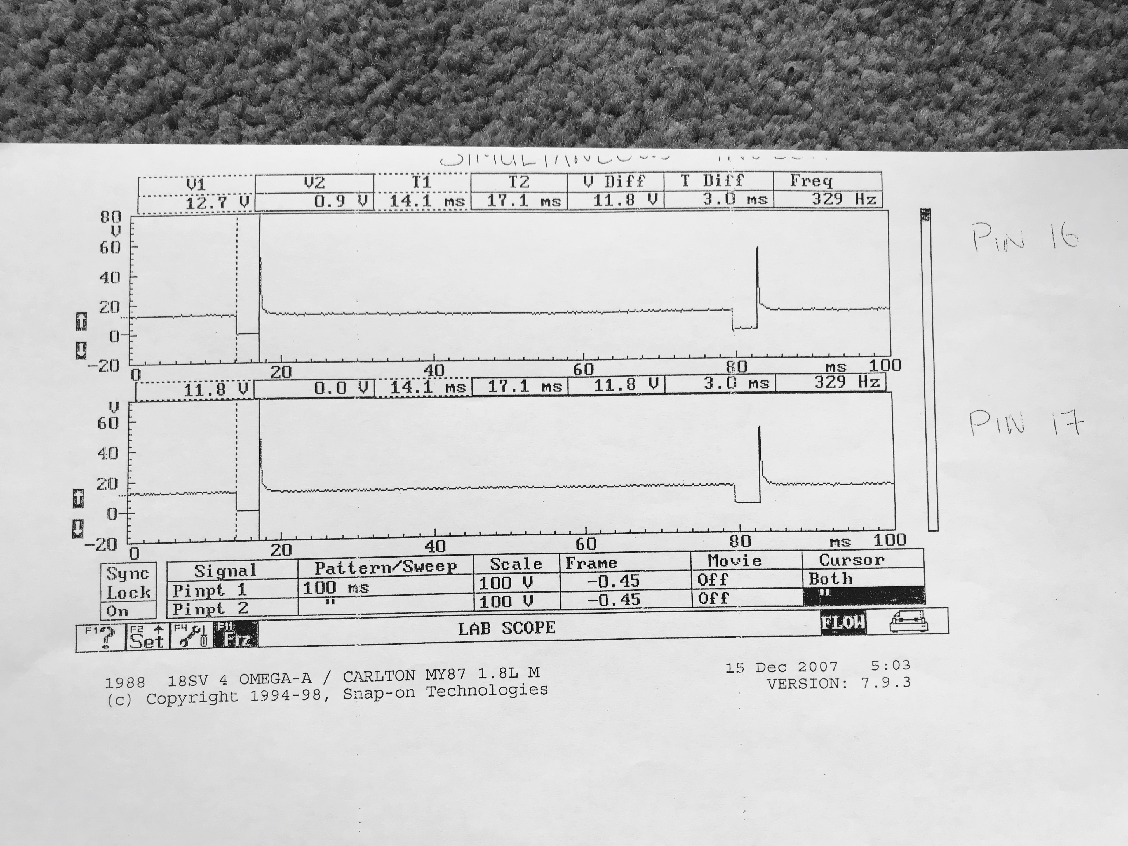Fig 2: Pin 16 & 17 (Motronic)

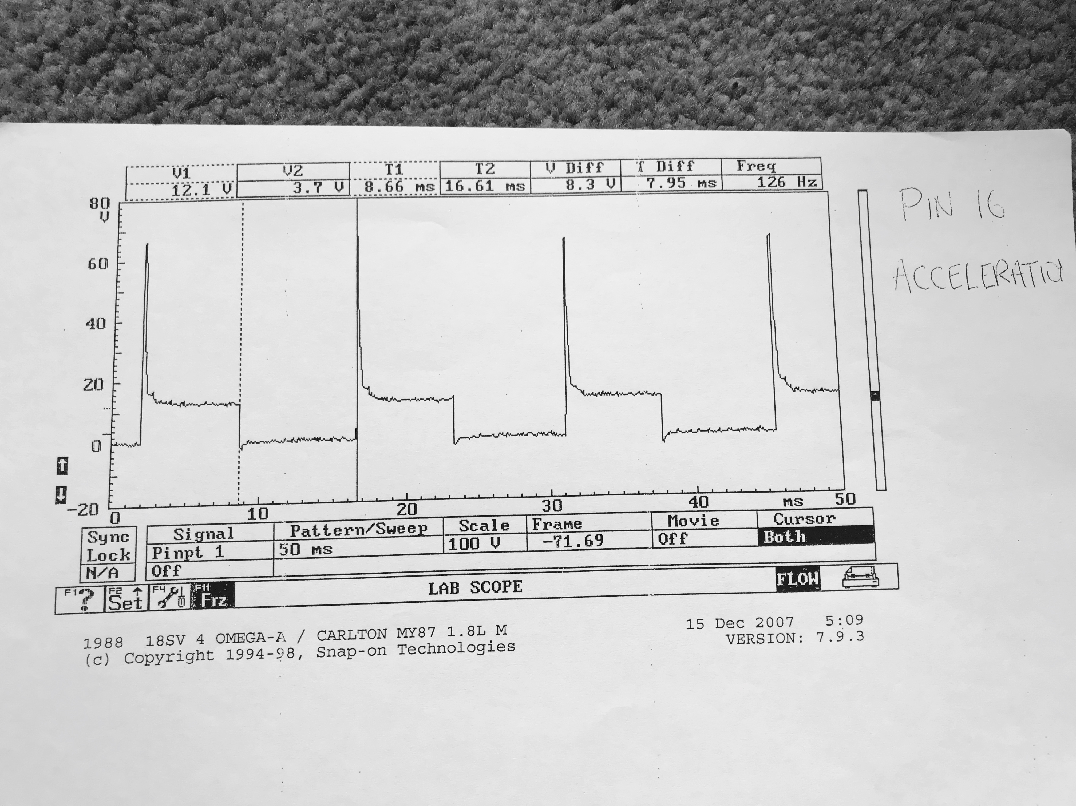Fig 3: Pin 16, Acceleration (Motronic)

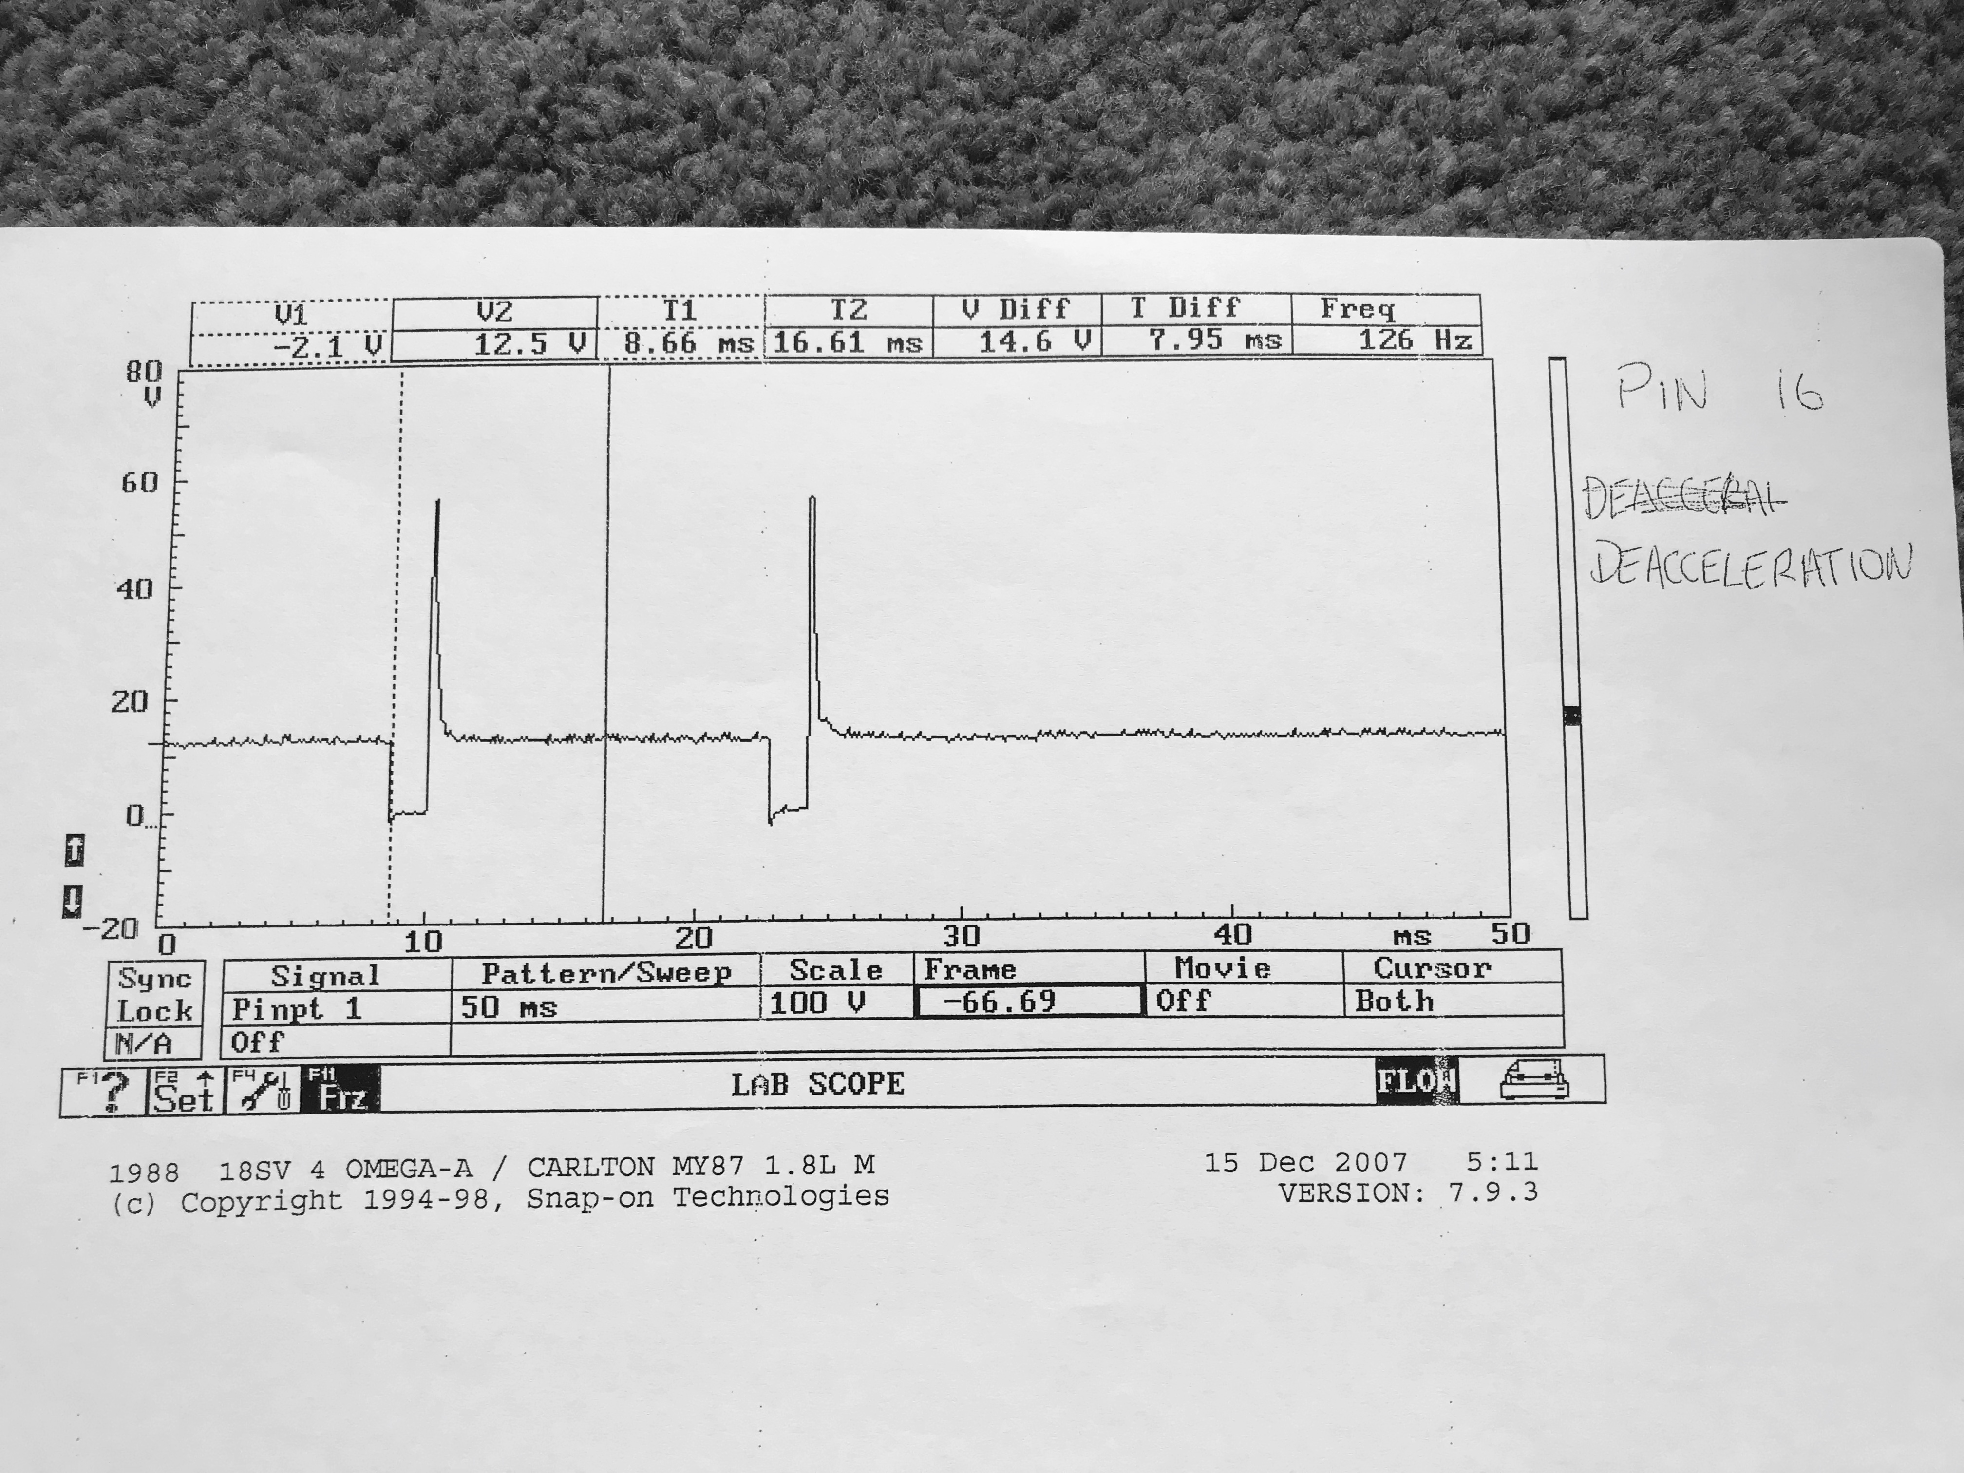Fig 4: Pin 16, Deceleration (Motronic)

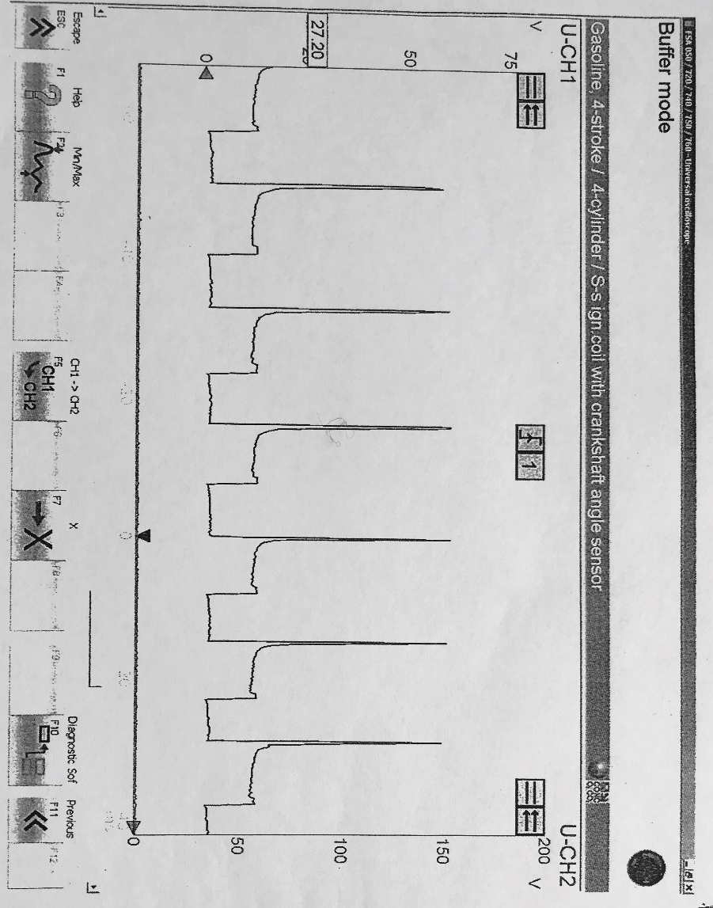
Fig 5: Pin 3, Acceleration (LE3 Jetronic)

Fig 6: Pin 3, Deceleration (LE3 Jetronic)
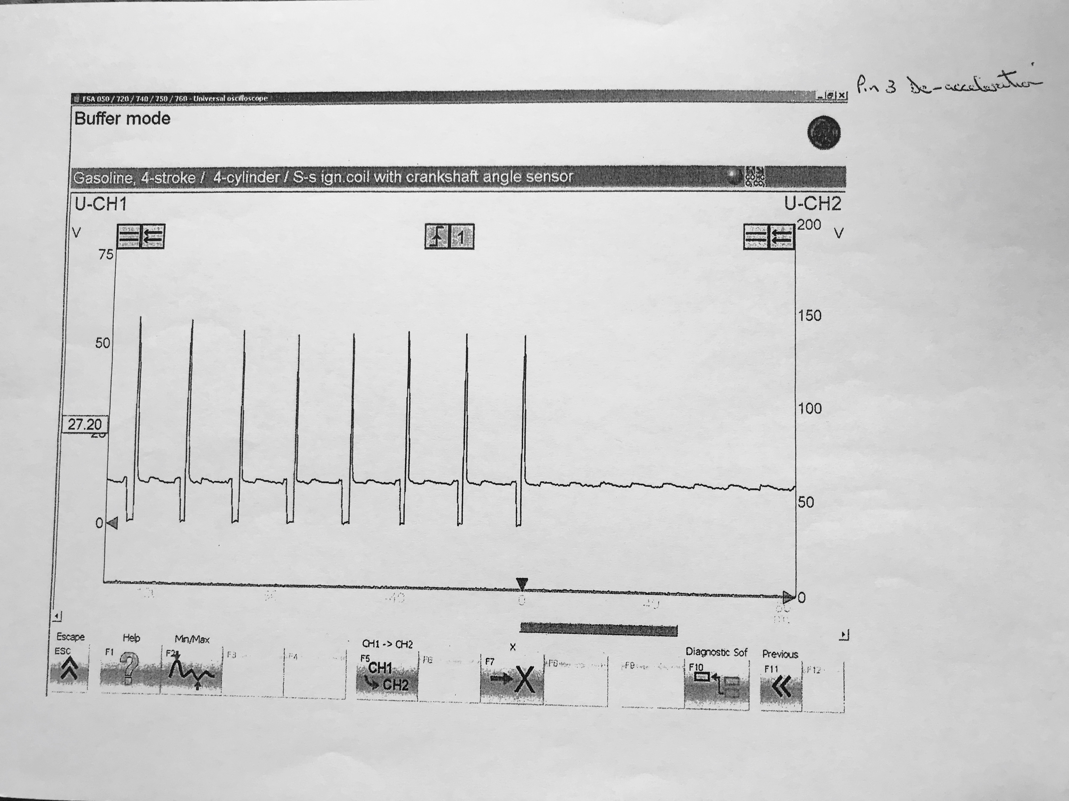

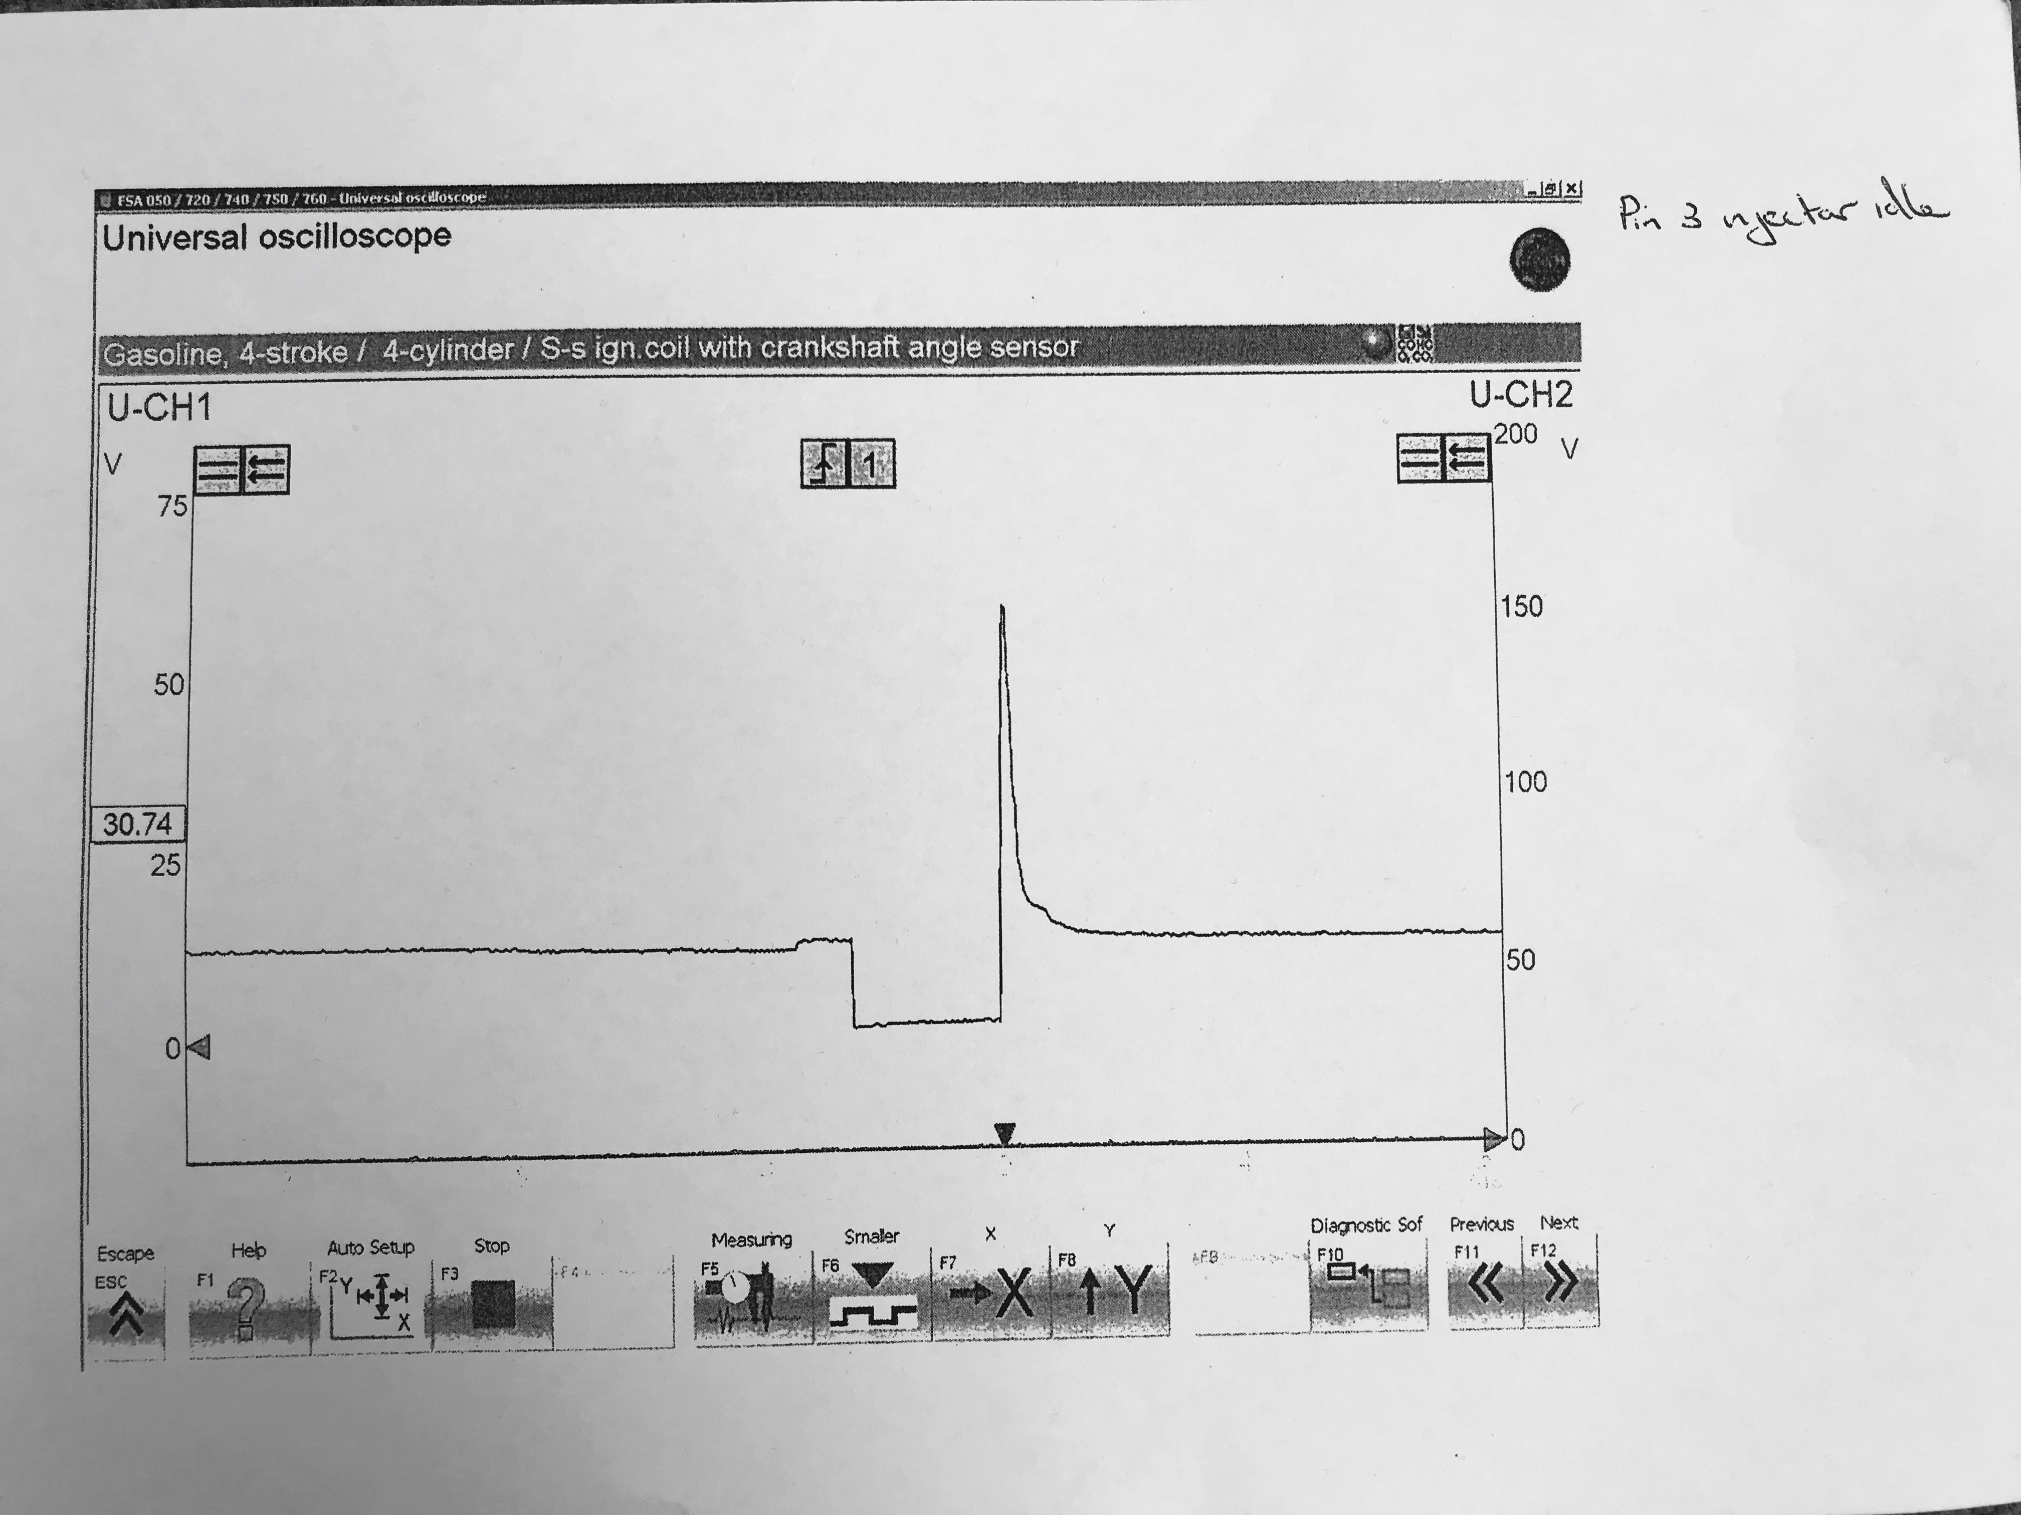Fig 7: Pin 3, Injector Idle (LE3 Jetronic)

Standard Testing Equipment
The primary piece of testing equipment used for the both engines in the workshop was a basic Sealey multimeter. This basic piece of equipment allows for a lot of testing for signal voltages around the systems, assisting us in discovering what functions were attributed to different pins on the modules used on both systems tested.
Dedicated Testing Equipment
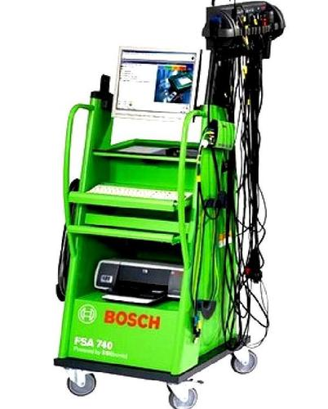
With regards to dedicated test equipment, a Bosch oscilloscope was used to analyse multiple parameters of the Bosch fuel & ignition systems found on each engine.
Bosch Engine Diagnostic System
The Bosch diagnostic unit allows for component testing, engine testing, signal analysis and sensor testing.

Image source: http: https://uk-ww.bosch-automotive.com/en_GB/products_workshopworld/testing_equipment_products/engine_system_testing/fsa_740_edition_1/fsa_740_edition
The reason for this choice of test equipment was simply because it is very versatile and effective at reading signals/waveforms. A basic sealey multimeter allows for basic recordings for voltage and resistance to be taken around the system circuits. The more advanced Bosch diagnostic unit allows for the oscilloscope feature which allows waveforms to be recorded, analysed and manipulated to be interoperated in the best way for the user, which is what it became helpful in doing; allowing for scales, live pausing and close analysis of any given waveform.
The test equipment also offered the quality of being low impeding units, preventing any damage to the circuits found on the engine electronics which could be easily damaged with overloading.

Procedure & Figures Obtained
To begin the testing, some checks must be put in place, with regards to health and safety, such as wearing the correct P.P.E (personal protective equipment) which includes steel toe cap boots, coveralls and fume extraction for the engine testing rigs, to allow for any exhaust gases to be ventilated into the atmosphere rather than collecting in the working environment and running the risk of carbon monoxide poisoning.
Within the testing group, different roles were allocated to each member, providing a responsibility for different aspects of the test, such as operating the diagnostic equipment, operating the engines ignition, a scribe to record results, in addition to a member who was allocated with using multiple probes to find signals around each system.
Initial testing on both systems began with identifying any voltage supplies while the ignition was switched off (as used on the Motronic system as it is constant energy), these being the feeds to the ECUs to maintain the memory when the engine is switched off. On the Motronic system these were revealed to be pins 18 (ECU memory live, 12.39V) and 36 (control circuit for supply to auxiliaries and ECU, from relay pin 85, 12.09V).
Once initial static testing with the ignition off had been performed, the same could be repeated with the ignition on, scoping the pins designated for testing on both systems (as observed and recorded in the figures section). It is vital when probing these small pins that a small and compact probe tip is used, such as something small and narrow like a paperclip or a specially designed probe which can often be supplied with the multimeter/scope via the manufacturer of the testing equipment. Doing this prevents any damage to the pins by forcing the joins/connections apart or damaging the wire.
After all figures were recorded, the live testing could begin on both systems, both with a key set of recordings and measurements that were to be taken. Initially, the first thing to perform was a cold start, which involved measuring the oil temperature to check the conditions in which the engine would be starting under (cold cranking temperatures). During cold cranking, the injection on time was recorded, the Motronic achieving 19.4ms at 17.9⁰C, with the Jetronic LE3 reaching 19.5ms at 16.9°C, overall reaching a similar result bar a 1 degree change in oil temperature.

To obtain the running data, the engines were warmed up phases, taking the temperature up by 10°C intervals until the running temperature of 80°C is reached. For the Motronic system, the measurements that were taken were as follows; NTC 2 resistance, NTC 2 voltage, injector pulse width, rotary idle valve opening percentage, in addition to the temperature range in which lambda and the charcoal canister were switched. For the Jetronic LE3 system; NTC 2 resistance, NTC 2 voltage and injector pulse width.

When testing voltages, the negative probe was clamped onto the negative terminal of the battery via a crocodile clip, while the positive end utilised a crocodile clip with a paper clip held in place, which allowed for precise probing around the system.

Bosch Motronic System
Cold cranking at 17.9°C.
Voltage recorded on ignition:
Pin 4: 9.86
Pin 5: 12.15
Pin 16: 12.1
Pin 17: 12.1
Pin 28: 0.42 (lambda switched off)
Pin 44: 3.75
Pin 45: 3.69
Multiple static measurements were taken on the system before running the engine such as resistance checks on system actuators such as the injectors, as well as sensors.
Resistance Tests: (all in ohms Ω)

TPS (Throttle Position Sensor):
1&2 – 2000 1&3 – 2560

Air Mass Meter:
2&4 – 30 3&4 – 560
Note: Pins 4 & 1 could not be measured because the system has no CO2 potentiometer as it is fitted with a catalytic converter (No Pin 1).

CTS (Coolant Temperature Sensor):
At room temperature – 2650

Air Temperature Sensor:
At room temperature – 2810

Idle Control Valve – 7.9

Injectors:
1 – 15.9 2 – 15.8 3 – 15.9 4 – 15.9
Ignition System

Plug leads:
1 – 1870
2 – 1770
3 – 1470
4 – 20 000

King Lead – faulty

Coil Primary – 600
Secondary – 7500

All resistance values measured around the system seemed to be reasonable, with all injector values being even across every cylinder, as well as no abnormalities, with figures that should be expected. However there was a fault with the King lead, as no resistance value could be measured. This defect in the ignition system would greatly affect the running of the engine, as the voltage would struggle to reach the distributor ready to be delivered to each high tension (HT) lead.

Running Tests
Oil temperature (°C) | Pin 45 (NTC 2) – Resistance (ohms Ω) | Pin 45  (Voltage) | Pin 16 –dwell time (m/s) | Pin 4 – Rotary idle valve opening (%) | Pin 5 – Charcoal canister solenoid | Pin 28 – lambda
20 | 1660 | 3.1 | 3.5 | 46 | Off | Off
30 | 1090 | 2.6 | 3.6 | 44 | Off | On (28-30°C range)
40 | 650 | 2 | 3.1 | 43 | Off | On
50 | 440 | 1.6 | 3 | 42 | Off | On
60 | 300 | 1.2 | 3 | 44 | On (50-62°C range) | On
70 | 240 | 1 | 2.9 | 44 | On | On
80 | 250 | 1 | 3.1 | 45 | On | On

Pin Designations (Motronic L5 ECU):
The following list details the list of pins needed for testing on the Vauxhall engine utilising the Motronic management.
4. Pulsed side of Rotary Idle Valve
5. Pulsed side of Tank Vent Valve
16. Pulsed side of Injectors (bank of 2)
17. Pulsed side of Injectors (bank of 2)
18. Permanent live to ECU to retain memory when engine/ignition is switched off
28. Lambda output
44. NTC 1 output
45. NTC 2 output
Additional Testing Data
Motronic
Static Testing at ECU pins:
Ignition OFF:
Pin 18 – 12.4V
Pin 36 – 12.1V
All others – 0V

Ignition ON:
1 – 12.3
2 – 0.04
3 – 12.18
4 – 9.86
5 – 12.15
6 – 11.41
7 – 0.34
10 – 0
12 – 5.09
13 – 10.2
14 – 0.03
16 – 12.1
17 – 12.1
18 – 12.1
19 – 0.01
22 – 0.95
24 – 0.04
26 – 0.09
27 – 12.2
28 – 0.42
32 – 11.4
36 – 0.34
37 – 12.1
40 – 0.07
41 – 0.07
42 – 0.03
44 – 3.75
45 – 3.7
46 – 0.2
48 – 0.07
49 – 0.11
53 – 0.65
55 – 11.05

Dynamic Testing

Cold Cranking:
19.4ms at 17.9⁰C

Warm up phase, 20⁰C:
CTS: 1660 Ω, 45 – 3.1V, 44 – 3.7V, 16 – 3.5ms, 4 – 46%

30⁰C:
CTS: 1090 Ω, 45 – 2.6V, 16 – 3.6ms, 4 – 44%

40⁰C:
CTS: 650 Ω, 45 – 2V, 16 – 3.1ms, 4 – 43%

50⁰C:
CTS – 440, 45 – 1.6V, 16 – 3ms, 4 – 42%

60⁰C:
CTS – 300, 45 – 1.2V, 16 – 3ms, 4 – 44%

70⁰C (Fan ON):
CTS – 240 Ω, 45 – 1V, 16 – 2.9ms, 4 – 44%

80⁰C (83, operating temperature):
CTS – 250 Ω, 45 – 1V, 44 – 3.4V, 16 – 3.1ms, 4 – 45%

Lambda (Pin 28) – witnessed at 36⁰C
Charcoal Canister Valve (Pin 5) – witnessed at 62⁰C

LE3 Jetronic
Cold cranking: 19.5ms at 16.9°C
Resistance Tests: (all in ohms Ω)

HT lead 1 – 8570
HT lead 2 – 8490
HT lead 3 – 7330
HT lead 4 – 5440
HT king lead – 5620

Throttle Valve:
Pin 2 & 18 – 0
Pin 3 & 18 – ∞

Auxiliary Air Valve – 46.2

Injectors:
1 – 16
2 – 16
3 – 16
4 – 16.1

Running Tests
Oil temperature (°C) | Pin 8 (NTC 2) – Resistance (ohms Ω) | Pin 8 – (V) | Pin 3 – Pulsed side of injectors (ms)
20 | 1786 | 1.5 | 3.8
30 | 973 | 1 | 2.9
40 | 743 | 0.8 | 2.9
50 | 493 | 0.6 | 2.6
60 | 382 | 0.5 | 2.5

Pin 8 – NTC 1
Pin 3 – Pulsed side of Injectors

Resistance Tests: (all in ohms Ω)

HT lead 1 – 8570
HT lead 2 – 8490
HT lead 3 – 7330
HT lead 4 – 5440
HT king lead – 5620

Throttle Valve:
Pin 2 & 18 – 0
Pin 3 & 18 – ∞

Auxiliary Air Valve – 46.2

Injectors:
1 – 16
2 – 16
3 – 16
4 – 16.1

Injection on Time
During cold cranking, the injection on time is extended largely, allowing a richer fuel mixture to aid combustion, delivering easier starting of the engine. The motronic system experienced cold cranking at 17.9°C, resulting in an injection on time of 19.4 ms.
At 20°C, the injection on time has been reduced down to 3.5 ms after the engine initially warms up. Throughout the warm-up phase, the injection on time is cut down from 3.6 ms at 30°C down to 3.1 at 80°C (operating temperature).
During idle speed at operating temperature (with the fan operational), the injection on time was higher than that when at 70°C (2.9 ms). This can be put down to the fact that the engine has reached its operating temperature, resulting in a return to regular idle speed, achieving a regular pulse width of around 3ms, which is to be expected at base idle on a large majority of indirect injected petrol engines.
As observed in the oscilloscope reading (Fig 1), when measuring at Pin 16 at 80°C, the pulse width/duration is 2.99ms, which is very similar to the results recorded during the testing session. In addition to this, at a similar frequency, Fig 2 shows a 3ms pulse width on both waveforms (one for each pair of injectors). Fig 7 represents the injector idle pulse on the LE3 system.
During acceleration, the engine requires more fuelling when reaching higher RPM. To compensate for this, the pulse width of the injectors increases, allowing for more fuel to be injected during the intake stroke. Fig 3 illustrates the higher frequency experienced at higher RPM, accompanied by a pulse width of around 8ms for every injection phase. Fig 5 also shows this on the LE3 system (Pin 3, switched side of injector circuit).
When deceleration occurs, the fuel system is not required to supply as much fuel to create a stronger burn. This is the time when the pulse width will be much narrower, as demonstrated in Fig 4 where the pulse widths are that of around just 1ms, even cutting out during rapid deceleration and when no throttle is applied. Fig 6 also illustrates this on the LE3 system, with very short pulse widths while decelerating.

Motronic 4.1 & LE3 Jetronic - Summary of Both Systems
The Motronic 4.1 system, introduced around 1987 and used on mostly 8 valve 2.0 – 3.0 Vauxhall engines used in vehicles such as the Astra, Omega, Carlton and Cavalier, in addition to having some use on XU series PSA engines.
As stated by the following pdf; Bosch Motronic 4.1: GM Copyright Equiptech “The electronic system used to control the GM 8 valve engines (1987 to 1990) is a fully integrated EMS that controls primary ignition, fuelling and idle control from within the same ECU.”
http: http://www.cardiagnostics.be/-now/Tech2_bestanden/Opel_MotronicML4.1.pdf
Fuel injection
The fuel injection system utilises many signals received from multiple inputs around the engine to achieve the optimum output signals and operations for the actuators (injectors), also stated in the Bosch Motronic 4.1: GM Copyright Equiptech report: “The Motronic ECU contains a fuel map with an injector opening time for basic conditions of speed and load. Information is then gathered from engine sensors such as the AFS, CAS, CTS, and TS. As a result of this information, the ECU will look-up the correct injector pulse duration right across the engine rpm, load and temperature range.”
Cold start is achieved by enrichment of the fuel mixture by pulsing the injectors for a longer period of time (as shown in the testing), in addition to general timing alterations, enabling a fast ‘cold start’ idle speed, reducing the time taken for the warm up period. It is also to note that this system is a constant energy ignition system, whereby the dwell time remains virtually constant over substantially the entire RPM range achieved by the engine thereby always recharging the coil to the same energy level between firings.
The Jetronic system, much like the Motronic system, was used on various Vauxhall Engines around 1989-1993, in addition to a selection of Alfa Romeo engines. It also features a cold start function which does away with the need of a cold start injector.
Overall, both systems make fine measures in ensuring an efficient cold start phase is achieved. As the Injection side of the systems are practically the same, both delivering indirect fuel injection via a set of 4 injectors which are switched via the ECU, both using simultaneous injection timing.
One big difference In the operation of the 2 systems however, is that the sensors on the Motronic unit operate using 5V signals, while the LE3 supplies 12V. This factor can aid the system if battery voltage runs low/drops.
It is also to note that the Motronic system is a self-diagnosing system to a certain extent. The Motronic overall delivers a number of advantageous variables and features over the Jetronic system to allow it to run the engine as efficiently as possible given the technology in the system.
References:
http | Author/Writer | Title | Date | Page/section
http://www.cardiagnostics.be/-now/Tech2_bestanden/Opel_MotronicML4.1.pdf |  | Bosch Motronic 4.1: GM Copyright Equiptech | N/A | 1, Motronic 4.1 operation
https://uk-ww.bosch-automotive.com/en_GB/products_workshopworld/testing_equipment_products/engine_system_testing/fsa_740_edition_1/fsa_740_edition | N/A | Bosch FSA740.jpeg Image | N/A
http://www.vauxhallcavalier.com/forum/viewtopic.php?f=6&t=13724&view=next

