DS 1 Template

My Screenshots/Photos

Screenshot/Photo 1
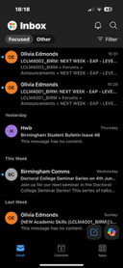
This is me using outlook to check my student emails. I think this is important as it shows I am capable of using the app correctly and reading significant emails from people like my lecturers, the university and even financial aid.

Screenshot/Photo 2

Here, I am scrolling through an app called tik tok. This is a well known app, and can be used to search for specific short videos such as cooking recipes/ tutorials, knowledgable videos like a podcast talking about finances and also fun videos such as pranks on family members. I like using tik tok because it helps me find out information on certain things that I need to know about at that exact moment.

Screenshot/Photo 3
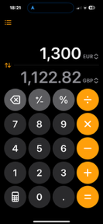
This is the calculator app that I use for many different things. These include, checking current exchange rates (as shown in the photo), adding numbers up to help me get the correct answer and also multiplying numbers to help me get the correct answer quicker than if I was to work it out myself. This shows my skills in using the calculator app because I am able to work out equations quickly and effectively.

Screenshot/Photo 4
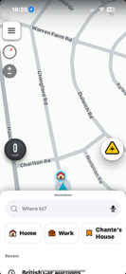
Here is an app I like to use called “Waze”. This app allows me to get directions, see speed cameras, warns of traffic ahead and even suggests quicker routes to get to my destination. I use this app quite regularly as it saves me a lot of time on traffic and because I am also very familiar with it as I’ve been using it for many years now. This shows my creativity and out-the-box thinking as I could easily just use an app like “Google maps” which is very well known.

Screenshot/Photo 5
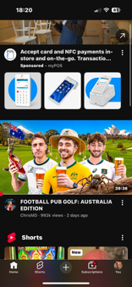
Showing here, is “YouTube”. I like to use this app later on at night as it helps me wind down just before going to bed. I like to watch videos such as football content, comedy skits and sometimes a documentary. It is crucial in my opinion to use YouTube as it can also be used to learn information. This information includes watching videos on how to start a business, how to manage finances correctly and also how to save money.

My Short Reflection

I often use these specific apps/tools as they are very familiar to me. I feel it’s important to have familiarity as you can feel more confident using them. I’d like to improve on discovering more apps to better suit my needs for things like managing files or for tracking calories. This is important as both can help with time keeping and making my life a bit less stressful. I sometimes feel nervous about using different tools as I start off not knowing what to press or where to start. I hope this module will help me improve my digital skills overall and help me build confidence in using different tools. Things like this are important to me as I like to expand my knowledge as much as I can because I feel it’ll help me in the future with any business ventures I may have.

