EFFECTIVE TEAM WORKING for team success

STUDENT Name: Joan Hird
Student Number:2028356
lecturer Name: Dale Clarke
BMSW Code: 4002

CONTENTS PAGES
CASE STUDY………………………………………………………………………………………………………………………………………3
INTRODUCTION…………………………………………………………………………………………………………………………………4
Tuckman Theory……………………………………………………………………………………………………………………………… 6
Tuckman model ……………………………………………………………………………………………………………………………….7
BelbinTheory……………………………………………………………………………………………………………………………………8
Conclusion……………………………………………………………………………………………………………………………………….
Reference………………………………………………………………………………………………………………………………………..

Abdul Case Study
FOREWORD
Abdul has been assigned to a new project for Vodafone UK where he’s a task to manage a group of 18 employees to deliver a community event with local stakeholders, commercial businesses, and voluntary organizations.
The team has been working for two months now but have not yet met as a team due to COVID restrictions
Abdul has contacted each member of the team to discuss their roles and responsibilities and seems to be sure that things have started well. However, recently he received several calls from community groups complaining about the poor level of communication from the project community liaison leads.
Abdul has also noted that each member of his team, failed to complete the project tasks according to the deadline and seems unconcerned about others on the team. When someone asked for help no one supports or responded to the email communications.
He was also told by a member of staff from the sales team that just yesterday. one of his projects staff failed to attend or give his apology at an important meeting that was arranged with the local MP and community groups.
Abdul urgently needs to do something as this is a bad start to the project.

INTRODUCTION
Based on Abdul’s case study we will be looking at ways of solving his problem of effective team working by using the Tuckman module of Forming, Norming, Storming, and performing we will also be looking at Belbin’s nine team roles
The types of behavior in which people engage are infinite but the range of useful
Behaviour, which makes an effective contribution to team performance, is finite.
These behaviors are grouped into a set number of related clusters, to which the team role is applied
Belbin’s theory states that if each member of the team understands their roles within the team ecosystem it’s easier to identify their strengths, weakness, and ability.
Tuckman’s THEORY
For a team to grow, face up to challenges tackle problems find solutions,
Plan work and delivering results in his five stages are necessary to build a strong and effective team. A Team with good communication and is working towards the same goals
On August the 16th. Whelan’s Scholarly articles on team working
Curiously, even though teams are a basic organizing unit of daily life most of us
Never deliberately, learn much about how they work or the tool to make them
Highly effective

Teamworking is the collaborative effort of a group to achieve a common goal or to complete a task most effectively and efficiently.
Something incredible happens when teamwork happens the way it’s supposed to happen. Things change when everyone on the team is equally invested in the overall purpose and goal you find yourself working faster, finding mistakes more easily, innovating better
Ultimately, you reach a point where you’re certain each person on your team has your back, and both your job satisfaction and performance skyrocket

How to develop an effective team
One theoretical model that can be used for this task is
The Tuckman Theory

To develop effective teamwork skills, you need to be able to communicate effectively. Communication is important and only effective with clear instruction and objectives, to establish what the team will be working towards. Honest reflective feedback is also imperative to ensure that as a team we are striving towards excellence and better practice. Working as a team opens the opportunity to be Reflective which challenges each member of the team to improve the practice and outcome of the team. To develop team working skills, you are required to listen to the different ideas which contribute to the overall progression of the group. Although this may be difficult but draw each other strengths to accomplish the overall goal.

What are the types of roles that are needed to create an effective team?
Within a team, it’s important to have one leader who will be the driving force of the group. Integrative practice with individuals that are willing to contribute ideas and methods to accomplish goals is needed for a good team. Understanding team interactions during the activity will identify the different roles that people are taking in the team, this will also help you improve your skill by observing what needs to be improved.

What type of impact can effective teamwork have on team success?

Working in a team and encouraging effective teamwork amongst
your staff can bring many benefits and competitive advantages to the business.
Increased productivity individuals contributing to helping a team produce results will feel valued, supported, and committed to each other. this can lead to happier, productive, and more motivated staff, deadlines met, problem-solving, new ideas and opportunities, a support network

What are the barriers to effective team working?
identify in a scenario
When communication breaks down or a lack of understanding is presented in the group, we begin to see barriers that impact effective teamwork. The reason why teamwork fails includes losing focus on their purpose or goals, having individuals that won’t take responsibility for their task leading to resentment and blame among team member individuals that don’t share information, and don’t communicate effectively. Don’t look for consensus when making a decision lack openness and trust aren’t provided with the resources, they need to get the job done aren’t fully supported by management.

The Tuckman model

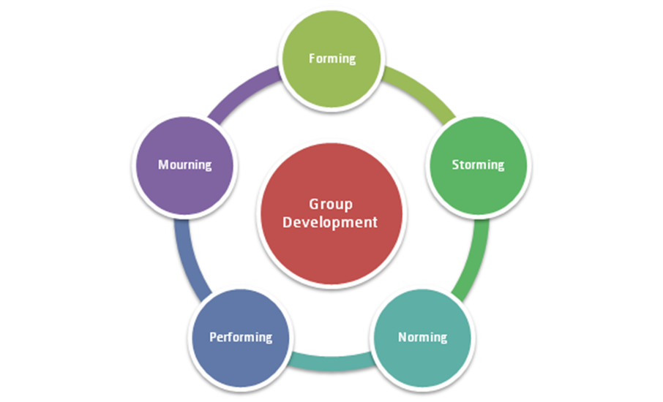

Source:(BIGSTOCK

The Tuckman model was created in 1965 by bruce Wayne Tuckman this is used for group development this is necessary and inevitable for a team to grow and tackle challenges and find solutions.
Tuckman’s model explains that as the team develops maturity and ability, relationships establish and the leader changes leadership style this simple overview of the Tuckman forming, storming, norming, performing model offers a simple way to understand how groups develop (12 Jun 2017).
1: forming: This is where the members first meet its important for the team leader to facilitate
The introductions and highlight each person’s skills. Team members are also given project details and opportunities to organize their responsibilities
2 Storming: At this stage team members openly share ideas and use this opportunity to stand out and be accepted by their peers
3 Norming: by now the teams have figured out how to work together theirs no more internal
Competition and goles are clear
4 Performing: there’s a high level of cohesion and trust between team members.
Teams are functioning at peak efficiency with less oversight from the team leader
5 Adjourning: teams complete their project and debrief on what went well and what could be
Improved for the future

Based on the case study Abdul need to meet face to face with all team member to discuss rebuilding the team making it more effective With the use of Belbin team roles.
(what is a team role?}
According to Mindtools (2022) Belbin’s team role is one of nine clusters of behavioral attributes identified by Dr. Meredith Belbin’s research at Henley as being effective to facilitate team progress. The research indicates that the most successful team were made up of a diverse mix of behaviors. each team needs access to each of the nine Belbin team roles behaviors to become a high-performing team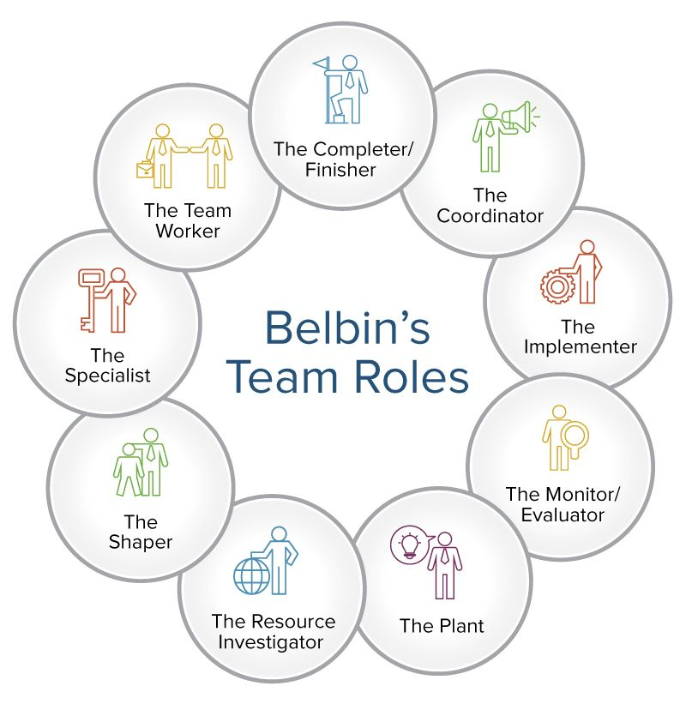

The nine-team roles are :
1: Resource investigators are someone who use their inquisitive nature to find ideas to bring back to the team. Strengths outgoing enthusiasm, explore opportunities, and develops contacts
2: Teamwork
Help the team to gel, using their versatility to identify the work required and complete it on behalf of the team .strength Co-operative, perceptive, and diplomatic listens and averts friction.
3: Co-ordinator the Belbin theory suggests the third team role Needed to focus on the team’s objectives, draw out team members
And delegate work appropriately. Strengths Mature, confident, identifies talent. Clarifies goals
4 Plant
Tends to be highly creative and good at solving problems in an unconventional way: strength creative imaginative, free-thinking, generates ideas and solves difficult problems
5 Monitor Evaluator
Provides a logical eye making impartial judgments where required and weighs up the team’s options in a dispassionate Strengths: sober, strategic, and discerning. See all options and judges accurately.
6 specialist
Brings in-depth knowledge of a key area to the team.
Strengths: single-minded
Self-starting and dedicated. They provide specialist knowledge and skill.

7 Shaper
Provides the necessary drive to ensure that the team keeps moving and does not lose focus or momentum.
Strengths: challenging, dynamic. Thrives on pressure. Has the drive and courage to overcome obstacles.
8 Implementer
Needed to plan a workable strategy and carry it out as efficiently as possible.
Strengths: practical, reliable, efficient .turns ideas into actions and organizes work that needs to be done,
9 Completer Finisher
Most effectively used at the end of the task to polish and scrutinize the work for errors subjecting it to the highest standards of quality control
By taking the team apart and putting it back together looking at each team member
Strength and weakness. Their ability to communicate effectively with each other in the team( most people do not listen to understand they listen with the intent to reply )
Time management is also very important in team development giving each member a set time to organize and complete tasks within the time allowed
The covid pandemic has played a large part in the team not meeting in person at a very important stage of the team building and could be the reason why team members lose focus on their purpose or goals have individuals that are too similar in terms of skills and ways of thinking
Will not be able to reach their full potential

Conclusion
The team leader needs to restructure the team giving each member a.
The specific task to complete in time allocated bosting team morals so the teams members feel fully supported by management. when team members take responsibility for their task there will be no resentment and blame among team members, Team members will start to share information and communicate effectively look for a consensus when making a decision. there will be more openness and trust amongst team members
When the team is provided with the resources they need the team members will get the job done

References
- Griffith, Brian A., and Ethan B. Dunham. Working in Teams : Moving From High Potential to High Performance, SAGE Publications, 2014.
- Morgan, P. (2017), The Business Student’s guide to study and employability, London, SAGE.
- Martin, V. and Rogers, A. M. (2004) Leading interprofessional teams in health and social care. [electronic resource]. Routledge. Available at: http://search.ebscohost.com
- Pentland, A., (2008), Honest Signals, Cambridge, MA, MIT Press.
- Scheepers, D. and Ellemers, N., 2019. Social identity theory. In Social psychology in action (pp. 129-143). Springer, Cham.
- Tsay,M., & Brady,M., (2010), A case study of co-operative learning and communication pedagogy:Does working in teams make a difference?, The Journal of Scholarship of teaching and learning, 10(2), p.78
- van Knippenburg, D. and Schnippers, M.C. (2007) Work group diversity. Annual Review of Psychology, 58, 515-541.
- Wheelan, S.A., (2016), Creating Effective Teams, 5th Ed, London, SAGE

