

Module Name & Code
Marketing Management - LCMB7024

Name: Md Asif Reza
Student id: 2523547

Brand Extension of Tesla “Tesla NeuroDrive”

Programme
Master of Business Administration

Lecturer’s Name: Dr Tola Odugbsesan

Word Count: 2534

Table of Contents
Introduction 3
Element 1: Brand Extension of Tesla “Tesla NeuroDrive” 4
Element 2: STDP Analysis “Tesla NeuroDrive” 5
2.1 Segmentation 5
2.2 Targeting 7
2.3 Differentiation 7
2.4 Positioning 8
Element 3: 4P Analysis of “Tesla NeuroDrive” 9
3.1 Product 10
3.2 Price 11
3.3 Place 11
3.4 Promotion 11
Element 4: Reflection using Gibbs Cycle 13
Conclusion 15
References 16

Introduction
Brand development is a strategic marketing strategy whereby companies leverage on the existing brand equity to launch new products or venture into new product categories to attain growth and competitive advantage (Kotler and Keller, 2016). A major variant of such a strategy is brand extension, where an already established brand name is used on a new product that identifies with the parent brand and its positioning (Sekar, Varki and Elsantil, 2024). The portfolio examines the proposed brand extension of Tesla, NeuroDrive, and assesses the strategic prospects of the product using the STDP analysis, marketing mix choices, and reflective insight, considering innovation, market presence, and sustainability.

Element 1: Brand Extension of Tesla “Tesla NeuroDrive”
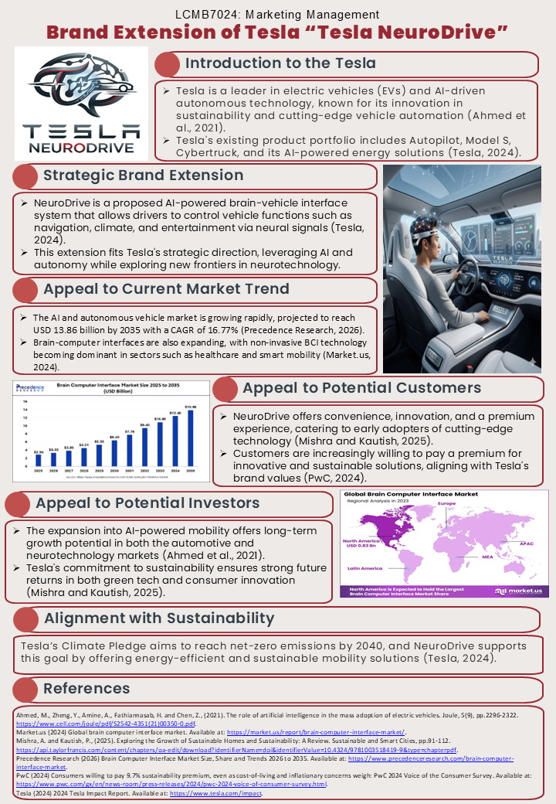

Element 2: STDP Analysis “Tesla NeuroDrive”
STDP is segmentation, targeting, differentiation, and positioning, the combination of which assists the firms in determining the most appealing customer segments and devising a clear market positioning strategy of a new product (Ansari, 2025). With Tesla NeuroDrive, an AI-driven braincar interface that would enable drivers to operate dedicated in-car functions via neural signals, STDP is especially significant since the idea is extremely innovative and will not be compatible with the entire market upon its release.
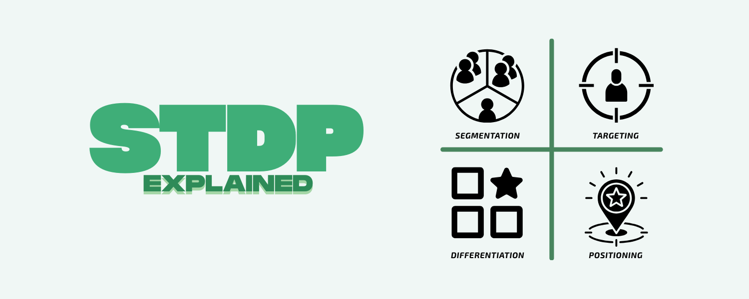
Figure 1: STDP
Source: (Ansari, 2025)

2.1 Segmentation
In the case of Tesla NeuroDrive, geographic, demographic, psychographic, and behavioural variables are suitable to segment the market as depicted in standard market segmentation models (Market Xcel, 2024).
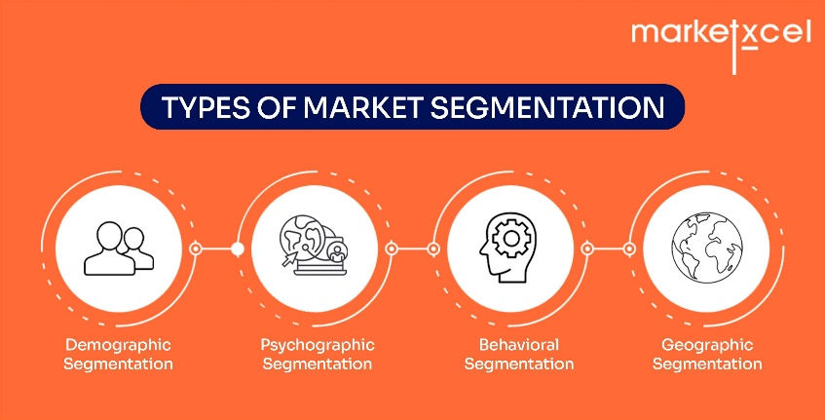
Figure 2: Market Segmentation
Source: (Market Xcel, 2024)
Geographic Segmentation: The Tesla NeuroDrive can be divided into geographic, demographic, psychographic and behavioural variable. Geographically, the most promising early markets would be North America, chosen countries in Europe and developed cities in Asia-Pacific (Market.us, 2024). These areas already exhibit greater integration of electric cars, greater digital maturity and openness to new mobility technologies.
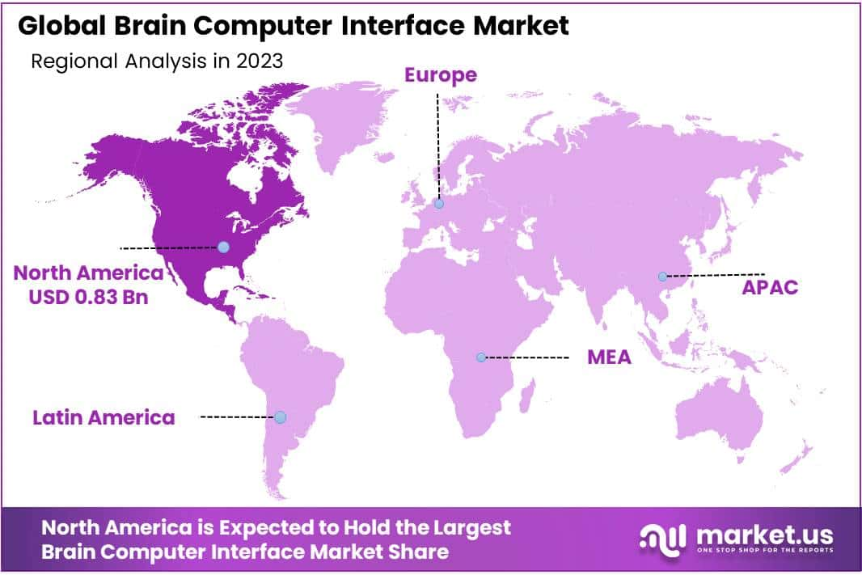
Figure 3: Global Brain Computer Interface Market
Source: (Market.us, 2024)
This is also backed by the broader expansion of the brain computer interface market which Precedence Research estimates to increase to an approximate of USD 2.94 billion in 2025, to USD 13.86 billion in 2035. This implies that NeuroDrive would join a market paradigm with an increasing commercial viability, as opposed to a strictly experimental market niche (Precedence Research, 2026).
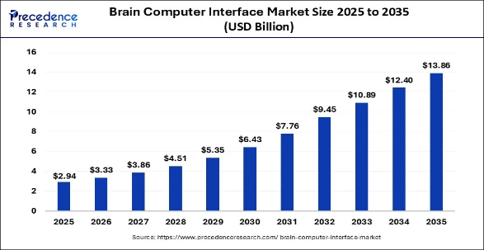
Figure 4: Market Size of Brain Computer
Source: (Precedence Research, 2026)
Demographic Segmentation: The demographics of the most appropriate customers would be high-income, well-educated adults aged approximately 25-50, who are highly confident in the digital world. This group is better able to afford high quality technology and is more apt to embrace complicated innovations. Studies of the uptake of electric vehicles suggest that probable early adopters tend to be both younger and more educated and financially stable than the common consumer. This trend is particularly applicable to Tesla since the company already appeals to technology-focused high-end customers as opposed to mass-market consumers who are more price-conscious (Mandys, 2021).
Psychographic Segmentation: Tesla NeuroDrive psychographically will attract customers who appreciate innovation, convenience, futurism and status. These customers are more likely to think about products as not just useful means, but also as identifiers and ways of life. Tesla is already a symbolic brand, which implies high-tech and futuristic mobile, so NeuroDrive would probably appeal to those people who need to be perceived as the first to be on the next level of smart cars and not just car users.
Behavioural Segmentation: The most powerful segment, behaviourally, is made of early adopters, current Tesla users and those consumers who are not afraid of software-based experiences (PwC, 2024). Research on EV adoption reveals that innovativeness, identity, pro-environmental attitudes and perceived performance are the key factors that contribute to the adoption. It implies that customers who already trust connected systems will be the most inclined to buy NeuroDrive and are willing to pay more to obtain technological leadership, as opposed to mere transportation utility (Zaino et al., 2024).

2.2 Targeting
Narrow Focused Approach: According to this segmentation, Tesla ought to employ a narrow focus approach at the time of launch. The main target market must be the rich, technology-focused Tesla users of developed EV markets who desire a smooth, luxurious and very intelligent in-car experience. This is the most desirable group since it is a combination of the purchasing power, technological openness and brand familiarity. A more generalized approach to targeting would not work as well since NeuroDrive is a radical extension and might not be needed or even frightening to mainstream users in the initial stage. Narrower launch is also aligned with the pattern of new technologies diffusing on the market, where a comparatively small circle of willing adopters is reached before it becomes more widespread (Stajić et al., 2023).

2.3 Differentiation
Innovative Interface: NeuroDrive stands out as one of the first to introduce a brain-vehicle interface, which is a substitute to traditional touchscreens, buttons or voice assistants. Studies on human machine interfaces in cars demonstrate that neural control is able to enhance reaction time, decrease driver workload, and perceived technological sophistication, particularly in early-adopting high-tech automotive technology users (Kwag and Kang, 2025).
Integration with Software Ecosystem: In contrast to standalone devices, NeuroDrive is integrated into the existing Tesla software ecosystem, which utilizes AI integration, automation, and constant digital improvements. It is proposed by literature on software-defined vehicles that close-knit extensions enhance user acceptance, interoperability, and platform stickiness, and adds functional and symbolic brand value (Pérez-Moure, Lampón and Cabanelas, 2024).
Symbolic and Ethical Differentiation: NeuroDrive will further enhance Tesla as a brand that is committed to the future as a mobility brand, but with ethical concerns. BCI study raises the issue of privacy, consent and neural-data governance (Sun and Ye, 2023). Tesla is thus differentiated not only by newness and functionality, but also by trust, safety and responsible execution, which renders the product reliable and appealing to both the consumers and the investors (Boonstra, 2025).

2.4 Positioning
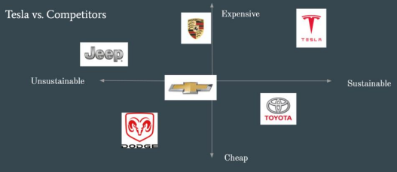
Figure 5: Positioning Map of Tesla
Source: (Galli, 2021)
Tesla NeuroDrive can be marketed as a luxury AI-powered neuro-mobility interface that will peep into tomorrow where drivers are in search of the new generation of smooth, intelligent and sustainable vehicle interface. This is a successful positioning since it builds on the existing brand name of Tesla, yet still has a meaningfully new element. It also promotes a high-value introduction approach instead of a mass-market introduction. It is important to note that the positioning of NeuroDrive must not create the perception that NeuroDrive is a science fiction. Rather, it ought to be presented as a natural continuation of software-first mobility at Tesla. The Tesla impact reporting and brand communication already imply the company with cleaner transport and technology-driven progress, and thus the NeuroDrive can be marketed as the extension of the bigger picture rather than an independent discovery (Tesla, 2024).

Element 3: 4P Analysis of “Tesla NeuroDrive”
The marketing mix transforms the strategic intent into operational decisions on the market. In the case of Tesla NeuroDrive, the 4Ps have to render a highly innovative brand extension to sound commercially plausible, technologically realistic, and in line with the Tesla premium brand image which is software-oriented (Deng and Messinger, 2022).
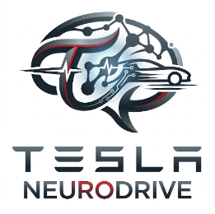
Figure 6: Tesla NeuroDrive Brand Identity
Source: Author
The success of brand-extension is greatly dependent on the perceived fit between parent brand and the new offering. It has been found that the greater the consumer reactions are, the better the fit of the extension in image, functional, resource, target market, and usage scenario (Sekar, Varki and Elsantil, 2024). NeuroDrive ought to be positioned as an extension of the Tesla platform of smart mobility and connected car creativity.
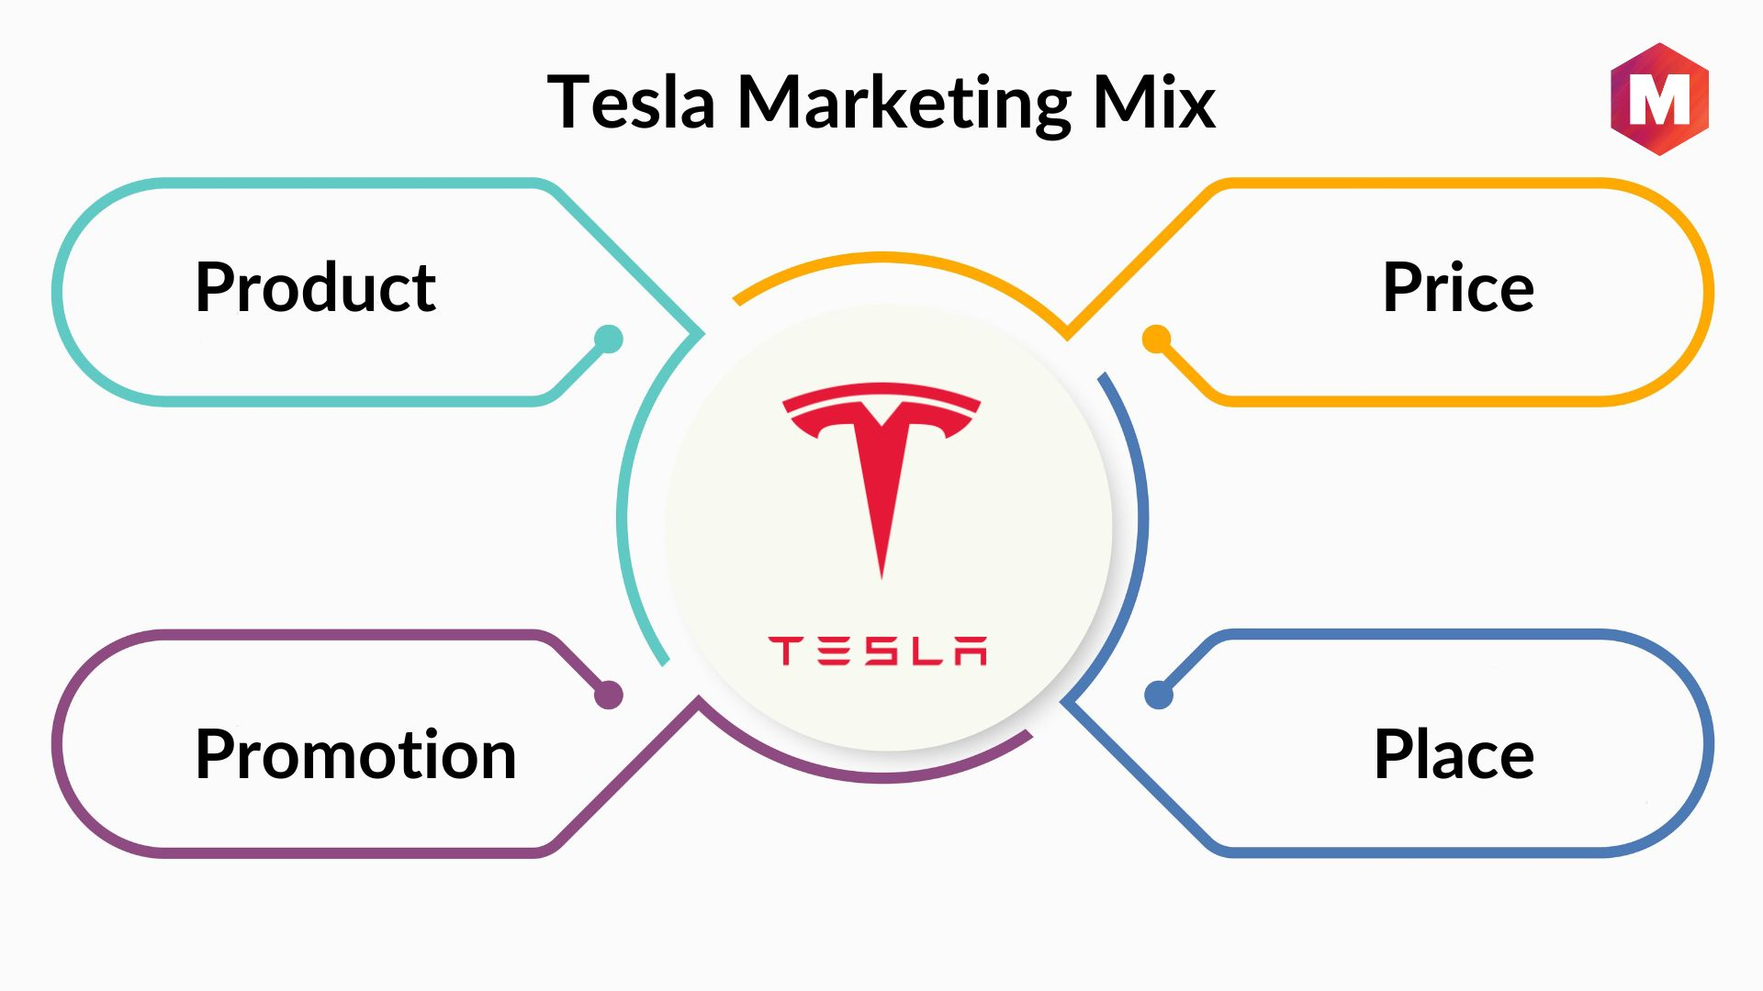
Figure 7: Marketing Mix
Source: (Bhasin, 2024)

3.1 Product
Core Product Design and Functional Scope: NeuroDrive is to be promoted as a premium augmented product, not a one-off hardware product. It provides a smooth driver-vehicle interface where chosen functions can be controlled using neural signals, which aligns with the trend toward software-defined vehicles, where value is created by flexible software, service layer flexibility, and continuous updates (Kwag and Kang, 2025).
Augmented Features: Onboarding, installation, remote diagnostics, software updates, and premium support should be provided as part of the product. Studies on EVs and on OTA-enabled services indicate that the intention of consumers is influenced by trust, satisfaction and product innovativeness (Wang and Khan, 2025). Only when reliability and cybersecurity are taken into consideration, OTA updates are convenient and provide new functionality (Iyieke et al., 2025). NeuroDrive must therefore be positioned as a reliable service platform that has been constantly improved, as opposed to a single innovation.
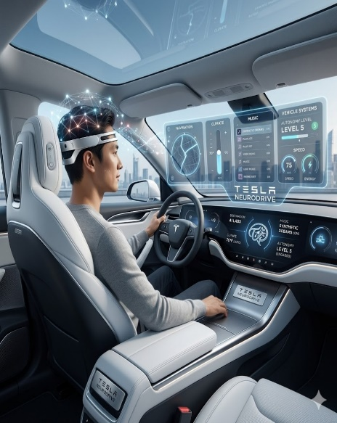
Figure 8: New Product
Source: Author
Product Strategy Analysis: The original product must not be required to perform safety-related duties, but only low-risk duties as infotainment, navigation inputs, or climate controls. BCI commercialisation cautions that consumer adoption can surpass scientific confidence and ethical regulation. Issues related to consent, privacy, the commodification of neural-data, and safety warrant the development of NeuroDrive as neural-assistance, but not full neural driving (Sun and Ye, 2023).

3.2 Price
Premium Skimming Logic: The launch price of NeuroDrive should be high indicating the introduction of a new product, exclusivity, and the cost of development. Skimming works when early adopters are sensitive to instant access to innovation and willingness to pay is different (Lotfi et al., 2024). Premium price will strengthen its positioning as a state of the art improvement.
Hybrid Revenue Model: The pricing model must include initial hardware costs plus long-term software updates or levels of subscription (Pérez-Moure, Lampón and Cabanelas, 2024). The literature on software-defined vehicles emphasizes the transition to one-off transactions to connectivity and platform-based services (Liu, Zhang and Zhao, 2022). A hybrid model will enable Tesla to recuperate expenses but will also generate recurring revenue in the long term.

3.3 Place
Direct-to-Consumer Distribution: NeuroDrive is better off employing a direct-to-consumer model, which can boost brand identity, competitive positioning, customer data capture, and retention (Knapp, Gebauer and Wortmann, 2025). DTC distribution enables Tesla to have a uniform messaging, experience quality, and feedback data (Zhang and Wang, 2023).
Service Ecosystem and Phased Rollout: Place is not to be seen as a sales channel, but as a service ecosystem. According to the digital mobility research, automotive business models are moving to customer-centric platforms, grounded on connectivity and digital services (Pérez-Moure, Lampón and Cabanelas, 2024). The staged introduction of EV markets in flagships will enable Tesla to gather information on their use, enhance interface, and reputational risk management before moving wider.

3.4 Promotion
Educational and Experiential Communication: NeuroDrive needs to be marketed on an educational, experiential, and trust-based basis instead of hype. Sense, feel, think, act, and relate dimensions of experience marketing have a positive effect on green purchase intention and EV adoption (Na et al., 2025). It is recommended to use controlled demonstrations, guided trials, immersive digital previews, and scenario-based communication.
Consistency, Brand Identity and Trust: Integration of promotion should be across channels. Regularity of messaging enhances brand strength, aids sales strategy, and affects purchase decisions in the digital age (Shams, Chatterjee and Chaudhuri, 2024). Communication must focus on smart help, social accountability, and high-quality technological convenience without purporting that the driver is being replaced.
4P approach reveals that NeuroDrive is best positioned as a high-end, software-based, and well-orchestrated brand extension. Designing products should focus on fit, trust, and limited-risk functionality; pricing should start with premium skimming and transition to recurring software revenues; place should be based on DTC distribution and platform-based support, and promotion should focus on guided experience, evidence, and responsible innovation. Collectively, these decisions render NeuroDrive as a viable second-stage expansion of the technology-focused brand image of Tesla.

Element 4: Reflection using Gibbs Cycle
The Reflective Cycle is a model of reflection that assists people in gaining experience by passing through six stages through description, feelings, evaluation, analysis, conclusion, and action plan (Gibbs, 1988).
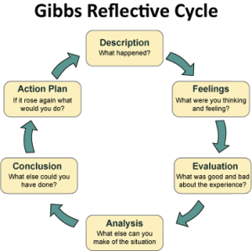
Figure 9: Gibbs Reflective Cycle
Source: (Crowe Associates Ltd., 2025)
Description: I used the Reflective Cycle by Gibbs to consider the creation of Tesla NeuroDrive and the way to present it in the form of a poster. My assignment was to transform a creative concept into a viable brand extension with STDP and 4P analysis. Initially, I paid more attention to the futuristic nature of the idea. Yet, in the portfolio, I realised that an effective extension should demonstrate strategic fit, customer relevance and commercial realism, and not novelty per se (Gibbs, 1988).
Feelings: I was confident in the beginning as the concept appeared innovative and directly connected to the innovative image of Tesla. Concurrently, I was unsure about whether the idea was too futuristic to be used in a marketing task. The fact that I had to prepare the poster added more pressure to that since I needed to present a complex idea in a brief and convincing manner. As I became more refined in the work, I got more confident since I realized that creativity is only worthwhile when it is backed by evidence and a clear line of marketing reasoning (Crowe Associates Ltd., 2025).
Evaluation: One of the key strengths of this process was the fact that it challenged me to go beyond mere description and think more critically. I have known that Tesla NeuroDrive could not be introduced as a mere exciting idea; it had to be supported by segmentation, targeting, differentiation, positioning and marketing mix choices. One of the areas of my performance that was weaker was that I initially tended to overload the poster with information. This demonstrated that powerful ideas become ineffective in the absence of selective, audience-oriented, and strategically planned communication (Sekar, Varki and Elsantil, 2024).
Analysis: A number of skills were reinforced in this experience. First, it enhanced my strategic thinking since I needed to relate the extension to the brand equity of Tesla and not to regard it as a one-off invention. Second, it enhanced my skills in balancing innovation and realism. Third, it enhanced my scholarship communication skills, particularly in selecting the appropriate evidence, making proper citations, and structuring arguments in a more professional manner. Besides that, the presentation also made me understand that visual communication is a strategic tool, as audiences consider the levels of clarity and credibility simultaneously (Kotler and Keller, 2016).
Conclusion and Action Plan: On the whole, the given project helped me to grow both personally and professionally, as I gained confidence in my ability to use the marketing theory to a new product idea. In future ventures, I would start earlier, cut the first draft on unnecessary text and practice my presentation with other people prior to presentation. I would also enhance my work by employing additional peer-reviewed sources earlier and by balancing risks, ethics and implementation barriers by focusing on all these earlier in the planning phase.

Conclusion
Tesla NeuroDrive teaches us that brand development is a good growth channel to utilize when innovation is streamlined with the brand equity, market demand and sustainability targets. The portfolio indicates that NeuroDrive is a potentially successful focused premium brand extension since it aligns with Tesla identity, should appeal to high-end early adopters and could be promoted by a well-consistent STDP and 4P approach. Simultaneously, its effectiveness would be based on prudent execution, conscientious communication and ethical and practical risk consideration. On the whole, NeuroDrive is a plausible future-looking extension that can enhance the long-term positioning of Tesla in terms of competitive advantage.

References
Ansari, R.S. (2025) STDP: The four steps of a customer-driven marketing strategy. Blogginc. Available at: https://www.blogginc.com/blog/stdp-the-four-steps-of-a-customer-driven-marketing-strategy/
Bhasin, H. (2024) Tesla marketing mix and 4Ps (Updated 2026). Marketing91. Available at: https://www.marketing91.com/marketing-mix-of-tesla-motors/
Boonstra, J.T. (2025) ‘Ethical imperatives in the commercialization of brain-computer interfaces’, IBRO Neuroscience Reports, 19, pp. 718–724. Available at: https://www.sciencedirect.com/science/article/pii/S2667242125001605
Crowe Associates Ltd. (2025) Gibbs Reflective Cycle. Available at: https://www.crowe-associates.co.uk/coaching-tools/gibbs-reflective-cycle/
Deng, Q.C. and Messinger, P.R., (2022). Dimensions of brand-extension fit. International journal of research in marketing, 39(3), pp.764-787. https://doi.org/10.1016/j.ijresmar.2021.09.013
Galli (2021) Tesla Model S: Part 1 – The Consumer and Market Analysis. Bucknell University. Available at: https://rgalli.blogs.bucknell.edu/files/2021/11/TESLA-Market-Analysis.pdf
Gibbs, G. (1988) Learning by Doing: A Guide to Teaching and Learning Methods. Oxford: Further Education Unit, Oxford Polytechnic. Available at: https://books.google.com/books/about/Learning_by_Doing.html?id=z2CxAAAACAAJ
Iyieke, V., Jadidbonab, H., Rakib, A., Bryans, J., Dhaliwal, D. and Kosmas, O., (2025). An adaptable security-by-design approach for ensuring a secure Over the Air (OTA) update in modern vehicles. Computers & Security, 150, p.104268. https://doi.org/10.1016/j.cose.2024.104268
Knapp, J., Gebauer, H., and Wortmann, F. (2025). Unlocking the benefits of direct-to-consumer (DTC) strategies without alienating dealers. Business Horizons. https://doi.org/10.1016/j.bushor.2025.04.011
Kotler, P. and Keller, K.L. (2016) Marketing Management. 15th edn. Harlow: Pearson Education Limited. Available at: https://books.google.com/books/about/Marketing_Management.html?id=BI6q0AEACAAJ
Kwag, S.J. and Kang, B., (2025). Key to the future of the automotive industry: SDV technology and reliability. JMST Advances, 7(1), pp.99-104.
Liu, Z., Zhang, W. and Zhao, F., (2022). Impact, challenges and prospect of software-defined vehicles. Automotive Innovation, 5(2), pp.180-194. https://doi.org/10.1007/s42154-022-00179-z
Lotfi, A., Naoum-Sawaya, J., Lotfi, A. and Jiang, Z. (2024) ‘To skim or not to skim: Studying the optimal pricing strategy for technology products’, Omega, 127, 103079. Available at: https://doi.org/10.1016/j.omega.2024.103079
Mandys, F. (2021) ‘Electric vehicles and consumer choices’, Renewable and Sustainable Energy Reviews, 142, 110874. Available at: https://doi.org/10.1016/j.rser.2021.110874
Market Xcel. (2024) Navigating the maze of market segmentation: mastering types, strategies, and benefits for business success. Available at: https://www.market-xcel.com/blogs/navigating-the-maze-of-market-segmentation-mastering-types-strategies-and-benefits-for-business-success
Market.us (2024) Global brain computer interface market. Available at: https://market.us/report/brain-computer-interface-market/
Na, Z., Hashim, N.M.H.N., Kakuda, N. and Si, S., (2025). Charging the soul: tailoring five experiential marketing dimensions to harness the appeal of electric vehicles for different psychological traits. Technology in Society, 82, p.102902. https://doi.org/10.1016/j.techsoc.2025.102902
Pérez-Moure, H., Lampón, J.F. and Cabanelas, P., (2024). Mobility business models toward a digital tomorrow: Challenges for automotive manufacturers. Futures, 156, p.103309. https://doi.org/10.1016/j.futures.2023.103309
Precedence Research (2026) Brain computer interface market size, share and trends 2026 to 2035. Available at: https://www.precedenceresearch.com/brain-computer-interface-market
PwC (2024) Consumers willing to pay 9.7% sustainability premium, even as cost-of-living and inflationary concerns weigh: PwC 2024 Voice of the Consumer Survey. Available at: https://www.pwc.com/gx/en/news-room/press-releases/2024/pwc-2024-voice-of-consumer-survey.html.
Sekar, S.B., Varki, S. and Elsantil, Y., (2024). Centrality of sensory attributes in brand extension evaluations. Journal of Consumer Marketing, 41(5), pp.477-490. https://doi.org/10.1108/JCM-11-2021-5016
Shams, R., Chatterjee, S. and Chaudhuri, R., (2024). Developing brand identity and sales strategy in the digital era: Moderating role of consumer belief in brand. Journal of Business Research, 179, p.114689. https://doi.org/10.1016/j.jbusres.2024.114689
Situmorang, I.R., Gultom, P. and Haubu, T.J., (2025). The Impact of Relationship Marketing and Customer Experience on Consumer Purchase Decisions in the Automotive Sector. Journal of Social Studies Arts and Humanities (JSSAH), 5(2), pp.056-061. https://journal.unpak.ac.id/index.php/proceedings/article/viewFile/12846/6177
Stajić, D., Pfeifer, A., Herc, L. and Logonder, M. (2023) ‘Early adoption of battery electric vehicles and owners’ motivation’, Cleaner Engineering and Technology, 15, 100658. Available at: https://doi.org/10.1016/j.clet.2023.100658
Sun, X. and Ye, B. (2023) ‘The functional differentiation of brain–computer interfaces and its ethical implications’, Humanities and Social Sciences Communications, 10, Article 878. Available at: https://doi.org/10.1057/s41599-023-02419-x.
Tesla (2024) Impact Report 2024. Available at: https://www.tesla.com/impact.
Wang, S. and Khan, A., (2025). Exploring the factors driving the sustainable consumer intentions for over-the-air updates in electric vehicles. Energy Exploration & Exploitation, 43(1), pp.319-339. https://doi.org/10.1177/01445987241284101
Zaino, R., Ahmed, V., Alhammadi, A.M. and Alghoush, M., (2024). Electric vehicle adoption: A comprehensive systematic review of technological, environmental, organizational and policy impacts. World electric vehicle journal, 15(8), p.375. https://doi.org/10.3390/wevj15080375
Zhang, Z. and Wang, Y., (2023). New-arrival or second-hand? A direct-to-consumer business model for electric vehicles in the sustainable transportation. Energy Reports, 10, pp.3035-3038. https://doi.org/10.1016/j.egyr.2023.09.101

