Introduction
In this essay I will be discussing three keywords which will lead into a question which I will use to guide my dissertation next year. Under these keywords I will be studying related imagery and philosophies to help point me further toward my underlying question for the dissertation. These keywords being:
- Wealth
- Desire
- Fame
I shall be using key images to visualise the keywords and therefore construct my own views from, also using key thinkers to aid me in further understanding the keywords. By doing this I will have a further understanding of my keywords which will directly feed into my dissertation. Understanding the contextual background of the underlying question is crucial to the overall essay and the foundation of my dissertation.
Wealth
I decided on wealth as my first key word as it is the driving force of our modern world. Whether people have it or if they are chasing it, the expression remains true; ‘money makes the world go around’. In a psychological standpoint to a point; everybody is attracted to wealth whether its monetary wealth, mindful wealth or wealth of knowledge. For the context of this keyword I will be primarily focusing on the monetary side of the keyword. I personally find it important because in any context, wealth plays a factor. Throughout the history of civilisation, the effect that wealth has had is clear to see, from autocracies to the creation of social classes. For bad and good wealth has played a huge role in shaping the world we currently live in.
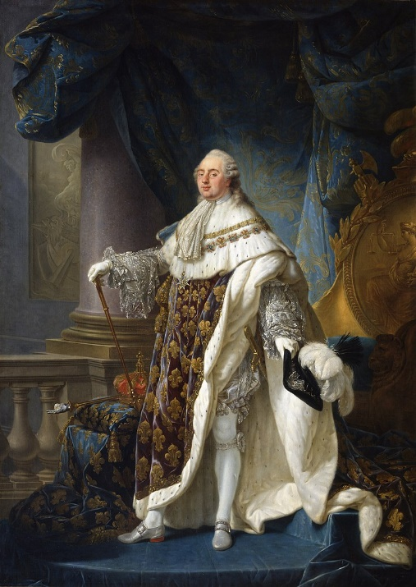

Callet, A. (1754). King Louis XVI. [Oil on Canvas] Paris: Louvre.

Key Image: Portrait of Louis XVI
I believe that this portrait of King Louis the sixteenth Is the epitome of wealth and what it means to be necessarily wealthy. Not knowing the context behind this portrait most would just see it as a classical style portrait of a monarch, but this was painted only a few years prior to the French revolution; one of the most iconic and defining moments of human history; a period in which the impoverished rose against the aristocracy. France’s own monarch draped in gold and blue as his people suffered from famine and poverty.
This portrait is a metaphor for how wealth can be considered and how it can dictate what a said person does, wealth drives people to do things from starting a revolution to going to work everyday for the rest of your life, since the start of civilisation it has been the catalyst for why people do what they do. The curtain used in the image can now been seen in an ironic sense, they are pulled in the background as if to cover something, that something being the built-up frustration and anger of the French people, ignoring it as they have done for hundreds of years up until this point. I think overall this portrait speaks of wealth on different classes, its effect on social classes and how it can make people act, all of these aspects are properties of human race; if you have wealth you flaunt it, if others do not don’t interact with them and of course the other side of the coin; why should I be treated a certain way because I don’t have wealth? Why don’t I have wealth? How can I become wealthy? Which leads to someone standing up for what they believe in. It is a subject of natural human emotions; greed, envy, pride and anger.
Søren Kierkegaard
“In the end, therefore, money will be the one thing people will desire, which is moreover only representative, an abstraction. Nowadays a young man hardly envies anyone his gifts, his art, the love of a beautiful girl, or his fame; he only envies him his money. Give me money, he will say, and I am saved...He would die with nothing to reproach himself with, and under the impression that if only he had had the money he might really have lived and might even have achieved something great.”
Kierkegaard, S. (1962). Present Age & Of the Difference Between a Genius & an Apostle. New York: Harper & Row.
This is a quote from Søren Kierkegaard a highly influential Danish philosopher, this was his view on money and wealth. He speaks of wealth in a way that most do not see, he has taken a step back from a first person view to see how wealth is interpreted in the world, he categories ‘us’ as ‘he’ to give personal emphasis on the belief. Kierkegaard sees us as being blinded by the obsession of wealth, chasing it for our whole lives, only to realise at the end of our lives had we accepted our lives for how they were and lived without pursuit they would be so much more fulfilled and meaningful. This impression of wealth being lifelong ambition fuelled by greed ties in with our key image for wealth, as the French aristocracy and monarchy did take from the poor to further amass their own personal wealth. The notion of wealth that it rules over us here in Kierkegaard’s view is solidified as one that will remain to the end of our lives, even though this was written over 150 years ago in 1846. The realisation of this ties in perfectly with our modern materialistic world which sees people having the need to be perceived as being wealthy even if they are not, through materialistic and consumer perspectives; cars, clothes and houses are the indicators of modern social classes and stigmas. We can see characteristics of wealth in today’s world in the portrait of King Louis XVI, and that the rat race of wealth is still if not more present than it was is Kierkegaard’s time.

Desire
For my second keyword I decided to use Desire, desire is a human instinct, as humans we cannot control what we desire such as we desire wealth as stated before. As a topic it is interesting to me to see why people have a desire to certain things whether it be a person, a job, clothing or a car. The psychology of why? Why do people desire the possessions of others? Does fulfilling our desires make us happy? Why do we desire things which are out of our reach? Particularly materialistic possessions, such as a car or a certain clothing brand, it is interesting for me to see what influenced them to have a desire of said material item. Desire is driven by a variety of things such as envy, lust, fame or curiosity the we desire is a curiosity to me; this is the reason I want this to feed into my dissertation as a key word.
Key Image: Accommodations of Desire
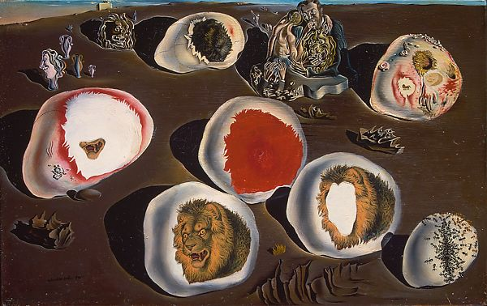

Dali, S. (1929). The Accommodations of Desire. [Oil on Canvas and Mixed Media] New York: Metropolitan Museum of Art.

Here is Dali’s famous depiction of desire within his own mind, this baron wasteland which Is characterised odd shapes, disfigured people and terrifying facets of lions. ‘The Accommodations of Desire’ is a painting that addresses Dali’s sexual anxieties due to an affair with a married and older woman. Gala, wife of poet Paul Elard, was Dali’s muse, in which he took inspiration from throughout the course of their relationship. He added seven stones on top of he painted what he believed was ahead of him in his life: aggressive lion heads which is drawn in irony to the title ‘The Accommodations of Desire’. In which the lions produce quite the opposite feeling in this image. The ant hill could also be seen as a symbol of decay within Dali’s own mind. The feelings emitted within this painting are the emotions that come along with desire, if not for desire these visualised feelings of anxiety, fearfulness and guilt would not be present in this image.

Personally, I believe that this image is a metaphor for the consequences of desire for Dali, I’m sure most can relate to these emotions. It tells a story of the human emotion of desire and consequently not being able to control them, especially in this circumstance in which the woman he lusts after is married. This truly is a representation of the human emotion of desire, the angst of it, the uncontrollability, the drive to get what you want regardless of what it means to fulfil the said desire.
G.E Moore
"In the first place, plainly, we are not always conscious of expecting pleasure, when we desire a thing. We may only be conscious of the thing which we desire and may be impelled to make for it at once, without any calculation as to whether it will bring us pleasure or pain. In the second place, even when we do expect pleasure, it can certainly be very rarely pleasure only which we desire.”
Moore, G. (1903). Present Age & Of the Difference Between a Genius & an Apostle. Cambridge: Cambridge University.
What I take away from this quotation summarises the underlying meaning of Dali’s painting for me, when we first desire something we are not conscious of why or how, we are impelled by ourselves to go after and fulfil the desire, without hesitation if it will bring is pleasure or pain. Even if the product of the desire will bring pleasure the journey to reaching that desire could be a painful one. As if we are searching for desires to calm our impulsive spirits seen in Dali’s work.
This impulsiveness can be seen when searching for pleasures, with the fame and influence of celebrity figures seen today, their profound effect on our desires goes often unnoticed. Small things such as the clothes these figures wear drive us to want to dress as they do, wear certain brands or styles, our desire to look and feel like these people is a subconscious decision of our mind, we feel need the to be like celebrities in anyway we can. In relation, the road to fulfilling these desires could cause pain, it is expected that these celebrities want to flaunt their wealth (as stated before in the wealth segment) so it can be expected that the clothes they wear are expensive. In this case to wear those certain clothes would cause pain on the way of reaching that desire, spending money they could use for something beneficial or that they truly need. This is the effect desire has on our lives. Our desires can be influenced upon by those who hold influence in the first place.
Fame
Fame in the modern day is hugely prominent and more so than ever before. With the use of multimedia such as social media or television, fame surrounds us. Some people are famous, and some strive to be. Having fame can mean having power in a lot of sense, when you’re famous indirectly you hold a large amount of influence. It is interesting to me how celebrities are so influential, what makes fame enough to cause a person to act or dress a certain way. I am also intrigued on why regular people are so invested in the lives of the famous and what causes this? Along with these questions I also decided to use fame as my third and final keyword because it ties nicely with the previous keywords, a famous person is likely to have wealth, people have the desire to reach fame etc. This way I can form a strong and collated question which will interest me and drive me enough to write a successful dissertation.
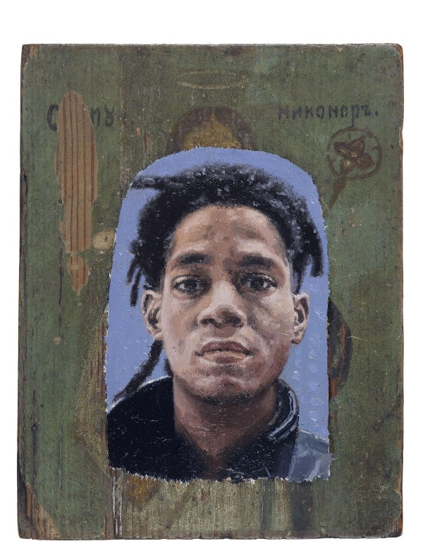
Key Image: Robert Priseman, FAME Jean-Michael Basquiat

Priseman, R. (2015). FAME. [Oil on Mixed Media] Arizona: University of Arizona Museum of Art.
This portrait over Jean-Michael Basquiat is part of an art project by artist Robert Priseman, the project consists of a collection of portraits which have been painted on damaged religious icons and documents. The faces depicted on the iconography all belong to celebrities who all died due to suicide or other drug related deaths. The collection features the faces of celebrities such as Jimi Hendrix, Alexander McQueen and Kurt Kobain. The correlation between the religious aspect and the fame aspect is what strikes me the most, it is clear that the message Priseman is trying to portray is that fame has replaced religion. It has even more emphasis when you the subjects of the portraits have all taken their lives or struggled with drug use throughout their lives, begging the question if celebrity really has replaced religion then why we as people look up to these broken icons. Is it safe for these individuals to have influence if they are famous? The context of the collection also challenges the audience to question the direct effects of fame on these people, if it causes them to take drugs or take their lives, is it humane for us as people to place these individuals on such a high pedestal? For me what this collection represents is the fragility and absurdness of fame, we put huge pressure on celebrities, and we expect them all to act accordingly, but when they’re in the public eye constantly it is easy to imagine the amount of psychological pressure that puts on them. Overall, I believe it stands as a testament of our modern world and the ridiculous aspects of it, in which celebrity and fame have replaced religion.
Francois de La Rochefoucauld
"The fame of great men ought to be judged always by the means they used to acquire it."
Duc De La Rochefoucauld, F. (1871). Reflections; Or Sentences and Moral Maxims. 10th ed. London: Simpson Low, Son, and Marston.

A quote from French philosopher Rochefoucauld is one that applies to how we perceive fame in the modern day, acquiring fame especially in a world in which everyone desires fame is particularly hard. I believe the thing to take away from this quote is how many people today feel the absolute need to become famous. To reach fame today, sacrifices must be made, luck also plays a massive factor in it, so many people strive to become famous and so many little do. Meaning people will try and emulate what celebrities do and dress like in order to feel like one themselves, this links back to the wealth portion of this essay when explaining how people (in this case celebrities) want to flaunt their wealth meaning they ware expensive clothes, regular people would buy this clothing to try and emulate them. A key word of the quote is ‘great’, there are many who have fame, but less who are famous because they are great. To be considered great is subjective, though to have fame for all the wrong reasons is very one sided yet they remain famous. People today are influenced by celebrity, they eat what they eat, they shop where they shop and wear what they wear, the power of celebrity is one that has increased majorly during this last century. Fame Is a two-sided coin, on one aspect it brings wealth and popularity but on the other it can destroy a person’s life and the lives of those who are influenced by that celebrity as seen in the work of Priseman.
Conclusion
These keywords I have researched have led me to comprise a question for my third-year dissertation, whilst researching each keyword. As mention before throughout the exploration of each keyword, wealth, desire and fame are all closely conjoined, meaning the question must be specific to one thing. I could not help but think of the effect and influence which celebrities have on the clothing industry, as it is something that I personally have an interest in as well I have seen their influence first hand. Once an influential celebrity wears a certain brand of clothing the brand’s popularity and recognition instantly rises by a significant amount. It was the aspects of the celebrities influencing subconscious desires, wealthy people wanting to flaunt their wealth are therefore influencing others to dress like them and the underlying power of fame and the fragility of it. Merging these keywords and what I have discussed about them in this essay as well as adding my own personal interests to keep me driven throughout the writing and research aspects of the dissertation. The brand is called Supreme, initially it was a small New York based skateboard brand which had a small market. Leveraging the power of celebrity and marketing tactics, using the celebrities to wear their clothing caused an enormous amount of desire and demand for the clothing. This is what I shall be researching in my dissertation.
Research Question
How did a small clothing brand become one of the biggest in the world and developed huge aftermarket value without the use of advertising?

