

Student name: Zumira Fernando Franco
Student ID: 2424773
Module name: Protecting and Supporting Families in Health and Care
Module code: (BMHP5021)
Lecturer name: Amanda Jones
Assessment (REPORT): An examination and analysis of how the ‘Early Help’ system is signposted to UK families by their local authority website.

Table of Contents

Introduction.......................................................................................................................3
The Early Help System......................................................................................................4
Multi-agency Working and Strategic Safeguarding Partnerships................................5
Evaluation of Leeds City Council....................................................................................6
Evaluation of Tower Hamlets Council.............................................................................7
Evaluation of Norfolk County Council............................................................................8
Comparative Analysis.....................................................................................................10,11
Conclusion.......................................................................................................................12
Recommendations..........................................................................................................12
References.......................................................................................................................13,14

Introduction
The Early Help system is an essential part of safeguarding practices in England, designed to recognise the needs of children and families as early as possible and offer prompt assistance to prevent issues from growing more intense. This system advocates for a preventative, child-focused strategy through efficient collaboration among local authorities, health services, education, police, and voluntary organisations, ensuring households obtain timely support (Department for Education and Department for Levelling Up, Housing and Communities, 2022). Additionally, the document “Working Together to Safeguard Children” (Department for Education, 2026) underscores that safeguarding is a collective responsibility and highlights the need for effective multi-agency cooperation to protect children, enhance outcomes, and promote their well-being.
The principles of the Early Help system are also applicable in healthcare settings. Healthcare professionals, particularly Senior Carers, play a crucial role in identifying early signs of vulnerability, appropriately voicing concerns, and collaborating with other agencies for coordinated care. Effective communication and teamwork can facilitate early intervention and help avoid crises for children and families (Department for Education, 2026).
This report analyses how the Early Help system information is presented on the websites of Leeds City Council, Norfolk County Council, and Tower Hamlets Council. It describes the Early Help system, assesses each website, compares their strengths and weaknesses, and concludes by identifying which local authority offers the most accessible and effective information for families.

What does the Early Help System refer to?
The Early Help System is a preventative approach, family-oriented strategy designed to recognise and address the developing requirements of children, adolescents, and their families before issues escalate into more serious safeguarding matters. Instead of waiting for statutory intervention to become necessary, Early Help prioritises delivering timely, coordinated, and appropriate support to enhance family resilience, mitigate risk factors, and encourage positive outcomes for children (Department for Education and Department for Levelling Up, Housing and Communities, 2022). The Early Help System Guide describes this approach as a collaborative partnership that allows local agencies to work together, ensuring that families receive the right support at the right time through effective assessment, planning, and coordinated actions.
The Early Help System is closely associated with the strategic safeguarding framework, as both aim to protect children and promote their well-being through the early identification of needs and effective collaboration among various agencies. According to Working Together to Safeguard Children (Department for Education, 2026), safeguarding partners including local authorities, Integrated Care Boards, and the police are tasked with creating local frameworks that facilitate information sharing, joint decision-making, and coordinated support for children and families.
A central aspect of the Early Help System is its focus on a whole-family approach. This recognises that a child’s outcomes are influenced by various interconnected factors, including factors like parental mental well-being, domestic abuse, substance use, financial difficulties, housing challenges, and physical health.
Healthcare professionals, including health visitors, school nurses, general practitioners, paediatric services, and Senior Carers working with families or vulnerable adults, play a vital role in the Early Help System by identifying early signs of vulnerability, accurately documenting concerns, sharing information appropriately, and making timely referrals to necessary support services. Their involvement in multidisciplinary collaboration ensures that children and families receive coordinated, person-centred assistance that promotes well-being and prevents issues from worsening, reflecting the principles of prevention and partnership that are essential to contemporary safeguarding practices (Department for Education, 2026).

Collaboration Across Agencies and Strategic Safeguarding Partnerships
Collaborative multi-agency work involves professionals from various organisations joining forces to protect children, identify needs early on, and offer coordinated support that enhances outcomes for children and their families. This approach is characterised by effective communication, timely sharing of information, and collaborative decision-making among local authorities, healthcare providers, educational institutions, police, voluntary organisations, and other relevant entities. Such collaboration ensures that no single agency bears sole responsibility for child safeguarding; rather, each contributes its expertise to achieve optimal outcomes (Department for Education, 2026).
According to “Working Together to Safeguard Children” (Department for Education, 2026), safeguarding is acknowledged as a collective responsibility facilitated by Multi-Agency Safeguarding Arrangements (MASA). These arrangements mandate that, the three main statutory safeguarding partners include the local authority., the Integrated Care Board (ICB), and the police provide strategic leadership, supervise local safeguarding practices, and ensure effective cooperation among agencies to identify, evaluate, and address the needs of children and families. Additionally, strategic safeguarding partnerships are tasked with overseeing local safeguarding practices, fostering continuous improvement, analysing local data, and learning from safeguarding reviews to enhance practices and outcomes.
The effectiveness of the Early Help system heavily relies on multi-agency collaboration, as children and families often face a range of interconnected challenges such as poverty, parental mental health issues, domestic violence, substance abuse, and housing instability. A unified response allows professionals to create comprehensive support plans that tackle these broader health and wellbeing factors before they escalate into formal child protection actions (Department for Education and Department for Levelling Up, Housing and Communities, 2022).

Assessment of Leeds City Council Website
Leeds City Council offers a detailed and well-organised online platform for Early Help and family support. The site has been recently revamped with a user-centred design to enhance accessibility and streamline navigation for parents, caregivers, and professionals. By consolidating Early Help, Family Information Services, and other relevant resources in one place, the website minimises the need for users to search through multiple pages, facilitating faster access to the necessary services. This initiative underscores the council's dedication to early intervention and aligns with the Early Help System Guide's principles, which stress the importance of providing timely support (Department for Education and Department for Levelling Up, Housing and Communities, 2022).
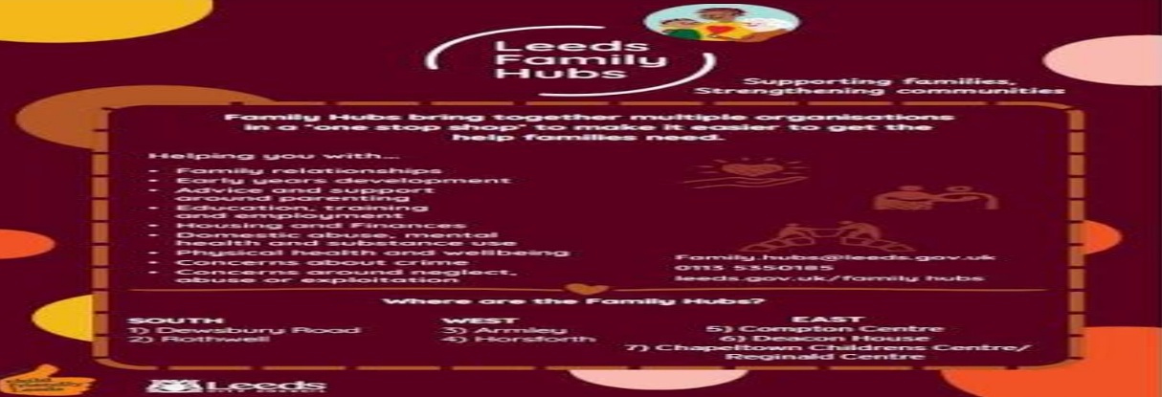
Figure 1. Leeds City Council Early Help and Family Information webpage (Leeds City Council, 2026)

A key advantage of the website is its straightforward explanation of Early Help, along with practical details on available services, referral processes, and family support. It caters to both professionals and families, fostering collaboration and assisting users in understanding how different organisations cooperate. The platform also includes information for children with special educational needs and disabilities (SEND), parenting assistance, and broader community services, all of which promote a comprehensive approach to family health and wellbeing.
Additionally, the website embodies the principles of multi-agency collaboration outlined in Working Together to Safeguard Children (Department for Education, 2026), directing families to vital health, education, and social care resources. From a healthcare standpoint, this integrated framework aids healthcare providers by clearly delineating referral pathways and available services, enabling sooner interventions and coordinated care.
Nonetheless, some information is scattered across linked pages, requiring users to navigate through several sections to find specific services. Families with limited digital literacy or lower reading levels might find it challenging to locate the information they need. While the website is extensive, incorporating clearer visual flowcharts or simplified step-by-step instructions could enhance accessibility for vulnerable families.

Assessment of the Tower Hamlets Council Website
Tower Hamlets Council offers Early Help as a preventive service for families from pregnancy up to a child’s 19th birthday, or 25 for young people with special educational needs and disabilities. The website effectively conveys the purpose of Early Help in clear, family-oriented language, making it easy for parents and caregivers to understand how and when to seek support. This aligns with national guidance that emphasizes the importance of accessible information and early intervention to prevent issues from worsening (Department for Education and Department for Levelling Up, Housing and Communities, 2022).

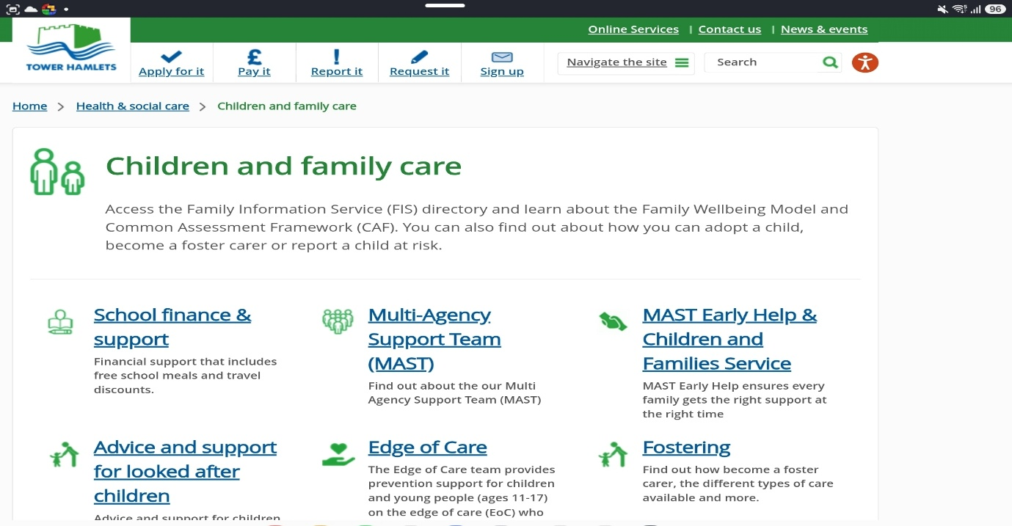
Figure 2. Tower Hamlets Council Early Help webpage (Tower Hamlets Council, 2026

As shown in Figure 2, Tower Hamlets Council prioritises integrated collaboration through its Multi-Agency Support Team (MAST) and Best Start Family Hubs. A notable advantage is how the website illustrates the contributions of professionals from various sectors including children’s services, health, education, policing, housing, probation, Child and Adolescent Mental Health Services (CAMHS), and the voluntary sector to a unified response. This aligns with the principles of Working Together to Safeguard Children (Department for Education, 2026), which highlights shared responsibility, effective information sharing, and collaboration among agencies.
Another important strength is the provision of clear referral pathways, contact details, and safeguarding resources, which facilitate early intervention by guiding families and professionals in accessing support before issues worsen. The Family Information Hub further enhances this strategy by consolidating information about Early Help, special educational needs and disabilities (SEND), and broader family support into a single online platform, minimising redundancy and improving the efficiency of information retrieval for families needing assistance from multiple services. (Tower Hamlets Council 2026).

Evaluation of Norfolk County Council Website
The Norfolk County Council website serves as a valuable and informative tool, effectively outlining the goals of the Early Help system and the available support for children, young people, and families. By adopting a strengths-based framework, the website emphasizes that Early Help is not an isolated service but rather a collective obligation of all professionals involved with families. This approach aligns with the principles in the Early Help System Guide, which advocates for a coordinated and holistic family strategy aimed at identifying needs early and delivering timely assistance before issues intensify (Department for Education and Department for Levelling Up, Housing and Communities, 2022).
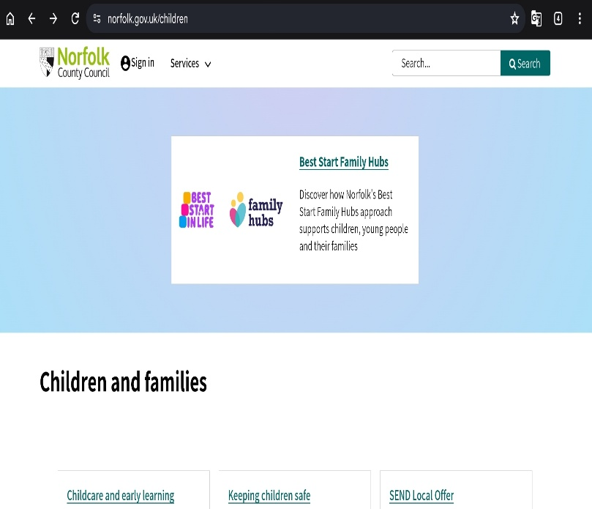
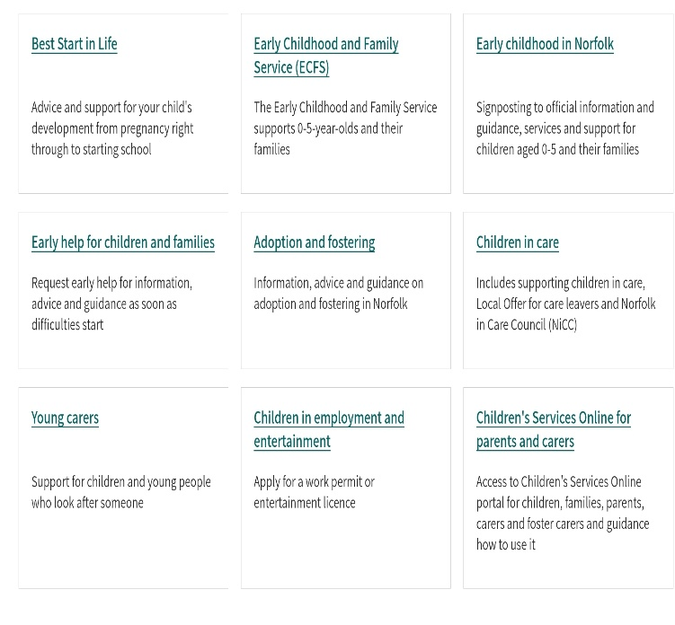

Figure 3. Norfolk Safeguarding Children Partnership Early Help webpage (Norfolk Safeguarding Children Partnership, 2026).

As shown in Figure 3, Norfolk offers comprehensive guidance on the Early Help Assessment and the Team Around the Family method, assisting both professionals and families in grasping the referral process. One of the website’s notable strengths is its clear description of the Early Help Assessment and the Team Around the Family methodology. It offers families and professionals thorough guidance on recognising concerns, formulating support plans, and enabling cooperation among various agencies to enhance outcomes. This approach is consistent with the Working Together to Safeguard Children framework (Department for Education, 2026), which underscores the significance of effective information sharing, partnership collaboration, and coordinated actions across safeguarding entities.

Comparative Analysis of the Strengths and Weaknesses of Three Local Authority Websites
Criteria | Leeds | Tower Hamlets | Norfolk
Easy to navigate | Good | Excellent | Good
Family-friendly language | Good | Excellent | Good
Referral information | Good | Excellent | Excellent
Family Hubs | Yes | Yes | Yes
Multi-agency explanation | Good | Excellent | Excellent
Healthcare information | Moderate | Good | Excellent
Accessibility | Good | Excellent | Good

Table 1: demonstrates that although all three local authorities provide comprehensive Early Help information, Tower Hamlets offers the most accessible website for families, while Norfolk provides the strongest professional guidance.

Table 2:
Advantages and Disadvantages
Council | Strengths | Weaknesses
Leeds | Good navigation, clear layout. | Some information spread across several pages.
Tower Hamlets | Family-friendly language, Family Hubs, MAST. | Large amount of information may overwhelm some users.
Norfolk | Excellent professional guidance, Team Around the Family. | Professional terminology may be difficult for parents.

Figure 4. Multi-agency approach within the Early Help System ( Department for Education, 2026).
Early Help

│
Families Professionals Community

│
Multi-agency Working

│
Health . Education. Police
Social Care. Voluntary Sector

│
Improved Outcomes

Figure 4: summarises the main strengths of each local authority website and demonstrates that Tower Hamlets provides the most accessible information for families, whereas Norfolk offers the most comprehensive professional guidance.

Critical Reflection
Although, all three councils adhere to statutory guidelines, there are differences in how accessible their information is. Families in crisis might find websites filled with complex professional language difficult to navigate. Enhancing digital accessibility, providing resources in multiple languages, and offering visual aids could help eliminate obstacles to utilising Early Help services.

Conclusion
This report has explored the Early Help System and its connection with strategic safeguarding partnerships, emphasizing the significance of early intervention and efficient collaboration among multiple agencies to enhance outcomes for children and families. An evaluation of the websites from Leeds City Council, Tower Hamlets Council, and Norfolk County Council revealed that all three authorities offer useful information about Early Help and family support services in accordance with national guidelines (Department for Education, 2026; Department for Education and Department for Levelling Up, Housing and Communities, 2022). Nonetheless, variations were noted in terms of accessibility, clarity, and organisation of the information. Tower Hamlets Council was identified as providing the most effective and user-friendly online resource, characterised by clear language, well-structured referral pathways, and an integrated Family Hub model, which simplifies the process for families seeking support. Leeds City Council presented a well-structured and easy-to-navigate website, while Norfolk County Council supplied the most comprehensive professional guidance.

Recommendations
This report presents several suggestions aimed at enhancing how local authorities share information about the Early Help system. First, local authority websites should adopt clearer, family-oriented language that minimises the use of professional jargon, making it more accessible for individuals with varying literacy and digital skills. Second, incorporating visual elements like flowcharts, infographics, and brief videos could aid families in comprehending the Early Help process, referral routes, and the support services available to them. Third, councils should continue to improve digital accessibility by offering resources in multiple languages, implementing features for individuals with disabilities, and ensuring that website designs are mobile friendly. Additionally, local authorities should frequently review and refresh website content to keep it accurate, up-to-date, and in conformity with statutory guidelines. Lastly, increasing the visibility of healthcare professionals, Family Hubs, and voluntary organisations on Early Help webpages would enhance multi-agency collaboration and motivate families to seek assistance sooner. (Department for Education, 2026; Department for Education and Department for Levelling Up, Housing and Communities, 2022).

Reference List
Children’s Commissioner (2024). Family Hubs and Early Help Services. London: Children’s Commissioner for England. Available at: https://www.childrenscommissioner.gov.uk (Accessed: 2 August 2026).
Department for Education (2026). Working Together to Safeguard Children 2026: A guide for collaborative efforts to support, protect, and enhance child welfare. London: Department for Education. Available at: https://www.gov.uk/government/publications/working-together-to-safeguard-children--2 (Accessed: 31 July 2026).
Department for Education and Department for Levelling Up, Housing and Communities (2022). Supporting Families: Early Help System Guide. London: HM Government. Available at: https://www.gov.uk/government/publications/supporting-families-early-help-system-guide (Accessed: 3 August 2026).
Early Intervention Foundation (2023). Early Intervention and Prevention. Available at: https://www.eif.org.uk (Accessed: 6 August 2026).
HM Government (2018). Information Sharing: Guidance for Practitioners Offering Safeguarding Services to Children, Young People, Parents, and Guardians. London: HM Government. Available at: https://www.gov.uk/government/publications/safeguarding-practitioners-information-sharing-advice (Accessed: 2 August 2026).
Leeds City Council (2026). Early Help and Family Information Services. Available at: https://familyinformation.leeds.gov.uk (Accessed: 8 August 2026).
Munro, E. (2019). The Munro Review of Child Protection: Final Report – A System Focused on the Child. London: Department for Education.
Norfolk Safeguarding Children Partnership (2026) Early Help. Available at: https://norfolklscp.org.uk/people-working-with-children/early-help (Accessed: 2 August 2026).
NHS England (2024). Safeguarding Children, Young People, and Vulnerable Adults in the NHS. Available at: https://www.england.nhs.uk (Accessed: 9 August 2026).
NICE (2023). Child Abuse and Neglect (NICE Guideline NG76). London: National Institute for Health and Care Excellence. Available at: https://www.nice.org.uk/guidance/ng76 (Accessed: 2 August 2026).
NSPCC (2025) Understanding Early Help. Available at: https://learning.nspcc.org.uk (Accessed: 10 August 2026).
Ofsted, Care Quality Commission, and His Majesty’s Inspectorate of Constabulary and Fire & Rescue Services (2023) The Multi-Agency Response to Families and Children in Need of Assistance. London: Ofsted. Available at: https://www.gov.uk/government/publications/the-multi-agency-response-to-children-and-families-who-need-help (Accessed: 2 August 2026).
Owens, R. And Lloyd, J. (2023). ‘Shifting from Behavioural to Ecological Approaches: Multi-Agency Responses to Extra-Familial Harm’, Journal of Social Work, 23(4), pp. 741–760. https://doi.org/10.1177/14680173231162553.
Shorrock, S., Parker, S., Addidle, G., Dimelow, M., Liddle, J., Martin, D., Proctor, T. And Olive, P. (2023). ‘Standardising Multi-Agency Safeguarding Hubs (MASH): Developing a Framework for Effective Risk Management’, Emerald Open Research. Available at: https://doi.org/10.35241/emeraldopenres.1114949.1.
Tower Hamlets Council (2026). Early Help. Available at: https://www.towerhamlets.gov.uk/lgnl/health__social_care/children_and_family_care/Early_Help/About_Early_Help.aspx (Accessed: 30 July 2026).
United Nations (1989). Convention on the Rights of the Child. New York: United Nations. Available at: https://www.ohchr.org/en/instruments-mechanisms/instruments/convention-rights-child (Accessed: 2 August 2026).
Wilson, K., Ruch, G., Lymbery, M., and Cooper, A. (2022) Social Work: An Introduction to Contemporary Practice. 3rd edn. Harlow: Pearson.

-

