MARK SPENCER
Workplace Culture and its impact onOrganisation EfficiencyBMSW5105
Student ID 192215
Mhammad faheem Danishmal
7-23-2021

What is hierarchical culture?

Hierarchical culture is the assortment of qualities, assumptions, and practices that guide and illuminate the activities regarding all colleagues. Consider it the assortment of characteristics that make your organization what it is. An incredible culture represents positive attributes that lead to further developed execution, while a broken organization culture brings out characteristics that can block even the best associations.

Try not to mistake culture for hierarchical objectives or a statement of purpose, albeit both can assist with characterizing it. Culture is made through reliable and real practices, not public statements, or strategy reports. You can watch organization culture in real life when you perceive how a CEO reacts to an emergency, how a group adjusts to new client requests, or how a supervisor amends a representative who commits an error.

The significance of culture to your organization

Authoritative culture influences all parts of your business, from reliability and tone to contract terms and worker benefits. At the point when work environment culture lines up with your representatives, they're bound to feel better, upheld, and esteemed. Organizations that focus on culture can likewise climate troublesome occasions and changes in the business climate and come out more grounded.

Culture is a key benefit with regards to drawing in ability and outflanking the opposition. 77% of laborers think about an organization's way of life prior to applying, and practically 50% of workers would leave their present place of employment for a lower-paying freedom at an association with a superior culture. The way of life of an association is additionally one of the top markers of representative fulfilment and one of the primary reasons that right around 66% (65%) of workers stay in their job

Definition

McKinsey 7s model

is a device that breaks down company's hierarchical plan by seeing 7 key inner components: methodology, structure, frameworks, shared qualities, style, staff and abilities, to distinguish in case they are adequately adjusted and permit association to accomplish its targets.

Understanding the instrument

McKinsey 7s model was created in 1980s by McKinsey experts Tom Peters, Robert Waterman and Julien Philips with an assistance from Richard Pascale and Anthony G. Athos. Since the presentation, the model has been broadly utilized by scholastics and specialists and stays perhaps the most well known vital arranging devices. It tried to introduce an accentuation on HR (Soft S), instead of the conventional large scale manufacturing effects of capital, framework and gear, as a key to higher authoritative execution. The objective of the model was to show how 7 components of the organization: Structure, Strategy, Skills, Staff, Style, Systems, and Shared qualities, can be adjusted together to accomplish viability in an organization. The central issue of the model is that every one of the seven regions are interconnected and an adjustment of one region requires change in the remainder of a firm for it to work viably.

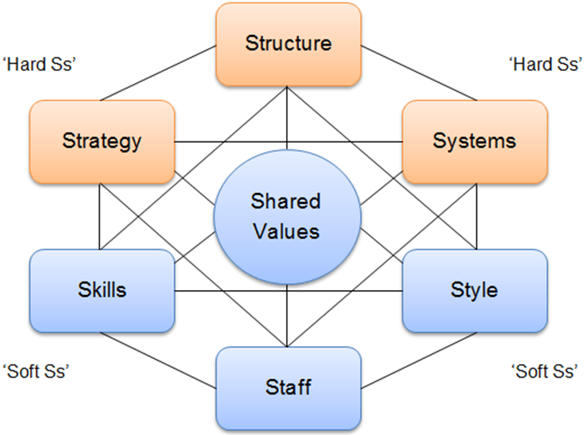
Beneath you can discover the McKinsey model, which addresses the associations between seven

