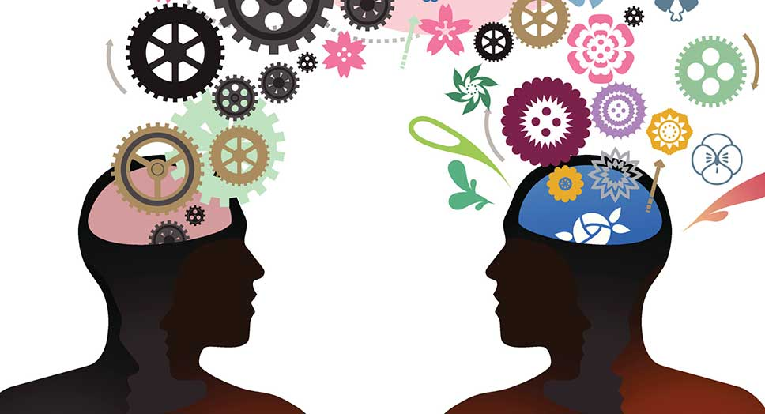  Developing Emotional intelligence skills for the workplace  BMSK6006 | Abstract  Emotional intelligence (EI), the capacity to perceive as well as control feelings in oneself amongst others, is a critical skill for healthcare professionals. This essay proposes an opportunity for St Margret’s Community (SMC) to introduce a staff development programme to nurses focussed on emotional intelligence and mindfulness to enhance work climate. Therefore, discussing the emergence of EI related with nursing and the development of EI, various conceptions of what comprises EI, significance of developing EI amongst nurse in SMC. Literature review findings showed that developing EI is essential to effectively communicating between staff and patients. In addition, demonstrating how nurses with high EI degree promote efficient hospital services. Three models of EI were analysed and the results indicated that the mixed model by Goleman would be best appropriate to apply within SMC. A critical appraisal of mindfulness was presented and found, without EI, mindfulness would not be effective and both EI and mindfulness are vital for the competitive edge of SMC.  Junior Richard (1605599)  Lecturer: Ze Zook

Table of Contents
Introduction 2
St Margaret’s community hospital (SMC) 2
Emotional intelligence 2
Significance of EI 5
EI link to effective communication and business advantage 6
EI models 9
Four-Branch Model 9
Bar-on Model 10
Goleman’s Mixed Model 10
Mindfulness 11
The significance of self-care 12
Mindfulness training in SMC 13
The potential of mindfulness & EI 13
Conclusion 14
References 14

Introduction
Emotion is central to healthcare practice (Smith, et al., 2009; Clancy, 2014). As professional healthcare staff, nurses establish and sustain relationships in emotionally volatile settings whereby feelings are fundamental to the framework of healthcare provision. Medical judgments, implicitly guided by ethical conduct as well as codes of conduct, arise in evolving and unpredictable settings. Emotions have an adverse effect on working relationships, influence patient outcomes and have an impact on healthcare professionals at intra-personal level. Throughout fields of study, there has been powerful recognition which understands the impact of emotion as crucial (Mark, 2005). In short, nurse leaders that can constructively utilize their emotions and understanding of them would have some benefits over those who could not. The aim of this essay is to advocate for a staff development programme within St Margret’s Community (SMC) focussed on EI and mindfulness. Therefore, this essay will demonstrate an understanding along with discussing the importance of EI within SMC, as well as the correlation among EI, effective communication and business advantage. In addition, objectively analyse EI models that can be applied to SMC along with an interpretation of the degree to which they are suitable for meeting the development needs of nursing leaders within SMC. Finally, critically assess the significance of EI and mindfulness to SMC and how developing EI may enable SMC to gain a competitive edge.

St Margaret’s community hospital (SMC)
SMC delivers aid and health care to both children and adults in Essex, England. SMC homes roughly 200 employees in various departments (Essex Partnership University NHS Foundation Trust, 2019). SMC is one of 200 sites that EPUT (NHS trust) own however was managed by The Princess Alexandra Hospital NHS Trust (PAH). EPUT’s vision is to enhance individuals lives accompanied openness, empowerment and compassion (EPUT’s values) (Essex Partnership University NHS Foundation Trust, 2019). This essay will discuss the poor workplace environment which has been previously identified through change. A Friends and Family Test (Staff – Work) was conducted by the NHS (PAH) were 660 responses out of 3454 members of which saw SMC being recommended as a place of work by 65% of employees and 78% recommend SMC for care (National Health Service, 2014). This essay will discuss the authors role as a nurse within SMC where the nurse is assumed a management role compared to healthcare assistants. Numerous nurses have demonstrated that burnout, job satisfaction and bullying are underlying issues that apply to SMC’s workplace.

Emotional intelligence
Being an effective nurse frequently defined as an ability to experience, use, communicate, recognise, recall, interpret, identify, learn, control, understand, as well as describe emotions (Salovey & Mayer, 1990). Lately, EI is recognised as an essential component of an effective leader (Vitello-Cicciu, 2002). It is also described as the ability for a nurse to comprehend one's own emotions and that of others, to motivate oneself as well as to control one's feelings well within oneself and others (Taft, 2013). This section will discuss EI and its components and then demonstrate the importance of EI to reduce workplace stressors within SMC and the relationship between EI, effective communication and business advantage.
In its roots, in the '70s and '80s, psychologists Howard Gardner, Peter Salovey and John Mayer founded the theory of EI. In the fields of leadership and management and organisational growth, the concept of EI has become increasingly important. Its concepts include a modern approach of understanding and analysing the actions, leadership styles, behaviours, interpersonal abilities and ability of individuals. EI plays a significant role throughout management problems affecting human capital such as human resources preparation, SMC’s culture, job evaluation, recruiting and selecting, management, patient experience, support and much more (Sinha & Sinha, 2015).
EI encompasses attributes that are distinguished from, yet comparable to, intellect or solely cognitive ability determined by an intelligent quotient. Emotional competencies (see Fig 1) were described as taught abilities based on EI which contributes to effective performance within the ward (Côté, et al., 2010). Through comprehensive research conducted by Goleman and others, emotional competence was observed to be multiple times as critical as intelligence quotient and technical ability coupled in the development of excellent administrative work. Nursing literature indicates broad support for EI as fundamental to SMC's nursing practice (Smith, et al., 2009).
Effectiveness requires more than IQ, which was often regarded as conventional measure of understanding and which overlooked basic elements of behaviour and personality. EI can be viewed as a comprehensive approach which integrates a wide array of individual capabilities and skills typically called soft skills or interpersonal abilities that go beyond conventional general intelligence and technological or professional capabilities (Ravi, 2001). In the era of information, one’s ability to evaluate and interpret their own feelings and emotions to distinguish between them and use this knowledge to guide their own as well as other's behaviour is vital. Emotions are a way to express deep emotions, beliefs, ideas, and so on. -The term may be verbal or non-verbal. Effectiveness depends upon whether the receiver can capture the same emotions in the appropriate way. Instead, it is also possible to deduce whether emotions have a drastic effect on the communication and distribution of the message, and here the role of EI is played (Sinha & Sinha, 2015).
Goleman categorized four aspects: self-awareness, self-management, social awareness and relationship management (see Fig1). For every aspect, the nurse's capacity to control oneself or others is dependent on both the awareness of oneself as well as others (Taft, 2013). Also, in figure 1 illustrates all competencies which are regarded as essential for leadership success, however, five of them are key competencies to which the others rely on. Key competencies include emotional self-awareness, accurate self-assessment and self-confidence, emotional self-control, and empathy to work with others efficiently. Leadership will not be effectively exercised without such key competencies. For instance, for a nurse to exercise emotional self-control, they must become aware by keeping in touch with their one’s feelings. Emotional self-control is critical for teamwork, team building or conflict management (McCallin & Bamford, 2007). Empathy is needed to constructively improve others, understand SMC's strategy or adapt quickly to the needs of staff and patients.

Figure 1: EI Framework & emotional competences
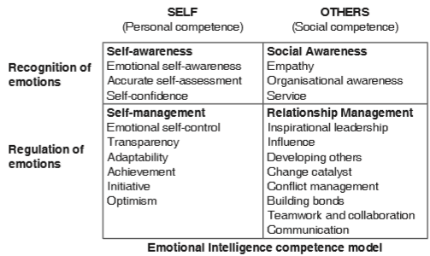
Source: (McShane & Von Glinow, 2004)
Self-awareness could be deemed an internal predictor, or perhaps a propeller, the nurse ought to recognise as well as direct the variability of moment-to-moment and situation-to-situation in feelings (Taft, 2013). Nurses and human beings in general are emotional species, continuously adapting to internally and externally stimulation. Such sensations could trigger emotions which are good or bad, inspirational or depressing, challenging or satisfying, thrilling or dull, and so forth. An emotionally intelligent nurse recognises emotions as they arise, communicates them effectively, and have the self-confidence to continue behaving within their meaning and irrespective their feelings (Taft, 2013).
Self-management improves nurse's EI through enabling one's self-control of feelings, preserving one's dignity, as well as adjusting to changing conditions. Nurses within SMC are low in self-awareness or emotional self-management, or perhaps both, as they can "blur" reactions during social settings, exhibit rigidity or fragility whenever confronted with differing opinions, become resistant towards criticism, behave contradictory to their shared values, or express vulnerability around colleagues (Taft, 2013). Emotionally intelligent relationships with other colleagues rely and develop on the nurse's strengths in self-awareness as well as self-management. Without some kind of strong foundation of self-understanding, self-control, emotional stability, trustworthiness, including the ability to adapt, it is extremely difficult to be open to colleagues and effective in professional relationships. Effective leaders should truly understand themselves and be able to determine how to react during stressful situations. Such attributes provide the basis for employees in SMC to working successfully with each other (Taft, 2013).
Effective relationships with team members and patients are demonstrated by social awareness and relationship management. These characteristics are called "social radar "— the ability to understand and function productively with others. Social awareness is specifically focused on the ability to be empathetic: to sense emotions, desires as well as concerns of others and to actively participate with them (Taft, 2013). Social awareness within SMC wards would refer to both the willingness to use strong political skills and positive, moral service orientation towards staff or patients. In order to show political shrewdness at work as well as to support vulnerable staff members and patients, the nurse should draw on their sympathy towards others, either people or groups (Taft, 2013).
Relationship management encompasses fields often mentioned in the leadership articles, books and journals. These are the most easily acquired emotional competencies, either through research, reading, and practice, or by leadership training programmes. Relationship management involves competencies in encouraging and shaping others, visioning, developing others, collaborating through working together, leading change projects, as well as conflict management. Efficient utilisation of working relationship management includes leadership in SMC that develops individual, community and organisational commitment towards potential achievements (Taft, 2013).

Significance of EI
The theory of EI includes inputs from various other fields, including Neuro-Linguistic programming (NLP), Transactional Analysis, and empathy, for example, in behaviour, cognitive and behavioural theories, e.g. Nurses not only become more competitive and effective by increasing their EI; they enable others to be efficient and productive. EI growth process and findings provide several components that are proven to alleviate personal and interpersonal tension by mitigating conflict, creating positive relationships and awareness, improving cohesion, consistency and unity then which in turn reduce workplace bullying experienced by some nurses within SMC (Sinha & Sinha, 2015).
Nurses with high EI result in higher nurse retention levels, greater quality of care, optimal workplace performance, and those that are emotionally intelligent appear to frequently demonstrate the positive behaviours demanded of healthcare professionals (Clancy, 2014). The role modelling, however, is not merely to show positive behaviours to colleagues while communicating with patients; it includes doing so irrespective of whether encounters is with patients, employees, doctors or colleagues (Clancy, 2014). To patient satisfaction, EI is an essential factor. In research work conducted by academics on the relationship between nurses' EI and patient satisfaction, demonstrated that, as level of EI increases in nurses, there is a significant rise in patient outcomes. Patient satisfaction is thus impacted by the level of EI of healthcare professionals (Oyur, 2017).
EI is the secret to successful patient outcomes (Clancy, 2014). In a new research Bramley & Matiti (2014), patients were questioned regarding their experiences concerning nursing compassion. Even though it was understood how overwhelmed nurses were, indeed, the slightest expressions of compassion are crucial of how they viewed the general nursing care, whereas Codler et al (2011) indicated the beneficial effect of peers coaching on EI amid intense organisational stress. In fact, Bennett and Sawatzky (2013) determined preparation and awareness for new nurse leaders can eliminate ‘horizontal workplace’ abuse as these leaders have the skills and expertise required to tackle offensive actions early, before feelings and consequences intensify (Clancy, 2014).
Nurses that develop EI can become skilled in self-awareness, self-regulation, social awareness, motivation, empathy as well as social skills. Some measures, measure EI which can offer valuable insights. The following are important for developing EI: emotional awareness, learning, practice, engagement and acknowledgement of input by others (Clancy, 2014). Effective leadership starts with nurses in SMC that are empowered yet self-aware. They should strive to develop, assume responsibility and hold themselves accountable. Nurses can recognise abilities and their potential for development through development in understanding of EI. Through practising such skills, nurses promote teamwork, foster enthusiasm amongst themselves and their colleagues, and effectively enhance the nursing profession with SMC (Clancy, 2014). Also, emotionally intelligent nurses provide more professional services that deliver far beyond patient expectations with regard to quality of care which in turn contribute to patient satisfaction, guarantee transactions and positively impact customer behaviour (Ranjbar Ezzatabadi, et al., 2012).

EI link to effective communication and business advantage
Communication, by itself, is unrelated to verbs, phrases, paragraphs and the entire spectrum of language resources and devices. At its purest nature, the components of one nervous system are transferred to another. Effective communication occurs as this parallelization happens in the most unimpeded possible way (Sinha & Sinha, 2015). Effective communication is quite generally and incorrectly thought to be a condition where there is no correlation among encoding and decoding a message. Effective communication seems to be the coupling of relational gap which does, and generally does, occur between the two parties to the communication. This requires that every member of the communication process to have a higher degree of EI. EI would be the foundation for any effective communication to occur within SMC (Sinha & Sinha, 2015).
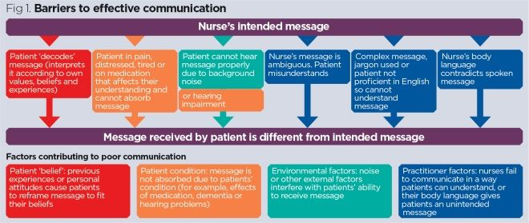
Figure 2: illustration of common variables that may have a negative impact on communication

Source: (Ali, 2017)
Communication is regarded as SMC's 'life-blood' (Sinha & Sinha, 2015). Messages can be transmitted from one end to the other unless the communication channels are open, clear and unimpeded. They are therefore perceived and responded to. Effective communication minimises tensions, improves efficiency which allows clinical practise overall to operate efficiently, in turn proving SMC with business advantage. Furthermore, it safeguards patients against possible misunderstandings and can have beneficial impact on nurses (Ali, 2017). However, if there are communication barriers or there are no communication capabilities among nurses, their capacity to work as a team is seriously impaired (see Fig2). It is estimated to cost the NHS £1bn per year, due to poor communication as it leads to poor medical regimes, disputes and litigations (McDonald, 2016). In this case, SMC would be expected to fail and thus indicating a correlation between communication and business advantage (Sinha & Sinha, 2015). The 7 Cs of effective communication shall be described as completeness, conciseness, consideration, clarity, correctness, courtesy and credibility. The inclusion or omission of such components will make a significant difference in the significance and relevance of the message. Clarity is the most significant among them, too. The bulk of communications come under one of the aforementioned groups with various degrees of openness (Sinha & Sinha, 2015)(see Fig3).
Figure 3: Communication categories varying in degree of clarity
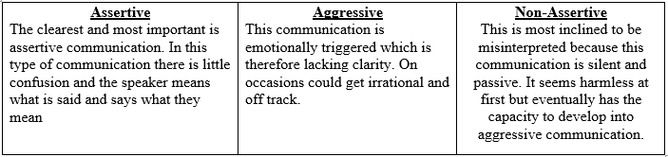
Source: adapted from (Sinha & Sinha, 2015)
Ineffective communication is therefore unproductive as well as preventable. Yet even the most terrible circumstances can be improved if there is a desire. The management of SMC should address the problems and devise plans, with a view to facilitating effective communication. Communication is not a one-way process; it must be understood. Feedback on the message received is the source of communication, then again (Sinha & Sinha, 2015).
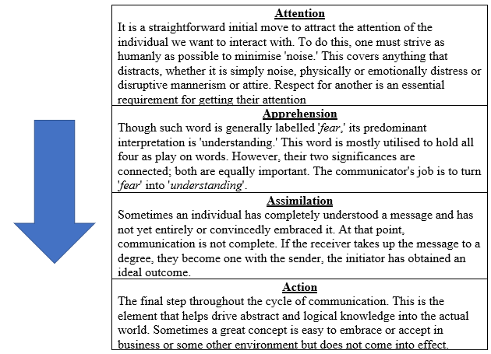
Figure 4: The four steps in effective communication

Source: adapted from (Sinha & Sinha, 2015)

There has been an increase in EI witnessed when an individual dedicates oneself to developing practical skills throughout daily circumstances. Empathy throughout interactions at SMC is vital and it signifies EI’s presence. Empathy is among the key skills which lead to one's success. Beginning with self-awareness. The concept is that a full understanding of one's own thoughts is a critical substratum for the germination of understanding the emotions of others (Sinha & Sinha, 2015).
Having no empathy is the main culprit of interpersonal problems that contribute to the instability of communication. Nurses in SMC do not see empathy as a competence, so resist learning it or being educated in it. Empathy is known to be a trait correlated with disadvantaged personality, not something hard-driving individuals would have. Traditionally, others also assume that the blind use of logical forces is just a path to prosperity, yet they are left questioning why they are not effective.
Empathy includes being attentive to colleagues, such as listening, communicating, supporting others and establishing relationships. Armies could be built with the help of empathic skills. It builds shared interest and cohesion, creating relationships which in turn will reduce workplace stress within SMC. When an individual is admired within SMC, they can inspire others to go the extra mile. Empathy needs to be balanced with focus and management becomes much more effective when it is balanced.
Both nurse and healthcare staff require empathy in order to properly manage patients, employees, suppliers and the general public. The nurse would need that more as they have to delegate duties and assignments to employees who do not enjoy it; one has to be respectful of the individuals around them; one has to deal with conflicts; provide negative news as and when required, such as lay-offs and cuts, etc. One is ought to learn to empathise with the negativity that might occur thereafter. In the middle of all this, one must not lose concentration and get back into work on the priorities and objectives set. Managers and executives with a high degree of empathic abilities can pick up emotional signals. Not only can they recognise certain emotions, but they are also able to know the origins (Sinha & Sinha, 2015).

EI models
EI models exist, nevertheless, there is three main theories as well as meanings have emerged from the literature review. Salvoy and Mayer (1990) characterised EI, as academic intelligence, as a skill that could be taught, as well as takes place when a person can recognise, evaluate, and express feelings. Thus, ability-based model sees emotions as a valuable source of information that allows us to function in a social context. Goleman (1995) described EI as a collection of skills and personal competencies, of which show aspects of motivation, self-awareness, self-regulation, empathy and achievement in interpersonal relationships. Bar-On (2005) establishes EI to be like an array of personality traits and abilities. Emotional social intelligence is a collection of emotional and social skills that allow people to express themselves and understand others.

Four-Branch Model
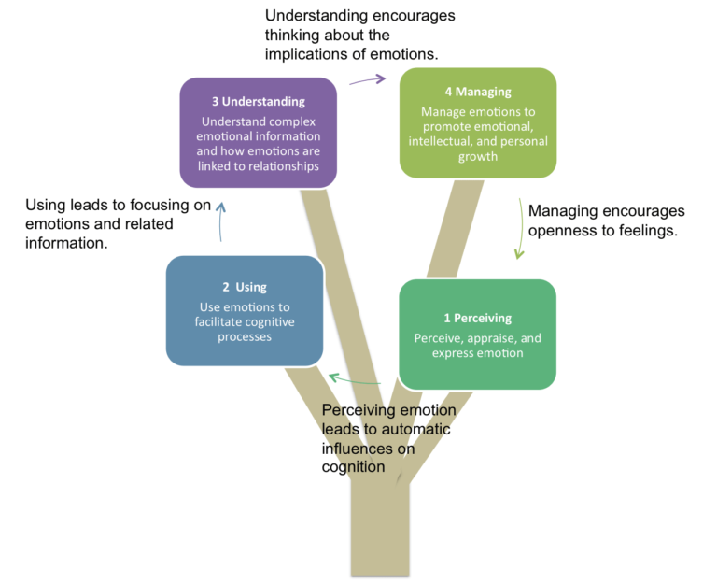
Figure 5: illustration of Mayer and Salovey’s (1997) model
Source: (Velisavljevic & Lily, 2008)
Number one branch, emotional perception, is the capacity to be self-conscious of feelings and to express feelings as well as emotional desires specifically to others. Emotional perception often requires the capacity to differentiate between truthful and deceptive manifestations of feeling. Branch number two, emotional assimilation is the capacity to differentiate between various emotions, such as thoughts and recognise those that affect their cognitive processes. Branch number three, emotional understanding is the capacity to grasp complicated feelings (such as experiencing two feelings simultaneously) as well as the ability to distinguish changes from one to another.

Bar-on Model
Figure 6: Bar-on model
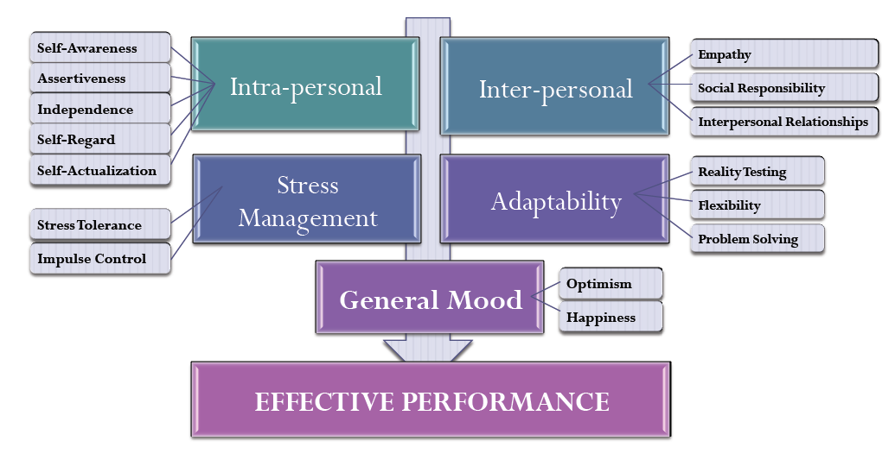
Source: (DocPlayer, 2017)
Bar-on revealed that individuals with greater than normal emotional quotient are usually more successful in addressing sustainability demands and stresses and lack of EI may contribute to a loss of performance and emotional issues. Bar-On believes that EI and cognitive intelligence relate similarly to the general intelligence of a nurse, which then gives an indicator of one's ability to achieve in life (Bar-On, 2002). Bar-On model identifies five dimensions of EI: intra-personal, interpersonal, adaptability, stress management, and general mood. These elements have sub-components, as shown in Fig6.

Goleman’s Mixed Model
Fig.1 demonstrates Goleman's analytical definition of EI and related emotional competencies. Structure and competencies come into one of four classifications: identification of emotions in oneself or in others, and control of emotions in oneself or in others. Four elements of the model were discussed previously: Self-awareness, self-management, social awareness and relationship management. This model is defined as being ideal for use within the SMC in order to meet the nurse's development needs.
Development of self-awareness is the cornerstone to adequately determining the nurse's self-personal strengths and weaknesses. In order to manage distressing factors such as fear and frustration, the nurse develops emotional self-management competence and can counteract the impulsion of the mood. In addition, the development and learning of internal and external power relations within SMC requires organisational awareness competence. Therefore, developing this competence will help one to recognise real decision-makers and influential individuals.
Good social skills and empathetic communication are important to any nursing practise that requires teamwork. Developing relationship building capabilities that have the most obvious effect on relationships with other individuals. In a profound way, the success the nurse's communication skills depend on one's ability to control or manipulate the feelings of another. In order to alleviate tension in the workforce due to lack of skills 'developing other' competence is important to consider other cognitive needs of others in SMC and to help improve their abilities.
While this capacity is invaluable to the nurse, it is identified as a significant capacity for efficient, high-level leadership. Developing inspirational leadership skills, therefore, entails a willingness to direct others. Developing this expertise would allow the nurse to express and encourage passion for a common vision and purpose, to step forward when required, to direct the success of others while keeping them accountable, and to show leadership. Influencing is the power to persuade, convince someone in order to gain approval on a specific agenda (workplace stress) or courses of action (staff development). In order to affect corporate culture positively, it was thus important to the nurse to establish this competence. Developing conflict resolution skills allows the nurse to deal diplomatically and tactfully with challenging people, parties, or tense circumstances. This competency enables the nurse to find the best solution to a given task or conflict.

Mindfulness
Mindfulness has become a commonly acknowledged benefit towards healthcare staff, along with compassion. EI involves clear coordination between the objective cognitive portion of the brain and the emotional portion of the brain, located inside the limbic system in the amygdala. Mindfulness bridges both brain structures and regularly applying such skills produces new neuronal networks which are greater and effective over time (Mager, 2019). This essay examines the definitions of mindfulness as well as compassion and their beneficial impact on patients and particularly staff. This section intends to critically appraise mindfulness and emotional intelligence along with demonstrating how they could enable SMC to gain a competitive advantage.
It is quite popular to find the terms ‘mindfulness’ and "compassion" throughout healthcare and personal growth; however, it is not entirely evident what they imply with these separate domains. SMC's requirement for nurses to be mindful as well as compassionate is asserted in research and policies, and yet hardly ever is there any debate of the significance of self-care in nurses or of how this is accomplished (Brass, 2016). Mindfulness has been described as a more inclusive 'mind-body' approach which supports individuals such as a nurse in SMC in changing their mindset and feeling, particularly stressful situations within the ward. It means that the nurse concentrates on their thoughts and emotions, so that they become fully aware of them, become less involved, and can handle them better (Haliwell, 2010). In brief, mindfulness means actively listening to one's experience (i.e. emotions, perceptions, feelings, or environments) with interest and empathy. Too frequently, nurses in SMC are on autopilot, strongly identifying with perceptions or emotions, responding irrationally to incidents, thus creating more problems by struggling with or denying one's experience (Brass, 2016).
“Paying attention in a particular way, on purpose, in the present moment and non-judgementally” is the operational definition of mindfulness (Kabat-Zinn, 1994). The nurse who pays attention 'on purpose' requires deliberate awareness to experience. For instance, several minutes of centred concentration on breathing stimuli could have a relaxing as well as rejuvenating impact on a demanding day within SMC. Paying attention 'at present moment' may provide a respite from rumination over problems or causes of concern over previous or upcoming events, while watching 'non-judgmentally' provides room to re-evaluate experience, pause before heading down well-worn paths of perception or response, and build room for new choices (Brass, 2016).
Whilst traditional eastern meditation has contributed to rituals of mindfulness, they have been implemented more and more in healthcare over the past 40 years. Kabat Zinn and his colleagues began their work at the University of Massachusetts Medical School in the 1970s. Compassion requires becoming open to, even affected by, the pain of others such as staff members, so that one wishes to relieve one emotional distress. This also includes giving empathy, patience and non-judgmental understanding to others, acknowledging that all team members are flawed, and make errors (Neff, 2003; Brass, 2016).
Even though compassionate care would not be a measurable ability or technique, compassion is essential for nursing in SMC. As SMC affects the lives of individuals in contexts of compassion and caring (NHS, 2015), compassion for nurses in SMC is a mandatory component of the job role: The code of conduct of the Nursing and Midwifery Council (2015) emphasises the need for one to treat individuals kindly, respectfully and compassionately. However, the perceived lack of compassion in nursing has become a source of widespread outcry and news headlines in recent years. The report from the Ombudsman of the Parliamentary and Health Services Agency (2011), on the care of the elderly revealed a cynical disposition on the part of staff and a strong disregard to deplorable quality of care, whereas Francis' (2013) study, on the provision of treatment at the Mid Staffordshire Foundation Trust described the lack of compassion, empathy, dignity and leadership that contributed to a scenario whereby basic expectations were not met.
Health care cannot always be easy to be sensitive and caring. The Royal College of Nursing (2013) says that the rapid change, under-employment and relentless competition erode the compassion and empathy of the staff, thereby causing decent people to be doing bad things. It has been confirmed that it is critical for nurses, teams and other medical personnel to be well cared for and to feel comfortable and to be enabled to serve and care for patients. Several factors can impede compassion and mindfulness in nursing, for instance; Time is lacking; consistency may not be an organisational goal; compassion can keep nurses accessible to exploitation; SMC are always waiting for nurses to keep busy, and the thought of hallowing and being calm is challenge(contemplation is unfriendly to nursing and can make certain people feel bad(Neff, 2003).

The significance of self-care
Compassion and mindfulness are interwoven, knowledge decreases self-judgement, allows one the ability to reduce negative emotional perceptions and make it easier seeing kindness than judgement. Greater self-compassion contributes to lowered depression and anxiety, and positive mental health (Neff, 2003). Self-compassion revealed itself to be tightly connected to well-being: following a mindfulness training, individuals appear to be:
- Less self-confident in circumstances of suffering or loss they accept themselves rather than being hard-hit
- Sympathetic by themselves
- Less lonely (their problems are more likely than not to be considered part of a broader human condition) (Neff, 2003)

Mindfulness training in SMC
It was reported nurses who integrated mindfulness into their daily life are more inclined to feel less stressed about work and that nurse-based stress reduction (MBSR) programmes strengthened their work by increasing the involvement of nurses. This, in effect, can improve SMC's patient treatment by increased quality and safety (Penque, 2009). Mindfulness preparation helps us to develop a "mental muscle" just as we would improve our physical muscles by exercise. Mindfulness is such an inherent human ability, and by learning it, we accumulate our mind's ability to adapt to stress and suffering within SMC. Since nurses are the largest group of caregivers in healthcare settings, it is important to understand that the idea of mindfulness enriches their work and their capacity to deliver quality care (Cullen, 2014).

The potential of mindfulness & EI
While the relief of suffering is a major goal for much of the population, it is especially important in healthcare. SMC employees work for this reason and are in regular communication with the suffering, whilst they struggle with their own health and wellbeing while caring for others (White, 2014).
American nurses and MBSR study indicated the importance for employees in SMC to learn self-compassion in order to defend themselves against adverse, traumatic experiences within the SMC as well as the vigorous work that goes on in the medical environment with patients and their family and friends. Nursing staff that nurture the virtues of empathy, self-compassion, peacefulness and mindfulness, lead to positive patient outcomes as well as competence in nursing practice, contributing to increased rates of patient satisfaction and improved healthcare (Penque, 2009).
For SMC as an organisation, nurses and healthcare assistants are constantly struggling to cope with a hospital setting that is pressurised, frequently, information overwhelmed yet full of disruption, and this capacity to manage one's focus and perception in an organised manner is vital to optimum individual efficiency as well as a core factor of team and organisational effectiveness (Stynes, 2017).
Furthermore, SMC’s culture is incredibly significant to the organisation's performance. It can be said the nature of SMC's culture can be simply recognised by the nature of the organisation's interactions. The attributes which need to be learned in order to build a culture of high quality is the capacity to listen, the ability to be truly attentive, to be curious and to ask relevant questions. These are the attributes that practicing mindfulness enhances. Given the complexities of the SMC's workplace, nurses and healthcare assistants are continually realising that it will no longer be about getting all the solutions, but more about trying to collaborate with and help others so that the best solutions and outcomes emerge from and through the team (Stynes, 2017).
Hospitals recently are becoming progressively conscious of the value of discovering validated and efficient ways to improve nurse’s performance. Although physical well-being is an significant factor of this in the past few years, with emphasis up until now predominantly on fitness and diet, next step is having individuals, and leaders in particular, concentrate on mental performance, by training attention management, EI and communication. Such are the key drivers of success in the 21st century, and mindfulness is at the heart of this (Stynes, 2017).

Conclusion
To summarise this essay discussed the negativity within SMC workplace, in order to reduce the burnout, job dissatisfaction and bullying employees are experiencing, this essay discussed EI, and how beneficial it is for one to work within SMC. The essay also looked at the how EI can benefit SMC and help the organisation gain business advantage. Through developing EI, it was found that it enables effective communication which then in turn impacts the organisations success. Furthermore, a critical analysis of the models of EI was conducted and Goleman’s mixed model was found to be suitable for the individuals needs within SMC. EI, mindfulness and compassion are useful in assisting each person cope with everyday stresses but can be more helpful in healthcare where there is massive pressure and the capacity to provide compassionate care is crucial. Healthcare professionals' workshops have proved valuable and to be considered for health-care staff in SMC.

References
Ali, M., 2017. Communication skills 1: benefits of effective communication for patients. Nursing Times, 113(12), pp. 18-19.
Bar-On, R., 1996. The Emotional Quotient Inventory (EQ-i): a test of emotional intelligence. Toronto: Multi-Health Systems.
Bennet, K. & V, S. J., 2013. Building emotional intelligence: a strategy for emerging nurse leaders to reduce workplace bullying. Nursing Administration Quaterly, 37(2), p. 144–151.
Bone, D., 2002. Dilemmas of emotion work in nursing under market-driven health care. The International Journal of Public Sector Management, 15(2), pp. 140-150.
Bramley, L. & Matiti, M., 2014. How does it really feel to be in my shoes? Patients' experiences of compassion within nursing care and their perception of developing compassionate nurses. Journal of Clinical Nursing, 23(19-20), p. 2790–2799.
Brass, E., 2016. How mindfulness can benefit nursing practice. Nursing Times, 112(18), pp. 21-23.
Brunton, M., 2005. Emotion in health care: the cost of caring. Journal of Health Organization & Management, Volume 19, pp. 340-357.
Clancy, C., 2014. The importance of emotional intelligence. Nursing Management, 21(8), p. 15.
Clancy, C., 2014. The importance of emotional intelligence. Nursing Management, 21(8), p. 15.
Codier, E., Kamikawa, C. & Kooker, B., 2011. The Impact of Emotional Intelligence Development on Nurse Managers. Nursing Administration Quarterly, 35(3), p. 270–276.
Côté, S., Lopes, P. N., Salovey, P. & Miners, C. T. H., 2010. Emotional intelligence and leadership emergence in small groups. The Leadership Quarterly, 21(3), p. 496–508.
Cullen, G., 2014. Realistic Evaluation of a Pilot Programme offering Mindful Compassion Training to Nurses, s.l.: s.n.
Department of Health, 2011. Compassion in Practice: Nursing, Midwifery and Care Staff – Our Vision and Strategy, s.l.: s.n.
DocPlayer, 2017. DocPlayer. [Online]
Available at: https://docplayer.net/27232550-Chapter-2-emotional-intelligence-an-overview.html
[Accessed 1 April 2020].
Essex Partnership University NHS Foundation Trust, 2019. Essex Partnership University NHS Foundation Trust. [Online]
Available at: https://eput.nhs.uk/our-services/essex/west-essex-community-health-services/adults/community-hospitals/inpatients-ward-st-margarets-hospital/
[Accessed 19 July 2019].
Francis, R., 2013. Report of the Mid Staffordshire NHS Foundation Trust Public, s.l.: s.n.
George, J. M., 2000. Emotions and Leadership: the role of emotional intelligence. Human Relations, 53(8), pp. 1022-1055.
Goleman, D., 1995. Emotional Intelligence. New York: Bantam.
Goleman, D., 1995. Emotional intelligence: why it can matter more than IQ. London: Bloomsbury.
Haliwell, E., 2010. MINDFULNESS.., s.l.: s.n.
Kabat-Zinn, J., 1994. Wherever You Go, There You Are. New York: Hachette Books.
Mager, D., 2019. Mindfulness and Emotional Intelligence, s.l.: s.n.
Mann, S., 2005. A health-care model of emotional labour. Journal of Organization and Management, Volume 19, pp. 304-317.
Mark, A., 2005. Organizing emotions in health care. Journal of Health Organization and Management, Volume 19, pp. 277-289.
Mayer, J. D., Carsuo, D. R. & Salovey, P., 2000. Models of Emotional Intelligence Handbook of Intelligence. Cambridge: Cambridge University Press.
McCallin, A. & Bamford, A., 2007. Interdisciplinary teamwirk: Is the Influence of emotional intelligence fully appreciated?. Journal of Nursing Management, Volume 15, pp. 386-391.
McDonald, A., 2016. The long and winding road: Improving communication with patietns in the NHS, s.l.: s.n.
McShane, S. & Von Glinow, M. A., 2004. Organizational Behavior. 3rd ed. Blacklick: McGraw-Hill Irwin.
Midwives, Nursing and Midwifery Council, 2015. The Code: Professional Standards of Practice and Behaviour for Nurses and Midwives, s.l.: s.n.
Moss, M. T., 2005. The emotionally intelligent nurse leader. 1st ed. San Francisco: Jossey-Bass .
National Health Service, 2014. National Health Service. [Online]
Available at: https://www.nhs.uk/Services/hospitals/overview/DefaultView.aspx?id=105920
[Accessed 1 April 2020].
Neff, K. D., 2003. The development and validation of a scale to measure self-compassion. Self and Identity, Volume 2, pp. 223-250.
NHS, 2015. The NHS Constitution, s.l.: s.n.
Obholzer, A., 2005. The impact of setting and agency. Journal of Health Organization and Management, Volume 19, pp. 297-303.
Oyur, C. G., 2017. The relationship between patient satisfaction and emotional intelligence skills of nurses working insurgical clinics. Patient Prefer Adherence, Volume 11, p. 1363—1368.
Penque, S., 2009. Mindfulness based stress reduction effects on registered nurses, s.l.: University of Minnesota Digital Conservancy.
Ranjbar Ezzatabadi, M. et al., 2012. Nurses' emotional intelligence impact on the quality of hospital services. Iranian Red Crescent medical journal, 14(12), p. 758–763.
Ravi, D., 2001. Emotional Intelligent- A Sine Qua Non of Leadership. The Journal of Indian Management & Strategy, 6(4), pp. 39-43.
Royal College of Nursing, 2013. Mid Staffordshire NHS Foundation Trust Public Inquiry Report: Response of the Royal College of Nursing, s.l.: s.n.
Salovey, P. & Mayer, J., 1990. Emotional Intelligence. Imagination, Cognation & Personality, Volume 9, pp. 185-211.
Sinha, D. & Sinha, S., 2015. The Relational Dynamics of Emotional Intelligence and Effective Communication. In: P. Verma, ed. Effective Communication, Managemnent & Organizational Growth. New Delhi: Variety Books Publishers’ Distributors, pp. 1-18.
Smith, K. B., Profetto-McGrath, J. & Cummings, G. G., 2009. Emotional intelligence and nursing: An integrative literature review. International journal of nursing studies, 46(12), pp. 1624-1636.
Stynes, S., 2017. How Mindfulness is Creating Better Organisations. [Online]
Available at: https://www.linkedin.com/pulse/how-mindfulness-creating-better-organisations-stephen-stynes
[Accessed 1 April 2020].
Stynes, S., 2017. Why Mindfulness is becoming a Competitive Advantage, s.l.: s.n.
Taft, S. H., 2013. Emotionally Intelligent Leadership in Nursing and Health Care Organizations. In: s.l.:Bartlett Publishers, pp. 59-85.
Velisavljevic & Lily, 2008. Positive psychology. [Online]
Available at: http://positivepsychology.org.uk/emotional-intelligence-mayer-salovey-theory/
[Accessed 1 April 2020].
Vitello-Cicciu, J. M., 2002. Exploring Emotional Intelligence: Implications for Nursing Leaders. Journal of Nursing Administration, 32(4), pp. 203-210.
White, L., 2014. Mindfulness in nursing: an evolutionary concept analysis. Journal of Advanced, 70(2), pp. 282-294.
Willard, S., 2006. Relationship of emotional intelligence and adherence to combination antiretroviral medications by individuals living with HIV disease. Journal of the Association of Nurses in AIDS Care, Volume 17, pp. 16-26.

