

LOCATION: Swansea | LLEOLIAD: abertawe
LEVEL 4 | LEFEL 4
EXAMINATION PERIOD | CYFNOD ARHOLIADAU
may 2024 | mai 2024

MODULE CODE: GOEE4001

Design of Electrical Installations

TIME: 2 HOURS

answer all questions

- Equipment or materials required – Calculator & Formula Sheet( All relevant BS 7671, 18TH EDITION & On Site Guide tables are provided)

Question one (10 marks)

- A school hall measuring 14m by 40 m is required to be lit using lamps with an
output of 16,000 lumens each. Using the lumen method, determine the theoretical
quantity of lamps required to provide a minimum light level of 370 lux.

(Assume: Utilisation Factor of 0.8, a Maintenance Factor of 0.7 and the luminaires are pendant types)

(5 marks)

- What is the lighting level 8m directly below one of the installed luminaires assuming a luminous intensity of 8000 cd?

(3 marks)

- With the aid of a sketch explain how you would arrange the locations of the luminaires

(2 marks)

Question two (5 marks)

- Electrical containment is to be installed from a distribution board. It is to be 8 m long with two bends as shown in Figure 1. It is to enclose 6 x 1.5 mm² BS6004 PVC solid, 6 x 2.5 mm² BS6004 PVC solid, 12 x 6 mm² BS7211 thermosetting stranded and 12 x 10mm² BS7211 thermosetting stranded cables. With the aid of the tables attached, determine a suitable size trunking.
(3 marks)

Figure 1

Figure 1
- Due to a change in use of the trunking, it has been calculated that all cables enclosed within the trunking are to be 10mm² BS7211 thermosetting. Determine the maximum number of 10mm² cables that could be installed in the trunking.
(2 marks)

Question three (10 marks)

You are required to determine the size of the neutral conductor in a three-phase installation within an office block. To do this, you need to calculate the size of the neutral current. Investigations reveal that all loads are purely resistive. You also find that the potential loads on each phase will be: -

- 150 Amp on Brown phase.
- 200 Amp on Black phase.
- 60 Amp on Grey phase.

- Determine the neutral current under normal conditions.
(6 marks)
- If the loads were to be partly reactive, how would this affect
the calculation?
(2 marks)
- If in order to balance the loads, you find that there are two or more phases supplying a single room. Describe 1 action you must make.
(2 marks)

Question four (15 marks)

Using the relevant extracts supplied from BS7671, determine the minimum live conductor and c.p.c. sizes for a factory installation circuit comprising an industrial process heater. The heater has a rated load of 39 A.
The heater will be supplied from a distribution board and protected by BS88-2 fuse. It is located 20m away from the distribution board.

The supply will be run in steel conduit using 70⁰C PVC singles (reference method B) with two other circuits. The run passes through an area where the ambient temperature may reach 34ºC. There is no thermal insulation.
A TN-S earthing system is employed with a measured Ze = 0.58 Ω.
20m

Singles in conduit

39A

0.58 ohms
Figure 2

Figure 2

( $Z_{s}=Z_{e}+ \frac{\left(R_{1}+R_{2}\right)*L*1.2}{1000}$ $s= \frac{\sqrt{I^{2}t}}{k}$ )
(15 marks)
Question five (10 marks)

A single phase 230V a.c. installation is provided with a TN-C-S earthing system, the Distribution Network Operator has declared that Z_{e} is 0.35 Ω. You have installed a shower circuit using 10 mm² 70⁰C thermoplastic T&E copper cable. A fault to earth has occurred on equipment 30m from the fuse as shown in Figure 3 below.
Using the information provided in Table 1 below:-

Line Conductor csa (mm²) | Protective conductor csa (mm²) | R/metre (mΩ /m)
10 | 4 | 6.44
10 | 10 | 3.66

Table 1

- Determine the prospective fault current.

(5 marks)

- With reference to Figure 3, describe the path the fault current would take around the circuit. What is the name of this path?
(5 marks)

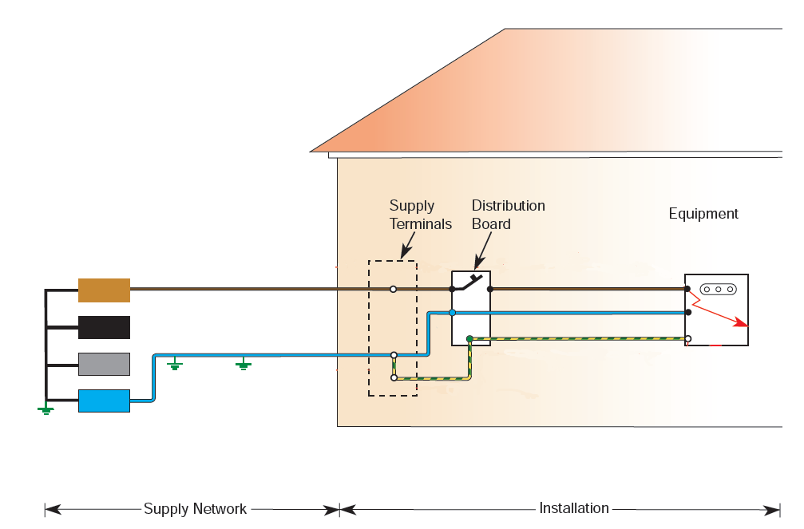
TN-C-S

.
30m

Figure 3

