
BERGAMO PASQUALE
1816096
MARKETING ESSENTIALS
M4X01916

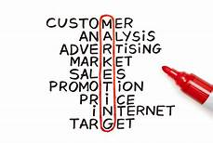

LECTURE: DALE CLARKE

1
PAGE CONTENTS

- PAGE CONTENTS………………………………..………………………………. 1

- INTRODUCTION …………………………………………………………………. 3

- THE FOUR MAIN ELEMENTS OF MIS …………………………………… 4

- MARKETING INFORMATION SYSTEM FOR MARKETING, INFORMATION GATHERING AND COMMUNICATION…………………………………………….……………..5 – 6

- WHAT IS MARKETING MIX?......................................................................... 7

- CONCLUSION…………………………………………………………………….. 8

- REFERENCES ……………………………………………………………………. 9

2
INTRODUCTION
In this assignment, we will examine how the Marketing Information System is used in the hotel industry. Hotel Marketing helps owners to give maximum value at bookings and revenue, it refers to the various strategies and techniques that hotels use, to promote their business and capture the customers. In practice, it serves to give a beautiful image of the hotel by making sure that as many people as possible are attracted to it.
‘’ The role of marketing is still, at the end of the day, to meet customers’ needs in the most effective, efficient and sustainable way possible for as long as it is possible to do so’’ (Blythe, 2005).
The most important role of the Marketing Information System is to do as much research as possible trough its different components to make the best decisions in the interest of the company which is taken by the Marketing Manager. He will decide how to implement them after collecting data from studies, statistics, opinions, internet and more.
According to Kotler's model, let’s list the important elements that make it up.

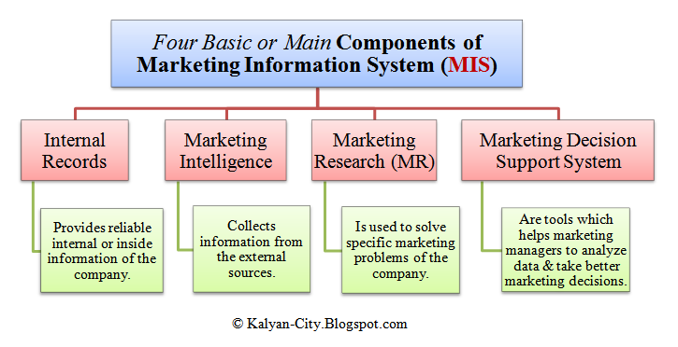

3
THE FOUR MAIN ELEMENTS OF MIS
The Marketing Information System has an important element used to gather information and so on which are:
- Internal Records,
- Marketing Intelligence,
- Marketing Research, and
- Marketing Decision Support System.
1. The first element of Marketing Information System is Internal Records. Managers collect so much report from the internal records of the corporation; these give them information about sales, inventories, costs, cash flows and accounts receivable and payable. A lot of companies support their computerized internal records and being all registered they can be much faster in gathering information.
2. The second component of Marketing Information System is Marketing Intelligence. This gives information from external sources and explains how the market moves based on the marketing environment. This can be gathered from newspapers, journals, commercial press. It can be used by the manager for taking decisions so it is one of the most important components of Marketing Information System.
3. This solves specific problems and from these, it collects data that are registered, analyzed and the conclusions are drawn. It can be used by Marketing Managers for particular purposes. One of its components is Social Media Marketing Research and the way to understand how to use it for your business is by focusing on the benefits and creating a real research plan.
‘’Maintaining objectivity in marketing research is essential if marketing management is to have sufficient confidence in its results to be prepared to take risky decisions based upon those results’’ (Crawford, 1997).
4. The last element of MIS is Marketing Decision Support System. It helps Managers to analyze data and make better decisions from them, include hardware, software programs, and computer. Today the use of computers is really important and managers. They cannot do without it because they are facilitated to do marketing segmentation, prize fixing, advertising budgets and so on.
.

4
MIS FOR MARKETING, INFORMATION GATHERING AND COMMUNICATION
As mentioned before the Marketing Information System consists of different types of data that can be internal and external. These internal and external data are used to create MIS or Database and once created they can be used for decision making. So the Marketing Information System allows us to create a Marketing and consequently to create a profit. Internal and external data in Gathering information are also and above all used to reach the final goal.
The first (internal) give us a general idea of what happens and is developed with the company, the second (external) follows the market and its events.
A great example of our days is the use of Apps and social networks.
‘’ First of all, business pages benefit you because it‟s a platform for you to talk about your business, promote your products and services and have a speech and interactions related to your business with your customers’’ (Spence, 2013)
Today these have become essential and all companies use them to exchange information much faster so that everyone always knows what Is happening. For example, in the Cahoots, which is the speakeasy where I work for, we have got a platform called ‘’Yapster’’ created specifically for teams work where announcements of meetings, feedbacks of the week, tasks and more are posted.
As already mentioned Communication is one of the most important factors because we sell experiences to our customers and we need to convey our concept, our ideas, and our message by analyzing the market and always looking at our competitors. The most important point that the concept of communication gives us is that we should add value to our products so the customer is pushed to buy from us instead that from our competitors. When a company creates a Marketing Communication Plan combines different forms of channels.

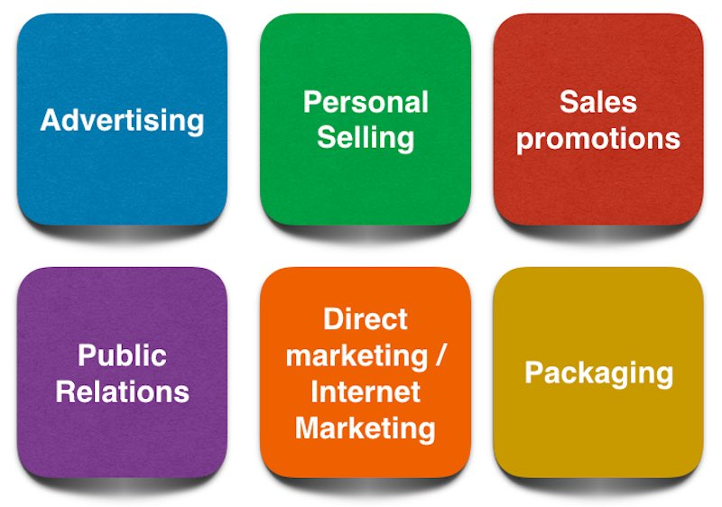
5
- Advertising wants you to have a message that gives an emotion;
- Personal selling is used to make people understand what your product is good for.
- Sales promotion is growing today especially after the popularity of E-commerce.
- Public relations, it helps to build a brand image and develop it.
- Digital Marketing, the benefit of it is that even small businesses can be advertised without high costs.
- Packaging can be used by marketers to encourage potential buyers to purchase the product.
‘’The marketing communication process identifies where the investments are being done and what is bringing more return on investment’’ (Managementstudyguide.com, 2019).
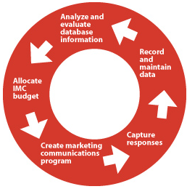

6
WHAT IS MARKETING MIX?
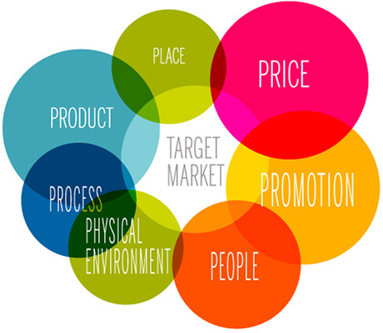
The Marketing Mix is the operational part of a marketing plan and is also called 4Ps and 7ps because it has got like main points price, place, product, and promotion and includes the addition of process, people and physical evidence.
The most used example is to think of a cake and what it contains and figure out how to get the final goal mixing the ingredients so for example if you want a sweeter cake you need to use more sugar.
‘’The product needed to be clearly differentiated and not just a ‘me too' product, and there had to be clear ‘kill or go' decision timeframes built into the process’’ (Jackson, 2013).
- The Product for a speakeasy like the Cahoots is his concept unique in the world.
‘’Leading brands communicate their promise to the market, encouraging customers to purchase the product or service’’ (Clifton and Simmons, 2003).
- The Place is one of the most important points, for example, taking into consideration the place where I work, the Cahoots respects the concept of a speakeasy or a cocktail bar of the Prohibition Era and it is not easy to find.
- Another point is the Promotion being very hidden the greatest strength of Cahoots is social media, the page of our company is one of the most followed by people of the industry.
- The Price must be chosen based on the offer and the customers, at Cahoots is medium being a place for everyone.
- ‘’When a business finds people who genuinely believe in the products or services that the particular business creates, it’s is highly likely that the employees will perform the best they can’’(Mix, 2019)
The People who are part of your team are your window to the market and are one of the most important factors in your business
- The Process in place is important to avoid high costs.
- Physical evidence one of the concepts of this is branding, for example, if you think of technology you can think of Apple.
7
CONCLUSION
In this assignment, we have analyzed what the MIS is, what are its components and how they work. Where it collects information and how it is connected with marketing and communication which will then be implemented by managers to make decisions.
We then analyzed the Marketing Mix and its 4Ps which then became 7 after in relation to a company, in this case, the one for which I work, focusing on the concept and therefore the product going to describe how the points are developed.
This assignment helped me to understand what to watch and how to analyze the market by giving value to our product for future projects.

8
REFERENCES
- Blythe, J. (2005). Essentials of Marketing. 3rd ed. Harlow: Pearson Education limited, p.322.
- Crawford, I. (1997). Marketing research and Information system. 1st ed. Rome: food and agriculture organization of the united nations, p.8.
- Clifton, R. and Simmons, J. (2003). Brands & Branding. London: The economist, p.69.
- Managementstudyguide.com. (2019). Marketing Communications - Meaning and its Process. [online] Available at: https://www.managementstudyguide.com/marketing-communications.htm [Accessed 24 Jul. 2019].
- Mix, T. (2019). Marketing Mix Definition - 4Ps & 7Ps of the Marketing Mix. [online] The Marketing Mix. Available at: https://marketingmix.co.uk/ [Accessed 24 Jul. 2019].
- Spence, A. (2013). Your Ultimate Guide to Facebook Marketing. p.34.
- Jackson, N. (2013). Promoting and Marketing events, Theory and practice. 1st ed. Oxon: Routledge, p.80.

9

