University of Wales Trinity Saint David
Wales institute of Science and Arts



Formula 750 EV Conversion Design Project

Group Design Project
ACHA5014

F750 Group 1

March 2023

Table of Contents
Table of Contents
Table of Contents 1
Table of Figures 3
Table Index 3
1. Introduction 3
2. Project Organisation 4
3. Aims and Objectives 5
3.1. Aims 5
3.2. Objectives 6
4. Regulations Research 7
4.1. Bodywork, Packaging and Thermal 7
4.2. Motor and Control 9
4.3. Battery and Management Regulations 11
4.4. Transmission 12
4.5. Chassis and Dynamics 13
4.5.1. Analysis of chassis and dynamics regulations 14
5. Contributions to the project 15
5.1. Bodywork, packaging & thermal (Badrakh) 15
5.2. Motor and control 19
5.2.1. Motor Research 19
5.2.2. Analysis of motor 19
5.2.3. Motor Controller Research (Kieran Dellow) 21
5.2.4. Controller Software Research (Kieran Dellow) 24
5.2.5. Motor Controller Mounting Plate 26
5.3. Transmission System (Joao Ferreira) 29
5.3.1. Regulation Analysis 29
5.3.2. Analysis of Grip Limits 29
5.3.3. Top Speed & Gear Ratio 30
5.3.4. Rear Differential Solution 31
5.3.7. Pulley and Belt Selection 36
5.3.8. Using New Gear Ratio with Drive Cycle Data 37
5.3.10. Drivetrain Layout 40
5.4. Chassis and dynamics (Joseph Britton) 45
5.4.1. Measuring suspension coordinates 45
5.4.1.1. Testing methodology 45
5.4.2. Analysis 47
5.4.3. Optimum Lap 53
5.4.3.1. Optimum lap limitations 54
5.4.4. Rear suspension 54
3.5 Battery and Management 55
3.5.1 Drive Cycle (Kieran Dellow) 55
3.5.2 Process to designing a battery pack. 58
3.5.3 Analysis of why lithium-ion battery chemistries are best suited for high performance vehicles. 59
3.5.4 Analysis of different Lithium-ion modules 59
3.5.5 Final battery module analysis 62
3.5.6 Battery Management System analysis – (Dylan Davies) 63
3.5.7 Chosen BMS 64
3.5.7 Battery Pack Configuration 65
3.5.8 CAD layout designs 66
3.5.9 Crash Management 66
3.5.10 Stress analysis on battery pack models 67
3.5.11 Future development of the battery pack 69
3.5.12 Peak power and peak torque graph 70
3.5.13 Regenerative Braking 70
3.5.14 Braking power and energy on front and rear wheels 71
5.5. 15 Energy available to recover at the rear wheels. 72
3.5.16 Limitations of method 72
3.5.17 Regenerative braking system technology 73
6. Achievements 75
7. Project review 76
7.1. Bodywork, packaging & thermal 76
7.2. Motor & control 76
7.3. Battery & management 76
5.3.1 Successes for Battery & management 76
5.3.2 Failures for Battery & management 77
7.4. Transmission 77
7.5. Chassis and Dynamics 77
7.5.1. Successes for Chassis and Dynamics 77
7.5.2. Failures for Chassis and Dynamics 78
8. References 79

Table of Figures
Figure 1 EMRAX 268 CAD (EMRAX innovation E-motor, 2023) 16
Figure 2 Efficiency map of EMRAX Motor 17
Figure 3 Voltsport Website Sevcon Gen4 Size 10 Motor Controller 18
Figure 4 Gen 4 Motor controller Current cutback curve – Voltsport Website 19
Figure 5 Speed Mode Vs Torque Mode DVT Software 21
Figure 6 - Screenshot from Gates Design Power Software 24
Figure 7 - Gates Design Software Results 25
Figure 8 - Gates PowergripTM GT4 Composition 25
Figure 9 - Side View of Drivetrain Layout 26
Figure 10 - Isometric (left) and Top (right) views of Drivetrain Layout 26
Figure 11 - Initial Differential Bracket Design 26
Figure 12 - Topology Study of Differential Bracket 27
Figure 13 - Resulting Bracket After Topology Study 27
Figure 14 - Fillet Edges for Controlling Stress Concentration 28
Figure 15 - Final Static FEA Study on Resulting Bracket 28
Figure 1416 – Frontal section of formula 750 29
Figure 17 lithium-ion flow 38
Figure 18 Charing of a Lithium-ion 38
19 Lithium-ion chemistries 39
Figure 20 VW ID 12S CAD model- Dylan Davies 42
Figure 21 Comparison of the features of various BMS functionalities (Battery management systems for large Lithium-Ion battery packs, 2010) 43
Figure 22 Example of digital BMS (Battery Management systems for large lithium-Ion Battery packs, 2010) 43
Figure 23 Orion BMS Lithium-Ion Battery management system 44
Figure 24 Battery pack layout 45
Figure 25 Battery pack Positioning- (Dylan Davies) 45
Figure 26 Honeycomb battery pack design- (Dylan Davies) 46
Figure 27 Stress analysis 46
Figure 28 Max yield stress of aluminium 47
Figure 29 Stress and displacement of improved battery pack design 47
Figure 30 Plate and curve improvements 48
Figure 31 Peak power and peak torque 49
Figure 32 Matlab loops to selected correct data. 50
Figure 33 Total Possible energy that can recovered over 1 lap at Anglesey. 50
Figure 34 Energy recovered and braking force from rear wheels over one lap at Anglesey 51

Table Index
Table 1-Chassis and dynamics relevant regulations 15
Table 2 EMRAX Manuel data 2020 version 5.4 18
Table 3 - Top Speed Figures 25
Table 4 – X, Y & Z coordinates for steering rack. 31
Table 5 Battery module calculated specifications. 41
Table 6 Decision matrix of battery module options 42
Table 7 Battery pack specifications 42

Introduction

The aim of this project is to develop an electric vehicle conversion kit that can be integrated into the existing Formula 750 chassis, currently powered by the 1108cc FIAT engine. The primary objective is to facilitate the transition of the Formula 750 series to a more sustainable era of motorsports while preserving its cost-effectiveness.
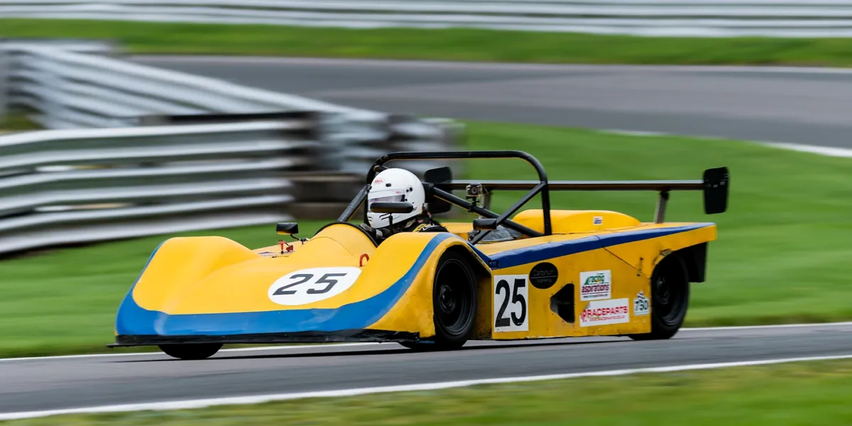
Figure 1 - Formula 750 Vehicle on Track (750 Motor Club, n.d.)
This project is motivated by the scarcity of the FIAT engine in the second-hand market, which has led to an increase in acquisition costs, as well as the need to address societal, political, and economic pressures that drive the adoption of more sustainable alternatives in motorsports. The development of the conversion kit will be guided by the goal of promoting non-professional racers' participation in EV racing series, thereby expanding the availability of this type of competition at the club motorsport level.

Project Organisation

The group was split at the start of the project to cover 5 areas regarding the project, these being Chassis and dynamics, transmission, battery and management, motor and control and finally bodywork, thermal and packaging.

- Chassis and dynamics – Joseph Britton (Team Leader)
- Transmission – Joao Ferreira
- Battery and Management – Kieran Dellow
- Motor and Control – Dylan Davies
- Bodywork, Packaging and Thermal – Badrakh Nyamsuren

These roles were allocated as such to cover a range of tasks that needed to be completed by the group whilst allowing for individuals to cover their specific areas. The project requires us to improve upon the Formula 750 race car whilst staying within the guidelines of the Motorsport UK blue book and the Formula 750 regulations. These regulations have an impact on each of the roles listed above, meaning the group needed to evaluate every decision made for the project with regards to them.

The role of the team leader was essential to keep everyone on task and should a group member find themselves without a project to work on the group leader will allocate them member in either assisting others with ongoing work or select a topic that needed to be covered for the member to begin working on.

For the group to stay on task, weekly meetings were held in which each member would discuss work that had been carried out over the previous week and decide on the direction the project needed to take. Alongside this, it was essential that the group stayed in touch throughout the week to inform everyone on any progress made or whether there was a task that required the aid of another member to collaborate with.

Aims and Objectives

Aims
- To design and create an EV Formula 750 vehicle that outperforms the ICE version in terms of acceleration, top speed, and overall driving experience.
- To minimize the environmental impact of the vehicle by using sustainable materials and reducing carbon emissions.
- To minimize the environmental impact of the vehicle by using sustainable materials and reducing carbon emissions.
- To create a vehicle that is safe and reliable, with advance safety features and a robust design.
- To show case the potential of EV technology in racing and promote its adoption in motorsport.
- To show case the potential of EV technology in racing and promote its adoption in motorsport.
- To create a Formula 750 concept using Solidworks software and further testing on Ansys Computational Fluid Dynamics (CFD) in order to decrease the drag of the body and increasing the efficiency.

Objectives
- To optimize the battery pack configuration and selection of materials to achieve a high energy density and fast charging capability.
- To design and implement a high-performance drivetrain that delivers superior acceleration and top speed.
- To design and implement a high-performance drivetrain that delivers superior acceleration and top speed.
- To minimize the vehicle weight through the use of lightweight materials and advance manufacturing techniques, without compromising safety.
- To develop a comprehensive testing and validation plan to ensure the vehicle meets safety and performance standards, and to identify areas for further improvements.
- To develop a comprehensive testing and validation plan to ensure the vehicle meets safety and performance standards, and to identify areas for further improvements.
- To develop a system for monitoring battery health and performance.
- Design a transmission that is optimized for electric motors torque and power characterises.
- Optimize and analysis suspension and design of chassis for maximum handling and control.
- Design a transmission that is optimized for electric motors torque and power characterises.
- Optimize and analysis suspension and design of chassis for maximum handling and control.
- Using CFD and Solid work programs to create various models and find the best suitable bodywork, thermal, and packaging design.

Regulations Research

Rules and regulations play an important role in the development of an electric vehicle conversion kit thus the following regulations are specifically for the technical regulations focusing on bodywork, package and thermal aspect. The following regulations have been sourced from the Motorsports UK Blue Book and AWDC regulations.

Bodywork, Packaging and Thermal
5.14.1 If the auxiliary battery is located near the driver compartment it must be situated behind the driver's seat.
5.14.7 Must display voltage warning symbol for voltage exceeding 60v (this will be displayed on the bodywork)
5.23.9. Modified and Bespoke EVs must undergo and pass a Vehicle Passport inspection irrespective of discipline or category.
5.24.12. All items on the Inspection Checklist must be clearly visible to the inspector without using instruments such as endoscopes or mirrors. Visible access may be provided by removing body panels or via removable access panels. Covers on the traction battery must only be removed by the nominated team HV qualified person if requested by the technical inspector.
5.26.3. Charging of the RESS must be done with the battery(s) in-situ.
5.27.7. The inverter may be integrated with or separate from the motor. The motor may be integrated with or separate from the gearbox.
5.27.12. All motor and inverter connections that use bolted HV terminals must be fitted with moulded insulated terminal covers that are sealed to satisfy a minimum IP65 rating.
5.28.7. The RESS must include appropriately specified fuses or circuit breakers to prevent over-current in the event of short circuit. The protection devices must be located inside the RESS as close as possible to the main power bus connectors.
5.28.1. The RESS must be comprised of a maximum of 2separate traction battery enclosures per vehicle.
5.28.8. If HV Service switches are used, they must be fitted into each battery pack. If a LV switch is used, only one is required (preferably mounted on one of the battery packs). The location of the Service Switch(es) should be clearly marked.
5.28.9. The RESS must be installed within the survival cell, passenger compartment, engine compartment or boot of the vehicle. Underfloor installation of the RESS is permitted if full impact protection is provided to meet the 60kN FIA impact energy requirements. Full details of the impact protection must be provided to Motorsport UK 3 months prior to the vehicle inspection.
5.28.10. The RESS must not be used as a stressed member.
5.28.12. The RESS enclosure must be to a minimum rating of IP65.
5.28.13. Cells/modules must be mechanically secured inside a metallic or composite enclosure. Any covers or access panels must be sealed and secured with fasteners requiring tools to remove.
5.28.14. The RESS must be designed to prevent short circuit of the conductive parts. In the event of compartment or component deformation, the design must ensure that no fluids enter the cockpit/passenger compartment.
5.28.15. The RESS must prevent the build-up of an ignitable gas/air or dust/air concentration inside the compartment by means of a burst valve or vent tube, positioned away from the driver. Any vent tube if fitted, must discharge direct to atmosphere external to the passenger compartment or survival cell.
5.28.16. All HV connections to the RESS must be made using either proprietary HV connectors with High Voltage Interlock Circuitry (HViL) or the cables must pass through HV rated cable glands of suitable size to match the cable and which preserve the IP rating of the external enclosure.
5.28.17. The enclosure containing the cells, must also contain the BMS voltage and temperature sensing elements associated with the cells, service switch, fuses/circuit breakers and contactors.
5.29.6. The design of the system must be such to ensure that a single point of failure cannot cause an electric shock hazardous to life.
5.29.7. HV Electrical cables and electrical equipment must be protected against any risk of mechanical damage (stones, corrosion, mechanical failure, etc.) as well as any risk of fire and electrical shock.
5.29.10. All parts of the electrical equipment must be protected using an appropriate IP class with min IP65 protection on all HV components.5.29.11. The HV traction circuit must be isolated from the vehicle chassis.
5.29.12. All HV cabling must comply with LV 216-2, ISO 6722and ISO 14572 Construction of HV wiring systems for hybrid and electric vehicles. All cables must be orange and shielded, either internally or by conduit and must be securely fixed to the vehicle chassis using insulated fixings. Tie wraps are not acceptable. Cable conductor material must be copper. The use of aluminium bus bars and terminals is permitted.
5.29.14. All HV cable runs must be a single contiguous piece of cable between connectors / terminals. Any cable joins or splices must be achieved using bolted terminals securely fixed in a min IP65 rated enclosure with glands/strain relief on the cable entry points. Any covers or access panels must be sealed and secured with fasteners requiring tools to remove.

Motor and Control

The following regulations are specifically for the motor and Kinetic energy recovery system, as well as the construction aspect of the project. Compliance with these regulations is required for project completion. As Formula 750 regulations do not provide extensive guidelines on electric vehicle technology, the majority of the regulations are sourced from the Motorsport UK Blue Book.

5.27.5. Only commercially available production motors and inverters are permitted.
5.27.6. Repurposing of OEM motors and inverters is
5.27.8. Brushed DC motors are permitted and motors with exposed commutators must be fitted with a commutator shield.
5.27.10. If the motor is air cooled, all ventilation holes must be small enough to prevent the passage of a 12mm diameter spherical test object through all holes.
5.27.11. When an electrical motor casing is rotating around the stator, a scatter shield must be included to surround the rotating parts of the motor. The shield must be constructed from min 2mm steel or 3mm thickness aluminium alloy. Does not apply to motors fully enclosed in the transmission housing.
5.27.9. If the motor or inverter is liquid cooled, >51% water-based coolant must be used. The use of Dielectric fluid is prohibited.
5.24.5. Electric Vehicle Inspections must be arranged by appointment with Motorsport UK and will be carried out by a Motorsport UK HV qualified Technical Official.
5.22.3. An EV may contain a High Voltage (HV) or Low Voltage (LV) propulsion system.
5.14.5. Have the Auxiliary battery earth lead, if not readily distinguishable, identified by a yellow marking.
5.14.6. If required to have a self-starter, be able to demonstrate during the competition that it is capable of starting the engine.5.14.6. If required to have a self-starter, be able to
5.14: VEHICLE WEIGHT: All cars are subject to a minimum weight of 480kg including driver. Ballast (if required) must be fitted in accordance with MOTORSPORT UK regulations J5.15.1 to J5.15.4.
5.14.5. Have the Auxiliary battery earth lead, if not readily distinguishable, identified by a yellow marking.
5.14.6. If required to have a self-starter, be able to demonstrate during the competition that it is capable of starting the engine.
5.14.8. Any vehicle incorporating an electrical system, with the exception of ignition systems, which may run at a voltage exceeding 60V must display the sign detailed in Drawing 5.14 next to all competition numbers.
5.22.2. High Voltage (HV) shall be as defined in FIA Appendix J Art 251 3.1.10 (from ISO 6469-1:2009): > 30V AC and ≤ 1000V AC or > 60V DC and ≤ 1500V DC. 5.22.3. An EV may contain a High Voltage (HV) or Low Voltage (LV) propulsion system.
Oil/Water cooling: Free within overall periphery of bodywork. Water based coolant must be used.
Regulations of building EV for competition
5.24.1. Anyone considering building a Bespoke EV for competition use must supply a project outline, including details/qualification of those engineering the vehicle for review by Motorsport UK Technical Department prior to starting construction. On-going dialogue
RECHARGEABLE ENERGY STORAGE SYSTEM (RESS).
General 5.28.1. The RESS must be comprised of a maximum of 2 separate traction battery enclosures per vehicle. 5.28.2. Capacitor and flywheel energy storage systems are prohibited.
5.26.3. Charging of the RESS must be done with the battery(s) in-situ.
5.26.5. The charging system must be automatic and must ensure that the battery cannot be overcharged or damaged if left permanently connected to the charger.

Battery and Management Regulations
Below are regulations regarding the battery pack, for both the Formula 750 regulations, and the more general MSUK Blue Book regulations.
■ - Formula 750 2022 Regulation ■ - MSUK Blue Book 2022 Regulation
- HV is defined as >30V AC, and <1000V AC, or > 60V DC and <1500V DC.
- Prohibited to carry out any tuning or modification that is not specifically permitted.
- Our car will be classed as a Bespoke vehicle (BEV) as opposed to a standard vehicle.
- A RESS (Rechargeable Energy Storage System) must be comprised of a maximum of 2 separate traction battery enclosures per vehicle.
- Capacitor & Flywheel energy storage systems are prohibited.
- 250kW power output limit at any given time through the RESS.
- 450V maximum voltage on the Power Bus.
- RESS must include appropriately specified fuses and/or circuit breakers to prevent over-current during a short circuit. Must be located as close as possible to the main power bus connectors inside the RESS.
- RESS must be able to be isolated from the Power Circuit by two systems. One manual system, and one automatic system. May be a HV device, which will be orange, and designed so that no HV potential is exposed if removed/operated.
(Formula 750 Racing, 2022)
- 5.27.10. If the motor is air cooled, all ventilation holes must be small enough to prevent the passage of a 12mm diameter spherical test object through all holes.
- 5.27.9. If the motor or inverter is liquid cooled, >51% water-based coolant must be used. The use of Dielectric fluid is prohibited.
- 5.24.5. Electric Vehicle Inspections must be arranged by appointment with Motorsport UK and will be carried out by a Motorsport UK HV qualified Technical Official.
- 5.22.3. An EV may contain a High Voltage (HV) or Low Voltage (LV) propulsion system.
- 5.14.5. Have the Auxiliary battery earth lead, if not readily distinguishable, identified by a yellow marking.
- 5.14.6. If required to have a self-starter, be able to demonstrate during the competition that it can start the engine.
(MSUK, 2022)

Transmission
The following requirements from the Motorsport UK’s Blue Book should be met in regard to the power transmission mechanism:
“A maximum of two motors, whose output are combined mechanically driving the wheels through a mechanical gearbox and differential are permitted. A maximum of two inverters are permitted.”
(Motorsport UK, 2022)
The requirements set forth by the 750 Motor Club (2022) primarily target the Internal Combustion Engine (ICE) variant of the vehicle. However, the applicable requirements extracted from their regulation booklet are outlined below.
- The control of gear selection and clutch operation should be the exclusively under control of the driver.
- The use of magnesium alloy bell housings and gearbox casings is prohibited.
- The use of automatic transmissions is not permitted.
- The use of torque biasing locked or limited slip differentials is strictly forbidden.
- The propulsion of the vehicle must originate from the rear wheels, which can be accomplished by either utilizing a live rear axle or a transaxle.

Chassis and Dynamics
To begin the project, we needed to research the guidelines set by the Motorsport UK blue book and the formula 750 regulations to ensure we adhered to them throughout the project. These are the applicable rules regarding the chassis and dynamics of the vehicle. Table 1 represents the relevant regulations for the chassis and dynamics area of the project.
Table 1-Chassis and dynamics relevant regulations

Analysis of chassis and dynamics regulations
The key points to note, considering the regulations, are the main chassis which has already been built to satisfy the regulations must be kept with the aforementioned dimensions. Also, as stated by the blue book, the driver must be able to exit the vehicle in a maximum time of 10 seconds. The suspension system, should it be modified is prohibited from being constructed from carbon fibre, Kevlar or other composites made from these materials. The tyres are bound to the YOKOHAMA radial, size 160/520/R13, code no: N2669. This in turn limits the size of the wheel to 13 inches. The MSUK (Motorsport UK) blue book states the use of pressure control systems within tyres is prohibited in all forms. Finally, the weight of the vehicle is subject to a minimum of 480Kg including the driver. Ballast, should it be required is free to be mounted anywhere due the vehicle being a single seater.

Contributions to the project

Bodywork, packaging & thermal (Badrakh)
Aerodynamics is a complex yet a large set of studies, where the interaction between air behaves with solid objects such as cars and aeroplanes, where the objective is to maximise the downforce. In aerodynamics there are number of principles to determine.
The properties of air in aerodynamics are explained as a fluid with certain properties where it is compressible and gaseous mixture consisting of 78% nitrogen and 21% oxygen (Seward, 2014, p. 202).
Gas laws:
$\left(P_{1}v_{1}\right)/T_{1}$ = constant = $\left(P_{2}v_{2}\right)/T_{2}$
$P_{i}$ = Absolute pressure
$V_{i}$ = Air volume
$T_{i}$ = Absolute temperature
Since the density of air ρ is inversely related to its volume, the equation above can be changed to:
$P_{1}/\left(T_{1}ρ_{1}\right)$ = constant = $P_{2}/\left(T_{2}ρ_{2}\right)$
$ρ_{n}$= Air density
The downforce can increase breaking and cornering performance greatly. ‘There is no other single aspect of competition car technology that has had such a big influence on performance as the exploitation of downforce’ (McBeath, 2006).
The front and the underside of the floor pan, and the rear wing are the most important elements, and each contribute roughly third of the downforce. In order for the car's understeer and oversteer characteristics to be acceptable at various speeds, the downforce must be balanced since aero forces increases in direct proportion to the square of the vehicle's velocity (Seward, 2014, p. 201).

The images below are the concept of the Formula 750 body design.

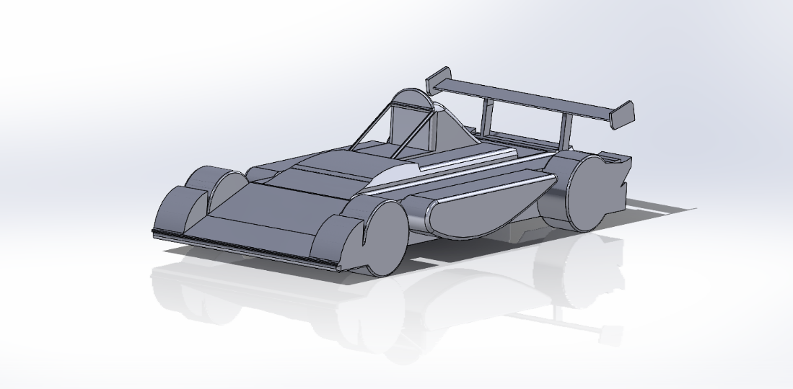
Figure 5.1.3 Front of the Formula 750 Body Concept
Thermal management in electrical vehicles is complex where the direct relation between energy requirement for the right thermal control and the battery can influence the charging processes.
Thus, when electric vehicles external to internal temperature conditions regulates the temperatures of the battery, electronic drives and motors, where playing a major role in the safety of the vehicle.

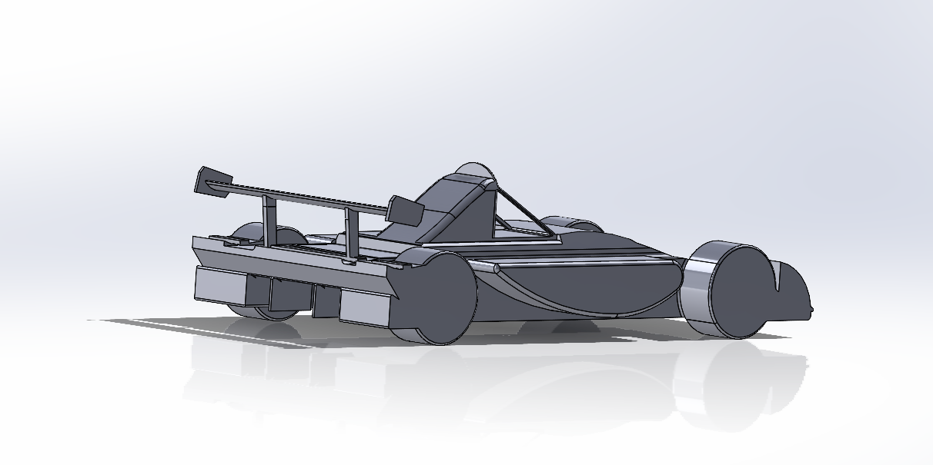
Figure 5.1.2 Rear of the Formula 750 Body Concept
t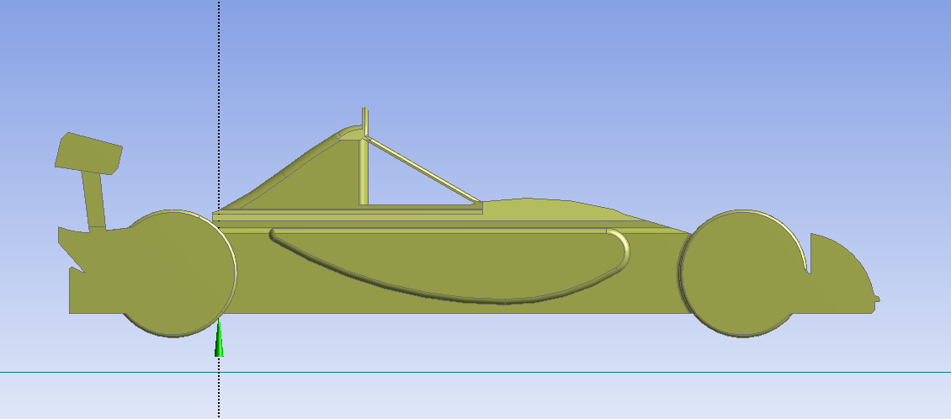
Figure 5.1.3 Side angle of the Formula 750 concept for CFD

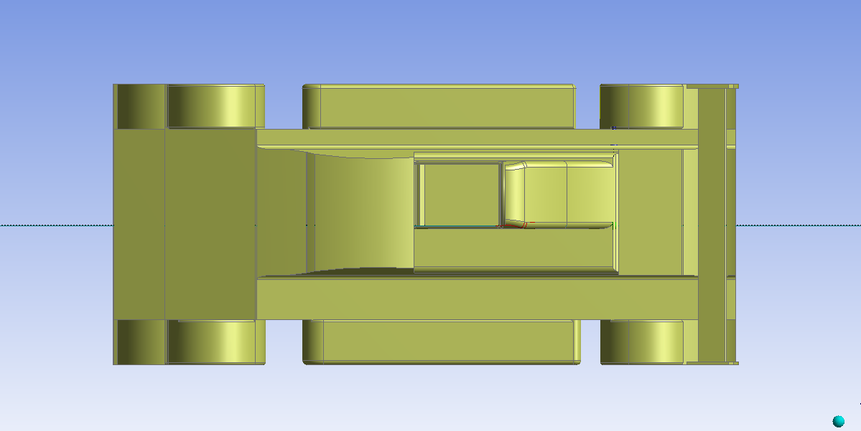
Figure 5.1.3 Top of the Formula 750 concept for CFD

The Bernoulli equation is one the fundamental principles in aerodynamics phenomena, where it states that incompressible fluid flow and assumes that the total energy of the particle is constant along a streamline. The energy can be seen in three forms:
- Kinetic Energy /
- Pressure Energy / PV
- Potential Energy /mh
From the following, v is velocity of flow an V is volume,
$1/2mv^{2}+PV+mh=$ constant
If density of fluid is ρ, then the V is volume V= m/ρ.
$1/2mv^{2}+Pm/ρ+mh=$ constant
Lastly, potential energy can be divided through by m and multiply by ρ.
$1/2ρv^{2}+P=$ constant
Aerodynamic drag on vehicles is also one of the fundamental principles where it affects the efficiency and range in electric vehicles, thus the drag force acts in the direction opposite to the direction of the motion. In other words, when a vehicle is travelling at high speed the drag force increases significantly and can reduce the range of the vehicle.
Overall, by reducing the aerodynamic drag can significantly impact vehicles design, efficiency, and rage thus by incorporating the principles of aerodynamics on the project can enhance and optimize the performance and maximize its range. Wings in aerodynamics and the development was initially seen in aircrafts and plays a lifting role, however, in electric vehicles, the wings are used to generate a downforce.
In electric vehicles, (Nefab, 2016) explained the packaging for electrical vehicles have gained importance in the recent years, thus the major solution focused on the safety and lightweight distribution of the products.

Motor and control
The Emrax 268 is a high-performance electric motor developed by the company Emrax. It is a permanent magnet axial flux synchronous motor, which means that the magnetic fields that generate torque are arranged in a disc-shaped configuration that is perpendicular to the axis of rotation.

Motor Research
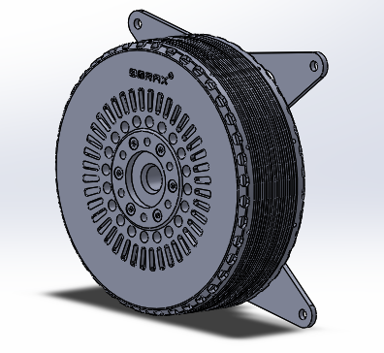
The Emrax 268 was designed for use in aviation, electric vehicles that require high power and torque density. It has a peak power output of 200 kW and a peak torque of 500 Nm.
Figure 2 EMRAX 268 CAD (EMRAX innovation E-motor, 2023)

Analysis of motor
The motor has a very high efficiency, “This is due to the use of permanent magnets for the excitation, which consume no power. The absence of a mechanical commutator and brushes means low mechanical friction losses and therefore higher efficiency.’’ The motor allows for very high flux density which allows the motor to produce high torque. As there is no current circulation in the rotor, the rotor doesn’t heat up which makes it extremely easier easy as the rotor doesn’t need to be cooled only the stator.
Synchronous operation
“The use of synchronous operation with a carefully designed wind arrangement results in a high efficiency motor with minimal energy loss’’ (Larminie & Lowry, 2012) This is extremely usefull for regenerating more braking energy and for the cooling side of the motor.

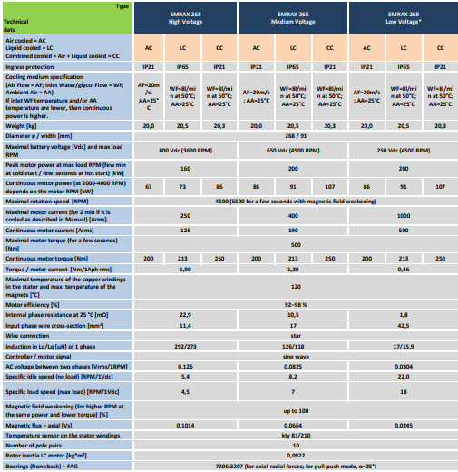
  - EMRAX 268 Data
Table 2 - EMRAX Manual Data 2020 Version 5.4

This is data from the median voltage section, which we are interested in as the project will be running a similar voltage. Max voltage and current values for the motor, are 650 volts and 400 amps. Max operation values are 200Kw peak power, 4500 RPM and 500Nm for maximal torque.

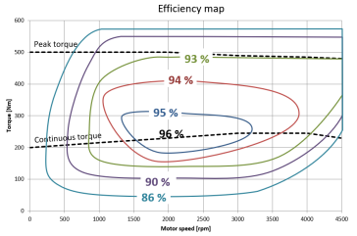
Figure 3 Efficiency map of EMRAX Motor

The graph illustrates that the motor operates at its highest efficiency within a specific range of torque values, specifically around 200Nm at 1500-3000 RPM. Running the motor with in this optimal operating zone, allows the team to operate the vehicle at maximum efficiency with little to no power loss.
  - Sections 3.2 to 3.2.3 - Author Dylan Davies

Motor Controller Research (Kieran Dellow)
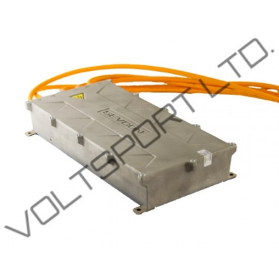

The Sevcon Gen 4 Size 10 Motor controller has a nominal supply voltage of 700V, and a continuous current of 200A, which is in the correct ballpark for the application of a replacement for the FIRE engine output.
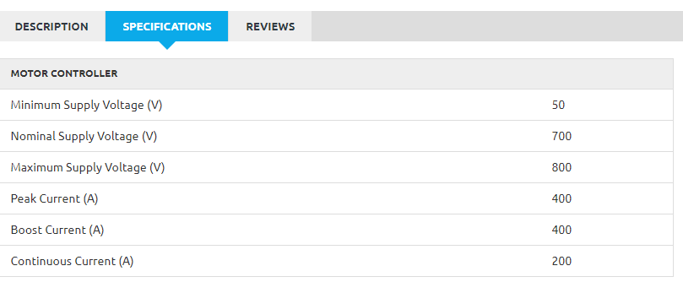
Figure 4 - Voltsport Website Sevcon Gen4 Size 10 Motor Controller (Voltsport, 2023)
The controller also has a fairly small form factor, which is integral to the project, as there is limited space inside the chassis of the vehicle for components such as the battery pack, motor and drivetrain. This is also a good choice for a controller as it has a IP rating of IP67, which means that it has “complete protection against dust over extended time, as well as protection against contact with objects greater than 1mm in diameter, such as a wire or a small tool” (Trenton Systems, 2021). IP67 also allows protection against the effects of temporary immersion between 15cm and 1m, for up to 30 minutes (Trenton Systems, 2021). This would be integral if there was any situation where the vehicle is exposed to a large quantity of water, such as a leak from a cooling system, as well as being fully protected from the weather.
With a weight of only 10.7Kg, it is lightweight component, so will most likely be one of the least prioritised location wise for weight distribution of the new drivetrain.
The recommended applications of the Gen 4 range of controllers are as follows:
- Ideal for traction applications such as mopeds and go-carts, motorbikes, city cars, forklift trucks and aerial work platforms.
- Separate operating modes allow for the unit to act as a fully-fledged VCU master or as a simple torque slave unit.
- Sevcon Pump Application technology allows the unit to drive a pump motor.
- Specialist support for safety-critical power steer applications.
(Voltsport, 2023)

These statements suggest that the controller is in the correct environment for optimal performance of our project, as the vehicle is relatively lightweight, while able to receive and transfer the correct values of amps and volts for the application.

Shown below is the cutback curve for the Gen4 Size 10 motor controller. This visualises the significance of cooling throughout its usage, dropping off at a steep gradient from 80 degrees. The fact that this graph shows current allowed (% of maximum) needs to be kept in mind though, as for our application in the vehicle, it will not be running at max output in any scenario, as our requirements are only around 30% of the capable output of the controller.
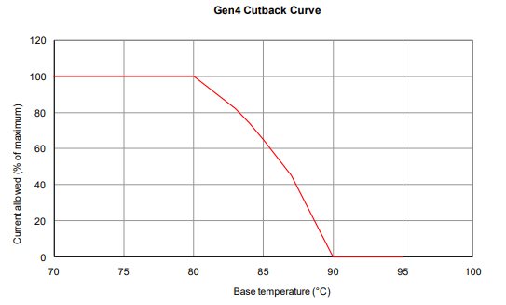
Figure 5 Gen 4 Motor controller Current cutback curve – Voltsport Website
(Voltsport, 2023)
Shown above is the cutback curve for the Gen4 Size 10 motor controller. This visualises the significance of cooling throughout its usage, dropping off at a steep gradient from 80 degrees. The fact that this graph shows current allowed (% of maximum) needs to be kept in mind though, as for our application in the vehicle, it will not be running at max output in any scenario, as our requirements are only around 30% of the capable output of the controller.
This will also reduce the cooling necessary, which means the controller will be able to run at higher temperatures before our application suffers any losses in current allowed due to this safety feature.

Controller Software Research (Kieran Dellow)
Sevcon also have a calibrator handset available to aid software functions within the controller, or DVT can be used, a Windows based configuration software tool made by Sevcon. This will allow electrical signals going into the controller to be interpreted differently if the vehicle requires it.
A common configuration comes with the controller as standard, but this may be customised for specialised applications, such as pumping, or in our application, traction.
DVT can also be used to monitor data during usage, which could prove useful to iron out issues that may crop up after realization of the project. DVT also incorporates usage of safety interlocks, such as a Deadman switch to prevent driveability of the car if it is inactive for a period of time, which would be imperative in a situation such as a driver becoming unconscious.
DVT also supports driveability profiles, which can be beneficial by setting maximum values for torque, speed acceleration, and deceleration, shown in the below graph.
(Voltsport, 2023)
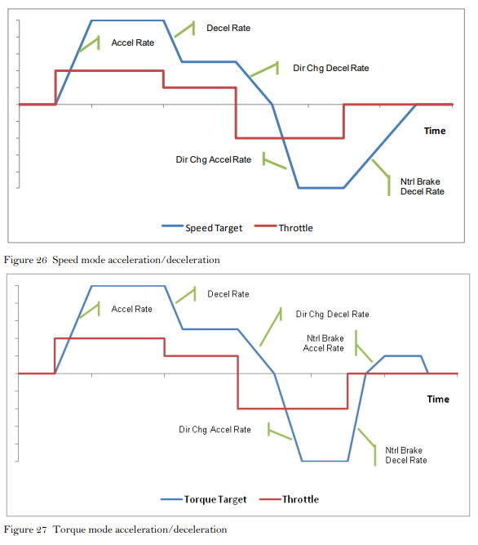
Figure 6 Speed Mode Vs Torque Mode DVT Software (Voltsport, 2023)
‘In Torque mode, the acceleration and deceleration rates control the rate of change of torque. In Speed mode, the acceleration and deceleration rates control the rate of change of speed.’
(Voltsport, 2023)

The controller also supports prevention of wheel lock scenarios, such as heavy braking, especially while downhill. This is ensured by addition of a speed limit to the controller, so as to not lock wheels, when an external braking force is applied, such as mechanical braking.
‘In these circumstances, the normal reaction of the driver is to release the brake to allow the wheels to rotate again. The correct operation of the controller in this scenario is to allow the wheels to continue to rotate, and not impose a speed limit.’
(Voltsport, 2023)

Motor Controller Mounting Plate
The controller will require a mounting plate to be installed between the chassis and the controller itself to improve rigidity while in movement.
The mounting location for the controller should be chosen with care taking into account the following considerations:
• Do not mount the controller on the outside of a vehicle where it would be accessible to unauthorized personnel.
• Do not mount the controller where it may be susceptible to damage due to minor collisions or impact from road debris.
• Although the controller has a high degree of ingress protection avoid mounting the controller in locations where it may be submerged in water or subjected to long term exposure to jets of water. (Refer to section 4-7 for IP ratings).
(Voltsport, 2023)

Above are some specifications for mounting the controller, which can be adhered to when designing a mounting plate. The controller has no specific orientation, so reducing the length of wire between the controller and other components can be prioritised. This is because resistance is directly proportional to the length of wire in question.

This can be expressed through the equation:
$$ρ = RA/l$$

Before designing a mounting plate for the controller, a mock-up of the controller itself will need to be modelled in CAD, to give positions required for mounting holes, as well as the location of the controller itself within the chassis.
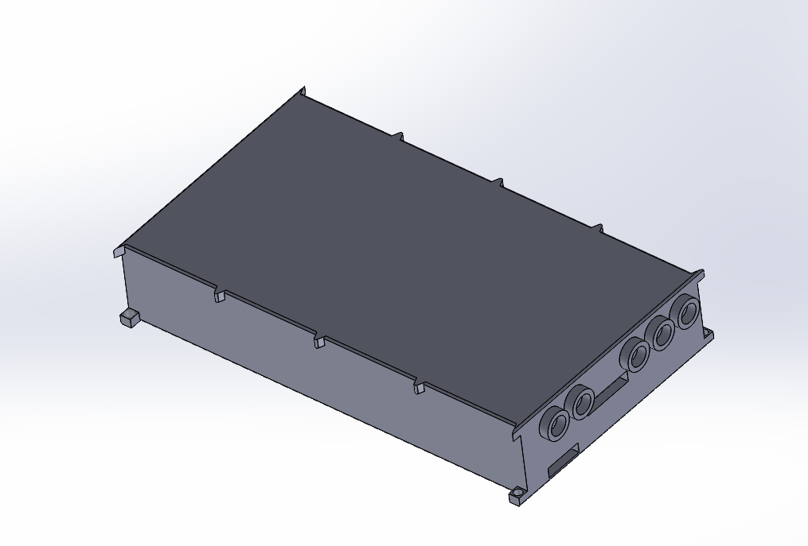
Figure 7 - CAD Model of Controller

Above is a model of the controller, which will then be used to create a mounting plate to bolt to the square holes in the motor controller, as well as the chassis itself.

Following the guidelines mentioned before, a mounting plate can be designed to sit in the compartment next to the driver, securing itself to the chassis using 5 bolts, as seen below.
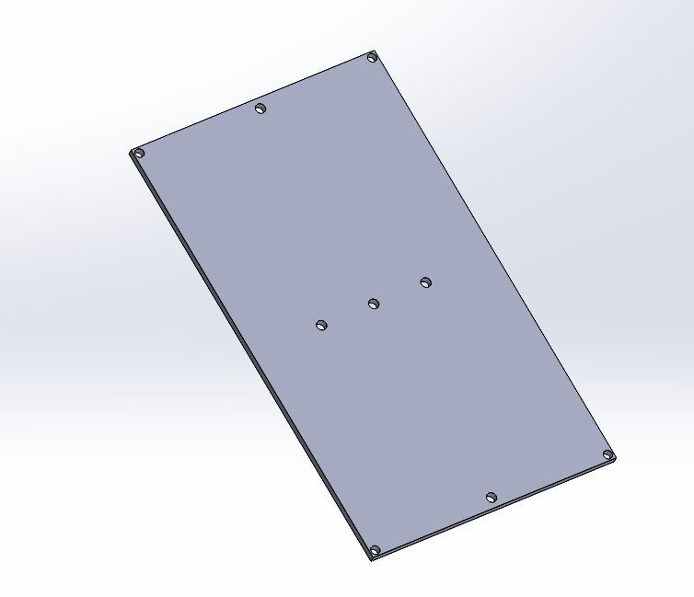
Figure 8 - Controller Mounting Plate

The controller, along with the mounting plate can then be bolted to the chassis, making use of beams running parallel to the controller.
This should help increase the rigidity of the controller, as well as secure it. As the car should produce under 3 Gs of acceleration at any given moment, this should be more than enough structural strength to withstand acceleration.
Below is a model of the chassis, with the controller and mounting plate to visualise how the controller would sit inside the vehicle, giving easy access to connectors, while minimising ingress of dirt and any particles/unwanted liquids during racing. Though this controller has an IP rating of IP66, it is still imperative to keep it away from any unwanted liquid/sediment.

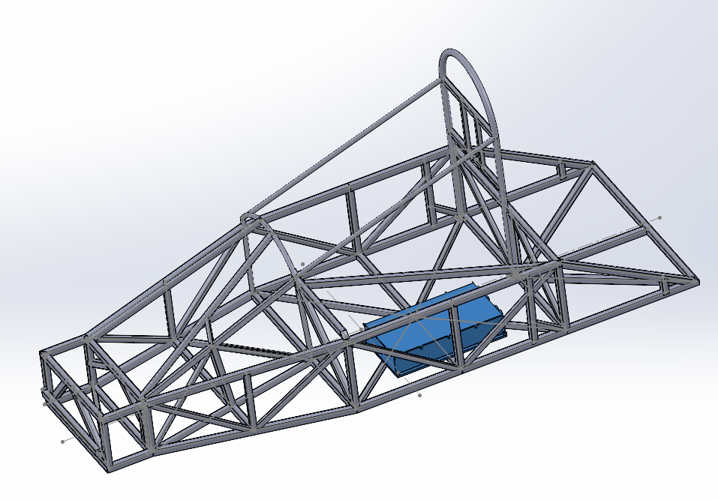
Figure 9 - Controller location in Chassis

This mounting plate would most likely be made out of 8mm thick aluminium, as 5mm of bolt thread is a minimum for any mounting bracket/plate for this controller, as well as increasing the rigidity of the plate itself with 8mm thick plate.
The placement of the controller within the chassis is also safety dictated, as the batteries sitting right next to the driver could pose a safety risk in the event of a crash. The controller on the other hand is much less likely to harm the driver during or after a crash.

Transmission System (Joao Ferreira)

Regulation Analysis
The regulations set forth by both Motorsport UK and the 750 Motor Club primarily focus on the Internal Combustion Engine (ICE) variant of the vehicle. Under the Motorsport UK regulations, a maximum of two motors is permitted, and their output must be combined mechanically to drive the wheels via a mechanical gearbox and differential. Additionally, the regulations mandate that the driver should have exclusive control over gear selection and clutch operation. The use of magnesium alloy bell housings and gearbox casings is prohibited, and automatic transmissions are not allowed. The use of torque biasing locked or limited slip differentials is strictly forbidden, and the regulations stipulate that the driven axle must be the rear.

Analysis of Grip Limits
Given an estimated mass of 750 kg after undergoing an EV conversion, and with an approximate mass distribution of 35%-65%, it is feasible to establish the tyre grip limits.

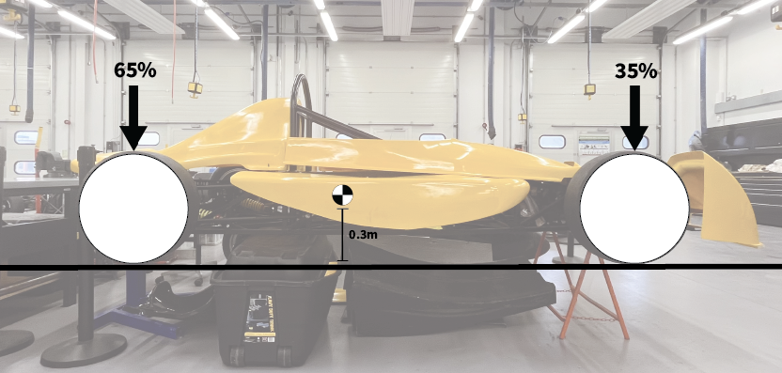
Figure 10 - Weight Distribution Diagram
$$W=m x g$$
$$750 x 9.81=7357.5 N$$
Assuming that 65% of the total weight is concentrated on the rear wheels:
$$7357.5*0.65=4782.38 N$$
With a 2m wheelbase and a centre of gravity positioned 0.3m above the ground, it is possible to determine the load transfer that occurs during maximum squat.
$$\frac{7357.5*0.30}{2}=1103.63 N$$
By combining these two factors, we can obtain the maximum weight at the rear axle, which includes both the normal load and the load transfer.
$$4782.38+ 1103.63=5886.01 N$$
Using the coefficient of friction of racing slick tires (μ = 1.5), it is possible to calculate the force exerted on the surface.
$$5886.01 x 1.5=8829.02 N$$
Subsequently, it is possible to determine the maximum torque allowable at the wheel.
$$T=F x r = 8829.02 x 0.26 =2295.54 Nm$$

Top Speed & Gear Ratio
Table X presents the top speed data provided.
Table - Top Speed Figures
Top Speed (km/h) | Track
171.198 | Donnington
164.398 | Anglesey

After considering the maximum top speed data of 171.198 km/h, it was determined that the vehicle's gearing limit should be set to 200 km/h. Given the maximum angular speed of the EMRAX 268 motor, which is 4500 RPM, and the regulated tire size of 160-520R13 with a radius of 0.26 m, it is possible to calculate the motor-to-wheel reduction ratio.
$$Motor Max Speed=4500 RPM x \frac{2π}{60}= 471.24 rad/s$$
$$200{km}/{h x \frac{1000}{3600}}= 55.56 m/s$$
$$ω= \frac{v}{r} =\frac{55.56}{0.26} =213.69 rad/s$$
$$Final Drive Ratio= \frac{471.24 rad/s}{213.69 rad/s}=2.21$$

Rear Differential Solution
To adhere to both the Motorsport UK and 750 Motor Club regulations for the vehicle's class and achieve a 2.21:1 gear ratio, a solution with an open differential is required. The research began with a focus on Quaife's well-known "Motorcycle Engined Car" units, specifically the QBE35G, QBA2R, and QBA11R. This configuration, with the transverse positioning of the driving sprocket due to the motorcycle engine, has gained popularity in vehicles such as the Radical SR3, where a longitudinal driveshaft is not feasible. However, the QBA11R, which weighs approximately 22kg, has limitations, including a lowest gear ratio of 2.43:1 which in our application would only achieve a maximum velocity of only 181.6km/h, making it unsuitable. Additionally, its limited-slip differential is not allowed in competition, and its base unit cost of £4,614.50 is not in line with the affordable club-level racing objectives of the project. The QBA2R, with a lower base price of £2,854.50, has similar limitations. The QBE35G, the last Quaife product examined, weighs only 8kg and costs £962.50. Its design allows for an appropriate final drive ratio by selecting the reduction ratio before the input to the unit itself. However, it is only available as a limited-slip differential. Also, all of these have a reverse lever which is of no use since the electric motor does not need reverse (Quaife, n.d.).
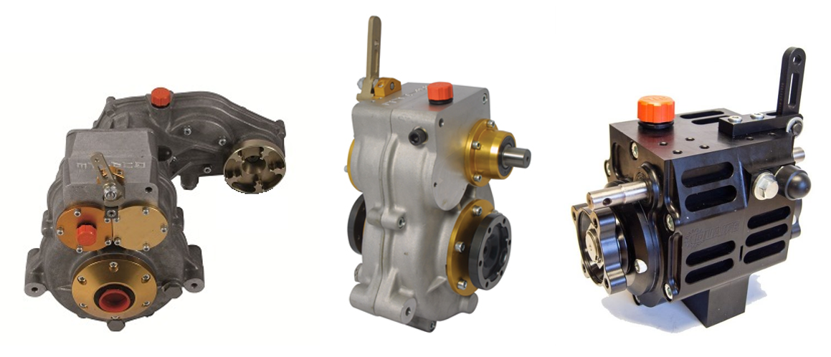
Figure 11 - Quaife QBA11R, QBA2R, and QBE35G (From Left to Right) (Quaife, n.d.)

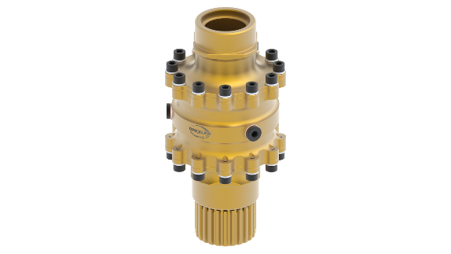
Figure 12 - Drexler FS Differential
In the course of researching design inspiration, a thorough investigation was conducted on several Formula Student vehicles. The results of this study revealed the Drexler FS Differential, one of the most frequently utilized options in this field. The popularity of this driveline can be attributed to its lightweight and compact design, but again as with the Quaife units is only available in plate type limited slip.
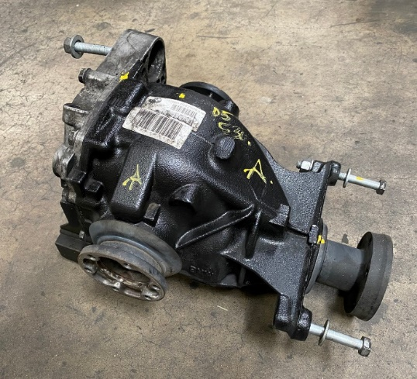
Figure 13 - BMW Rear Differential Unit (BimmerMerchant, n.d.)
An alternative solution that was considered involved repurposing the rear differential unit from a road vehicle with comparable torque and ratio specifications required for the project. However, upon further examination, it was determined that the most closely matched readily available vehicles were the diesel variants of the 1, 3, and 5 series BMW models (E87, E90, and E60, respectively). These vehicles utilize a rear differential unit with a 2.45:1 gear ratio and are available in the second-hand market at an affordable price of approximately £200. However, due to this gear ratio, our vehicle would only be capable of achieving a top speed of 180km/h, which is insufficient for our purposes. Furthermore, the dimensions of this unit would present constraints, and its weight of 38.5kg would significantly increase the overall mass of our vehicle.
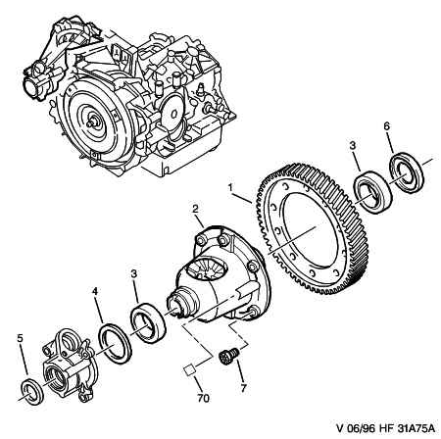
Figure 14 - Peugeot 306 Gearbox Diagram (Catcar.info, n.d.)
A final possibility considered was the repurposing of only the differential component from a road vehicle, eliminating the crown gear and instead installing a pulley or sprocket to drive the differential in that manner. Such an approach would result in a solution that is both compact and cost-effective, and furthermore, it would be environmentally sustainable since the component could be sourced from a defective gearbox. Additionally, this solution would meet regulatory standards by incorporating an open differential design.
Table - Decision Matrix for Rear Differential Solution
Driveline Option | Weight | Cost | Ease of Replacement/Serviceability | Compliance with Regulations | Packaging | Total
Quaife QBE35G/QBA2R/QBA11R | 3 | 1 | 1 | 0 | 3 | 8
Drexler STANDARD FS Differential | 4 | 2 | 2 | 0 | 5 | 13
BMW E60/E87/E90 Manual (Diesel) | 2 | 3 | 3 | 5 | 3 | 16
Chain/belt drive converted unit from a FWD gearbox/RWD differential | 4 | 5 | 4 | 5 | 4 | 22

Table 3 has been developed as a decision matrix to aid in the selection of the optimal driveline option for the design of the Formula 750 EV driveline. The decision matrix takes into consideration various evaluation criteria such as cost, weight, performance, and regulatory compliance. To assess each option's performance for a given criterion, a score of 1 to 5 has been assigned, with 5 being the most favourable and 1 being the least favourable. By comparing and contrasting the scores for each option in the matrix, it is possible to make an informed decision about the most suitable driveline option for the project. This approach provides a systematic and objective way to evaluate the different alternatives and facilitates the decision-making process.
The decision-making process has resulted in the two repurposed road vehicle units being selected as the most beneficial options for the project. Compliance with open differential regulations was deemed to be a crucial factor in the decision-making process. Ultimately, the chain/belt drive converted unit was selected for the following reasons:
- Tunability of gear ratios.
- Ease of packaging.
- Weight/cost ratio.
- Sustainability factor.
Overall, the selected driveline option is expected to meet the project's requirements effectively, and its tunability, ease of packaging, weight/cost ratio, and sustainability factor make it a strong choice for the Formula 750 EV driveline design.
    - Drive System Selection
Given the decision to rely on either chain or belt drive, it was determined at an early stage that propelling the rear differential via a shaft would not be pursued.
Table - Drive System Decision Matrix
Drive System | Weight | Cost | Ease of Replacement/Serviceability | Operating Noise | Total
Chain Drive | 4 | 5 | 4 | 3 | 13
Belt Drive | 5 | 4 | 5 | 4 | 14
In order to determine the most suitable option between chain drive and belt drive, a decision matrix was developed based on several criteria that were deemed important. The evaluation was conducted by assigning a score to each option based on how well it met each.
After the evaluation was completed, it was determined that belt drive was the preferred choice with a total score of 14 out of 20 possible points, compared to 13 points for chain drive. Belt drive scored higher in efficiency, noise level, maintenance, and tensioning required, while chain drive scored higher in cost.
One of the main factors that favoured the use of belt drive was its efficiency, as it is known to provide better power transmission than chain drive. Moreover, belt drive was also found to produce less noise, require less maintenance, and involve less tensioning when compared to chain drive. On the other hand, chain drive was more cost-effective, which was the main criterion in which it scored higher than belt drive.
    - Differential Acquisition & CAD Modelling
In order to proceed with the project and obtain the necessary measurements for CAD modelling, a local vehicle dismantler was contacted. The aim was to identify any defective transaxle gearboxes that would be suitable for the project's requirements. After a thorough search of the available stock, a transaxle gearbox unit from a Peugeot 306 1.9D was selected and purchased for the sum of £38. Making it even better valued that previously estimated.
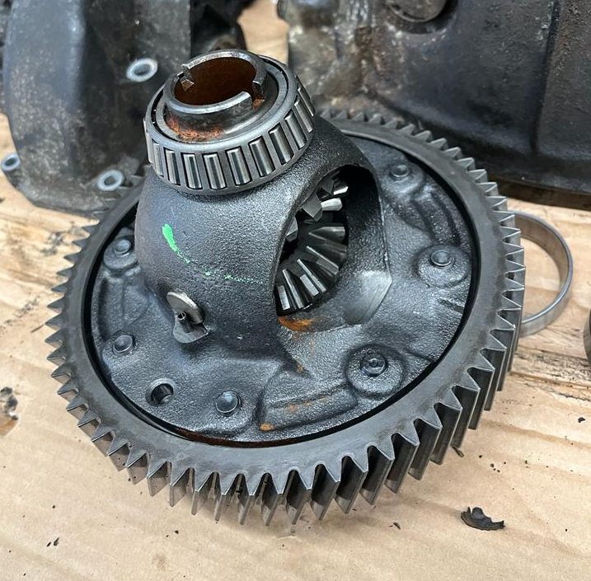
Figure 15 - Differential Unit from Peugeot Gearbox
This unit is expected to withstand the torque input generated by the EMRAX 268 motor, owing to the fact that the torque input in its original application through the crown gear was significantly higher, owing to the mechanical advantage inherent to the final drive and highest gear ratio.
The dismantling of the gearbox and subsequent removal of the differential ring gear and bearings, as depicted above, was undertaken to enable the required measurements necessary for the translation of the gearbox into CAD models.
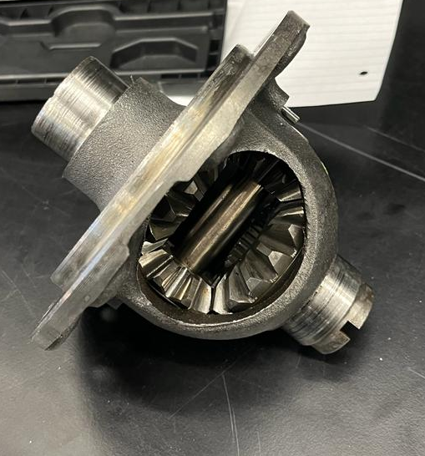
Figure 16 - Bare Differential Unit
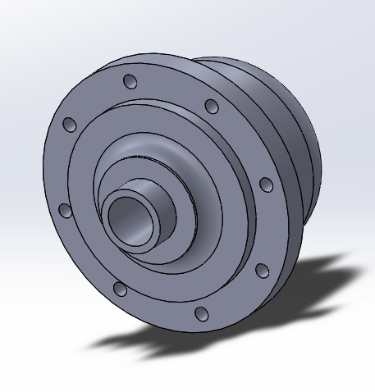
Figure 17 - CAD Model of Differential

Pulley and Belt Selection
Taking into consideration the aforementioned factors, the next step in the process was to utilize the Gates Design Power Software, a computer-aided design tool, to determine the appropriate specifications for both the motor and differential pulleys, as well as the corresponding belt required for optimal performance.
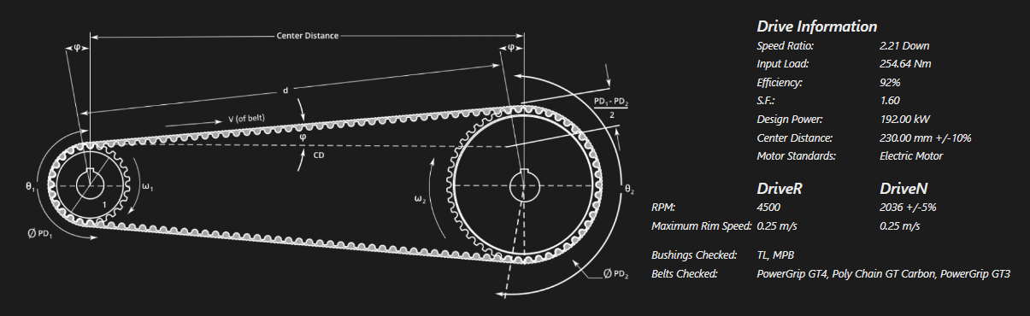
Figure 18 - Screenshot from Gates Design Power Software
Upon inputting the values derived from the preceding calculations into the Gates Design Power Software, it was revealed that an exact match for the intended 2.21 reduction ratio could not be achieved. However, the software generated a proximate solution, resulting in a 2.11 reduction ratio, thereby yielding a top speed of 209.56 km/h for the vehicle.
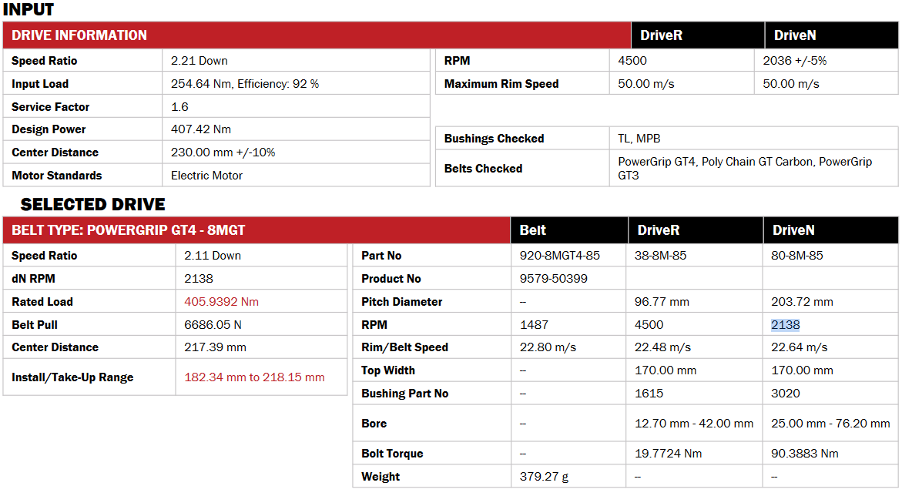
Figure 19 - Gates Design Software Results
The chosen drive belt was identified as the Gates reference number 920-8MGT4-85, which is a member of the POWERGRIP GT4 line of ethylene elastomer high-torque synchronous reinforced with fiberglass chord (Gates Corporation, n.d.).
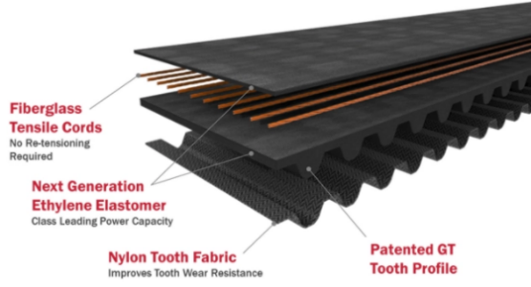
Figure 20 - Gates PowergripTM GT4 Composition
The 38-8M-85 pulley with 38 teeth and a pitch diameter of 96.77 mm was selected as the driver pulley. The driven pulley for the system was determined to be the 80-8M-85 pulley, featuring 80 teeth and a pitch diameter of 203.72 mm. The centre distance between both was established as 217.39 mm, with deliberate consideration to provide clearance for both the differential and the axial flux motor casing radii.

Using New Gear Ratio with Drive Cycle Data
Figure 14, shows the RPM range of the EMRAX 268 motor with the determined gear ratio.

Figure 21 - Electric Motor Speed with New Gear Ratio Applied to the Drive Cycle Data

Figure 22 - Electric Motor Torque with New Gear Ratio Applied to the Drive Cycle Data
As illustrated in Figure 15, the torque value consistently remains above 244Nm, which represents a substantial increase of 187% in torque when compared to the original 1108cc engine, which only generated 85Nm at 3500rpm.
    - Differential Conversion to Belt Drive
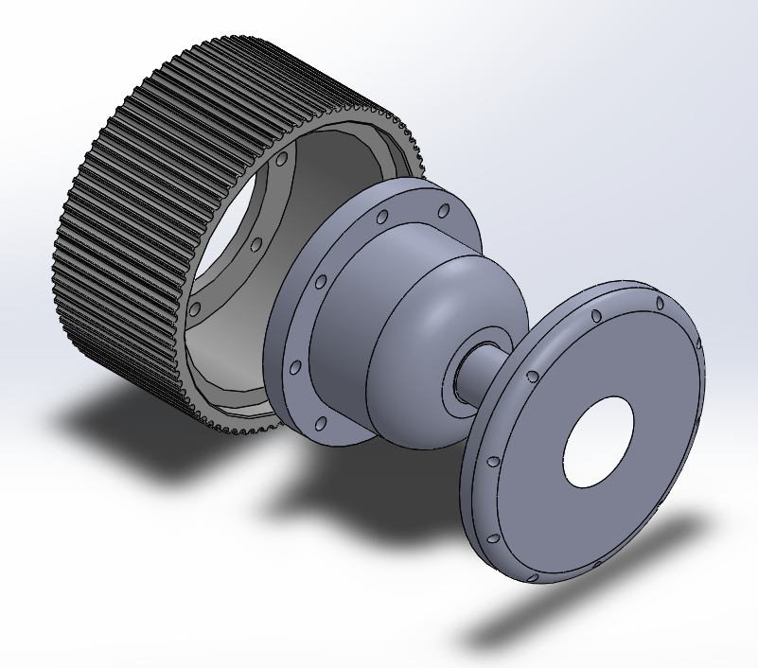
Figure 23 - Exploded View of Belt Drive Differential System
Figure 16 displays the final output of the belt drive conversion process for the differential, which involved modifying the selected pulley to conform to the same bolt pattern as the original crown wheel, in addition to designing a side cover (Figure 17) to seal the oil bath surrounding the differential side gears and pinions.
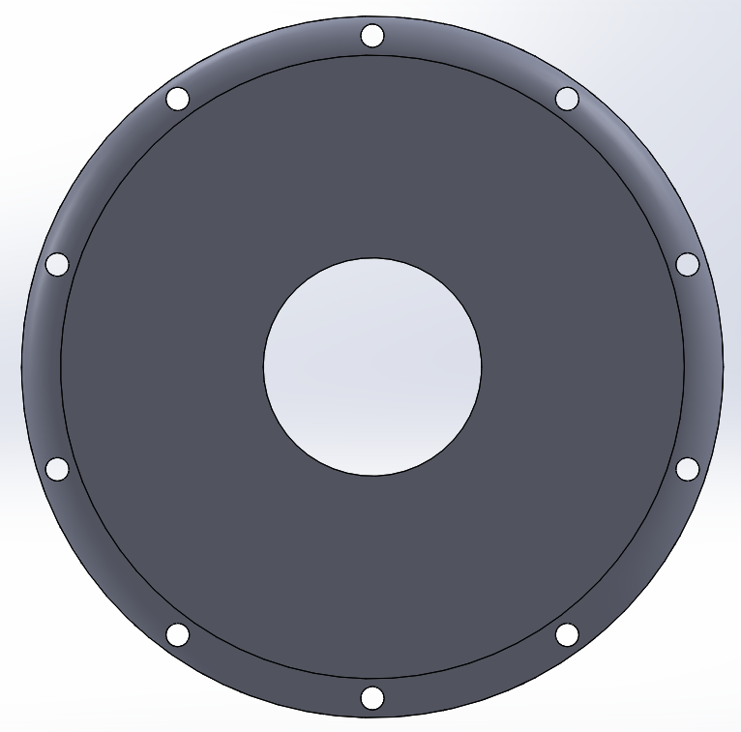
Figure 24 - Differential Side Cover

Drivetrain Layout
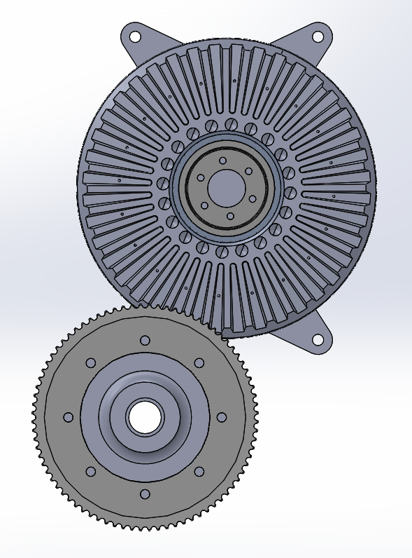
Figure 25 - Side View of Drivetrain Layout
The belt system mandates a fixed centre distance between the motor and differential, and the resulting proposed drivetrain configuration. This arrangement situates the differential in a manner comparable to the original engine, which is advantageous due to the rear suspension design that restricts access to the driveshaft and influences the driveshaft angles.
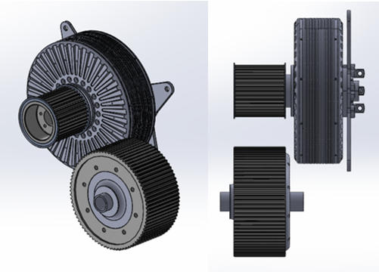
Figure 26 - Isometric (left) and Top (right) views of Drivetrain Layout

    - Bearing Selection & Differential Bracket Design
The Timken JL69310 bearings, with a tapered roller design featuring an inside diameter of 38mm, an outside diameter of 63mm, and a width of 17mm, were the original differential bearings. While these bearings could possibly be repurposed, their design is tailored to handle axial loads from the helical ring gear in their original application. Since our proposed design implies normal operating conditions with predominantly radial loads, it would be preferable to use deep groove ball bearings to simplify the overall design. This will also not require the bearing to have axial preload, further aiding simplicity in the assembly process.
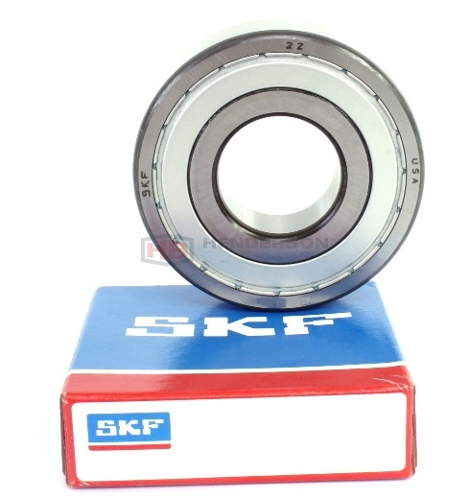
Figure 27 - 207-2Z SKF Deep Grove Ball Bearing (Henderson Bearings, n.d.)
Despite pursuing numerous supplier catalogues, no deep groove ball bearings with a 38mm inside diameter were identified. However, the SKF model 207-2Z, with a 35mm inside diameter, was ultimately located. Although minor adjustments will be required to facilitate seating on the differential, these modifications were deemed manageable. The SKF model can adequately handle our radial load requirements, and with a limiting speed of 11000RPM, it is more than adequate for the 2040.58RPM rotational velocity that the differential will attain at the vehicle's maximum speed. (Henderson Bearings, n.d.)
To ensure that the differential bracket design would be optimal for the bearings chosen, a rough draft was initially mocked up as a base. This provided a tangible representation of the bracket's configuration, which could be analysed and assessed for any potential issues or modifications that may need to be made.
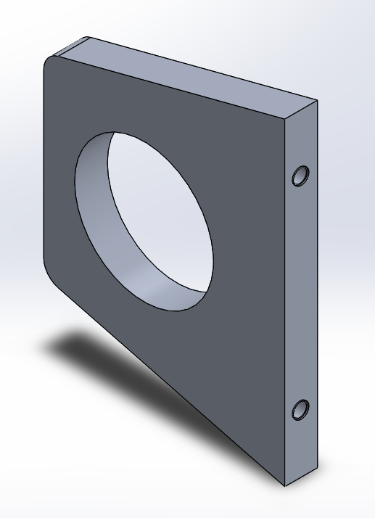
Figure 28 - Initial Differential Bracket Design
With the fundamental design of the differential bracket established, further analysis was required to reduce its weight while maintain the required stiffness to ensure performance. To achieve this, a topology study was conducted using Solidworks.

Figure 29 - Topology Study of Differential Bracket
The part was then constrained as it would be on the vehicle and a torque (equivalent to the maximum torque of the motor plus its mechanical advantage provided by the pulley system) was applied around the press fit surface of the bearing, mimicking the worst case scenario where all of the motor’s torque was applied to the differential bracket in case of a bearing failure. The study was conducted on aluminium alloy 2040 (commonly used in aerospace applications) with the objective of reducing its mass by 45. The study was performed while keeping the part constrained to the specified thickness of 17mm.
The data generated from this study was explored and utilized to modify the part design. The study provided valuable insights into areas of the bracket that could be optimized for reduced mass, while still maintaining its strength and functionality.
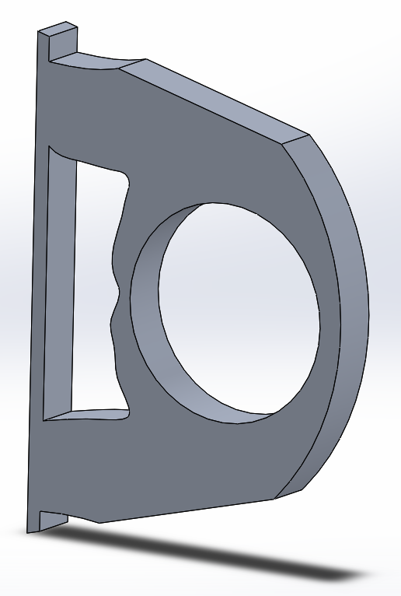
Figure 30 - Resulting Bracket After Topology Study
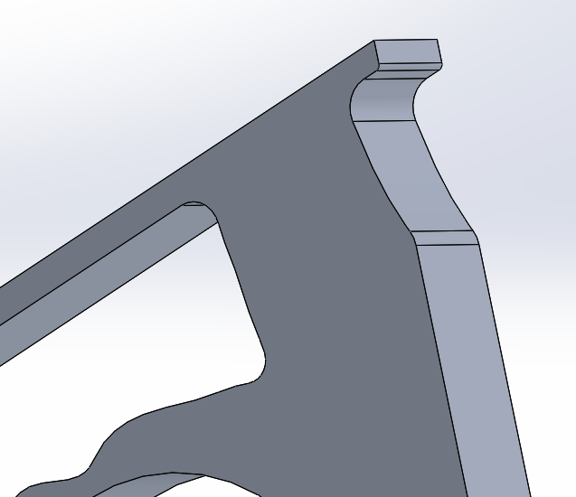
Figure 31 - Fillet Edges for Controlling Stress Concentration
Subsequently, a final static study was performed on the finished part to evaluate its deformation characteristics when subjected to such loads. The findings indicated that even at high loads, the part would experience a maximum deformation of 35 micrometres at its point of highest displacement.
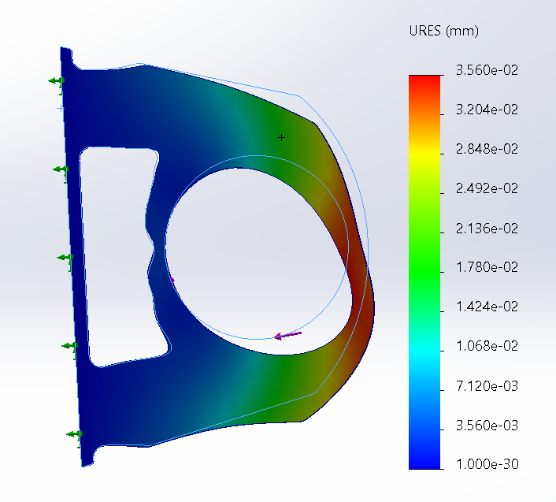
Figure 32 - Final Static FEA Study on Resulting Bracket
    - Driveshaft Selection and Sizing
Currently, there is no set decision regarding the packaging of the rear, and thus no judgment has been made concerning the driveshafts, except for the need to adapt them from a Peugeot 309 inner CV joint with 23 teeth spline and a Fiat Seicento 1.1 outer CV joint with 22 teeth.

Chassis and dynamics (Joseph Britton)

Measuring suspension coordinates
The area of chassis and dynamics within this project covers the suspension systems which will be analysed to see whether they are suitable for the vehicle once the conversion is completed. This requires testing of the suspension through WinGeo to see how the vehicle is affected through roll and steer. The testing method that was adopted required the full suspension plots to be taken is to use an origin point and measure distances from this point to the suspension component. The traditional method for completing this task would be to select an appropriate origin point (datum) and measure the points on the chassis which you need for analysis conforming with the LSA coordinates system. This system states that the x value denotes the value along the wheelbase of the vehicle with positive values going in the direction of the rear of the vehicle, the y value considers the track of the vehicle, and the z coordinate shows the value for the vertical axis (Lotus Cars ltd., 2015).

Testing methodology
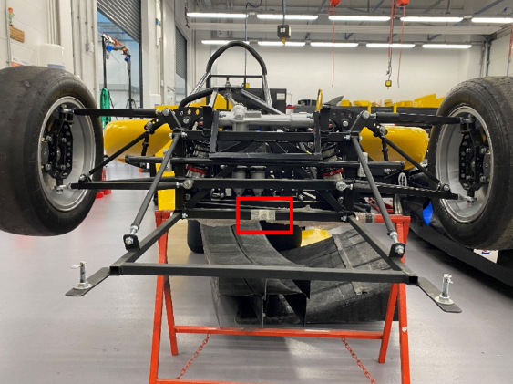
The first step in this process is to select a suitable datum. To do so you must measure from a point that is square on the chassis. In most cases the point is taken along the centre of the track of the vehicle along the centreline of the front wheels at a specific height from the ground. However due to this unusual case for this vehicle the point was taken differently. The construction of this chassis was quite rudimentary compared to modern vehicle construction, being that it was assembly by a single worker using hand tools rather than precise robotic machines. This resulted in a slightly asymmetric chassis which meant that the typical datum that would be used in most cases would not be suitable for this application. Using this information another point on the vehicle was selected. The point was still taken along the centreline of the track however the x and y coordinates were selected differently. The front of the vehicle has a square box which allowed the coordinates to be easily taken from so this area was used, this can be seen in figure 27.

A laser was shone down the vehicle from the square box at the front so that a point on the rear of the vehicle can be used that was square with the front. A series of measuring apparatus were used which included vernier callipers, tape measures, levels, and engineering squares to gather all the data. To measure the points of interest for the steering rack, it was essential that the steering was clamped into a straight position to gather the best data.

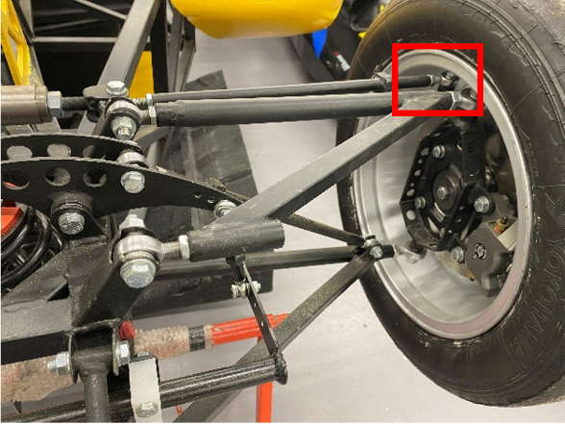
The largest difference in values is the x coordinate for the point taken at the wheel. This could be due to the difference in toe and camber for each side. Shown in figure 28 is the point of concern, another reason which could’ve contributed to the large difference in values may have been inaccuracies when setting the steering straight on the vehicle, however due to the accuracy of the x coordinate for the point taken at the steering rack this is unlikely. Both the x and z coordinates have significantly larger differences measured at the wheel compared the points measured at the rack which indicates a slight difference in the length of the rods connecting the two points.
Figure 33 - Highlighting steering rod attachment

Analysis
The largest percentage differences are seen to typically appear for the z coordinates, this is also true for the rear of the vehicle. These are the largest inaccuracies measured throughout the vehicle. Table 6 displays the measured data with percentage differences for the steering rack.
Table – X, Y & Z coordinates for steering rack
Table – X, Y & Z coordinates for steering rack.
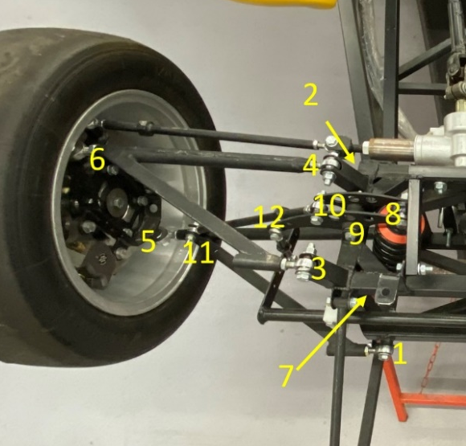
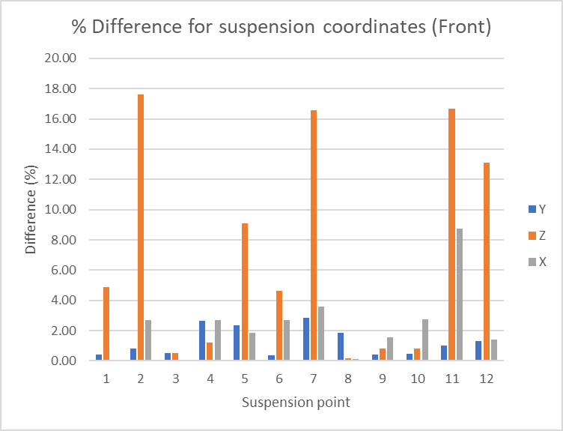
As seen in figure 30, the largest percentage difference for values regarding both front and rear of the vehicle all come for the z coordinate. Figure 29 shows the suspension points numbered. The greatest percentage seen in point 2 which is the rearward mount to the chassis for the lower wishbone. The other two points above 16% are the shock mount and shock mount to the lower wishbone.
Figure 34 - Suspension points numbered.
Figure 35 - Percentage difference between side for suspension coordinates

Being that the measured values show an asymmetry for the chassis it is important to know whether this influences the dynamics of the vehicle. To do this a WinGeo model of the vehicle was created to analyse the roll centre of the vehicle throughout roll. Typically, in production vehicles a roll centre is designed to be perfectly centre on a vehicle leaving room for minimum lateral migration however in some cases regarding racing vehicles, the lateral movement of the roll centre can be a design element (Mitchell, 1998). Due to the vehicle having an unusual rear suspension, being a combination of a few styles, it was not possible for it to be analysed within WinGeo. Figure 31 is an image of a WinGeo model based on the measured data gathered. It can clearly be seen to have an asymmetric roll centre with a y coordinate of -60.344 and a z coordinate of 147.201. There is a clear effect on the roll centre shown in the graphs listed on figure 31.
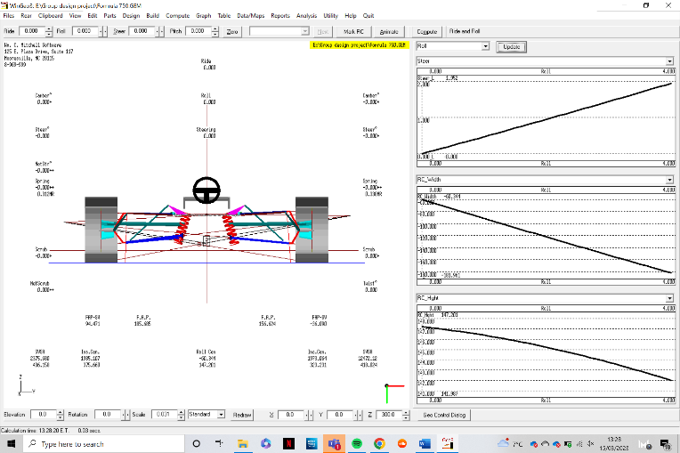
However, to better understand the magnitude of impact two other WinGeo models were made. One with values symmetric from the left side and one with values symmetric from the right side. The two other models that were created used measurements taken from a single side of the vehicle and copied over to the other side. Table 8 shows these values.
Like the steering rack, all the large difference in measurements for the front suspension reside on the z axis. The suspension points with the largest differences are points 2, 5, 7, 12 and 12 referring to figure 29. As mentioned previously the z axis covers the vertical plane, which for points 2 and 5 will affect the roll centre of the vehicle more than the other points due to the lower wishbones having a higher effect on the roll centre (tech, n.d.). The model using the onside (left) measurements will have a higher roll centre on the vertical axis because of this difference in geometry.
Figure 36 - WinGeo model of chassis
Table - measured suspension coordinates with percentage differences
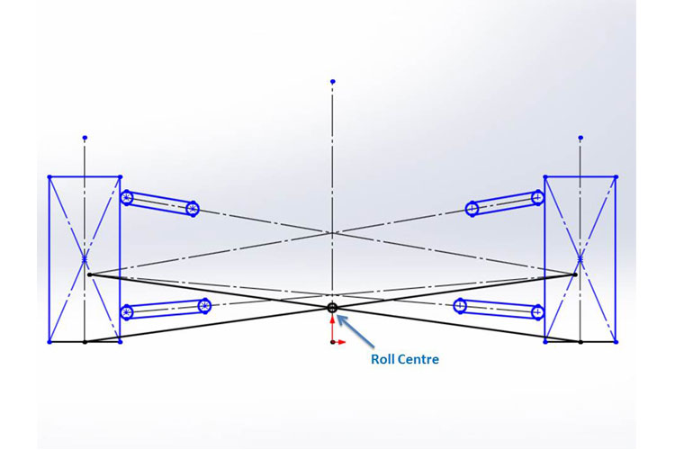
The reason the lower suspension components have a higher effect on roll centre location is due to the way roll centre is determined. Figure 32 shows how it is done. Essentially by drawing lines from the instant centres to the centre of each opposite tyre, the point at which they intercept is the roll centre (Suspension secrets, 2019). Hence why the angle of the lower wishbones has this increased affect compared to the upper wishbones.
Figure 37 - Diagram on how to locate roll centre.
Due to both theoretical models having identical suspension from left to right, both setups have the roll centre directly central. However, they differ in the height of the roll centre and the migration of the roll centre. Figures 33 & 34 depict the models that show the symmetrical values. Although the graphs look identical the values show that the model with values symmetric from the right side of the vehicle has a higher roll centre. This model will have an increased roll response due to the decreased roll inertia (Vogel, n.d.). Reducing the body roll of a vehicle will in turn increase the geometric load transfer, resulting in a quick turn in.
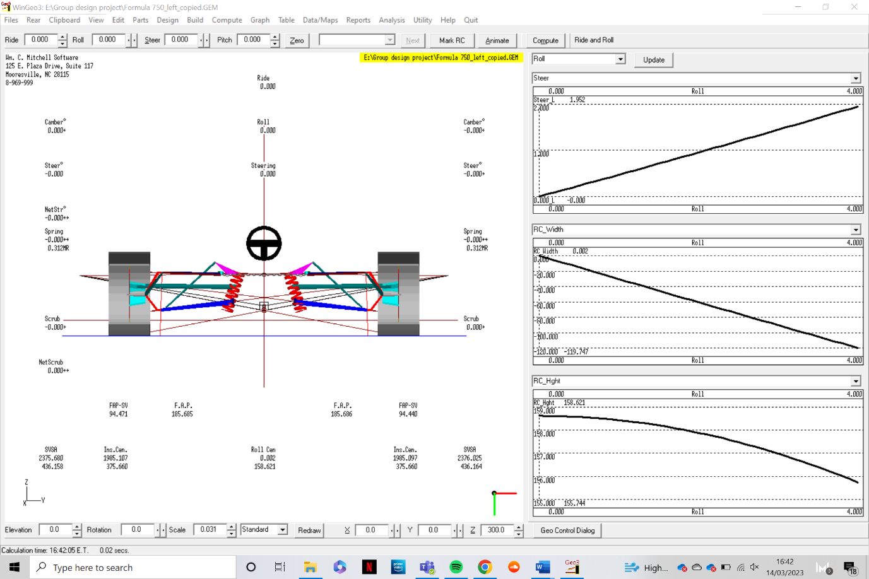
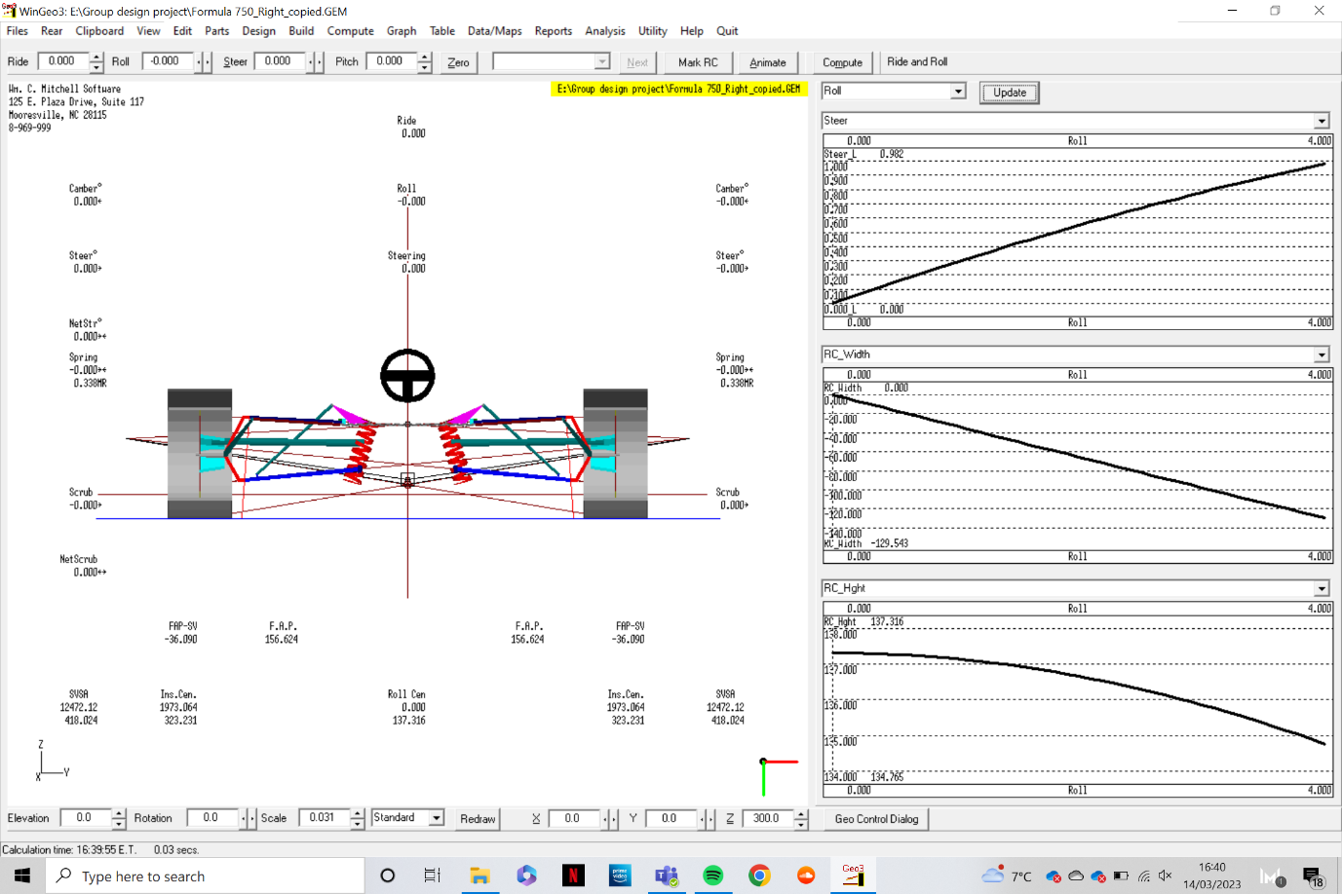
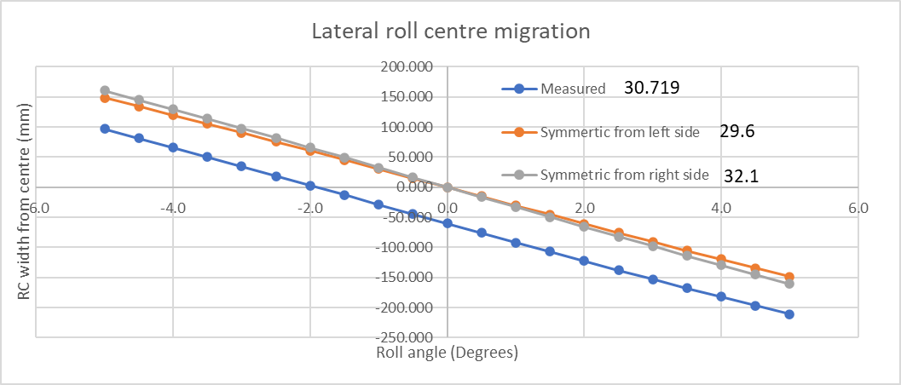
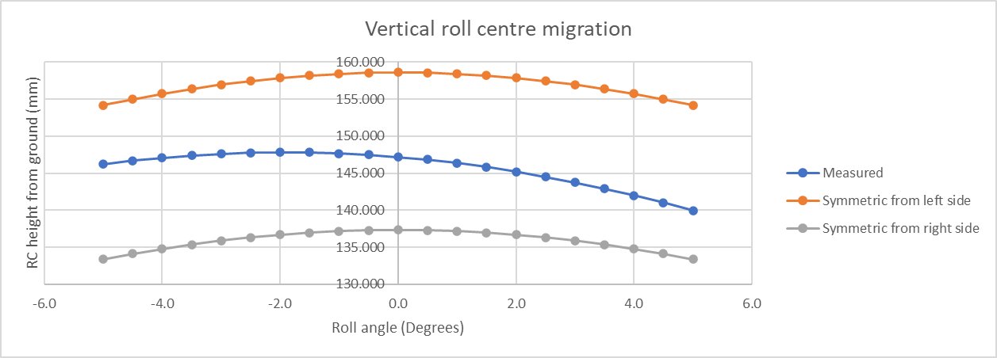
Figures 35 & 36 illustrate how the roll centre migrates through 10 degrees of roll. It can be seen the model with the highest rate of change is the model that is symmetric to the right side of the vehicle, from the graph considering RC width. Despite this, due to the measured vehicle already having an offset roll centre, it reaches the greatest distance from centre. From this we can see that the model with values symmetrical to the left side controls the roll centre the best with regards to RC width. A vehicle that has a roll centre that migrates significantly will be more unpredictable and less balanced, this is not ideal for a racing vehicle. Although the model with symmetry for the left side controls the migration of the RC width the best, it’s roll centre is the furthest from the ground vertically. Dependant on the Centre of gravity height this can either be good or bad. A vehicle with a high RC will have more geometric load transfer than elastic load transfer, resulting in instant load transfer. This will mean a quick turn in. A vehicle with a low RC will have more elastic load transfer compared to geometric load transfer, resulting in a lethargic turn into a corner. Based on the vehicle structure and the planned layout for the final design considering the placement of motor, controller, and batteries, we can assume the vehicle to have a low centre of gravity especially when you consider the low ride height. The higher the RC the more force will be put through the wishbones and less through the spring and dampers (Vogel, n.d.). Being that the RC migration for the model which is symmetric to the right side has only a lower gradient only by a small amount, however, has a much lower roll centre along the vertical axis, it is clear to say that this model would be the most suitable for the vehicle. Should the vehicles suspension pick up points be amended then they should keep the right side of the vehicle the same whilst copying those coordinates to the left side of the vehicle.
Figure 38 - WinGeo model symmetric to left side
Figure 39 - WinGeo model symmetric to right side
Figure 40 - Lateral migration of roll centre

Figure 41 - Vertical migration of roll centre

Optimum Lap

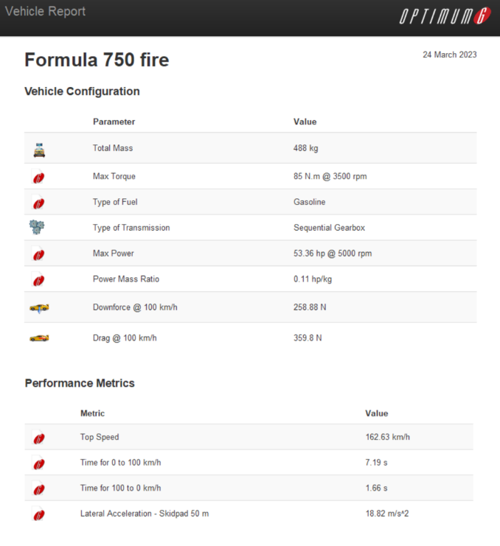
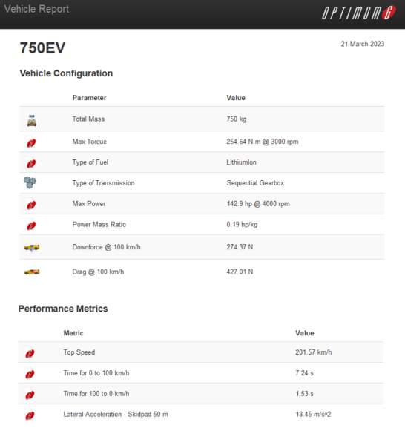
This software is an easy way of predicting how a vehicle will perform around a track. Two vehicle models were created, one depicting the vehicle before the conversion took place using engine data from the original engine (fiat punto 55). The second model used data from the motor specifications, calculated gear ratios and an estimated final mass. Both models shared estimated data regarding the frontal area, longitudinal and lateral friction and rolling resistance. The vehicle reports are shown in figures 37 & 38.
Figure 42 - Vehicle report for Formula 750 fire
Figure 43 - Vehicle report for formula 750 EV
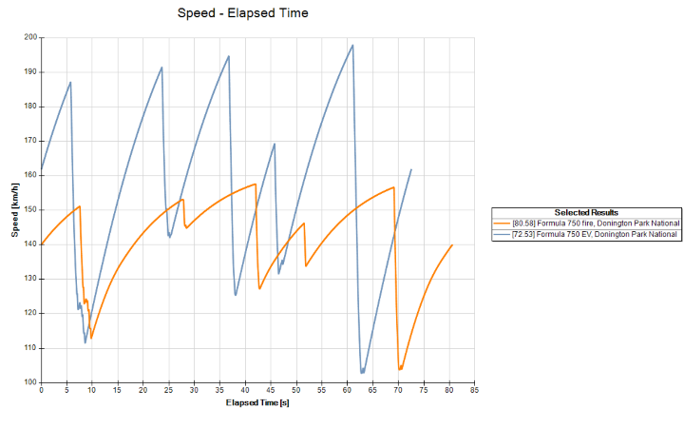
The results were validated against lap times recorded on the formula 750 website from current competitors and compared to the lap times stated form the simulator. The simulated original vehicle ran a 1:20.58 around Donnington Park national whilst the fastest lap around the same course from the most recent race was 1:19.22. This tells us the simulation is realistic and lands right within the competition. The simulated vehicle post conversion ran a 1:12.53 which shows a significant improvement over the standard vehicle. Figure 39 illustrates this improvement.
Figure 44 - Speed/time graph comparing pre and post conversion

Optimum lap limitations

While this software is very useful to gauge how a vehicle will perform. It is not a great tool to gather any final figures, this is due to the lack of parameters that it considers. It also makes unrealistic assumptions that hinder its performance. The system implements its own traction control which would not be fitted to this car and is a lot more effect than any human effort. The system also assumes constant lateral and longitudinal grip which is highly unlikely in a real-world scenario. The only way to get any final figures to work with and track how well the vehicle has progressed since beginning the project is to compare a lap around an identical track with the same driver in matching conditions. Given this scenario is highly unlikely the simulation made using optimum lap is a relatively good tool for comparison.

Rear suspension

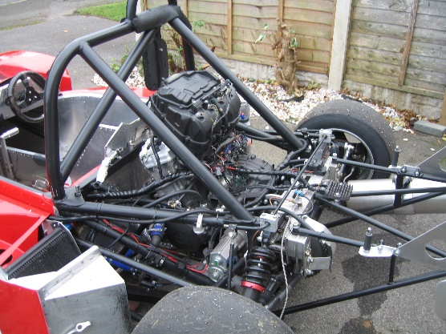
Due to the complexity of the rear suspension, it increases the difficulty to fit the whole motor package in. This creates a large problem for packaging, which the easiest solution to is a redesign of the whole rear suspension to a simpler double wishbone system. This reduces complexity, it also allows for extra room to package the system. Once more this increases the room for driveshafts to be fitted. The proposed system would be like on figure 40, this shows a formula 750 competitor which runs a double wishbone setup. This allows for a larger whole to slot the driveshafts into which also helps servicing and replacement of parts when compared to figure 41, this is an image of the current rear suspension on the vehicle without any of the drivetrain which is clearly already quite clustered. This is the direction that the project would continue in.
Figure 45 - Double wishbone suspension on a formula 750 race car
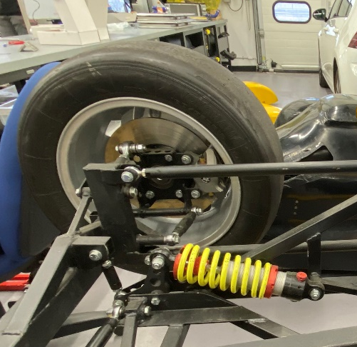
Figure 46 - Current rear suspension setup

3.5 Battery and Management

3.5.1 Drive Cycle (Kieran Dellow)
Using MATLAB, data taken from previous laps at Anglesey raceway, and Donington Park, and read into a MATLAB file.
Velocity data was then manipulated, through the use of smoothing functions and filtering, to remove any “noise” from the data. This could be due to malfunctioning equipment.
Once the data had been cleaned up using smoothing functions, it could then be plotted, and compared to the original raw data from the lap.

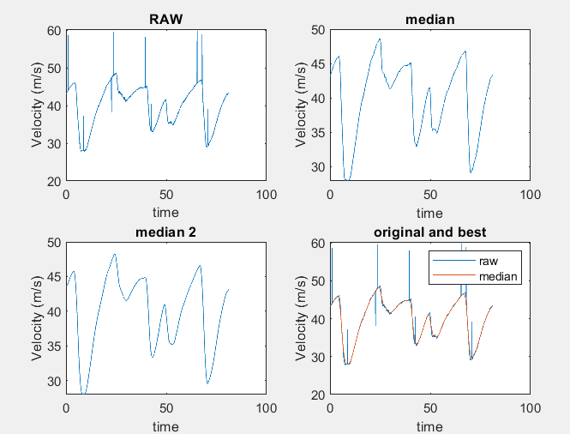
Figure 47 MATLAB raw data vs smoothed data

This gave a good indication of how different the data could be, which could be amplified further when calculating other values such as lateral acceleration, or total energy output.
After the new value for velocity had been calculated, lateral acceleration across the lap was calculated using the new smoothed data, as using the raw velocity data resulted in peak lateral acceleration of over 60 Gs, which is clearly incorrect.

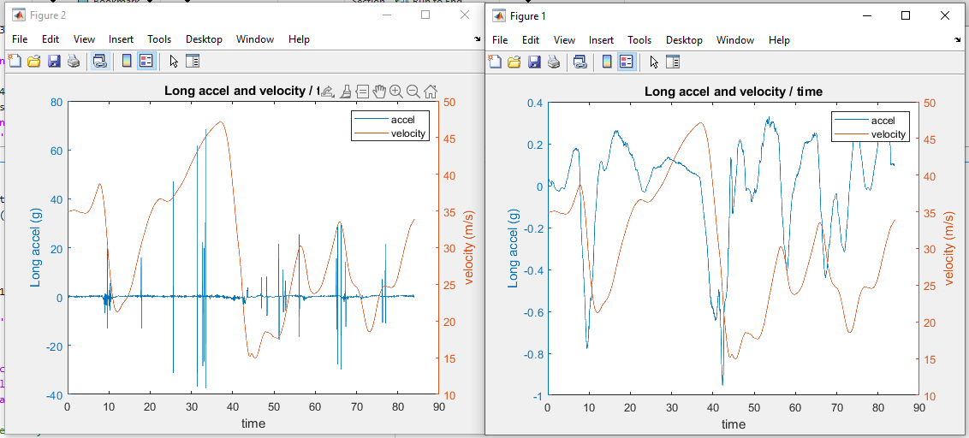
Figure 48 MATLAB Long accel and velocity raw vs smoothed

In order to calculate values such as total energy output, resistances had to be considered, such as the aerodynamic drag of the vehicle. It was assumed that the air density was a constant around the track, at 1.202 kg/m^3.

Coefficient of drag was given at 0.7, which was used to calculate the air resistance at any given point on the track, using the respective velocity at that moment, as well as the weight of the vehicle, given as 488kg

Figure 49 Car weight message

The coefficient of rolling resistance was also assumed at 0.015, slightly higher than the average for a car on a tarmac road, as tires that maximise grip were used as opposed to regular consumer tires.
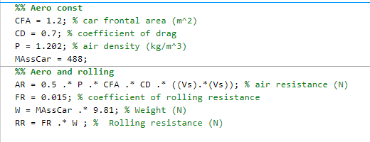
Figure 50 Aerodynamic and rolling resistance coding
Inertial resistance was also calculated using the mass of the car and its acceleration. This was then, in addition to rolling resistance and air resistance, used to calculate the total resistance of the vehicle at any given moment around the track.
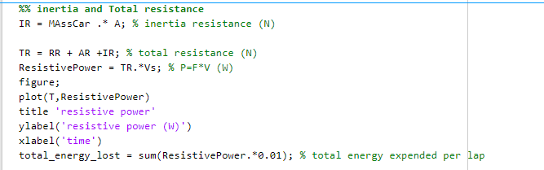
Figure 51 Inertial resistance and total resistance coding
This was then manipulated into resistive power by multiplying by velocity, which could then be plotted against time to give a visualisation of how much resistance there is.

Total energy lost across the whole lap was then calculated by dividing the energy by a value of 0.01 and totalling these values.
Total energy used over the lap was also calculated, by calculating kinetic energy across the lap, and then using the ‘diff’ function to calculate the change in KE.
Resistances were then subtracted from this value, and then finally the total energy transferred to motion was calculated by simply subtracting ‘total energy lost’ from ‘total energy’.
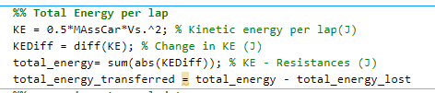
Figure 52 Total energy coding
Finally, the model was then compared to actual energy figures across the lap, by using fuel consumed per lap, calculating the calorific value of the fuel, per litre. A figure of 20% efficiency was then used for the FIRE engine, to give a total useful energy, which was ultimately compared to the model’s predicted value.
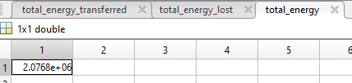
Figure 53 Total energy value
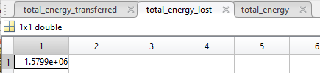
Figure 54 Total energy lost value
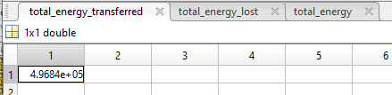
Figure 55 Total energy transferred to motion value
Shown above are the values in Joules of the total energy, total energy expended, and total energy transferred to motion. Below is the real energy expended (FJE) calculated through the calorific value of the fuel burnt, which can be compared to ‘total_energy’
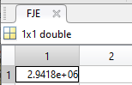
Figure 56 Real total energy value

Looking at these results, it shows that the model can be a useful tool for the development of the project, giving a good indication of how much energy will be needed to be stored inside the battery pack. This value will most likely have to be extrapolated, as the new weight of the car with the battery pack, motor, cooling system, new differential, BMS, Controller module, and any other changes to the vehicle, will most likely weigh 150-200kg more than before, requiring more energy.

The data model was also reused for donington data, to determine whether or not it was valid for other tracks. Below is a value for total energy transferred to motion at donington park raceway.
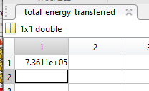

This output of the model suggests that it is valid for different tracks, with the transferred energy being in the same ballpark as the Anglesey data. There was no data for fuel consumption at donington park to compare with the calculated energy transferred, so the only comparison we can make is the same calculation, between the two tracks.

3.5.2 Process to designing a battery pack.
  - Author-Dylan Davies

3.5.3 Analysis of why lithium-ion battery chemistries are best suited for high performance vehicles.

  - Lithium-ion chemistry
The energy flow is created by the transfer of ions from the anode to the cathode during the application of current, while the opposite occurs during discharge. A separator material made of porous polypropylene is used to facilitate this process. Charging generates flow which is then conducted through a copper current collector.
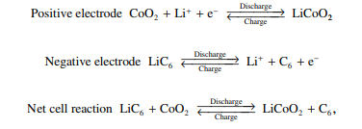
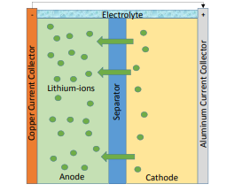
Figure 57 lithium-ion flow
Figure 58 Charing of a Lithium-ion

Lithium-ion battery typically have higher voltage. Lithium-ion batteries also have a higher energy density. The lithium-ion chemistries will be able to last tens of thousands of cycles. Different lithium-ion chemistries can be found in figure 19.

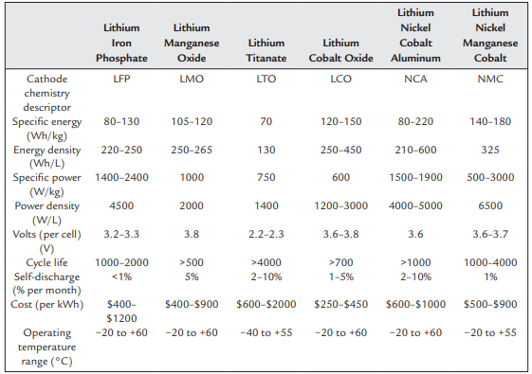
59 Lithium-ion chemistries

3.5.4 Analysis of different Lithium-ion modules

  - Research carried out on different battery lithium-ion battery modules.
Research was carried out on 10 different battery module options and data was gathered. The following were researched:

- -VW ID Module 8S -( 6.85Kwh, /234ah/29.6v)
- -Tesla model S/X module – (5.3Kwh/232Ah/22.8v)
- -VW e-golf module- (1.6Kwh/108Ah/15v)
- -VW ID module 12S –(6.85Kwh/156Ah/44v)
- -VW E-golf Module- (0.8Kwh/107Ah/7.6v)
- -BMW i3 Module- (5.27Kwh/120Ah/44v)
- -Jaguar I-Pace- (2.6Kwh/236Ah/11v)
- -Mitsubishi Outlander Module LEV46-8 - 1.3kWh / 46Ah / 29V
- -BMW i3 Module - 4.1kWh / 94Ah / 44V
- -Tesla Model S/X Module - 6.4kWh / 287Ah / 22.8V

  - Mathematical method to determine suitable battery module option.
Peak power and energy of the system was gathered from the drive cycle done by kieran. A peak power of 100Kw and 4.44E+06(joules) of system energy was decided. The energy was calculated by times the energy used for one lap by 15.
The following maths was done for each battery module research in section 23242.

$C rate discharge \left(10s\right)=\frac{Max c rate discharge (A)}{Module Current (Ah)}$ Equation 1

‘’A C-rate is measure of rate at which battery is charged or discharged relative to its capacity. It is defined as the current flowing in or out of a battery divided by its rated capacity, expressed in amperes’’. As the vehicle of the project is required to have a high-power output, a high c-rate is needed to load fastest and more efficiently without suffering from voltage drop or excessive heating.

$Number in modules in series(n in series)=\frac{Peak power required (w)}{Modules volts×module current×C rate discharge}$ Equation 2

The next step is to figure out how many cells are needed to meet the peak power required.

$System Power Output (Kw)= \frac{(Module volts×N in series)×(Module current×C rate discharge)}{1000}$ Equation 3

$System energy Kwh=\frac{(Module volts×N in series)×(module current×3600)}{3600000}$ Equation 4

$Number of sessions=\frac{System Energy(Kw)}{Total Energy required (Kw)}$ Equation 5

$Total pack mass \left(Kg\right)=Module mass×n in series$Equation 6

$Wh per Kg=\frac{Capacity(wh)}{Mass (kg)}$Equation 7

Also known as Specific energy, this is the maximum energy that can be generated per unit of total mass.

$£ per Kwh={Module price }/{Capacity Kwh}$Equation 8

$Total Volts=Module volts ×n in series$Equation 9
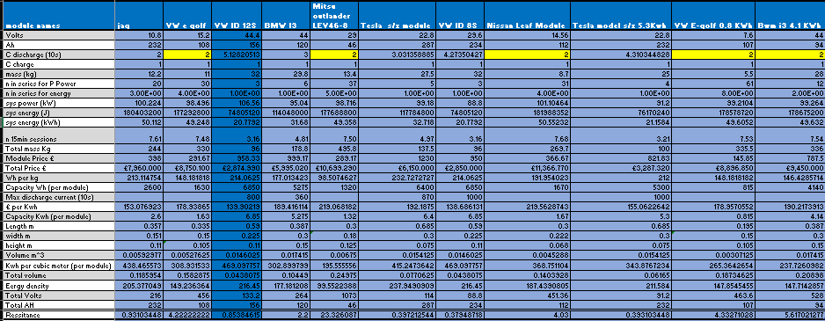
$Energy density=\frac{(module volts(v)×module current(Ah))}{Mass (Kg)}$Equation 10

Table Battery module calculated specifications.

Table 5 presents a summary of the mathematical equations performed in section 3.5.4 Analysis of different Lithium-ion modules. The highlighted data in yellow signifies the unavailability of certain values. A value of 2c has been utilized instead if the c-rate was unavailable. The one limitation of this is, the modules may have different c rates which will affect the peak power they can generate and energy in the system.

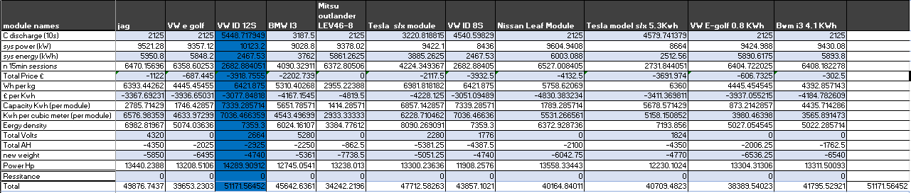
  - Decision matrix of lithium-ion battery modules
Table Decision matrix of battery module options

The evaluation criteria were selected based on each factor. The score for each factor is multiplied by a weighting. The weighting is the importance for each factor. Using a decision matrix ensures that the selection process is done correctly, and all factors are considered to their relative importance.
From table 6, its clearly that highest scoring module is the VW Id 12s, which will be the chosen project module.

3.5.5 Final battery module analysis

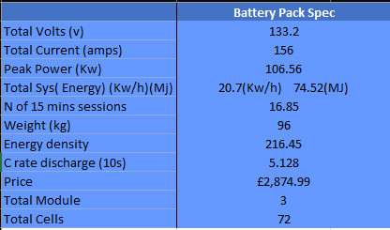
  - Final battery specifications
Table Battery pack specifications

The battery has a discharge c-rate of 5.128 which is desirable for EVS used in racing applications. A high c-rate of 5.128 indicates that battery pack can deliver a lot of power and a high c-rate allows for fastest acceleration and better performance. The high c-rate will allow for fast charging which is really needed as the battery is designed. The pack energy density is 216.45 wh/kg which is high, this shows that the pack will be able to store a lot of energy per unit of weight. The pack has a total 74.52MJ of energy which allows to do a total of 16.85 20 mins sections, . The ability to run the car for an entire weekend allows the team to focus on other aspects of racing without worrying about battery performance. The vehicle peak power is 106.56kw which is impressive and indicates that this power can be used for short periods of time which is needed for higher speeds sections of certain tracks in the Formula 750 championship. The peak power value is also much better than those produce by an ICE formula 750.

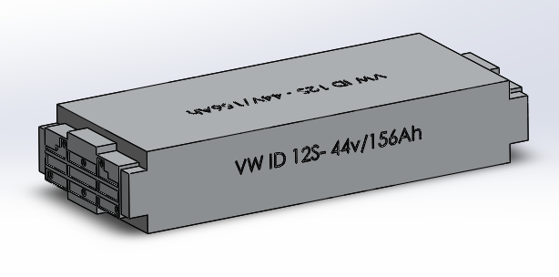
Figure 60 VW ID 12S CAD model- Dylan Davies
A CAD model of the Module was then sized and design up on solid works so it could be used to help the over packaging design of the vehicle.

3.5.6 Battery Management System analysis – (Dylan Davies)

‘’The BMS is an electronic controller that monitors and manages all the functions of the battery operation.’’ (Battery Management Systems for Large Lithium-Ion Battery Packs, 2010). The BMS will have separate electronics that will monitor temperature and voltage (VTM). There may be a thermal management system which will manage the liquid and air-cooled system that the cooled liquid/air through the battery pack design. There will also be switches to turn current flow on and off and wiring. All these systems will allow for a functionable battery pack.

The BMS is highly important to battery pack design as its used to ‘’ protect the safety of the operator of the battery-powered system’’ and ‘’to prolong the life of the battery under normal operating cases.’’ (Battery Management Systems, volume II, 2016) Motorsport is an expensive sport, so prolonging the life of the batteries will safe drastic amounts of money when racing.

  - Functionality of BMS (Balancer)
For large packs a balancer is the right option as ‘’it maximizes the pack’s performance by balancing the cells’’ (Battery Management Systems for Large Lithium-Ion Battery Packs, 2010). Balancers, however, are not standalone devices and usually include a communication link to allow for data to be sent to the rest of the system.
A balancer is perfect for the project BMS only if it’s wired correctly so charging source and discharging load can be controlled. Other options for BMS are shown in figure 21.
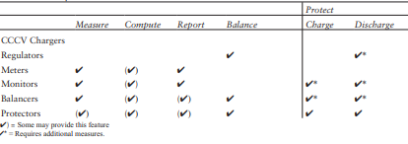
Figure 61 Comparison of the features of various BMS functionalities (Battery management systems for large Lithium-Ion battery packs, 2010)
  - Technology
There are two different technology that are usually used being digital and analog. Analog technology which is often referred as a simple technology knows the cells/module voltage when its low but doesn’t know which cells are low or how. An analog technology won’t be used in this project as it doesn’t fit the criteria of the chosen battery pack.

  - Sophisticated (Digital)
This digital BMS will know each cells/module voltage. This allows for an analysis of the battery pack. Sophisticated technologies are used normally in large Lithium-ion packs, hence the ideal choice for the project BMS.
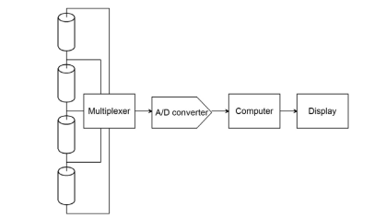
Figure 62 Example of digital BMS (Battery Management systems for large lithium-Ion Battery packs, 2010)

3.5.7 Chosen BMS
From analysis different functions and technologies were considered from different research, it’s obvious however, that the project will use a digital BMS will a balancer function. To determine the right size BMS total cells of the pack hade to be calculate, which can be shown in equation 1.

$Total battery cells=Cells per module×number of cells$ Equation 11

The total pack contains 72 cells so a BMS that can monitor 72 or more cells is required.
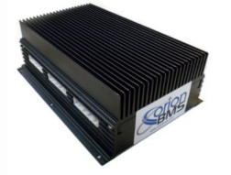
The chosen BMS was picked due its compatibility with the designed battery pack and the way it’s designed to meet tough requirements of protection.
Figure 63 Orion BMS Lithium-Ion Battery management system

The main features of the Orion BMS are that can monitor every cell voltage, it has intelligent cell balancing, enforces minimum and maxim cell voltages when also enforces max current limits. The BMS can limit temperature and monitor the state of charge. The design is robust but still should be place in a safe location where minimal damage to the vehicle won’t affect it.

‘’Cell Voltage Monitoring Specs
- Cell voltage resolution of about 1.5mV
- Maximum individual cell voltage rating: 0.5v to 5v per cell tap.
- Total pack voltages from 13v up to 850v (max.)
- Supports from 4 to 180 cells per BMS (more if units in series.)’’
(Orion BMS Specifcation.pdf, 2023)

3.5.7 Battery Pack Configuration

Battery pack generate heat during operation and the layout should allow for efficient cooling and eat dissipation. The cooling system or heat sink should be in contact with each module in the pack to prevent overheating. Safety must be considered in the design of the layout to ensure modules are protected from physical damage and that the module are isolated to prevent contact or exposure.

3.5.8 CAD layout designs
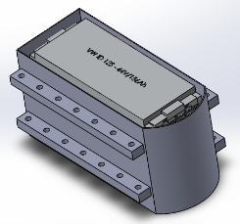
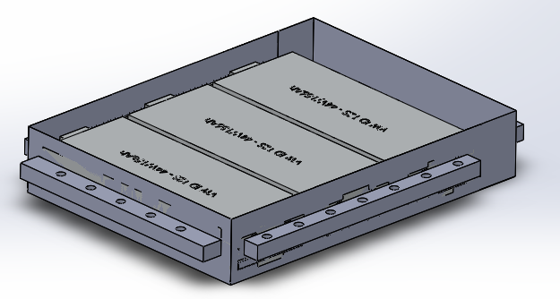
Figure 64 Battery pack layout

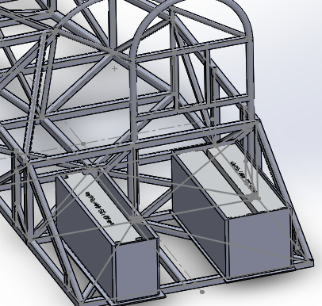
The layout of the modules are highly important for thermal management and packaging of the entire vehicle as space is limited as preferable the project would want to have the diff in the rear centre of the vehicle.
Figure 65 Battery pack Positioning- (Dylan Davies)
“The use of a split pack can provide many benefits, including improved weight distribution, more efficient cooling and heating of the battery, and easier replacement and serviceability of individual modules”. (Liu et al., 2016) The pack must be designed like this to have a motor and diff position in the centre and to avoid the suspension.

3.5.9 Crash Management

The Porsche Taycan using aluminium extrusions to carry structural load. Which can absorb energy when the vehicle crashes. ‘’Porsche engineers say that the battery and pack represent about 10% of the vehicle body stiffness:’’ (Aluminium Extruders council, 2023)
A key design feature from the taycan which will be used in the project design of the battery pack is the honeycomb structure. A more improved battery pack was design using the extrusion honeycomb design on CAD.
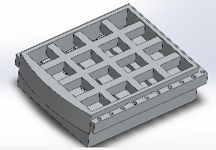
Figure 66 Honeycomb battery pack design- (Dylan Davies)
Figure 26 shows the load path distribution. During a crash the honeycomb structure will protect the battery modules due to the strength and energy absorption. The extrusions can also be used for fluid transport. The extrusions would be made from aluminium because its corrosion resistive has structural integrity and light.

Benefits of using extrusions honeycomb design
- Torsional stiffness
- Crash energy absorption
- Strength with minimal weight

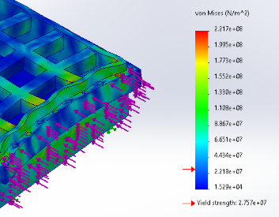
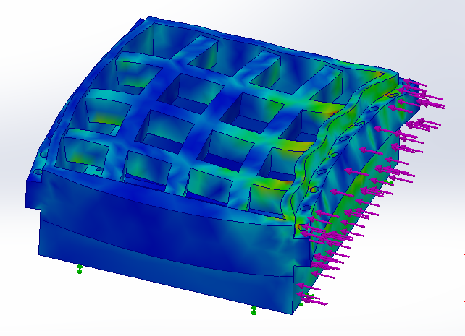
3.5.10 Stress analysis on battery pack models
Figure 67 Stress analysis

Battery pack designed made from aluminium didn’t maintain structural integrity and didn’t protect the battery modules. Analysis was done by applying a 600Kn force to the vehicle as if it was crashing at 30mph. The stresses were much greater than the yield strength of aluminium. ‘’yield strength is defined as the stress at which a material begins to deform plastically, meaning that it will not return to its original shape after the stress is removed’’ (Hibbeler,2011). This is an important study of the project, as the battery must be kept in good conditions as they are expensive and as a team you don’t want to be replacing them every time you crash.

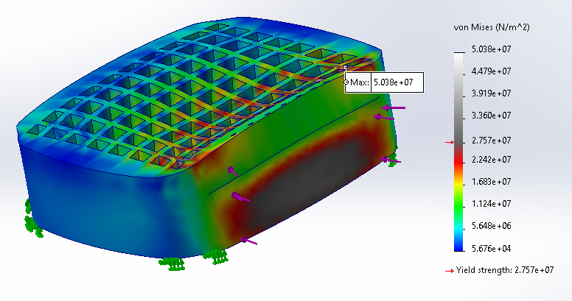
Further design was taken place to improve the honeycomb design and make a more robust battery pack.
Figure 68 Max yield stress of aluminium

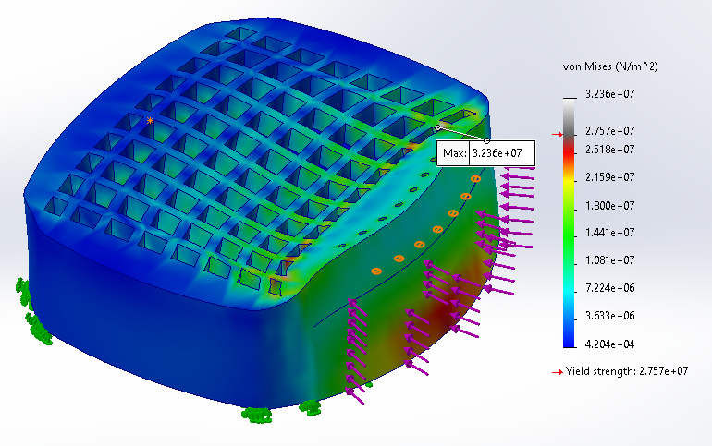
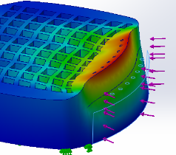
Aluminium has a yield strength of 2.75e+07Nm but the battery pack was experiencing a max stress of 5.03e+07Nm. Further design development was then done by curving the design. Curved shapes can be beneficial for distributing stress evenly across a structure however, if the curvature is too extreme, it will weaken the material and reduce overall strength.
Figure 69 Stress and displacement of improved battery pack design
Maximum stress has decreased to 3.36e+07. The model’s battery housing area is not affected by the displacement change but further design and stress analysis must be done at greater speeds.
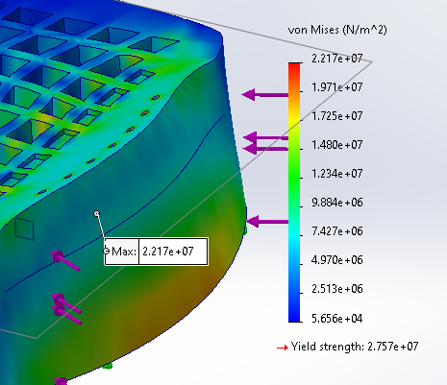

Figure 70 Plate and curve improvements
Finally, a small plate was adding between the first layer of honeycomb pattern to help reduce the stress and by curving the out edges more of the design. This final design gives a maximum stress of 2.217e+07, which is below the yield strength.

3.5.11 Future development of the battery pack

The pack will be made from aluminium alloy 5052 . The battery pack will have to undergo weight reduction. The weight can be reduction by integrating the battery casing with the frame or body of the vehicle. ‘’3D printing and advanced casting can allow for complex geometries and precise material distribution, which can further reduce weight while maintaining strength.’’ (Fenton,2017). This allows for greater complex designs in solid works. Future analysis and design improvements must be done to fine a optimal battery pack design. The battery pack design in figure 343 is for the two module battery pack on the left side of the vehicle, a similar design will then be used for the single module pack using the same stress analysis improvements.

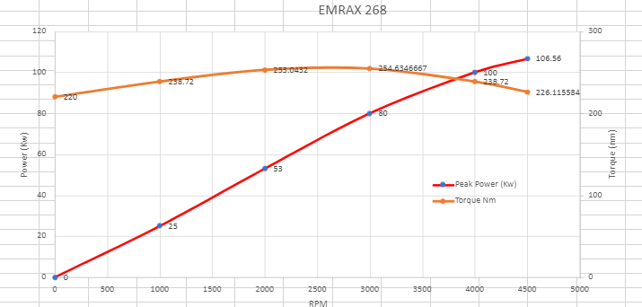
3.5.12 Peak power and peak torque graph
Figure 71 Peak power and peak torque

From the battery pack specifications in figure 234232, a power and torque graph can be produced for the motor.

$Torque (N.m) = 9.5488 x Power (W) / Speed (RPM)$Equation 12

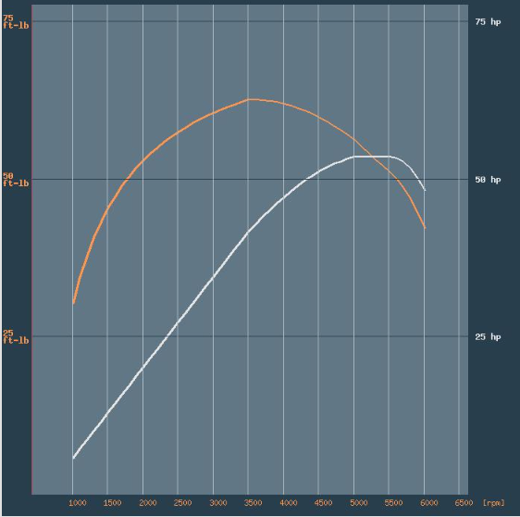
The torque was calculated by using equation 12. Torque at peak power is 226.1Nm, Peak torque is at 80Kw which is 254.6Nm. This graph was created by working off the given EMRAX motor graph at continuous power. The importance of this graph is to determine a motor efficiency. From figure343, its clear that motor can work in the max efficiency zone of 96% between 1500RPM-3000RPM.
Figure 72 Fiat Fiat Punto 55 S (man. 5 speed) 1998
Comparing figure 67 to 68 its clear that Ev converted formula 750 vehicle will have massive power and torque improvement however, it will weigh more so more torque is needed. The Ev graph shows that vehicle will have a smoother acceleration due to its flatter torque curve and has a much higher torque output at low speeds.

3.5.13 Regenerative Braking

Regenerative braking allows the vehicle to recover amounts of energy from braking, the electric motors can then be used to ‘’operate as generators to convert the kinetic or potential energy of the vehicle mass into electric energy that can be stored in the energy storage and reused’’ ( Ehsani , 2019)

3.5.14 Braking power and energy on front and rear wheels

  - Calculating resistance forces
$Rolling Resistance force=(Rolling resistance ×mass of vehicle)×0.000000277778$Equation 13

$Coefficient of drag force=Coefficient of drag ×mass of vehicle)×0.000000277778$Equation 14

$Total Resistance= Coefficient of drag force+$ $Rolling Resistance force$Equation 15

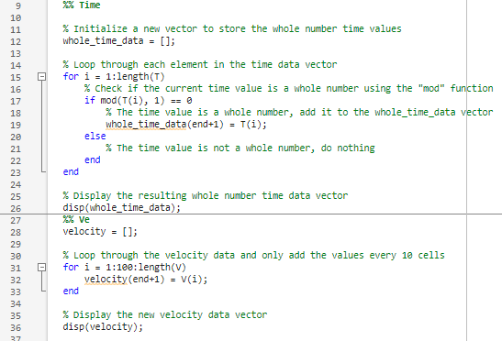
  - Method to calculating total braking energy able to recover.
Figure 73 Matlab loops to selected correct data.
As the Anglesey data is extremely accurate as it measures variables at 0.01 of a second, loops where made in Matlab to selected time data at whole numbers and corresponding velocity at that time.

  - Mathematical inertia and equivalent mass equations
$Wheel Inertia = Mk^2$Equation 16

$Engine inertia + (Gfd^2/radw^2 * inertia)$Equation 17

$equivalent mass= Actual mass+ 4(Wheel inertia*wheel rolling radius) + (engine and driveline inertia/ wheel rolling radius*4.3^2)$Equation 18
Figure 74 Total Possible energy that can recovered over 1 lap at Anglesey.

(It must be stated that Kw/h is a unit of power but is used to present energy as its easier from a reader point of view. EV companies present their data the same, hence the same format has been used to compare data.)

15 Energy available to recover at the rear wheels.

  - Method to calculating energy recovered at rear wheels.

$Rear wheel mass (Kg)=Vehicle weight ×estimate rear weight distribution$

$Rear Braking force (N)=Rear wheel mass ×Acceleration$
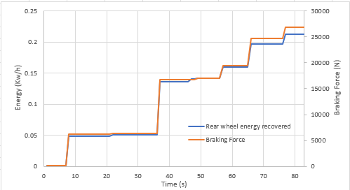
Figure 75 Energy recovered and braking force from rear wheels over one lap at Anglesey

3.5.16 Limitations of method

“As weight is transferred from the rear wheels to the front wheels, the amount of energy that can be recovered by the front regenerative braking system increases, while the amount of energy that can be recovered by rear regenerative braking system decreases.” (Husain,2011) “ If the weight distribution is not taken into account, the amount of energy that can be recovered may be overestimated.” (Yang Lu, Sun &Zhu, 2018)

Another Limitation of the method is the fact gradient resistance isn’t accounted for, as a steeper gradient would slow the vehicle down fastest which requires less braking force.

3.5.17 Regenerative braking system technology
  - Parallel brake system
This system keeps the major components from a mechanical brake system and adds electric braking on the rear axle. The motor will apply its braking torque to the rear axle which will be controlled by a controller. This torque is ‘’based on vehicle speed and brake pedal position signals, which represent the desired braking strength and braking control strategy embedded in the vehicle controller’’(Ehsani, 2019). This issue with this system is the control over the electric braking force to recover as much energy as possible.

  - Sections 3.5.2-3.5.17 Author-Dylan Davies

Achievements
The project has been successful in determining the suitable drivetrain and geartrain and gathering data to do calculations for the new vehicle however the development of these ideas is still ongoing. Enough data was gathered to perform experimental simulations using optimum lap to get some comparable lap times to see whether the vehicle has been improved from the original. This simulated lap showed an improvement however the validity, as mentioned earlier, is questionable due to the lack of real-world variables it considers. Final designs are still being developed with good progress being made. The initial timing chart, figure 51, did not discuss how the project would continue through the new year. Due to this we are unable to discuss how the project has progressed since relating back to it.
Figure 76 - Initial Gantt chart

Project review

Bodywork, packaging & thermal
In the following, body work has been researched thoroughly, as the main focused around working on CFD programs. Although the CFD files are lost on due date and Solidworks file are also had issue on the university computer. The Formula 750 car design have been redesigned but CFD couldn’t developed due to shortage of time. Limitations such as CFD file was only available in university computers. Overall, the risk management and time management need to be improved.

Motor & control
In depth battery pack research has taken place which has allowed for a high density, high power and high torque producing battery pack. Analysis and research have been done to give a better understanding on choosing the right module for the chosen application. Better understanding of BMS has been shown and put to work in choosing a suitable option for the pack. Weight distribution has been considered when choosing the optimal position for the battery pack. The pack design has been split for better distribution and packaging. Stress analysis testing has been done to analysis and improve safety of the battery pack in case of a crash. Kinetic energy recovery has been calculating at the rear and the limitations of this method has been explained. Peak torque and power figures have been presented to give a better understanding of performance of the ev vehicle and why it’s better than the ICE version. Overall, a theoretical battery pack has been designed that could be used to however, further development would have to be done to make the battery packs more rigid as they are split. Further research and thermal management would have to be done. The cooling system would have to be done to cool the battery so the is still work that needs to be done.

Battery & management

5.3.1 Successes for Battery & management
This field of the project has been successful to a degree, calculating the energy required per lap, and the output power figure, which was then used to calculate battery capacity, as well as the quantity of volts and amps required by the motor. The MATLAB model was also helpful for other areas such as Transmission, giving figures for wheel speed reached during the ICE laps, which gear ratios could then be calculated from. An optimal model of battery module was then selected from a list, based on variables such as energy density, Kw/Kg, price, and C rate. The finalised battery pack is able to race for over 4 hours on a single charge, at around 100 Kw of power, or around 75 HP, equivalent to that of the previous ICE configuration.

5.3.2 Failures for Battery & management
More options could’ve been explored as to power, and runtime, in order to reduce weight, and optimise weight distribution. This could be an area to explore to increase competitiveness, as it would most likely decrease lap times. This field of the project could have been further developed by testing different setups, with different battery modules, which may weigh more each, but meet goals of power and runtime with less overall weight for the pack. CAD modelling could’ve incorporated other components in order to fully visualise space available, but this is more of a future development for the entire team.

Transmission
Various options were explored for the transmission system, including chain and belt drive, and ultimately decided on a belt drive due to its higher efficiency, lower noise level, and simpler maintenance requirements. Designs were made to make the differential a custom belt drive conversion. Shortcomings of the transmission field were mainly not ultimately deciding on the permanent placing of the components and therefore no deciding on specifications for the driveshafts. This also affected the analysis and development of mounting brackets to withstand the forces exerted by the components.

Chassis and Dynamics

Successes for Chassis and Dynamics
The successes taken from this area of the project are a working optimum lap that displays the theoretical vehicle created from an estimated final mass, motor specifications and data from the vehicle, show that the vehicle has an improved top speed and lap time despite the extra weight. Once more, from the measurements taken on the chassis, we have reached the conclusion that the current suspension would need to be worked on to become symmetrical using the measurements from the left side of the chassis as it offers preferable dynamics for cornering. The rear suspension has been analysed and it has been decided that a double wishbone setup would improve the room in the rear for serviceability and removal of parts should that need to happen in the pit lanes.

Failures for Chassis and Dynamics
As far as failures are concerned, the project would have felt more complete if some CAD drawings of a proposed rear suspension setup were done. This would have given the project a better direction to head in. If extra kinematics test were conducted, then we would be able to evaluate the suspension further. Using this information, we would be able to consider how to set the vehicle up in terms of camber and caster. This information would help the project have a finalised vehicle.

References

Andrea, D. (2010) Battery management systems for large lithium ion battery packs. Artech House.

Drexler Motorsports (n.d.) Adjustable LSD Formula Student V3. [online] Available at: https://shop.drexler-motorsport.com/limited-slip-differential/formula-student/532/adjustable-limited-slip-differential-formula-student-v3?c=126 [Accessed 4 Dec. 2022]

Ehsani, Gao, Y., Longo, S., & Ebrahimi, K. M. (2019). Modern electric, hybrid electric, and fuel cell vehicles (Third edition, International student edition). CRC Press, an imprint of Taylor & Francis Group.

Ehsani, Ebrahimi, K., Gao, Y., & Longo, S. (2018). Modern electric, hybrid electric, and fuel cell vehicles (Third edition.). CRC Press. https://doi.org/10.1201/9780429504884

Electric vehicle battery box (2023) AEC. Available at: https://aec.org/page/electric-vehicle battery-box (Accessed: March 25, 2023).

Emadi, A. (2020) Advanced Electric Drive Vehicles. Boca Raton, FL: Taylor and Francis, an imprint of CRC Press.

Fenton, J. (2017). Lightweight Electric/hybrid vehicle design. Elsevier

Gates Corporation (n.d.) PowergripTM GT4TM Rubber Synchronous Belt. www.gates.com. Available at: https://www.gates.com/gb/en/power-transmission/synchronous-belts/rubber-synchronous-belts.p.9579-000000-000000.v.9577-00020.html?related=true [Accessed 12 Jan. 2023]

Henderson Bearings (n.d.) 207-2Z SKF Maximum Capacity Ball Bearing with filling slots 35x72x17mm. [online] Available at: https://www.hendersonbearings.co.uk/bl207zz-aka-m207zz-207zz-skf-maximum-capacity-ball-bearing-with-filling-slots-35x72x17mm.html [Accessed 26 Jan. 2023].750 Motor Club (n.d.). 750 Formula Championship. [online] 750 Formula Championship. Available at: https://750formulachampionship.com/ [Accessed 26 Mar. 2023].
Hibbeler, R. C. (2011). Mechanics of materials. Pearson education
268 (210kw: 500nm) (2023) EMRAX. Available at: https://emrax.com/e-motors/emrax-268/ (Accessed: March 25, 2023).

Husain, I (2011). Electric and hybrid vehicles: Design Fundamentals. CRC Press.
Voltsport (2022). Sevcon-Gen4-Controller-Size10-700V-Resolver-0.5-Gain. https://www.voltsport.co.uk/Sevcon-Gen4-Controller-Size10-700V-Resolver-0.5-Gain

Lotus Cars ltd., 2015. GETTING STARTED WITH LOTUS SUSPENSION ANALYSIS, s.l.: s.n.

Lithium Ion Battery Management System - orionbms (2023). Available at: https://www.orionbms.com/downloads/documents/orionbms_specifications.pdf (Accessed: March 22, 2023).

McBeath, S. (2006) Competition Car Aerodynamics. London: Haynes Publishing Group.
Mitchell, W. C., 1998. JOURNAL OF PASSENGER CARS. Vol. 107 ed. s.l.:SAE International.

Motorsport UK (2022) The Motorsport UK Yearbook 2022. 66th ed. [online] Motorsport UK Association Ltd. Available at: https://www.motorsportuk.org/wp-content/uploads/2021/12/BB-2022-low-res-complete-April-2022.pdf [Accessed 30 Oct. 2022]

Nefab (2016) Packaging solutions for lithium batteries. Available at: nefab.com/en/news-insights/2016/nefabs-electric-vehicle-initiative/ (Accessed: 21 March 2023).
Plett, G.L. (2016) Battery Management Systems, volume II: Equivalent-circuit methods. Norwood: Artech House.

Quaife. (n.d.) Motorcycle Engined Cars Archives. [online] Available at: https://shop.quaife.co.uk/category/motorcycle-engined-cars/ [Accessed 25 Nov. 2022]

Seward, D. (2014) Race Car Design. London: PALGRAVE.
Suspension secrets, 2019. [Online]
Available at: https://suspensionsecrets.co.uk/roll-centre-and-roll-moment/
[Accessed 25 March 2023].

tech, T. c., n.d. Roll centre understood, s.l.: s.n.

Vogel, J., n.d. Tech Explained: Roll Centre. [Online]
Available at: https://www.racecar-engineering.com/tech-explained/tech-explained-roll-centre/
[Accessed 22 March 2023].

Voltsport, 2023. Sevcon Ge4 Controller Size 10. [Online]
Available at: https://www.voltsport.co.uk/Sevcon-Gen4-Controller-Size10-700V-Resolver-0.5-Gain
[Accessed 21 3 2023].

Warner, J. (2015) The Handbook of Lithium-Ion Battery Pack Design: Chemistry, components, types and terminology. Amsterdam: Elsevier.

Yang, Y ., Lu X,. Sun, F., & Zhu, Y. (2018). Study on energy recovery of regenerative braking system for electric vehicles. IOP conference series: Materials science and engineering, 471(1), 022035

750 Motor Club (2022) 750 Formula Championship Sporting & Technical Regulations 2022. [online] Available at: https://www.750mc.co.uk/ugc-1/1/1/0/e5efc5e8-7825-4af3-bbbe-bcf80ad059ed.pdf [Accessed 30 Oct. 2022]

