Cloud Computing Architecture
Assessment 2
Module Name | Cloud Computing Architecture
Programme | BSc Cloud Computing
Modul Code | ACCA5025
Lecture | KOUSHIK MODAK
Student ID | 2121853
Student | Ana-Elena Tocariu

TABLE OF CONTENTS
QUESTION 1 2
RESOURCES ASSOCIATED WITH VIRTUAL MACHINE 2
CREATING AND MANAGING VIRTUAL MACHINE 3
vNETS AND NETWORK SECURITY GROUPS 4
QUESTION 2 6
USE OF IMAGES 6
USE OF IMAGES IN AZURE 7
ADDITIONAL EXERCISE 8
DEPLOYING FIRST VIRTUAL MACHINE 8
DEPLOYING SECOND VIRTUAL MACHINE 17
COMMUNICATION 26
REFERENCES 27

QUESTION 1

RESOURCES ASSOCIATED WITH VIRTUAL MACHINE
The physical hardware is decoupled from the operating system through virtualization. Every Virtual Machine has a set of virtual hardware. For a Virtual Machine to function properly, there are four main resources, that is, the CPU, memory, hard disk and the network. These resources are similar to the physical hardware. A Virtual Machine is given access to a part of the resources at the time of the creation of a Virtual Machine and could be changed anytime thereafter[1]. In case a Virtual Machine has a constraint, usually, it is due to the creation of a bottleneck in either of the four resources[2].
The Virtual Machine’s guest operating system is responsible for the allocation of memory to the applications, scheduling of the processes, writing to the storage, sending and receiving the data on a network and lastly for interaction with the virtual hardware through hypervisor[3]. In a virtual environment, the interaction of the Virtual Machine with the hardware happens via a thin layer of software which is termed the hypervisor or the virtualization layer.
The layer of virtualization executes the CPU-based instructions to run the Virtual Machines in a manner that a physical processor is being accessed on the hypervisor. 64 virtual CPUs can be configured on a Virtual Machine. The maximum limit is dependent on the logical cores that the actual hardware has. Another factor is licensing in most of the platforms. There is a scheduler in the CPU which could dynamically schedule the virtual CPUs on the hypervisor’s processor[4].
The Virtual Machine considers a contiguous virtual address space which is made by the hypervisor as the configured memory. A contiguous virtual address space is created through which the hardware, as well as the operating system, could handle the translation of addresses among physical as well as virtual addresses. Because every Virtual Machine has its own virtual address space, the hypervisor runs more than one Virtual Machine in a single go. The memory is protected for access via the other Virtual Machines. Thus, there are three layers of the virtual memory within the hypervisor[4]. These are the physical memory, the memory of the guest operating system and the virtual memory of the guest operating system.
The figure below shows the Virtual Machine and the four primary resources in it[4].
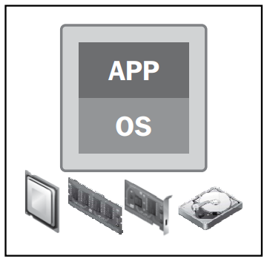
Figure 1: Virtual Machine with four primary resources[4]
For networking, virtual switches and virtual Ethernet adapters are the main components. The virtual Ethernet adapters are known as vNICs. Shared storage resource is the foundation because the virtual environment has various features like High Availability, etc. Virtual Machine’sare enclosed within a set of discrete files which are stored on a datastore. On the datastore, there exists a directory which contains the files of Virtual Machine[4].

CREATING AND MANAGING VIRTUAL MACHINE
Virtual Machine is a separate environment to run its operating system as well as applications independently from the host or other virtual machines. The OS of the Virtual Machine is known as the guest OS and is usually the same or different from the host OS. Thus, one system could host many Virtual Machines. Virtual Machine still depends on the physical resources of the host which are distributed across the Virtual Machine[5].
A computer hosting a Virtual Machine needs a special software known as the hypervisor. Hypervisor simulates the CPU, memory, hard disk, networks and remaining hardware resources, to make a pool of resources which could be allocated to different Virtual machines following specific requirements [6]. Hypervisor could support many virtual hardware platforms which remain isolated from one another which enables Virtual Machines for running on Linux.
The hypervisor could give every Virtual Machine the resources which allocate and manage the schedule of the Virtual Machine concerning the physical resources. The physical hardware does the execution, the CPU executes the instructions requested by the Virtual Machine, and the hypervisor manages the schedule. Thus, the hypervisor is responsible for managing the Virtual Machine[7]. There are two types of hypervisors, namely, Type I hypervisor and Type II hypervisor. The type I hypervisor runs on the host system directly. This is thus, also termed the Native Hypervisor. Type I hypervisor does not require a base server operating system. It could directly access the hardware resources. Some examples are ESXi (by VMWare), Hyper V (by Microsoft), and Citrix XenServer. The host operating system runs on the base host system, forming the base for Type II or Hosted Hypervisor. These do not run directly, a bit in form of an application on the host. Hypervisor in this case instructs the operating system towards making hardware call. Examples of Type 2 hypervisors are VMWare’s Player, and Parallel Desktop[8].

vNETS AND NETWORK SECURITY GROUPS
Network Security Groups, are usually implemented like a portion of vNet. This ensures higher flexibility when templates are been taken for deployment[9].
vNets are the containers through which there can be communication between the Virtual Machine and the boundary that exists between the environment and the external world. Within the vNets, subnets are created for network organization as per the requirement and a routing rule can be created to define the flow of the traffic. vNets give the feature of hooking things similar to VPN and Express route[10].
Network Security Groups are the firewalls which filter out which traffic is allowed. It is an important fact that the Network Security Group could be applied to individual machines or subnets. This means that the Network Security Group could be applied to a subnet as well as for controlling traffic that is allowed from the external world and also from the other subnets present on the network. This could also be defined at the NIC level in the Virtual Machine to enable the settings just for a particular Virtual Machine[10].
Through a network security group, network traffic could be filtered both ways, to the virtual machine and from the virtual machine. Herein, a set of security rules are defined that either deny or allow the inbound traffic into or outbound traffic from, different resources within the Virtual Machine. For every rule, a source as well as a destination, port as well as protocol could be mentioned[11].
The figure below shows various cases of the network security group deployment for allowing traffic to and from the web on the TCP port number 80[11].
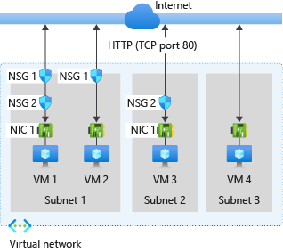
Figure 2: Deploying network security group on TCP port 80[11]

QUESTION 2

USE OF IMAGES
The image represents a copy of the file system structure as well as the data on the disk. Usually an image is designed in a manner to rapidly make a data disk, which is usually the boot disk of a Virtual Machine[6]. Images could be used for the distribution of the software, for example, OS distributions, or having disks with some software installed.
The images are in various formats. The format is a manner of checking how the files are arranged in the storage. Knowledge about the format is needed for the customer to know the content of the file[7].
Usually, the image has two format types, namely, container format and disk format. In a container format, the file stored could be a container which has the virtual disk. As an example, the virtual disk in tar format must be opened prior to retrieval of the disk. It is however possible, that the virtual disk could not be in a file, but stored simply. In the disk format, the virtual disk has its bits in a particular format. The service using this should be aware of the format prior could use it like a virtual disk[12].
The Virtual Machine image could be used while creating a Virtual Machine. For deployment of a new Virtual Machine, the Virtual Machine and the Virtual Machine Image location must be the same. The name of the Virtual Machine Image must be given for use. For a generalized image, information provision, as well as network configuration, must be given as well. Upon deployment of the Virtual Machine, it is similar to a Virtual Machine made through an OS image or OS disk. Once the Virtual Machine is deployed through a special Virtual Machine image, Virtual Machine spins up and looks in a running state post-deployment. The Virtual Machine could take time for booting up, in case of remote desktop, SSH etc. type of connections[12].

USE OF IMAGES IN AZURE
In Azure, the images are used for giving the new Virtual Machine an operating system. The image could contain single or multiple data disks. The images can be obtained from various sources, like, the Azure Marketplace, Open Source via VMDepot and uploading own images[9].
Azure has the feasibility to use two kinds of images, Virtual MachineImage and OS Images. In a Virtual Machine image, there is an operating system and the disks attached to the Virtual Machine during the creation of the image itself. This is a new type of image. While the VIRTUAL Machines were introduced, there were only general operating system-based images in Azure without any additional disk. In case the Virtual Machine image only has the general operating system, that is, similar to the original image type, is an OS image[10].

ADDITIONAL EXERCISE

DEPLOYING THE FIRST VIRTUAL MACHINE
The first Virtual Machine needs to be deployed with an nginx server.
Open the Azure platform.
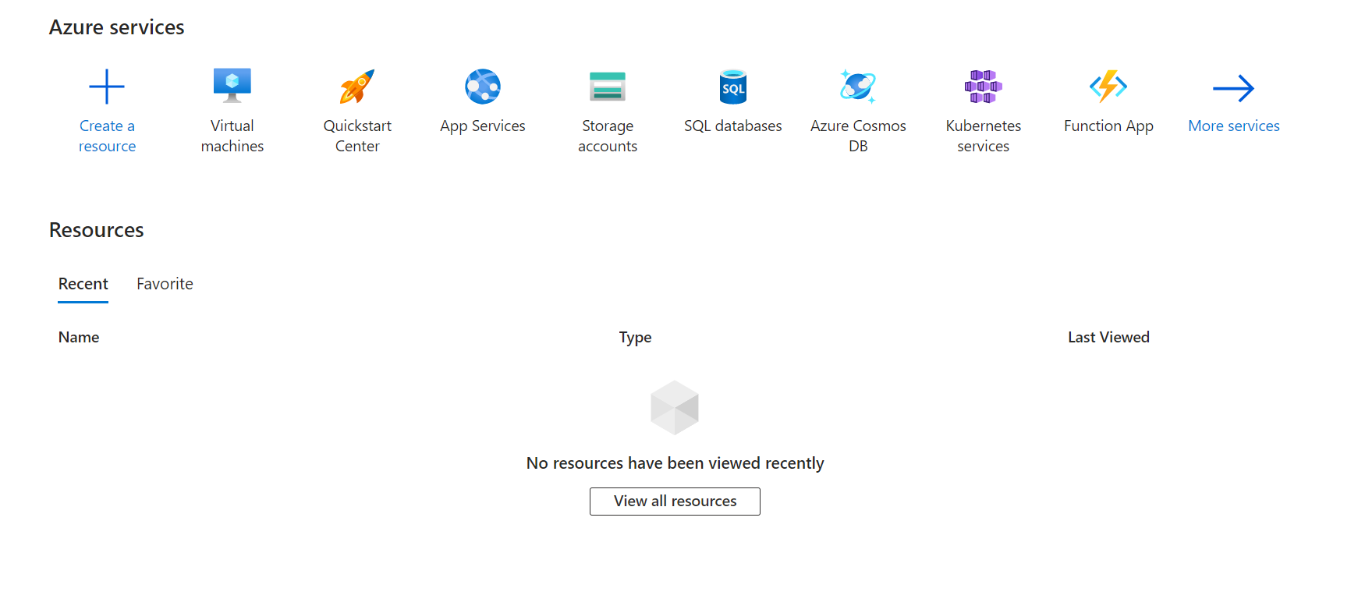
Click on “Virtual Machines” under the Azure services section. It will show up all the Virtual Machines present.
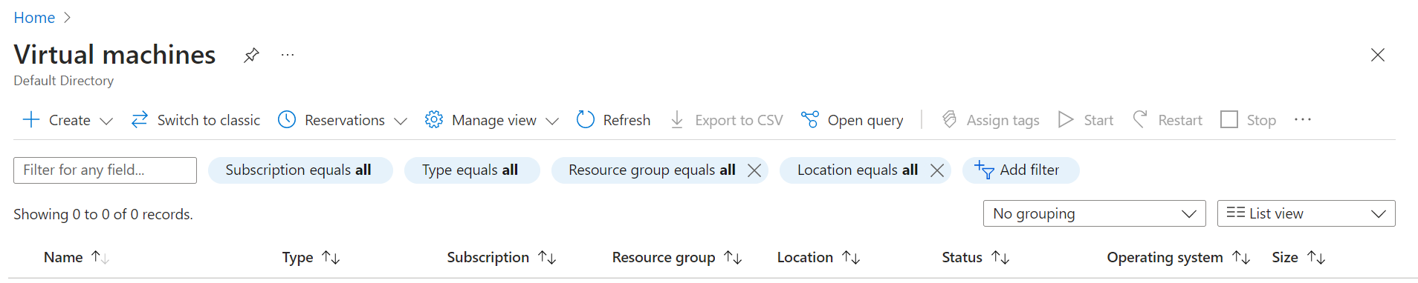
Click on Create button and select the Azure Virtual Machine option.
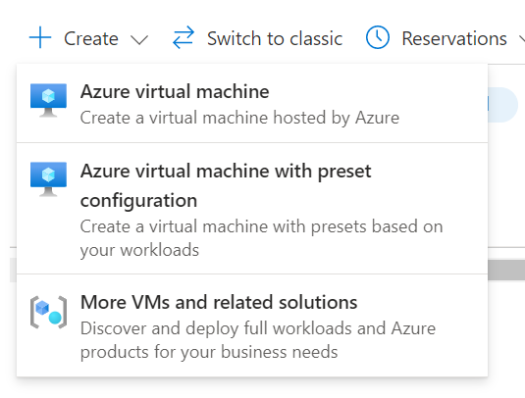
The Virtual Machine creating wizard pops up.
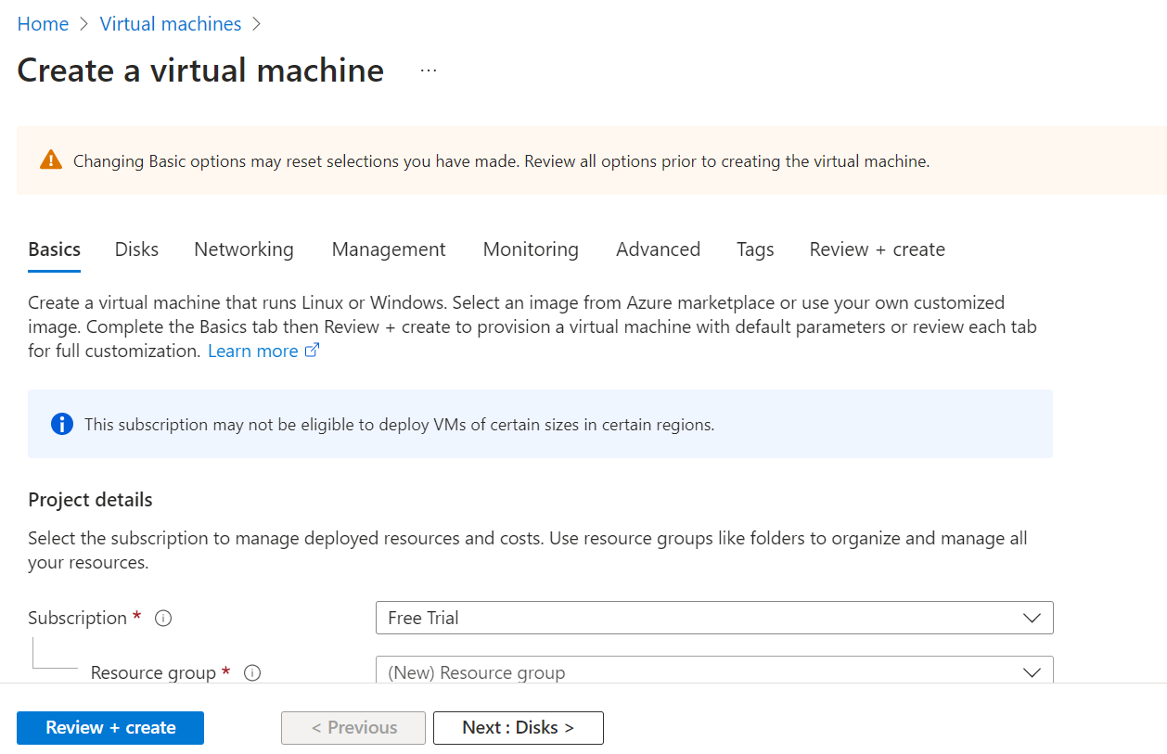
Select an appropriate subscription. Let the option Resource group remain as is. Name the Virtual Machine, “VM1-nginx”. Select a region. The security type should be selected as “Standard”. The image selected should be “Ubuntu 20.04”.
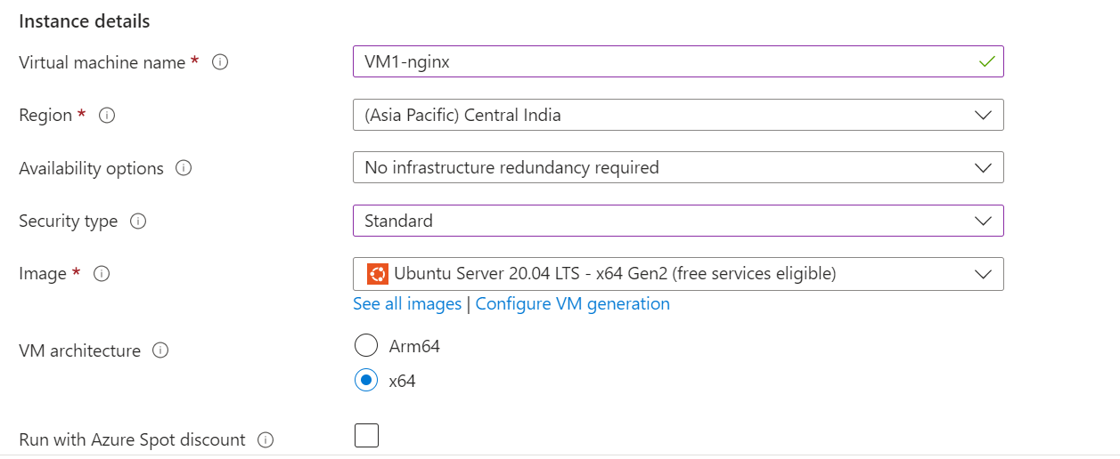
The size selected is Standard B1s. The authentication type should be SSH public key. Give an appropriate username. The username given is “azure user”.
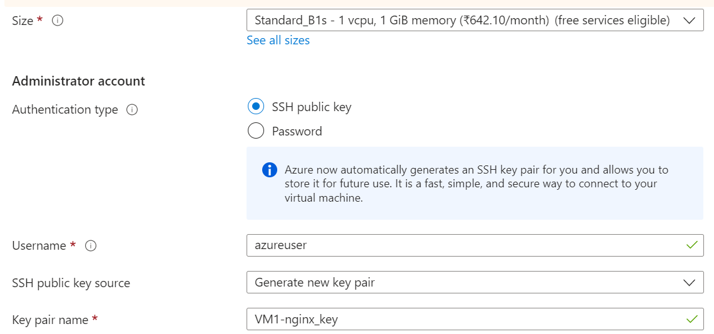
Select the inbound port as HTTP and SSH.
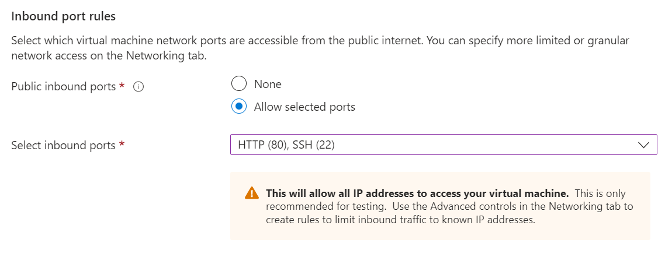
Click on “Next: Disks”. The OS disk size and OS disk type is changed.
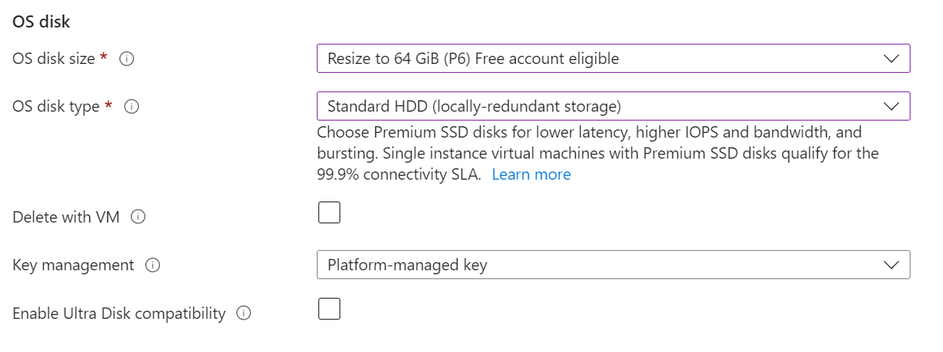
Click on “Review + Create”. It should show “Validation passed”.
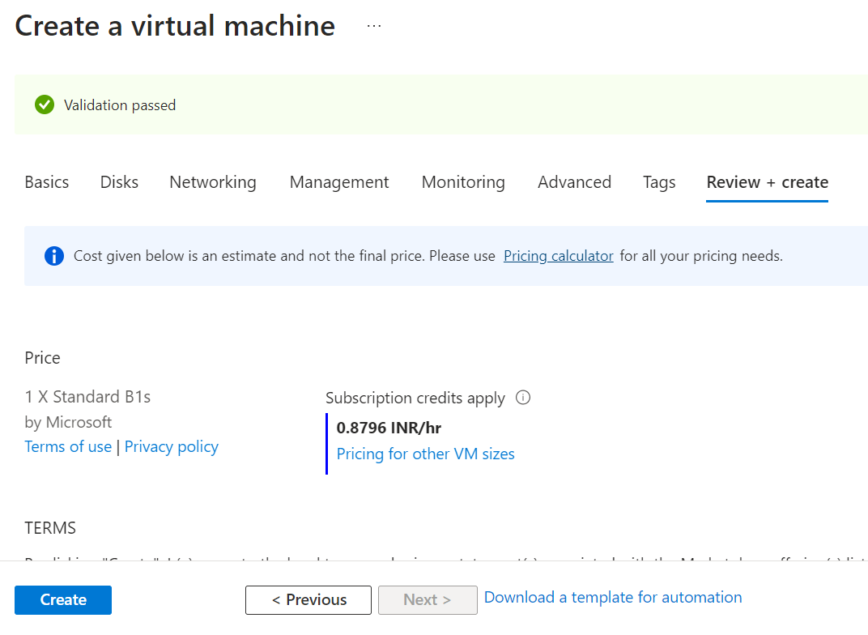
Click on the “Create” button on button. A pop-up will show up to download the private key.
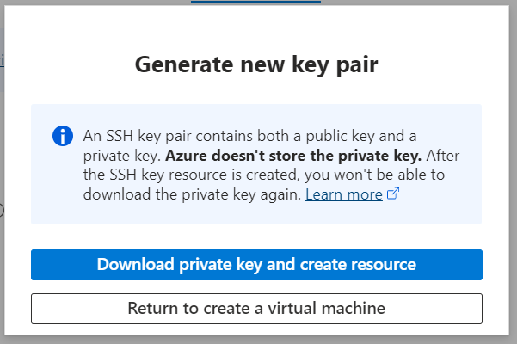
Click on the option “Download private key and create resource” to download the private key. The deployment will begin.
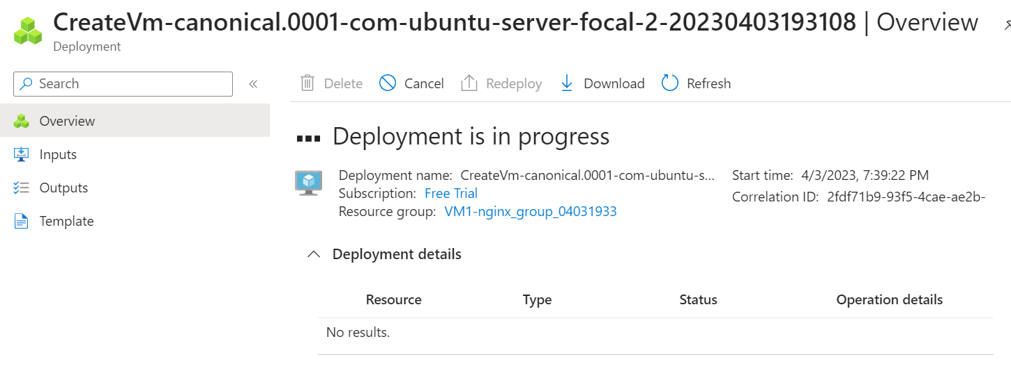
Once the deployment is complete, an option is shown as “Go to resource”.
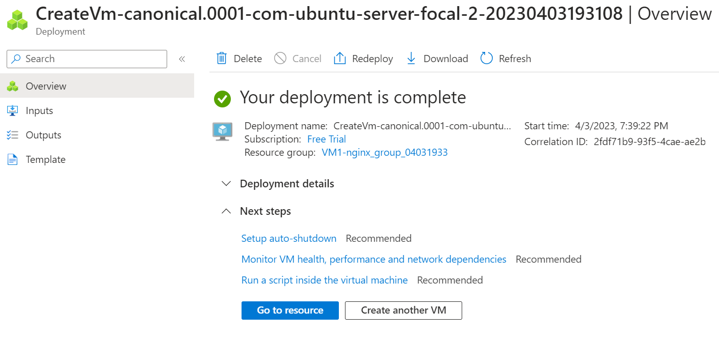
The overview section pops up and is shown below.
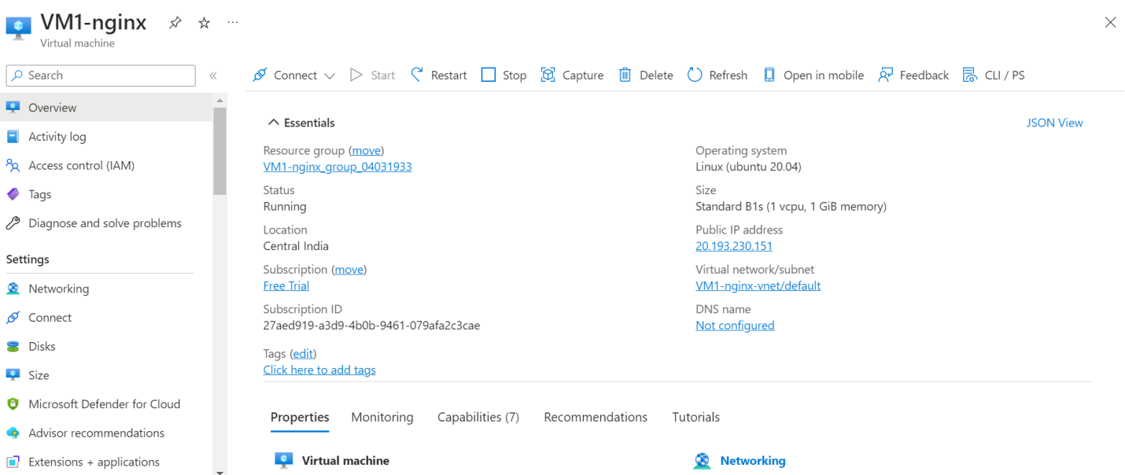
A public IP address is copied for further use. This will be used to run the Virtual Machine.
Open the Bash. Key in the command:
ssh -i<private key path>azureuser@20.193.230.151
Replace the <private key path> with the path of the key file downloaded before the deployment of the Virtual Machine.
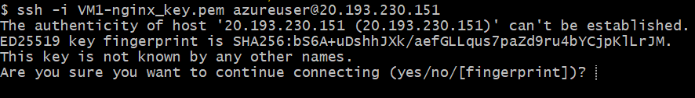
Enter “yes”. Wait for the process to complete.
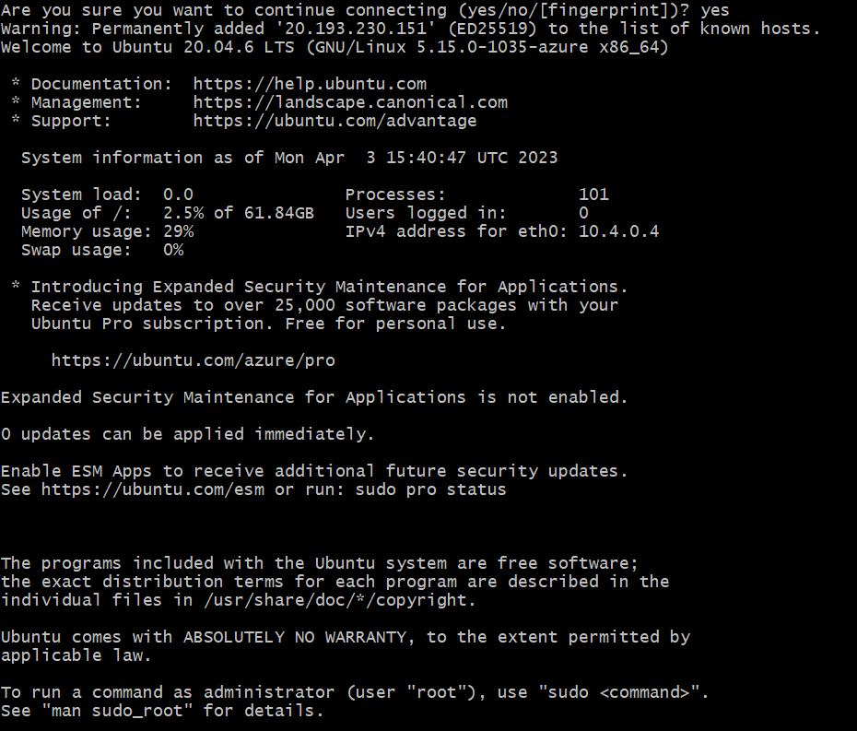
Next is deploying nginx webserver on this Virtual Machine.
Type in the command:
sudo apt-get -y update
The command will run updates.
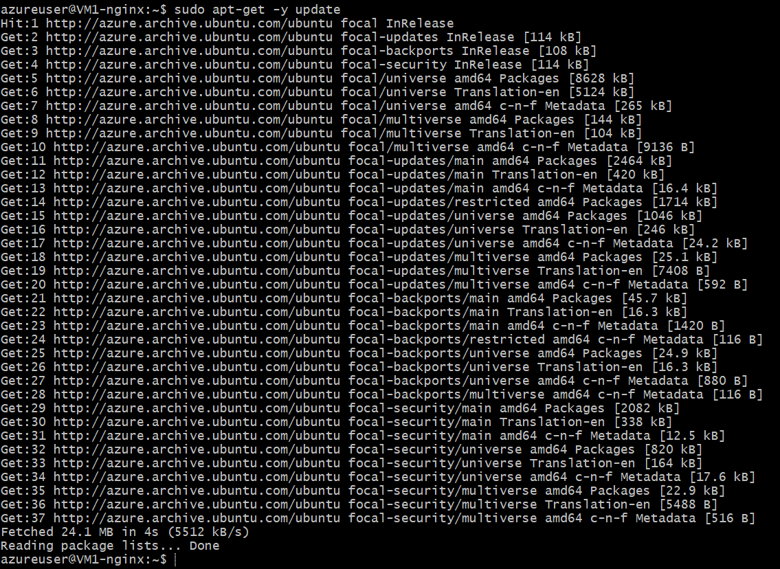
Finally, type in the command to install nginx:
sudo apt-get -y install nginx
After some time, the command is completed and nginx will be installed. Bash can be closed now.
Browse to the public IP in the web browser. Nginx page will be displayed confirming the installation.
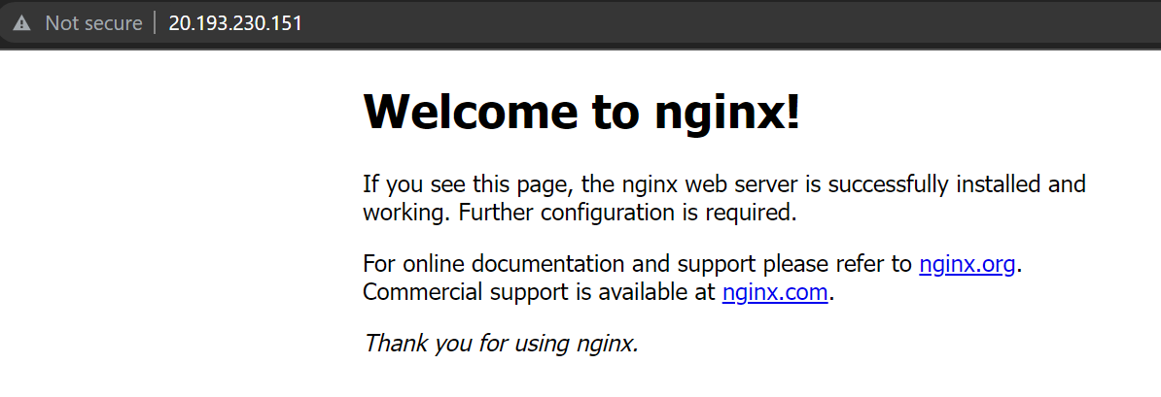

DEPLOYING A SECOND VIRTUAL MACHINE
For the second Virtual Machine, PostgreSQL will be installed in a private vNet and implementation by a Network Security Group.
Similar to the previous deployment, reach to Create a Virtual Machine page.
Name the Virtual Machine“VM2-PostgreSQL”. Select region and security type as Standard. The image should be Red Hat Enterprise Linux 8.6.
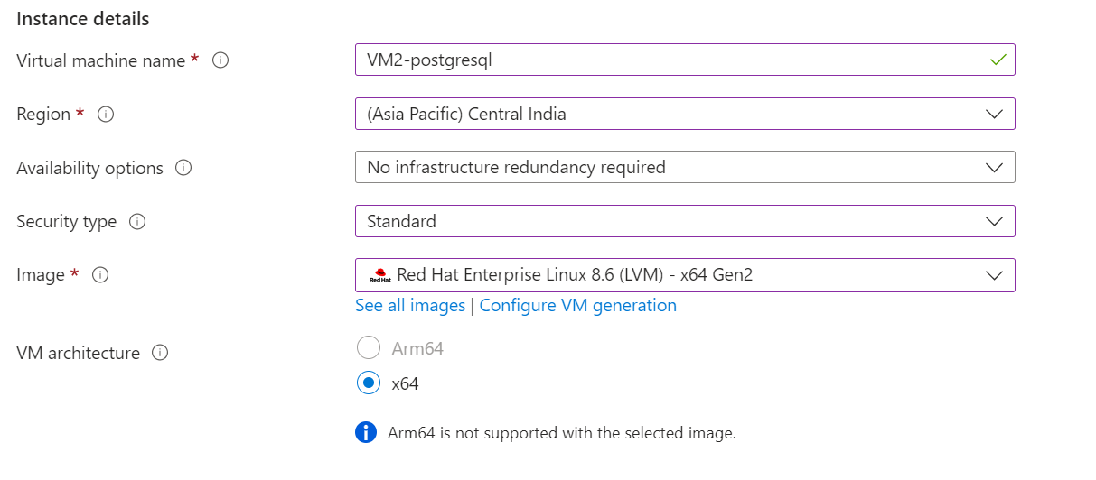
The size should remain Standard B1s. Select the option “Password” under Authentication Type in the Administrator account. Give an appropriate username and password.
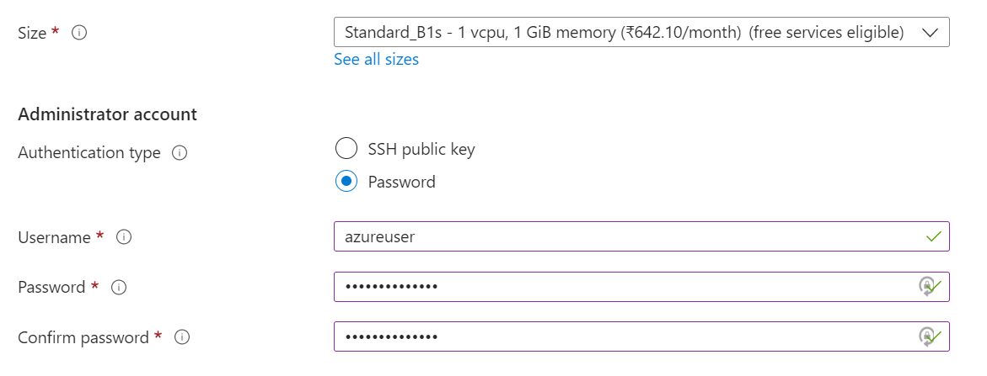
Keep the other settings as is and move on to the Disks section. Select the appropriate disk type. Standard HDD can be selected to minimize the costs.
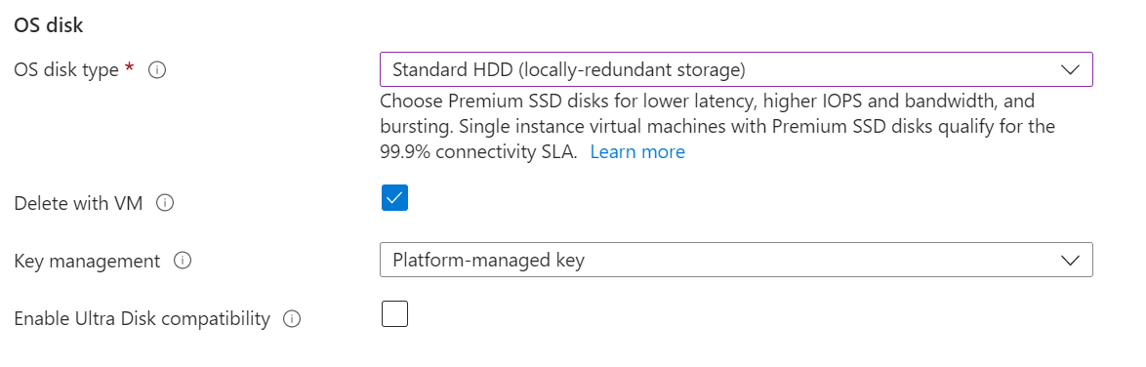
Move on to the “Networking” section. Since, the Virtual Machine needs to be private, select None in Public IP.
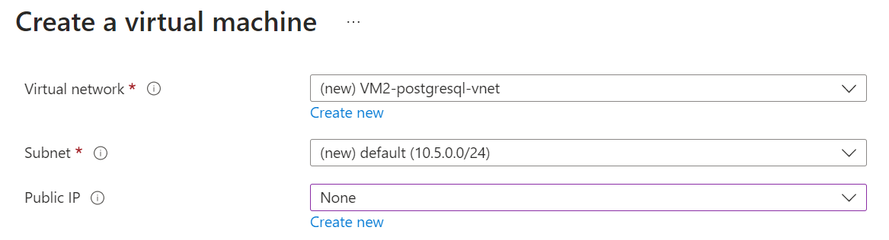
Under the NIC network security group, select Advanced to create a new network security group.
Remove the existing inbound rule and click on Add an inbound rule. Select the source as “My IP Address”.
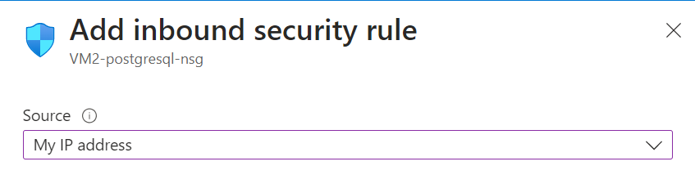
Select the service as PostgreSQL. Action should be allowed and the priority must be set as 1000.
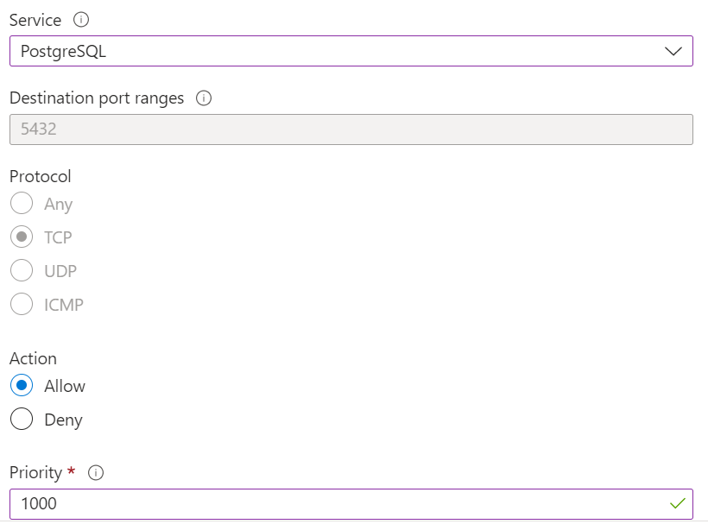
Click on Add. Create another inbound rule to deny all other IP addresses. All other settings remain as is, except the service and action. The service should be “PostgreSQL” and the action should be “Deny”.
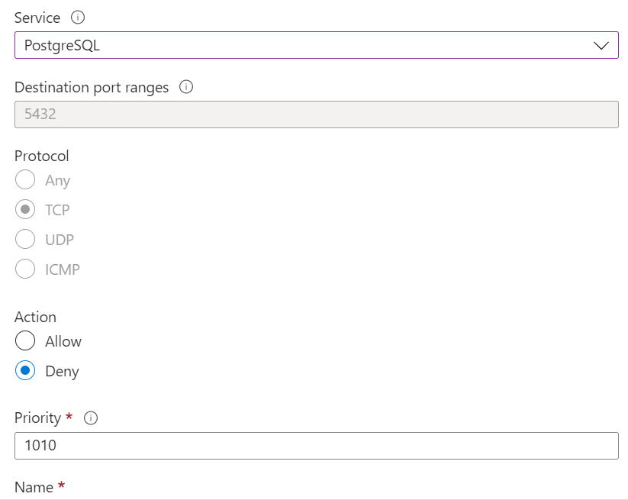
Click on Add.
There will be two network security groups.
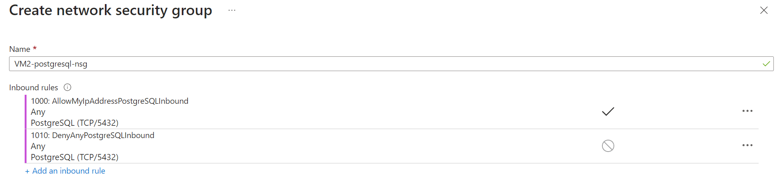
Click on OK. Other settings will remain as is. Thus, click on “Review + Create”. It should show Validation Passed.
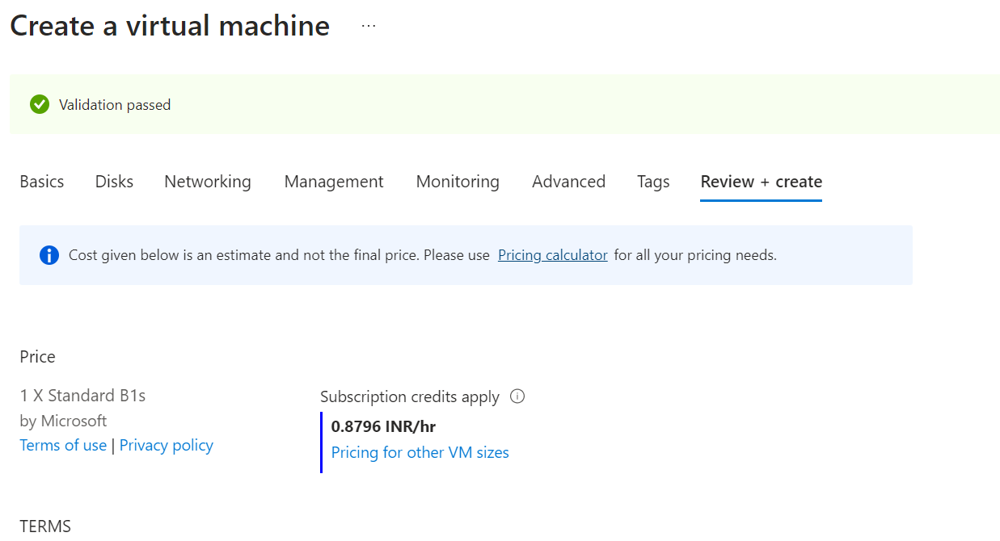
Click on Create. The deployment will begin.
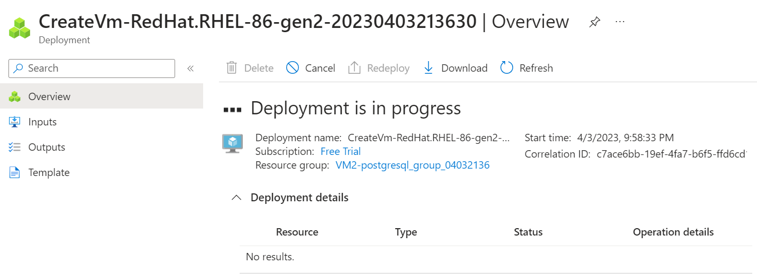
Once the deployment is complete, open PuTTy and key in the IP address. Allow the port to be 22.
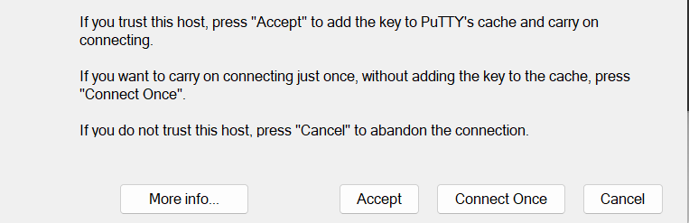
Accept the warning. The terminal will prompt for a username and password. Enter the details entered while creating the Virtual Machine. Once entered, it should display the Virtual Machine name before the command line.
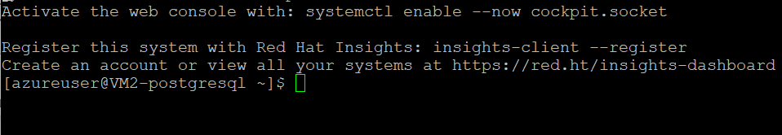
Install PostgreSQL using the following commands:
sudodnf install -y https://download.postgresql.org/pub/repos/yum/reporpms/EL-8-x86_64/pgdg-redhat-repo-latest.noarch.rpm
sudodnf -qy module disable postgresql
sudodnf install -y postgresql15-server
sudo /usr/pgsql-15/bin/postgresql-15-setup initdb
sudosystemctl enable postgresql-15
sudosystemctl start postgresql-15
Wait for the installation to complete.
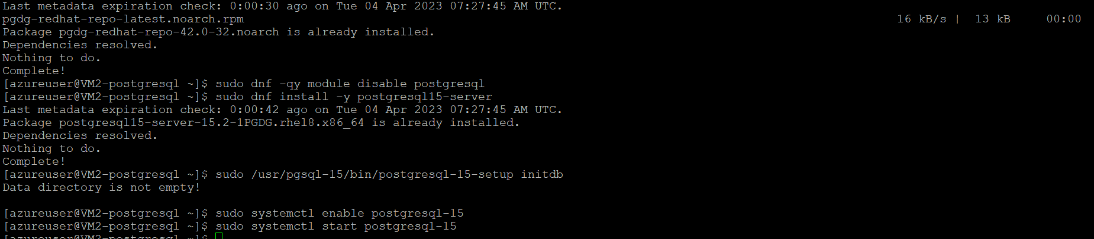
Once the installation is done, the status can be checked using the command:
sudosystemctl status postgresql-15
It confirms that the service has started.
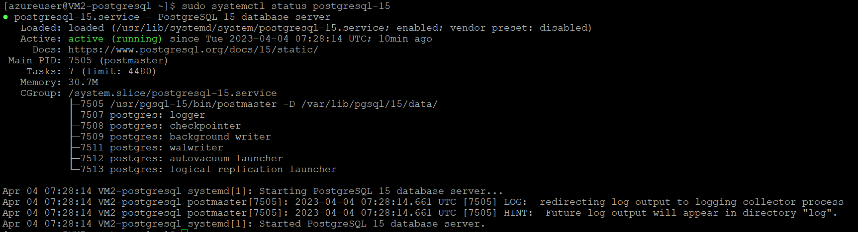
Selinux disabling process will now be done. Enter the following commands:
sudo vi /etc/selinux/config
sudo cat /etc/selinux/config|grep -i SELINUX=disabled
When the first command is run, the state of SELINUX is confirmed.
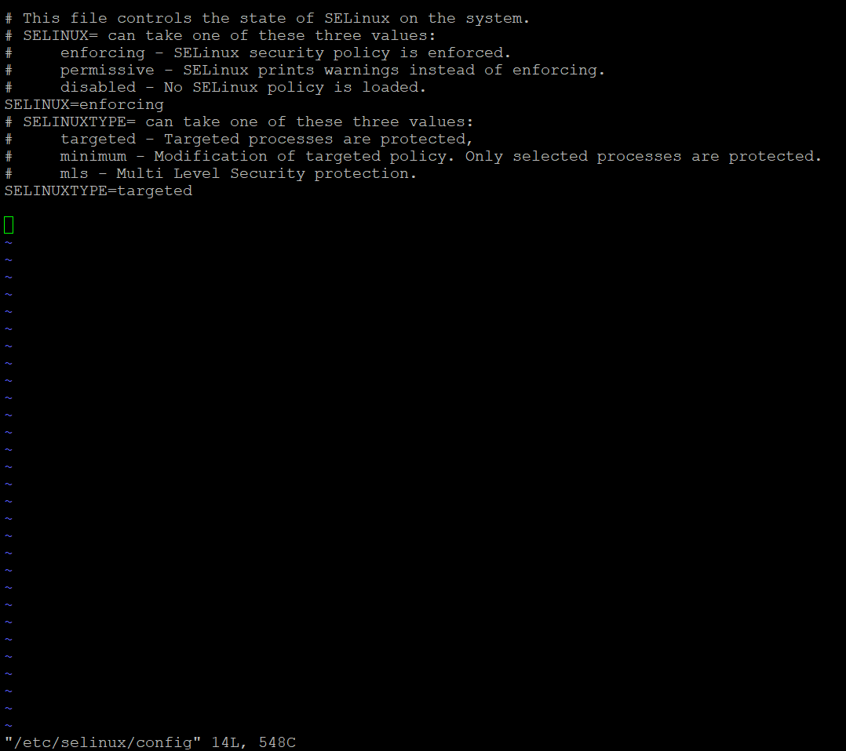
Next is to stop and disable the firewall. The following commands would perform this task:
sudosystemctl status firewalld
sudosystemctl stop firewalld
sudosystemctl disable firewalld
The command should display the result as:
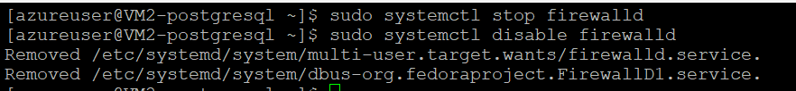
Type in “psql” to enter the postgres mode.
Set the password using:
alter user Postgres password ‘NEW_PASSWORD’;
It will display a message “ALTER ROLE” confirming the change. Type “\q” to exit from postgres mode.
Remote access edit should now be enabled, using:
vi /var/lib/psql/15/data/postgresql.conf
Add the server in pgadmin.

COMMUNICATION
Install “pgcli” on VIRTUAL MACHINE1. Connect to VIRTUAL MACHINE1 and run the command:
pip install pgcli
The successful install message will confirm.
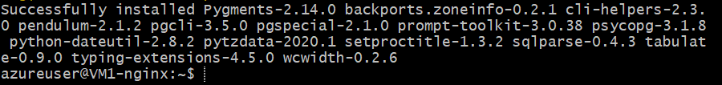
Connect this VIRTUAL MACHINE to the other VIRTUAL MACHINE using the:
pgcli -h <IP for VIRTUAL MACHINE2> -U <Username> -w <Password>
The connection has been established.

REFERENCES

[1] | W. Lin, C. Xiong, W. Wu, F. Shi, K. Li and M. Xu, "Performance interference of virtual machines: a survey," ACM Computing Surveys, vol. 55, no. 12, pp. 1-37, 2023.
[2] | P. Zhang, M. Zhou and X. Wang, "An intelligent optimization method for optimal virtual machine allocation in cloud data centers," IEEE Transactions on Automation Science and Engineering, vol. 17, no. 4, pp. 1725-1735, 2020.
[3] | S. Talwani, J. Singla, G. Mathur, N. Malik, N. J. Jhanjhi, N. Z. Jhanjhi, M. Masud and S. Aljahdali, "Machine-Learning-Based Approach for Virtual Machine Allocation and Migration," Electronics, vol. 11, no. 19, p. 3249, 2022.
[4] | R. Fitzhugh, vSphere Virtual Machine Management, Birmingham: Packt Publishing, 2016.
[5] | M. Aldossary, K. Djemame, I. Alzamil, A. Kostopoulos, A. Dimakis and E. Agiatzidou, "Energy-aware cost prediction and pricing of virtual machines in cloud computing environments," Future Generation Computer Systems, vol. 93, pp. 442-459, 2019.
[6] | A. M. Potdar, D. G. Narayan, S. Kengond and M. M. Mulla, "Performance evaluation of docker container and virtual machine," Procedia Computer Science, vol. 171, pp. 1419-1428, 2020.
[7] | Z. Tao, Q. Xia, Z. Hao, C. Li, L. Ma, S. Yi and Q. Li, "A survey of virtual machine management in edge computing," Proceedings of the IEEE, vol. 107, no. 8, pp. 1482-1499, 2019.
[8] | N. Bisht, "Hypervisor," Geeks for Geeks, 29 June 2022. [Online]. Available: https://www.geeksforgeeks.org/hypervisor/. [Accessed 04 April 2023].
[9] | R. Sahay and R. Sahay, "Managing Virtual Networks," in Microsoft Azure Architect Technologies Study Companion: Hands-on Preparation and Practice for Exam AZ-300 and AZ-303, Berkeley, CA, Apress, 2020, pp. 237-264.
[10] | V. Stefanovic and M. Katinski, "Virtual Networks in Azure," in Pro Azure Administration and Automation: A Comprehensive Guide to Successful Cloud Management, Berkeley, CA, Apress, 2021, pp. 39-61.
[11] | Microsoft, "How network security groups filter network traffic," Microsoft, 11 February 2023. [Online]. Available: https://learn.microsoft.com/en-us/azure/virtual-network/network-security-group-how-it-works. [Accessed 04 April 2023].
[12] | S. K. Tiwari, S. G. Neogi and A. Mishra, "Securing Virtual Images in Cloud Environment," Mathematical Statistician and Engineering Applications, vol. 71, no. 4, pp. 7871-7882, 2022.

