Explanation of Residential care Homes.
A Residential Care Home is a facility that provides long-term support for individuals who are unable to live independently due to age, disability, chronic illness or mental health needs. These homes offer 24- hour care, including assistance with daily activities such as bathing, dressing, eating and medication management. Unlike hospitals, residential care homes focus on social care and personal wellbeing rather than acute medical treatment. Residents benefit from structured environments that promote safety, community and social engagement. Many hones also provide activities such as exercise classes, arts and crafts, or outings to reduce isolation and enhance quality of life. The care provide is tailored to individual needs, following a person – centred approach that recognises each resident preferences, routines, and cultural background. Residential care homes can be operated privately, by local authorities, or charitable organisations, and they are strictly regulated to ensure safety, quality, of care, and compliance with legal standards. Regulatory bodies assess staffing levels, training, hygiene, and health and safety, ensuring residents receive appropriate support. Visual elements such as diagrams of typical home layouts, showing private rooms, communal areas, and activity spaces, can help illustrate how residential care homes combine personal privacy with opportunities for social interaction. By offering both practical support and emotional care, these homes play a critical role in maintain independence and wellbeing for people who cannot safely remain In their own homes.
 RESIDENTIAL CARE HOMES
History Of Residential Care Homes.
The history of residential care homes dates back several centuries, evolving from early charitable institutions that offered shelter and support t the poor, elderly, and disabled. In the seventeenth and eighteenth centuries, alms-houses and workhouses provided rudimentary accommodation, but the focus was primarily on survival rather than the quality of life. During the industrial revolution, family structures changed, and urbanisation increased the need for formal residential care for older adults. In the late nineteenth century, municipal and charitable homes began to develop, offering more structured long – term care. The twentieth century marked significant reforms, especially following the establishment of the National Health Service in 1948, which created standards for healthcare and social care services. At this point, care homes began to shift from custodial institutions to facilities that emphasised wellbeing, personal choice, and community. In the latter part of the twentieth century, residential care homes increasingly adopted person – centred, residential care approaches, catering to individuals with dementia, physical disabilities, and mental health needs. Over the past ten years, the sector has continued to evolve with improvements in staff training, technology, and regulatory oversight. The focus on quality of life, alongside safety and medical support, has become central. A timeline infographic could visually depict this evolution, highlighting key milestones such as creation of nursing standards, legislative changes, and modern regulatory frameworks, helping viewers understand how residential care homes have transitioned into professional, support environments for vulnerable populations.

Current Functioning of Residential care Homes.
In the past ten years, residential care homes have increasingly adopted person-centred approaches, prioritising residents’ wellbeing. Care is delivered 24 hours a day by trained staff, with responsibilities including personal care, medication administration, meal preparation, and emotional support. Staff training has become more specialised, with modules on dementia care, palliative care, safeguarding, and mental health awareness, reflecting the complex needs of modern residents. Care homes collaborate closely with healthcare providers, including general practitioners, community nurses, and physiotherapist, to ensure residents receive comprehensive care. Technological advances have enhanced operational efficiency and safety, with electronic care records, digital medication management, and telehealth consultations becoming more common. Activities and social programmes are central to daily life, promoting engagement, reducing loneliness, and supporting mental wellbeing. Many homes now offer specialist units for dementia or physical rehabilitation, ensuring residents receive care suited to their conditions. Regulatory bodies conduct regular inspections to access compliance with safety, staffing, and quality standards. Current data indicates that care homes vary widely in resident demographics, staffing ratios, and funding sources, highlighting the diverse and tailored nature of the services.

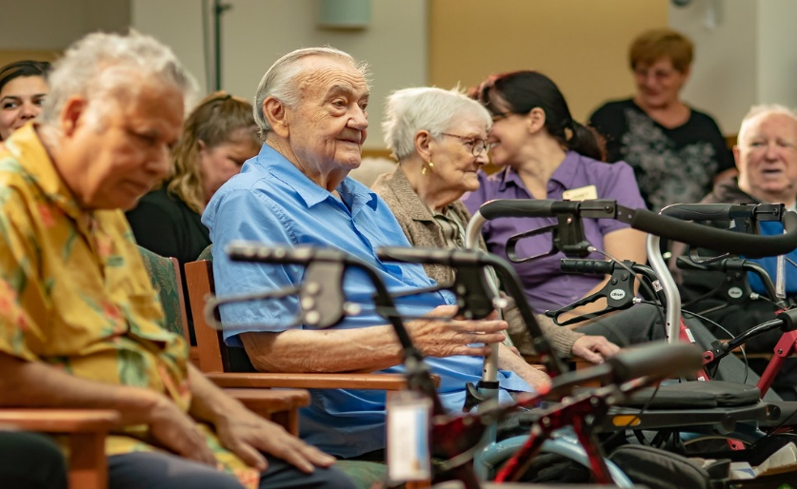
This Photo by Unknown Author is licensed under CC BY-NC-ND
Challenges faced by Residential Care Homes.
Residential are homes face ongoing challenges that can affect the quality and sustainability of services. A major challenge is workforce recruitment and retention. Staff turnover is high due to low pay, demanding workloads, and emotional stress associated with caring for vulnerable individuals. Maintaining a stable, skilled workforce is essential to ensure continuity of care, but, but many homes struggle to attract and retain staff. Staff shortages can lead to increased workload, burnout, and reduced quality of care. Another significant challenge is financial sustainability. Residential care homes often rely on a combination of private payments, local authority funding, and charitable contributions. Rising costs, including wages, utilities, medical supplies, and building maintenance, can strain budgets. Limited funding may restrict investments in training, activities, or technological improvements, which can impact resident wellbeing. The COVID-19 pandemic highlighted these challenges, exacerbating staffing shortages and increasing operational pressures. Visual representations such as charts showing staff turnover, resident-to-staff ratios, or funding shortfalls can illustrate these issues clearly. Addressing these challenges requires policy interventions, adequate funding, workforce support, and innovative approaches to care delivery. Ensuring sustainability, high-quality services is crucial for maintaining the safety, dignity, and wellbeing of residents, as well as supporting the staff who provide essential care daily basis.
,l

NAME: HAYLEY PRINSEP
STUDENT ID: 250
MODULE CODE: LCHS4003
MODULE: INTRODUCTION TO HEALTH AND SOCIAL CARE
LECTURER: AZIDA ZAINOL

Ambulance services: ORIGINS AND HISTORICAL DEVELOPMENT
Ambulance services are a vital part of modern healthcare, providing emergency medical care and transport for individuals experiencing illness or injury. They operate at the interface between community and hospitals ensuring timely and appropriate treatment. The transportation of injured individuals for medical care can be tracked back to ancient civilisations. During the Roman Empire, wounded soldiers were removed from battlefields using carts, representing an early form of organised casualty transport (Bennett, 2011). However, the foundations of modern ambulance services developed in the late eighteenth and nineteenth centuries, particularly during the warfare and industrialisation. The Napoleonic Wars highlighted the importance of rapid evacuation and mobile field hospitals for treating injured soldiers (Roudsari et al.,2007).
In the United Kingdom, organised civilian ambulance services emerged in the late nineteenth century. The metropolitan asylums board introduced horse-drawn ambulances in London in 1879 to transport patients with infectious diseases (Nicholson, 2013). As urban populations expanded and industrial accidents increased. Demand for structured emergency transport grew. By the early twentieth century, motorised ambulances replaced horse-drawn vehicles, improving response time efficiency.
The establishment of (NHS) 1948 marked a key turning point, as ambulance services became publicly funded and nationally coordinated. This ensured more equal access to emergency care regardless of income or location (NHS ENGLAND, 2023). Over time, ambulance services expanded beyond transportation to include on-scene medical assessment and treatment. The introduction of paramedics in the 1970s enabled advanced lifesaving interventions before hospital arrival, transforming pre-hospital care (Wankhade and Mackway-Jones, 2015)

Function of Ambulances Services:
Today, ambulance services function as complex healthcare providers rather than simple transport systems. In England, they respond to emergency calls by accessing urgency and deploying appropriate resources (NHS ENGLAND, 2023). Dispatch systems prioritise life-threatening conditions such as cardiac arrest, stroke and major trauma to ensure rapid response.
Modern ambulances carry advanced equipment, including defibrillators, oxygen, monitoring devices and medications. Paramedics and emergency medical technicians assess, stabilise and treat patients at the scene. Approaches such as “ see and treat” and “hear and treat” aim to reduce unnecessary hospital admissions by managing patients safely in the community.

ENHACHING THE QUALITY OF LIFE
Ambulance services improve quality of life by delivering rapid life-saving care. Early intervention in conditions such like heart attacks and strokes increases survival rates and reduces long-term disability (British heart foundation,2022). This allows individuals to recover more effectively and resume daily activities. Beyond emergencies, ambulance services support vulnerable groups, including older adults and individuals experiencing mental health crisis. Community paramedicine initiatives provide home visits, health education and medication reviews, reducing hospital dependence and promoting independence (Bigham et al.,2013).

References:
British heart foundation (2022) heart attack statistics
House of common Health Committee (2021) the impact of covid-19 on ambulances services
The kings fund appleb, J (2019) ambulance service England
Age Uk, 2020. Care homes and nursing homes. Age Uk 19 febuary 2026

