Name:_Noah John________________________________

Student Number: _2502346_______________________
__________________________________________________________

WORKSHEET 5 – TESTING (Hunting for Treasure)

For this worksheet, the program can be implemented in a number of different ways and demonstrate different features.
Create your own test set to demonstrate strengths and/or limitations of your solution. Use as many of the template boxes below as you need.

Test: Input Validation ii: Enter “a” when asked for map length

Screenshot(s) of output:
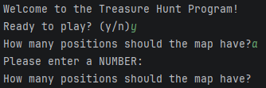
Result: Did the programme behave as expected ie syntactically and logically correct?
YES
If YES, comment on what happened.
If NO, what went wrong and why? Comment on how you would fix the problem.

The input is invalid as the program is expecting an integer and therefore a “ValueError” is produced triggering an “except” command and prompts the user to re-enter a valid input via this while loop within the “getNumber” function:

def getNumber(prompt, minVal, maxVal):
while True:
try:
val = int(input(prompt))
if val < minVal or val > maxVal:
print("Out of range! ({}-{})".format(minVal,maxVal))
else:
return val
except ValueError:
print("Please enter a NUMBER:")

Test: Input Validation ii: Enter “%!” for position guess

Screenshot(s) of output:
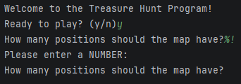
Result: Did the programme behave as expected ie syntactically and logically correct?
YES
If YES, comment on what happened.
If NO, what went wrong and why? Comment on how you would fix the problem.

The input is invalid as the program is expecting an integer and therefore a “ValueError” is produced triggering an “except” command and prompts the user to re-enter a valid input via this while loop within the “getNumber” function:

def getNumber(prompt, minVal, maxVal):
while True:
try:
val = int(input(prompt))
if val < minVal or val > maxVal:
print("Out of range! ({}-{})".format(minVal,maxVal))
else:
return val
except ValueError:
print("Please enter a NUMBER:")
Test: Input Validation iii Enter a blank input
Screenshot(s) of output:
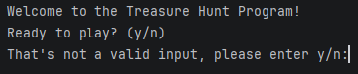
Result: Did the programme behave as expected ie syntactically and logically correct?
YES
If YES, comment on what happened.
If NO, what went wrong and why? Comment on how you would fix the problem.

The input is invalid as the program is expecting either a “y” or “n” in this case, therefore a “not in” command is triggered and prompts the user to re-enter a valid input via this while loop within the “askYN” function:

def askYN(prompt):
choice = input(prompt).lower().strip()
while choice not in ["y", "n"]:
choice = input("That's not a valid input, please enter y/n:").strip().lower()
if choice == "y":
return True
else:
return False
Test: Input Validation iv Enter “5.5” (decimal)

Screenshot(s) of output:
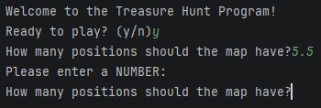
Result: Did the programme behave as expected ie syntactically and logically correct?
YES
If YES, comment on what happened.
If NO, what went wrong and why? Comment on how you would fix the problem.

The input is invalid as the program is expecting an integer and therefore a “ValueError” is produced triggering an “except” command and prompts the user to re-enter a valid input via this while loop within the “getNumber” function:

def getNumber(prompt, minVal, maxVal):
while True:
try:
val = int(input(prompt))
if val < minVal or val > maxVal:
print("Out of range! ({}-{})".format(minVal,maxVal))
else:
return val
except ValueError:
print("Please enter a NUMBER:")
Test: Boundary and Range Testing i Enter -1 for a position
Screenshot(s) of output:
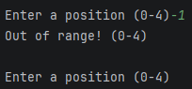
Result: Did the programme behave as expected ie syntactically and logically correct?
YES
If YES, comment on what happened.
If NO, what went wrong and why? Comment on how you would fix the problem.

The program knows this is out of range by using an if statement within the “getNumber” function and prompts the user to re-enter a valid position while reminding of the possible range. The if statement in question:

def getNumber(prompt, minVal, maxVal):
while True:
try:
val = int(input(prompt))
if val < minVal or val > maxVal:
print("Out of range! ({}-{})".format(minVal,maxVal))
else:
return val
except ValueError:
print("Please enter a NUMBER:")
Test: Boundary and Range Testing ii If map has 10 positions enter 10

Screenshot(s) of output:
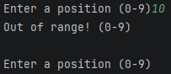
Result: Did the programme behave as expected ie syntactically and logically correct?
YES
If YES, comment on what happened.
If NO, what went wrong and why? Comment on how you would fix the problem.

The program knows this is out of range by using an if statement within the “getNumber” function and prompts the user to re-enter a valid position while reminding of the possible range. The if statement in question:

def getNumber(prompt, minVal, maxVal):
while True:
try:
val = int(input(prompt))
if val < minVal or val > maxVal:
print("Out of range! ({}-{})".format(minVal,maxVal))
else:
return val
except ValueError:
print("Please enter a NUMBER:")
Test: Boundary and Range Testing iii If map is 10 enter 0

Screenshot(s) of output:
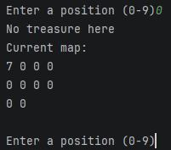
Result: Did the programme behave as expected ie syntactically and logically correct?
YES
If YES, comment on what happened.
If NO, what went wrong and why? Comment on how you would fix the problem.

The program accepts the valid input and continues with the program as intended.
Test: Boundary and Range Testing iv Set map length to 1

Screenshot(s) of output:
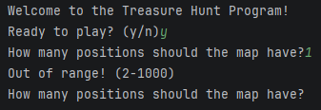
Result: Did the programme behave as expected ie syntactically and logically correct?
YES
If YES, comment on what happened.
If NO, what went wrong and why? Comment on how you would fix the problem.

The program asks the user to re-enter a realistic map length and displays the possible range of inputs to choose from. It does this by using this function call line that defines the minimum and maximum value range in combination with an if statement within the “getNumber” function:
mapLength = getNumber("How many positions should the map have?", 2, 1000)

def getNumber(prompt, minVal, maxVal):
while True:
try:
val = int(input(prompt))
if val < minVal or val > maxVal:
print("Out of range! ({}-{})".format(minVal,maxVal))
else:
return val
except ValueError:
print("Please enter a NUMBER:")
Test: Game Logic and Rules i Enter duplicate guess, “3” and “3” again
Screenshot(s) of output:
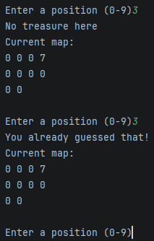
Result: Did the programme behave as expected ie syntactically and logically correct?
YES
If YES, comment on what happened.
If NO, what went wrong and why? Comment on how you would fix the problem.

The program recognises that the entered value has been entered previously as each guess is stored in a list called “guessHistory “, which works in conjunction with this if statement:

if userGuess in guessHistory:
print("You already guessed that!")
continue
Test: Game Logic and Rules ii Guess the position of the treasure

Screenshot(s) of output:
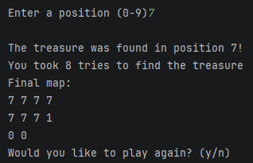
Result: Did the programme behave as expected ie syntactically and logically correct?
YES
If YES, comment on what happened.
If NO, what went wrong and why? Comment on how you would fix the problem.

When the user has found the treasure, they are prompted to play again if they’d like as intended.
Test: Game Logic and Rules iii Use all max guesses without finding treasure.

Screenshot(s) of output:
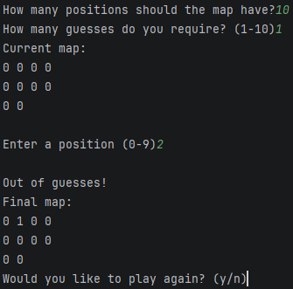
Result: Did the programme behave as expected ie syntactically and logically correct?
YES
If YES, comment on what happened.
If NO, what went wrong and why? Comment on how you would fix the problem.

If the user reaches their entered guess limit the program ends the current game and prompts the user to play again using this part of the main if statement:

elif tryCount == maxGuesses:
print("\nOut of guesses!")
currentMap(map, "Final")
if not askYN("Would you like to play again? (y/n)"):
runProg = False
break
Test: Game Logic and Rules iv When prompted “Would you like to play again?” enter “y” and then “n”

Screenshot(s) of output:
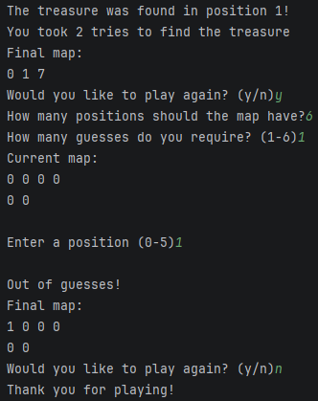
Result: Did the programme behave as expected ie syntactically and logically correct?
YES
If YES, comment on what happened.
If NO, what went wrong and why? Comment on how you would fix the problem.

When the user is prompted to play again they can either choose “y” for yes and “n” for no, the input is first run through this logic within the “askYN” function to validate and decide the meaning of the input:

def askYN(prompt):
choice = input(prompt).lower().strip()
while choice not in ["y", "n"]:
choice = input("That's not a valid input, please enter y/n:").strip().lower()
if choice == "y":
return True
else:
return False

This output is then used here:

if not askYN("Would you like to play again? (y/n)"):
runProg = False
break

Which tells the program, if the input is “y” (true), to skip the if block and break the current loop to restart the game. But if “n” (false) is inputted it becomes true and enters the if statement setting “runProg” to false and killing the game while displaying the “Thank you for playing!” message.
Test: Visuals and Formatting i Enter map size “2”

Screenshot(s) of output:
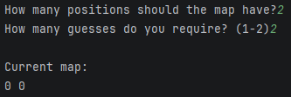
Result: Did the programme behave as expected ie syntactically and logically correct?
YES
If YES, comment on what happened.
If NO, what went wrong and why? Comment on how you would fix the problem.

Map is displayed as intended.
Test: Visuals and Formatting ii Enter map size “100”

Screenshot(s) of output:
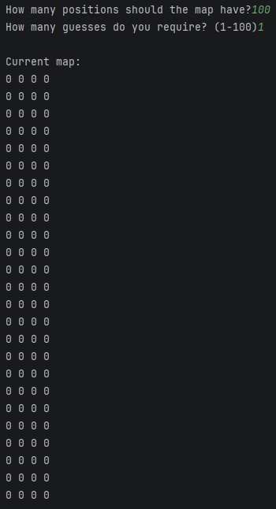
Result: Did the programme behave as expected ie syntactically and logically correct?
YES
If YES, comment on what happened.
If NO, what went wrong and why? Comment on how you would fix the problem.

The map is displayed as intended in 4 columns using this, “currentMap” function:

def currentMap(mapToPrint, title):
print("{} map:".format(title))
for counter in range(0, len(mapToPrint), 1):
print(mapToPrint[counter], end=" ")
if (counter + 1) % 4 == 0:
print()
print()
Test: Visuals and Formatting iii Enter odd map size “7”

Screenshot(s) of output:
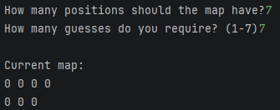
Result: Did the programme behave as expected ie syntactically and logically correct?
YES
If YES, comment on what happened.
If NO, what went wrong and why? Comment on how you would fix the problem.

Because of the fixed 4 columns the map only displays 3 positions on the bottom row as intended.

Final code:

[Copy and paste your code here – note, do not use a screenshot.

Note that there is no “before” and “after” code for this Worksheet because it is “Open” – not done in class. Therefore just post your final code below]

import random
def currentMap(mapToPrint, title):
print("{} map:".format(title))
for counter in range(0, len(mapToPrint), 1):
print(mapToPrint[counter], end=" ")
if (counter + 1) % 4 == 0:
print()
print()
def askYN(prompt):
choice = input(prompt).lower().strip()
while choice not in ["y", "n"]:
choice = input("That's not a valid input, please enter y/n:").strip().lower()
if choice == "y":
return True
else:
return False
def getNumber(prompt, minVal, maxVal):
while True:
try:
val = int(input(prompt))
if val < minVal or val > maxVal:
print("Out of range! ({}-{})".format(minVal,maxVal))
else:
return val
except ValueError:
print("Please enter a NUMBER:")
runProg = True
print("Welcome to the Treasure Hunt Program!")
if not askYN("Ready to play? (y/n)"):
print("No problem, maybe next time!")
runProg = False
while runProg:
tryCount = 0
guessHistory = []
map = []
visMap = []
mapLength = getNumber("\nHow many positions should the map have?", 2, 1000)
maxGuesses = getNumber("How many guesses do you require? (1-{})".format(mapLength),1,mapLength)
for counter in range(0, mapLength, 1):
map.append(0)
for counter2 in range(0, len(map), 1):
visMap.append(0)
treasure = random.randint(0, mapLength - 1)
map.pop(treasure)
map.insert(treasure, 1)
while True:
currentMap(visMap, "\nCurrent")
userGuess = getNumber("\nEnter a position (0-{})".format(mapLength - 1),0, mapLength - 1)
if userGuess in guessHistory:
print("You already guessed that!")
continue
tryCount = tryCount + 1
if map[userGuess] == 1:
print("\nThe treasure was found in position {}!".format(userGuess))
print("You took {} tries to find the treasure".format(tryCount))
currentMap(map, "Final")
if not askYN("Would you like to play again? (y/n)"):
runProg = False
break
elif tryCount == maxGuesses:
print("\nOut of guesses!")
currentMap(map, "Final")
if not askYN("Would you like to play again? (y/n)"):
runProg = False
break
else:
print("No treasure here")
visMap.pop(userGuess)
visMap.insert(userGuess, 7)
map.pop(userGuess)
map.insert(userGuess, 7)
guessHistory.append(userGuess)
print("Thank you for playing!")

