E-Portfolio Evidence of Learning

Jamie Dick (2103999)
Changemakers: Creativity and Value Creation (BMPS5011)
Public Services and Law
Sadie France
Contents

Task 01 – Mind Map ……………………………………………………………… pg.2
Task 02 – Summary………………………………………………………………. pg. 3-4
Task 03 – Elevator style pitch and flyer ………………………………………… pg. 5
Task 04 – A3 Poster ………………………………………………………………. pg. 6
Prototype ……………………………………………………………………………pg. 7
References …………………………………………………………………………. pg. 8-9

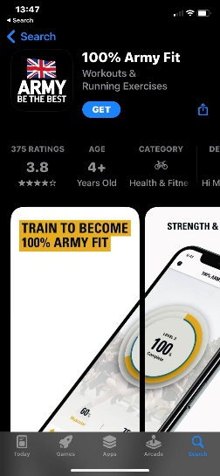
Task 1 – Mind Map
There have been websites, such as HM armed forces and apps on different public service tests and training. However, in the UK there are no apps or websites that include all the public services requirements.
There is already a UK army fitness app, however it only has the army and not the other armed forces units, for example (the royal marines or the royal air force).
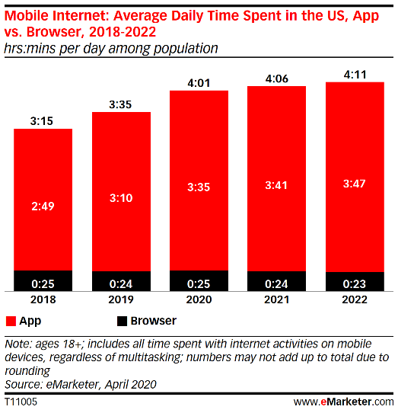
This graph shows the daily average time spent on phones by US adults. The average time spent on phones is increasing, especially adults using apps.
Apps store their data locally on mobile devices, unlike websites that generally use web servers. For this reason, data retrieval happens more swiftly in mobile apps
Apps also can work offline
According to Deshdeep (2022) "apps can perform actions much quicker than a mobile website".
An app is easier to use, as it is on a person’s smart phone. They can make an account, so if they sign in with another device, they will not lose their progress
Vodovatova (2021)
The app also helps individuals with their training as it has videos from experienced coaches to show the individual how to do certain exercises, for example, what is the correct form for a push up, to prevent themselves getting injured.
The app is to help individuals understand the requirements for what they must do to pass their chosen public services fitness test.
The idea is to create a fitness app for all UK public services
Ozonefit (2015)
100% Army fit (2018)
Previous ideas
The app itself
Innovation
The problem with this idea is the target audience. The app could be used more for young people who are in school, college or university, studying public services and want to join a public service after they have graduated or completed their course, or to give them inspiration.
Target Audience
What is the problem
Dashdeep (2022)
The Uniformed Public Service App
Known Knows
Wurmser (2020)
How do you solve a problem


Task 2 – Summary
This is a health and fitness app which provides information and training programs for all UK public services. The app was designed so young people could help prepare themselves, if they decide to go into their specific public service. The app contains fitness requirements but also different training methods on how to improve certain key components of fitness, the training methods are videos from public service professionals.
Me in college studying level 3 Public Services

What’s the idea?
The reason this idea came about was because, when I was in college I wanted to go into the army, partially because of the amount of physical exercise they did. Representatives from the Royal marines gave us talk and afterwards gave us a fitness test, which involved cardio, muscular endurance, and muscular strength. I also wanted to join, to see how far I could push myself and to see whether I would be able to cope under the pressure of joining the army.
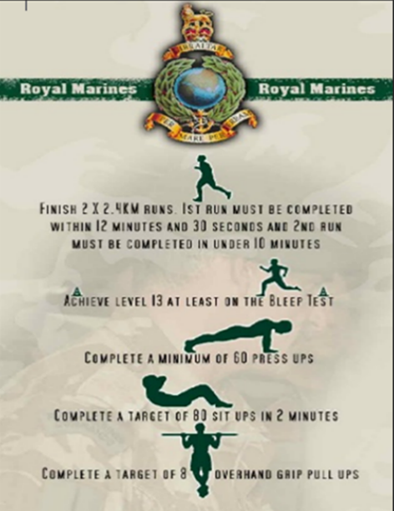
The reason I thought the app was a good idea was so that young people who are in college or university, can practice each week, so that when they finish their course, and are ready to join the public service of their choice, they will be well prepared. There has been an attempt at this by Ozonefit (2015), who designed a poster to put on their website explaining the different public services tests, however the poster does not have all the public services and it has not been updated since 2015 meaning the poster is slightly outdated, for example the pull up requirements for the Royal Marines in 2015 were 8, however in 2019 (Royal Marines, 2019, 01:40) the requirement was 16 pull ups.
The purpose of the app is to make finding up to date information easier for the user so they can research fitness exams and any qualifications needed, for example needing both English and Maths GCSE, or where to get voluntary experience from.
A poster from Ozonefit (2015), describing the Royal Marines Fitness test

Apps are better than websites!
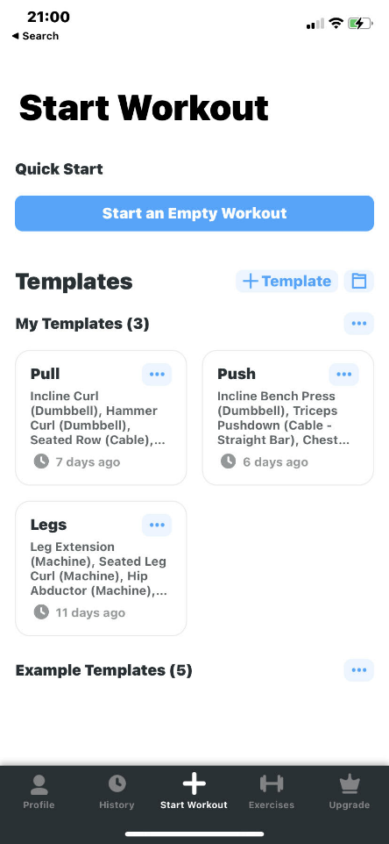
There is growing support for the claim that apps are better than websites. Dashdeep (2022) claims that apps are better for personalisation, as he explains saying apps can allow a “user to set up their preferences” before they can start using the app, so it could suggest that the user can select what they are interested in so when using the app in the future it will show the content that relates to the user. Also, some apps can track “customer engagement”, so the app will know what the user is interested in so they can offer recommendations for something similar.
Unlike websites apps can work offline so the user can use their app on the go and still track their progress. However, if the app has an online purpose, for example checking friends on social media, then the app will require Wi-Fi or Mobile internet.

Inspiration
The inspiration for coming up with the app came from other apps as well for example a gym app called ‘Strong Workout Tracker Gym Log’. The app is a workout tracker, which is designed for the user to get good workout results. Also apps such as Army fit have similar ideas, where in the Army they have videos and templates to help the user do training.
The ‘start workout’ page on the ‘Strong’ app

Task 3 – Elevator style pitch and flyer
Elevator style Pitch - https://youtu.be/FNkgoZ4iMdY
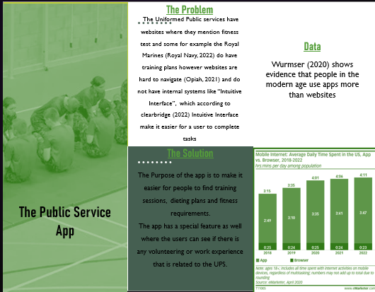

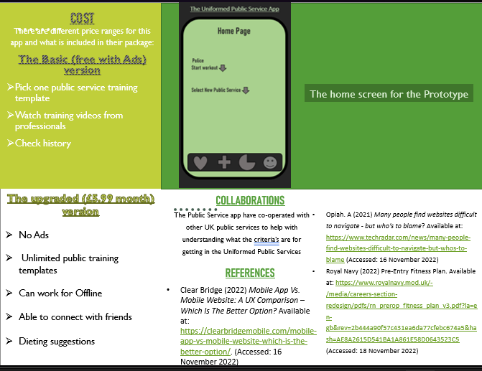

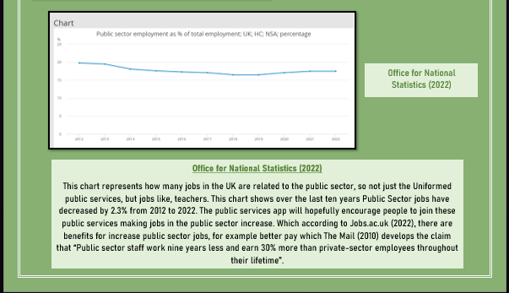
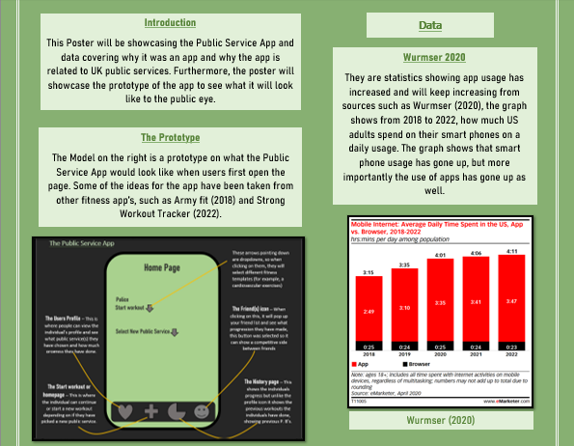
Task 4 – A3 Poster

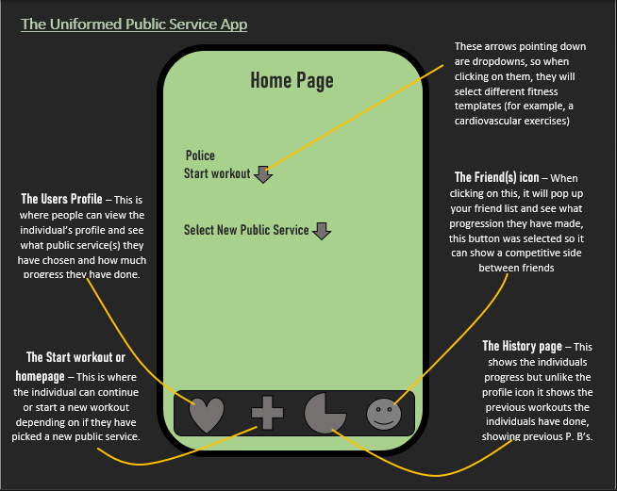
The Prototype

References
Clear Bridge (2022) Mobile App Vs. Mobile Website: A UX Comparison – Which Is The Better Option? Available at: https://clearbridgemobile.com/mobile-app-vs-mobile-website-which-is-the-better-option/. (Accessed: 16 November 2022)
Dashdeep. N (2022) Mobile App Or Website? 10 Reasons Why Apps Are Better. Available at: https://vwo.com/blog/10-reasons-mobile-apps-are-better/#:~:text=A%20well%2Ddesigned%20mobile%20app,happens%20swiftly%20in%20mobile%20apps. (Accessed: 14 November 2022)
Hi Mum! Said Dad. (2018). 100% Army Fit. (Version 2.4.0) [Mobile app]. (Accessed 13 November 2022)
Jobs.ac.uk (2022) Benefits of Working in The Public Sector. Available at: https://career-advice.jobs.ac.uk/career-development/benefits-of-working-in-the-public-sector/ (Accessed 20 November 2022)
Office for National Statistics (2022) Public sector employment as % of total employment; UK; HC; NSA; percentage. Available at: https://www.ons.gov.uk/employmentandlabourmarket/peopleinwork/publicsectorpersonnel/timeseries/db36/pse (Accessed: 20 November 2022)
Opiah. A (2021) Many people find websites difficult to navigate - but who's to blame? Available at: https://www.techradar.com/news/many-people-find-websites-difficult-to-navigate-but-whos-to-blame (Accessed: 16 November 2022)
Ozonefit (2015) Fitness Requirements for Public Service Roles. Available at: https://www.ozonefit.co.uk/2015/01/23/fitness-requirements-for-public-service-roles/ (Accessed: 12 November 2022)
Royal Marines (2019) Royal Marines training | Potential Royal Marines Course. 9 August. Available at: https://www.youtube.com/watch?v=f9tb-NR8BoE (Accessed: 15 November 2022)
Royal Navy (2022) Pre-Entry Fitness Plan. Available at: https://www.royalnavy.mod.uk/-/media/careers-section-redesign/pdfs/rn_prerop_fitness_plan_v3.pdf?la=en-gb&rev=2b444a90f57c431ea6da77cfebc674a5&hash=AE8A2615D541BA1A861E58D0643523C5 (Accessed: 18 November 2022)
Strong Fitness PTE Limited (2022) Strong Workout Tracker Gym Log. (Version 5. 15. 18). [Mobile app]. (Accessed 13 November 2022)
The Mail (2010) Great jobs apartheid: Public sector staff spend nine fewer years at work over lifetime than private employees AND earn 30% more. Available at: https://www.dailymail.co.uk/news/article-1287497/Public-sector-staff-spend-9-fewer-years-work-earn-30-private-employees.html (Accessed 20 November 2022)
Vodovatova. E (2021) Mobile App Vs Mobile Website: What To Choose? Available at: https://theappsolutions.com/blog/development/app-vs-website/ (Accessed: 16 November 2022)
Wurmser. Y (2020) The Majority of Americans’ Mobile Time Spent Takes Place in Apps. Available at: https://www.insiderintelligence.com/content/the-majority-of-americans-mobile-time-spent-takes-place-in-apps (Accessed: 14 November 2022)

