Taguchi Experiment Analysis Exercise
Author: | Leo Smith (2217998) | Module Name: | Systems Engineering
Date: | 24/04/2025 | Module Code: | ACDA 5021
Introduction:
To efficiently design a superior product, systems engineers must intrinsically understand the factors influencing the performance of their system. This knowledge underpins all elements of the design and manufacturing cycle, identifying both technical risks as well as opportunities for efficiency, allowing the targeted application of engineering resource. This concept was intimately understood by Genichi Taguchi, a thought leader in systems engineering, who stood by the principle that the best way to reduce cost, was to ensure quality [1].

This report explores Taguchi’s Methods for statistically analysing the influence of controls and noises on a system, and discussed how this insight contributes to effective system design [1]. To support this a case study is conducted on a table-top catapult, Figure 1. Here the key factors influencing the catapult range are identified and used to suggest an optimal system configuration.

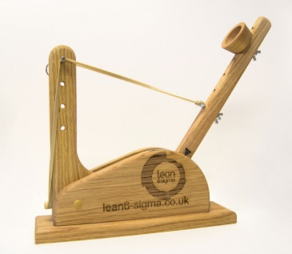
Figure 1 - Visual representation of the catapult used in the case study [2].

Methodology:
The Taguchi Method has three stages, System, Parameter and Tolerance Design. The most important of these is Parameter Design as this identifies the system configuration with the highest performance and lowest variance, hence ensuring quality [1].

To explore Parameter Design however the systems objective must first be design outlining the aim of the optimisation. For this case study this objective was the projection range.
Subsequently, the Factors, be those controls or noises, influencing the system must then be identified [3]. One effective method for this is a Parameter Diagram which is a tool used to identify all the factors, direct or indirect, which may influence the systems performance. The P-Diagram as conducted for this task is shown in Figure 2.

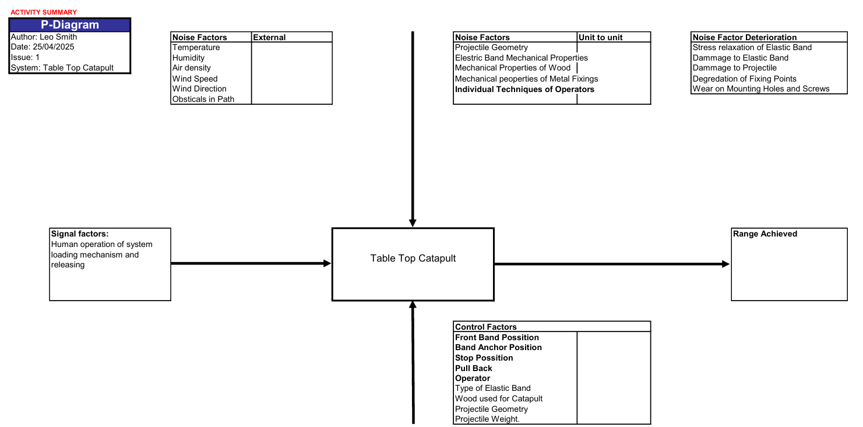
Figure 2 - Parameter Diagram for Catapult System.

As shown in Figure 2, P-Diagrams often identify a substantial number of system parameters. These, fit into two distinct categories: Quantitative and Qualitative [3]. Quantitative Factors, such as “Pull Back” have infinite potential options making it impossible to test every scenario. As such the Taguchi Method exploits the concept of Levels, with a Level being a chosen value for a parameter. The number of Levels chosen for a Quantitative factor varies by application. A higher number of levels, however, often gives an improved understanding but at the cost of experimental resources. As such a balance must be struck between the quality and efficiency. Qualitative Factors, such as “The Operator” however, have discrete options to choose from and hence a Level must be assigned to each potential choice [3].

No matter what testing method is used the number of parameters explored, and the number of levels for each parameter influences the number of experimental tests required [1]. As such, it is important before testing to rationalise the parameters to those which are deemed most important and levels to match the testing resources available. This, however, will always come at a cost to the knowledge gained. For the case study in question the parameters and levels chosen are shown in Table 1. These aimed to explore the most critical factors across the whole range of their domains.
Table 1 - Parameters and Levels Explored During Case Study.
Parameters Explored
 | Band front position | Band Anchor position | 1,2 Interaction | Stop Position | Pull back | 2,4 Interaction | Operator
Levels
Level 1 | 1 | 2 |  | 1 | 140 |  | A
Level 2 | 3 | 4 |  | 3 | 170 |  | B

Traditional experimental methods, such as One-Variable-At-A-Time (OVAT), would now systematically change each parameter in turn to explore its effect [3]. This, however, is a slow and resource intensive process which often fails to capture the interrelationships between system parameters. As such, the Taguchi Method employs Orthogonal Arrays to determine the parameter settings for each test [1], [4]. Here, parameters are changes simultaneously but in a way that allows the individual parameters to be characterised in a minimal number of tests [1], [4]. The size of the array, and the layout is influenced both by the number of parameters and levels with standard arrays being available in literature for a range of configurations. The case study, however, explores five parameters and two interactions, at two levels so adheres to the test matrix shown in Table 2.

Table 2 - Taguchi Method Orthogonal Array Test Matrix
Factor | 1 | 2 | 3 | 4 | 5 | 6 | 7
Factor | Band front position | Band Anchor position | 1,2 Interaction | Stop Position | Pull back | 2,4 Interaction | Operator
Expt 1 | L1 | L1 | L1 | L1 | L1 | L1 | L1
Expt 2 | L1 | L1 | L1 | L2 | L2 | L2 | L2
Expt 3 | L1 | L2 | L2 | L1 | L1 | L2 | L2
Expt 4 | L1 | L2 | L2 | L2 | L2 | L1 | L1
Expt 5 | L2 | L1 | L2 | L1 | L2 | L1 | L2
Expt 6 | L2 | L1 | L2 | L2 | L1 | L2 | L1
Expt 7 | L2 | L2 | L1 | L1 | L2 | L2 | L1
Expt 8 | L2 | L2 | L1 | L2 | L1 | L1 | L2

To explore the catapult system in question, this the test matrix in Table 2 was adhered to strictly. For each test built, three firings were conducted to explore the noise and variability present in each set up, as well as to reduce the effect of anomalous results. These results are presented below in Table 3.

Experimental Data:
Table 3 - Experimental Results
Experiment: | Firing 1 (cm): | Firing 2 (cm): | Firing 3 (cm): | Average (cm):
1 | 145 | 132 | 235 | 170.6666667
2 | 309 | 303 | 307 | 306.3333333
3 | 112 | 115 | 107 | 111.3333333
4 | 271 | 244 | 201 | 238.6666667
5 | 132 | 132 | 131 | 131.6666667
6 | 99 | 107 | 109 | 105
7 | 127 | 132 | 112 | 123.6666667
8 | 67 | 60 | 74 | 67

Traditional Taguchi Experiments are analysed using a statistical formula which evaluated the noise to signal ratio of each factor to determine the most critical [1], [4]. Application of this mathematical approach is out of scope so instead, the average range for both Level 1 and Level 2 of each factor was calculated. The difference between the range at each level, Delta, then indicates the influence of the parameter. This is shown in Table 4.

Table 4 - The Difference in Range Between Levels for each Factor
 | Band front position | Band Anchor position | AB Inter-action | Stop Position | Pull back | BC Inter-action | Operator
Level 1 | 206.75 | 178.4166667 | 166.9166667 | 134.3333333 | 113.5 | 152 | 159.5
Level 2 | 106.8333333 | 135.1666667 | 146.6666667 | 179.25 | 200.0833333 | 161.5833333 | 161.5833333
Delta | 99.92 | 43.25 | 20.25 | 44.92 | -86.58 | -9.58 | -2.08

By plotting the Delta value for each parameter, the sensitivity of the system to changes in each factor is visualised as shown in Figure 3.

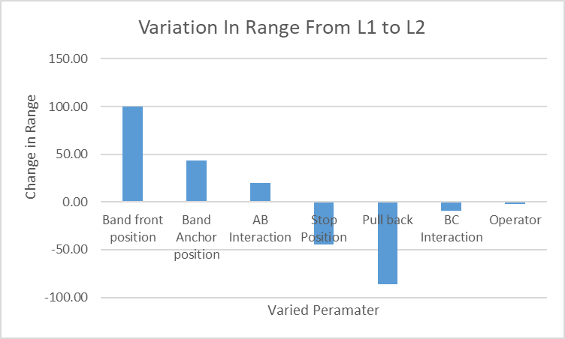

Figure 3 - Visualization of the Influence of Each Factor on System Performance.
Interpretation and Discussion:
Figure 3 clearly shows that the “Front Band Position” and “Pull Back Distance” have the most significant effect on the performance of the system with a variability of 99.9 and -86.6 cm respectively. This means they can be regarded as the Key Control Factors within the system.

In a practical design task, the identification of these Key Control Factors would then allow most engineering resource to be dedicated to understanding and controlling these factors. This would help ensure variability on these factors, which shown to significantly impact performance is reduces ensuring quality products.

In this case study further exploration was conducted on these two control factors. This aimed to better understand the key factors and develop a predictive model using these two factors to estimate the range. To perform these tests the optimal Level for all other factors was chosen and the Key Factors varied and tested as shown in Table 5.

Table 5 - Further Exploration into Key Control Factors
 | Front Pos. | PB. |  | Shot 1 | Shot 2 | Shot 3 | Average
Firing 1 | L1 | L1 | Range: | 138 | 114 | 98 | 116.6667
Firing 2 | L2 | L1 | Range: | 60 | 53 | 71 | 61.33333
Firing 3 | L1 | L2 | Range: | 272 | 273 | 240 | 261.6667
Firing 4 | L2 | L2 | Range: | 140 | 189 | 152 | 160.3333

This testing was then processed to provide a matrix showing how the performance varied as each Key Control Factor varied this was again calculated by averaging the firing results for each factor and is shown in Table 6.

Table 6 - Influence of Key Control Factors.
 | Level 1 | Level 2
Front Position | 189.2 | 89
Pull Back | 110.8 | 211

When compared to Table 4 this confirmed the trend observed but allowed the effects to be isolated. With the behaviour of each control factor identified the observed relationship was used to produce a predictive model. Here the range was estimated for a firing where both Key Control Factors were set at the midpoint between Level 1 and 2. To estimate this range the midpoint between each factors individual range was calculated and the result averaged. This gave a predicted range of 150cm. To validate this prediction a test was conducted as given in Table 7.

Table 7 - Predictive Model Validation Test
 | Front Pos. | PB. |  | Firing 1 | Firing 2 | Firing 3 | Average | Estimate
Firing 1 | 2 | 155 | Range | 120 | 142 | 135 | 132.33 | 150

Here it is observed that the actual recorded result was 132cm compared to the estimate of 150cm representing a 12% error. This suggests the generated model is not ideal and the relationship for each control factor is not linear.

Conclusions:
In this report it has been demonstrated that Taguchi Methods may be used to identify the Key Factors influencing the performance of a system. It is discussed that Taguchi Methods provide an efficient method for conducting this exploration when compared to traditional methods. This is re-enforced by a practical case study.

In this case study a catapult is analysed and through Taguchi Methods it is identified that the Front Band Position and Pull Back Distance are the key factors influencing system performance. These factors are explored further confirming this conclusion and producing a simple linear predictive model to estimate the performance of an intermediary test.

When validated this predictive test had an error of 12% suggesting it was not reflective of the systems performance. This indicated that the relationship between the Key Factors and performance is not linear instead representing a more complex function. To explore this further testing should be conducted evaluating these parameters at an increased number of levels.

Reflections:
Although the testing was deemed successful several challenges were identified. If the testing was repeated these challenges should be addressed to improve understanding of the system.

- Testing was not run in a randomised order allowing systematic bias to be introduced [3].
- Many parameters from the P-Diagram were not considered leaving potential key factors un-explored.
- The measurement techniques applied, visual via tape measure, where inherently inaccurate leading to un-reliable results.
- No analysis was conducted to explore noise factors such as material wear and fatigue.

These reflections are not comprehensive but have been condensed for accessibility. Due to the challenging nature of systems engineering to remedy many of these challenges significant work would be required.

References:
[1] | S. K. Karna, “An Overview on Taguchi Method,” Researchgate, 2016.
[2] | D. Holley, “L5 - Systems Engineering & Work-Based Group Project (ACDA5021&ACDA5022),” [Online]. [Accessed 25 April 2025].
[3] | J. Antony, Design of Experiments for Engineers and Scientists, Elsevier, 2014.
[4] | H. de Souza, M. Silva, C. Moyes, F. Alberto, F. Pontes, U. Ferreira, R. Duarte and C. da Silva, “ Robust Design and Taguchi Method Application,” in Design of Experiments - Applications, Intech, 2013.

