Dissertation Proposal
Topic: Impact of Social Media Marketing on Customer Engagement in Indian Banks

AI use Acknowledgement

For completing this project, I have not applied any AI tool to generate any part of answer and this work is solely done with best of my knowledge.
Table of Contents
1. Introduction 3
1.1 Background 3
1.2 Motivation 3
2. Literature review 5
2.1 Social media marketing in the banking sector 5
2.2 Customer engagement via social media platforms 5
2.3 Digital transformation and consumer behaviour in India 6
3. Methodology 7
3.1 Research philosophy 7
3.2 Research Approach 7
3.3 Research design 8
3.4 Research strategy 8
3.5 Data collection 8
3.6 Sampling strategy 8
3.6 Data analysis 9
3.7 Ethical consideration 9
4. Result and discussion 9
4.1 Expected results 9
4.2 Potential limitations 10
5. Significance 10
5.1 Contribution 10
5.2 Application 10
5.3 Value to society 11
8. References 12
Appendix: Time frame 15

1. Introduction
Social media marketing is used as a significant tool that enables banks to develop seamless connections with users, strengthening financial services and building long-term relationships. In the Indian banking sector, a higher degree of internet penetration and users on social media platforms elevates customer interaction, trust and desired satisfaction.

1.1 Background
In the recent era, the growth of digital technologies has come forward to enhance the mode of marketing strategies. It is seen that in the banking sector, social media marketing is used widely to build relationships, communicate with customers, and enhance engagement (Rehmanet al. 2025). It is recorded that throughout the globe, about 92% of financial institutions use social media in their marketing strategies, while 87% of retail banks use Facebook as a primary channel for customer interaction (Team Cross & Crown, 2026). In the same way, in India, the banking sector has reached over 142 million users across major social media platforms. This research will shed light on understanding how the Indian banking sector is managing customer engagement through social media marketing.

1.2 Motivation
Research gap
It is obvious that every research study must have some gaps and the previous studies have also been identified with some gaps, which will be mitigated in the current study. Firstly, it is seen that previous researchers did not emphasise on social media marketing in the banking sector in depth. Moreover, the current scenario in the Indian banking sector is not also evaluated in linking with theories and models. The gradual growth of social media marketing in the banking sector can be evaluated through collecting real-world information along with theoretical underpinnings.
Research problem
As mentioned by Oharaet al.(2024), the development of social media marketing has brought a revolution in managing marketing practices in different industries. In this regard, it is prominent that the Indian banking sector is using social media sites such as Facebook, Instagram and Twitter (X) to communicate with customers, promote financial services, and strengthen brand presence. Despite huge investments in managing digital marketing strategy, many banks still struggle to convert online interactions into meaningful customer engagement. From this point of view, it is evident through the research that like other industries, the Indian banking industry may also have immense benefits if they become able to leverage social media marketing to uplift the customer engagement rate.
Aim
The aim of the research will be to assess the impact of Social Media Marketing on Customer Engagement in Indian Banks.
Research objectives
- To evaluate the impacts of social media marketing in the banking sector
- To examine the impact of Social Media Marketing on Customer Engagement in Indian Banks
- To find out the issues based on the lack of social media marketing in the Indian banking sector
- To recommend feasible strategies through which customer engagement can be enhanced in Indian Banks
Research questions
- What are the impacts of social media marketing in the banking sector?
- How Social Media Marketing acts on Customer Engagement in Indian Banks?
- What are the issues based on the lack of social media marketing in the Indian banking sector?
- What can be feasible strategies through which customer engagement can be enhanced in Indian Banks?
Hypotheses
₀H⁰:There is no positive correlation between social media marketing and customer engagement in the Indian banking sector
₀H¹: There is a positive correlation between social media marketing and customer engagement in the Indian banking sector

2. Literature review

2.1Social media marketing in the banking sector
Social media marketing has a greater role as a pivotal component in digital marketing strategies across different industries, including banking. Banks are increasingly using social media platforms such as Facebook, LinkedIn and Instagram also in regard to communicating with customers, promoting products and optimising brand relationships. As studied by Azar et al. (2025), large banking institutions integrate social media within their marketing strategies to improve customer communication and ensure reach development. On the contrary, Liu et al. (2023) argued that the leading adoption of social media platforms by banks is highly appreciable, but there are many organizations that have failed to develop effective engagement strategies. Additionally, many scholarly studies highlighted that banks often prioritized promotional content rather than communicating with customers. Due to this, banks face limitations in dealing with customer participation. Therefore, this perspective highlighted that social media ensures opportunities for leading customer engagement, but it requires a strategic approach for maintaining digital interaction.

2.2 Customer engagement via social media platforms
Customer engagement is strongly dependent on behavioural, emotional and cognitive interactions between the users and the banking service providers. In the words of Del Sarto et al. (2025), social media platforms ensure significant value for banks to build interactive relationships through commitments, constructive feedback and securing communication support. The use of social media platforms also raises awareness among customers, maintaining satisfaction and ensuring loyalty to the banks. On the other hand, social media provides access to banks to connect with millions of valuable customers. Using social media platforms such as Facebook, Instagram and LinkedIn, banking organizations reach a broader range of customers which they maintain continuity in communication and subsequent improvement in service operations. In contrast to this, the scholarly study of Eslamiet al. (2022) argued that customer engagement is not directly aligned with presence on social media. However, it requires engaging content, ensuring on-time response and optimisation through customer-centric communication or interactions.

2.3 Digital transformation and consumer behaviour in India
In the Indian economy, digital transformation shaped consumer behaviours across the banking sector. Due to the increasing number of social media users and average spending time on social media platforms, consumers' behaviour has already changed. The study of Siregar et al. (2023) highlighted that banking organizations are more likely to follow the trends regarding the significance of social media in response to strategic communication and embracing loyalty. Digital transformation is mainly symbolised through automation, consistency in use of the internet and AI, Big data, APIs (Bhat, 2022). On the other hand, digital transformation leads to critical challenges in relation to security concerns, privacy risks, as well as imposing a burden for digital literacy. However, social media marketing leads variations across the different demographics, specifically in the segment of urban and rural consumers.
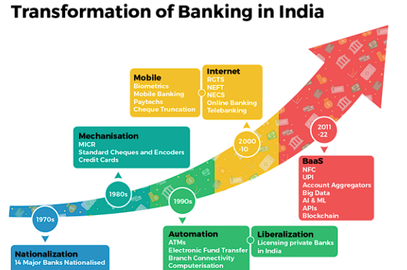
Figure 1: Digital transformation of Banking in India
(Source: Xpheno, 2025)

3. Methodology

3.1 Research philosophy
Positivism research philosophy will be appropriate for this research as it believes social realities are subjective and socially constructed instead of objectivity (Pervin and Mokhtar, 2022). With this, this research can express knowledge oriented to customers’ perception and maintain valuable experience prior to social media marketing. In contrast to this, realism and interpretivism will not be effective as it prioritizes objective measures anddo notrely on statistical data.
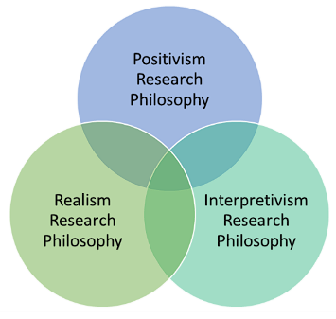
Figure 2: Research Philosophies
(Source: Business-review, 2024)

3.2 Research Approach
A deductive approach is proposed for this research as it aims to articulate valuable insights from newly gathered information based on the research topic. For qualitative research, an inductive approach will be meaningful as it can help in finding trends to develop themes (Naeem et al. 2023). Whereas the deductive approach concerns testing existing hypotheses, which will be appropriate to gather valuable data on social media marketing and consumer behaviours.

3.3 Research design
Exploratory will be meaningful as it helps in identifying recent trends, patterns and connections between the factors responsible for changing consumer behaviours for social media use by Indian banks. While, descriptive design will not be applicable as it is responsible for secondary research and explanatory design focuses on analysing defined variables (Thomas &Zubkov, 2023).

3.4 Research strategy
A quantitative research strategy is adopted as it is more appropriate for understanding the perception, experience, and interpretation of social media engagement,collecting real-world data (Chowdhury, 2024). On the contrary, qualitative research strategy is effective in terms of collection of theoretical data, but quantitative research strategies are more appropriate for numerical analysis through offering more insights into behavioural patterns and communication strategies adopted by banks.

3.5 Data collection
This study will be using a primary survey-based data collection strategy, considering the customers of Indian Banks. For this purpose, a social media post will be developed on Facebook and LinkedIn, mentioning the research purpose and the area of research. From the comments, around 150 individuals will be selected and communicated with through inboxes. If it will be seen that 100 individuals will be from Indian Banks, they will be confirmed as survey participants. Then they will be connected through mailboxes mentioning the date, time and process of the survey. Around 12-15 questions will be developed in Google Forms and the link to the form will be distributed through the mailbox within a specified time.

3.6 Sampling strategy
There are two main types of sampling strategies, such as random sampling and non-random sampling (Mulisa, 2022). The random sampling will be applied in this research as it will increase the chance of having an adequate number of participants for the survey. The only criterion will be that the participants need to be customers of Indian banks.

3.6 Data analysis
This research will include data analysis techniques such as quantitative analysis. For this purpose, Ms-Excel will be used and the survey output will be assessed through Excel. The thematic analysis method is insightful in determining recurring trends, and patterns from the gathered sources to interpret meanings solely (Polat, 2025). But as the research will consider the collection of numerical data, so that thematic analysis will be rejected. The chosen method of analysis will support for conveying meaningful concepts related to the social media influence of consumers’behaviours in the Indian baking sector.

3.7 Ethical consideration
In order to complete this study in a proper manner, research ethics must be followed. Firstly, anonymity of research participants will be maintained by following the principles of the Data Protection Act 2018 (Legislation, 2025). Along with this, the ethical issue based on plagiarism and the use of AI tools will be strictly avoided. Any kind of manipulation of survey findings will be ignored to maintain the quality of the research thoroughly.

4. Result and discussion

4.1 Expected results
The expected outcome of the study indicates that social media marketing is important in developing customer engagement across Indian banks. Due to rapid growth in digital technology, the rise of social media use has reshaped the banking service dynamics prior to customer satisfaction and loyalty. In India, over 462 million active users are on social media platforms (Tiwari and Khan, 2025). This is an indication that banks are likely to have increased customer interactions. In addition, it is notable that Indian internet users are spending about 2.5 hours on all social media platforms on a daily basis (Krishnan, 2025). This will provide banks with greater opportunities for interacting with their customers through social media platforms. Such interactions might help in enhancing brand popularity, customer satisfaction as well as loyalty. The results will also demonstrate that content on social media has an impact on customer engagement. In this aspect, visual content, especially video content, is likely to have better rates of interaction than text-based interaction. Studies have shown that video content on finances can have over 1200% shares than other content on social media (Mitchell, 2026). This indicates that banks that incorporate multimedia marketing will have better results in terms of engagement.

4.2 Potential limitations
There are certain limitations associated with the current research, which might have an impact on the extent of the results. Firstly, the current research is based on secondary data sources only. This means that the current research might not reflect the latest customer experiences. Secondly, the absence of primary data might have an impact on the extent of customer information.

5. Significance
Social media platforms are used as an essential tool for the improvement of communication between banks as well as users or customers. With the increasing digitalization of financial services in India, social media sites have the potential to improve the relationship between banks and customers, leading to an increase in customer satisfaction.

5.1 Contribution
As per the growth and development of digital marketing, it becomes necessary for the banking sector to maintain thorough communication with customers (Nkpurukweet al.2025). In this aspect, social media can be an effective tool through which the banking sector can make the path of marketing wider and stronger. This study will be effective in showing the strategies through which social media marketing can be leveraged by the Indian banking sector to enhance competitiveness and business processivity by increasing customer engagement rate.

5.2 Application
The research will be helpful in terms of showing the use of digital marketing in the Indian banking sector. As highlighted by THAKUR(2022), as time progresses, social media has become a part of commercialisation. From this view, it is needless to state that if the Indian banking sector will use social media marketing, it will be helpful for them to maintain connections with older as well as newer customers in a competitive market.

5.3 Value to society
The research paper will bring a huge value to society in terms of showing the usefulness of social media marketing, mainly in the banking sector.Besides, it will be effective in presenting the reasons behind the growth of the business and the optimised use of social media. In the era of business globalisation, it is never possible to run a business by engaging huge customers if digitalisation will not be included in marketing.

8. References
Azar, J. F., Rousta, A., and Asayesh, F. 2025. Presenting a Social Media Marketing Model in the Banking Services Industry: A Mixed Methods Study. Management Strategies and Engineering Sciences, 7(4), 133-144.https://msesj.com/index.php/mses/article/view/233
Bhat, J. 2022. The Role of Intelligent Data Engineering in Enterprise Digital Transformation. International Journal of AI, BigData, Computational and Management Studies, 3(4), 106-114.https://ijaibdcms.org/index.php/ijaibdcms/article/view/331
Business Review (2024) HOW TO WRITE A research methodology, George Business Review. Available at: https://www.george-business-review.com/how-to-write-a-research-methodology/ (Accessed: 07 March 2026).
Chowdhury, R. H. 2024. Sentiment analysis and social media analytics in brand management: Techniques, trends, and implications. World Journal of Advanced Research and Reviews, 23(2), 287-296.https://www.researchgate.net/profile/Rakibul-Chowdhury-6/publication/392529227_Sentiment_analysis_and_social_media_analytics_in_brand_management_Techniques_trends_and_implications/links/684787e68a76251f22ec92d5/Sentiment-analysis-and-social-media-analytics-in-brand-management-Techniques-trends-and-implications.pdf
Del Sarto, N., Bocchialini, E., Gai, L., and Ielasi, F. (2025). Digital banking: How social media is shaping the game. Qualitative Research in Financial Markets, 17(2), 348-369.https://www.emerald.com/qrfm/article/17/2/348/1241453
Eslami, S. P., Ghasemaghaei, M., and Hassanein, K. (2022). Understanding consumer engagement in social media: The role of product lifecycle. Decision Support Systems, 162, 113707.https://www.sciencedirect.com/science/article/pii/S0167923621002177
Jadhav, G. G., Gaikwad, S. V., and Bapat, D. (2023). A systematic literature review: digital marketing and its impact on SMEs. Journal of Indian Business Research, 15(1), 76-91.https://www.emerald.com/jibr/article-abstract/15/1/76/213341/A-systematic-literature-review-digital-marketing?redirectedFrom=fulltext
Krishnan, V.B. (2025). How much time do Indians spend on social media?,The Hindu. Available at: https://www.thehindu.com/news/national/how-much-time-do-indians-spend-on-social-media/article29201363.ece (Accessed: 07 March 2026).
Legislation (2025) Data protection act 2018, Legislation.gov.uk. Available at: https://www.legislation.gov.uk/ukpga/2018/12/contents (Accessed: 16 March 2026)
Liu, Y., Naveed, R. T., Kanwal, S., Tahir Khan, M., Dalain, A. F., and Lan, W. (2023). Psychology in action: Social media communication, CSR, and consumer behavior management in banking. PloS one, 18(8), e0289281.https://journals.plos.org/plosone/article?id=10.1371/journal.pone.0289281
Mitchell, S. (2026) Marketing in the Banking Industry Statistics: Market Data Report 2026, Gitnux. Available at: https://gitnux.org/marketing-in-the-banking-industry-statistics/?utm_source=chatgpt.com (Accessed: 07 March 2026).
Mulisa, F., 2022. Sampling techniques involving human subjects: Applications, pitfalls, and suggestions for further studies. International Journal of Academic Research in Education, 8(1), pp.74-83. https://dergipark.org.tr/en/download/article-file/2856569
Naeem, M., Ozuem, W., Howell, K., and Ranfagni, S. (2023). A step-by-step process of thematic analysis to develop a conceptual model in qualitative research. International journal of qualitative methods, 22, 16094069231205789.https://journals.sagepub.com/doi/full/10.1177/16094069231205789
Nkpurukwe, O., Arumdeben, G. and Tungkir, K., 2025. Digital Marketing Communication Strategies: A Sure Way of Gaining Customer Patronage. Abuja journal of business and management, 3(1). https://ajbam.com.ng/index.php/ajbam/article/download/119/120
Ohara, M.R., Suparwata, D.O. and Rijal, S., 2024. Revolutionary marketing strategy: Optimising social media utilisation as an effective tool for MSMEs in the digital age. Journal of Contemporary Administration and Management (ADMAN), 2(1), pp.313-318. https://journal.literasisainsnusantara.com/index.php/adman/article/download/125/102
Pervin, N., and Mokhtar, M. (2022). The interpretivist research paradigm: A subjective notion of a social context. International Journal of Academic Research in Progressive Education and Development, 11(2), 419-428. http://dx.doi.org/10.6007/IJARPED/v11-i2/12938
Polat, A. (2025). Thematic analysis in qualitative research: Common pitfalls and practical insights for academic writing. International Journal of Qualitative Methods, 24, 16094069251372835.https://journals.sagepub.com/doi/full/10.1177/16094069251372835
Rehman, F.U., Zahid, H., Qayyum, A. and Jamil, R.A., 2025. Building relationship equity: Role of social media marketing activities, customer engagement, and relational benefits. Journal of Theoretical and Applied Electronic Commerce Research, 20(3), p.223. https://www.mdpi.com/0718-1876/20/3/223
Siregar, N., Nursyamsi, S. E., Angellia, F., Hamboer, M. J. E., and Riyantie, M. (2023). The role of social media in increasing customer interaction and brand loyalty. JurnalMinfoPolgan, 12(2), 1865-1873.https://jurnal.polgan.ac.id/index.php/jmp/article/view/13058
Team Cross & Crown (2026) Social Media Marketing for Financial Institutions: 7 key trends: Cross & crown, Cross & Crown |. Available at: https://cacpro.com/insights/social-media-marketing-for-financial-institutions-7-key-trends/ (Accessed: 16 March 2026)
THAKUR, A., 2022. Commercialisation of Media. International Journal of Legal Science and Innovation, 4(2), pp.15-26. https://ijlsi.com/wp-content/uploads/Commercialisation-of-Media.pdf
Thomas, D., and Zubkov, P. (2023). Quantitative research designs. Quantitative research for practical theology, 5(6), 103-114.https://www.researchgate.net/profile/Darrin-Thomas/publication/370630979_Quantitative_Research_Designs/links/645a8b0c2edb8e5f094afcfe/Quantitative-Research-Designs.pdf
Tiwari, A. and Khan, Dr. (2025). Growth of Social Media in India: An Overview. Communication Today. 29. 76-85. https://www.researchgate.net/publication/389943981_Growth_of_Social_Media_in_India_An_Overview
Xpheno (2025). How mid-tier banks in India can survive the Digital Banking Revolution, Xpheno. Available at: https://blogs.xpheno.com/how-mid-tier-banks-in-india-can-survive-the-digital-banking-revolution/ (Accessed: 07 March 2026)

Appendix: Time frame
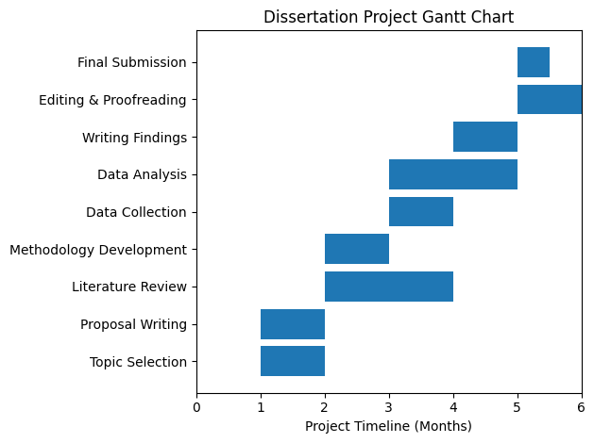
Figure 3: Gantt chart
(Source: Self-created)

