Personal Development Plan
Lareesa Young (1901947) | Project Management and Professional Development | 7/2/20
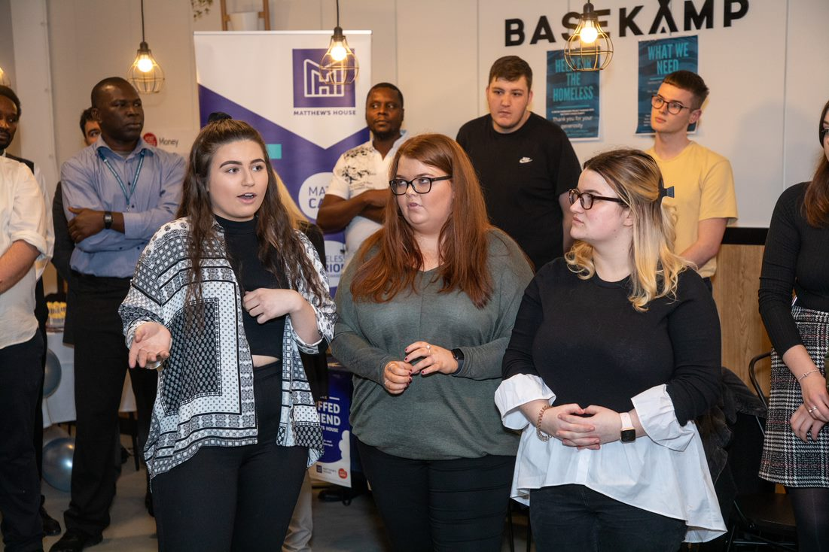

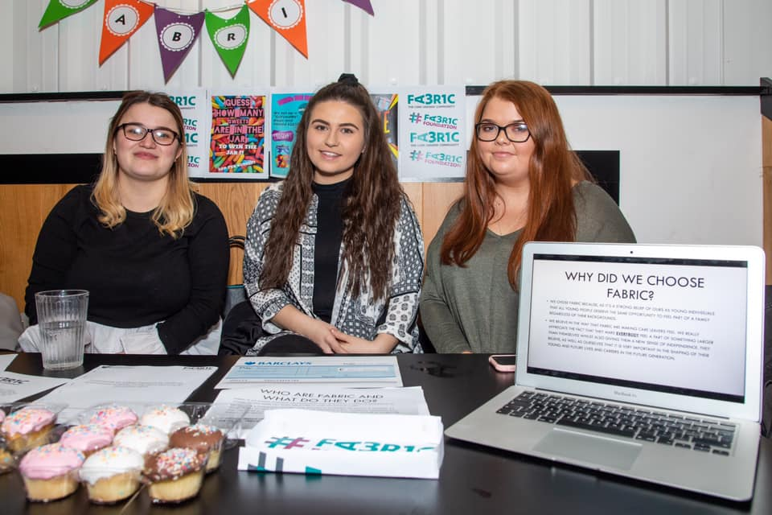

Introduction

Over the last semester at University of Wales Trinity Saint David, I have completed many assignments. Whilst completing these I have received feedback of my strengths and weaknesses in my Literature, Knowledge and understanding, my intellectual and practical skills along with my transferable skills for life and professional practice. After analysis this feedback, I have put together a Personal Development Plan of the skills I would like to improve whilst being at university. A PDP is an action plan that sets out a programme of training and learning both on and off the job that will allow me to increase my competencies in line with requirement of the university and future employers. It is crucial I develop the skills I lack to ensure that I am set for a future job, this could lead to the benefit of improving my future career as well as offering me more opportunities to get a job in the future (Heery and Noon, 2008).

Personal Development

What do I want/need to learn?  (specific & Relevant) | What will I do to achieve this?  (Specific) | What resources or support will I need?  (Achievable) | What will my success criteria be?  (Measurable) | Target dates for review and completion  (timebound)
As all theorists need to be referenced in the correct Harvard style layout throughout my assignments, I missed out on marks for not using the correct style in previous assignments. From this I would like to develop my skills in referencing and learn how to correctly reference academic sources such as books and websites correctly in my work. | I will use the UWTSD referencing handbook when completing work and I will also use my old assignment feedback in this section to see where I went wrong and amend my mistakes in new pieces of work. | The resources I will need to help me with my goal would be the referencing handbook itself, along with a laptop or access to a computer to have open whilst completing assignments to look back at to ensure I am doing it correctly. | Checking to see if I had higher marks in the engagement with literature section of the mark scheme. | 7th February 2020.
I will need to know how to source suitable theoretical models in my work. In my previous assignment I used website which were not academically correct which will affect the quality of my work also meaning I will lose marks in certain sections in the mark scheme. These skills will help me in future assignments as well as in situations in future employment as theory helps understand when partnerships are appropriate and what their different intentions imply (World Economic Forum, 2020). | I have been recommended by my lectures to use the university online library to find academic sources which are suitable to use in my work. I will also use google scholar as this is known for academic sources. | I will need the use of a laptop or computer to achieve this goal, I will need to have access to the internet to use google scholar and the online library. | I will be to achieve more marks in the mark scheme for the theories used in my work compared to the marks I achieve in my previous assignments. | 7th February 2020.
I need to learn how to complete my LinkedIn profile to a good professional standard, as LinkedIn is the largest professional network on the internet. It can be used to find jobs and gives you the ability to connect and strengthen professional relationships as well as helping you learn the skills needed for specific roles (Linkedin, 2020) | I will seek help from lectures, who know a lot about LinkedIn as well as asking family members who have set up their own businesses and succeeded in creating a strong linked in profile for themselves. | I will need to use my email to communication with lectures, other professionals and family who know about LinkedIn and how to use it , to maybe organise a meeting where they will be able to show me what to do and how to work the App correctly to present myself to companies and organisations who could be future employers. | I will get someone with a professional background with knowledge of LinkedIn, to look at my profile before and after I have spoken to lectures etc. to see what they think and to see if they have any feedback on my profile. | I would like to achieve this by the end of my first year at university as I will be able to start gaining connections in the field of work I would like to be employed in the future.
I will need to develop my confidence in public speaking, where I will need to adapt my tone and volume etc. to different clientele. According to the World Economic Forum, to be a good leader you need to be a good presenter, where they present their talks like a storyteller (World Economic Forum, 2020). | To achieve this, I will gain experience in public speaking. I have already started working on this skill when I represented my team in a showcase event for an assignment I have recently completed, where I volunteered to speak Infront of the whole audience that showed up to the event. | I will need to research tips using a laptop and the internet on how to overcome nerves whilst speaking Infront of bigger groups of people and to be confident with my ideas. | I will know if I am developing my public speaking skills when I am able to be more confident with my ideas and my ability to present. I could ask for feedback of lectures etc. to see if they believe I am improving. | I would like to achieve this goal by the end of my time at university as I do not believe this is something that could be learnt over night and I would like to develop this slowly to ensure I build on my confidence.
I would like to develop my leadership skills. According to World Economic Forum students require leaderships skills for the 21st century (World Economic Forum, 2020). | I will volunteer to be team leader in group activities to develop this skill. | Group activities to take part in where I can nominate myself as team leader. | If I succeed in becoming a team leader in my activities. | May 2020
I want to develop my decision-making skills as I find in some situations, I am indecisive. I took a small test with Belin’s nine roles in a team and I fell into the team worker category, the disadvantage to this was being indecisive in situations (Mullins, 2013). | I will avoid basing my decisions on emotional, personal choices and think of the outcomes. | I will use pen and paper to perhaps write pros and cons down of certain outcomes, then eventually do this in my head in crunch situations. | In crunch situation I will make more rapid decisions. | Mid May 2020
I need to gain work experience in Human Resources to gain more of an understanding of what the job includes. According to UCAS a recent survey showed two thirds of employers look for graduates with relevant work experience because it helps them prepare for work and develop general business awareness. Importantly, one third of employers felt that applicants did not have a satisfactory level of knowledge about their chosen career or job (UCAS, 2020). | I will look for summer placements or voluntary work to gain experience. I also have family friends who work within HR management roles so I will also talk to them to see if they can help me find experience. | I will need my phone to contact family and I will also need the internet to keep an eye out for any work experience jobs available. | I will have achieved a work experience role within HR. | January 2021
I need to be more Creative in my ideas and presenting my work | To achieve this, I will look at example works and templates to lay my work out in a professional way using creative examples. I will also look at previous feedback from my lectures. | I will need my laptop and the internet to do research on examples of certain pieces of work and how to present it. | I will compare recent examples of work to previous work to see whether there are any positive changes. | May 2020
I would like to develop my negotiation skills, where I will be able to give my opinion into a debate rather than just agreeing with other people and keeping my view to myself. | I will put my point of view across in group discussions to get my point heard. | Group Activities to talk and debate with other members. | I will ask other peers whether they think I am participating more towards discussions and negotiations compared to previous ones. | May 2020

References for PDP
Heery, E. and Noon, M. (2008). A dictionary of human resource management. Oxford: Oxford University Press.
Linkedin.com. (2020). How LinkedIn Can Help You | LinkedIn Help. [online] Available at: https://www.linkedin.com/help/linkedin/answer/45?lang=en [Accessed 1 Feb. 2020].
Mullins, L. (2013). Management and Organisational Behaviour. 10th ed. Great Britain: Financial Times Pitman Publishing, p.336.
UCAS. (2020). Is work experience important?. [online] Available at: https://www.ucas.com/connect/blogs/work-experience-important [Accessed 3 Feb. 2020].
World Economic Forum. (2020). How theory can help to improve the real world. [online] Available at: https://www.weforum.org/agenda/2014/05/understanding-isnt-partnership-matters/ [Accessed 1 Feb. 2020].
World Economic Forum. (2020). What are the 21st-century skills every student needs?. [online] Available at: https://www.weforum.org/agenda/2016/03/21st-century-skills-future-jobs-students/ [Accessed 3 Feb. 2020].
World Economic Forum. (2020). 4 public speaking skills you need to master to become a leader. [online] Available at: https://www.weforum.org/agenda/2015/07/4-public-speaking-skills-you-need-to-master-to-become-a-leader/ [Accessed 1 Feb. 2020].

Project Reflection Video Link

It Takes Three to Spill the Tea!
Click Below for Reflection Video!
https://youtu.be/pZsP6OhwjOA

Reference list for Video
Belbin.com. (2019). Belbin. [online] Available at: https://www.belbin.com/about/belbin-team-roles/.
Dörner, D. and Funke, J. (2017). Complex Problem Solving: What It Is and What It Is Not. Frontiers in Psychology, 8.
Mullins, L.J. (2013). Management and Organisational Behaviour. 10th ed. Great Britain: Financial Times Pitman Publishing.
Secrets Of Successful Teamwork: Insights From Google. (2018). YouTube. Available at: https://www.youtube.com/watch?v=hHIikHJV9fI&feature=emb_title [Accessed 6 Feb. 2020].
Soffel, J. (2016). What are the 21st-century skills every student needs? [online] World Economic Forum. Available at: https://www.weforum.org/agenda/2016/03/21st-century-skills-future-jobs-students/ [Accessed 28 Oct. 2019].
‌

